HL7_XPARADIGM_CIMI_LM_R1_O1_2017JAN



**CIMI Logical Models, Release 1 (PI ID: 1253)**

January 2017

**HL7 For Comment Ballot**

**Sponsored by:  
HL7 CIMI Work Group**

**HL7 Clinical Decision Support Work Group**

**HL7 Clinical Quality Information Work Group**

**HL7 Patient Care Work Group**

Copyright © 2016-2017 Health Level Seven International ® ALL RIGHTS RESERVED. The reproduction of this material in any form is strictly forbidden without the written permission of the publisher. HL7 and Health Level Seven are registered trademarks of Health Level Seven International. Reg. U.S. Pat & TM Off**.**

Use of this material is governed by HL7's [**IP Compliance Policy**](http://www.hl7.org/legal/ippolicy.cfm?ref=nav).**IMPORTANT NOTES:**

HL7 licenses its standards and select IP free of charge. **If you did not acquire a free license from HL7 for this document,** you are not authorized to access or make any use of it. To obtain a free license, please visit http://www.HL7.org/implement/standards/index.cfm.

**If you are the individual that obtained the license for this HL7 Standard, specification or other freely licensed work (in each and every instance "Specified Material")**, the following describes the permitted uses of the Material.

**A. HL7 INDIVIDUAL, STUDENT AND HEALTH PROFESSIONAL MEMBERS,** who register and agree to the terms of HL7’s license, are authorized, without additional charge, to read, and to use Specified Material to develop and sell products and services that implement, but do not directly incorporate, the Specified Material in whole or in part without paying license fees to HL7.

INDIVIDUAL, STUDENT AND HEALTH PROFESSIONAL MEMBERS wishing to incorporate additional items of Special Material in whole or part, into products and services, or to enjoy additional authorizations granted to HL7 ORGANIZATIONAL MEMBERS as noted below, must become ORGANIZATIONAL MEMBERS of HL7.

**B. HL7 ORGANIZATION MEMBERS,** who register and agree to the terms of HL7's License, are authorized, without additional charge, on a perpetual (except as provided for in the full license terms governing the Material), non-exclusive and worldwide basis, the right to (a) download, copy (for internal purposes only) and share this Material with your employees and consultants for study purposes, and (b) utilize the Material for the purpose of developing, making, having made, using, marketing, importing, offering to sell or license, and selling or licensing, and to otherwise distribute, Compliant Products, in all cases subject to the conditions set forth in this Agreement and any relevant patent and other intellectual property rights of third parties (which may include members of HL7). No other license, sublicense, or other rights of any kind are granted under this Agreement.

**C. NON-MEMBERS,** who register and agree to the terms of HL7’s IP policy for Specified Material, are authorized, without additional charge, to read and use the Specified Material for evaluating whether to implement, or in implementing, the Specified Material, and to use Specified Material to develop and sell products and services that implement, but do not directly incorporate, the Specified Material in whole or in part.

NON-MEMBERS wishing to incorporate additional items of Specified Material in whole or part, into products and services, or to enjoy the additional authorizations granted to HL7 ORGANIZATIONAL MEMBERS, as noted above, must become ORGANIZATIONAL MEMBERS of HL7.

Please see http://www.HL7.org/legal/ippolicy.cfm for the full license terms governing the Material.

**Ownership. Licensee agrees and acknowledges that HL7 owns all right, title, and interest, in and to the Materials. Licensee shall take no action contrary to, or inconsistent with, the foregoing.**

**Licensee agrees and acknowledges that HL7 may not own all right, title, and interest, in and to the Materials and that the Materials may contain and/or reference intellectual property owned by third parties (“Third Party IP”). Acceptance of these License Terms does not grant Licensee any rights with respect to Third Party IP. Licensee alone is responsible for identifying and obtaining any necessary licenses or authorizations to utilize Third Party IP in connection with the Materials or otherwise. Any actions, claims or suits brought by a third party resulting from a breach of any Third Party IP right by the Licensee remains the Licensee’s liability.**

Following is a non-exhaustive list of third-party terminologies that may require a separate license:

| **Terminology** | **Owner/Contact** |
| --- | --- |
| Current Procedures Terminology (CPT) code set | American Medical Association http://www.ama-assn.org/ama/pub/physician-resources/solutions-managing-your-practice/coding-billing-insurance/cpt/cpt-products-services/licensing.page? |
| SNOMED CT | International Healthcare Terminology Standards Development Organization (IHTSDO) <http://www.ihtsdo.org/snomed-ct/get-snomed-ct> or info@ihtsdo.org |
| Logical Observation Identifiers Names & Codes (LOINC) | Regenstrief Institute |
| International Classification of Diseases (ICD) codes | World Health Organization (WHO) |
| NUCC Health Care Provider Taxonomy code set | American Medical Association. Please see 222.nucc.org. AMA licensing contact: 312-464-5022 (AMA IP services) |

CIMI Reference Model Specification

The CIMI Reference Model

HL7 CIMI Working Group

Version: 1.0

| Table of Contents |
| --- |
| Introduction 1  **Purpose** 1  **Model Specification** 1  CIMI RM Core Module 3  **CIMI Core Model** 3  **CIMI Data Value Types** 3  **CIMI Primitive Types** 4  CIMI RM Foundation Module 5  **Foundation** 5  **Party** 6  CIMI RM Clinical Module 7  **Virtual Cluster - Core** 8  **Topic - Core** 9  **Topic - Assertion** 11  **Topic - WoundAssertion** 12  **Topic - Evaluation** 13  **Context -Core** 14  **Context - Action** 15  **Provenance** 17  **Party - Specializations** 18  **Data Structure - Party** 19  **Relationship** 20  **Participation** 21  **Data Structure - Address** 22  **Data Structure - Material Entity** 23  **Data Structure - Other** 24  **Redefined Intervals** 26  **RelatedClinicalStatement** 26  Package CIMI Clinical 27  Package CIMI Clinical::ClinicalStatement 27  **Class ClinicalStatement** 27  **Attribute Detail** 28  additionalText 28  authored 28  context 28  contextAttribution 29  contextStatusHistory 29  cosigned 29  identifier 29  key 29  recorded 29  recordStatus 30  signed 30  topic 30  verified 30  **Relation Detail** 30  Association 30  Generalization 31  **Class CompoundClinicalStatement** 31  **Relation Detail** 31  Generalization 31  **Class IndivisibleClinicalStatement** 31  **Relation Detail** 32  Generalization 32  Package CIMI Clinical::Data Structure 32  **Class Absent** 32  **Attribute Detail** 32  informationAbsentReason 32  **Relation Detail** 33  Generalization 33  **Class Accreditation** 33  **Attribute Detail** 33  accreditationOrganization 33  identifier 33  type 33  validityPeriod 34  **Relation Detail** 34  Generalization 34  **Class Act** 34  **Relation Detail** 34  Generalization 34  **Class ActionContext** 34  **Attribute Detail** 35  currentStatus 35  justification 35  **Relation Detail** 35  Generalization 35  **Class ActorName** 36  **Relation Detail** 36  Generalization 36  **Class Address** 36  **Attribute Detail** 37  addressLine 37  addressPart 37  dateTimeRange 37  noFixedAddressIndicator 37  preferenceIndicator 37  status 37  use 38  value 38  **Relation Detail** 38  Generalization 38  **Class AddressLine** 38  **Attribute Detail** 39  additionalLocator 39  careOf 39  censusArea 39  city 39  country 39  delimiter 39  deliveryInstallationArea 40  deliveryInstallationQualifier 40  deliveryInstallationType 40  deliveryMode 40  deliveryModeIdentifier 40  deliveryNumber 40  deliveryPointIdentifier 40  district 41  floorOrLevelNumber 41  floorOrLevelType 41  intersectionDescription 41  lineNumber 41  lotNumber 41  postalBoxNumber 41  postalCode 42  siteName 42  stateTerritoryOrProvince 42  street 42  streetNumber 42  suburbTownOrLocality 42  type 42  unitNumber 42  unitType 43  visualization 43  **Relation Detail** 43  Generalization 43  **Class AdvanceDirective** 43  **Attribute Detail** 43  category 43  comments 44  dateRange 44  directiveDocument 44  paperLocation 44  status 44  **Relation Detail** 44  Generalization 44  **Class Age** 44  **Attribute Detail** 45  ageGroup 45  value 45  **Relation Detail** 45  Generalization 45  **Class AnatomicalLocation** 45  **Attribute Detail** 45  anatomicalDirection 46  laterality 46  **Relation Detail** 46  Generalization 46  **Class Assertion** 46  **Attribute Detail** 46  ageAtOnset 46  alleviatingFactor 46  associatedPrecondition 47  associatedSignAndSymptom 47  bodyLocation 47  bodyLocationPrecoord 47  causativeAgent 47  clinicalCourse 48  clinicalStatus 48  dateAbated 48  diagnosisDate 48  diseasePhase 48  dueTo 48  dueToCode 49  episodicity 49  exacerbatingFactor 49  findingMethod 49  interpretation 49  name 49  periodicity 50  periodOfLife 50  severity 50  verificationStatus 50  **Relation Detail** 50  Association 50  Generalization 50  **Class Attribution** 50  **Attribute Detail** 51  activity 51  agent 51  datetimeRange 52  entity 52  identifier 52  location 52  method 52  policy 52  reason 52  recordedBy 53  recordedOn 53  signature 53  **Relation Detail** 53  Generalization 53  **Class BiometricData** 53  **Attribute Detail** 54  biometricDeviceIdentification 54  creatingAuthority 54  creationDate 54  dataTemplate 54  locationOfBiometricIdentifier 54  quality 54  schema 54  type 55  **Relation Detail** 55  Generalization 55  **Class BirthData** 55  **Attribute Detail** 55  birthAddress 55  birthCertificateNumber 55  birthDatetime 56  birthOrder 56  birthPlurality 56  multipleBirthIndicator 56  **Relation Detail** 56  Generalization 56  **Class Citizenship** 56  **Attribute Detail** 57  dateRange 57  value 57  **Relation Detail** 57  Generalization 57  **Class ClinicalStatementAssociation** 57  **Attribute Detail** 57  target 57  **Relation Detail** 57  Association 58  Generalization 58  **Class ContactInformation** 58  **Attribute Detail** 58  contact 58  name 58  type 58  **Relation Detail** 59  Generalization 59  **Class DeathData** 59  **Attribute Detail** 59  ageAtDeath 59  deathAddress 59  deathCertificateNumber 59  deathDatetime 60  deceasedIndicator 60  recorded 60  **Relation Detail** 60  Generalization 60  **Class Device** 60  **Attribute Detail** 61  contact 61  expirationDate 61  lotNumber 61  manufactureDate 61  manufacturer 61  model 61  note 62  owner 62  status 62  type 62  udiCarrier 62  url 62  version 62  **Relation Detail** 62  Generalization 63  **Class DimensionalFeature** 63  **Attribute Detail** 63  area 63  circumference 63  depth 63  length 63  volume 63  width 64  **Relation Detail** 64  Generalization 64  **Class ElectronicContact** 64  **Attribute Detail** 64  dateTimeRange 64  medium 64  preferenceIndicator 65  preferredTiming 65  protocol 65  status 65  use 65  value 65  **Relation Detail** 65  Generalization 65  **Class Entitlement** 66  **Attribute Detail** 66  dateRange 66  description 66  identificationComment 66  number 66  type 66  **Relation Detail** 67  Generalization 67  **Class EvaluationResult** 67  **Attribute Detail** 67  deltaFlag 67  device 67  evaluationProcedure 68  interpretation 68  method 68  multimedia 68  priority 68  referenceRange 68  result 68  sequence 69  **Relation Detail** 69  Association 69  Generalization 69  **Class Finding** 69  **Attribute Detail** 69  dateOfOnset 69  key 70  precondition 70  **Relation Detail** 70  Generalization 70  **Class FindingContext** 70  **Attribute Detail** 71  currentStatus 71  **Relation Detail** 71  Generalization 71  **Class Goal** 71  **Relation Detail** 71  Generalization 71  **Class Industry** 72  **Attribute Detail** 72  qualifier 72  value 72  **Relation Detail** 72  Generalization 72  **Class Ingredient** 72  **Attribute Detail** 73  amount 73  substance 73  substanceCode 73  **Relation Detail** 73  Generalization 73  **Class Interpretation** 73  **Attribute Detail** 74  hasInterpretation 74  **Relation Detail** 74  Generalization 74  **Class Justification** 74  **Attribute Detail** 74  justification 74  **Relation Detail** 75  Generalization 75  **Class KnownOrSuspectedPresent** 75  **Attribute Detail** 75  certainty 75  **Relation Detail** 75  Generalization 75  **Class LaboratoryProcedure** 75  **Attribute Detail** 76  specimen 76  **Relation Detail** 76  Generalization 76  **Class LaboratoryTestResult** 76  **Attribute Detail** 76  diagnosis 76  diagnosticService 77  poctIndicator 77  specimen 77  **Relation Detail** 77  Generalization 77  **Class LanguageCapability** 77  **Attribute Detail** 77  languageCode 78  mode 78  preferenceIndicator 78  proficiency 78  translatorRequired 78  **Relation Detail** 78  Generalization 78  **Class Location** 78  **Attribute Detail** 79  address 79  bed 79  building 79  condition 79  dateTimeRange 80  description 80  directions 80  electronicContact 80  floor 80  gpsLocation 80  identifier 80  locationName 81  mobileIndicator 81  pointOfCare 81  position 81  room 81  status 81  type 81  **Relation Detail** 81  Generalization 81  **Class LocationName** 82  **Attribute Detail** 82  dateTimeRange 82  use 82  value 82  **Relation Detail** 82  Generalization 82  **Class MaterialEntity** 83  **Attribute Detail** 83  description 83  identifier 83  name 83  **Relation Detail** 83  Generalization 83  **Class Medication** 84  **Attribute Detail** 84  manufacturer 84  package 84  product 84  **Relation Detail** 85  Generalization 85  **Class MedicationPackage** 85  **Attribute Detail** 85  containerType 85  content 85  **Relation Detail** 85  Generalization 85  **Class MedicationProduct** 85  **Attribute Detail** 86  amount 86  batch 86  form 86  ingredient 86  **Relation Detail** 86  Generalization 86  **Class NonCompletion** 87  **Attribute Detail** 87  nonCompletionTimeframe 87  **Relation Detail** 87  Generalization 87  **Class NonPerformance** 87  **Attribute Detail** 88  nonPerformanceTime 88  **Relation Detail** 88  Generalization 88  **Class Occupation** 88  **Attribute Detail** 88  qualifier 88  value 88  years 89  **Relation Detail** 89  Generalization 89  **Class Order** 89  **Attribute Detail** 89  expectedPerformanceTime 89  expectedPerformer 89  fromProposal 90  prnReason 90  urgency 90  **Relation Detail** 90  Generalization 90  **Class OrganizationName** 90  **Attribute Detail** 90  identifier 90  usage 91  **Relation Detail** 91  Generalization 91  **Class Part** 91  **Attribute Detail** 91  partNumber 91  type 91  value 92  **Relation Detail** 92  Generalization 92  **Class PartyName** 92  **Attribute Detail** 92  value 92  **Relation Detail** 92  Generalization 92  **Class Performance** 93  **Attribute Detail** 93  enactsPlan 93  fromProposal 93  fulfillsOrder 93  **Relation Detail** 93  Generalization 93  **Class Person** 94  **Attribute Detail** 94  administrativeGender 94  advanceDirective 94  biometricData 95  birthData 95  citizenship 95  contactPerson 95  dateRange 95  deathData 95  disability 95  educationLevel 95  entitlement 95  ethnicity 96  fathersName 96  healthCareProvider 96  identificationComment 96  industry 96  language 96  maritalStatus 96  mothersFamilyName 96  mothersIdentifier 96  occupation 96  organDonorType 97  qualification 97  race 97  religion 97  residency 97  spouseName 97  studentCategory 97  translatorRequired 97  **Relation Detail** 97  Generalization 97  **Class PersonName** 98  **Attribute Detail** 98  dateTimeRange 98  identifier 98  part 98  preferredFlag 98  status 99  usageConditions 99  use 99  **Relation Detail** 99  Generalization 99  **Class PersonNameDetailed** 99  **Attribute Detail** 100  familyName 100  givenName 100  middleName 100  suffix 100  title 100  **Relation Detail** 100  Generalization 100  **Class PhysicalEvaluationResult** 100  **Attribute Detail** 101  bodyLocation 101  bodyLocationPrecoord 101  bodyPosition 101  **Relation Detail** 101  Generalization 101  **Class Plan** 101  **Attribute Detail** 102  expectedPerformanceTime 102  expectedPerformer 102  fromProposal 102  fulfillsOrder 102  **Relation Detail** 102  Generalization 102  **Class PresenceAbsenceContext** 103  **Relation Detail** 103  Generalization 103  **Class Procedure** 103  **Attribute Detail** 104  access 104  description 104  device 104  deviceCode 104  findings 104  implant 104  implantCode 105  method 105  name 105  priority 105  site 105  surgicalApproach 105  usingEnergy 105  usingSubstance 106  **Relation Detail** 106  Association 106  Generalization 106  **Class ProductBatch** 106  **Attribute Detail** 106  expirationDate 106  lotNumber 106  **Relation Detail** 107  Generalization 107  **Class Proposal** 107  **Attribute Detail** 107  expectedPerformanceTime 107  expectedPerformer 107  prnReason 108  urgency 108  **Relation Detail** 108  Generalization 108  **Class ProposalAgainst** 108  **Attribute Detail** 108  nonPerformanceTime 108  **Relation Detail** 108  Generalization 109  **Class Provenance** 109  **Attribute Detail** 109  attribution 109  target 109  **Relation Detail** 109  Association 109  Generalization 109  **Class Qualification** 110  **Attribute Detail** 110  dateIssued 110  employer 110  issuingCountry 110  issuingInstitution 110  level 111  name 111  role 111  **Relation Detail** 111  Generalization 111  **Class QualitativeReferenceRange** 111  **Attribute Detail** 111  referenceValue 111  **Relation Detail** 112  Generalization 112  **Class QuantitativeReferenceRange** 112  **Attribute Detail** 112  range 112  **Relation Detail** 112  Generalization 112  **Class ReferenceRange** 112  **Attribute Detail** 113  criteria 113  narrative 113  referenceCriterion 113  **Relation Detail** 113  Generalization 113  **Class Registration** 114  **Attribute Detail** 114  dateTimeRange 114  identifier 114  registeringOrganization 114  status 114  **Relation Detail** 114  Generalization 115  **Class Residency** 115  **Attribute Detail** 115  dateRange 115  value 115  **Relation Detail** 115  Generalization 115  **Class Risk** 115  **Relation Detail** 116  Generalization 116  **Class Signature** 116  **Attribute Detail** 116  mimeType 116  onBehalfOf 116  signatureContext 117  type 117  when 117  who 117  **Relation Detail** 117  Generalization 117  **Class Specimen** 117  **Attribute Detail** 118  accessionIdentifier 118  collection 118  container 118  handlingRisk 118  receiveAction 118  sourceSpecimen 119  specialHandling 119  status 119  treatment 119  type 119  **Relation Detail** 119  Generalization 119  **Class SpecimenCollection** 119  **Attribute Detail** 120  amount 120  collectionSite 120  collectionSitePrecoord 120  comment 120  dimension 120  size 121  volume 121  **Relation Detail** 121  Generalization 121  **Class SpecimenContainer** 121  **Attribute Detail** 121  additive 121  additiveCode 122  capacity 122  description 122  identifier 122  sequenceNumber 122  specimenQuantity 122  type 122  **Relation Detail** 122  Generalization 123  **Class SpecimenTreatment** 123  **Attribute Detail** 123  additive 123  description 123  procedure 123  **Relation Detail** 123  Generalization 123  **Class StatementContext** 124  **Attribute Detail** 124  context 124  relationshipToSubject 124  subjectOfInformation 124  temporalContext 125  **Relation Detail** 125  Generalization 125  **Class StatementTopic** 125  **Relation Detail** 125  Generalization 126  **Class Street** 126  **Attribute Detail** 126  direction 126  name 126  streetType 126  suffix 127  type 127  **Relation Detail** 127  Generalization 127  **Class StreetNumber** 127  **Attribute Detail** 127  numeric 127  suffix 128  type 128  **Relation Detail** 128  Generalization 128  **Class Substance** 128  **Attribute Detail** 128  category 128  ingredient 129  instance 129  **Relation Detail** 129  Generalization 129  **Class SubstanceContainer** 129  **Attribute Detail** 129  expiry 129  identifier 129  quantity 130  **Relation Detail** 130  Generalization 130  **Class Tunneling** 130  **Attribute Detail** 130  direction 130  length 130  **Relation Detail** 131  Generalization 131  **Class Undermining** 131  **Attribute Detail** 131  direction 131  length 131  **Relation Detail** 131  Generalization 131  **Class UnitOfDistribution** 131  **Relation Detail** 132  Generalization 132  **Class Use** 132  **Attribute Detail** 132  dateTimeRange 132  identifier 133  value 133  **Relation Detail** 133  Generalization 133  **Class WoundAssertion** 133  **Attribute Detail** 133  descriptionOfPeriwound 133  dressing 134  exudate 134  tunneling 134  undermining 134  woundBedAndEdge 134  woundSize 134  **Relation Detail** 134  Generalization 134  **Class WoundBedAndEdge** 134  **Attribute Detail** 135  woundBaseAppearance 135  woundBaseColor 135  woundBedAppearanceToWoundBaseBedRatio 135  woundClosureType 135  woundEdgeAppearance 135  woundEdgeColor 135  **Relation Detail** 136  Generalization 136  **Class WoundDressing** 136  **Attribute Detail** 136  dressing 136  purpose 136  **Relation Detail** 136  Generalization 136  **Class WoundExudate** 137  **Attribute Detail** 137  appearance 137  color 137  drainageAmount 137  odor 137  **Relation Detail** 137  Generalization 137  Package CIMI Clinical::Participation 138  **Class SubjectOfInformation** 138  **Attribute Detail** 138  subjectRelationship 138  **Relation Detail** 138  Generalization 138  Package CIMI Clinical::Party 138  **Class BaseActor** 138  **Attribute Detail** 139  actorName 139  address 139  description 139  electronicContact 139  **Relation Detail** 139  Generalization 139  **Class BaseRole** 140  **Attribute Detail** 140  confidentialityLevel 140  dateTimeRange 140  status 140  **Relation Detail** 140  Generalization 140  **Class HealthCareConsumerRole** 140  **Attribute Detail** 141  diet 141  healthCareProvider 141  importance 141  nextOfKin 141  organDonorType 141  paperRecord 141  preferredContactMethod 142  preferredContactTime 142  preferredWrittenCommunicationFormat 142  **Relation Detail** 142  Generalization 142  **Class HealthCareProviderIndividualRole** 142  **Attribute Detail** 142  employer 142  qualification 143  registration 143  role 143  **Relation Detail** 143  Generalization 143  **Class HealthCareProviderOrganizationRole** 143  **Relation Detail** 143  Generalization 143  **Class HealthCareProviderRole** 143  **Attribute Detail** 144  fieldOfPractice 144  organizationRelationship 144  primaryIndicator 144  providerClassification 144  providerType 144  value 144  **Relation Detail** 145  Generalization 145  **Class Organization** 145  **Attribute Detail** 145  accreditation 145  dateRange 145  departmentOrUnit 145  industry 145  status 146  **Relation Detail** 146  Generalization 146  Package CIMI Clinical::Redefined Datatypes 146  **Class DateInterval** 146  **Relation Detail** 146  Template Binding 146  **Class DateTimeInterval** 146  **Relation Detail** 147  Template Binding 147  **Class QuantityInterval** 147  **Relation Detail** 147  Template Binding 147  Package CIMI Clinical::Relationship 147  **Class EmployerRelationship** 147  **Attribute Detail** 148  occupation 148  rank 148  role 148  salaryQuantity 148  salaryType 148  **Relation Detail** 148  Generalization 148  **Class HealthCareProviderRelationship** 149  **Attribute Detail** 149  datetimeRange 149  identifier 149  priority 149  status 149  **Relation Detail** 149  Generalization 149  **Class NextOfKinRelationship** 150  **Attribute Detail** 150  datetimeRange 150  identifier 150  priority 150  status 150  **Relation Detail** 150  Generalization 150  **Class OrganizationRelationship** 150  **Relation Detail** 151  Generalization 151  **Class PartyRelationship** 151  **Attribute Detail** 151  location 151  scopingStatus 151  **Relation Detail** 152  Generalization 152  Package CIMI Foundation RM 152  Package CIMI Foundation RM::Foundation 152  **Class CLUSTER** 152  **Relation Detail** 153  Generalization 153  **Class COMPOSITION** 155  **Attribute Detail** 155  content 155  **Relation Detail** 156  Association 156  Generalization 156  **Class COMPOUND_ENTRY** 156  **Attribute Detail** 156  entry 156  **Relation Detail** 156  Association 156  Generalization 156  **Class CONTENT** 157  **Relation Detail** 157  Association 157  Generalization 157  **Class ENTRY** 157  **Relation Detail** 158  Association 158  Generalization 158  **Class INDIVISIBLE_ENTRY** 158  **Relation Detail** 159  Generalization 159  **Class SECTION** 159  **Attribute Detail** 159  content 159  **Relation Detail** 159  Association 159  Generalization 159  **Class VIRTUAL_CLUSTER** 159  **Relation Detail** 160  Generalization 160  Package CIMI Foundation RM::Party 160  **Class ACTOR** 161  **Relation Detail** 161  Generalization 161  **Class PARTICIPATION** 162  **Attribute Detail** 162  party 162  **Relation Detail** 162  Association 162  Generalization 162  **Class PARTY** 162  **Attribute Detail** 163  identifier 163  relationship 163  type 163  **Relation Detail** 163  Association 163  Generalization 163  **Class PARTY_RELATIONSHIP** 164  **Attribute Detail** 164  party 164  **Relation Detail** 164  Association 164  Generalization 164  **Class ROLE** 165  **Relation Detail** 165  Generalization 165  Package CIMI Reference Model 165  Package CIMI Reference Model::Core 165  **Class ARCHETYPED** 165  **Attribute Detail** 166  archetype_id 166  rm_version 166  **Relation Detail** 166  Association 166  **Class ASSOCIATION_CLASS** 166  **Attribute Detail** 167  type 167  **Relation Detail** 167  Generalization 167  **Class LOCATABLE** 167  **Attribute Detail** 168  archetype_details 168  archetype_node_id 168  name 168  **Relation Detail** 168  Association 168  Generalization 168  Package CIMI Reference Model::Data Value Types 168  **Class AMOUNT** 169  **Attribute Detail** 169  accuracy 169  accuracy_is_percent 169  **Relation Detail** 169  Generalization 169  **Class CODED_TEXT** 170  **Attribute Detail** 170  code 170  term 170  terminology_id 170  terminology_version 171  uri 171  **Relation Detail** 171  Association 171  Generalization 171  **Class COUNT** 171  **Attribute Detail** 171  value 172  **Relation Detail** 172  Generalization 172  **Class DATA_VALUE** 172  **Relation Detail** 172  Generalization 172  **Class DATE** 173  **Relation Detail** 173  Generalization 173  **Class DATE_TIME** 173  **Attribute Detail** 173  value 174  **Relation Detail** 174  Generalization 174  **Class DURATION** 174  **Attribute Detail** 174  duration_text 174  **Operation Detail** 175  is_strictly_comparable_to 175  **Relation Detail** 175  Generalization 175  **Class EHR_URI** 175  **Relation Detail** 175  Generalization 175  **Class ENCAPSULATED** 175  **Relation Detail** 176  Generalization 176  **Class IDENTIFIER** 176  **Attribute Detail** 176  id 176  issuer 176  type 177  **Relation Detail** 177  Generalization 177  **Class INTERVAL_VALUE** 177  **Attribute Detail** 177  lower 177  lower_included 178  lower_unbounded 178  upper 178  upper_included 178  upper_unbounded 178  **Relation Detail** 178  Generalization 178  **Class MULTIMEDIA** 178  **Attribute Detail** 179  alternate_text 179  data 179  media_type 179  uri 179  **Relation Detail** 179  Generalization 179  **Class ORDERED_VALUE** 180  **Relation Detail** 180  Generalization 180  **Class ORDINAL** 180  **Attribute Detail** 181  symbol 181  value 181  **Relation Detail** 181  Generalization 181  **Class PARSABLE** 181  **Attribute Detail** 181  formalism 182  value 182  **Relation Detail** 182  Generalization 182  **Class PLAIN_TEXT** 182  **Attribute Detail** 182  language 182  **Relation Detail** 182  Generalization 182  **Class PROPORTION** 183  **Attribute Detail** 183  denominator 183  numerator 183  precision 183  type 184  **Relation Detail** 184  Generalization 184  **Class QUANTIFIED** 184  **Attribute Detail** 184  value_status 184  **Relation Detail** 184  Dependency 184  Generalization 185  **Class QUANTITY** 185  **Attribute Detail** 185  precision 185  units 185  value 186  **Relation Detail** 186  Generalization 186  **Class TERM_MAPPING** 186  **Attribute Detail** 186  match 186  purpose 187  target 187  **Relation Detail** 187  Association 187  Dependency 187  **Class TEXT** 187  **Attribute Detail** 187  mapping 188  value 188  **Relation Detail** 188  Association 188  Generalization 188  **Class TIME** 188  **Relation Detail** 189  Generalization 189  **Class URI_VALUE** 189  **Attribute Detail** 189  value 189  **Relation Detail** 189  Generalization 189  **Class YESNO** 189  **Attribute Detail** 190  value 190  **Relation Detail** 190  Generalization 190  **Enumeration QuantifiedValueStatusEnum** 190  **Relation Detail** 191  Dependency 191  **Enumeration TermMappingMatchEnum** 191  **Relation Detail** 191  Dependency 191  Package CIMI Reference Model::Primitive Types 191  **Class Any** 191  **Class Array** 192  **Class List** 192 |

| Table of Figures |
| --- |
| Figure 1. CIMI Core Model 3  Figure 2. CIMI Data Value Types 3  Figure 3. CIMI Primitive Types 4  Figure 4. Foundation 5  Figure 5. Party 6  Figure 6. ClinicalStatement 7  Figure 7. Virtual Cluster - Core 8  Figure 8. Topic - Core 9  Figure 9. Topic - Act 10  Figure 10. Topic - Assertion 11  Figure 11. Topic - Evaluation 13  Figure 12. Context -Core 14  Figure 13. Context - Action 15  Figure 14. Context - Finding 16  Figure 15. Provenance 17  Figure 16. Party - Specializations 18  Figure 17. Data Structure - Party 19  Figure 18. Relationship 20  Figure 19. Participation 21  Figure 20. Data Structure - Address 22  Figure 21. Data Structure - Material Entity 23  Figure 22. Data Structure - Other 25  Figure 23. Redefined Intervals 26  Figure 24. RelatedClinicalStatement 26  Figure 25. CIMI Clinical 27  Figure 26. ClinicalStatement 28  Figure 27. CompoundClinicalStatement 31  Figure 28. IndivisibleClinicalStatement 32  Figure 29. Absent 32  Figure 30. Accreditation 33  Figure 31. Act 34  Figure 32. ActionContext 35  Figure 33. ActorName 36  Figure 34. Address 36  Figure 35. AddressLine 38  Figure 36. AdvanceDirective 43  Figure 37. Age 45  Figure 38. AnatomicalLocation 45  Figure 39. Assertion 46  Figure 40. Attribution 51  Figure 41. BiometricData 53  Figure 42. BirthData 55  Figure 43. Citizenship 56  Figure 44. ClinicalStatementAssociation 57  Figure 45. ContactInformation 58  Figure 46. DeathData 59  Figure 47. Device 60  Figure 48. DimensionalFeature 63  Figure 49. ElectronicContact 64  Figure 50. Entitlement 66  Figure 51. EvaluationResult 67  Figure 52. Finding 69  Figure 53. FindingContext 70  Figure 54. Goal 71  Figure 55. Industry 72  Figure 56. Ingredient 72  Figure 57. Interpretation 73  Figure 58. Justification 74  Figure 59. KnownOrSuspectedPresent 75  Figure 60. LaboratoryProcedure 76  Figure 61. LaboratoryTestResult 76  Figure 62. LanguageCapability 77  Figure 63. Location 79  Figure 64. LocationName 82  Figure 65. MaterialEntity 83  Figure 66. Medication 84  Figure 67. MedicationPackage 85  Figure 68. MedicationProduct 86  Figure 69. NonCompletion 87  Figure 70. NonPerformance 87  Figure 71. Occupation 88  Figure 72. Order 89  Figure 73. OrganizationName 90  Figure 74. Part 91  Figure 75. PartyName 92  Figure 76. Performance 93  Figure 77. Person 94  Figure 78. PersonName 98  Figure 79. PersonNameDetailed 99  Figure 80. PhysicalEvaluationResult 101  Figure 81. Plan 102  Figure 82. PresenceAbsenceContext 103  Figure 83. Procedure 103  Figure 84. ProductBatch 106  Figure 85. Proposal 107  Figure 86. ProposalAgainst 108  Figure 87. Provenance 109  Figure 88. Qualification 110  Figure 89. QualitativeReferenceRange 111  Figure 90. QuantitativeReferenceRange 112  Figure 91. ReferenceRange 113  Figure 92. Registration 114  Figure 93. Residency 115  Figure 94. Risk 116  Figure 95. Signature 116  Figure 96. Specimen 118  Figure 97. SpecimenCollection 120  Figure 98. SpecimenContainer 121  Figure 99. SpecimenTreatment 123  Figure 100. StatementContext 124  Figure 101. StatementTopic 125  Figure 102. Street 126  Figure 103. StreetNumber 127  Figure 104. Substance 128  Figure 105. SubstanceContainer 129  Figure 106. Tunneling 130  Figure 107. Undermining 131  Figure 108. UnitOfDistribution 132  Figure 109. Use 132  Figure 110. WoundAssertion 133  Figure 111. WoundBedAndEdge 135  Figure 112. WoundDressing 136  Figure 113. WoundExudate 137  Figure 114. SubjectOfInformation 138  Figure 115. BaseActor 139  Figure 116. BaseRole 140  Figure 117. HealthCareConsumerRole 141  Figure 118. HealthCareProviderIndividualRole 142  Figure 119. HealthCareProviderOrganizationRole 143  Figure 120. HealthCareProviderRole 144  Figure 121. Organization 145  Figure 122. DateInterval 146  Figure 123. DateTimeInterval 146  Figure 124. QuantityInterval 147  Figure 125. EmployerRelationship 148  Figure 126. HealthCareProviderRelationship 149  Figure 127. NextOfKinRelationship 150  Figure 128. OrganizationRelationship 151  Figure 129. PartyRelationship 151  Figure 130. Foundation 152  Figure 131. CLUSTER 152  Figure 132. COMPOSITION 155  Figure 133. COMPOUND_ENTRY 156  Figure 134. CONTENT 157  Figure 135. ENTRY 158  Figure 136. INDIVISIBLE_ENTRY 158  Figure 137. SECTION 159  Figure 138. VIRTUAL_CLUSTER 160  Figure 139. Party 161  Figure 140. ACTOR 161  Figure 141. PARTICIPATION 162  Figure 142. PARTY 163  Figure 143. PARTY_RELATIONSHIP 164  Figure 144. ROLE 165  Figure 145. Core 165  Figure 146. ARCHETYPED 166  Figure 147. ASSOCIATION_CLASS 166  Figure 148. LOCATABLE 167  Figure 149. AMOUNT 169  Figure 150. CODED_TEXT 170  Figure 151. COUNT 171  Figure 152. DATA_VALUE 172  Figure 153. DATE 173  Figure 154. DATE_TIME 173  Figure 155. DURATION 174  Figure 156. EHR_URI 175  Figure 157. ENCAPSULATED 175  Figure 158. IDENTIFIER 176  Figure 159. INTERVAL_VALUE 177  Figure 160. MULTIMEDIA 179  Figure 161. ORDERED_VALUE 180  Figure 162. ORDINAL 180  Figure 163. PARSABLE 181  Figure 164. PLAIN_TEXT 182  Figure 165. PROPORTION 183  Figure 166. QUANTIFIED 184  Figure 167. QUANTITY 185  Figure 168. TERM_MAPPING 186  Figure 169. TEXT 187  Figure 170. TIME 188  Figure 171. URI_VALUE 189  Figure 172. YESNO 190  Figure 173. QuantifiedValueStatusEnum 190  Figure 174. TermMappingMatchEnum 191  Figure 175. Any 191  Figure 176. Array 192  Figure 177. List 192 |

# **Introduction**

## **Purpose**

This CIMI Reference Model was modeled using the Archetype Modeling Language (AML) in MagicDraw, a standard UML modeling tool from No Magic, Inc. This documentation is auto-generated from three AML models (CIMI RM Core, CIMI RM Foundation, CIMI RM Clinical). The corresponding three Basic Metamodel (BMM) files also included in this distribution are also auto-generated from these models. BMM files are the formal OpenEHR serialization of the CIMI Reference Model. Thus, the AML representation of the CIMI Reference Model is the formal specification of CIMI reference model classes.

## **Model Specification**

The CIMI RM provides three layers of classes.   
  
The first layer contains the datatypes and a small number of classes necessary for the construction of more complex types.

The second layer defines the fundamental reference model patterns that align with ISO 13606 and the OpenEHR reference model.

The third layer contains the domain classes, representing all of the properties to be used in CIMI archetypes.

The archetypes work by constraining the properties defined in the reference model: *they do not add new properties*. Note that the archetypes are hand-created and not generated from the AML source *at this time*.  
  
Note that many CIMI properties have "model bindings" to SNOMED CT concept model attributes. The intent is to assert explicit semantics that can be used in description logics inference. For instance, a record of a pain with finding site of chest can be classified as equivalent to the concept of chest pain, which may have implications for treatment that are recognized by clinical decision support.  
  
In the future, model bindings will be included in the AML model. At this time, though, they are introduced in the accompanying ADL archetypes.

Please refer to the ***Architecture, Methodology and Style Guide*** for more information about the model itself.

# **CIMI RM Core Module**

## **CIMI Core Model**

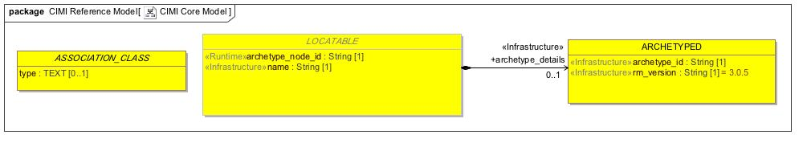

1. CIMI Core Model

## **CIMI Data Value Types**

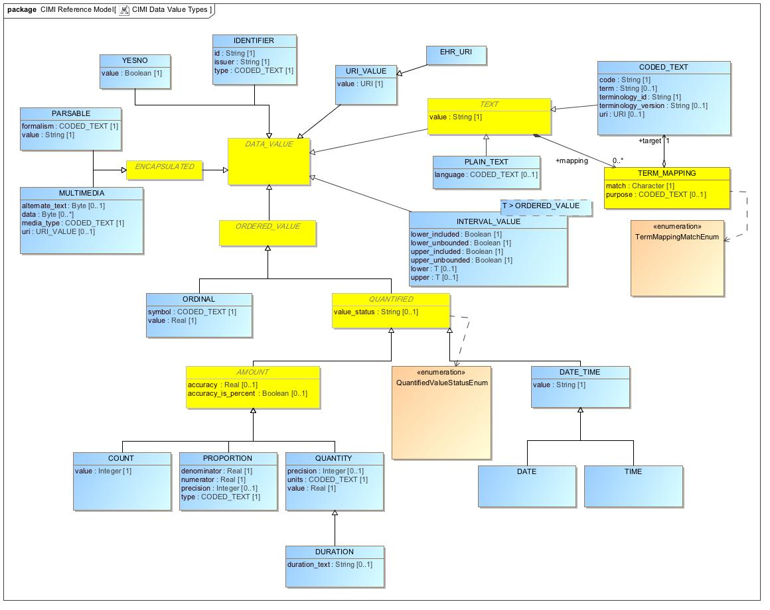

1. CIMI Data Value Types

## **CIMI Primitive Types**

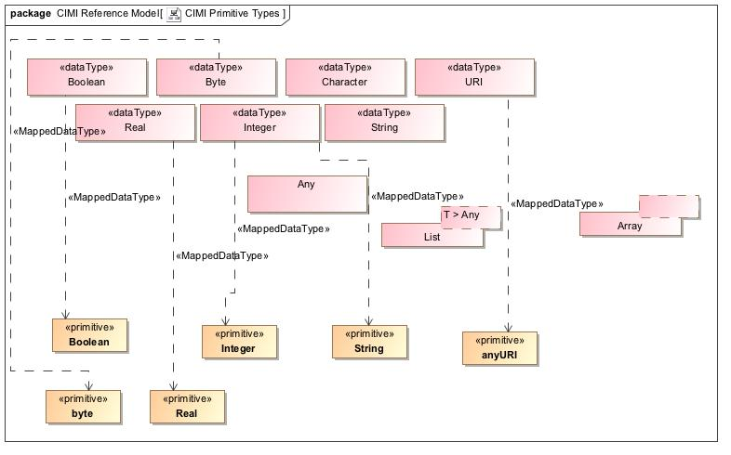

1. CIMI Primitive Types

# **CIMI RM Foundation Module**

## **Foundation**

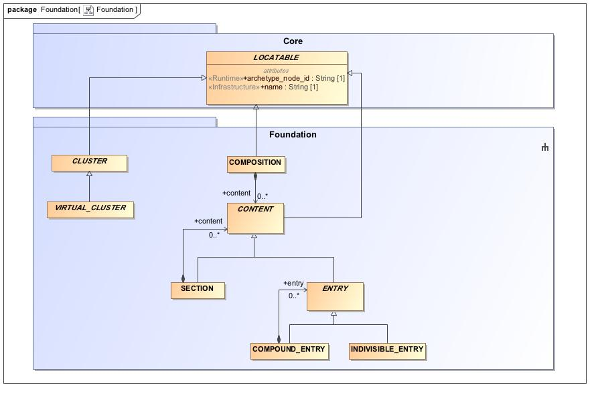

1. Foundation

## **Party**

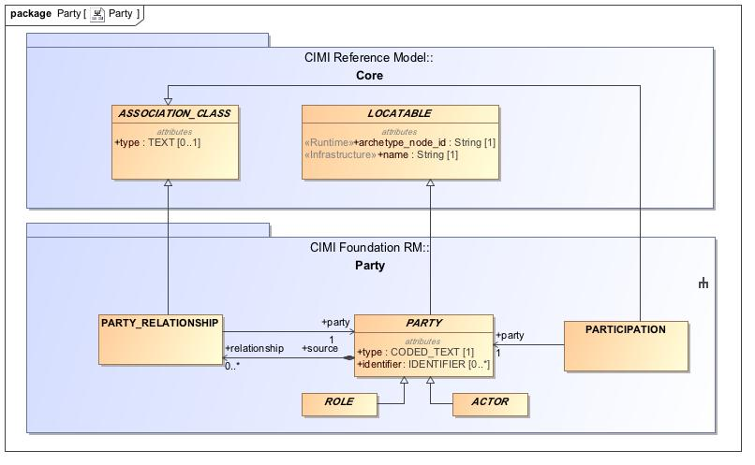

1. Party

# **CIMI RM Clinical Module**

**ClinicalStatement**

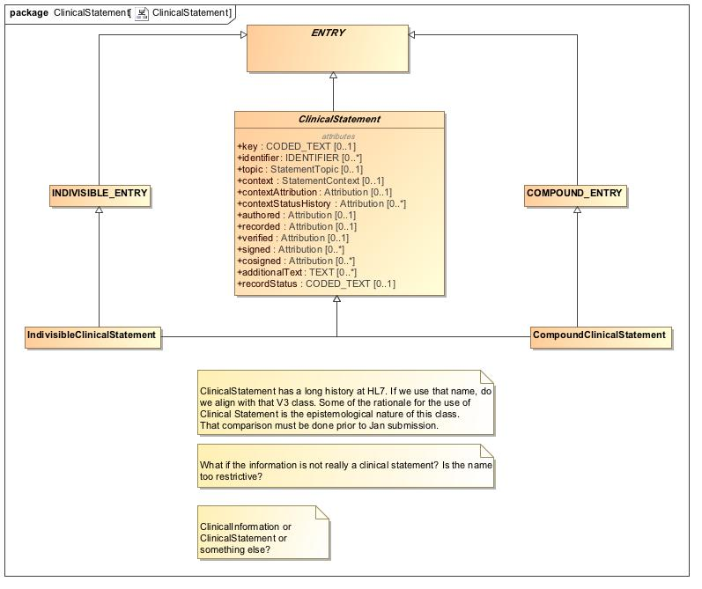

1. ClinicalStatement

## **Virtual Cluster - Core**

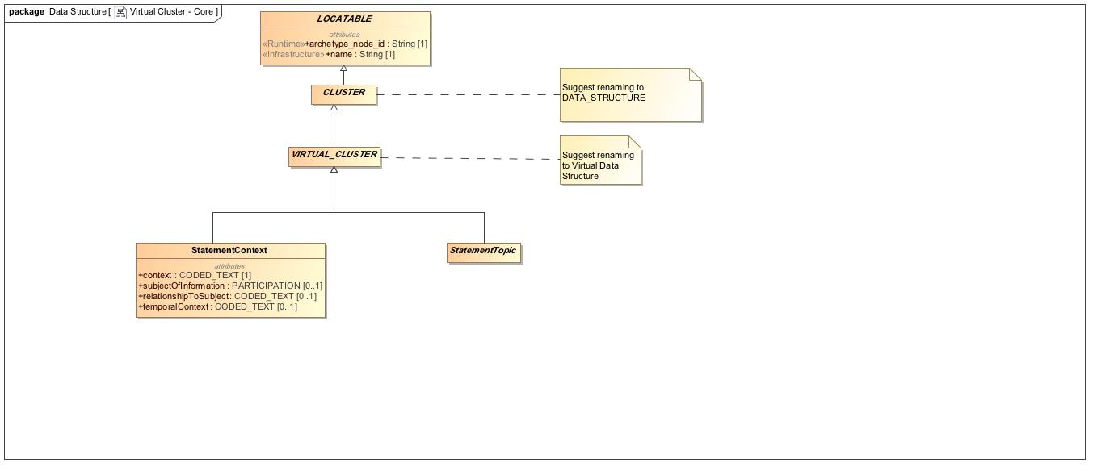

1. Virtual Cluster - Core

## **Topic - Core**

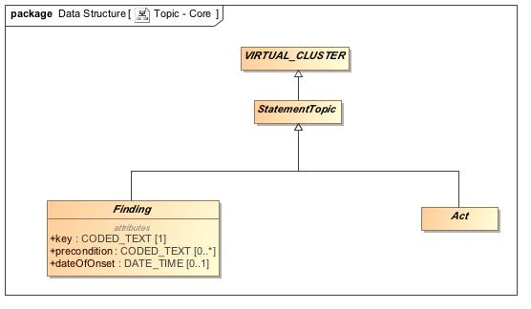

1. Topic - Core

**Topic - Act**

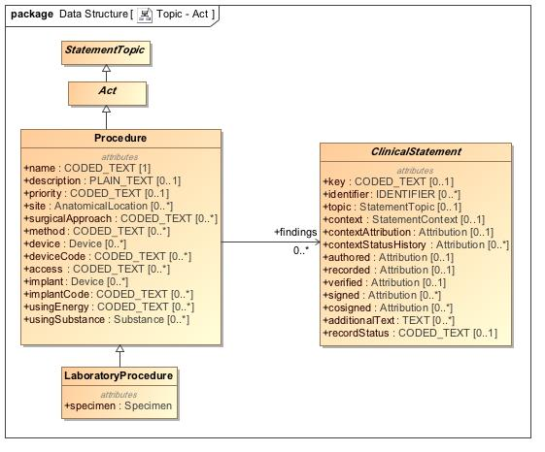

1. Topic - Act

## **Topic - Assertion**

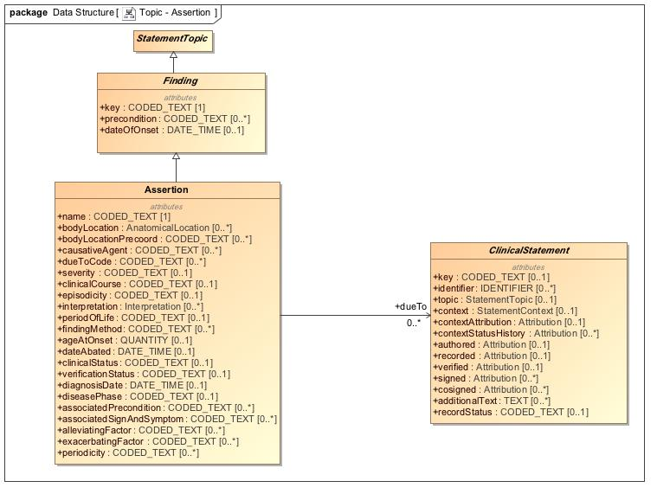

1. Topic - Assertion

## **Topic - WoundAssertion**

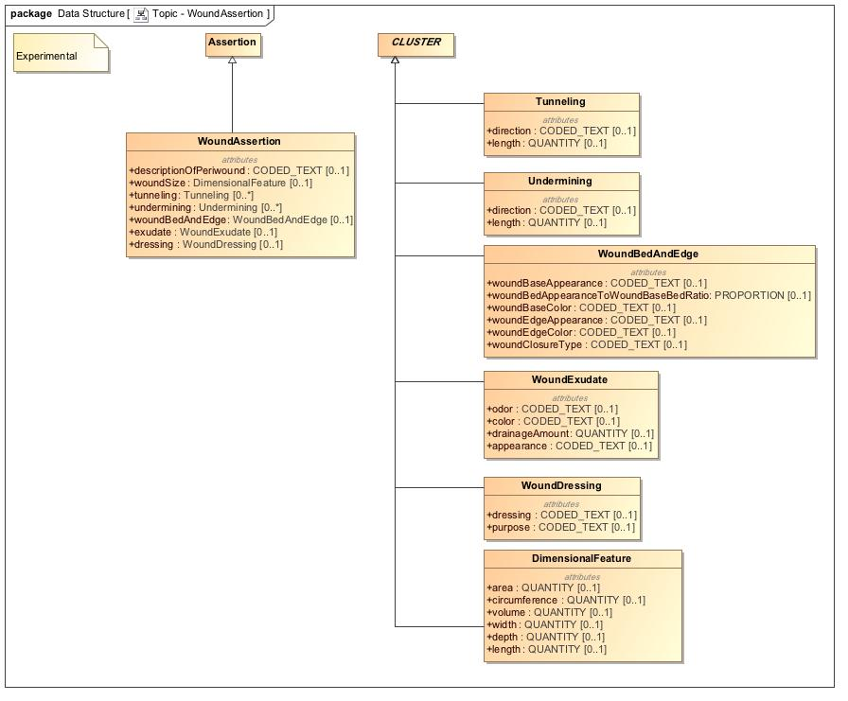

Topic - WoundAssertion

## **Topic - Evaluation**

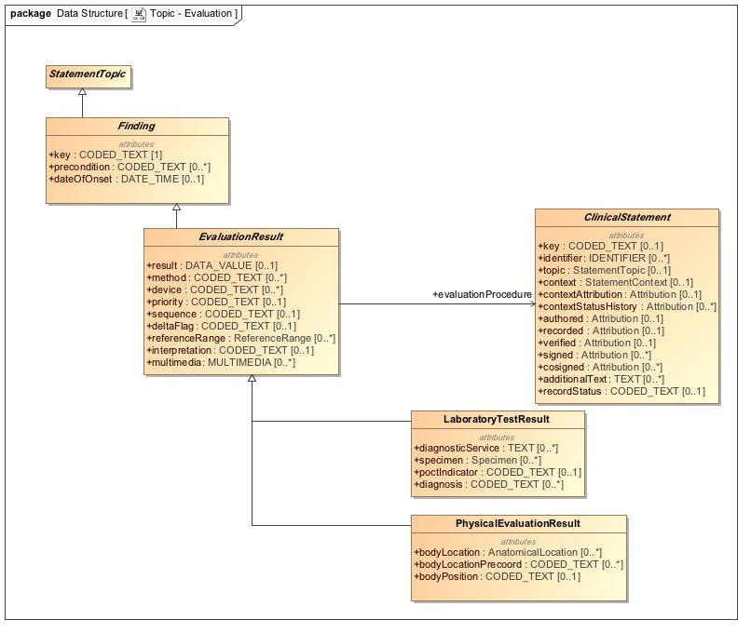

1. Topic - Evaluation

## **Context -Core**

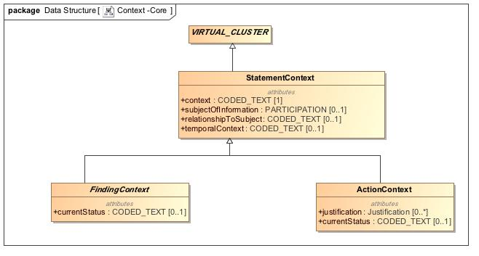

1. Context -Core

## **Context - Action**

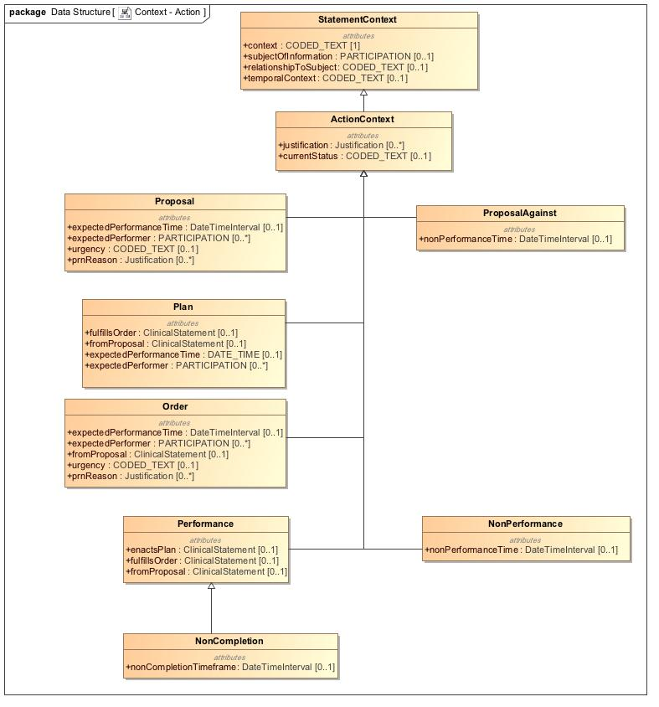

1. Context - Action

**Context - Finding**

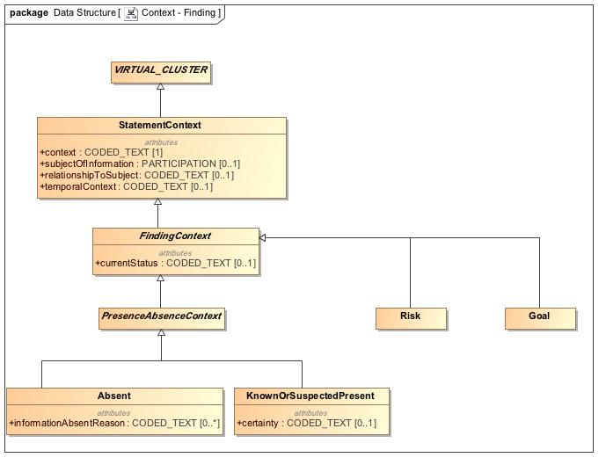

1. Context - Finding

## **Provenance**

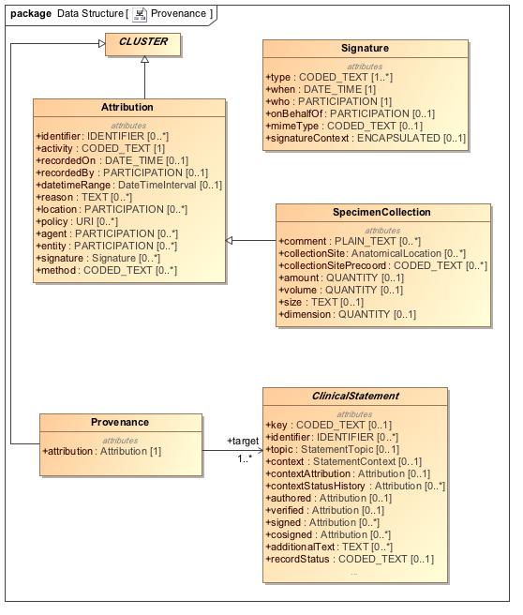

1. Provenance

## **Party - Specializations**

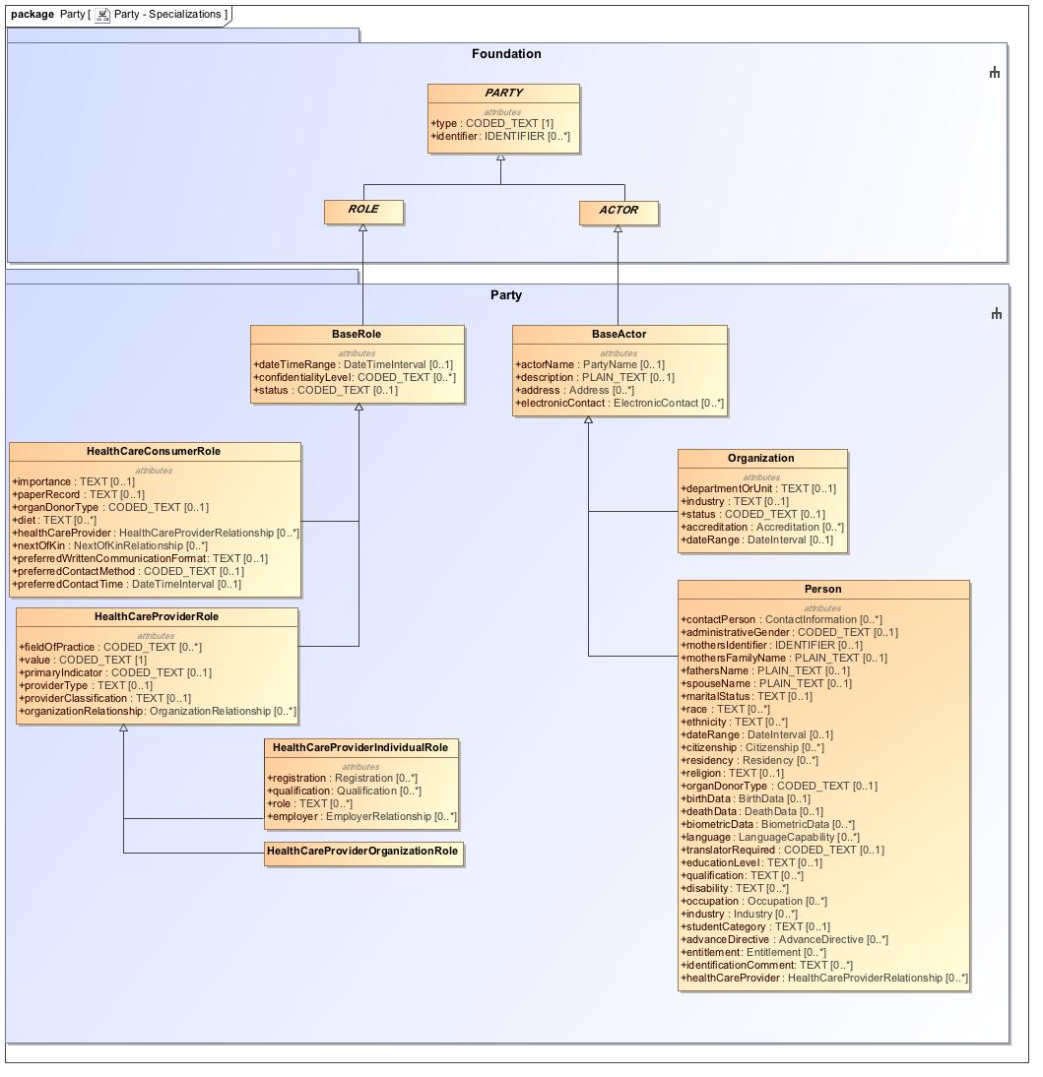

1. Party - Specializations

## **Data Structure - Party**

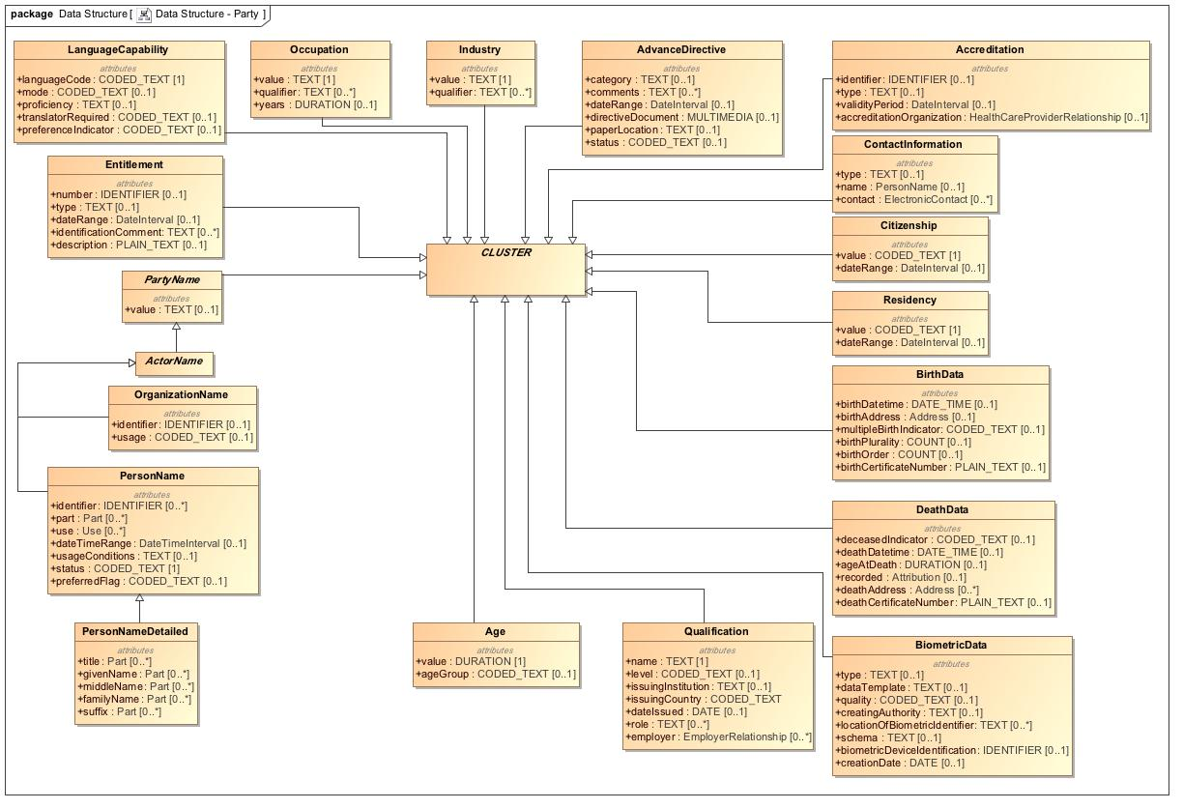

1. Data Structure - Party

## **Relationship**

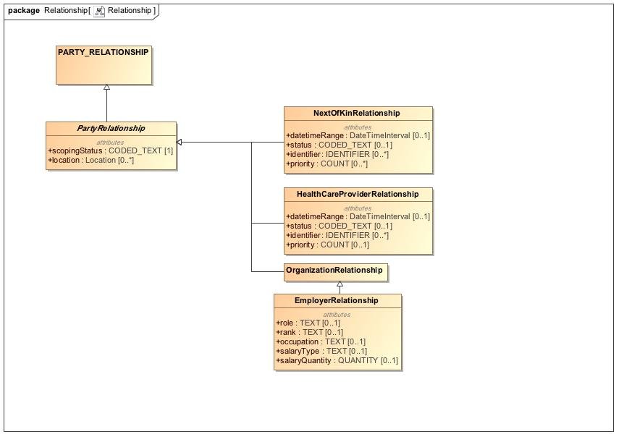

1. Relationship

## **Participation**

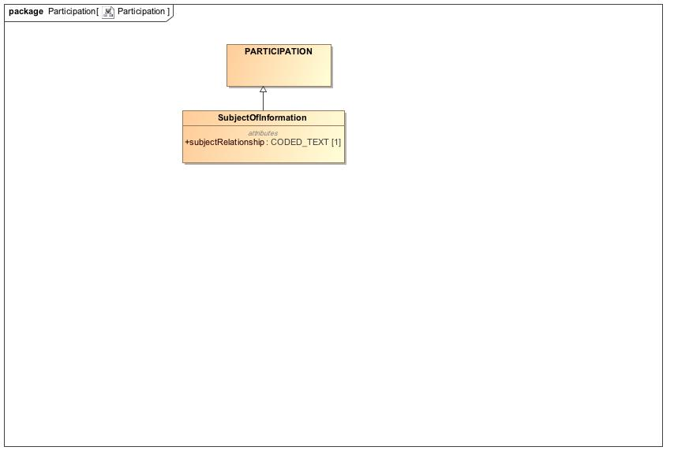

1. Participation

## **Data Structure - Address**

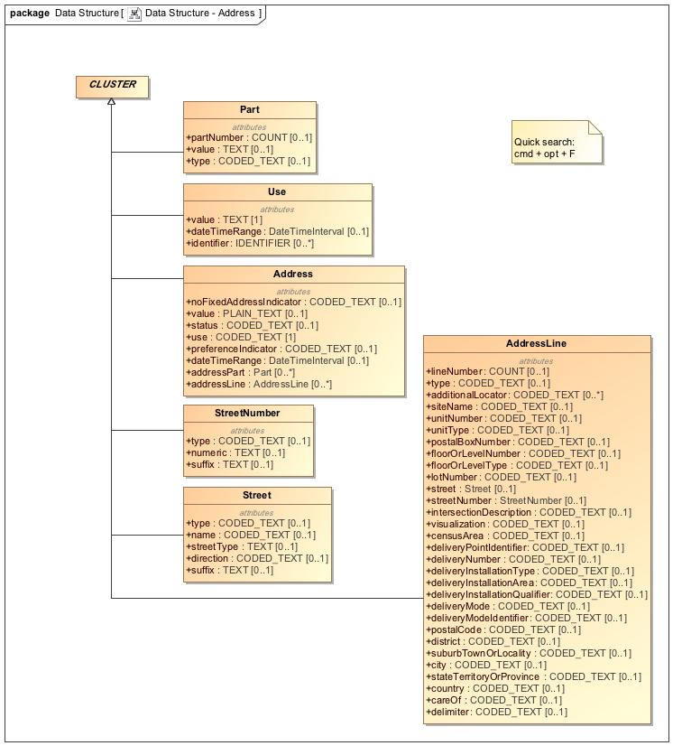

1. Data Structure - Address

## **Data Structure - Material Entity**

The weight of the specimen.

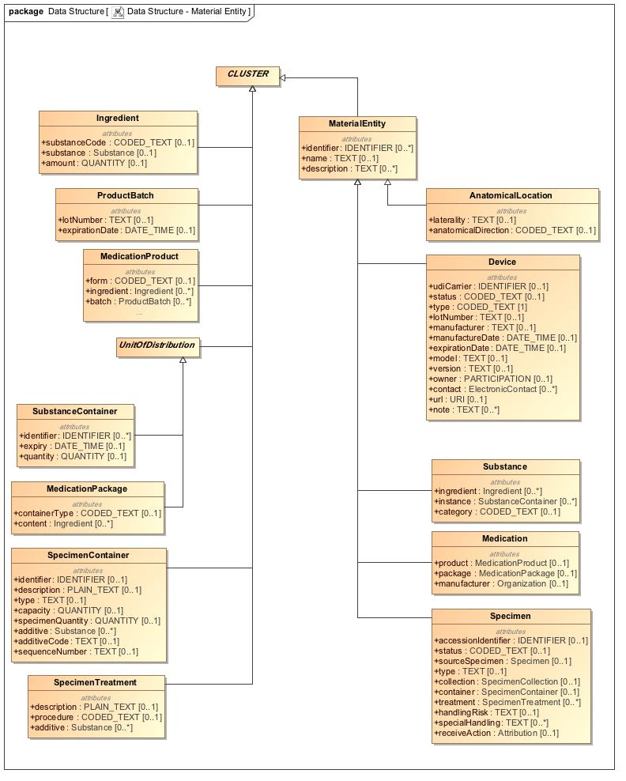

1. Data Structure - Material Entity

## **Data Structure - Other**

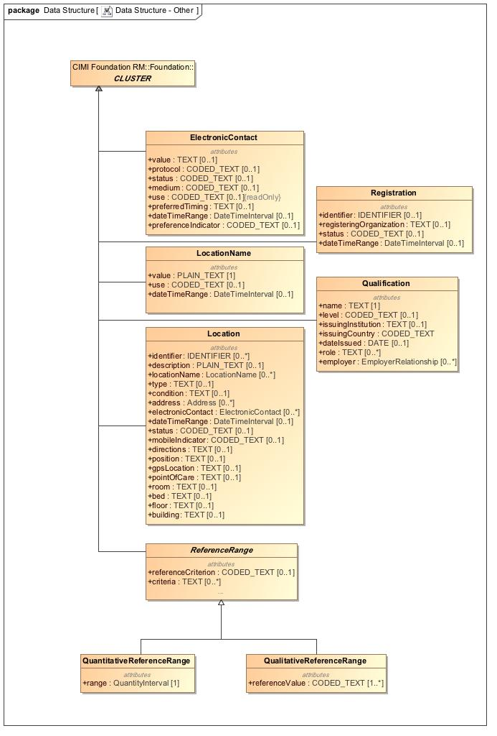

1. Data Structure - Other

## **Redefined Intervals**

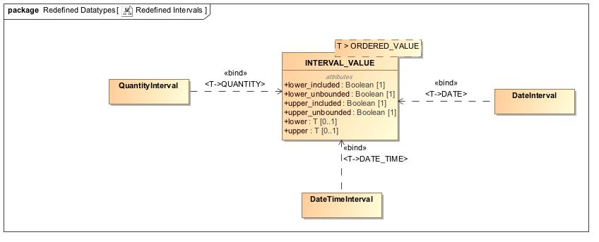

1. Redefined Intervals

## **RelatedClinicalStatement**

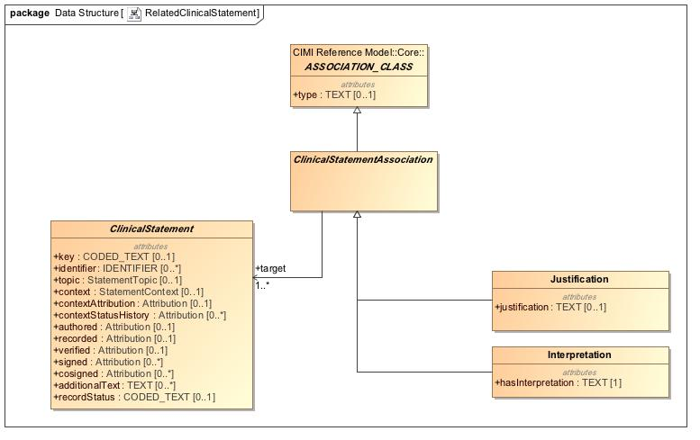

1. RelatedClinicalStatement

# **Package CIMI Clinical**

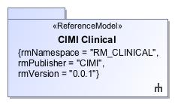

1. CIMI Clinical

|  |  |
| --- | --- |
| **Name** | CIMI Clinical |
| **Qualified Name** | CIMI Clinical |

# **Package CIMI Clinical::ClinicalStatement**

|  |  |
| --- | --- |
| **Name** | ClinicalStatement |
| **Qualified Name** | CIMI Clinical::ClinicalStatement |

## **Class** **ClinicalStatement**

The documentation of clinical information about a subject of information such as a patient or a relative of the patient, asserted by a particular source, recorded, and potentially verified. The ClinicalStatement class provides the core pattern for more specific clinical statement archetypes, such as a statement that a finding has been found in a patient or that a procedure has been proposed by a clinical decision support system.  
  
The ClinicalStatement pattern defines the core attributes common to most clinical statements and specifies a composition pattern that encourage model component reuse and better alignment with the SNOMED CT Concept Model.   
  
A clinical statement is composed of the StatementTopic class (grouping of attributes for capturing information about a procedure or a clinical finding) and the StatementContext class (grouping of attributes providing the context for the statement topic such as whether a procedure was performed, requested, not performed or whether a finding is suspected present or absent in the patient). At the archetype level, the topic and context components are coordinated to form the clinical statement. For instance, the composition of the ProcedureTopic with the NotPerformed context indicates that the given procedure was not performed.

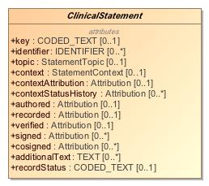

1. ClinicalStatement

|  |  |
| --- | --- |
| **Name** | ClinicalStatement |
| **Qualified Name** | CIMI Clinical::ClinicalStatement::ClinicalStatement |
| **Visibility** | public |
| **Abstract** | true |
| **Base Classifier** | * ENTRY |
| **Realized Interface** |  |

### **Attribute Detail**

#### additionalText

Unstructured notes appended to a clinical statement.

|  |  |
| --- | --- |
| **Type** | TEXT |
| **Default Value** |  |
| **Visibility** | public |
| **Multiplicity** | 0..* |

#### authored

Provenance information specific to the assertion being made (e.g., the author(s), when authored, the location where the assertion was made, etc...).

|  |  |
| --- | --- |
| **Type** | Attribution |
| **Default Value** |  |
| **Visibility** | public |
| **Multiplicity** | 0..1 |

#### context

The ontological status of the statement, e.g., whether it exists, does not exist, is planned, etc. Attribute aligns with the SNOMED CT Situation with Explicit Context Concept Model context attributes 'Finding context (attribute)' (SCTID: 408729009) and 'Procedure context (attribute)' (SCTID: 408730004). The range of this attribute is a structure (StatementContext) rather than a value set. The context of the clinical statement must align with the range specified by the SWEC Concept Model. For instance, if the 'context' attribute's meaning is bound to 'Finding context', then the context may not be a specialization of the ActionContext statement context. Instead, it should be a specialization of the FindingContext statement context.

|  |  |
| --- | --- |
| **Type** | StatementContext |
| **Default Value** |  |
| **Visibility** | public |
| **Multiplicity** | 0..1 |

#### contextAttribution

The attribution for the given context such as the who, what, when, where, how (e.g., origination mode) responsible for proposing, planning, ordering and authorizing, etc...   
  
The contextAttribution attribute is intended to be constrained appropriately within CIMI archetypes.

|  |  |
| --- | --- |
| **Type** | Attribution |
| **Default Value** |  |
| **Visibility** | public |
| **Multiplicity** | 0..1 |

#### contextStatusHistory

A record of the states for an action in a specified action context, e.g., an order may evolve from draft to placed to in progress to completed or canceled.  
  
The use of Attribution rather than a simple code for status supports the consistent capture of additional metadata associated with the specified status. For instance, if the proposal was declined, who declined it, when was it declined, and so on ...

|  |  |
| --- | --- |
| **Type** | Attribution |
| **Default Value** |  |
| **Visibility** | public |
| **Multiplicity** | 0..* |

#### cosigned

Provenance information specific to the cosigning of the clinical statement.

|  |  |
| --- | --- |
| **Type** | Attribution |
| **Default Value** |  |
| **Visibility** | public |
| **Multiplicity** | 0..* |

#### identifier

The unique identifier(s) of this clinical statement. It must be entered if user wants it returned as part of any output (e.g., a wound number), otherwise it will be auto-generated, if needed, by the system serving the record. An identifier does not need to be the actual identifier of the source system.

|  |  |
| --- | --- |
| **Type** | IDENTIFIER |
| **Default Value** |  |
| **Visibility** | public |
| **Multiplicity** | 0..* |

#### key

The 'key' attribute is an optional attribute allowing the coding of some of the information represented by the clinical statement. The range of this attribute (i.e., allowable codes assigned as a value for this attribute) must derive from and conform with the SNOMED CT Situation with Explicit Context (SWEC) concept hierarchies defined in SNOMED CT. Note that this attribute may consist of precoordinated codes (not recommended) or SNOMED CT expressions.

|  |  |
| --- | --- |
| **Type** | CODED_TEXT |
| **Default Value** |  |
| **Visibility** | public |
| **Multiplicity** | 0..1 |

#### recorded

Provenance information specific to the recording of the clinical statement (e.g., when recorded, where recorded, etc...).

|  |  |
| --- | --- |
| **Type** | Attribution |
| **Default Value** |  |
| **Visibility** | public |
| **Multiplicity** | 0..1 |

#### recordStatus

Concept indicating the state of this record. E.g., 'entered in error'.

|  |  |
| --- | --- |
| **Type** | CODED_TEXT |
| **Default Value** |  |
| **Visibility** | public |
| **Multiplicity** | 0..1 |

#### signed

Provenance information specific to the signing of the clinical statement.

|  |  |
| --- | --- |
| **Type** | Attribution |
| **Default Value** |  |
| **Visibility** | public |
| **Multiplicity** | 0..* |

#### topic

What the statement is about, e.g., the kind of finding or procedure asserted. Attribute aligns with the SNOMED CT Situation with Explicit Context (SWEC) Concept Model attributes 'Associated finding (attribute)' (SCTID: 246090004) and 'Associated procedure (attribute)' (SCTID: 363589002). The range of this attribute is a structure (StatementTopic) rather than a value set. The topic of the clinical statement must align with the range specified by the SWEC Concept Model. For instance, if the 'topic' attribute's meaning is bound to 'Associated finding', then the topic may not be a specialization of the Act statement topic.

|  |  |
| --- | --- |
| **Type** | StatementTopic |
| **Default Value** |  |
| **Visibility** | public |
| **Multiplicity** | 0..1 |

#### verified

Provenance information specific to the verification process associated with this statement (e.g., verifier, verification method, when verified, etc...).

|  |  |
| --- | --- |
| **Type** | Attribution |
| **Default Value** |  |
| **Visibility** | public |
| **Multiplicity** | 0..1 |

### **Relation Detail**

#### Association

|  |  |
| --- | --- |
| **Name** |  |
| **Related Element** | * Procedure |

|  |  |
| --- | --- |
| **Name** |  |
| **Related Element** | * Provenance |

|  |  |
| --- | --- |
| **Name** |  |
| **Related Element** | * Assertion |

|  |  |
| --- | --- |
| **Name** |  |
| **Related Element** | * EvaluationResult |

|  |  |
| --- | --- |
| **Name** |  |
| **Related Element** | * ClinicalStatementAssociation |

#### Generalization

|  |  |
| --- | --- |
| **Name** |  |
| **Related Element** | * CompoundClinicalStatement |

|  |  |
| --- | --- |
| **Name** |  |
| **Related Element** | * IndivisibleClinicalStatement |

|  |  |
| --- | --- |
| **Name** |  |
| **Related Element** | * ENTRY |

## **Class** **CompoundClinicalStatement**

Clinical statement representing information whose components may have an independent existence outside of the composition. For instance, a laboratory panel.  
  
A composite clinical statement may be composed of both indivisible clinical statements or composite clinical statements with arbitrary nesting. Nesting rules can be specified as constraints at the archetype level.

1917427250.jpg

1. CompoundClinicalStatement

|  |  |
| --- | --- |
| **Name** | CompoundClinicalStatement |
| **Qualified Name** | CIMI Clinical::ClinicalStatement::CompoundClinicalStatement |
| **Visibility** | public |
| **Abstract** | false |
| **Base Classifier** | * ClinicalStatement * COMPOUND_ENTRY |
| **Realized Interface** |  |

### **Relation Detail**

#### Generalization

|  |  |
| --- | --- |
| **Name** |  |
| **Related Element** | * ClinicalStatement |

|  |  |
| --- | --- |
| **Name** |  |
| **Related Element** | * COMPOUND_ENTRY |

## **Class** **IndivisibleClinicalStatement**

Clinical statement representing the smallest unit of information capable of having an independent existence. For instance, a standalone hematocrit lab observation.   
  
An indivisible clinical statement may also be represented as part of a composite clinical statement such as a panel.

269038031.jpg

1. IndivisibleClinicalStatement

|  |  |
| --- | --- |
| **Name** | IndivisibleClinicalStatement |
| **Qualified Name** | CIMI Clinical::ClinicalStatement::IndivisibleClinicalStatement |
| **Visibility** | public |
| **Abstract** | false |
| **Base Classifier** | * ClinicalStatement * INDIVISIBLE_ENTRY |
| **Realized Interface** |  |

### **Relation Detail**

#### Generalization

|  |  |
| --- | --- |
| **Name** |  |
| **Related Element** | * ClinicalStatement |

|  |  |
| --- | --- |
| **Name** |  |
| **Related Element** | * INDIVISIBLE_ENTRY |

# **Package CIMI Clinical::Data Structure**

|  |  |
| --- | --- |
| **Name** | Data Structure |
| **Qualified Name** | CIMI Clinical::Data Structure |

## **Class** **Absent**

Context indicating the known absence of a finding in the subject of information. If the finding is suspected to be absent, use the known or suspected present context instead.

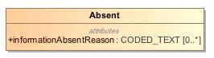

1. Absent

|  |  |
| --- | --- |
| **Name** | Absent |
| **Qualified Name** | CIMI Clinical::Data Structure::Absent |
| **Visibility** | public |
| **Abstract** | false |
| **Base Classifier** | * PresenceAbsenceContext |
| **Realized Interface** |  |

### **Attribute Detail**

#### informationAbsentReason

The reason for missing information. Mostly relevant for evaluation results.

|  |  |
| --- | --- |
| **Type** | CODED_TEXT |
| **Default Value** |  |
| **Visibility** | public |
| **Multiplicity** | 0..* |

### **Relation Detail**

#### Generalization

|  |  |
| --- | --- |
| **Name** |  |
| **Related Element** | * PresenceAbsenceContext |

## **Class** **Accreditation**

Type supporting the capture of accreditation information.

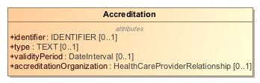

1. Accreditation

|  |  |
| --- | --- |
| **Name** | Accreditation |
| **Qualified Name** | CIMI Clinical::Data Structure::Accreditation |
| **Visibility** | public |
| **Abstract** | false |
| **Base Classifier** | * CLUSTER |
| **Realized Interface** |  |

### **Attribute Detail**

#### accreditationOrganization

The organization that supplies the accreditation.

|  |  |
| --- | --- |
| **Type** | HealthCareProviderRelationship |
| **Default Value** |  |
| **Visibility** | public |
| **Multiplicity** | 0..1 |

#### identifier

An identifier for the accreditation.

|  |  |
| --- | --- |
| **Type** | IDENTIFIER |
| **Default Value** |  |
| **Visibility** | public |
| **Multiplicity** | 0..1 |

#### type

The type of accreditation - e.g., degree, board certified, license.

|  |  |
| --- | --- |
| **Type** | TEXT |
| **Default Value** |  |
| **Visibility** | public |
| **Multiplicity** | 0..1 |

#### validityPeriod

The period of validity for the accreditation.

|  |  |
| --- | --- |
| **Type** | DateInterval |
| **Default Value** |  |
| **Visibility** | public |
| **Multiplicity** | 0..1 |

### **Relation Detail**

#### Generalization

|  |  |
| --- | --- |
| **Name** |  |
| **Related Element** | * CLUSTER |

## **Class** **Act**

Description of a healthcare action, independent of action context.

-2046839455.jpg

1. Act

|  |  |
| --- | --- |
| **Name** | Act |
| **Qualified Name** | CIMI Clinical::Data Structure::Act |
| **Visibility** | public |
| **Abstract** | true |
| **Base Classifier** | * StatementTopic |
| **Realized Interface** |  |

### **Relation Detail**

#### Generalization

|  |  |
| --- | --- |
| **Name** |  |
| **Related Element** | * StatementTopic |

|  |  |
| --- | --- |
| **Name** |  |
| **Related Element** | * Procedure |

## **Class** **ActionContext**

The ActionContext class aligns with the SNOMED Situations with Explicit Context and provides the context for the Act topic of a clinical statement. For instance, a statement about a procedure may specify that the procedure has been proposed, ordered, planned, performed or possibly not performed.

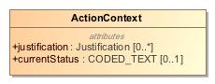

1. ActionContext

|  |  |
| --- | --- |
| **Name** | ActionContext |
| **Qualified Name** | CIMI Clinical::Data Structure::ActionContext |
| **Visibility** | public |
| **Abstract** | false |
| **Base Classifier** | * StatementContext |
| **Realized Interface** |  |

### **Attribute Detail**

#### currentStatus

The latest status of an action within the specified context. An action may be interpretable within a specific context such as whether it is planned, ordered, or performed. Moreover, within each of these context, an action may have a set of allowable states in which it can exist. For instance, a proposal may be rejected or an order may be signed, canceled or superceded by another order. It is expected that set of such states will vary based on the type of action context.   
  
The status code must coincide with the activity code of one of the attribution elements of statusHistory if a context status history is provided.

|  |  |
| --- | --- |
| **Type** | CODED_TEXT |
| **Default Value** |  |
| **Visibility** | public |
| **Multiplicity** | 0..1 |

#### justification

Reason the action was done or justification for the action. Reasons may also be specified for not performing an action.

|  |  |
| --- | --- |
| **Type** | Justification |
| **Default Value** |  |
| **Visibility** | public |
| **Multiplicity** | 0..* |

### **Relation Detail**

#### Generalization

|  |  |
| --- | --- |
| **Name** |  |
| **Related Element** | * Order |

|  |  |
| --- | --- |
| **Name** |  |
| **Related Element** | * StatementContext |

|  |  |
| --- | --- |
| **Name** |  |
| **Related Element** | * Plan |

|  |  |
| --- | --- |
| **Name** |  |
| **Related Element** | * ProposalAgainst |

|  |  |
| --- | --- |
| **Name** |  |
| **Related Element** | * Performance |

|  |  |
| --- | --- |
| **Name** |  |
| **Related Element** | * Proposal |

|  |  |
| --- | --- |
| **Name** |  |
| **Related Element** | * NonPerformance |

## **Class** **ActorName**

The name of an actor - typically either the name of a person or of an organization.

800985597.jpg

1. ActorName

|  |  |
| --- | --- |
| **Name** | ActorName |
| **Qualified Name** | CIMI Clinical::Data Structure::ActorName |
| **Visibility** | public |
| **Abstract** | true |
| **Base Classifier** | * PartyName |
| **Realized Interface** |  |

### **Relation Detail**

#### Generalization

|  |  |
| --- | --- |
| **Name** |  |
| **Related Element** | * PartyName |

|  |  |
| --- | --- |
| **Name** |  |
| **Related Element** | * PersonName |

|  |  |
| --- | --- |
| **Name** |  |
| **Related Element** | * OrganizationName |

## **Class** **Address**

Type representing an address.

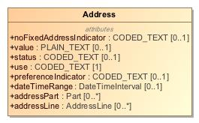

1. Address

|  |  |
| --- | --- |
| **Name** | Address |
| **Qualified Name** | CIMI Clinical::Data Structure::Address |
| **Visibility** | public |
| **Abstract** | false |
| **Base Classifier** | * CLUSTER |
| **Realized Interface** |  |

### **Attribute Detail**

#### addressLine

An address line.

|  |  |
| --- | --- |
| **Type** | AddressLine |
| **Default Value** |  |
| **Visibility** | public |
| **Multiplicity** | 0..* |

#### addressPart

An address component that is not an address line.

|  |  |
| --- | --- |
| **Type** | Part |
| **Default Value** |  |
| **Visibility** | public |
| **Multiplicity** | 0..* |

#### dateTimeRange

Period when address is in effect.

|  |  |
| --- | --- |
| **Type** | DateTimeInterval |
| **Default Value** |  |
| **Visibility** | public |
| **Multiplicity** | 0..1 |

#### noFixedAddressIndicator

Code indicating if person has no fixed address.

|  |  |
| --- | --- |
| **Type** | CODED_TEXT |
| **Default Value** |  |
| **Visibility** | public |
| **Multiplicity** | 0..1 |

#### preferenceIndicator

Code indicating whether this address is preferred.

|  |  |
| --- | --- |
| **Type** | CODED_TEXT |
| **Default Value** |  |
| **Visibility** | public |
| **Multiplicity** | 0..1 |

#### status

NEED DEFINITION AND EXAMPLES

|  |  |
| --- | --- |
| **Type** | CODED_TEXT |
| **Default Value** |  |
| **Visibility** | public |
| **Multiplicity** | 0..1 |

#### use

Code indicating use preference for this address.

|  |  |
| --- | --- |
| **Type** | CODED_TEXT |
| **Default Value** |  |
| **Visibility** | public |
| **Multiplicity** | 1 |

#### value

Unstructured address when a structured address is not obtainable or for system that cannot process structured addresses.

|  |  |
| --- | --- |
| **Type** | PLAIN_TEXT |
| **Default Value** |  |
| **Visibility** | public |
| **Multiplicity** | 0..1 |

### **Relation Detail**

#### Generalization

|  |  |
| --- | --- |
| **Name** |  |
| **Related Element** | * CLUSTER |

## **Class** **AddressLine**

An address line.

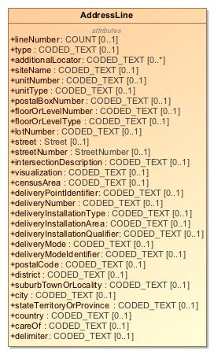

1. AddressLine

|  |  |
| --- | --- |
| **Name** | AddressLine |
| **Qualified Name** | CIMI Clinical::Data Structure::AddressLine |
| **Visibility** | public |
| **Abstract** | false |
| **Base Classifier** | * CLUSTER |
| **Realized Interface** |  |

### **Attribute Detail**

#### additionalLocator

NEED DEFINITION

|  |  |
| --- | --- |
| **Type** | CODED_TEXT |
| **Default Value** |  |
| **Visibility** | public |
| **Multiplicity** | 0..* |

#### careOf

Care of information.

|  |  |
| --- | --- |
| **Type** | CODED_TEXT |
| **Default Value** |  |
| **Visibility** | public |
| **Multiplicity** | 0..1 |

#### censusArea

The census area.

|  |  |
| --- | --- |
| **Type** | CODED_TEXT |
| **Default Value** |  |
| **Visibility** | public |
| **Multiplicity** | 0..1 |

#### city

The city code.

|  |  |
| --- | --- |
| **Type** | CODED_TEXT |
| **Default Value** |  |
| **Visibility** | public |
| **Multiplicity** | 0..1 |

#### country

The country

|  |  |
| --- | --- |
| **Type** | CODED_TEXT |
| **Default Value** |  |
| **Visibility** | public |
| **Multiplicity** | 0..1 |

#### delimiter

NEED DEFINITION

|  |  |
| --- | --- |
| **Type** | CODED_TEXT |
| **Default Value** |  |
| **Visibility** | public |
| **Multiplicity** | 0..1 |

#### deliveryInstallationArea

The name of a village, town, municipality, city or metropolitan area that forms part of a DELIVERY INSTALLATION NAME.

|  |  |
| --- | --- |
| **Type** | CODED_TEXT |
| **Default Value** |  |
| **Visibility** | public |
| **Multiplicity** | 0..1 |

#### deliveryInstallationQualifier

When more than one delivery installation serves an area described by the DELIVERY INSTALLATION AREA NAME, the qualifier name uniquely identifies the delivery installation.

|  |  |
| --- | --- |
| **Type** | CODED_TEXT |
| **Default Value** |  |
| **Visibility** | public |
| **Multiplicity** | 0..1 |

#### deliveryInstallationType

The category of delivery installation. The valid values are:   
   
BDP = Bureau De Poste CC = Concession Commerciale CDO = Commercial Dealership Outlet CMC = Community Mail Centre CPC = Centre Postal Communautaire CSP = Comptoir Service Postal LCD = Letter Carrier Depot PDF = Poste De Facteurs PO = Post Office RPO = Retail Postal Outlet STN = Station SUCC = Succursale

|  |  |
| --- | --- |
| **Type** | CODED_TEXT |
| **Default Value** |  |
| **Visibility** | public |
| **Multiplicity** | 0..1 |

#### deliveryMode

Both U.S and Canada have delivery modes and the value set is realm specific:  
  
https://www.uspsoig.gov/blog/modes-delivery  
  
https://www.canadapost.ca/cpo/mr/assets/pdf/business/delmodetechspecs_en.pdf

|  |  |
| --- | --- |
| **Type** | CODED_TEXT |
| **Default Value** |  |
| **Visibility** | public |
| **Multiplicity** | 0..1 |

#### deliveryModeIdentifier

NEED DEFINITION

|  |  |
| --- | --- |
| **Type** | CODED_TEXT |
| **Default Value** |  |
| **Visibility** | public |
| **Multiplicity** | 0..1 |

#### deliveryNumber

The delivery number.

|  |  |
| --- | --- |
| **Type** | CODED_TEXT |
| **Default Value** |  |
| **Visibility** | public |
| **Multiplicity** | 0..1 |

#### deliveryPointIdentifier

The delivery point identifier.

|  |  |
| --- | --- |
| **Type** | CODED_TEXT |
| **Default Value** |  |
| **Visibility** | public |
| **Multiplicity** | 0..1 |

#### district

The district code.

|  |  |
| --- | --- |
| **Type** | CODED_TEXT |
| **Default Value** |  |
| **Visibility** | public |
| **Multiplicity** | 0..1 |

#### floorOrLevelNumber

The floor or level of the residence or business.

|  |  |
| --- | --- |
| **Type** | CODED_TEXT |
| **Default Value** |  |
| **Visibility** | public |
| **Multiplicity** | 0..1 |

#### floorOrLevelType

The type of floor or level.

|  |  |
| --- | --- |
| **Type** | CODED_TEXT |
| **Default Value** |  |
| **Visibility** | public |
| **Multiplicity** | 0..1 |

#### intersectionDescription

Information about the nearest intersection.

|  |  |
| --- | --- |
| **Type** | CODED_TEXT |
| **Default Value** |  |
| **Visibility** | public |
| **Multiplicity** | 0..1 |

#### lineNumber

The number of this address line in a multi-line address.

|  |  |
| --- | --- |
| **Type** | COUNT |
| **Default Value** |  |
| **Visibility** | public |
| **Multiplicity** | 0..1 |

#### lotNumber

The number of the lot.

|  |  |
| --- | --- |
| **Type** | CODED_TEXT |
| **Default Value** |  |
| **Visibility** | public |
| **Multiplicity** | 0..1 |

#### postalBoxNumber

A P.O. Box number.

|  |  |
| --- | --- |
| **Type** | CODED_TEXT |
| **Default Value** |  |
| **Visibility** | public |
| **Multiplicity** | 0..1 |

#### postalCode

The postal or zip code.

|  |  |
| --- | --- |
| **Type** | CODED_TEXT |
| **Default Value** |  |
| **Visibility** | public |
| **Multiplicity** | 0..1 |

#### siteName

The name of the site.

|  |  |
| --- | --- |
| **Type** | CODED_TEXT |
| **Default Value** |  |
| **Visibility** | public |
| **Multiplicity** | 0..1 |

#### stateTerritoryOrProvince

The state or territory or province code.

|  |  |
| --- | --- |
| **Type** | CODED_TEXT |
| **Default Value** |  |
| **Visibility** | public |
| **Multiplicity** | 0..1 |

#### street

Information about the street.

|  |  |
| --- | --- |
| **Type** | Street |
| **Default Value** |  |
| **Visibility** | public |
| **Multiplicity** | 0..1 |

#### streetNumber

The number of the location on the street.

|  |  |
| --- | --- |
| **Type** | StreetNumber |
| **Default Value** |  |
| **Visibility** | public |
| **Multiplicity** | 0..1 |

#### suburbTownOrLocality

The suburb, town, or locality code.

|  |  |
| --- | --- |
| **Type** | CODED_TEXT |
| **Default Value** |  |
| **Visibility** | public |
| **Multiplicity** | 0..1 |

#### type

NEED DEFINITION

|  |  |
| --- | --- |
| **Type** | CODED_TEXT |
| **Default Value** |  |
| **Visibility** | public |
| **Multiplicity** | 0..1 |

#### unitNumber

The number of the unit.

|  |  |
| --- | --- |
| **Type** | CODED_TEXT |
| **Default Value** |  |
| **Visibility** | public |
| **Multiplicity** | 0..1 |

#### unitType

The type of unit.

|  |  |
| --- | --- |
| **Type** | CODED_TEXT |
| **Default Value** |  |
| **Visibility** | public |
| **Multiplicity** | 0..1 |

#### visualization

NEED DEFINITION

|  |  |
| --- | --- |
| **Type** | CODED_TEXT |
| **Default Value** |  |
| **Visibility** | public |
| **Multiplicity** | 0..1 |

### **Relation Detail**

#### Generalization

|  |  |
| --- | --- |
| **Name** |  |
| **Related Element** | * CLUSTER |

## **Class** **AdvanceDirective**

Patient or proxy-supplied prospective instructions for treatment.

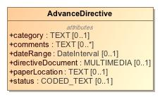

1. AdvanceDirective

|  |  |
| --- | --- |
| **Name** | AdvanceDirective |
| **Qualified Name** | CIMI Clinical::Data Structure::AdvanceDirective |
| **Visibility** | public |
| **Abstract** | false |
| **Base Classifier** | * CLUSTER |
| **Realized Interface** |  |

### **Attribute Detail**

#### category

Legal function of directive; e.g., living will, poa, organ donation permission.

|  |  |
| --- | --- |
| **Type** | TEXT |
| **Default Value** |  |
| **Visibility** | public |
| **Multiplicity** | 0..1 |

#### comments

Additional notes or instructions concerning the directive.

|  |  |
| --- | --- |
| **Type** | TEXT |
| **Default Value** |  |
| **Visibility** | public |
| **Multiplicity** | 0..* |

#### dateRange

The period of time during which the directive is intended to apply.

|  |  |
| --- | --- |
| **Type** | DateInterval |
| **Default Value** |  |
| **Visibility** | public |
| **Multiplicity** | 0..1 |

#### directiveDocument

The physical advance directive document such as an image of the document or the document in PDF form.

|  |  |
| --- | --- |
| **Type** | MULTIMEDIA |
| **Default Value** |  |
| **Visibility** | public |
| **Multiplicity** | 0..1 |

#### paperLocation

Where the physically signed copy of the directive can be found.

|  |  |
| --- | --- |
| **Type** | TEXT |
| **Default Value** |  |
| **Visibility** | public |
| **Multiplicity** | 0..1 |

#### status

Whether the directive is applicable. Active, inactive.

|  |  |
| --- | --- |
| **Type** | CODED_TEXT |
| **Default Value** |  |
| **Visibility** | public |
| **Multiplicity** | 0..1 |

### **Relation Detail**

#### Generalization

|  |  |
| --- | --- |
| **Name** |  |
| **Related Element** | * CLUSTER |

## **Class** **Age**

Type for the capture of age-related information.

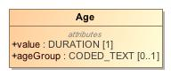

1. Age

|  |  |
| --- | --- |
| **Name** | Age |
| **Qualified Name** | CIMI Clinical::Data Structure::Age |
| **Visibility** | public |
| **Abstract** | false |
| **Base Classifier** | * CLUSTER |
| **Realized Interface** |  |

### **Attribute Detail**

#### ageGroup

Classification of age - e.g., neonatal, infant, pre-adolescent, etc...

|  |  |
| --- | --- |
| **Type** | CODED_TEXT |
| **Default Value** |  |
| **Visibility** | public |
| **Multiplicity** | 0..1 |

#### value

The age of the entity.

|  |  |
| --- | --- |
| **Type** | DURATION |
| **Default Value** |  |
| **Visibility** | public |
| **Multiplicity** | 1 |

### **Relation Detail**

#### Generalization

|  |  |
| --- | --- |
| **Name** |  |
| **Related Element** | * CLUSTER |

## **Class** **AnatomicalLocation**

A part of the body.

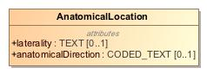

1. AnatomicalLocation

|  |  |
| --- | --- |
| **Name** | AnatomicalLocation |
| **Qualified Name** | CIMI Clinical::Data Structure::AnatomicalLocation |
| **Visibility** | public |
| **Abstract** | false |
| **Base Classifier** | * MaterialEntity |
| **Realized Interface** |  |

### **Attribute Detail**

#### anatomicalDirection

Example values: proximal, distal, lateral, medial...

|  |  |
| --- | --- |
| **Type** | CODED_TEXT |
| **Default Value** |  |
| **Visibility** | public |
| **Multiplicity** | 0..1 |

#### laterality

The laterality of a bilaterally duplicated structure.

|  |  |
| --- | --- |
| **Type** | TEXT |
| **Default Value** |  |
| **Visibility** | public |
| **Multiplicity** | 0..1 |

### **Relation Detail**

#### Generalization

|  |  |
| --- | --- |
| **Name** |  |
| **Related Element** | * MaterialEntity |

## **Class** **Assertion**

Clinical Assertions assert the existence of clinical conditions, diseases, symptoms, etc. in the patient.

-849858592.jpg

1. Assertion

|  |  |
| --- | --- |
| **Name** | Assertion |
| **Qualified Name** | CIMI Clinical::Data Structure::Assertion |
| **Visibility** | public |
| **Abstract** | false |
| **Base Classifier** | * Finding |
| **Realized Interface** |  |

### **Attribute Detail**

#### ageAtOnset

The age of the patient or subject at onset of the Condition. Note that this property could potentially be derived.

|  |  |
| --- | --- |
| **Type** | QUANTITY |
| **Default Value** |  |
| **Visibility** | public |
| **Multiplicity** | 0..1 |

#### alleviatingFactor

An action or intervention which makes a symptom less severe. Examples of data from the value set may include: rest, heat, ice, etc.   
  
[TO ADDRESS: we may need a semantic scope: are these substances or procedures? Procedures, with the assumption that if you put in a substance it means “application (procedure)”?

|  |  |
| --- | --- |
| **Type** | CODED_TEXT |
| **Default Value** |  |
| **Visibility** | public |
| **Multiplicity** | 0..* |

#### associatedPrecondition

Previously existing conditions or states that could affect a measurement or assesment. For example; a patients weight taken while clothed, a patients height with or without shoes, a patients blood pressure taken while standing or lying down.

|  |  |
| --- | --- |
| **Type** | CODED_TEXT |
| **Default Value** |  |
| **Visibility** | public |
| **Multiplicity** | 0..* |

#### associatedSignAndSymptom

Physical observations captured by a clinician or subjective conditions experienced by a patient that are related to a medical condition.

|  |  |
| --- | --- |
| **Type** | CODED_TEXT |
| **Default Value** |  |
| **Visibility** | public |
| **Multiplicity** | 0..* |

#### bodyLocation

The body site affected by a condition.

|  |  |
| --- | --- |
| **Type** | AnatomicalLocation |
| **Default Value** |  |
| **Visibility** | public |
| **Multiplicity** | 0..* |

#### bodyLocationPrecoord

Captures the pre-coordinated body location information, for example pre-coordinating body side left with body location hand to make left hand.

|  |  |
| --- | --- |
| **Type** | CODED_TEXT |
| **Default Value** |  |
| **Visibility** | public |
| **Multiplicity** | 0..* |

#### causativeAgent

An exogenous physical substance or force that causes the disease. It does not include vectors, e.g. a mosquito that transmits malaria. The range of this attribute can be found in the following SNOMED CT hierarchies:  
  
| Organism | 410607006 (<<)  
| Substance | 105590001 (<<)  
| Physical object | 260787004 (<<)  
| Physical force | 78621006 (<<)  
| Pharmaceutical / biologic product | 373873005 (<< Q only)  
| SNOMED CT Concept | 138875005 (==)

|  |  |
| --- | --- |
| **Type** | CODED_TEXT |
| **Default Value** |  |
| **Visibility** | public |
| **Multiplicity** | 0..* |

#### clinicalCourse

Both the course and onset of a disease. Many conditions with an acute (sudden) onset also have an acute (short duration) course. Few diseases with a chronic (long - term) course would need to have their onset sub-divided into rapid or gradual subtypes, and thus there is no clear need for separating the rapidity of onset from the duration of a disease; based on testing by implementers and modelers, a single attribute with values that combine these meanings has clearly been more reproducible  
and useful than two attributes that attempt to separate the meanings.

|  |  |
| --- | --- |
| **Type** | CODED_TEXT |
| **Default Value** |  |
| **Visibility** | public |
| **Multiplicity** | 0..1 |

#### clinicalStatus

The physiological state of the condition with respect to whether it is actually of concern. Values may typicall include: Active, Relapse, Remission, Resolved, Confirmed, Ruled out, Unknown.

|  |  |
| --- | --- |
| **Type** | CODED_TEXT |
| **Default Value** |  |
| **Visibility** | public |
| **Multiplicity** | 0..1 |

#### dateAbated

Date, if known, when clinical finding abated.

|  |  |
| --- | --- |
| **Type** | DATE_TIME |
| **Default Value** |  |
| **Visibility** | public |
| **Multiplicity** | 0..1 |

#### diagnosisDate

Date and time the health problem was diagnosed. Added for Public Health Reporting Initiative, 10/5/2012.

|  |  |
| --- | --- |
| **Type** | DATE_TIME |
| **Default Value** |  |
| **Visibility** | public |
| **Multiplicity** | 0..1 |

#### diseasePhase

The physiological state of a condition that develops over time. For instance, Incubation period (exposed, asymptomatic), Prodromal (symptoms but not full disease breakout), Acute (full manifestation of disease), Convalescent.

|  |  |
| --- | --- |
| **Type** | CODED_TEXT |
| **Default Value** |  |
| **Visibility** | public |
| **Multiplicity** | 0..1 |

#### dueTo

This attribute is used to relate a |Clinical finding| directly to its cause. If a clinical finding merely predisposes to or worsens another disorder, rather than causing it directly, then the more general attribute | ASSOCIATED WITH | is used instead.

|  |  |
| --- | --- |
| **Type** | ClinicalStatement |
| **Default Value** |  |
| **Visibility** | public |
| **Multiplicity** | 0..* |

#### dueToCode

The cause of the Clinical finding. This includes such causes as disease vectors and endogenous states (e.g., macular degeneration due to diabetes). Exogenous substances and forces should be captured as causative agent.

|  |  |
| --- | --- |
| **Type** | CODED_TEXT |
| **Default Value** |  |
| **Visibility** | public |
| **Multiplicity** | 0..* |

#### episodicity

TO DISCUSS: Do we need this? (STAN)  
  
|EPISODICITY| is used to represent episodes of care provided by a physician or other care provider, typically a general practitioner, not episodes of disease experienced by the patient. See EPISODICITY no longer modeled in active content (7.1), regarding the origin of the attribute. For example, asthma with |EPISODICITY|=|  
first episode | represents the first time the patient presents to their health care provider with asthma. EPISODICITY is not used to model any concepts pre-coordinated in the International Release but it can still be used in post-coordination as a qualifier.

|  |  |
| --- | --- |
| **Type** | CODED_TEXT |
| **Default Value** |  |
| **Visibility** | public |
| **Multiplicity** | 0..1 |

#### exacerbatingFactor

An action or intervention which makes a symptom more severe.

|  |  |
| --- | --- |
| **Type** | CODED_TEXT |
| **Default Value** |  |
| **Visibility** | public |
| **Multiplicity** | 0..* |

#### findingMethod

The means by which a clinical finding is determined.

|  |  |
| --- | --- |
| **Type** | CODED_TEXT |
| **Default Value** |  |
| **Visibility** | public |
| **Multiplicity** | 0..* |

#### interpretation

A clinical judgment concerning the significance of an observation. This attribute refers to the entity being evaluated or interpreted, when an evaluation, interpretation or “judgment” is intrinsic to the meaning of a concept. This attribute is usually grouped with the | HAS INTERPRETATION | attribute.

|  |  |
| --- | --- |
| **Type** | Interpretation |
| **Default Value** |  |
| **Visibility** | public |
| **Multiplicity** | 0..* |

#### name

Concept representing a clinical finding.

|  |  |
| --- | --- |
| **Type** | CODED_TEXT |
| **Default Value** |  |
| **Visibility** | public |
| **Multiplicity** | 1 |

#### periodicity

The length of time from one occurrence to the next (e.g., intermittent, weekly, continuous).

|  |  |
| --- | --- |
| **Type** | CODED_TEXT |
| **Default Value** |  |
| **Visibility** | public |
| **Multiplicity** | 0..* |

#### periodOfLife

This attribute provides information about the underlying pathological process for a disorder, but only when the results of that process are not structural and cannot be represented by the |ASSOCIATED MORPHOLOGY| attribute.  
The values |Infectious process (qualifier value)| and its subtype |Parasitic process (qualifier value)| are included in the range for | PATHOLOGICAL PROCESS |. These were added to accommodate the change in the modeling of concepts in the |Infectious disease (disorder)| subhierarchy where the infectious aspect of the disease is represented using |PATHOLOGICAL PROCESS|.

|  |  |
| --- | --- |
| **Type** | CODED_TEXT |
| **Default Value** |  |
| **Visibility** | public |
| **Multiplicity** | 0..1 |

#### severity

Intensity of a symptom or condition. The criteria for this value differ by condition.

|  |  |
| --- | --- |
| **Type** | CODED_TEXT |
| **Default Value** |  |
| **Visibility** | public |
| **Multiplicity** | 0..1 |

#### verificationStatus

The state of knowledge concerning the presence of a putative condition; e.g., confirmed, refuted, provisional, suspected.

|  |  |
| --- | --- |
| **Type** | CODED_TEXT |
| **Default Value** |  |
| **Visibility** | public |
| **Multiplicity** | 0..1 |

### **Relation Detail**

#### Association

|  |  |
| --- | --- |
| **Name** |  |
| **Related Element** | * ClinicalStatement |

#### Generalization

|  |  |
| --- | --- |
| **Name** |  |
| **Related Element** | * Finding |

|  |  |
| --- | --- |
| **Name** |  |
| **Related Element** | * WoundAssertion |

## **Class** **Attribution**

Attribution provides a formal pattern and reusable structure for attributes of a record that describes an activity in a process involved in producing, delivering or otherwise influencing that resource. Attribution provides a critical foundation for assessing authenticity, enabling trust, and allowing reproducibility. Provenance assertions are a form of contextual metadata and can themselves become important records with their own provenance. Provenance statement indicates clinical significance in terms of confidence in authenticity, reliability, and trustworthiness, integrity, and stage in lifecycle (e.g. Document Completion - has the artifact been legally authenticated), all of which may impact security, privacy, and trust policies.  
  
Attribution provides a common reference model pattern that may be included directly within a clinical statement (e.g., the metadata associated with the recording of a clinical statement in a system) or within the Provenance pattern when it is preferrable to have such information external to but referencing the clinical statement (see Provenance). Note that, when included directly within a clinical statement, updates made to attribution attribute values will result in a versioning change in the instance. When part of the Provenance class, updates to provenance do not result in an update of the clinical statement referenced by the Provenance class (see Provenance.target).

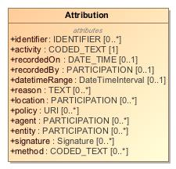

1. Attribution

|  |  |
| --- | --- |
| **Name** | Attribution |
| **Qualified Name** | CIMI Clinical::Data Structure::Attribution |
| **Visibility** | public |
| **Abstract** | false |
| **Base Classifier** | * CLUSTER |
| **Realized Interface** |  |

### **Attribute Detail**

#### activity

An activity is something that occurs over a period of time and acts upon or with entities; it may include asserting, recording, verifying, consuming, processing, transforming, modifying, relocating, using, or generating entities.

|  |  |
| --- | --- |
| **Type** | CODED_TEXT |
| **Default Value** |  |
| **Visibility** | public |
| **Multiplicity** | 1 |

#### agent

A person or other party responsible for execution of some facet of the activity. The agent in an activity for which it can be assigned some degree of responsibility for the activity taking place. The agent comprises both the party involved and its role.

|  |  |
| --- | --- |
| **Type** | PARTICIPATION |
| **Default Value** |  |
| **Visibility** | public |
| **Multiplicity** | 0..* |

#### datetimeRange

The period during which the activity occurred.

|  |  |
| --- | --- |
| **Type** | DateTimeInterval |
| **Default Value** |  |
| **Visibility** | public |
| **Multiplicity** | 0..1 |

#### entity

An entity used in this activity.

|  |  |
| --- | --- |
| **Type** | PARTICIPATION |
| **Default Value** |  |
| **Visibility** | public |
| **Multiplicity** | 0..* |

#### identifier

A token that uniquely identifies the act of attribution.

|  |  |
| --- | --- |
| **Type** | IDENTIFIER |
| **Default Value** |  |
| **Visibility** | public |
| **Multiplicity** | 0..* |

#### location

Where the activity occurred, if relevant.

|  |  |
| --- | --- |
| **Type** | PARTICIPATION |
| **Default Value** |  |
| **Visibility** | public |
| **Multiplicity** | 0..* |

#### method

This component captures the method used to perform the activity. For instance, in Verified, it captures how verification is achieved (verbal, written, telephone, etc.). In a specimen collection, examples include sputum, finger stick.

|  |  |
| --- | --- |
| **Type** | CODED_TEXT |
| **Default Value** |  |
| **Visibility** | public |
| **Multiplicity** | 0..* |

#### policy

Policy or plan that defines the activity. Typically, a single activity may have multiple applicable policy documents, such as patient consent, guarantor funding, etc.

|  |  |
| --- | --- |
| **Type** | URI |
| **Default Value** |  |
| **Visibility** | public |
| **Multiplicity** | 0..* |

#### reason

The reason that the activity was taking place.

|  |  |
| --- | --- |
| **Type** | TEXT |
| **Default Value** |  |
| **Visibility** | public |
| **Multiplicity** | 0..* |

#### recordedBy

The person or entity capturing the attribution information.

|  |  |
| --- | --- |
| **Type** | PARTICIPATION |
| **Default Value** |  |
| **Visibility** | public |
| **Multiplicity** | 0..1 |

#### recordedOn

The time at which the activity was recorded.

|  |  |
| --- | --- |
| **Type** | DATE_TIME |
| **Default Value** |  |
| **Visibility** | public |
| **Multiplicity** | 0..1 |

#### signature

A digital signature on the target Reference(s). The signer should match a Provenance.agent. The purpose of the signature is indicated.

|  |  |
| --- | --- |
| **Type** | Signature |
| **Default Value** |  |
| **Visibility** | public |
| **Multiplicity** | 0..* |

### **Relation Detail**

#### Generalization

|  |  |
| --- | --- |
| **Name** |  |
| **Related Element** | * SpecimenCollection |

|  |  |
| --- | --- |
| **Name** |  |
| **Related Element** | * CLUSTER |

## **Class** **BiometricData**

Type supporting the capture of biometric information.

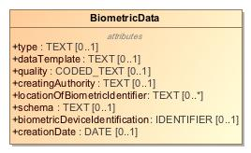

1. BiometricData

|  |  |
| --- | --- |
| **Name** | BiometricData |
| **Qualified Name** | CIMI Clinical::Data Structure::BiometricData |
| **Visibility** | public |
| **Abstract** | false |
| **Base Classifier** | * CLUSTER |
| **Realized Interface** |  |

### **Attribute Detail**

#### biometricDeviceIdentification

Identifier for the device used in the capture of the biometric information.

|  |  |
| --- | --- |
| **Type** | IDENTIFIER |
| **Default Value** |  |
| **Visibility** | public |
| **Multiplicity** | 0..1 |

#### creatingAuthority

The creating authority.

|  |  |
| --- | --- |
| **Type** | TEXT |
| **Default Value** |  |
| **Visibility** | public |
| **Multiplicity** | 0..1 |

#### creationDate

The date the biometric data was captured.

|  |  |
| --- | --- |
| **Type** | DATE |
| **Default Value** |  |
| **Visibility** | public |
| **Multiplicity** | 0..1 |

#### dataTemplate

Electronic persistence algorithm for this biometric pattern.  
  
WE SOLICIT COMMENTS FOR A BETTER DEFINITION.

|  |  |
| --- | --- |
| **Type** | TEXT |
| **Default Value** |  |
| **Visibility** | public |
| **Multiplicity** | 0..1 |

#### locationOfBiometricIdentifier

NEED DEFINITION

|  |  |
| --- | --- |
| **Type** | TEXT |
| **Default Value** |  |
| **Visibility** | public |
| **Multiplicity** | 0..* |

#### quality

The quality of the biometric information capture.

|  |  |
| --- | --- |
| **Type** | CODED_TEXT |
| **Default Value** |  |
| **Visibility** | public |
| **Multiplicity** | 0..1 |

#### schema

NEED DEFINITION

|  |  |
| --- | --- |
| **Type** | TEXT |
| **Default Value** |  |
| **Visibility** | public |
| **Multiplicity** | 0..1 |

#### type

Type of biometric used - finger print, iris scan, etc...

|  |  |
| --- | --- |
| **Type** | TEXT |
| **Default Value** |  |
| **Visibility** | public |
| **Multiplicity** | 0..1 |

### **Relation Detail**

#### Generalization

|  |  |
| --- | --- |
| **Name** |  |
| **Related Element** | * CLUSTER |

## **Class** **BirthData**

Type supporting the capture of birth-related information.

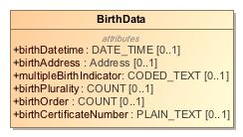

1. BirthData

|  |  |
| --- | --- |
| **Name** | BirthData |
| **Qualified Name** | CIMI Clinical::Data Structure::BirthData |
| **Visibility** | public |
| **Abstract** | false |
| **Base Classifier** | * CLUSTER |
| **Realized Interface** |  |

### **Attribute Detail**

#### birthAddress

Address where birth occurred.

|  |  |
| --- | --- |
| **Type** | Address |
| **Default Value** |  |
| **Visibility** | public |
| **Multiplicity** | 0..1 |

#### birthCertificateNumber

The birth certificate number associated with this birth.

|  |  |
| --- | --- |
| **Type** | PLAIN_TEXT |
| **Default Value** |  |
| **Visibility** | public |
| **Multiplicity** | 0..1 |

#### birthDatetime

When the birth occurred.

|  |  |
| --- | --- |
| **Type** | DATE_TIME |
| **Default Value** |  |
| **Visibility** | public |
| **Multiplicity** | 0..1 |

#### birthOrder

Integer indicating the sequence number of this birth.

|  |  |
| --- | --- |
| **Type** | COUNT |
| **Default Value** |  |
| **Visibility** | public |
| **Multiplicity** | 0..1 |

#### birthPlurality

The number of babies resulting from a single pregnancy

|  |  |
| --- | --- |
| **Type** | COUNT |
| **Default Value** |  |
| **Visibility** | public |
| **Multiplicity** | 0..1 |

#### multipleBirthIndicator

Indicates whether the birth event was a multiple birth event.

|  |  |
| --- | --- |
| **Type** | CODED_TEXT |
| **Default Value** |  |
| **Visibility** | public |
| **Multiplicity** | 0..1 |

### **Relation Detail**

#### Generalization

|  |  |
| --- | --- |
| **Name** |  |
| **Related Element** | * CLUSTER |

## **Class** **Citizenship**

Type supporting the capture of citizenship information.

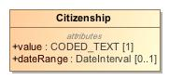

1. Citizenship

|  |  |
| --- | --- |
| **Name** | Citizenship |
| **Qualified Name** | CIMI Clinical::Data Structure::Citizenship |
| **Visibility** | public |
| **Abstract** | false |
| **Base Classifier** | * CLUSTER |
| **Realized Interface** |  |

### **Attribute Detail**

#### dateRange

The period when the citizenship was held.

|  |  |
| --- | --- |
| **Type** | DateInterval |
| **Default Value** |  |
| **Visibility** | public |
| **Multiplicity** | 0..1 |

#### value

Code representing the country of citizenship.

|  |  |
| --- | --- |
| **Type** | CODED_TEXT |
| **Default Value** |  |
| **Visibility** | public |
| **Multiplicity** | 1 |

### **Relation Detail**

#### Generalization

|  |  |
| --- | --- |
| **Name** |  |
| **Related Element** | * CLUSTER |

## **Class** **ClinicalStatementAssociation**

Association class used to represent the relationship between a class and one or more clinical statements where the relationship is qualified by one or more attributes.

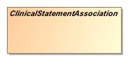

1. ClinicalStatementAssociation

|  |  |
| --- | --- |
| **Name** | ClinicalStatementAssociation |
| **Qualified Name** | CIMI Clinical::Data Structure::ClinicalStatementAssociation |
| **Visibility** | public |
| **Abstract** | true |
| **Base Classifier** | * ASSOCIATION_CLASS |
| **Realized Interface** |  |

### **Attribute Detail**

#### target

The associated statement(s)

|  |  |
| --- | --- |
| **Type** | ClinicalStatement |
| **Default Value** |  |
| **Visibility** | public |
| **Multiplicity** | 1..* |

### **Relation Detail**

#### Association

|  |  |
| --- | --- |
| **Name** |  |
| **Related Element** | * ClinicalStatement |

#### Generalization

|  |  |
| --- | --- |
| **Name** |  |
| **Related Element** | * Interpretation |

|  |  |
| --- | --- |
| **Name** |  |
| **Related Element** | * ASSOCIATION_CLASS |

|  |  |
| --- | --- |
| **Name** |  |
| **Related Element** | * Justification |

## **Class** **ContactInformation**

Represents contact details such as an emergency contact or contact information for a next-of-kin.

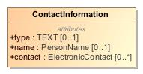

1. ContactInformation

|  |  |
| --- | --- |
| **Name** | ContactInformation |
| **Qualified Name** | CIMI Clinical::Data Structure::ContactInformation |
| **Visibility** | public |
| **Abstract** | false |
| **Base Classifier** | * CLUSTER |
| **Realized Interface** |  |

### **Attribute Detail**

#### contact

The contact information for this person.

|  |  |
| --- | --- |
| **Type** | ElectronicContact |
| **Default Value** |  |
| **Visibility** | public |
| **Multiplicity** | 0..* |

#### name

The name of the person to contact.

|  |  |
| --- | --- |
| **Type** | PersonName |
| **Default Value** |  |
| **Visibility** | public |
| **Multiplicity** | 0..1 |

#### type

The type of contact information - e.g., an emergency contact.

|  |  |
| --- | --- |
| **Type** | TEXT |
| **Default Value** |  |
| **Visibility** | public |
| **Multiplicity** | 0..1 |

### **Relation Detail**

#### Generalization

|  |  |
| --- | --- |
| **Name** |  |
| **Related Element** | * CLUSTER |

## **Class** **DeathData**

Information of about a death event.

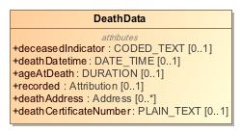

1. DeathData

|  |  |
| --- | --- |
| **Name** | DeathData |
| **Qualified Name** | CIMI Clinical::Data Structure::DeathData |
| **Visibility** | public |
| **Abstract** | false |
| **Base Classifier** | * CLUSTER |
| **Realized Interface** |  |

### **Attribute Detail**

#### ageAtDeath

The age of the person at death

|  |  |
| --- | --- |
| **Type** | DURATION |
| **Default Value** |  |
| **Visibility** | public |
| **Multiplicity** | 0..1 |

#### deathAddress

Address where the patient expired.

|  |  |
| --- | --- |
| **Type** | Address |
| **Default Value** |  |
| **Visibility** | public |
| **Multiplicity** | 0..* |

#### deathCertificateNumber

The death certificate number.

|  |  |
| --- | --- |
| **Type** | PLAIN_TEXT |
| **Default Value** |  |
| **Visibility** | public |
| **Multiplicity** | 0..1 |

#### deathDatetime

The time of death to the level of granularity known.

|  |  |
| --- | --- |
| **Type** | DATE_TIME |
| **Default Value** |  |
| **Visibility** | public |
| **Multiplicity** | 0..1 |

#### deceasedIndicator

Code indicating whether the patient is deceased.

|  |  |
| --- | --- |
| **Type** | CODED_TEXT |
| **Default Value** |  |
| **Visibility** | public |
| **Multiplicity** | 0..1 |

#### recorded

Identifier for the entity that provided information about the deceased status of the person.

|  |  |
| --- | --- |
| **Type** | Attribution |
| **Default Value** |  |
| **Visibility** | public |
| **Multiplicity** | 0..1 |

### **Relation Detail**

#### Generalization

|  |  |
| --- | --- |
| **Name** |  |
| **Related Element** | * CLUSTER |

## **Class** **Device**

This resource identifies an instance or a type of a manufactured item that is used in the provision of healthcare without being substantially changed through that activity. The device may be a medical or non-medical device. Medical devices includes durable (reusable) medical equipment, implantable devices, as well as disposable equipment used for diagnostic, treatment, and research for healthcare and public health. Non-medical devices may include items such as a machine, cellphone, computer, application, etc.

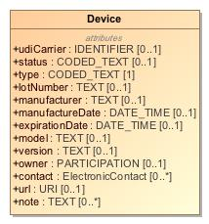

1. Device

|  |  |
| --- | --- |
| **Name** | Device |
| **Qualified Name** | CIMI Clinical::Data Structure::Device |
| **Visibility** | public |
| **Abstract** | false |
| **Base Classifier** | * MaterialEntity |
| **Realized Interface** |  |

### **Attribute Detail**

#### contact

Contact details for an organization or a particular human that is responsible for the device.

|  |  |
| --- | --- |
| **Type** | ElectronicContact |
| **Default Value** |  |
| **Visibility** | public |
| **Multiplicity** | 0..* |

#### expirationDate

The date and time beyond which this device is no longer valid or should not be used (if applicable).

|  |  |
| --- | --- |
| **Type** | DATE_TIME |
| **Default Value** |  |
| **Visibility** | public |
| **Multiplicity** | 0..1 |

#### lotNumber

Lot number assigned by the manufacturer.

|  |  |
| --- | --- |
| **Type** | TEXT |
| **Default Value** |  |
| **Visibility** | public |
| **Multiplicity** | 0..1 |

#### manufactureDate

The date and time when the device was manufactured.

|  |  |
| --- | --- |
| **Type** | DATE_TIME |
| **Default Value** |  |
| **Visibility** | public |
| **Multiplicity** | 0..1 |

#### manufacturer

A name of the manufacturer.

|  |  |
| --- | --- |
| **Type** | TEXT |
| **Default Value** |  |
| **Visibility** | public |
| **Multiplicity** | 0..1 |

#### model

The "model" is an identifier assigned by the manufacturer to identify the product by its type. This number is shared by the all devices sold as the same type.

|  |  |
| --- | --- |
| **Type** | TEXT |
| **Default Value** |  |
| **Visibility** | public |
| **Multiplicity** | 0..1 |

#### note

Descriptive information, usage information or implantation information that is not captured in an existing element.

|  |  |
| --- | --- |
| **Type** | TEXT |
| **Default Value** |  |
| **Visibility** | public |
| **Multiplicity** | 0..* |

#### owner

A party that is responsible for the provision and ongoing maintenance of the device.

|  |  |
| --- | --- |
| **Type** | PARTICIPATION |
| **Default Value** |  |
| **Visibility** | public |
| **Multiplicity** | 0..1 |

#### status

Status of the Device availability.

|  |  |
| --- | --- |
| **Type** | CODED_TEXT |
| **Default Value** |  |
| **Visibility** | public |
| **Multiplicity** | 0..1 |

#### type

The kind of device.

|  |  |
| --- | --- |
| **Type** | CODED_TEXT |
| **Default Value** |  |
| **Visibility** | public |
| **Multiplicity** | 1 |

#### udiCarrier

Unique device identifier (UDI) barcode or rfid string assigned to device label or package.

|  |  |
| --- | --- |
| **Type** | IDENTIFIER |
| **Default Value** |  |
| **Visibility** | public |
| **Multiplicity** | 0..1 |

#### url

A network address on which the device may be contacted directly.

|  |  |
| --- | --- |
| **Type** | URI |
| **Default Value** |  |
| **Visibility** | public |
| **Multiplicity** | 0..1 |

#### version

The device software or firmware version label.

|  |  |
| --- | --- |
| **Type** | TEXT |
| **Default Value** |  |
| **Visibility** | public |
| **Multiplicity** | 0..1 |

### **Relation Detail**

#### Generalization

|  |  |
| --- | --- |
| **Name** |  |
| **Related Element** | * MaterialEntity |

## **Class** **DimensionalFeature**

Feature's physical attributes such as a growth or wound.

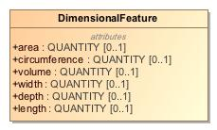

1. DimensionalFeature

|  |  |
| --- | --- |
| **Name** | DimensionalFeature |
| **Qualified Name** | CIMI Clinical::Data Structure::DimensionalFeature |
| **Visibility** | public |
| **Abstract** | false |
| **Base Classifier** | * CLUSTER |
| **Realized Interface** |  |

### **Attribute Detail**

#### area

|  |  |
| --- | --- |
| **Type** | QUANTITY |
| **Default Value** |  |
| **Visibility** | public |
| **Multiplicity** | 0..1 |

#### circumference

|  |  |
| --- | --- |
| **Type** | QUANTITY |
| **Default Value** |  |
| **Visibility** | public |
| **Multiplicity** | 0..1 |

#### depth

|  |  |
| --- | --- |
| **Type** | QUANTITY |
| **Default Value** |  |
| **Visibility** | public |
| **Multiplicity** | 0..1 |

#### length

|  |  |
| --- | --- |
| **Type** | QUANTITY |
| **Default Value** |  |
| **Visibility** | public |
| **Multiplicity** | 0..1 |

#### volume

|  |  |
| --- | --- |
| **Type** | QUANTITY |
| **Default Value** |  |
| **Visibility** | public |
| **Multiplicity** | 0..1 |

#### width

|  |  |
| --- | --- |
| **Type** | QUANTITY |
| **Default Value** |  |
| **Visibility** | public |
| **Multiplicity** | 0..1 |

### **Relation Detail**

#### Generalization

|  |  |
| --- | --- |
| **Name** |  |
| **Related Element** | * CLUSTER |

## **Class** **ElectronicContact**

Data structure representing an electronic contact such as an email address.

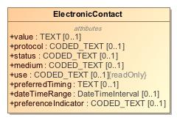

1. ElectronicContact

|  |  |
| --- | --- |
| **Name** | ElectronicContact |
| **Qualified Name** | CIMI Clinical::Data Structure::ElectronicContact |
| **Visibility** | public |
| **Abstract** | false |
| **Base Classifier** | * CLUSTER |
| **Realized Interface** |  |

### **Attribute Detail**

#### dateTimeRange

Time period when the contact point was/is in use

|  |  |
| --- | --- |
| **Type** | DateTimeInterval |
| **Default Value** |  |
| **Visibility** | public |
| **Multiplicity** | 0..1 |

#### medium

NEED A DEFINITION:  
  
The mime type for the communication.

|  |  |
| --- | --- |
| **Type** | CODED_TEXT |
| **Default Value** |  |
| **Visibility** | public |
| **Multiplicity** | 0..1 |

#### preferenceIndicator

Code indicating whether the contact information is preferred.

|  |  |
| --- | --- |
| **Type** | CODED_TEXT |
| **Default Value** |  |
| **Visibility** | public |
| **Multiplicity** | 0..1 |

#### preferredTiming

The period of day during which the contact should be used.

|  |  |
| --- | --- |
| **Type** | TEXT |
| **Default Value** |  |
| **Visibility** | public |
| **Multiplicity** | 0..1 |

#### protocol

Telecommunications form for contact point - what communications system is required to make use of the contact.

|  |  |
| --- | --- |
| **Type** | CODED_TEXT |
| **Default Value** |  |
| **Visibility** | public |
| **Multiplicity** | 0..1 |

#### status

NEED A DEFINITION

|  |  |
| --- | --- |
| **Type** | CODED_TEXT |
| **Default Value** |  |
| **Visibility** | public |
| **Multiplicity** | 0..1 |

#### use

Identifies the purpose for the contact point.

|  |  |
| --- | --- |
| **Type** | CODED_TEXT |
| **Default Value** |  |
| **Visibility** | public |
| **Multiplicity** | 0..1 |

#### value

The electronic contact address.

|  |  |
| --- | --- |
| **Type** | TEXT |
| **Default Value** |  |
| **Visibility** | public |
| **Multiplicity** | 0..1 |

### **Relation Detail**

#### Generalization

|  |  |
| --- | --- |
| **Name** |  |
| **Related Element** | * CLUSTER |

## **Class** **Entitlement**

Indicates characteristic of patient that may requires special consideration in handling or information disclosure - e.g., royalty, celebrity, felon, etc...

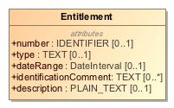

1. Entitlement

|  |  |
| --- | --- |
| **Name** | Entitlement |
| **Qualified Name** | CIMI Clinical::Data Structure::Entitlement |
| **Visibility** | public |
| **Abstract** | false |
| **Base Classifier** | * CLUSTER |
| **Realized Interface** |  |

### **Attribute Detail**

#### dateRange

Validity period for entitlement.

|  |  |
| --- | --- |
| **Type** | DateInterval |
| **Default Value** |  |
| **Visibility** | public |
| **Multiplicity** | 0..1 |

#### description

Description of the entitlement above and beyond that provided by the type.

|  |  |
| --- | --- |
| **Type** | PLAIN_TEXT |
| **Default Value** |  |
| **Visibility** | public |
| **Multiplicity** | 0..1 |

#### identificationComment

Description of how entitlement was ascertained.

|  |  |
| --- | --- |
| **Type** | TEXT |
| **Default Value** |  |
| **Visibility** | public |
| **Multiplicity** | 0..* |

#### number

Identifier for entitlement.

|  |  |
| --- | --- |
| **Type** | IDENTIFIER |
| **Default Value** |  |
| **Visibility** | public |
| **Multiplicity** | 0..1 |

#### type

Concept representing or description for the entitlement - e.g., queen, convicted murderer, etc...

|  |  |
| --- | --- |
| **Type** | TEXT |
| **Default Value** |  |
| **Visibility** | public |
| **Multiplicity** | 0..1 |

### **Relation Detail**

#### Generalization

|  |  |
| --- | --- |
| **Name** |  |
| **Related Element** | * CLUSTER |

## **Class** **EvaluationResult**

The outcome of an evaluation of a characteristic. This model holds a "question" in the key and holds a value in the result. This value is further qualified through the model's properties.

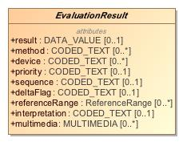

1. EvaluationResult

|  |  |
| --- | --- |
| **Name** | EvaluationResult |
| **Qualified Name** | CIMI Clinical::Data Structure::EvaluationResult |
| **Visibility** | public |
| **Abstract** | true |
| **Base Classifier** | * Finding |
| **Realized Interface** |  |

### **Attribute Detail**

#### deltaFlag

Flag indicating whether there was a significant change from previous results.

|  |  |
| --- | --- |
| **Type** | CODED_TEXT |
| **Default Value** |  |
| **Visibility** | public |
| **Multiplicity** | 0..1 |

#### device

The device used to evaluate the characteristic such as the type of blood pressure cuff used on a patient.

|  |  |
| --- | --- |
| **Type** | CODED_TEXT |
| **Default Value** |  |
| **Visibility** | public |
| **Multiplicity** | 0..* |

#### evaluationProcedure

|  |  |
| --- | --- |
| **Type** | ClinicalStatement |
| **Default Value** |  |
| **Visibility** | public |
| **Multiplicity** |  |

#### interpretation

A clinical judgment about the significance of an evaluation result.  
  
Interpretation is used to clarify data from measurements and other evaluations. For example, if a measured analyte is greater than a predetermined threshold the interpretation could be Positive, or if a measurement is lower than a normal physiological range the interpretation could be low or critical low. Some values include normal, abnormal, panic high, panic low, ...  
  
Interpretation may also be used to indicate whether or not the result is outside the range for the patient.

|  |  |
| --- | --- |
| **Type** | CODED_TEXT |
| **Default Value** |  |
| **Visibility** | public |
| **Multiplicity** | 0..1 |

#### method

The means by which a measurement, evaluation, or assessment was made.

|  |  |
| --- | --- |
| **Type** | CODED_TEXT |
| **Default Value** |  |
| **Visibility** | public |
| **Multiplicity** | 0..* |

#### multimedia

Associated media produced during the evaluation such as an X-ray.

|  |  |
| --- | --- |
| **Type** | MULTIMEDIA |
| **Default Value** |  |
| **Visibility** | public |
| **Multiplicity** | 0..* |

#### priority

The urgency of the evaluation result.   
  
To reviewers: should we retain this attribute in the model.

|  |  |
| --- | --- |
| **Type** | CODED_TEXT |
| **Default Value** |  |
| **Visibility** | public |
| **Multiplicity** | 0..1 |

#### referenceRange

The range for the measurement.

|  |  |
| --- | --- |
| **Type** | ReferenceRange |
| **Default Value** |  |
| **Visibility** | public |
| **Multiplicity** | 0..* |

#### result

The unqualified value of the evaluation.

|  |  |
| --- | --- |
| **Type** | DATA_VALUE |
| **Default Value** |  |
| **Visibility** | public |
| **Multiplicity** | 0..1 |

#### sequence

Sequence is a number placed onto the data which refers to the order it occurred in or needs to be retrieved by.

|  |  |
| --- | --- |
| **Type** | CODED_TEXT |
| **Default Value** |  |
| **Visibility** | public |
| **Multiplicity** | 0..1 |

### **Relation Detail**

#### Association

|  |  |
| --- | --- |
| **Name** |  |
| **Related Element** | * ClinicalStatement |

#### Generalization

|  |  |
| --- | --- |
| **Name** |  |
| **Related Element** | * Finding |

|  |  |
| --- | --- |
| **Name** |  |
| **Related Element** | * PhysicalEvaluationResult |

|  |  |
| --- | --- |
| **Name** |  |
| **Related Element** | * LaboratoryTestResult |

## **Class** **Finding**

The characteristics looked for in medical investigations or diagnostics and the outcome.

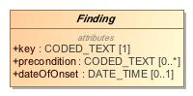

1. Finding

|  |  |
| --- | --- |
| **Name** | Finding |
| **Qualified Name** | CIMI Clinical::Data Structure::Finding |
| **Visibility** | public |
| **Abstract** | true |
| **Base Classifier** | * StatementTopic |
| **Realized Interface** |  |

### **Attribute Detail**

#### dateOfOnset

Date or time when the characteristic was first observed.  
  
When the asserted condition began manifesting. This property may have a broad precision (e.g., a year rather than a date).

|  |  |
| --- | --- |
| **Type** | DATE_TIME |
| **Default Value** |  |
| **Visibility** | public |
| **Multiplicity** | 0..1 |

#### key

The conceptual classification of the thing being observed.

|  |  |
| --- | --- |
| **Type** | CODED_TEXT |
| **Default Value** |  |
| **Visibility** | public |
| **Multiplicity** | 1 |

#### precondition

Describes the previously existing conditions or states that could effect a measurement or assesment. For example; a patients weight taken while clothed, a patients height with or without shoes, a patients blood pressure taken while standing or lying down.  
  
Precondition aligns with the SNOMED CT Observable model attribute 704326004 |Precondition (attribute)|

|  |  |
| --- | --- |
| **Type** | CODED_TEXT |
| **Default Value** |  |
| **Visibility** | public |
| **Multiplicity** | 0..* |

### **Relation Detail**

#### Generalization

|  |  |
| --- | --- |
| **Name** |  |
| **Related Element** | * EvaluationResult |

|  |  |
| --- | --- |
| **Name** |  |
| **Related Element** | * StatementTopic |

|  |  |
| --- | --- |
| **Name** |  |
| **Related Element** | * Assertion |

## **Class** **FindingContext**

The FindingContext class aligns with the SNOMED Situation with Explicit Context for findings and provides the context for the EvaluationResult and Assertion topics of a clinical statement. For instance, a statement about findings may state that the finding was observed present or absent.

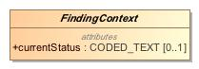

1. FindingContext

|  |  |
| --- | --- |
| **Name** | FindingContext |
| **Qualified Name** | CIMI Clinical::Data Structure::FindingContext |
| **Visibility** | public |
| **Abstract** | true |
| **Base Classifier** | * StatementContext |
| **Realized Interface** |  |

### **Attribute Detail**

#### currentStatus

Current state of the evaluation (e.g., pending, complete, partial).

|  |  |
| --- | --- |
| **Type** | CODED_TEXT |
| **Default Value** |  |
| **Visibility** | public |
| **Multiplicity** | 0..1 |

### **Relation Detail**

#### Generalization

|  |  |
| --- | --- |
| **Name** |  |
| **Related Element** | * StatementContext |

|  |  |
| --- | --- |
| **Name** |  |
| **Related Element** | * Goal |

|  |  |
| --- | --- |
| **Name** |  |
| **Related Element** | * PresenceAbsenceContext |

|  |  |
| --- | --- |
| **Name** |  |
| **Related Element** | * Risk |

## **Class** **Goal**

Context for clinical goals.

-1588381498.jpg

1. Goal

|  |  |
| --- | --- |
| **Name** | Goal |
| **Qualified Name** | CIMI Clinical::Data Structure::Goal |
| **Visibility** | public |
| **Abstract** | false |
| **Base Classifier** | * FindingContext |
| **Realized Interface** |  |

### **Relation Detail**

#### Generalization

|  |  |
| --- | --- |
| **Name** |  |
| **Related Element** | * FindingContext |

## **Class** **Industry**

Type representing an industry.

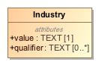

1. Industry

|  |  |
| --- | --- |
| **Name** | Industry |
| **Qualified Name** | CIMI Clinical::Data Structure::Industry |
| **Visibility** | public |
| **Abstract** | false |
| **Base Classifier** | * CLUSTER |
| **Realized Interface** |  |

### **Attribute Detail**

#### qualifier

Additional description or further refinement for the industry

|  |  |
| --- | --- |
| **Type** | TEXT |
| **Default Value** |  |
| **Visibility** | public |
| **Multiplicity** | 0..* |

#### value

The industry name.

|  |  |
| --- | --- |
| **Type** | TEXT |
| **Default Value** |  |
| **Visibility** | public |
| **Multiplicity** | 1 |

### **Relation Detail**

#### Generalization

|  |  |
| --- | --- |
| **Name** |  |
| **Related Element** | * CLUSTER |

## **Class** **Ingredient**

A components that go to make up the described item.

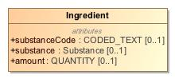

1. Ingredient

|  |  |
| --- | --- |
| **Name** | Ingredient |
| **Qualified Name** | CIMI Clinical::Data Structure::Ingredient |
| **Visibility** | public |
| **Abstract** | false |
| **Base Classifier** | * CLUSTER |
| **Realized Interface** |  |

### **Attribute Detail**

#### amount

The amount of the component item.

|  |  |
| --- | --- |
| **Type** | QUANTITY |
| **Default Value** |  |
| **Visibility** | public |
| **Multiplicity** | 0..1 |

#### substance

Identifies a component item.

|  |  |
| --- | --- |
| **Type** | Substance |
| **Default Value** |  |
| **Visibility** | public |
| **Multiplicity** | 0..1 |

#### substanceCode

Identifies a component items

|  |  |
| --- | --- |
| **Type** | CODED_TEXT |
| **Default Value** |  |
| **Visibility** | public |
| **Multiplicity** | 0..1 |

### **Relation Detail**

#### Generalization

|  |  |
| --- | --- |
| **Name** |  |
| **Related Element** | * CLUSTER |

## **Class** **Interpretation**

The interpretation provided by the containing type for the set of clinical statements that comprise the target of the relationship.   
  
For instance, Assertion.interpretation can be interpreted as follows: the assertion interprets the set of clinical statements specified as the range of Assertion.interpretation.target and the interpretation is specified by the Assertion.interpretation.hasInterpretation code.

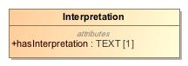

1. Interpretation

|  |  |
| --- | --- |
| **Name** | Interpretation |
| **Qualified Name** | CIMI Clinical::Data Structure::Interpretation |
| **Visibility** | public |
| **Abstract** | false |
| **Base Classifier** | * ClinicalStatementAssociation |
| **Realized Interface** |  |

### **Attribute Detail**

#### hasInterpretation

Narrative or code representing the interpretation assigned by the containing class on the set of clinical statements that comprise the target of the relationship.

|  |  |
| --- | --- |
| **Type** | TEXT |
| **Default Value** |  |
| **Visibility** | public |
| **Multiplicity** | 1 |

### **Relation Detail**

#### Generalization

|  |  |
| --- | --- |
| **Name** |  |
| **Related Element** | * ClinicalStatementAssociation |

## **Class** **Justification**

Asserted clinical justification to perform or not perform an act such as a diagnostic test, a medication treatment, or a procedure.  
  
The justification can be specified as a code or as a clinical statement, e.g., code for diabetes (ICD-9-CM 250.0) or a Condition occurrence statement (with diabetes code) documented elsewhere in a patient's record.

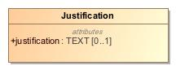

1. Justification

|  |  |
| --- | --- |
| **Name** | Justification |
| **Qualified Name** | CIMI Clinical::Data Structure::Justification |
| **Visibility** | public |
| **Abstract** | false |
| **Base Classifier** | * ClinicalStatementAssociation |
| **Realized Interface** |  |

### **Attribute Detail**

#### justification

A code or narrative representing the justification. Typically, the code is for a condition that is suspected or is observed in a patient.

|  |  |
| --- | --- |
| **Type** | TEXT |
| **Default Value** |  |
| **Visibility** | public |
| **Multiplicity** | 0..1 |

### **Relation Detail**

#### Generalization

|  |  |
| --- | --- |
| **Name** |  |
| **Related Element** | * ClinicalStatementAssociation |

## **Class** **KnownOrSuspectedPresent**

Context indicating that finding is known present or suspected present.

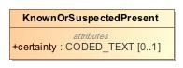

1. KnownOrSuspectedPresent

|  |  |
| --- | --- |
| **Name** | KnownOrSuspectedPresent |
| **Qualified Name** | CIMI Clinical::Data Structure::KnownOrSuspectedPresent |
| **Visibility** | public |
| **Abstract** | false |
| **Base Classifier** | * PresenceAbsenceContext |
| **Realized Interface** |  |

### **Attribute Detail**

#### certainty

|  |  |
| --- | --- |
| **Type** | CODED_TEXT |
| **Default Value** |  |
| **Visibility** | public |
| **Multiplicity** | 0..1 |

### **Relation Detail**

#### Generalization

|  |  |
| --- | --- |
| **Name** |  |
| **Related Element** | * PresenceAbsenceContext |

## **Class** **LaboratoryProcedure**

Specialization of Procedure that represents a procedure performed on a collected specimen such as a blood panel or a biopsy.

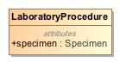

1. LaboratoryProcedure

|  |  |
| --- | --- |
| **Name** | LaboratoryProcedure |
| **Qualified Name** | CIMI Clinical::Data Structure::LaboratoryProcedure |
| **Visibility** | public |
| **Abstract** | false |
| **Base Classifier** | * Procedure |
| **Realized Interface** |  |

### **Attribute Detail**

#### specimen

Tissues, objects, or samples taken from the patient during the procedure including biopsies, aspiration fluid, or other samples sent for pathological analysis.

|  |  |
| --- | --- |
| **Type** | Specimen |
| **Default Value** |  |
| **Visibility** | public |
| **Multiplicity** |  |

### **Relation Detail**

#### Generalization

|  |  |
| --- | --- |
| **Name** |  |
| **Related Element** | * Procedure |

## **Class** **LaboratoryTestResult**

Measurement resulted from a laboratory.

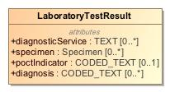

1. LaboratoryTestResult

|  |  |
| --- | --- |
| **Name** | LaboratoryTestResult |
| **Qualified Name** | CIMI Clinical::Data Structure::LaboratoryTestResult |
| **Visibility** | public |
| **Abstract** | false |
| **Base Classifier** | * EvaluationResult |
| **Realized Interface** |  |

### **Attribute Detail**

#### diagnosis

A condition for which the lab result is pathoneumonic. The lab result is sufficient to assert the diagnosis.

|  |  |
| --- | --- |
| **Type** | CODED_TEXT |
| **Default Value** |  |
| **Visibility** | public |
| **Multiplicity** | 0..* |

#### diagnosticService

The service completing the observations, e.g. biochemistry, microbiology, blood bank, etc.

|  |  |
| --- | --- |
| **Type** | TEXT |
| **Default Value** |  |
| **Visibility** | public |
| **Multiplicity** | 0..* |

#### poctIndicator

NEED DEFINITION OR REMOVE (STAN?)

|  |  |
| --- | --- |
| **Type** | CODED_TEXT |
| **Default Value** |  |
| **Visibility** | public |
| **Multiplicity** | 0..1 |

#### specimen

The specimen used for the analysis.

|  |  |
| --- | --- |
| **Type** | Specimen |
| **Default Value** |  |
| **Visibility** | public |
| **Multiplicity** | 0..* |

### **Relation Detail**

#### Generalization

|  |  |
| --- | --- |
| **Name** |  |
| **Related Element** | * EvaluationResult |

## **Class** **LanguageCapability**

Type representing proficiency in a language.

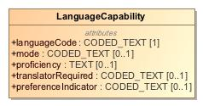

1. LanguageCapability

|  |  |
| --- | --- |
| **Name** | LanguageCapability |
| **Qualified Name** | CIMI Clinical::Data Structure::LanguageCapability |
| **Visibility** | public |
| **Abstract** | false |
| **Base Classifier** | * CLUSTER |
| **Realized Interface** |  |

### **Attribute Detail**

#### languageCode

ISO code representing the language name.

|  |  |
| --- | --- |
| **Type** | CODED_TEXT |
| **Default Value** |  |
| **Visibility** | public |
| **Multiplicity** | 1 |

#### mode

The channel of communication evaluated; e.g., spoken, written, heard.

|  |  |
| --- | --- |
| **Type** | CODED_TEXT |
| **Default Value** |  |
| **Visibility** | public |
| **Multiplicity** | 0..1 |

#### preferenceIndicator

Code indicating whether the language is preferred for communication.

|  |  |
| --- | --- |
| **Type** | CODED_TEXT |
| **Default Value** |  |
| **Visibility** | public |
| **Multiplicity** | 0..1 |

#### proficiency

Degree of fluency in the language.

|  |  |
| --- | --- |
| **Type** | TEXT |
| **Default Value** |  |
| **Visibility** | public |
| **Multiplicity** | 0..1 |

#### translatorRequired

Code indicating need for translator.

|  |  |
| --- | --- |
| **Type** | CODED_TEXT |
| **Default Value** |  |
| **Visibility** | public |
| **Multiplicity** | 0..1 |

### **Relation Detail**

#### Generalization

|  |  |
| --- | --- |
| **Name** |  |
| **Related Element** | * CLUSTER |

## **Class** **Location**

Data structure representing a geographical location such as a location on a map.

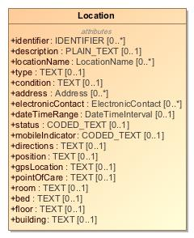

1. Location

|  |  |
| --- | --- |
| **Name** | Location |
| **Qualified Name** | CIMI Clinical::Data Structure::Location |
| **Visibility** | public |
| **Abstract** | false |
| **Base Classifier** | * CLUSTER |
| **Realized Interface** |  |

### **Attribute Detail**

#### address

The postal addresses associated with this location.

|  |  |
| --- | --- |
| **Type** | Address |
| **Default Value** |  |
| **Visibility** | public |
| **Multiplicity** | 0..* |

#### bed

The bed at the specified location, floor, and room - E.g., 10 West Bed 2

|  |  |
| --- | --- |
| **Type** | TEXT |
| **Default Value** |  |
| **Visibility** | public |
| **Multiplicity** | 0..1 |

#### building

The building at the specified location.

|  |  |
| --- | --- |
| **Type** | TEXT |
| **Default Value** |  |
| **Visibility** | public |
| **Multiplicity** | 0..1 |

#### condition

A description of the condition of the location.

|  |  |
| --- | --- |
| **Type** | TEXT |
| **Default Value** |  |
| **Visibility** | public |
| **Multiplicity** | 0..1 |

#### dateTimeRange

The interval of time when this location is relevant or available.

|  |  |
| --- | --- |
| **Type** | DateTimeInterval |
| **Default Value** |  |
| **Visibility** | public |
| **Multiplicity** | 0..1 |

#### description

A narrative describing the location.

|  |  |
| --- | --- |
| **Type** | PLAIN_TEXT |
| **Default Value** |  |
| **Visibility** | public |
| **Multiplicity** | 0..1 |

#### directions

How to navigate to the location. May be context-sensitive.

|  |  |
| --- | --- |
| **Type** | TEXT |
| **Default Value** |  |
| **Visibility** | public |
| **Multiplicity** | 0..1 |

#### electronicContact

Contact information associated with this location - for instance, contact information to reserve the location.

|  |  |
| --- | --- |
| **Type** | ElectronicContact |
| **Default Value** |  |
| **Visibility** | public |
| **Multiplicity** | 0..* |

#### floor

The floor at the specified location.

|  |  |
| --- | --- |
| **Type** | TEXT |
| **Default Value** |  |
| **Visibility** | public |
| **Multiplicity** | 0..1 |

#### gpsLocation

The location's geospatial coordinates such as latitude and longitude.

|  |  |
| --- | --- |
| **Type** | TEXT |
| **Default Value** |  |
| **Visibility** | public |
| **Multiplicity** | 0..1 |

#### identifier

The identifier of the location.

|  |  |
| --- | --- |
| **Type** | IDENTIFIER |
| **Default Value** |  |
| **Visibility** | public |
| **Multiplicity** | 0..* |

#### locationName

Names associated with this location. E.g., 10 West

|  |  |
| --- | --- |
| **Type** | LocationName |
| **Default Value** |  |
| **Visibility** | public |
| **Multiplicity** | 0..* |

#### mobileIndicator

An indicator of whether or not the location is mobile.

|  |  |
| --- | --- |
| **Type** | CODED_TEXT |
| **Default Value** |  |
| **Visibility** | public |
| **Multiplicity** | 0..1 |

#### pointOfCare

The care setting at the location.

|  |  |
| --- | --- |
| **Type** | TEXT |
| **Default Value** |  |
| **Visibility** | public |
| **Multiplicity** | 0..1 |

#### position

Description of the position of the location.

|  |  |
| --- | --- |
| **Type** | TEXT |
| **Default Value** |  |
| **Visibility** | public |
| **Multiplicity** | 0..1 |

#### room

The room at the specified location and floor - E.g., 10 West

|  |  |
| --- | --- |
| **Type** | TEXT |
| **Default Value** |  |
| **Visibility** | public |
| **Multiplicity** | 0..1 |

#### status

A code representing the status of the location.

|  |  |
| --- | --- |
| **Type** | CODED_TEXT |
| **Default Value** |  |
| **Visibility** | public |
| **Multiplicity** | 0..1 |

#### type

The location's category.

|  |  |
| --- | --- |
| **Type** | TEXT |
| **Default Value** |  |
| **Visibility** | public |
| **Multiplicity** | 0..1 |

### **Relation Detail**

#### Generalization

|  |  |
| --- | --- |
| **Name** |  |
| **Related Element** | * CLUSTER |

## **Class** **LocationName**

Data structure capturing the name of a location

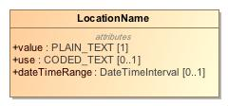

1. LocationName

|  |  |
| --- | --- |
| **Name** | LocationName |
| **Qualified Name** | CIMI Clinical::Data Structure::LocationName |
| **Visibility** | public |
| **Abstract** | false |
| **Base Classifier** | * CLUSTER |
| **Realized Interface** |  |

### **Attribute Detail**

#### dateTimeRange

Time period when name was/is in use

|  |  |
| --- | --- |
| **Type** | DateTimeInterval |
| **Default Value** |  |
| **Visibility** | public |
| **Multiplicity** | 0..1 |

#### use

Identifies the purpose for this name.

|  |  |
| --- | --- |
| **Type** | CODED_TEXT |
| **Default Value** |  |
| **Visibility** | public |
| **Multiplicity** | 0..1 |

#### value

The location's name

|  |  |
| --- | --- |
| **Type** | PLAIN_TEXT |
| **Default Value** |  |
| **Visibility** | public |
| **Multiplicity** | 1 |

### **Relation Detail**

#### Generalization

|  |  |
| --- | --- |
| **Name** |  |
| **Related Element** | * CLUSTER |

## **Class** **MaterialEntity**

Root class for material entities such as anatomical locations, devices, and substances.

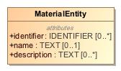

1. MaterialEntity

|  |  |
| --- | --- |
| **Name** | MaterialEntity |
| **Qualified Name** | CIMI Clinical::Data Structure::MaterialEntity |
| **Visibility** | public |
| **Abstract** | false |
| **Base Classifier** | * CLUSTER |
| **Realized Interface** |  |

### **Attribute Detail**

#### description

A description of the entity.

|  |  |
| --- | --- |
| **Type** | TEXT |
| **Default Value** |  |
| **Visibility** | public |
| **Multiplicity** | 0..* |

#### identifier

An identifier for the material entity.

|  |  |
| --- | --- |
| **Type** | IDENTIFIER |
| **Default Value** |  |
| **Visibility** | public |
| **Multiplicity** | 0..* |

#### name

The name or code of the entity.

|  |  |
| --- | --- |
| **Type** | TEXT |
| **Default Value** |  |
| **Visibility** | public |
| **Multiplicity** | 0..1 |

### **Relation Detail**

#### Generalization

|  |  |
| --- | --- |
| **Name** |  |
| **Related Element** | * Specimen |

|  |  |
| --- | --- |
| **Name** |  |
| **Related Element** | * Medication |

|  |  |
| --- | --- |
| **Name** |  |
| **Related Element** | * AnatomicalLocation |

|  |  |
| --- | --- |
| **Name** |  |
| **Related Element** | * Device |

|  |  |
| --- | --- |
| **Name** |  |
| **Related Element** | * CLUSTER |

|  |  |
| --- | --- |
| **Name** |  |
| **Related Element** | * Substance |

## **Class** **Medication**

Class representing a medication. It covers the ingredients and the packaging for a medication.

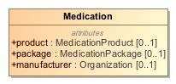

1. Medication

|  |  |
| --- | --- |
| **Name** | Medication |
| **Qualified Name** | CIMI Clinical::Data Structure::Medication |
| **Visibility** | public |
| **Abstract** | false |
| **Base Classifier** | * MaterialEntity |
| **Realized Interface** |  |

### **Attribute Detail**

#### manufacturer

The manufacturer of the substance.

|  |  |
| --- | --- |
| **Type** | Organization |
| **Default Value** |  |
| **Visibility** | public |
| **Multiplicity** | 0..1 |

#### package

The form in which the product is marketed.

|  |  |
| --- | --- |
| **Type** | MedicationPackage |
| **Default Value** |  |
| **Visibility** | public |
| **Multiplicity** | 0..1 |

#### product

Information that only applies to medication products (not packages).

|  |  |
| --- | --- |
| **Type** | MedicationProduct |
| **Default Value** |  |
| **Visibility** | public |
| **Multiplicity** | 0..1 |

### **Relation Detail**

#### Generalization

|  |  |
| --- | --- |
| **Name** |  |
| **Related Element** | * MaterialEntity |

## **Class** **MedicationPackage**

A package for a medication.

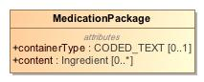

1. MedicationPackage

|  |  |
| --- | --- |
| **Name** | MedicationPackage |
| **Qualified Name** | CIMI Clinical::Data Structure::MedicationPackage |
| **Visibility** | public |
| **Abstract** | false |
| **Base Classifier** | * UnitOfDistribution |
| **Realized Interface** |  |

### **Attribute Detail**

#### containerType

The kind of container that this package comes as.

|  |  |
| --- | --- |
| **Type** | CODED_TEXT |
| **Default Value** |  |
| **Visibility** | public |
| **Multiplicity** | 0..1 |

#### content

The set of medication ingredients

|  |  |
| --- | --- |
| **Type** | Ingredient |
| **Default Value** |  |
| **Visibility** | public |
| **Multiplicity** | 0..* |

### **Relation Detail**

#### Generalization

|  |  |
| --- | --- |
| **Name** |  |
| **Related Element** | * UnitOfDistribution |

## **Class** **MedicationProduct**

Information that only applies to medication products (not packages).

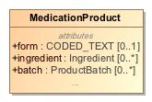

1. MedicationProduct

|  |  |
| --- | --- |
| **Name** | MedicationProduct |
| **Qualified Name** | CIMI Clinical::Data Structure::MedicationProduct |
| **Visibility** | public |
| **Abstract** | false |
| **Base Classifier** | * CLUSTER |
| **Realized Interface** |  |

### **Attribute Detail**

#### amount

|  |  |
| --- | --- |
| **Type** | QUANTITY |
| **Default Value** |  |
| **Visibility** | public |
| **Multiplicity** | 0..1 |

#### batch

Information about a group of medication produced or packaged from one production run.

|  |  |
| --- | --- |
| **Type** | ProductBatch |
| **Default Value** |  |
| **Visibility** | public |
| **Multiplicity** | 0..* |

#### form

Describes the form of the item. Powder; tablets; capsule.

|  |  |
| --- | --- |
| **Type** | CODED_TEXT |
| **Default Value** |  |
| **Visibility** | public |
| **Multiplicity** | 0..1 |

#### ingredient

Identifies a particular constituent of interest in the product.

|  |  |
| --- | --- |
| **Type** | Ingredient |
| **Default Value** |  |
| **Visibility** | public |
| **Multiplicity** | 0..* |

### **Relation Detail**

#### Generalization

|  |  |
| --- | --- |
| **Name** |  |
| **Related Element** | * CLUSTER |

## **Class** **NonCompletion**

A record that a clinical act was initiated by not completed.

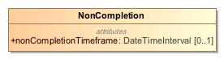

1. NonCompletion

|  |  |
| --- | --- |
| **Name** | NonCompletion |
| **Qualified Name** | CIMI Clinical::Data Structure::NonCompletion |
| **Visibility** | public |
| **Abstract** | false |
| **Base Classifier** | * Performance |
| **Realized Interface** |  |

### **Attribute Detail**

#### nonCompletionTimeframe

The time interval considered when the action had been intended for execution.

|  |  |
| --- | --- |
| **Type** | DateTimeInterval |
| **Default Value** |  |
| **Visibility** | public |
| **Multiplicity** | 0..1 |

### **Relation Detail**

#### Generalization

|  |  |
| --- | --- |
| **Name** |  |
| **Related Element** | * Performance |

## **Class** **NonPerformance**

A record that a clinical act was not performed and/or never initiated. Do not use this context if the act was initiated or started but aborted or cancelled. Use the NotPerformed context instead.

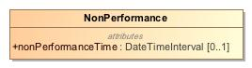

1. NonPerformance

|  |  |
| --- | --- |
| **Name** | NonPerformance |
| **Qualified Name** | CIMI Clinical::Data Structure::NonPerformance |
| **Visibility** | public |
| **Abstract** | false |
| **Base Classifier** | * ActionContext |
| **Realized Interface** |  |

### **Attribute Detail**

#### nonPerformanceTime

The time period during which the act had been intended for execution.

|  |  |
| --- | --- |
| **Type** | DateTimeInterval |
| **Default Value** |  |
| **Visibility** | public |
| **Multiplicity** | 0..1 |

### **Relation Detail**

#### Generalization

|  |  |
| --- | --- |
| **Name** |  |
| **Related Element** | * ActionContext |

## **Class** **Occupation**

An association between a person and a kind of job that the person has held.

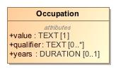

1. Occupation

|  |  |
| --- | --- |
| **Name** | Occupation |
| **Qualified Name** | CIMI Clinical::Data Structure::Occupation |
| **Visibility** | public |
| **Abstract** | false |
| **Base Classifier** | * CLUSTER |
| **Realized Interface** |  |

### **Attribute Detail**

#### qualifier

Additional description for the occupation such journeyman, master, apprentice, etc...

|  |  |
| --- | --- |
| **Type** | TEXT |
| **Default Value** |  |
| **Visibility** | public |
| **Multiplicity** | 0..* |

#### value

An occupation. Likely to be realm-specific.

|  |  |
| --- | --- |
| **Type** | TEXT |
| **Default Value** |  |
| **Visibility** | public |
| **Multiplicity** | 1 |

#### years

Years performing this occupation.

|  |  |
| --- | --- |
| **Type** | DURATION |
| **Default Value** |  |
| **Visibility** | public |
| **Multiplicity** | 0..1 |

### **Relation Detail**

#### Generalization

|  |  |
| --- | --- |
| **Name** |  |
| **Related Element** | * CLUSTER |

## **Class** **Order**

An instruction by a healthcare provider to another healthcare provider to perform some act.

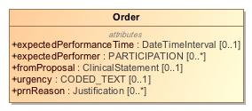

1. Order

|  |  |
| --- | --- |
| **Name** | Order |
| **Qualified Name** | CIMI Clinical::Data Structure::Order |
| **Visibility** | public |
| **Abstract** | false |
| **Base Classifier** | * ActionContext |
| **Realized Interface** |  |

### **Attribute Detail**

#### expectedPerformanceTime

Time when the ordered act is expected to be performed.

|  |  |
| --- | --- |
| **Type** | DateTimeInterval |
| **Default Value** |  |
| **Visibility** | public |
| **Multiplicity** | 0..1 |

#### expectedPerformer

Persons who are expected to or intended to perform this action, e.g., the person who will perform the surgery.

|  |  |
| --- | --- |
| **Type** | PARTICIPATION |
| **Default Value** |  |
| **Visibility** | public |
| **Multiplicity** | 0..* |

#### fromProposal

The proposal that is partly or wholly fulfilled by the performance of this act.

|  |  |
| --- | --- |
| **Type** | ClinicalStatement |
| **Default Value** |  |
| **Visibility** | public |
| **Multiplicity** | 0..1 |

#### prnReason

Condition under which the ordered act should be performed. E.g.., shortness of breath, SpO2 less than x%, insomnia, nausea.

|  |  |
| --- | --- |
| **Type** | Justification |
| **Default Value** |  |
| **Visibility** | public |
| **Multiplicity** | 0..* |

#### urgency

How quickly the action must be initiated. Includes concepts such as stat, urgent, routine.

|  |  |
| --- | --- |
| **Type** | CODED_TEXT |
| **Default Value** |  |
| **Visibility** | public |
| **Multiplicity** | 0..1 |

### **Relation Detail**

#### Generalization

|  |  |
| --- | --- |
| **Name** |  |
| **Related Element** | * ActionContext |

## **Class** **OrganizationName**

The name of an organization.

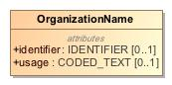

1. OrganizationName

|  |  |
| --- | --- |
| **Name** | OrganizationName |
| **Qualified Name** | CIMI Clinical::Data Structure::OrganizationName |
| **Visibility** | public |
| **Abstract** | false |
| **Base Classifier** | * ActorName |
| **Realized Interface** |  |

### **Attribute Detail**

#### identifier

An identifier for the organization.

|  |  |
| --- | --- |
| **Type** | IDENTIFIER |
| **Default Value** |  |
| **Visibility** | public |
| **Multiplicity** | 0..1 |

#### usage

Code indicating when the name is used.

|  |  |
| --- | --- |
| **Type** | CODED_TEXT |
| **Default Value** |  |
| **Visibility** | public |
| **Multiplicity** | 0..1 |

### **Relation Detail**

#### Generalization

|  |  |
| --- | --- |
| **Name** |  |
| **Related Element** | * ActorName |

## **Class** **Part**

A component of a name or an address.

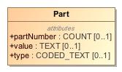

1. Part

|  |  |
| --- | --- |
| **Name** | Part |
| **Qualified Name** | CIMI Clinical::Data Structure::Part |
| **Visibility** | public |
| **Abstract** | false |
| **Base Classifier** | * CLUSTER |
| **Realized Interface** |  |

### **Attribute Detail**

#### partNumber

The position of the part in the overall structure.

|  |  |
| --- | --- |
| **Type** | COUNT |
| **Default Value** |  |
| **Visibility** | public |
| **Multiplicity** | 0..1 |

#### type

The type of the part - e.g., 'given name' or 'street number'.

|  |  |
| --- | --- |
| **Type** | CODED_TEXT |
| **Default Value** |  |
| **Visibility** | public |
| **Multiplicity** | 0..1 |

#### value

The value of the given part - e.g., a given name such as 'John'.

|  |  |
| --- | --- |
| **Type** | TEXT |
| **Default Value** |  |
| **Visibility** | public |
| **Multiplicity** | 0..1 |

### **Relation Detail**

#### Generalization

|  |  |
| --- | --- |
| **Name** |  |
| **Related Element** | * CLUSTER |

## **Class** **PartyName**

Abstract supertype for the name of a party.

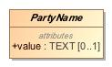

1. PartyName

|  |  |
| --- | --- |
| **Name** | PartyName |
| **Qualified Name** | CIMI Clinical::Data Structure::PartyName |
| **Visibility** | public |
| **Abstract** | true |
| **Base Classifier** | * CLUSTER |
| **Realized Interface** |  |

### **Attribute Detail**

#### value

|  |  |
| --- | --- |
| **Type** | TEXT |
| **Default Value** |  |
| **Visibility** | public |
| **Multiplicity** | 0..1 |

### **Relation Detail**

#### Generalization

|  |  |
| --- | --- |
| **Name** |  |
| **Related Element** | * ActorName |

|  |  |
| --- | --- |
| **Name** |  |
| **Related Element** | * CLUSTER |

## **Class** **Performance**

Context indicating actual performance or execution of a healthcare-related action, e.g., 3rd dose of Hepatitis B vaccine administered on Dec 4th 2012, appendectomy performed today.

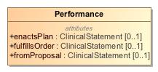

1. Performance

|  |  |
| --- | --- |
| **Name** | Performance |
| **Qualified Name** | CIMI Clinical::Data Structure::Performance |
| **Visibility** | public |
| **Abstract** | false |
| **Base Classifier** | * ActionContext |
| **Realized Interface** |  |

### **Attribute Detail**

#### enactsPlan

The plan that is partly or wholly enacted by the performance of this act.

|  |  |
| --- | --- |
| **Type** | ClinicalStatement |
| **Default Value** |  |
| **Visibility** | public |
| **Multiplicity** | 0..1 |

#### fromProposal

The proposal that is partly or wholly fulfilled by the performance of this act.

|  |  |
| --- | --- |
| **Type** | ClinicalStatement |
| **Default Value** |  |
| **Visibility** | public |
| **Multiplicity** | 0..1 |

#### fulfillsOrder

The order that is partly or wholly enacted by the performance of this act.

|  |  |
| --- | --- |
| **Type** | ClinicalStatement |
| **Default Value** |  |
| **Visibility** | public |
| **Multiplicity** | 0..1 |

### **Relation Detail**

#### Generalization

|  |  |
| --- | --- |
| **Name** |  |
| **Related Element** | * NonCompletion |

|  |  |
| --- | --- |
| **Name** |  |
| **Related Element** | * ActionContext |

## **Class** **Person**

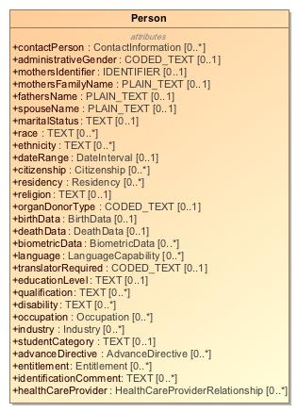

1. Person

|  |  |
| --- | --- |
| **Name** | Person |
| **Qualified Name** | CIMI Clinical::Data Structure::Person |
| **Visibility** | public |
| **Abstract** | false |
| **Base Classifier** | * BaseActor |
| **Realized Interface** |  |

### **Attribute Detail**

#### administrativeGender

|  |  |
| --- | --- |
| **Type** | CODED_TEXT |
| **Default Value** |  |
| **Visibility** | public |
| **Multiplicity** | 0..1 |

#### advanceDirective

|  |  |
| --- | --- |
| **Type** | AdvanceDirective |
| **Default Value** |  |
| **Visibility** | public |
| **Multiplicity** | 0..* |

#### biometricData

|  |  |
| --- | --- |
| **Type** | BiometricData |
| **Default Value** |  |
| **Visibility** | public |
| **Multiplicity** | 0..* |

#### birthData

|  |  |
| --- | --- |
| **Type** | BirthData |
| **Default Value** |  |
| **Visibility** | public |
| **Multiplicity** | 0..1 |

#### citizenship

|  |  |
| --- | --- |
| **Type** | Citizenship |
| **Default Value** |  |
| **Visibility** | public |
| **Multiplicity** | 0..* |

#### contactPerson

|  |  |
| --- | --- |
| **Type** | ContactInformation |
| **Default Value** |  |
| **Visibility** | public |
| **Multiplicity** | 0..* |

#### dateRange

|  |  |
| --- | --- |
| **Type** | DateInterval |
| **Default Value** |  |
| **Visibility** | public |
| **Multiplicity** | 0..1 |

#### deathData

|  |  |
| --- | --- |
| **Type** | DeathData |
| **Default Value** |  |
| **Visibility** | public |
| **Multiplicity** | 0..1 |

#### disability

|  |  |
| --- | --- |
| **Type** | TEXT |
| **Default Value** |  |
| **Visibility** | public |
| **Multiplicity** | 0..* |

#### educationLevel

|  |  |
| --- | --- |
| **Type** | TEXT |
| **Default Value** |  |
| **Visibility** | public |
| **Multiplicity** | 0..1 |

#### entitlement

|  |  |
| --- | --- |
| **Type** | Entitlement |
| **Default Value** |  |
| **Visibility** | public |
| **Multiplicity** | 0..* |

#### ethnicity

|  |  |
| --- | --- |
| **Type** | TEXT |
| **Default Value** |  |
| **Visibility** | public |
| **Multiplicity** | 0..* |

#### fathersName

|  |  |
| --- | --- |
| **Type** | PLAIN_TEXT |
| **Default Value** |  |
| **Visibility** | public |
| **Multiplicity** | 0..1 |

#### healthCareProvider

|  |  |
| --- | --- |
| **Type** | HealthCareProviderRelationship |
| **Default Value** |  |
| **Visibility** | public |
| **Multiplicity** | 0..* |

#### identificationComment

|  |  |
| --- | --- |
| **Type** | TEXT |
| **Default Value** |  |
| **Visibility** | public |
| **Multiplicity** | 0..* |

#### industry

|  |  |
| --- | --- |
| **Type** | Industry |
| **Default Value** |  |
| **Visibility** | public |
| **Multiplicity** | 0..* |

#### language

|  |  |
| --- | --- |
| **Type** | LanguageCapability |
| **Default Value** |  |
| **Visibility** | public |
| **Multiplicity** | 0..* |

#### maritalStatus

|  |  |
| --- | --- |
| **Type** | TEXT |
| **Default Value** |  |
| **Visibility** | public |
| **Multiplicity** | 0..1 |

#### mothersFamilyName

|  |  |
| --- | --- |
| **Type** | PLAIN_TEXT |
| **Default Value** |  |
| **Visibility** | public |
| **Multiplicity** | 0..1 |

#### mothersIdentifier

|  |  |
| --- | --- |
| **Type** | IDENTIFIER |
| **Default Value** |  |
| **Visibility** | public |
| **Multiplicity** | 0..1 |

#### occupation

|  |  |
| --- | --- |
| **Type** | Occupation |
| **Default Value** |  |
| **Visibility** | public |
| **Multiplicity** | 0..* |

#### organDonorType

|  |  |
| --- | --- |
| **Type** | CODED_TEXT |
| **Default Value** |  |
| **Visibility** | public |
| **Multiplicity** | 0..1 |

#### qualification

|  |  |
| --- | --- |
| **Type** | TEXT |
| **Default Value** |  |
| **Visibility** | public |
| **Multiplicity** | 0..* |

#### race

|  |  |
| --- | --- |
| **Type** | TEXT |
| **Default Value** |  |
| **Visibility** | public |
| **Multiplicity** | 0..* |

#### religion

|  |  |
| --- | --- |
| **Type** | TEXT |
| **Default Value** |  |
| **Visibility** | public |
| **Multiplicity** | 0..1 |

#### residency

|  |  |
| --- | --- |
| **Type** | Residency |
| **Default Value** |  |
| **Visibility** | public |
| **Multiplicity** | 0..* |

#### spouseName

|  |  |
| --- | --- |
| **Type** | PLAIN_TEXT |
| **Default Value** |  |
| **Visibility** | public |
| **Multiplicity** | 0..1 |

#### studentCategory

|  |  |
| --- | --- |
| **Type** | TEXT |
| **Default Value** |  |
| **Visibility** | public |
| **Multiplicity** | 0..1 |

#### translatorRequired

|  |  |
| --- | --- |
| **Type** | CODED_TEXT |
| **Default Value** |  |
| **Visibility** | public |
| **Multiplicity** | 0..1 |

### **Relation Detail**

#### Generalization

|  |  |
| --- | --- |
| **Name** |  |
| **Related Element** | * BaseActor |

## **Class** **PersonName**

The generic representation of the name of a person. The name of a person can vary greatly across cultures and countries.

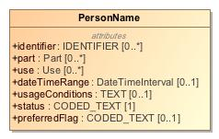

1. PersonName

|  |  |
| --- | --- |
| **Name** | PersonName |
| **Qualified Name** | CIMI Clinical::Data Structure::PersonName |
| **Visibility** | public |
| **Abstract** | false |
| **Base Classifier** | * ActorName |
| **Realized Interface** |  |

### **Attribute Detail**

#### dateTimeRange

Time period when the name was used.

|  |  |
| --- | --- |
| **Type** | DateTimeInterval |
| **Default Value** |  |
| **Visibility** | public |
| **Multiplicity** | 0..1 |

#### identifier

An identifier for the name.

|  |  |
| --- | --- |
| **Type** | IDENTIFIER |
| **Default Value** |  |
| **Visibility** | public |
| **Multiplicity** | 0..* |

#### part

A component of a name.

|  |  |
| --- | --- |
| **Type** | Part |
| **Default Value** |  |
| **Visibility** | public |
| **Multiplicity** | 0..* |

#### preferredFlag

Code indicating the preference associated with the use of this name.

|  |  |
| --- | --- |
| **Type** | CODED_TEXT |
| **Default Value** |  |
| **Visibility** | public |
| **Multiplicity** | 0..1 |

#### status

NEED DEFINITION

|  |  |
| --- | --- |
| **Type** | CODED_TEXT |
| **Default Value** |  |
| **Visibility** | public |
| **Multiplicity** | 1 |

#### usageConditions

NEED DEFINITION AND EXAMPLE

|  |  |
| --- | --- |
| **Type** | TEXT |
| **Default Value** |  |
| **Visibility** | public |
| **Multiplicity** | 0..1 |

#### use

Context of use

|  |  |
| --- | --- |
| **Type** | Use |
| **Default Value** |  |
| **Visibility** | public |
| **Multiplicity** | 0..* |

### **Relation Detail**

#### Generalization

|  |  |
| --- | --- |
| **Name** |  |
| **Related Element** | * ActorName |

|  |  |
| --- | --- |
| **Name** |  |
| **Related Element** | * PersonNameDetailed |

## **Class** **PersonNameDetailed**

NEED TO CONSIDER REFACTORING THIS CLASS

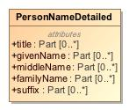

1. PersonNameDetailed

|  |  |
| --- | --- |
| **Name** | PersonNameDetailed |
| **Qualified Name** | CIMI Clinical::Data Structure::PersonNameDetailed |
| **Visibility** | public |
| **Abstract** | false |
| **Base Classifier** | * PersonName |
| **Realized Interface** |  |

### **Attribute Detail**

#### familyName

The person's surname (family name).

|  |  |
| --- | --- |
| **Type** | Part |
| **Default Value** |  |
| **Visibility** | public |
| **Multiplicity** | 0..* |

#### givenName

The person's given name - e.g., John

|  |  |
| --- | --- |
| **Type** | Part |
| **Default Value** |  |
| **Visibility** | public |
| **Multiplicity** | 0..* |

#### middleName

The person's middle name.

|  |  |
| --- | --- |
| **Type** | Part |
| **Default Value** |  |
| **Visibility** | public |
| **Multiplicity** | 0..* |

#### suffix

The suffix for the name.

|  |  |
| --- | --- |
| **Type** | Part |
| **Default Value** |  |
| **Visibility** | public |
| **Multiplicity** | 0..* |

#### title

The person's title - e.g., Dr, Mr, etc...

|  |  |
| --- | --- |
| **Type** | Part |
| **Default Value** |  |
| **Visibility** | public |
| **Multiplicity** | 0..* |

### **Relation Detail**

#### Generalization

|  |  |
| --- | --- |
| **Name** |  |
| **Related Element** | * PersonName |

## **Class** **PhysicalEvaluationResult**

Measurement resulting from a physical assessment procedure.

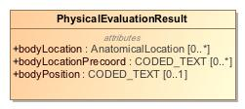

1. PhysicalEvaluationResult

|  |  |
| --- | --- |
| **Name** | PhysicalEvaluationResult |
| **Qualified Name** | CIMI Clinical::Data Structure::PhysicalEvaluationResult |
| **Visibility** | public |
| **Abstract** | false |
| **Base Classifier** | * EvaluationResult |
| **Realized Interface** |  |

### **Attribute Detail**

#### bodyLocation

Captures the post-coordinated location on the body where the characteristic was observed.

|  |  |
| --- | --- |
| **Type** | AnatomicalLocation |
| **Default Value** |  |
| **Visibility** | public |
| **Multiplicity** | 0..* |

#### bodyLocationPrecoord

Captures the pre-coordinated body location information, for example pre-coordinating body side left with body location hand to make left hand. .

|  |  |
| --- | --- |
| **Type** | CODED_TEXT |
| **Default Value** |  |
| **Visibility** | public |
| **Multiplicity** | 0..* |

#### bodyPosition

Captures the position of the body when an observation is done. E.g., supine, prone, etc...

|  |  |
| --- | --- |
| **Type** | CODED_TEXT |
| **Default Value** |  |
| **Visibility** | public |
| **Multiplicity** | 0..1 |

### **Relation Detail**

#### Generalization

|  |  |
| --- | --- |
| **Name** |  |
| **Related Element** | * EvaluationResult |

## **Class** **Plan**

Description of action that is planned to be performed. Typically, this would include a time at which the action is scheduled to be performed.

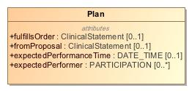

1. Plan

|  |  |
| --- | --- |
| **Name** | Plan |
| **Qualified Name** | CIMI Clinical::Data Structure::Plan |
| **Visibility** | public |
| **Abstract** | false |
| **Base Classifier** | * ActionContext |
| **Realized Interface** |  |

### **Attribute Detail**

#### expectedPerformanceTime

The time when the action is expected to be performed.

|  |  |
| --- | --- |
| **Type** | DATE_TIME |
| **Default Value** |  |
| **Visibility** | public |
| **Multiplicity** | 0..1 |

#### expectedPerformer

Persons who are expected to or intended to perform this action, e.g., the person who will perform the surgery.

|  |  |
| --- | --- |
| **Type** | PARTICIPATION |
| **Default Value** |  |
| **Visibility** | public |
| **Multiplicity** | 0..* |

#### fromProposal

The proposal that is partly or wholly fulfilled by the performance of this act.

|  |  |
| --- | --- |
| **Type** | ClinicalStatement |
| **Default Value** |  |
| **Visibility** | public |
| **Multiplicity** | 0..1 |

#### fulfillsOrder

The order that is partly or wholly enacted by the performance of this act.

|  |  |
| --- | --- |
| **Type** | ClinicalStatement |
| **Default Value** |  |
| **Visibility** | public |
| **Multiplicity** | 0..1 |

### **Relation Detail**

#### Generalization

|  |  |
| --- | --- |
| **Name** |  |
| **Related Element** | * ActionContext |

## **Class** **PresenceAbsenceContext**

-419274319.jpg

1. PresenceAbsenceContext

|  |  |
| --- | --- |
| **Name** | PresenceAbsenceContext |
| **Qualified Name** | CIMI Clinical::Data Structure::PresenceAbsenceContext |
| **Visibility** | public |
| **Abstract** | true |
| **Base Classifier** | * FindingContext |
| **Realized Interface** |  |

### **Relation Detail**

#### Generalization

|  |  |
| --- | --- |
| **Name** |  |
| **Related Element** | * FindingContext |

|  |  |
| --- | --- |
| **Name** |  |
| **Related Element** | * KnownOrSuspectedPresent |

|  |  |
| --- | --- |
| **Name** |  |
| **Related Element** | * Absent |

## **Class** **Procedure**

An action intended to treat, cure, or restore function or structure such as surgical and physical rehabilitation procedures.

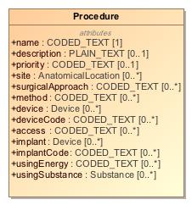

1. Procedure

|  |  |
| --- | --- |
| **Name** | Procedure |
| **Qualified Name** | CIMI Clinical::Data Structure::Procedure |
| **Visibility** | public |
| **Abstract** | false |
| **Base Classifier** | * Act |
| **Realized Interface** |  |

### **Attribute Detail**

#### access

The route used to access the site of a procedure. It is used to distinguish open, closed, and percutaneous procedures.

|  |  |
| --- | --- |
| **Type** | CODED_TEXT |
| **Default Value** |  |
| **Visibility** | public |
| **Multiplicity** | 0..* |

#### description

An account of the procedure in narrative form.

|  |  |
| --- | --- |
| **Type** | PLAIN_TEXT |
| **Default Value** |  |
| **Visibility** | public |
| **Multiplicity** | 0..1 |

#### device

Instrument, apparatus, appliance, software, material, or other article - whether used alone or in combination, associated with the performance of the procedure. For instance, an endoscope.  
  
Note that this differs from an implant which remains in the body after the procedure is performed.

|  |  |
| --- | --- |
| **Type** | Device |
| **Default Value** |  |
| **Visibility** | public |
| **Multiplicity** | 0..* |

#### deviceCode

Instrument, apparatus, appliance, software, material, or other article - whether used alone or in combination, associated with the performance of the procedure. For instance, an endoscope.  
  
Note that this differs from an implant which remains in the body after the procedure is performed.

|  |  |
| --- | --- |
| **Type** | CODED_TEXT |
| **Default Value** |  |
| **Visibility** | public |
| **Multiplicity** | 0..* |

#### findings

Records clinically significant observations confirmed or discovered during the procedure or surgery. For example, "Necrotic left ovarian cyst was discovered"

|  |  |
| --- | --- |
| **Type** | ClinicalStatement |
| **Default Value** |  |
| **Visibility** | public |
| **Multiplicity** | 0..* |

#### implant

Something placed in a person's body or on its surface during the procedure and remains postoperatively. E.g., stents, tubes, artificial joints, and drains.

|  |  |
| --- | --- |
| **Type** | Device |
| **Default Value** |  |
| **Visibility** | public |
| **Multiplicity** | 0..* |

#### implantCode

Concept representing something placed in a person's body or on its surface during the procedure and remains postoperatively. E.g., stents, tubes, artificial joints, and drains.

|  |  |
| --- | --- |
| **Type** | CODED_TEXT |
| **Default Value** |  |
| **Visibility** | public |
| **Multiplicity** | 0..* |

#### method

Technique or way of accomplishing the procedure. E.g., endoscopic, arthroscopic, etc...

|  |  |
| --- | --- |
| **Type** | CODED_TEXT |
| **Default Value** |  |
| **Visibility** | public |
| **Multiplicity** | 0..* |

#### name

Concept representing the type of procedure performed.

|  |  |
| --- | --- |
| **Type** | CODED_TEXT |
| **Default Value** |  |
| **Visibility** | public |
| **Multiplicity** | 1 |

#### priority

Priority assigned to a procedure.

|  |  |
| --- | --- |
| **Type** | CODED_TEXT |
| **Default Value** |  |
| **Visibility** | public |
| **Multiplicity** | 0..1 |

#### site

Anatomical location of the procedure.

|  |  |
| --- | --- |
| **Type** | AnatomicalLocation |
| **Default Value** |  |
| **Visibility** | public |
| **Multiplicity** | 0..* |

#### surgicalApproach

The technique used to reach the site of the procedure. Approaches may be through the skin or mucous membrane, through an orifice or external.

|  |  |
| --- | --- |
| **Type** | CODED_TEXT |
| **Default Value** |  |
| **Visibility** | public |
| **Multiplicity** | 0..* |

#### usingEnergy

The energy used to execute the procedure. E.g., gamma rays.

|  |  |
| --- | --- |
| **Type** | CODED_TEXT |
| **Default Value** |  |
| **Visibility** | public |
| **Multiplicity** | 0..* |

#### usingSubstance

Substance used to execute the action of a procedure. E.g., radiographic contrast media.

|  |  |
| --- | --- |
| **Type** | Substance |
| **Default Value** |  |
| **Visibility** | public |
| **Multiplicity** | 0..* |

### **Relation Detail**

#### Association

|  |  |
| --- | --- |
| **Name** |  |
| **Related Element** | * ClinicalStatement |

#### Generalization

|  |  |
| --- | --- |
| **Name** |  |
| **Related Element** | * LaboratoryProcedure |

|  |  |
| --- | --- |
| **Name** |  |
| **Related Element** | * Act |

## **Class** **ProductBatch**

Information about a group of medication produced or packaged from one production run.

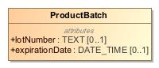

1. ProductBatch

|  |  |
| --- | --- |
| **Name** | ProductBatch |
| **Qualified Name** | CIMI Clinical::Data Structure::ProductBatch |
| **Visibility** | public |
| **Abstract** | false |
| **Base Classifier** | * CLUSTER |
| **Realized Interface** |  |

### **Attribute Detail**

#### expirationDate

When this specific batch of product will expire.

|  |  |
| --- | --- |
| **Type** | DATE_TIME |
| **Default Value** |  |
| **Visibility** | public |
| **Multiplicity** | 0..1 |

#### lotNumber

The assigned lot number of a batch of the specified product.

|  |  |
| --- | --- |
| **Type** | TEXT |
| **Default Value** |  |
| **Visibility** | public |
| **Multiplicity** | 0..1 |

### **Relation Detail**

#### Generalization

|  |  |
| --- | --- |
| **Name** |  |
| **Related Element** | * CLUSTER |

## **Class** **Proposal**

An offer or a suggestion to perform a healthcare act. A recommendation to a provider is an example of proposal made by a CDS system. A proposal must be accepted by an entity in order for it to be performed.

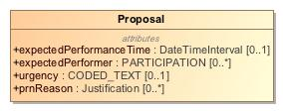

1. Proposal

|  |  |
| --- | --- |
| **Name** | Proposal |
| **Qualified Name** | CIMI Clinical::Data Structure::Proposal |
| **Visibility** | public |
| **Abstract** | false |
| **Base Classifier** | * ActionContext |
| **Realized Interface** |  |

### **Attribute Detail**

#### expectedPerformanceTime

The time when the proposed action is expected to be performed.

|  |  |
| --- | --- |
| **Type** | DateTimeInterval |
| **Default Value** |  |
| **Visibility** | public |
| **Multiplicity** | 0..1 |

#### expectedPerformer

Persons who are expected to or intended to perform this action, e.g., the person who will perform the surgery.

|  |  |
| --- | --- |
| **Type** | PARTICIPATION |
| **Default Value** |  |
| **Visibility** | public |
| **Multiplicity** | 0..* |

#### prnReason

Condition under which the ordered act should be performed. E.g.., shortness of breath, SpO2 less than x%, insomnia, nausea.

|  |  |
| --- | --- |
| **Type** | Justification |
| **Default Value** |  |
| **Visibility** | public |
| **Multiplicity** | 0..* |

#### urgency

How quickly the proposed act must be initiated. Includes concepts such as stat, urgent, routine.

|  |  |
| --- | --- |
| **Type** | CODED_TEXT |
| **Default Value** |  |
| **Visibility** | public |
| **Multiplicity** | 0..1 |

### **Relation Detail**

#### Generalization

|  |  |
| --- | --- |
| **Name** |  |
| **Related Element** | * ActionContext |

## **Class** **ProposalAgainst**

Concept represents a recommendation from a clinical decision support system or advice from a consultation to not perform an act.

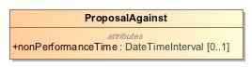

1. ProposalAgainst

|  |  |
| --- | --- |
| **Name** | ProposalAgainst |
| **Qualified Name** | CIMI Clinical::Data Structure::ProposalAgainst |
| **Visibility** | public |
| **Abstract** | false |
| **Base Classifier** | * ActionContext |
| **Realized Interface** |  |

### **Attribute Detail**

#### nonPerformanceTime

The time period during which the act should not be performed.

|  |  |
| --- | --- |
| **Type** | DateTimeInterval |
| **Default Value** |  |
| **Visibility** | public |
| **Multiplicity** | 0..1 |

### **Relation Detail**

#### Generalization

|  |  |
| --- | --- |
| **Name** |  |
| **Related Element** | * ActionContext |

## **Class** **Provenance**

The Provenance pattern supports the attachment of attribution information to one or more clinical statements and is not part of the clinical statements themselves.  
  
The attachment of provenance information to a clinical statement in this manner does not impact the versioning of the clinical statement target since attribution information is external to the statement.

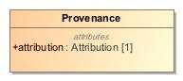

1. Provenance

|  |  |
| --- | --- |
| **Name** | Provenance |
| **Qualified Name** | CIMI Clinical::Data Structure::Provenance |
| **Visibility** | public |
| **Abstract** | false |
| **Base Classifier** | * CLUSTER |
| **Realized Interface** |  |

### **Attribute Detail**

#### attribution

The activity provenance details. Refer to the Attribution class.

|  |  |
| --- | --- |
| **Type** | Attribution |
| **Default Value** |  |
| **Visibility** | public |
| **Multiplicity** | 1 |

#### target

The clinical statement that were generated or updated by the activity described. A provenance can point to more than one target if multiple resources were created/updated by the same activity.

|  |  |
| --- | --- |
| **Type** | ClinicalStatement |
| **Default Value** |  |
| **Visibility** | public |
| **Multiplicity** | 1..* |

### **Relation Detail**

#### Association

|  |  |
| --- | --- |
| **Name** |  |
| **Related Element** | * ClinicalStatement |

#### Generalization

|  |  |
| --- | --- |
| **Name** |  |
| **Related Element** | * CLUSTER |

## **Class** **Qualification**

Education, training or special skills.

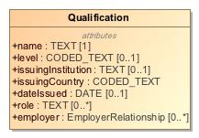

1. Qualification

|  |  |
| --- | --- |
| **Name** | Qualification |
| **Qualified Name** | CIMI Clinical::Data Structure::Qualification |
| **Visibility** | public |
| **Abstract** | false |
| **Base Classifier** | * CLUSTER |
| **Realized Interface** |  |

### **Attribute Detail**

#### dateIssued

The date the qualification was issued.

|  |  |
| --- | --- |
| **Type** | DATE |
| **Default Value** |  |
| **Visibility** | public |
| **Multiplicity** | 0..1 |

#### employer

A person's employing organization.

|  |  |
| --- | --- |
| **Type** | EmployerRelationship |
| **Default Value** |  |
| **Visibility** | public |
| **Multiplicity** | 0..* |

#### issuingCountry

The issuing country where the qualification is valid.

|  |  |
| --- | --- |
| **Type** | CODED_TEXT |
| **Default Value** |  |
| **Visibility** | public |
| **Multiplicity** |  |

#### issuingInstitution

The organization responsible for issuing the qualification.

|  |  |
| --- | --- |
| **Type** | TEXT |
| **Default Value** |  |
| **Visibility** | public |
| **Multiplicity** | 0..1 |

#### level

The level of the qualification

|  |  |
| --- | --- |
| **Type** | CODED_TEXT |
| **Default Value** |  |
| **Visibility** | public |
| **Multiplicity** | 0..1 |

#### name

The name of the qualification

|  |  |
| --- | --- |
| **Type** | TEXT |
| **Default Value** |  |
| **Visibility** | public |
| **Multiplicity** | 1 |

#### role

The roles where the qualification applies - e.g. registered nurse, physician

|  |  |
| --- | --- |
| **Type** | TEXT |
| **Default Value** |  |
| **Visibility** | public |
| **Multiplicity** | 0..* |

### **Relation Detail**

#### Generalization

|  |  |
| --- | --- |
| **Name** |  |
| **Related Element** | * CLUSTER |

## **Class** **QualitativeReferenceRange**

A qualitative reference range specified by a code - e.g., abnormal, severely abnormal.

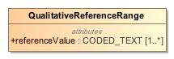

1. QualitativeReferenceRange

|  |  |
| --- | --- |
| **Name** | QualitativeReferenceRange |
| **Qualified Name** | CIMI Clinical::Data Structure::QualitativeReferenceRange |
| **Visibility** | public |
| **Abstract** | false |
| **Base Classifier** | * ReferenceRange |
| **Realized Interface** |  |

### **Attribute Detail**

#### referenceValue

Code representing the reference range.

|  |  |
| --- | --- |
| **Type** | CODED_TEXT |
| **Default Value** |  |
| **Visibility** | public |
| **Multiplicity** | 1..* |

### **Relation Detail**

#### Generalization

|  |  |
| --- | --- |
| **Name** |  |
| **Related Element** | * ReferenceRange |

## **Class** **QuantitativeReferenceRange**

A reference range specifying a quantity interval.

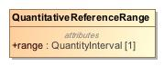

1. QuantitativeReferenceRange

|  |  |
| --- | --- |
| **Name** | QuantitativeReferenceRange |
| **Qualified Name** | CIMI Clinical::Data Structure::QuantitativeReferenceRange |
| **Visibility** | public |
| **Abstract** | false |
| **Base Classifier** | * ReferenceRange |
| **Realized Interface** |  |

### **Attribute Detail**

#### range

The specified reference range.

|  |  |
| --- | --- |
| **Type** | QuantityInterval |
| **Default Value** |  |
| **Visibility** | public |
| **Multiplicity** | 1 |

### **Relation Detail**

#### Generalization

|  |  |
| --- | --- |
| **Name** |  |
| **Related Element** | * ReferenceRange |

## **Class** **ReferenceRange**

A reference range for the specific instance after lookup from, say, a reference range table given specific criteria. Note that this reference range is not definitional in nature but rather refers to the reference range considered for the given observation for a subject.

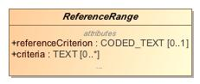

1. ReferenceRange

|  |  |
| --- | --- |
| **Name** | ReferenceRange |
| **Qualified Name** | CIMI Clinical::Data Structure::ReferenceRange |
| **Visibility** | public |
| **Abstract** | true |
| **Base Classifier** | * CLUSTER |
| **Realized Interface** |  |

### **Attribute Detail**

#### criteria

The specific criteria that apply for the given reference range. For instance, reference ranges may be specified in a lookup table based on a set of criteria. If a row in this table is selected as the applicable reference range for a measurement, 'criteria' lists the specific criteria for that row in the table. E.g., reference range for post-menopausal women.

|  |  |
| --- | --- |
| **Type** | TEXT |
| **Default Value** |  |
| **Visibility** | public |
| **Multiplicity** | 0..* |

#### narrative

|  |  |
| --- | --- |
| **Type** | TEXT |
| **Default Value** |  |
| **Visibility** | public |
| **Multiplicity** | 0..1 |

#### referenceCriterion

Indicates whether the given range is normal, critically high, ...

|  |  |
| --- | --- |
| **Type** | CODED_TEXT |
| **Default Value** |  |
| **Visibility** | public |
| **Multiplicity** | 0..1 |

### **Relation Detail**

#### Generalization

|  |  |
| --- | --- |
| **Name** |  |
| **Related Element** | * QuantitativeReferenceRange |

|  |  |
| --- | --- |
| **Name** |  |
| **Related Element** | * QualitativeReferenceRange |

|  |  |
| --- | --- |
| **Name** |  |
| **Related Element** | * CLUSTER |

## **Class** **Registration**

NEED DEFINITION

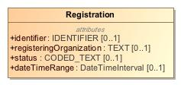

1. Registration

|  |  |
| --- | --- |
| **Name** | Registration |
| **Qualified Name** | CIMI Clinical::Data Structure::Registration |
| **Visibility** | public |
| **Abstract** | false |
| **Base Classifier** | * CLUSTER |
| **Realized Interface** |  |

### **Attribute Detail**

#### dateTimeRange

NEED DEFINITION

|  |  |
| --- | --- |
| **Type** | DateTimeInterval |
| **Default Value** |  |
| **Visibility** | public |
| **Multiplicity** | 0..1 |

#### identifier

NEED DEFINITION

|  |  |
| --- | --- |
| **Type** | IDENTIFIER |
| **Default Value** |  |
| **Visibility** | public |
| **Multiplicity** | 0..1 |

#### registeringOrganization

NEED DEFINITION

|  |  |
| --- | --- |
| **Type** | TEXT |
| **Default Value** |  |
| **Visibility** | public |
| **Multiplicity** | 0..1 |

#### status

NEED DEFINITION

|  |  |
| --- | --- |
| **Type** | CODED_TEXT |
| **Default Value** |  |
| **Visibility** | public |
| **Multiplicity** | 0..1 |

### **Relation Detail**

#### Generalization

|  |  |
| --- | --- |
| **Name** |  |
| **Related Element** | * CLUSTER |

## **Class** **Residency**

Type supporting the capture of residency information.

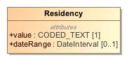

1. Residency

|  |  |
| --- | --- |
| **Name** | Residency |
| **Qualified Name** | CIMI Clinical::Data Structure::Residency |
| **Visibility** | public |
| **Abstract** | false |
| **Base Classifier** | * CLUSTER |
| **Realized Interface** |  |

### **Attribute Detail**

#### dateRange

Period when residency was in effect.

|  |  |
| --- | --- |
| **Type** | DateInterval |
| **Default Value** |  |
| **Visibility** | public |
| **Multiplicity** | 0..1 |

#### value

Residency code.

|  |  |
| --- | --- |
| **Type** | CODED_TEXT |
| **Default Value** |  |
| **Visibility** | public |
| **Multiplicity** | 1 |

### **Relation Detail**

#### Generalization

|  |  |
| --- | --- |
| **Name** |  |
| **Related Element** | * CLUSTER |

## **Class** **Risk**

Context for clinical risks.

-67184742.jpg

1. Risk

|  |  |
| --- | --- |
| **Name** | Risk |
| **Qualified Name** | CIMI Clinical::Data Structure::Risk |
| **Visibility** | public |
| **Abstract** | false |
| **Base Classifier** | * FindingContext |
| **Realized Interface** |  |

### **Relation Detail**

#### Generalization

|  |  |
| --- | --- |
| **Name** |  |
| **Related Element** | * FindingContext |

## **Class** **Signature**

A digital signature along with supporting context. The signature may be electronic/cryptographic in nature, or a graphical image representing a hand-written signature, or a signature process. Different Signature approaches have different utilities.

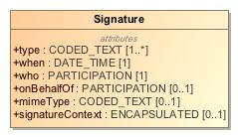

1. Signature

|  |  |
| --- | --- |
| **Name** | Signature |
| **Qualified Name** | CIMI Clinical::Data Structure::Signature |
| **Visibility** | public |
| **Abstract** | false |
| **Base Classifier** | * CLUSTER |
| **Realized Interface** |  |

### **Attribute Detail**

#### mimeType

A mime type that indicates the technical format of the signature. Important mime types are application/signature+xml for X ML DigSig, application/jwt for JWT, and image/* for a graphical image of a signature, etc.

|  |  |
| --- | --- |
| **Type** | CODED_TEXT |
| **Default Value** |  |
| **Visibility** | public |
| **Multiplicity** | 0..1 |

#### onBehalfOf

A reference to an application-usable description of the identity that is represented by the signature.

|  |  |
| --- | --- |
| **Type** | PARTICIPATION |
| **Default Value** |  |
| **Visibility** | public |
| **Multiplicity** | 0..1 |

#### signatureContext

The base64 encoding of the Signature content. When signature is not recorded electronically this element would be empty.

|  |  |
| --- | --- |
| **Type** | ENCAPSULATED |
| **Default Value** |  |
| **Visibility** | public |
| **Multiplicity** | 0..1 |

#### type

An indication of the reason that the entity signed this document. This may be explicitly included as part of the signature information and can be used when determining accountability for various actions concerning the document.

|  |  |
| --- | --- |
| **Type** | CODED_TEXT |
| **Default Value** |  |
| **Visibility** | public |
| **Multiplicity** | 1..* |

#### when

When the digital signature was signed.

|  |  |
| --- | --- |
| **Type** | DATE_TIME |
| **Default Value** |  |
| **Visibility** | public |
| **Multiplicity** | 1 |

#### who

A reference to an application-usable description of the identity that signed (e.g. the signature used their private key).

|  |  |
| --- | --- |
| **Type** | PARTICIPATION |
| **Default Value** |  |
| **Visibility** | public |
| **Multiplicity** | 1 |

### **Relation Detail**

#### Generalization

|  |  |
| --- | --- |
| **Name** |  |
| **Related Element** | * CLUSTER |

## **Class** **Specimen**

Sample for analysis

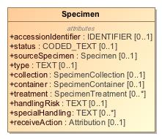

1. Specimen

|  |  |
| --- | --- |
| **Name** | Specimen |
| **Qualified Name** | CIMI Clinical::Data Structure::Specimen |
| **Visibility** | public |
| **Abstract** | false |
| **Base Classifier** | * MaterialEntity |
| **Realized Interface** |  |

### **Attribute Detail**

#### accessionIdentifier

Identifier assigned by the lab

|  |  |
| --- | --- |
| **Type** | IDENTIFIER |
| **Default Value** |  |
| **Visibility** | public |
| **Multiplicity** | 0..1 |

#### collection

Attribution information about the specimen collection activity.

|  |  |
| --- | --- |
| **Type** | SpecimenCollection |
| **Default Value** |  |
| **Visibility** | public |
| **Multiplicity** | 0..1 |

#### container

Information about the vessel holding the specimen.

|  |  |
| --- | --- |
| **Type** | SpecimenContainer |
| **Default Value** |  |
| **Visibility** | public |
| **Multiplicity** | 0..1 |

#### handlingRisk

Cautions on the handling of this specimen.

|  |  |
| --- | --- |
| **Type** | TEXT |
| **Default Value** |  |
| **Visibility** | public |
| **Multiplicity** | 0..1 |

#### receiveAction

Attribution information associated with receiving the specimen.

|  |  |
| --- | --- |
| **Type** | Attribution |
| **Default Value** |  |
| **Visibility** | public |
| **Multiplicity** | 0..1 |

#### sourceSpecimen

Identifier for the source specimen from which this specimen was derived.

|  |  |
| --- | --- |
| **Type** | Specimen |
| **Default Value** |  |
| **Visibility** | public |
| **Multiplicity** | 0..1 |

#### specialHandling

Information about the proper handling of the specimen.

|  |  |
| --- | --- |
| **Type** | TEXT |
| **Default Value** |  |
| **Visibility** | public |
| **Multiplicity** | 0..* |

#### status

Code indicating the status of the specimen. E.g., available, unavailable, unsatisfactory

|  |  |
| --- | --- |
| **Type** | CODED_TEXT |
| **Default Value** |  |
| **Visibility** | public |
| **Multiplicity** | 0..1 |

#### treatment

Treatment and processing step details

|  |  |
| --- | --- |
| **Type** | SpecimenTreatment |
| **Default Value** |  |
| **Visibility** | public |
| **Multiplicity** | 0..* |

#### type

Kind of material that forms the specimen

|  |  |
| --- | --- |
| **Type** | TEXT |
| **Default Value** |  |
| **Visibility** | public |
| **Multiplicity** | 0..1 |

### **Relation Detail**

#### Generalization

|  |  |
| --- | --- |
| **Name** |  |
| **Related Element** | * MaterialEntity |

## **Class** **SpecimenCollection**

Attribution specific to the collection of a specimen.

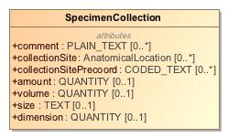

1. SpecimenCollection

|  |  |
| --- | --- |
| **Name** | SpecimenCollection |
| **Qualified Name** | CIMI Clinical::Data Structure::SpecimenCollection |
| **Visibility** | public |
| **Abstract** | false |
| **Base Classifier** | * Attribution |
| **Realized Interface** |  |

### **Attribute Detail**

#### amount

The quantity of specimen collected

|  |  |
| --- | --- |
| **Type** | QUANTITY |
| **Default Value** |  |
| **Visibility** | public |
| **Multiplicity** | 0..1 |

#### collectionSite

Anatomical collection site as a post-coordinated body site.

|  |  |
| --- | --- |
| **Type** | AnatomicalLocation |
| **Default Value** |  |
| **Visibility** | public |
| **Multiplicity** | 0..* |

#### collectionSitePrecoord

Anatomical collection site as a precoordinated code.

|  |  |
| --- | --- |
| **Type** | CODED_TEXT |
| **Default Value** |  |
| **Visibility** | public |
| **Multiplicity** | 0..* |

#### comment

Specimen collection notes.

|  |  |
| --- | --- |
| **Type** | PLAIN_TEXT |
| **Default Value** |  |
| **Visibility** | public |
| **Multiplicity** | 0..* |

#### dimension

The dimension of the collected specimen.

|  |  |
| --- | --- |
| **Type** | QUANTITY |
| **Default Value** |  |
| **Visibility** | public |
| **Multiplicity** | 0..1 |

#### size

The size of the collected specimen.

|  |  |
| --- | --- |
| **Type** | TEXT |
| **Default Value** |  |
| **Visibility** | public |
| **Multiplicity** | 0..1 |

#### volume

The volume of the collected specimen

|  |  |
| --- | --- |
| **Type** | QUANTITY |
| **Default Value** |  |
| **Visibility** | public |
| **Multiplicity** | 0..1 |

### **Relation Detail**

#### Generalization

|  |  |
| --- | --- |
| **Name** |  |
| **Related Element** | * Attribution |

## **Class** **SpecimenContainer**

Direct container of specimen (tube/slide, etc.)

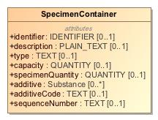

1. SpecimenContainer

|  |  |
| --- | --- |
| **Name** | SpecimenContainer |
| **Qualified Name** | CIMI Clinical::Data Structure::SpecimenContainer |
| **Visibility** | public |
| **Abstract** | false |
| **Base Classifier** | * CLUSTER |
| **Realized Interface** |  |

### **Attribute Detail**

#### additive

Additive associated with container.

|  |  |
| --- | --- |
| **Type** | Substance |
| **Default Value** |  |
| **Visibility** | public |
| **Multiplicity** | 0..* |

#### additiveCode

Additive associated with container.

|  |  |
| --- | --- |
| **Type** | TEXT |
| **Default Value** |  |
| **Visibility** | public |
| **Multiplicity** | 0..1 |

#### capacity

Container volume or size.

|  |  |
| --- | --- |
| **Type** | QUANTITY |
| **Default Value** |  |
| **Visibility** | public |
| **Multiplicity** | 0..1 |

#### description

Textual description of the container

|  |  |
| --- | --- |
| **Type** | PLAIN_TEXT |
| **Default Value** |  |
| **Visibility** | public |
| **Multiplicity** | 0..1 |

#### identifier

An identifier for the vessel containing the specimen.

|  |  |
| --- | --- |
| **Type** | IDENTIFIER |
| **Default Value** |  |
| **Visibility** | public |
| **Multiplicity** | 0..1 |

#### sequenceNumber

The sequence number for this specimen in a collection of specimens.

|  |  |
| --- | --- |
| **Type** | TEXT |
| **Default Value** |  |
| **Visibility** | public |
| **Multiplicity** | 0..1 |

#### specimenQuantity

Quantity of specimen within container.

|  |  |
| --- | --- |
| **Type** | QUANTITY |
| **Default Value** |  |
| **Visibility** | public |
| **Multiplicity** | 0..1 |

#### type

Kind of container holding the specimen - e.g. a vial or well.

|  |  |
| --- | --- |
| **Type** | TEXT |
| **Default Value** |  |
| **Visibility** | public |
| **Multiplicity** | 0..1 |

### **Relation Detail**

#### Generalization

|  |  |
| --- | --- |
| **Name** |  |
| **Related Element** | * CLUSTER |

## **Class** **SpecimenTreatment**

Treatment performed on the specimen.

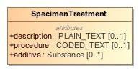

1. SpecimenTreatment

|  |  |
| --- | --- |
| **Name** | SpecimenTreatment |
| **Qualified Name** | CIMI Clinical::Data Structure::SpecimenTreatment |
| **Visibility** | public |
| **Abstract** | false |
| **Base Classifier** | * CLUSTER |
| **Realized Interface** |  |

### **Attribute Detail**

#### additive

|  |  |
| --- | --- |
| **Type** | Substance |
| **Default Value** |  |
| **Visibility** | public |
| **Multiplicity** | 0..* |

#### description

|  |  |
| --- | --- |
| **Type** | PLAIN_TEXT |
| **Default Value** |  |
| **Visibility** | public |
| **Multiplicity** | 0..1 |

#### procedure

|  |  |
| --- | --- |
| **Type** | CODED_TEXT |
| **Default Value** |  |
| **Visibility** | public |
| **Multiplicity** | 0..1 |

### **Relation Detail**

#### Generalization

|  |  |
| --- | --- |
| **Name** |  |
| **Related Element** | * CLUSTER |

## **Class** **StatementContext**

Compositional and reusable grouping of clinical statement attributes that provides the context for the topic of a clinical statement. The StatementContext class aligns with the SNOMED CT Situations with Explicit Context. The StatementContext provides the expressivity required to specify that an act was performed or not performed or that a finding was asserted to be present or absent for the given subject of information. It also often holds provenance information relevant to the context of the clinical statement. It is important to note that by default the context applies to the conjunction of the attribute specified in the statement. For instance, if a clinical statement has a topic describing a rash on left arm and a context of 'absent', then the statement states that the subject of interest did not have a rash on the left arm but might have had one on the right arm.

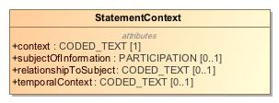

1. StatementContext

|  |  |
| --- | --- |
| **Name** | StatementContext |
| **Qualified Name** | CIMI Clinical::Data Structure::StatementContext |
| **Visibility** | public |
| **Abstract** | false |
| **Base Classifier** | * VIRTUAL_CLUSTER |
| **Realized Interface** |  |

### **Attribute Detail**

#### context

The ontological status of the statement, e.g., whether it exists, does not exist, is planned, etc. Attribute aligns with the SNOMED CT Situation with Explicit Context (SWEC) Concept Model context attributes: 'Finding context (attribute)' (SCTID: 408729009) and 'Procedure context (attribute)' (SCTID: 408730004).   
  
The range allowed for this attribute shall be consistent with the SNOMED CT concept model specification for SWEC.

|  |  |
| --- | --- |
| **Type** | CODED_TEXT |
| **Default Value** |  |
| **Visibility** | public |
| **Multiplicity** | 1 |

#### relationshipToSubject

Indicates the statement's subject relationship to the subject of record. For instance, the statement maybe about the subject of record in which case the relationship is self or the subject of the statement may be a relative to the subject of record such as is the case with family history statements.

|  |  |
| --- | --- |
| **Type** | CODED_TEXT |
| **Default Value** |  |
| **Visibility** | public |
| **Multiplicity** | 0..1 |

#### subjectOfInformation

The entity being described by this statement. The entity may be animate (a patient, a relative of the patient, a veterinary patient, a cohort) or inanimate (a well, a geographical location). The subject of information is constrained in archetypes.   
  
This attribute aligns with the SNOMED CT Situation with Explicit Context (SWEC) and is bound to the SNOMED attribute: 'Subject relationship context (attribute)' (SCTID: 408732007).

|  |  |
| --- | --- |
| **Type** | PARTICIPATION |
| **Default Value** |  |
| **Visibility** | public |
| **Multiplicity** | 0..1 |

#### temporalContext

Whether the topic is prospective or retrospective. E.g., action occurred in the past. This attribute is aligned with the SNOMED Situation With Explicit Context temporal context attribute.

|  |  |
| --- | --- |
| **Type** | CODED_TEXT |
| **Default Value** |  |
| **Visibility** | public |
| **Multiplicity** | 0..1 |

### **Relation Detail**

#### Generalization

|  |  |
| --- | --- |
| **Name** |  |
| **Related Element** | * FindingContext |

|  |  |
| --- | --- |
| **Name** |  |
| **Related Element** | * VIRTUAL_CLUSTER |

|  |  |
| --- | --- |
| **Name** |  |
| **Related Element** | * ActionContext |

## **Class** **StatementTopic**

Compositional and reusable grouping of clinical statement attributes that make up the clinical focus of the statement. StatementTopic class attributes are aligned with SNOMED CT Concept Model attributes when such an overlap exists. Note that this class does not include contextual attributes such as the nature of the action (ordered, proposed, planned, etc...), the nature of the patient state being described (e.g., present, suspected present, absent), and the provenance of this information (the who, when, where, how, why of the information recorded).

-1315570727.jpg

1. StatementTopic

|  |  |
| --- | --- |
| **Name** | StatementTopic |
| **Qualified Name** | CIMI Clinical::Data Structure::StatementTopic |
| **Visibility** | public |
| **Abstract** | true |
| **Base Classifier** | * VIRTUAL_CLUSTER |
| **Realized Interface** |  |

### **Relation Detail**

#### Generalization

|  |  |
| --- | --- |
| **Name** |  |
| **Related Element** | * Finding |

|  |  |
| --- | --- |
| **Name** |  |
| **Related Element** | * Act |

|  |  |
| --- | --- |
| **Name** |  |
| **Related Element** | * VIRTUAL_CLUSTER |

## **Class** **Street**

The name of a street.

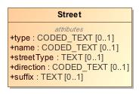

1. Street

|  |  |
| --- | --- |
| **Name** | Street |
| **Qualified Name** | CIMI Clinical::Data Structure::Street |
| **Visibility** | public |
| **Abstract** | false |
| **Base Classifier** | * CLUSTER |
| **Realized Interface** |  |

### **Attribute Detail**

#### direction

Direction code such as N, S, W, NE, etc...

|  |  |
| --- | --- |
| **Type** | CODED_TEXT |
| **Default Value** |  |
| **Visibility** | public |
| **Multiplicity** | 0..1 |

#### name

Name of the street from a list of names maintained by an organization such as the US Postal Service.

|  |  |
| --- | --- |
| **Type** | CODED_TEXT |
| **Default Value** |  |
| **Visibility** | public |
| **Multiplicity** | 0..1 |

#### streetType

The type of street - Court, Lane, Street, Road, Circle, etc...

|  |  |
| --- | --- |
| **Type** | TEXT |
| **Default Value** |  |
| **Visibility** | public |
| **Multiplicity** | 0..1 |

#### suffix

Term used to qualify the street name suitable for directional references.

|  |  |
| --- | --- |
| **Type** | TEXT |
| **Default Value** |  |
| **Visibility** | public |
| **Multiplicity** | 0..1 |

#### type

NEED DEFINITION  
  
How does this differ from streetType?

|  |  |
| --- | --- |
| **Type** | CODED_TEXT |
| **Default Value** |  |
| **Visibility** | public |
| **Multiplicity** | 0..1 |

### **Relation Detail**

#### Generalization

|  |  |
| --- | --- |
| **Name** |  |
| **Related Element** | * CLUSTER |

## **Class** **StreetNumber**

The number of a residence in a street.

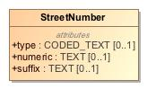

1. StreetNumber

|  |  |
| --- | --- |
| **Name** | StreetNumber |
| **Qualified Name** | CIMI Clinical::Data Structure::StreetNumber |
| **Visibility** | public |
| **Abstract** | false |
| **Base Classifier** | * CLUSTER |
| **Realized Interface** |  |

### **Attribute Detail**

#### numeric

The street number.

|  |  |
| --- | --- |
| **Type** | TEXT |
| **Default Value** |  |
| **Visibility** | public |
| **Multiplicity** | 0..1 |

#### suffix

NEED DEFINITION

|  |  |
| --- | --- |
| **Type** | TEXT |
| **Default Value** |  |
| **Visibility** | public |
| **Multiplicity** | 0..1 |

#### type

Type of street number.  
  
NEED DEFINITION AND EXAMPLES

|  |  |
| --- | --- |
| **Type** | CODED_TEXT |
| **Default Value** |  |
| **Visibility** | public |
| **Multiplicity** | 0..1 |

### **Relation Detail**

#### Generalization

|  |  |
| --- | --- |
| **Name** |  |
| **Related Element** | * CLUSTER |

## **Class** **Substance**

A homogeneous material with a definite composition.

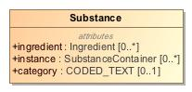

1. Substance

|  |  |
| --- | --- |
| **Name** | Substance |
| **Qualified Name** | CIMI Clinical::Data Structure::Substance |
| **Visibility** | public |
| **Abstract** | false |
| **Base Classifier** | * MaterialEntity |
| **Realized Interface** |  |

### **Attribute Detail**

#### category

A code that classifies the general type of substance. This is used for searching, sorting and display purposes.

|  |  |
| --- | --- |
| **Type** | CODED_TEXT |
| **Default Value** |  |
| **Visibility** | public |
| **Multiplicity** | 0..1 |

#### ingredient

A substance can be composed of other substances.

|  |  |
| --- | --- |
| **Type** | Ingredient |
| **Default Value** |  |
| **Visibility** | public |
| **Multiplicity** | 0..* |

#### instance

Substance may be used to describe a kind of substance, or a specific package/container of the substance: an instance.

|  |  |
| --- | --- |
| **Type** | SubstanceContainer |
| **Default Value** |  |
| **Visibility** | public |
| **Multiplicity** | 0..* |

### **Relation Detail**

#### Generalization

|  |  |
| --- | --- |
| **Name** |  |
| **Related Element** | * MaterialEntity |

## **Class** **SubstanceContainer**

A specific package/container of the substance.

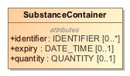

1. SubstanceContainer

|  |  |
| --- | --- |
| **Name** | SubstanceContainer |
| **Qualified Name** | CIMI Clinical::Data Structure::SubstanceContainer |
| **Visibility** | public |
| **Abstract** | false |
| **Base Classifier** | * UnitOfDistribution |
| **Realized Interface** |  |

### **Attribute Detail**

#### expiry

When no longer valid to use.

|  |  |
| --- | --- |
| **Type** | DATE_TIME |
| **Default Value** |  |
| **Visibility** | public |
| **Multiplicity** | 0..1 |

#### identifier

Identifier of the package/container

|  |  |
| --- | --- |
| **Type** | IDENTIFIER |
| **Default Value** |  |
| **Visibility** | public |
| **Multiplicity** | 0..* |

#### quantity

Amount of substance in the package.

|  |  |
| --- | --- |
| **Type** | QUANTITY |
| **Default Value** |  |
| **Visibility** | public |
| **Multiplicity** | 0..1 |

### **Relation Detail**

#### Generalization

|  |  |
| --- | --- |
| **Name** |  |
| **Related Element** | * UnitOfDistribution |

## **Class** **Tunneling**

whether tunneling is present

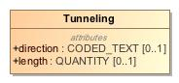

1. Tunneling

|  |  |
| --- | --- |
| **Name** | Tunneling |
| **Qualified Name** | CIMI Clinical::Data Structure::Tunneling |
| **Visibility** | public |
| **Abstract** | false |
| **Base Classifier** | * CLUSTER |
| **Realized Interface** |  |

### **Attribute Detail**

#### direction

direction from center of wound to tunneling, expressed as the clock number if the 12 position were at the cranial, superior, or proximal position of the wound

|  |  |
| --- | --- |
| **Type** | CODED_TEXT |
| **Default Value** |  |
| **Visibility** | public |
| **Multiplicity** | 0..1 |

#### length

distance from the wound edge to the farthest extent of the tunneling

|  |  |
| --- | --- |
| **Type** | QUANTITY |
| **Default Value** |  |
| **Visibility** | public |
| **Multiplicity** | 0..1 |

### **Relation Detail**

#### Generalization

|  |  |
| --- | --- |
| **Name** |  |
| **Related Element** | * CLUSTER |

## **Class** **Undermining**

whether undermining is present

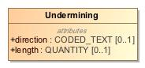

1. Undermining

|  |  |
| --- | --- |
| **Name** | Undermining |
| **Qualified Name** | CIMI Clinical::Data Structure::Undermining |
| **Visibility** | public |
| **Abstract** | false |
| **Base Classifier** | * CLUSTER |
| **Realized Interface** |  |

### **Attribute Detail**

#### direction

direction from center of wound to undermining, expressed as the clock number if the 12 position were at the cranial, superior, or proximal position of the wound

|  |  |
| --- | --- |
| **Type** | CODED_TEXT |
| **Default Value** |  |
| **Visibility** | public |
| **Multiplicity** | 0..1 |

#### length

distance from the wound edge to the farthest extent of the undermining

|  |  |
| --- | --- |
| **Type** | QUANTITY |
| **Default Value** |  |
| **Visibility** | public |
| **Multiplicity** | 0..1 |

### **Relation Detail**

#### Generalization

|  |  |
| --- | --- |
| **Name** |  |
| **Related Element** | * CLUSTER |

## **Class** **UnitOfDistribution**

Abstract class representing a substance container or package.

-843691960.jpg

1. UnitOfDistribution

|  |  |
| --- | --- |
| **Name** | UnitOfDistribution |
| **Qualified Name** | CIMI Clinical::Data Structure::UnitOfDistribution |
| **Visibility** | public |
| **Abstract** | true |
| **Base Classifier** | * CLUSTER |
| **Realized Interface** |  |

### **Relation Detail**

#### Generalization

|  |  |
| --- | --- |
| **Name** |  |
| **Related Element** | * SubstanceContainer |

|  |  |
| --- | --- |
| **Name** |  |
| **Related Element** | * MedicationPackage |

|  |  |
| --- | --- |
| **Name** |  |
| **Related Element** | * CLUSTER |

## **Class** **Use**

Structure capturing usage preferences for, say, a name, an address, or contact information.

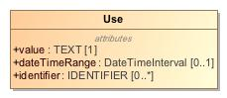

1. Use

|  |  |
| --- | --- |
| **Name** | Use |
| **Qualified Name** | CIMI Clinical::Data Structure::Use |
| **Visibility** | public |
| **Abstract** | false |
| **Base Classifier** | * CLUSTER |
| **Realized Interface** |  |

### **Attribute Detail**

#### dateTimeRange

Period when the use is in effect.

|  |  |
| --- | --- |
| **Type** | DateTimeInterval |
| **Default Value** |  |
| **Visibility** | public |
| **Multiplicity** | 0..1 |

#### identifier

An identifier for the use.

|  |  |
| --- | --- |
| **Type** | IDENTIFIER |
| **Default Value** |  |
| **Visibility** | public |
| **Multiplicity** | 0..* |

#### value

A code for the use.

|  |  |
| --- | --- |
| **Type** | TEXT |
| **Default Value** |  |
| **Visibility** | public |
| **Multiplicity** | 1 |

### **Relation Detail**

#### Generalization

|  |  |
| --- | --- |
| **Name** |  |
| **Related Element** | * CLUSTER |

## **Class** **WoundAssertion**

An assertion of a wound.

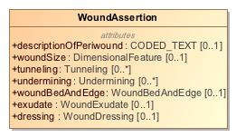

1. WoundAssertion

|  |  |
| --- | --- |
| **Name** | WoundAssertion |
| **Qualified Name** | CIMI Clinical::Data Structure::WoundAssertion |
| **Visibility** | public |
| **Abstract** | false |
| **Base Classifier** | * Assertion |
| **Realized Interface** |  |

### **Attribute Detail**

#### descriptionOfPeriwound

A description of the skin around the wound (periwound). (LOINC)

|  |  |
| --- | --- |
| **Type** | CODED_TEXT |
| **Default Value** |  |
| **Visibility** | public |
| **Multiplicity** | 0..1 |

#### dressing

|  |  |
| --- | --- |
| **Type** | WoundDressing |
| **Default Value** |  |
| **Visibility** | public |
| **Multiplicity** | 0..1 |

#### exudate

|  |  |
| --- | --- |
| **Type** | WoundExudate |
| **Default Value** |  |
| **Visibility** | public |
| **Multiplicity** | 0..1 |

#### tunneling

|  |  |
| --- | --- |
| **Type** | Tunneling |
| **Default Value** |  |
| **Visibility** | public |
| **Multiplicity** | 0..* |

#### undermining

|  |  |
| --- | --- |
| **Type** | Undermining |
| **Default Value** |  |
| **Visibility** | public |
| **Multiplicity** | 0..* |

#### woundBedAndEdge

|  |  |
| --- | --- |
| **Type** | WoundBedAndEdge |
| **Default Value** |  |
| **Visibility** | public |
| **Multiplicity** | 0..1 |

#### woundSize

|  |  |
| --- | --- |
| **Type** | DimensionalFeature |
| **Default Value** |  |
| **Visibility** | public |
| **Multiplicity** | 0..1 |

### **Relation Detail**

#### Generalization

|  |  |
| --- | --- |
| **Name** |  |
| **Related Element** | * Assertion |

## **Class** **WoundBedAndEdge**

Characteristics of the wound's base and its edge.

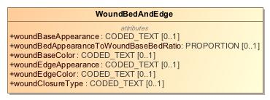

1. WoundBedAndEdge

|  |  |
| --- | --- |
| **Name** | WoundBedAndEdge |
| **Qualified Name** | CIMI Clinical::Data Structure::WoundBedAndEdge |
| **Visibility** | public |
| **Abstract** | false |
| **Base Classifier** | * CLUSTER |
| **Realized Interface** |  |

### **Attribute Detail**

#### woundBaseAppearance

LOINC: "Described as necrotic, sloughing, fibrinous, granulated, intact, approximated, etc. The wound bed appearance may or may not be differentiated from the wound edge, especially if the wound is healing well." Need to rewrite, e.g., "physiological state of wound surface tissue as evaluated by visual inspection"

|  |  |
| --- | --- |
| **Type** | CODED_TEXT |
| **Default Value** |  |
| **Visibility** | public |
| **Multiplicity** | 0..1 |

#### woundBaseColor

The color of the base of the wound.

|  |  |
| --- | --- |
| **Type** | CODED_TEXT |
| **Default Value** |  |
| **Visibility** | public |
| **Multiplicity** | 0..1 |

#### woundBedAppearanceToWoundBaseBedRatio

the area of identified wound bed appearance (necrotic, sloughing, etc.; see LOINC 72371-8) compared to the total area of the wound bed. For example, 40% of the wound bed is necrotic. Results can either be subjective or measured.

|  |  |
| --- | --- |
| **Type** | PROPORTION |
| **Default Value** |  |
| **Visibility** | public |
| **Multiplicity** | 0..1 |

#### woundClosureType

Description of the wound closure.

|  |  |
| --- | --- |
| **Type** | CODED_TEXT |
| **Default Value** |  |
| **Visibility** | public |
| **Multiplicity** | 0..1 |

#### woundEdgeAppearance

The appearance of the edge of a wound.

|  |  |
| --- | --- |
| **Type** | CODED_TEXT |
| **Default Value** |  |
| **Visibility** | public |
| **Multiplicity** | 0..1 |

#### woundEdgeColor

The color of the edge of the wound when different than the bed.

|  |  |
| --- | --- |
| **Type** | CODED_TEXT |
| **Default Value** |  |
| **Visibility** | public |
| **Multiplicity** | 0..1 |

### **Relation Detail**

#### Generalization

|  |  |
| --- | --- |
| **Name** |  |
| **Related Element** | * CLUSTER |

## **Class** **WoundDressing**

Description of the dressing on a wound.

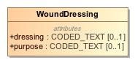

1. WoundDressing

|  |  |
| --- | --- |
| **Name** | WoundDressing |
| **Qualified Name** | CIMI Clinical::Data Structure::WoundDressing |
| **Visibility** | public |
| **Abstract** | false |
| **Base Classifier** | * CLUSTER |
| **Realized Interface** |  |

### **Attribute Detail**

#### dressing

The type of dressing used.

|  |  |
| --- | --- |
| **Type** | CODED_TEXT |
| **Default Value** |  |
| **Visibility** | public |
| **Multiplicity** | 0..1 |

#### purpose

The purpose of the dressing.

|  |  |
| --- | --- |
| **Type** | CODED_TEXT |
| **Default Value** |  |
| **Visibility** | public |
| **Multiplicity** | 0..1 |

### **Relation Detail**

#### Generalization

|  |  |
| --- | --- |
| **Name** |  |
| **Related Element** | * CLUSTER |

## **Class** **WoundExudate**

Description of the exudate from a wound.

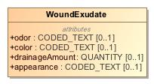

1. WoundExudate

|  |  |
| --- | --- |
| **Name** | WoundExudate |
| **Qualified Name** | CIMI Clinical::Data Structure::WoundExudate |
| **Visibility** | public |
| **Abstract** | false |
| **Base Classifier** | * CLUSTER |
| **Realized Interface** |  |

### **Attribute Detail**

#### appearance

|  |  |
| --- | --- |
| **Type** | CODED_TEXT |
| **Default Value** |  |
| **Visibility** | public |
| **Multiplicity** | 0..1 |

#### color

|  |  |
| --- | --- |
| **Type** | CODED_TEXT |
| **Default Value** |  |
| **Visibility** | public |
| **Multiplicity** | 0..1 |

#### drainageAmount

|  |  |
| --- | --- |
| **Type** | QUANTITY |
| **Default Value** |  |
| **Visibility** | public |
| **Multiplicity** | 0..1 |

#### odor

|  |  |
| --- | --- |
| **Type** | CODED_TEXT |
| **Default Value** |  |
| **Visibility** | public |
| **Multiplicity** | 0..1 |

### **Relation Detail**

#### Generalization

|  |  |
| --- | --- |
| **Name** |  |
| **Related Element** | * CLUSTER |

# **Package CIMI Clinical::Participation**

|  |  |
| --- | --- |
| **Name** | Participation |
| **Qualified Name** | CIMI Clinical::Participation |

## **Class** **SubjectOfInformation**

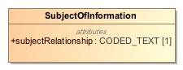

1. SubjectOfInformation

|  |  |
| --- | --- |
| **Name** | SubjectOfInformation |
| **Qualified Name** | CIMI Clinical::Participation::SubjectOfInformation |
| **Visibility** | public |
| **Abstract** | false |
| **Base Classifier** | * PARTICIPATION |
| **Realized Interface** |  |

### **Attribute Detail**

#### subjectRelationship

|  |  |
| --- | --- |
| **Type** | CODED_TEXT |
| **Default Value** |  |
| **Visibility** | public |
| **Multiplicity** | 1 |

### **Relation Detail**

#### Generalization

|  |  |
| --- | --- |
| **Name** |  |
| **Related Element** | * PARTICIPATION |

# **Package CIMI Clinical::Party**

|  |  |
| --- | --- |
| **Name** | Party |
| **Qualified Name** | CIMI Clinical::Party |

## **Class** **BaseActor**

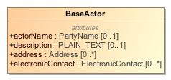

1. BaseActor

|  |  |
| --- | --- |
| **Name** | BaseActor |
| **Qualified Name** | CIMI Clinical::Party::BaseActor |
| **Visibility** | public |
| **Abstract** | false |
| **Base Classifier** | * ACTOR |
| **Realized Interface** |  |

### **Attribute Detail**

#### actorName

|  |  |
| --- | --- |
| **Type** | PartyName |
| **Default Value** |  |
| **Visibility** | public |
| **Multiplicity** | 0..1 |

#### address

|  |  |
| --- | --- |
| **Type** | Address |
| **Default Value** |  |
| **Visibility** | public |
| **Multiplicity** | 0..* |

#### description

|  |  |
| --- | --- |
| **Type** | PLAIN_TEXT |
| **Default Value** |  |
| **Visibility** | public |
| **Multiplicity** | 0..1 |

#### electronicContact

|  |  |
| --- | --- |
| **Type** | ElectronicContact |
| **Default Value** |  |
| **Visibility** | public |
| **Multiplicity** | 0..* |

### **Relation Detail**

#### Generalization

|  |  |
| --- | --- |
| **Name** |  |
| **Related Element** | * ACTOR |

|  |  |
| --- | --- |
| **Name** |  |
| **Related Element** | * Organization |

|  |  |
| --- | --- |
| **Name** |  |
| **Related Element** | * Person |

## **Class** **BaseRole**

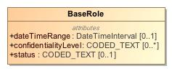

1. BaseRole

|  |  |
| --- | --- |
| **Name** | BaseRole |
| **Qualified Name** | CIMI Clinical::Party::BaseRole |
| **Visibility** | public |
| **Abstract** | false |
| **Base Classifier** | * ROLE |
| **Realized Interface** |  |

### **Attribute Detail**

#### confidentialityLevel

|  |  |
| --- | --- |
| **Type** | CODED_TEXT |
| **Default Value** |  |
| **Visibility** | public |
| **Multiplicity** | 0..* |

#### dateTimeRange

|  |  |
| --- | --- |
| **Type** | DateTimeInterval |
| **Default Value** |  |
| **Visibility** | public |
| **Multiplicity** | 0..1 |

#### status

|  |  |
| --- | --- |
| **Type** | CODED_TEXT |
| **Default Value** |  |
| **Visibility** | public |
| **Multiplicity** | 0..1 |

### **Relation Detail**

#### Generalization

|  |  |
| --- | --- |
| **Name** |  |
| **Related Element** | * HealthCareProviderRole |

|  |  |
| --- | --- |
| **Name** |  |
| **Related Element** | * ROLE |

|  |  |
| --- | --- |
| **Name** |  |
| **Related Element** | * HealthCareConsumerRole |

## **Class** **HealthCareConsumerRole**

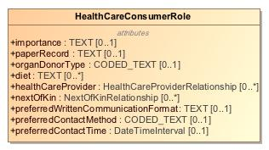

1. HealthCareConsumerRole

|  |  |
| --- | --- |
| **Name** | HealthCareConsumerRole |
| **Qualified Name** | CIMI Clinical::Party::HealthCareConsumerRole |
| **Visibility** | public |
| **Abstract** | false |
| **Base Classifier** | * BaseRole |
| **Realized Interface** |  |

### **Attribute Detail**

#### diet

|  |  |
| --- | --- |
| **Type** | TEXT |
| **Default Value** |  |
| **Visibility** | public |
| **Multiplicity** | 0..* |

#### healthCareProvider

|  |  |
| --- | --- |
| **Type** | HealthCareProviderRelationship |
| **Default Value** |  |
| **Visibility** | public |
| **Multiplicity** | 0..* |

#### importance

|  |  |
| --- | --- |
| **Type** | TEXT |
| **Default Value** |  |
| **Visibility** | public |
| **Multiplicity** | 0..1 |

#### nextOfKin

|  |  |
| --- | --- |
| **Type** | NextOfKinRelationship |
| **Default Value** |  |
| **Visibility** | public |
| **Multiplicity** | 0..* |

#### organDonorType

|  |  |
| --- | --- |
| **Type** | CODED_TEXT |
| **Default Value** |  |
| **Visibility** | public |
| **Multiplicity** | 0..1 |

#### paperRecord

|  |  |
| --- | --- |
| **Type** | TEXT |
| **Default Value** |  |
| **Visibility** | public |
| **Multiplicity** | 0..1 |

#### preferredContactMethod

|  |  |
| --- | --- |
| **Type** | CODED_TEXT |
| **Default Value** |  |
| **Visibility** | public |
| **Multiplicity** | 0..1 |

#### preferredContactTime

|  |  |
| --- | --- |
| **Type** | DateTimeInterval |
| **Default Value** |  |
| **Visibility** | public |
| **Multiplicity** | 0..1 |

#### preferredWrittenCommunicationFormat

|  |  |
| --- | --- |
| **Type** | TEXT |
| **Default Value** |  |
| **Visibility** | public |
| **Multiplicity** | 0..1 |

### **Relation Detail**

#### Generalization

|  |  |
| --- | --- |
| **Name** |  |
| **Related Element** | * BaseRole |

## **Class** **HealthCareProviderIndividualRole**

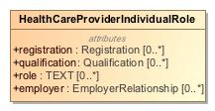

1. HealthCareProviderIndividualRole

|  |  |
| --- | --- |
| **Name** | HealthCareProviderIndividualRole |
| **Qualified Name** | CIMI Clinical::Party::HealthCareProviderIndividualRole |
| **Visibility** | public |
| **Abstract** | false |
| **Base Classifier** | * HealthCareProviderRole |
| **Realized Interface** |  |

### **Attribute Detail**

#### employer

|  |  |
| --- | --- |
| **Type** | EmployerRelationship |
| **Default Value** |  |
| **Visibility** | public |
| **Multiplicity** | 0..* |

#### qualification

|  |  |
| --- | --- |
| **Type** | Qualification |
| **Default Value** |  |
| **Visibility** | public |
| **Multiplicity** | 0..* |

#### registration

|  |  |
| --- | --- |
| **Type** | Registration |
| **Default Value** |  |
| **Visibility** | public |
| **Multiplicity** | 0..* |

#### role

|  |  |
| --- | --- |
| **Type** | TEXT |
| **Default Value** |  |
| **Visibility** | public |
| **Multiplicity** | 0..* |

### **Relation Detail**

#### Generalization

|  |  |
| --- | --- |
| **Name** |  |
| **Related Element** | * HealthCareProviderRole |

## **Class** **HealthCareProviderOrganizationRole**

-365779988.jpg

1. HealthCareProviderOrganizationRole

|  |  |
| --- | --- |
| **Name** | HealthCareProviderOrganizationRole |
| **Qualified Name** | CIMI Clinical::Party::HealthCareProviderOrganizationRole |
| **Visibility** | public |
| **Abstract** | false |
| **Base Classifier** | * HealthCareProviderRole |
| **Realized Interface** |  |

### **Relation Detail**

#### Generalization

|  |  |
| --- | --- |
| **Name** |  |
| **Related Element** | * HealthCareProviderRole |

## **Class** **HealthCareProviderRole**

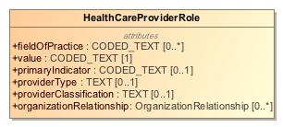

1. HealthCareProviderRole

|  |  |
| --- | --- |
| **Name** | HealthCareProviderRole |
| **Qualified Name** | CIMI Clinical::Party::HealthCareProviderRole |
| **Visibility** | public |
| **Abstract** | false |
| **Base Classifier** | * BaseRole |
| **Realized Interface** |  |

### **Attribute Detail**

#### fieldOfPractice

|  |  |
| --- | --- |
| **Type** | CODED_TEXT |
| **Default Value** |  |
| **Visibility** | public |
| **Multiplicity** | 0..* |

#### organizationRelationship

|  |  |
| --- | --- |
| **Type** | OrganizationRelationship |
| **Default Value** |  |
| **Visibility** | public |
| **Multiplicity** | 0..* |

#### primaryIndicator

|  |  |
| --- | --- |
| **Type** | CODED_TEXT |
| **Default Value** |  |
| **Visibility** | public |
| **Multiplicity** | 0..1 |

#### providerClassification

|  |  |
| --- | --- |
| **Type** | TEXT |
| **Default Value** |  |
| **Visibility** | public |
| **Multiplicity** | 0..1 |

#### providerType

|  |  |
| --- | --- |
| **Type** | TEXT |
| **Default Value** |  |
| **Visibility** | public |
| **Multiplicity** | 0..1 |

#### value

|  |  |
| --- | --- |
| **Type** | CODED_TEXT |
| **Default Value** |  |
| **Visibility** | public |
| **Multiplicity** | 1 |

### **Relation Detail**

#### Generalization

|  |  |
| --- | --- |
| **Name** |  |
| **Related Element** | * BaseRole |

|  |  |
| --- | --- |
| **Name** |  |
| **Related Element** | * HealthCareProviderOrganizationRole |

|  |  |
| --- | --- |
| **Name** |  |
| **Related Element** | * HealthCareProviderIndividualRole |

## **Class** **Organization**

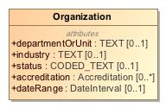

1. Organization

|  |  |
| --- | --- |
| **Name** | Organization |
| **Qualified Name** | CIMI Clinical::Party::Organization |
| **Visibility** | public |
| **Abstract** | false |
| **Base Classifier** | * BaseActor |
| **Realized Interface** |  |

### **Attribute Detail**

#### accreditation

|  |  |
| --- | --- |
| **Type** | Accreditation |
| **Default Value** |  |
| **Visibility** | public |
| **Multiplicity** | 0..* |

#### dateRange

|  |  |
| --- | --- |
| **Type** | DateInterval |
| **Default Value** |  |
| **Visibility** | public |
| **Multiplicity** | 0..1 |

#### departmentOrUnit

|  |  |
| --- | --- |
| **Type** | TEXT |
| **Default Value** |  |
| **Visibility** | public |
| **Multiplicity** | 0..1 |

#### industry

|  |  |
| --- | --- |
| **Type** | TEXT |
| **Default Value** |  |
| **Visibility** | public |
| **Multiplicity** | 0..1 |

#### status

|  |  |
| --- | --- |
| **Type** | CODED_TEXT |
| **Default Value** |  |
| **Visibility** | public |
| **Multiplicity** | 0..1 |

### **Relation Detail**

#### Generalization

|  |  |
| --- | --- |
| **Name** |  |
| **Related Element** | * BaseActor |

# **Package CIMI Clinical::Redefined Datatypes**

|  |  |
| --- | --- |
| **Name** | Redefined Datatypes |
| **Qualified Name** | CIMI Clinical::Redefined Datatypes |

## **Class** **DateInterval**

-1813324537.jpg

1. DateInterval

|  |  |
| --- | --- |
| **Name** | DateInterval |
| **Qualified Name** | CIMI Clinical::Redefined Datatypes::DateInterval |
| **Visibility** | public |
| **Abstract** | false |
| **Base Classifier** |  |
| **Realized Interface** |  |

### **Relation Detail**

#### Template Binding

|  |  |
| --- | --- |
| **Name** |  |
| **Related Element** |  |

## **Class** **DateTimeInterval**

620812094.jpg

1. DateTimeInterval

|  |  |
| --- | --- |
| **Name** | DateTimeInterval |
| **Qualified Name** | CIMI Clinical::Redefined Datatypes::DateTimeInterval |
| **Visibility** | public |
| **Abstract** | false |
| **Base Classifier** |  |
| **Realized Interface** |  |

### **Relation Detail**

#### Template Binding

|  |  |
| --- | --- |
| **Name** |  |
| **Related Element** |  |

## **Class** **QuantityInterval**

-1977362776.jpg

1. QuantityInterval

|  |  |
| --- | --- |
| **Name** | QuantityInterval |
| **Qualified Name** | CIMI Clinical::Redefined Datatypes::QuantityInterval |
| **Visibility** | public |
| **Abstract** | false |
| **Base Classifier** |  |
| **Realized Interface** |  |

### **Relation Detail**

#### Template Binding

|  |  |
| --- | --- |
| **Name** |  |
| **Related Element** |  |

# **Package CIMI Clinical::Relationship**

|  |  |
| --- | --- |
| **Name** | Relationship |
| **Qualified Name** | CIMI Clinical::Relationship |

## **Class** **EmployerRelationship**

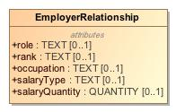

1. EmployerRelationship

|  |  |
| --- | --- |
| **Name** | EmployerRelationship |
| **Qualified Name** | CIMI Clinical::Relationship::EmployerRelationship |
| **Visibility** | public |
| **Abstract** | false |
| **Base Classifier** | * OrganizationRelationship |
| **Realized Interface** |  |

### **Attribute Detail**

#### occupation

|  |  |
| --- | --- |
| **Type** | TEXT |
| **Default Value** |  |
| **Visibility** | public |
| **Multiplicity** | 0..1 |

#### rank

|  |  |
| --- | --- |
| **Type** | TEXT |
| **Default Value** |  |
| **Visibility** | public |
| **Multiplicity** | 0..1 |

#### role

|  |  |
| --- | --- |
| **Type** | TEXT |
| **Default Value** |  |
| **Visibility** | public |
| **Multiplicity** | 0..1 |

#### salaryQuantity

|  |  |
| --- | --- |
| **Type** | QUANTITY |
| **Default Value** |  |
| **Visibility** | public |
| **Multiplicity** | 0..1 |

#### salaryType

|  |  |
| --- | --- |
| **Type** | TEXT |
| **Default Value** |  |
| **Visibility** | public |
| **Multiplicity** | 0..1 |

### **Relation Detail**

#### Generalization

|  |  |
| --- | --- |
| **Name** |  |
| **Related Element** | * OrganizationRelationship |

## **Class** **HealthCareProviderRelationship**

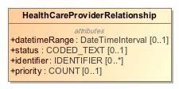

1. HealthCareProviderRelationship

|  |  |
| --- | --- |
| **Name** | HealthCareProviderRelationship |
| **Qualified Name** | CIMI Clinical::Relationship::HealthCareProviderRelationship |
| **Visibility** | public |
| **Abstract** | false |
| **Base Classifier** | * PartyRelationship |
| **Realized Interface** |  |

### **Attribute Detail**

#### datetimeRange

|  |  |
| --- | --- |
| **Type** | DateTimeInterval |
| **Default Value** |  |
| **Visibility** | public |
| **Multiplicity** | 0..1 |

#### identifier

|  |  |
| --- | --- |
| **Type** | IDENTIFIER |
| **Default Value** |  |
| **Visibility** | public |
| **Multiplicity** | 0..* |

#### priority

|  |  |
| --- | --- |
| **Type** | COUNT |
| **Default Value** |  |
| **Visibility** | public |
| **Multiplicity** | 0..1 |

#### status

|  |  |
| --- | --- |
| **Type** | CODED_TEXT |
| **Default Value** |  |
| **Visibility** | public |
| **Multiplicity** | 0..1 |

### **Relation Detail**

#### Generalization

|  |  |
| --- | --- |
| **Name** |  |
| **Related Element** | * PartyRelationship |

## **Class** **NextOfKinRelationship**

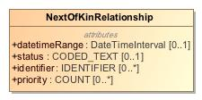

1. NextOfKinRelationship

|  |  |
| --- | --- |
| **Name** | NextOfKinRelationship |
| **Qualified Name** | CIMI Clinical::Relationship::NextOfKinRelationship |
| **Visibility** | public |
| **Abstract** | false |
| **Base Classifier** | * PartyRelationship |
| **Realized Interface** |  |

### **Attribute Detail**

#### datetimeRange

|  |  |
| --- | --- |
| **Type** | DateTimeInterval |
| **Default Value** |  |
| **Visibility** | public |
| **Multiplicity** | 0..1 |

#### identifier

|  |  |
| --- | --- |
| **Type** | IDENTIFIER |
| **Default Value** |  |
| **Visibility** | public |
| **Multiplicity** | 0..* |

#### priority

|  |  |
| --- | --- |
| **Type** | COUNT |
| **Default Value** |  |
| **Visibility** | public |
| **Multiplicity** | 0..* |

#### status

|  |  |
| --- | --- |
| **Type** | CODED_TEXT |
| **Default Value** |  |
| **Visibility** | public |
| **Multiplicity** | 0..1 |

### **Relation Detail**

#### Generalization

|  |  |
| --- | --- |
| **Name** |  |
| **Related Element** | * PartyRelationship |

## **Class** **OrganizationRelationship**

528355621.jpg

1. OrganizationRelationship

|  |  |
| --- | --- |
| **Name** | OrganizationRelationship |
| **Qualified Name** | CIMI Clinical::Relationship::OrganizationRelationship |
| **Visibility** | public |
| **Abstract** | false |
| **Base Classifier** | * PartyRelationship |
| **Realized Interface** |  |

### **Relation Detail**

#### Generalization

|  |  |
| --- | --- |
| **Name** |  |
| **Related Element** | * PartyRelationship |

|  |  |
| --- | --- |
| **Name** |  |
| **Related Element** | * EmployerRelationship |

## **Class** **PartyRelationship**

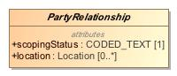

1. PartyRelationship

|  |  |
| --- | --- |
| **Name** | PartyRelationship |
| **Qualified Name** | CIMI Clinical::Relationship::PartyRelationship |
| **Visibility** | public |
| **Abstract** | true |
| **Base Classifier** | * PARTY_RELATIONSHIP |
| **Realized Interface** |  |

### **Attribute Detail**

#### location

|  |  |
| --- | --- |
| **Type** | Location |
| **Default Value** |  |
| **Visibility** | public |
| **Multiplicity** | 0..* |

#### scopingStatus

|  |  |
| --- | --- |
| **Type** | CODED_TEXT |
| **Default Value** |  |
| **Visibility** | public |
| **Multiplicity** | 1 |

### **Relation Detail**

#### Generalization

|  |  |
| --- | --- |
| **Name** |  |
| **Related Element** | * OrganizationRelationship |

|  |  |
| --- | --- |
| **Name** |  |
| **Related Element** | * PARTY_RELATIONSHIP |

|  |  |
| --- | --- |
| **Name** |  |
| **Related Element** | * NextOfKinRelationship |

|  |  |
| --- | --- |
| **Name** |  |
| **Related Element** | * HealthCareProviderRelationship |

# **Package CIMI Foundation RM**

|  |  |
| --- | --- |
| **Name** | CIMI Foundation RM |
| **Qualified Name** | CIMI Foundation RM |

# **Package CIMI Foundation RM::Foundation**

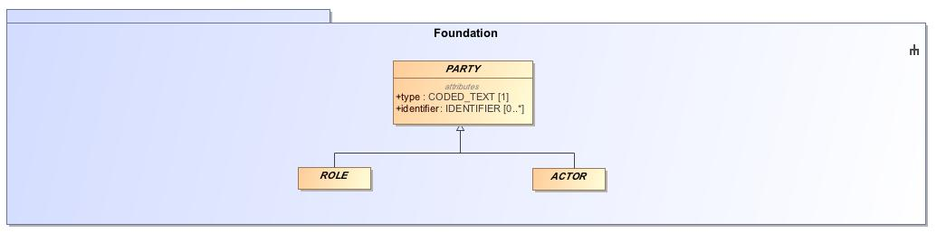

1. Foundation

|  |  |
| --- | --- |
| **Name** | Foundation |
| **Qualified Name** | CIMI Foundation RM::Foundation |

## **Class** **CLUSTER**

Abstract class representing a reusable structure in a model such as an address or an entity such as a device.

-132942850.jpg

1. CLUSTER

|  |  |
| --- | --- |
| **Name** | CLUSTER |
| **Qualified Name** | CIMI Foundation RM::Foundation::CLUSTER |
| **Visibility** | public |
| **Abstract** | true |
| **Base Classifier** | * LOCATABLE |
| **Realized Interface** |  |

### **Relation Detail**

#### Generalization

|  |  |
| --- | --- |
| **Name** |  |
| **Related Element** | * VIRTUAL_CLUSTER |

|  |  |
| --- | --- |
| **Name** |  |
| **Related Element** | * Undermining |

|  |  |
| --- | --- |
| **Name** |  |
| **Related Element** | * WoundBedAndEdge |

|  |  |
| --- | --- |
| **Name** |  |
| **Related Element** | * Street |

|  |  |
| --- | --- |
| **Name** |  |
| **Related Element** | * Age |

|  |  |
| --- | --- |
| **Name** |  |
| **Related Element** | * Signature |

|  |  |
| --- | --- |
| **Name** |  |
| **Related Element** | * WoundDressing |

|  |  |
| --- | --- |
| **Name** |  |
| **Related Element** | * ContactInformation |

|  |  |
| --- | --- |
| **Name** |  |
| **Related Element** | * LocationName |

|  |  |
| --- | --- |
| **Name** |  |
| **Related Element** | * Provenance |

|  |  |
| --- | --- |
| **Name** |  |
| **Related Element** | * Citizenship |

|  |  |
| --- | --- |
| **Name** |  |
| **Related Element** | * LanguageCapability |

|  |  |
| --- | --- |
| **Name** |  |
| **Related Element** | * UnitOfDistribution |

|  |  |
| --- | --- |
| **Name** |  |
| **Related Element** | * AdvanceDirective |

|  |  |
| --- | --- |
| **Name** |  |
| **Related Element** | * StreetNumber |

|  |  |
| --- | --- |
| **Name** |  |
| **Related Element** | * Use |

|  |  |
| --- | --- |
| **Name** |  |
| **Related Element** | * Accreditation |

|  |  |
| --- | --- |
| **Name** |  |
| **Related Element** | * DeathData |

|  |  |
| --- | --- |
| **Name** |  |
| **Related Element** | * Occupation |

|  |  |
| --- | --- |
| **Name** |  |
| **Related Element** | * MaterialEntity |

|  |  |
| --- | --- |
| **Name** |  |
| **Related Element** | * ReferenceRange |

|  |  |
| --- | --- |
| **Name** |  |
| **Related Element** | * SpecimenTreatment |

|  |  |
| --- | --- |
| **Name** |  |
| **Related Element** | * ProductBatch |

|  |  |
| --- | --- |
| **Name** |  |
| **Related Element** | * Entitlement |

|  |  |
| --- | --- |
| **Name** |  |
| **Related Element** | * WoundExudate |

|  |  |
| --- | --- |
| **Name** |  |
| **Related Element** | * ElectronicContact |

|  |  |
| --- | --- |
| **Name** |  |
| **Related Element** | * Address |

|  |  |
| --- | --- |
| **Name** |  |
| **Related Element** | * Qualification |

|  |  |
| --- | --- |
| **Name** |  |
| **Related Element** | * Industry |

|  |  |
| --- | --- |
| **Name** |  |
| **Related Element** | * Part |

|  |  |
| --- | --- |
| **Name** |  |
| **Related Element** | * BiometricData |

|  |  |
| --- | --- |
| **Name** |  |
| **Related Element** | * PartyName |

|  |  |
| --- | --- |
| **Name** |  |
| **Related Element** | * SpecimenContainer |

|  |  |
| --- | --- |
| **Name** |  |
| **Related Element** | * DimensionalFeature |

|  |  |
| --- | --- |
| **Name** |  |
| **Related Element** | * AddressLine |

|  |  |
| --- | --- |
| **Name** |  |
| **Related Element** | * LOCATABLE |

|  |  |
| --- | --- |
| **Name** |  |
| **Related Element** | * Attribution |

|  |  |
| --- | --- |
| **Name** |  |
| **Related Element** | * BirthData |

|  |  |
| --- | --- |
| **Name** |  |
| **Related Element** | * Location |

|  |  |
| --- | --- |
| **Name** |  |
| **Related Element** | * Ingredient |

|  |  |
| --- | --- |
| **Name** |  |
| **Related Element** | * Tunneling |

|  |  |
| --- | --- |
| **Name** |  |
| **Related Element** | * MedicationProduct |

|  |  |
| --- | --- |
| **Name** |  |
| **Related Element** | * Registration |

|  |  |
| --- | --- |
| **Name** |  |
| **Related Element** | * Residency |

## **Class** **COMPOSITION**

A composition is considered the unit of modification of the record, the unit of transmission in record extracts, and the unit of attestation by authorising clinicians. In this latter sense, it may be considered equivalent to a signed document.

1012610853.jpg

1. COMPOSITION

|  |  |
| --- | --- |
| **Name** | COMPOSITION |
| **Qualified Name** | CIMI Foundation RM::Foundation::COMPOSITION |
| **Visibility** | public |
| **Abstract** | false |
| **Base Classifier** | * LOCATABLE |
| **Realized Interface** |  |

### **Attribute Detail**

#### content

|  |  |
| --- | --- |
| **Type** | CONTENT |
| **Default Value** |  |
| **Visibility** | public |
| **Multiplicity** | 0..* |

### **Relation Detail**

#### Association

|  |  |
| --- | --- |
| **Name** |  |
| **Related Element** | * CONTENT |

#### Generalization

|  |  |
| --- | --- |
| **Name** |  |
| **Related Element** | * LOCATABLE |

## **Class** **COMPOUND_ENTRY**

An composite entry composed of other ENTRY components. COMPOUND_ENTRYs can be arbitrarily nested and can be treated as a unit (e.g., a complex medication orderable).

1902245445.jpg

1. COMPOUND_ENTRY

|  |  |
| --- | --- |
| **Name** | COMPOUND_ENTRY |
| **Qualified Name** | CIMI Foundation RM::Foundation::COMPOUND_ENTRY |
| **Visibility** | public |
| **Abstract** | false |
| **Base Classifier** | * ENTRY |
| **Realized Interface** |  |

### **Attribute Detail**

#### entry

|  |  |
| --- | --- |
| **Type** | ENTRY |
| **Default Value** |  |
| **Visibility** | public |
| **Multiplicity** | 0..* |

### **Relation Detail**

#### Association

|  |  |
| --- | --- |
| **Name** |  |
| **Related Element** | * ENTRY |

#### Generalization

|  |  |
| --- | --- |
| **Name** |  |
| **Related Element** | * ENTRY |

|  |  |
| --- | --- |
| **Name** |  |
| **Related Element** | * CompoundClinicalStatement |

## **Class** **CONTENT**

Abstract ancestor of all concrete content types. A unit of content that makes up a composition - e.g., a clinical statement in a patient record, a simple or composite action is a knowledge document.

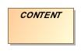

1. CONTENT

|  |  |
| --- | --- |
| **Name** | CONTENT |
| **Qualified Name** | CIMI Foundation RM::Foundation::CONTENT |
| **Visibility** | public |
| **Abstract** | true |
| **Base Classifier** | * LOCATABLE |
| **Realized Interface** |  |

### **Relation Detail**

#### Association

|  |  |
| --- | --- |
| **Name** |  |
| **Related Element** | * SECTION |

|  |  |
| --- | --- |
| **Name** |  |
| **Related Element** | * COMPOSITION |

#### Generalization

|  |  |
| --- | --- |
| **Name** |  |
| **Related Element** | * SECTION |

|  |  |
| --- | --- |
| **Name** |  |
| **Related Element** | * ENTRY |

|  |  |
| --- | --- |
| **Name** |  |
| **Related Element** | * LOCATABLE |

## **Class** **ENTRY**

An ENTRY is the root of a logical item of hard clinical information created in the clinical statement context, within a clinical session or of clinical knowledge in a knowledge artifact.   
  
With regards to clinical information entries, there can be numerous such contexts in a clinical session. Observations and other Entry types only ever document information captured/created in the event documented by the enclosing Composition.  
  
An ENTRY is also the minimal unit of information any query should return, since a whole ENTRY (including subparts) records spatial structure, timing information, and contextual information, as well as the subject and generator of the information.



1. ENTRY

|  |  |
| --- | --- |
| **Name** | ENTRY |
| **Qualified Name** | CIMI Foundation RM::Foundation::ENTRY |
| **Visibility** | public |
| **Abstract** | true |
| **Base Classifier** | * CONTENT |
| **Realized Interface** |  |

### **Relation Detail**

#### Association

|  |  |
| --- | --- |
| **Name** |  |
| **Related Element** | * COMPOUND_ENTRY |

#### Generalization

|  |  |
| --- | --- |
| **Name** |  |
| **Related Element** | * COMPOUND_ENTRY |

|  |  |
| --- | --- |
| **Name** |  |
| **Related Element** | * INDIVISIBLE_ENTRY |

|  |  |
| --- | --- |
| **Name** |  |
| **Related Element** | * ClinicalStatement |

|  |  |
| --- | --- |
| **Name** |  |
| **Related Element** | * CONTENT |

## **Class** **INDIVISIBLE_ENTRY**

An ENTRY representing an atomic unit of information that is identifiable and can be referenced independently of a parent context such as a specific hematocrit measurement viewed in isolation of its parent panel.

602669907.jpg

1. INDIVISIBLE_ENTRY

|  |  |
| --- | --- |
| **Name** | INDIVISIBLE_ENTRY |
| **Qualified Name** | CIMI Foundation RM::Foundation::INDIVISIBLE_ENTRY |
| **Visibility** | public |
| **Abstract** | false |
| **Base Classifier** | * ENTRY |
| **Realized Interface** |  |

### **Relation Detail**

#### Generalization

|  |  |
| --- | --- |
| **Name** |  |
| **Related Element** | * IndivisibleClinicalStatement |

|  |  |
| --- | --- |
| **Name** |  |
| **Related Element** | * ENTRY |

## **Class** **SECTION**

Represents a heading in a heading structure, or section tree . Can also be used to represent a collection of entries without metadata. (For collections of entries with shared metadata, use COMPOUND _ENTRY instead). Created according to archetyped structures for typical headings such as SOAP, physical examination, but also pathology result heading structures. Should not be used instead of ENTRY hierarchical structures.

1368420154.jpg

1. SECTION

|  |  |
| --- | --- |
| **Name** | SECTION |
| **Qualified Name** | CIMI Foundation RM::Foundation::SECTION |
| **Visibility** | public |
| **Abstract** | false |
| **Base Classifier** | * CONTENT |
| **Realized Interface** |  |

### **Attribute Detail**

#### content

|  |  |
| --- | --- |
| **Type** | CONTENT |
| **Default Value** |  |
| **Visibility** | public |
| **Multiplicity** | 0..* |

### **Relation Detail**

#### Association

|  |  |
| --- | --- |
| **Name** |  |
| **Related Element** | * CONTENT |

#### Generalization

|  |  |
| --- | --- |
| **Name** |  |
| **Related Element** | * CONTENT |

## **Class** **VIRTUAL_CLUSTER**

A dependent model structure designed to support attribute reuse but which may be ignored by tooling such as code generators. This allows grouping of attributes to be used in a number of compositional structures in order to encourage pattern reuse and consistency but which can be structurally flattened in a derived artifact (e.g., a java class representing the composition). An example of this pattern is the CIMI Clinical Statement pattern which combines statement context and topic to build the set of relevant clinical statements.

895402206.jpg

1. VIRTUAL_CLUSTER

|  |  |
| --- | --- |
| **Name** | VIRTUAL_CLUSTER |
| **Qualified Name** | CIMI Foundation RM::Foundation::VIRTUAL_CLUSTER |
| **Visibility** | public |
| **Abstract** | true |
| **Base Classifier** | * CLUSTER |
| **Realized Interface** |  |

### **Relation Detail**

#### Generalization

|  |  |
| --- | --- |
| **Name** |  |
| **Related Element** | * CLUSTER |

|  |  |
| --- | --- |
| **Name** |  |
| **Related Element** | * StatementContext |

|  |  |
| --- | --- |
| **Name** |  |
| **Related Element** | * StatementTopic |

# **Package CIMI Foundation RM::Party**

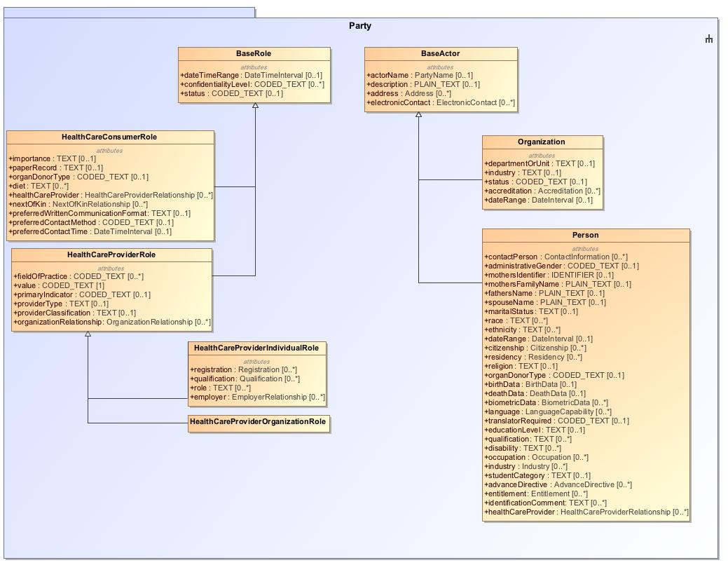

1. Party

|  |  |
| --- | --- |
| **Name** | Party |
| **Qualified Name** | CIMI Foundation RM::Party |

## **Class** **ACTOR**

Entity involved in an activity. Typically a specific person or organization.

-1513829186.jpg

1. ACTOR

|  |  |
| --- | --- |
| **Name** | ACTOR |
| **Qualified Name** | CIMI Foundation RM::Party::ACTOR |
| **Visibility** | public |
| **Abstract** | true |
| **Base Classifier** | * PARTY |
| **Realized Interface** |  |

### **Relation Detail**

#### Generalization

|  |  |
| --- | --- |
| **Name** |  |
| **Related Element** | * PARTY |

|  |  |
| --- | --- |
| **Name** |  |
| **Related Element** | * BaseActor |

## **Class** **PARTICIPATION**

Model of a participation of a Party (any Actor or Role) in an activity. Used to represent any participation of a Party in some activity, which is not explicitly in the model, e.g. assisting nurse. Can be used to record past or future participations. Should not be used in place of more permanent relationships between demographic entities.

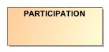

1. PARTICIPATION

|  |  |
| --- | --- |
| **Name** | PARTICIPATION |
| **Qualified Name** | CIMI Foundation RM::Party::PARTICIPATION |
| **Visibility** | public |
| **Abstract** | false |
| **Base Classifier** | * ASSOCIATION_CLASS |
| **Realized Interface** |  |

### **Attribute Detail**

#### party

|  |  |
| --- | --- |
| **Type** | PARTY |
| **Default Value** |  |
| **Visibility** | public |
| **Multiplicity** | 1 |

### **Relation Detail**

#### Association

|  |  |
| --- | --- |
| **Name** |  |
| **Related Element** | * PARTY |

#### Generalization

|  |  |
| --- | --- |
| **Name** |  |
| **Related Element** | * ASSOCIATION_CLASS |

|  |  |
| --- | --- |
| **Name** |  |
| **Related Element** | * SubjectOfInformation |

## **Class** **PARTY**

A party involved in an activity. PARTY has two specializations: ACTOR and ROLE.

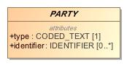

1. PARTY

|  |  |
| --- | --- |
| **Name** | PARTY |
| **Qualified Name** | CIMI Foundation RM::Party::PARTY |
| **Visibility** | public |
| **Abstract** | true |
| **Base Classifier** | * LOCATABLE |
| **Realized Interface** |  |

### **Attribute Detail**

#### identifier

An identifier for the party.

|  |  |
| --- | --- |
| **Type** | IDENTIFIER |
| **Default Value** |  |
| **Visibility** | public |
| **Multiplicity** | 0..* |

#### relationship

Party relationship(s) associated with this party. E.g., the roles an actor may play.

|  |  |
| --- | --- |
| **Type** | PARTY_RELATIONSHIP |
| **Default Value** |  |
| **Visibility** | public |
| **Multiplicity** | 0..* |

#### type

Code for the party.

|  |  |
| --- | --- |
| **Type** | CODED_TEXT |
| **Default Value** |  |
| **Visibility** | public |
| **Multiplicity** | 1 |

### **Relation Detail**

#### Association

|  |  |
| --- | --- |
| **Name** |  |
| **Related Element** | * PARTY_RELATIONSHIP |

|  |  |
| --- | --- |
| **Name** |  |
| **Related Element** | * PARTY_RELATIONSHIP |

|  |  |
| --- | --- |
| **Name** |  |
| **Related Element** | * PARTICIPATION |

#### Generalization

|  |  |
| --- | --- |
| **Name** |  |
| **Related Element** | * ACTOR |

|  |  |
| --- | --- |
| **Name** |  |
| **Related Element** | * LOCATABLE |

|  |  |
| --- | --- |
| **Name** |  |
| **Related Element** | * ROLE |

## **Class** **PARTY_RELATIONSHIP**

Association class relating two parties such as the association of an actor with one or more roles.

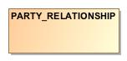

1. PARTY_RELATIONSHIP

|  |  |
| --- | --- |
| **Name** | PARTY_RELATIONSHIP |
| **Qualified Name** | CIMI Foundation RM::Party::PARTY_RELATIONSHIP |
| **Visibility** | public |
| **Abstract** | false |
| **Base Classifier** | * ASSOCIATION_CLASS |
| **Realized Interface** |  |

### **Attribute Detail**

#### party

The party target of the relationship.

|  |  |
| --- | --- |
| **Type** | PARTY |
| **Default Value** |  |
| **Visibility** | public |
| **Multiplicity** | 1 |

### **Relation Detail**

#### Association

|  |  |
| --- | --- |
| **Name** |  |
| **Related Element** | * PARTY |

|  |  |
| --- | --- |
| **Name** |  |
| **Related Element** | * PARTY |

#### Generalization

|  |  |
| --- | --- |
| **Name** |  |
| **Related Element** | * PartyRelationship |

|  |  |
| --- | --- |
| **Name** |  |
| **Related Element** | * ASSOCIATION_CLASS |

## **Class** **ROLE**

Capacity in which an actor is involved in an activity. For instance, 'attending physician'.

-828384730.jpg

1. ROLE

|  |  |
| --- | --- |
| **Name** | ROLE |
| **Qualified Name** | CIMI Foundation RM::Party::ROLE |
| **Visibility** | public |
| **Abstract** | true |
| **Base Classifier** | * PARTY |
| **Realized Interface** |  |

### **Relation Detail**

#### Generalization

|  |  |
| --- | --- |
| **Name** |  |
| **Related Element** | * BaseRole |

|  |  |
| --- | --- |
| **Name** |  |
| **Related Element** | * PARTY |

# **Package CIMI Reference Model**

|  |  |
| --- | --- |
| **Name** | CIMI Reference Model |
| **Qualified Name** | CIMI Reference Model |

# **Package CIMI Reference Model::Core**

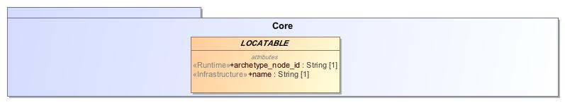

1. Core

|  |  |
| --- | --- |
| **Name** | Core |
| **Qualified Name** | CIMI Reference Model::Core |

## **Class** **ARCHETYPED**

Archetypes act as the configuration basis for the particular structures of instances defined by the reference model. To enable archetypes to be used to create valid data, key classes in the reference model act as root points for archetyping; accordingly, these classes have the archetype_details attribute set.  
  
An instance of the class ARCHETYPED contains the relevant archetype identification information, allowing generating archetypes to be matched up with data instances.

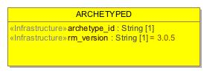

1. ARCHETYPED

|  |  |
| --- | --- |
| **Name** | ARCHETYPED |
| **Qualified Name** | CIMI Reference Model::Core::ARCHETYPED |
| **Visibility** | public |
| **Abstract** | false |
| **Base Classifier** |  |
| **Realized Interface** |  |

### **Attribute Detail**

#### archetype_id

Globally unique archetype identifier.

|  |  |
| --- | --- |
| **Type** | String |
| **Default Value** |  |
| **Visibility** | public |
| **Multiplicity** | 1 |

#### rm_version

Version of the CIMI reference model used to create this object. Expressed in terms of the release version string, e.g. 1.0 , 1.2.4 .

|  |  |
| --- | --- |
| **Type** | String |
| **Default Value** | 3.0.5 |
| **Visibility** | public |
| **Multiplicity** | 1 |

### **Relation Detail**

#### Association

|  |  |
| --- | --- |
| **Name** |  |
| **Related Element** | * LOCATABLE |

## **Class** **ASSOCIATION_CLASS**

Abstract parent type for an association class.

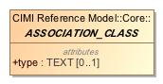

1. ASSOCIATION_CLASS

|  |  |
| --- | --- |
| **Name** | ASSOCIATION_CLASS |
| **Qualified Name** | CIMI Reference Model::Core::ASSOCIATION_CLASS |
| **Visibility** | public |
| **Abstract** | true |
| **Base Classifier** |  |
| **Realized Interface** |  |

### **Attribute Detail**

#### type

The type of the association.

|  |  |
| --- | --- |
| **Type** | TEXT |
| **Default Value** |  |
| **Visibility** | public |
| **Multiplicity** | 0..1 |

### **Relation Detail**

#### Generalization

|  |  |
| --- | --- |
| **Name** |  |
| **Related Element** | * ClinicalStatementAssociation |

|  |  |
| --- | --- |
| **Name** |  |
| **Related Element** | * PARTICIPATION |

|  |  |
| --- | --- |
| **Name** |  |
| **Related Element** | * PARTY_RELATIONSHIP |

## **Class** **LOCATABLE**

Most classes in the CIMI reference model inherit from the LOCATABLE class, which defines the idea of 'locatability in an archetyped structure'. LOCATABLE defines a runtime name and an archetype_node_id. The archetype_node_id is the standardised semantic code for a node and comes from the corresponding node in the archetype used to create the data. The only exception is at archetype root points in data, where archetype_node_id carries the archetype identifier in string form rather than an interior node id from an archetype. LOCATABLE also provides the attribute archetype_details, which is non-Void for archetype root points in data, and carries meta-data relevant to root points. The name attribute carries a name created at runtime. The 'meaning' of any node is derived formally from the archetype by obtaining the text value for the archetype_node_id code from the archetype ontology section, in the language required.

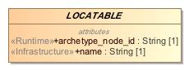

1. LOCATABLE

|  |  |
| --- | --- |
| **Name** | LOCATABLE |
| **Qualified Name** | CIMI Reference Model::Core::LOCATABLE |
| **Visibility** | public |
| **Abstract** | true |
| **Base Classifier** |  |
| **Realized Interface** |  |

### **Attribute Detail**

#### archetype_details

LOCATABLE also provides the attribute Archetype_details, which is non-Void for archetype root points in data, and carries meta-data relevant to root points.

|  |  |
| --- | --- |
| **Type** | ARCHETYPED |
| **Default Value** |  |
| **Visibility** | public |
| **Multiplicity** | 0..1 |

#### archetype_node_id

The standardised semantic code for a node and comes from the corresponding node in the archetype used to create the data. The only exception is at archetype root points in data, where archetype_node_id carries the archetype identifier in string form rather than an interior node id from an archetype.

|  |  |
| --- | --- |
| **Type** | String |
| **Default Value** |  |
| **Visibility** | public |
| **Multiplicity** | 1 |

#### name

A name created at runtime

|  |  |
| --- | --- |
| **Type** | String |
| **Default Value** |  |
| **Visibility** | public |
| **Multiplicity** | 1 |

### **Relation Detail**

#### Association

|  |  |
| --- | --- |
| **Name** |  |
| **Related Element** | * ARCHETYPED |

#### Generalization

|  |  |
| --- | --- |
| **Name** |  |
| **Related Element** | * CLUSTER |

|  |  |
| --- | --- |
| **Name** |  |
| **Related Element** | * PARTY |

|  |  |
| --- | --- |
| **Name** |  |
| **Related Element** | * COMPOSITION |

|  |  |
| --- | --- |
| **Name** |  |
| **Related Element** | * CONTENT |

# **Package CIMI Reference Model::Data Value Types**

|  |  |
| --- | --- |
| **Name** | Data Value Types |
| **Qualified Name** | CIMI Reference Model::Data Value Types |

## **Class** **AMOUNT**

Abstract class defining the concept of relative quantified amounts. For relative quantities, the +' and -' operators are defined.

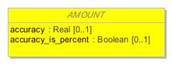

1. AMOUNT

|  |  |
| --- | --- |
| **Name** | AMOUNT |
| **Qualified Name** | CIMI Reference Model::Data Value Types::AMOUNT |
| **Visibility** | public |
| **Abstract** | true |
| **Base Classifier** | * QUANTIFIED |
| **Realized Interface** |  |

### **Attribute Detail**

#### accuracy

Accuracy of measurement, expressed either as a half-range percent value (accuracy_is_percent = True) or a half-range quantity. A value of 0 means that accuracy is 100%, i.e. no error.  
  
A value of unknown_accuracy_value means that accuracy was not recorded.

|  |  |
| --- | --- |
| **Type** | Real |
| **Default Value** |  |
| **Visibility** | public |
| **Multiplicity** | 0..1 |

#### accuracy_is_percent

If True, indicates that when this object was created, accuracy was recorded as a percent value; if False, as an absolute quantity value.

|  |  |
| --- | --- |
| **Type** | Boolean |
| **Default Value** |  |
| **Visibility** | public |
| **Multiplicity** | 0..1 |

### **Relation Detail**

#### Generalization

|  |  |
| --- | --- |
| **Name** |  |
| **Related Element** | * COUNT |

|  |  |
| --- | --- |
| **Name** |  |
| **Related Element** | * PROPORTION |

|  |  |
| --- | --- |
| **Name** |  |
| **Related Element** | * QUANTITY |

|  |  |
| --- | --- |
| **Name** |  |
| **Related Element** | * QUANTIFIED |

## **Class** **CODED_TEXT**

A text item whose value must be the rubric from a controlled terminology, the key (i.e. the code') of which is the code attribute. In other words: a CODED_TEXT is a combination of a CODE_PHRASE (effectively a code) and the rubric of that term, from a terminology service, in the language in which the data was authored.  
  
Since CODED_TEXT is a subtype of TEXT, it can be used in place of it, effectively allowing the type TEXT to mean a text item, which may optionally be coded.  
  
Misuse: If the intention is to represent a term code attached in some way to a fragment of plain text, CODED_TEXT should not be used.

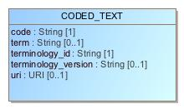

1. CODED_TEXT

|  |  |
| --- | --- |
| **Name** | CODED_TEXT |
| **Qualified Name** | CIMI Reference Model::Data Value Types::CODED_TEXT |
| **Visibility** | public |
| **Abstract** | false |
| **Base Classifier** | * TEXT |
| **Realized Interface** |  |

### **Attribute Detail**

#### code

The identifier of a concept in a terminology.

|  |  |
| --- | --- |
| **Type** | String |
| **Default Value** |  |
| **Visibility** | public |
| **Multiplicity** | 1 |

#### term

The preferred textual rendition of the code attribute.

|  |  |
| --- | --- |
| **Type** | String |
| **Default Value** |  |
| **Visibility** | public |
| **Multiplicity** | 0..1 |

#### terminology_id

The terminology that provides the namespace for the code attribute.

|  |  |
| --- | --- |
| **Type** | String |
| **Default Value** |  |
| **Visibility** | public |
| **Multiplicity** | 1 |

#### terminology_version

The version of the terminology where the concept exists.

|  |  |
| --- | --- |
| **Type** | String |
| **Default Value** |  |
| **Visibility** | public |
| **Multiplicity** | 0..1 |

#### uri

A URI representation for the identifier of the concept represented by CODED_TEXT.

|  |  |
| --- | --- |
| **Type** | URI |
| **Default Value** |  |
| **Visibility** | public |
| **Multiplicity** | 0..1 |

### **Relation Detail**

#### Association

|  |  |
| --- | --- |
| **Name** |  |
| **Related Element** | * TERM_MAPPING |

#### Generalization

|  |  |
| --- | --- |
| **Name** |  |
| **Related Element** | * TEXT |

## **Class** **COUNT**

Countable quantities. Used for countable types such as pregnancies and steps (taken by a physiotherapy patient), number of cigarettes smoked in a day.  
  
Misuse: Not to be used for amounts of physical entities (which all have units).

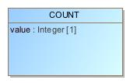

1. COUNT

|  |  |
| --- | --- |
| **Name** | COUNT |
| **Qualified Name** | CIMI Reference Model::Data Value Types::COUNT |
| **Visibility** | public |
| **Abstract** | false |
| **Base Classifier** | * AMOUNT |
| **Realized Interface** |  |

### **Attribute Detail**

#### value

|  |  |
| --- | --- |
| **Type** | Integer |
| **Default Value** |  |
| **Visibility** | public |
| **Multiplicity** | 1 |

### **Relation Detail**

#### Generalization

|  |  |
| --- | --- |
| **Name** |  |
| **Related Element** | * AMOUNT |

## **Class** **DATA_VALUE**

Serves as a common ancestor of all CIMI complex types.

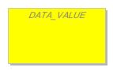

1. DATA_VALUE

|  |  |
| --- | --- |
| **Name** | DATA_VALUE |
| **Qualified Name** | CIMI Reference Model::Data Value Types::DATA_VALUE |
| **Visibility** | public |
| **Abstract** | true |
| **Base Classifier** |  |
| **Realized Interface** |  |

### **Relation Detail**

#### Generalization

|  |  |
| --- | --- |
| **Name** |  |
| **Related Element** | * INTERVAL_VALUE |

|  |  |
| --- | --- |
| **Name** |  |
| **Related Element** | * URI_VALUE |

|  |  |
| --- | --- |
| **Name** |  |
| **Related Element** | * TEXT |

|  |  |
| --- | --- |
| **Name** |  |
| **Related Element** | * IDENTIFIER |

|  |  |
| --- | --- |
| **Name** |  |
| **Related Element** | * ENCAPSULATED |

|  |  |
| --- | --- |
| **Name** |  |
| **Related Element** | * YESNO |

|  |  |
| --- | --- |
| **Name** |  |
| **Related Element** | * ORDERED_VALUE |

## **Class** **DATE**

Represents an absolute point in time, as measured on the Gregorian calendar, and specified only to the day. Semantics defined by ISO 8601. Used for recording dates in real world time. The partial form is used for approximate birth dates, dates of death, etc.

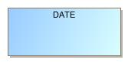

1. DATE

|  |  |
| --- | --- |
| **Name** | DATE |
| **Qualified Name** | CIMI Reference Model::Data Value Types::DATE |
| **Visibility** | public |
| **Abstract** | false |
| **Base Classifier** | * DATE_TIME |
| **Realized Interface** |  |

### **Relation Detail**

#### Generalization

|  |  |
| --- | --- |
| **Name** |  |
| **Related Element** | * DATE_TIME |

## **Class** **DATE_TIME**

Represents an absolute point in time, specified to the second. Semantics defined by ISO 8601.  
  
Used for recording a precise point in real world time, and for approximate time stamps, e.g. the origin of a HISTORY in an OBSERVATION which is only partially known.

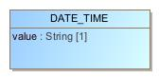

1. DATE_TIME

|  |  |
| --- | --- |
| **Name** | DATE_TIME |
| **Qualified Name** | CIMI Reference Model::Data Value Types::DATE_TIME |
| **Visibility** | public |
| **Abstract** | false |
| **Base Classifier** | * QUANTIFIED |
| **Realized Interface** |  |

### **Attribute Detail**

#### value

ISO8601 date/time string.

|  |  |
| --- | --- |
| **Type** | String |
| **Default Value** |  |
| **Visibility** | public |
| **Multiplicity** | 1 |

### **Relation Detail**

#### Generalization

|  |  |
| --- | --- |
| **Name** |  |
| **Related Element** | * TIME |

|  |  |
| --- | --- |
| **Name** |  |
| **Related Element** | * QUANTIFIED |

|  |  |
| --- | --- |
| **Name** |  |
| **Related Element** | * DATE |

## **Class** **DURATION**

Represents a period of time with respect to a notional point in time, which is not specified. A sign may be used to indicate the duration is backwards in time rather than forwards.  
  
NOTE  
a deviation from ISO8601 is supported, allowing the W' designator to be mixed with other designators. See assumed types section in the Support IM.  
Used for recording the duration of something in the real world, particularly when there is a need a) to represent the duration in customary format, i.e. days, hours, minutes etc, and b) if it will be used in computational operations with date/time quantities, i.e. additions, subtractions etc.  
  
Misuse: Durations cannot be used to represent points in time, or intervals of time.

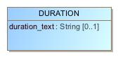

1. DURATION

|  |  |
| --- | --- |
| **Name** | DURATION |
| **Qualified Name** | CIMI Reference Model::Data Value Types::DURATION |
| **Visibility** | public |
| **Abstract** | false |
| **Base Classifier** | * QUANTITY |
| **Realized Interface** |  |

### **Attribute Detail**

#### duration_text

ISO8601 duration string.

|  |  |
| --- | --- |
| **Type** | String |
| **Default Value** |  |
| **Visibility** | public |
| **Multiplicity** | 0..1 |

### **Operation Detail**

#### is_strictly_comparable_to

|  |  |
| --- | --- |
| **Type** |  |
| **Visibility** | public |
| **Is Abstract** | false |
| **Parameter** | * in other : |

### **Relation Detail**

#### Generalization

|  |  |
| --- | --- |
| **Name** |  |
| **Related Element** | * QUANTITY |

## **Class** **EHR_URI**

A EHR_URI is a URI which has the scheme name 'ehr', and which can only reference items in EHRs.  
  
Used to reference items in an EHR, which may be the same as the current EHR (containing this link), or another.

1658395172.jpg

1. EHR_URI

|  |  |
| --- | --- |
| **Name** | EHR_URI |
| **Qualified Name** | CIMI Reference Model::Data Value Types::EHR_URI |
| **Visibility** | public |
| **Abstract** | false |
| **Base Classifier** | * URI_VALUE |
| **Realized Interface** |  |

### **Relation Detail**

#### Generalization

|  |  |
| --- | --- |
| **Name** |  |
| **Related Element** | * URI_VALUE |

## **Class** **ENCAPSULATED**

Abstract class defining the common meta-data of all types of encapsulated data.

-357038799.jpg

1. ENCAPSULATED

|  |  |
| --- | --- |
| **Name** | ENCAPSULATED |
| **Qualified Name** | CIMI Reference Model::Data Value Types::ENCAPSULATED |
| **Visibility** | public |
| **Abstract** | true |
| **Base Classifier** | * DATA_VALUE |
| **Realized Interface** |  |

### **Relation Detail**

#### Generalization

|  |  |
| --- | --- |
| **Name** |  |
| **Related Element** | * MULTIMEDIA |

|  |  |
| --- | --- |
| **Name** |  |
| **Related Element** | * PARSABLE |

|  |  |
| --- | --- |
| **Name** |  |
| **Related Element** | * DATA_VALUE |

## **Class** **IDENTIFIER**

Type for representing identifiers of real-world entities. Typical identifiers include drivers licence number, social security number, veterans affairs number, prescription id, order id, and so on.

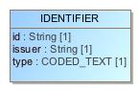

1. IDENTIFIER

|  |  |
| --- | --- |
| **Name** | IDENTIFIER |
| **Qualified Name** | CIMI Reference Model::Data Value Types::IDENTIFIER |
| **Visibility** | public |
| **Abstract** | false |
| **Base Classifier** | * DATA_VALUE |
| **Realized Interface** |  |

### **Attribute Detail**

#### id

The identifier value. Often structured, according to the definition of the issuing authority’s rules.

|  |  |
| --- | --- |
| **Type** | String |
| **Default Value** |  |
| **Visibility** | public |
| **Multiplicity** | 1 |

#### issuer

Optional organisation that assigned the id to the item being identified.

|  |  |
| --- | --- |
| **Type** | String |
| **Default Value** |  |
| **Visibility** | public |
| **Multiplicity** | 1 |

#### type

Optional identifier type, such as prescription, or Social Security Number. One day a controlled vocabulary might be possible for this.

|  |  |
| --- | --- |
| **Type** | CODED_TEXT |
| **Default Value** |  |
| **Visibility** | public |
| **Multiplicity** | 1 |

### **Relation Detail**

#### Generalization

|  |  |
| --- | --- |
| **Name** |  |
| **Related Element** | * DATA_VALUE |

## **Class** **INTERVAL_VALUE**

Generic class defining an interval (i.e. range) of a comparable type. An interval is a contiguous subrange of a comparable base type. Used to define intervals of dates, times, quantities (whose units match) and so on. The type parameter, T, must be a descendant of the type ORDERED_VALUE, which is necessary (but not sufficient) for instances to be compared (strictly_comparable is also needed).  
  
The basic semantics are derived from the class Interval<T>, described in the support RM.

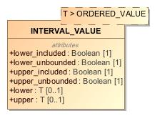

1. INTERVAL_VALUE

|  |  |
| --- | --- |
| **Name** | INTERVAL_VALUE |
| **Qualified Name** | CIMI Reference Model::Data Value Types::INTERVAL_VALUE |
| **Visibility** | public |
| **Abstract** | false |
| **Base Classifier** | * DATA_VALUE |
| **Realized Interface** |  |

### **Attribute Detail**

#### lower

The interval's lower bound. Values outside the lower bound lie outside the range specified by this interval.

|  |  |
| --- | --- |
| **Type** | T |
| **Default Value** |  |
| **Visibility** | public |
| **Multiplicity** | 0..1 |

#### lower_included

True if the lower bound of the interval is included. False otherwise.

|  |  |
| --- | --- |
| **Type** | Boolean |
| **Default Value** |  |
| **Visibility** | public |
| **Multiplicity** | 1 |

#### lower_unbounded

True if the interval does not specify a lower bound. False otherwise.

|  |  |
| --- | --- |
| **Type** | Boolean |
| **Default Value** |  |
| **Visibility** | public |
| **Multiplicity** | 1 |

#### upper

The reference range's upper bound. Values outside the upper bound lie outside the range specified by this interval.

|  |  |
| --- | --- |
| **Type** | T |
| **Default Value** |  |
| **Visibility** | public |
| **Multiplicity** | 0..1 |

#### upper_included

True if the upper bound of the interval is included. Otherwise, false.

|  |  |
| --- | --- |
| **Type** | Boolean |
| **Default Value** |  |
| **Visibility** | public |
| **Multiplicity** | 1 |

#### upper_unbounded

True if the upper bound is unspecified. False otherwise.

|  |  |
| --- | --- |
| **Type** | Boolean |
| **Default Value** |  |
| **Visibility** | public |
| **Multiplicity** | 1 |

### **Relation Detail**

#### Generalization

|  |  |
| --- | --- |
| **Name** |  |
| **Related Element** | * DATA_VALUE |

## **Class** **MULTIMEDIA**

A specialisation of DV_ENCAPSULATED for audiovisual and biosignal types. Includes further metadata relating to multimedia types which are not applicable to other subtypes of DV_ENCAPSULATED.

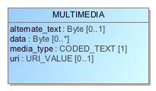

1. MULTIMEDIA

|  |  |
| --- | --- |
| **Name** | MULTIMEDIA |
| **Qualified Name** | CIMI Reference Model::Data Value Types::MULTIMEDIA |
| **Visibility** | public |
| **Abstract** | false |
| **Base Classifier** | * ENCAPSULATED |
| **Realized Interface** |  |

### **Attribute Detail**

#### alternate_text

Text to display in lieu of multimedia display/replay.

|  |  |
| --- | --- |
| **Type** | Byte |
| **Default Value** |  |
| **Visibility** | public |
| **Multiplicity** | 0..1 |

#### data

The actual data found at uri, if supplied inline.

|  |  |
| --- | --- |
| **Type** | Byte |
| **Default Value** |  |
| **Visibility** | public |
| **Multiplicity** | 0..* |

#### media_type

Data media type coded from openEHR code set media types (interface for the IANA MIME types code set).

|  |  |
| --- | --- |
| **Type** | CODED_TEXT |
| **Default Value** |  |
| **Visibility** | public |
| **Multiplicity** | 1 |

#### uri

URI reference to electronic information stored outside the record as a file, database entry etc, if supplied as a reference.

|  |  |
| --- | --- |
| **Type** | URI_VALUE |
| **Default Value** |  |
| **Visibility** | public |
| **Multiplicity** | 0..1 |

### **Relation Detail**

#### Generalization

|  |  |
| --- | --- |
| **Name** |  |
| **Related Element** | * ENCAPSULATED |

## **Class** **ORDERED_VALUE**

Abstract class defining the concept of ordered values, which includes ordinals as well as true quantities.

1872616523.jpg

1. ORDERED_VALUE

|  |  |
| --- | --- |
| **Name** | ORDERED_VALUE |
| **Qualified Name** | CIMI Reference Model::Data Value Types::ORDERED_VALUE |
| **Visibility** | public |
| **Abstract** | true |
| **Base Classifier** | * DATA_VALUE |
| **Realized Interface** |  |

### **Relation Detail**

#### Generalization

|  |  |
| --- | --- |
| **Name** |  |
| **Related Element** | * QUANTIFIED |

|  |  |
| --- | --- |
| **Name** |  |
| **Related Element** | * DATA_VALUE |

|  |  |
| --- | --- |
| **Name** |  |
| **Related Element** | * ORDINAL |

## **Class** **ORDINAL**

Models rankings and scores, e.g. pain, Apgar values, etc, where there is a) implied ordering, b) no implication that the distance between each value is constant, and c) the total number of values is finite. Note that although the term ordinal' in mathematics means natural numbers only, here any integer is allowed, since negative and zero values are often used by medical professionals for values around a neutral point. Examples of sets of ordinal values:  
  
-3, -2, -1, 0, 1, 2, 3  — reflex response values  
0, 1, 2  — Apgar values  
This class is used for recording any clinical datum which is customarily recorded using symbolic values. Example: the results on a urinalysis strip, e.g. {neg, trace, , , } are used for leucocytes, protein, nitrites etc; for non-haemolysed blood {neg, trace, moderate}; for haemolysed blood small, moderate, large}.

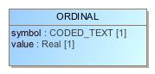

1. ORDINAL

|  |  |
| --- | --- |
| **Name** | ORDINAL |
| **Qualified Name** | CIMI Reference Model::Data Value Types::ORDINAL |
| **Visibility** | public |
| **Abstract** | false |
| **Base Classifier** | * ORDERED_VALUE |
| **Realized Interface** |  |

### **Attribute Detail**

#### symbol

Coded textual representation of this value in the enumeration, which may be strings made from + symbols, or other enumerations of terms such as mild , moderate , severe , or even the same number series as the values, e.g. 1 , 2 , 3 . Codes come from archetype.

|  |  |
| --- | --- |
| **Type** | CODED_TEXT |
| **Default Value** |  |
| **Visibility** | public |
| **Multiplicity** | 1 |

#### value

Value in ordered enumeration of values. Any integer value can be used.

|  |  |
| --- | --- |
| **Type** | Real |
| **Default Value** |  |
| **Visibility** | public |
| **Multiplicity** | 1 |

### **Relation Detail**

#### Generalization

|  |  |
| --- | --- |
| **Name** |  |
| **Related Element** | * ORDERED_VALUE |

## **Class** **PARSABLE**

Encapsulated data expressed as a parsable String. The internal model of the data item is not described in the openEHR model in common with other encapsulated types, but in this case, the form of the data is assumed to be plaintext, rather than compressed or other types of large binary data.

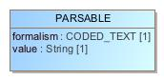

1. PARSABLE

|  |  |
| --- | --- |
| **Name** | PARSABLE |
| **Qualified Name** | CIMI Reference Model::Data Value Types::PARSABLE |
| **Visibility** | public |
| **Abstract** | false |
| **Base Classifier** | * ENCAPSULATED |
| **Realized Interface** |  |

### **Attribute Detail**

#### formalism

Name of the formalism, e.g. GLIF 1.0 , Proforma etc.

|  |  |
| --- | --- |
| **Type** | CODED_TEXT |
| **Default Value** |  |
| **Visibility** | public |
| **Multiplicity** | 1 |

#### value

The string, which may validly be empty in some syntaxes.

|  |  |
| --- | --- |
| **Type** | String |
| **Default Value** |  |
| **Visibility** | public |
| **Multiplicity** | 1 |

### **Relation Detail**

#### Generalization

|  |  |
| --- | --- |
| **Name** |  |
| **Related Element** | * ENCAPSULATED |

## **Class** **PLAIN_TEXT**

Plain text potentially with simple formatting

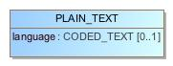

1. PLAIN_TEXT

|  |  |
| --- | --- |
| **Name** | PLAIN_TEXT |
| **Qualified Name** | CIMI Reference Model::Data Value Types::PLAIN_TEXT |
| **Visibility** | public |
| **Abstract** | false |
| **Base Classifier** | * TEXT |
| **Realized Interface** |  |

### **Attribute Detail**

#### language

|  |  |
| --- | --- |
| **Type** | CODED_TEXT |
| **Default Value** |  |
| **Visibility** | public |
| **Multiplicity** | 0..1 |

### **Relation Detail**

#### Generalization

|  |  |
| --- | --- |
| **Name** |  |
| **Related Element** | * TEXT |

## **Class** **PROPORTION**

Models a ratio of values, i.e. where the numerator and denominator are both pure numbers. The valid_proportion_kind property of the PROPORTION_KIND class is used to control the type attribute to be one of a defined set.  
  
Used for recording titers (e.g. 1:128), concentration ratios, e.g. Na:K (unitary denominator), albumin:creatinine ratio, and percentages, e.g. red cell distirbution width (RDW).  
  
Misuse: Should not be used to represent things like blood pressure which are often written using a '/' character, giving the misleading impression that the item is a ratio, when in fact it is a structured value. Similarly, visual acuity, often written as (e.g.) “6/24” in clinical notes is not a ratio but an ordinal (which includes non-numeric symbols like CF = count fingers etc). Should not be used for formulations.

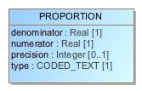

1. PROPORTION

|  |  |
| --- | --- |
| **Name** | PROPORTION |
| **Qualified Name** | CIMI Reference Model::Data Value Types::PROPORTION |
| **Visibility** | public |
| **Abstract** | false |
| **Base Classifier** | * AMOUNT |
| **Realized Interface** |  |

### **Attribute Detail**

#### denominator

Denominator of ratio.

|  |  |
| --- | --- |
| **Type** | Real |
| **Default Value** |  |
| **Visibility** | public |
| **Multiplicity** | 1 |

#### numerator

Numerator of ratio.

|  |  |
| --- | --- |
| **Type** | Real |
| **Default Value** |  |
| **Visibility** | public |
| **Multiplicity** | 1 |

#### precision

Precision to which the numerator and denominator values of the proportion are expressed, in terms of number of decimal places. The value 0 implies an integral quantity. The value -1 implies no limit, i.e. any number of decimal places.

|  |  |
| --- | --- |
| **Type** | Integer |
| **Default Value** |  |
| **Visibility** | public |
| **Multiplicity** | 0..1 |

#### type

Indicates semantic type of proportion, including percent, unitary etc.

|  |  |
| --- | --- |
| **Type** | CODED_TEXT |
| **Default Value** |  |
| **Visibility** | public |
| **Multiplicity** | 1 |

### **Relation Detail**

#### Generalization

|  |  |
| --- | --- |
| **Name** |  |
| **Related Element** | * AMOUNT |

## **Class** **QUANTIFIED**

Abstract class defining the concept of true quantified values, i.e. values which are not only ordered, but which have a precise magnitude.

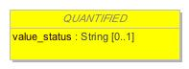

1. QUANTIFIED

|  |  |
| --- | --- |
| **Name** | QUANTIFIED |
| **Qualified Name** | CIMI Reference Model::Data Value Types::QUANTIFIED |
| **Visibility** | public |
| **Abstract** | true |
| **Base Classifier** | * ORDERED_VALUE |
| **Realized Interface** |  |

### **Attribute Detail**

#### value_status

Optional status of magnitude with values:  
  
= : magnitude is a point value  
< : value is < magnitude  
> : value is > magnitude  
\<= : value is <= magnitude  
>= : value is >= magnitude  
~ : value is approximately magnitude  
If not present, meaning is = .

|  |  |
| --- | --- |
| **Type** | String |
| **Default Value** |  |
| **Visibility** | public |
| **Multiplicity** | 0..1 |

### **Relation Detail**

#### Dependency

|  |  |
| --- | --- |
| **Name** |  |
| **Related Element** | * QuantifiedValueStatusEnum |

#### Generalization

|  |  |
| --- | --- |
| **Name** |  |
| **Related Element** | * ORDERED_VALUE |

|  |  |
| --- | --- |
| **Name** |  |
| **Related Element** | * DATE_TIME |

|  |  |
| --- | --- |
| **Name** |  |
| **Related Element** | * AMOUNT |

## **Class** **QUANTITY**

Quantitified type representing scientific quantities, i.e. quantities expressed as a magnitude and units. Units were inspired by the Unified Code for Units of Measure (UCUM), developed by Gunther Schadow and Clement J. McDonald of The Regenstrief Institute.  
  
Can also be used for time durations, where it is more convenient to treat these as simply a number of seconds rather than days, months, years.

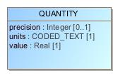

1. QUANTITY

|  |  |
| --- | --- |
| **Name** | QUANTITY |
| **Qualified Name** | CIMI Reference Model::Data Value Types::QUANTITY |
| **Visibility** | public |
| **Abstract** | false |
| **Base Classifier** | * AMOUNT |
| **Realized Interface** |  |

### **Attribute Detail**

#### precision

Precision to which the value of the quantity is expressed, in terms of number of decimal places. The value 0 implies an integral quantity. The value -1 implies no limit, i.e. any number of decimal places.

|  |  |
| --- | --- |
| **Type** | Integer |
| **Default Value** |  |
| **Visibility** | public |
| **Multiplicity** | 0..1 |

#### units

Units, expressed expressed as codes (generally UCUM), e.g. "kg/m2", “mm[Hg]", "ms-1", "km/h". Implemented accordingly in subtypes.

|  |  |
| --- | --- |
| **Type** | CODED_TEXT |
| **Default Value** |  |
| **Visibility** | public |
| **Multiplicity** | 1 |

#### value

Numeric magnitude of the quantity.

|  |  |
| --- | --- |
| **Type** | Real |
| **Default Value** |  |
| **Visibility** | public |
| **Multiplicity** | 1 |

### **Relation Detail**

#### Generalization

|  |  |
| --- | --- |
| **Name** |  |
| **Related Element** | * DURATION |

|  |  |
| --- | --- |
| **Name** |  |
| **Related Element** | * AMOUNT |

## **Class** **TERM_MAPPING**

Represents a coded term mapped to a TEXT, and the relative match of the target term with respect to the mapped item. Plain or coded text items may appear in the EHR for which one or mappings in alternative terminologies are required. Mappings are only used to enable computer processing, so they can only be instances of CODED_TEXT. Used for adding classification terms (e.g. adding ICD classifiers to SNOMED descriptive terms), or mapping into equivalents in other terminologies (e.g. across nursing vocabularies).

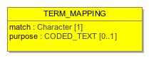

1. TERM_MAPPING

|  |  |
| --- | --- |
| **Name** | TERM_MAPPING |
| **Qualified Name** | CIMI Reference Model::Data Value Types::TERM_MAPPING |
| **Visibility** | public |
| **Abstract** | false |
| **Base Classifier** |  |
| **Realized Interface** |  |

### **Attribute Detail**

#### match

The relative match of the target term with respect to the mapped text item. Result meanings:  
  
'>': the mapping is to a broader term e.g. orginal text = arbovirus infection , target = viral infection  
'=': the mapping is to a (supposedly) equivalent to the original item  
'<': the mapping is to a narrower term. e.g. original text = diabetes , mapping = diabetes mellitus .  
'?': the kind of mapping is unknown.  
The first three values are taken from the ISO standards 2788 ( Guide to Establishment and development of monolingual thesauri ) and 5964 ( Guide to Establishment and development of multilingual thesauri ).

|  |  |
| --- | --- |
| **Type** | Character |
| **Default Value** |  |
| **Visibility** | public |
| **Multiplicity** | 1 |

#### purpose

|  |  |
| --- | --- |
| **Type** | CODED_TEXT |
| **Default Value** |  |
| **Visibility** | public |
| **Multiplicity** | 0..1 |

#### target

|  |  |
| --- | --- |
| **Type** | CODED_TEXT |
| **Default Value** |  |
| **Visibility** | public |
| **Multiplicity** | 1 |

### **Relation Detail**

#### Association

|  |  |
| --- | --- |
| **Name** |  |
| **Related Element** | * CODED_TEXT |

|  |  |
| --- | --- |
| **Name** |  |
| **Related Element** | * TEXT |

#### Dependency

|  |  |
| --- | --- |
| **Name** |  |
| **Related Element** | * TermMappingMatchEnum |

## **Class** **TEXT**

Abstract parent for text and coded text item, which may contain any amount of legal characters arranged as e.g. words, sentences etc (i.e. one TEXT may be more than one word). Visual formatting and hyperlinks may be included.

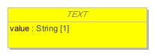

1. TEXT

|  |  |
| --- | --- |
| **Name** | TEXT |
| **Qualified Name** | CIMI Reference Model::Data Value Types::TEXT |
| **Visibility** | public |
| **Abstract** | true |
| **Base Classifier** | * DATA_VALUE |
| **Realized Interface** |  |

### **Attribute Detail**

#### mapping

|  |  |
| --- | --- |
| **Type** | TERM_MAPPING |
| **Default Value** |  |
| **Visibility** | public |
| **Multiplicity** | 0..* |

#### value

Displayable rendition of the item, regardless of its underlying structure. For CODED_TEXT, this is the rubric of the complete term as provided by the terminology service. No carriage returns, line feeds, or other non-printing characters permitted.

|  |  |
| --- | --- |
| **Type** | String |
| **Default Value** |  |
| **Visibility** | public |
| **Multiplicity** | 1 |

### **Relation Detail**

#### Association

|  |  |
| --- | --- |
| **Name** |  |
| **Related Element** | * TERM_MAPPING |

#### Generalization

|  |  |
| --- | --- |
| **Name** |  |
| **Related Element** | * DATA_VALUE |

|  |  |
| --- | --- |
| **Name** |  |
| **Related Element** | * CODED_TEXT |

|  |  |
| --- | --- |
| **Name** |  |
| **Related Element** | * PLAIN_TEXT |

## **Class** **TIME**

Represents an absolute point in time from an origin usually interpreted as meaning the start of the current day, specified to a fraction of a second. Semantics defined by ISO 8601.  
  
Used for recording real world times, rather than scientifically measured fine amounts of time. The partial form is used for approximate times of events and substance administrations.

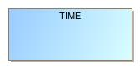

1. TIME

|  |  |
| --- | --- |
| **Name** | TIME |
| **Qualified Name** | CIMI Reference Model::Data Value Types::TIME |
| **Visibility** | public |
| **Abstract** | false |
| **Base Classifier** | * DATE_TIME |
| **Realized Interface** |  |

### **Relation Detail**

#### Generalization

|  |  |
| --- | --- |
| **Name** |  |
| **Related Element** | * DATE_TIME |

## **Class** **URI_VALUE**

A reference to an object which conforms to the Universal Resource Identifier (URI) standard. See "Universal Resource Identifiers in WWW" by Tim Berners-Lee at http://www.ietf.org/rfc/rfc3986.txt. This is a World-Wide Web RFC for global identification of resources. See http://www.w3.org/Addressing for a starting point on URIs.

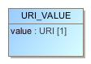

1. URI_VALUE

|  |  |
| --- | --- |
| **Name** | URI_VALUE |
| **Qualified Name** | CIMI Reference Model::Data Value Types::URI_VALUE |
| **Visibility** | public |
| **Abstract** | false |
| **Base Classifier** | * DATA_VALUE |
| **Realized Interface** |  |

### **Attribute Detail**

#### value

Value of URI

|  |  |
| --- | --- |
| **Type** | URI |
| **Default Value** |  |
| **Visibility** | public |
| **Multiplicity** | 1 |

### **Relation Detail**

#### Generalization

|  |  |
| --- | --- |
| **Name** |  |
| **Related Element** | * DATA_VALUE |

|  |  |
| --- | --- |
| **Name** |  |
| **Related Element** | * EHR_URI |

## **Class** **YESNO**

Items which are truly boolean data, such as true/false or yes/no answers. For such data, it is important to devise the meanings (usually questions in subjective data) carefully, so that the only allowed results are in fact true or false.  
  
Misuse: The DV_BOOLEAN class should not be used as a replacement for naively modelled enumerated types such as male/female etc. Such values should be coded, and in any case the enumeration often has more than two values.

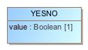

1. YESNO

|  |  |
| --- | --- |
| **Name** | YESNO |
| **Qualified Name** | CIMI Reference Model::Data Value Types::YESNO |
| **Visibility** | public |
| **Abstract** | false |
| **Base Classifier** | * DATA_VALUE |
| **Realized Interface** |  |

### **Attribute Detail**

#### value

The boolean value for the type.

|  |  |
| --- | --- |
| **Type** | Boolean |
| **Default Value** |  |
| **Visibility** | public |
| **Multiplicity** | 1 |

### **Relation Detail**

#### Generalization

|  |  |
| --- | --- |
| **Name** |  |
| **Related Element** | * DATA_VALUE |

## **Enumeration** **QuantifiedValueStatusEnum**



1. QuantifiedValueStatusEnum

|  |  |
| --- | --- |
| **Name** | QuantifiedValueStatusEnum |
| **Qualified Name** | CIMI Reference Model::Data Value Types::QuantifiedValueStatusEnum |
| **Visibility** | public |
| **Base Classifier** |  |

### **Relation Detail**

#### Dependency

|  |  |
| --- | --- |
| **Name** |  |
| **Related Element** | * QUANTIFIED |

## **Enumeration** **TermMappingMatchEnum**

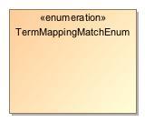

1. TermMappingMatchEnum

|  |  |
| --- | --- |
| **Name** | TermMappingMatchEnum |
| **Qualified Name** | CIMI Reference Model::Data Value Types::TermMappingMatchEnum |
| **Visibility** | public |
| **Base Classifier** |  |

### **Relation Detail**

#### Dependency

|  |  |
| --- | --- |
| **Name** |  |
| **Related Element** | * TERM_MAPPING |

# **Package CIMI Reference Model::Primitive Types**

|  |  |
| --- | --- |
| **Name** | Primitive Types |
| **Qualified Name** | CIMI Reference Model::Primitive Types |

## **Class** **Any**

1784429252.jpg

1. Any

|  |  |
| --- | --- |
| **Name** | Any |
| **Qualified Name** | CIMI Reference Model::Primitive Types::Any |
| **Visibility** | public |
| **Abstract** | false |
| **Base Classifier** |  |
| **Realized Interface** |  |

## **Class** **Array**

2000638326.jpg

1. Array

|  |  |
| --- | --- |
| **Name** | Array |
| **Qualified Name** | CIMI Reference Model::Primitive Types::Array |
| **Visibility** | public |
| **Abstract** | false |
| **Base Classifier** |  |
| **Realized Interface** |  |

## **Class** **List**

874879303.jpg

1. List

|  |  |
| --- | --- |
| **Name** | List |
| **Qualified Name** | CIMI Reference Model::Primitive Types::List |
| **Visibility** | public |
| **Abstract** | false |
| **Base Classifier** |  |
| **Realized Interface** |  |