HL7_XPARADIGM_CIMI_LM_R1_O1_2017JAN



**CIMI Logical Models, Release 1 (PI ID: 1253)**

January 2017

**HL7 For Comment Ballot**

**Sponsored by:  
HL7 CIMI Work Group**

**HL7 Clinical Decision Support Work Group**

**HL7 Clinical Quality Information Work Group**

**HL7 Patient Care Work Group**

Copyright © 2016-2017 Health Level Seven International ® ALL RIGHTS RESERVED. The reproduction of this material in any form is strictly forbidden without the written permission of the publisher. HL7 and Health Level Seven are registered trademarks of Health Level Seven International. Reg. U.S. Pat & TM Off**.**

Use of this material is governed by HL7's [**IP Compliance Policy**](http://www.hl7.org/legal/ippolicy.cfm?ref=nav).**IMPORTANT NOTES:**

HL7 licenses its standards and select IP free of charge. **If you did not acquire a free license from HL7 for this document,** you are not authorized to access or make any use of it. To obtain a free license, please visit http://www.HL7.org/implement/standards/index.cfm.

**If you are the individual that obtained the license for this HL7 Standard, specification or other freely licensed work (in each and every instance "Specified Material")**, the following describes the permitted uses of the Material.

**A. HL7 INDIVIDUAL, STUDENT AND HEALTH PROFESSIONAL MEMBERS,** who register and agree to the terms of HL7’s license, are authorized, without additional charge, to read, and to use Specified Material to develop and sell products and services that implement, but do not directly incorporate, the Specified Material in whole or in part without paying license fees to HL7.

INDIVIDUAL, STUDENT AND HEALTH PROFESSIONAL MEMBERS wishing to incorporate additional items of Special Material in whole or part, into products and services, or to enjoy additional authorizations granted to HL7 ORGANIZATIONAL MEMBERS as noted below, must become ORGANIZATIONAL MEMBERS of HL7.

**B. HL7 ORGANIZATION MEMBERS,** who register and agree to the terms of HL7's License, are authorized, without additional charge, on a perpetual (except as provided for in the full license terms governing the Material), non-exclusive and worldwide basis, the right to (a) download, copy (for internal purposes only) and share this Material with your employees and consultants for study purposes, and (b) utilize the Material for the purpose of developing, making, having made, using, marketing, importing, offering to sell or license, and selling or licensing, and to otherwise distribute, Compliant Products, in all cases subject to the conditions set forth in this Agreement and any relevant patent and other intellectual property rights of third parties (which may include members of HL7). No other license, sublicense, or other rights of any kind are granted under this Agreement.

**C. NON-MEMBERS,** who register and agree to the terms of HL7’s IP policy for Specified Material, are authorized, without additional charge, to read and use the Specified Material for evaluating whether to implement, or in implementing, the Specified Material, and to use Specified Material to develop and sell products and services that implement, but do not directly incorporate, the Specified Material in whole or in part.

NON-MEMBERS wishing to incorporate additional items of Specified Material in whole or part, into products and services, or to enjoy the additional authorizations granted to HL7 ORGANIZATIONAL MEMBERS, as noted above, must become ORGANIZATIONAL MEMBERS of HL7.

Please see http://www.HL7.org/legal/ippolicy.cfm for the full license terms governing the Material.

**Ownership. Licensee agrees and acknowledges that HL7 owns all right, title, and interest, in and to the Materials. Licensee shall take no action contrary to, or inconsistent with, the foregoing.**

**Licensee agrees and acknowledges that HL7 may not own all right, title, and interest, in and to the Materials and that the Materials may contain and/or reference intellectual property owned by third parties (“Third Party IP”). Acceptance of these License Terms does not grant Licensee any rights with respect to Third Party IP. Licensee alone is responsible for identifying and obtaining any necessary licenses or authorizations to utilize Third Party IP in connection with the Materials or otherwise. Any actions, claims or suits brought by a third party resulting from a breach of any Third Party IP right by the Licensee remains the Licensee’s liability.**

Following is a non-exhaustive list of third-party terminologies that may require a separate license:

| **Terminology** | **Owner/Contact** |
| --- | --- |
| Current Procedures Terminology (CPT) code set | American Medical Association http://www.ama-assn.org/ama/pub/physician-resources/solutions-managing-your-practice/coding-billing-insurance/cpt/cpt-products-services/licensing.page? |
| SNOMED CT | International Healthcare Terminology Standards Development Organization (IHTSDO) <http://www.ihtsdo.org/snomed-ct/get-snomed-ct> or info@ihtsdo.org |
| Logical Observation Identifiers Names & Codes (LOINC) | Regenstrief Institute |
| International Classification of Diseases (ICD) codes | World Health Organization (WHO) |
| NUCC Health Care Provider Taxonomy code set | American Medical Association. Please see 222.nucc.org. AMA licensing contact: 312-464-5022 (AMA IP services) |

|  |
| --- |
| CIMI Modeling Architecture, Methodology & Style Guide |
| Version 1 |
| **Submitted On:** 12/04/2017  **Authors:** HL7 CIMI Work Group |

Background 7

CIMI and FHIR 7

Scope of Work 8

Future work 9

Request for Comments 9

CIMI Model Architecture 10

Introduction 10

Core Modeling Principles 11

The CIMI Model’s Alignment to Terminology 12

A High Level View of the CIMI Logical Model 12

The CIMI Reference Model 13

The CIMI Archetype Hierarchies 14

Reference Model 15

The CIMI Core Reference Model Module 15

CIMI primitives 16

CIMI Complex Types 16

The LOCATABLE and ASSOCIATION_CLASS Root Types 18

The CIMI Foundational Reference Model Module 19

The CIMI Clinical Reference Model Module 21

The CIMI Party, Participation Patterns 21

The CIMI Clinical Statement Pattern 22

The CIMI Attribution/Provenance patterns 28

The CIMI Assertion and EvaluationResult Pattern 30

The CIMI Procedure pattern 32

CIMI Data Structures 33

Association Classes 38

An Introduction to CIMI Archetype Hierarchies 38

Top Level CIMI Archetypes 39

The attribution archetype hierarchy 39

The StatementContext hierarchy 40

The Statement Topic Hierarchies 41

The Clinical Statement Hierarchies 42

A Note About Other Cluster Archetype Hierarchies 45

Top Level Value Set Constraints 45

Archetypes that constrain attribute types 46

Archetypes as templates 47

The CIMI Style Guide 49

Modeling Style 49

Quality Criteria 49

Scope of Clinical Models 50

Model Granularity, Reuse, and Composition 50

Isosemantic Models 51

Terminology Binding 52

Terminology Binding Guidelines 53

Semantic Model Binding 54

Semantic Model Range Binding 54

Value Set Binding 54

Modeling Layers 54

Topic Patterns 56

Assertion 56

Assertion Subtypes 57

EvaluationResult 58

Evaluation Subtypes 59

Procedures 60

Figure 1 - CIMI Architectural Framework 15

Figure 2 - CIMI Primitive Types 16

Figure 3 - CIMI Data Value Types 18

Figure 4 - CIMI Core Model 18

Figure 5 - CIMI Foundational Package 19

Figure 6 - CIMI Party Package 20

Figure 7 - Specialization of the PARTY Class 22

Figure 8 - Clinical Statement Pattern 23

Figure 9 - Clinical Statement Topics 23

Figure 10 - Example Lifecycle of a Proposal 24

Figure 11 - State Transition History 25

Figure 12 - ClinicalStatement Contexts 25

Figure 13 - Finding Contexts 26

Figure 14 - Action Contexts 27

Figure 15 - Provenance Patterns 30

Figure 16 - Assertion Statement Topic 31

Figure 17 - Action Topics 33

Figure 18 - Material Entities 34

Figure 19 - Other Data Structures 35

Figure 20 - Address Structures 36

Figure 21 - Party and Related Structures 37

Figure 22 - Association Class Specializations 38

Figure 23 - Attribution Archetype Hierarchy 39

Figure 24 - Statement Context Archetype Hierarchies 41

Figure 25 - Top Level Statement Topic Hierarchies 42

Figure 26 - Top Level Indivisible Statement Hierarchies 43

Figure 27 - Top Level Compound Statement Hierarchies 43

Figure 28 - Act Clinical Statements 44

Figure 29 - Finding Clinical Statements 45

Figure 30 - Progressive Value Set Constraints 46

Figure 31 - Type Constraints 47

Figure 32 - The Clinical Statement Pattern in Archetypes 48

Figure 33 - Illustration of CIMI Modeling Layers 55

# Background

The Clinical Information Modeling Initiative (CIMI) is a Health Level Seven (HL7) workgroup dedicated to providing a common definition of health information content so that semantically interoperable information may be created and shared in health records, messages and documents.

In achieving this goal, CIMI has established a CIMI modeling architecture, methodology, style guide and a set of models, which together demonstrate and test the approach to CIMI clinical modeling.

CIMI modeling is the overall strategy for specifying, at a granular level and in a computable fashion, the structure and semantics of the common data elements that will be stored in an Electronic Health Record (EHR). More exactly, the CIMI Model specifies how to create a “model” of a particular type of element (e.g., a heart rate measurement, a laboratory observation, or a procedure performed). The model declares how a valid “instance” of that element should be structured, and the semantics of that structure. By analogy, a blueprint is used for building cars. All the cars built as a result of the blueprint conform to the specifications of the blueprint. The cars conforming to the blueprints are analogous to instances of data (e.g., John Smith’s heart rate measurement at 11 am on January 26th, the observation of Mary Black’s blood glucose on March 20th, or the procedure performed on Jeff Brown June 23rd at 10 am), while the blueprints are analogous to the models (e.g., a model for heart rate measurement instances, a model for laboratory observation instances, or a model for procedure performed instances).

The purpose of this document is to give modelers practical information needed to author CIMI models. This document describes some initial proposals by the CIMI modeling task force that will help to inform CIMI’s model architecture, modeling methodology and style guide.

# CIMI and FHIR

The CIMI Logical Model and the FHIR Resource Model are complementary models. Unlike FHIR, CIMI does not provide a specification for the representation of instances of clinical data. It relies on implementation models such as FHIR to do so. On the other hand, the CIMI Model offers a formal specification for a set of consistent FHIR logical, resource, and extension profiles that can enable both the interoperable exchange of clinical information and the queries, analysis, and computations performed upon such information. Services whose APIs make use of these FHIR profiles will be able to leverage the expressivity and computability of the CIMI logical model within health applications. In the area of Clinical Decision Support, the CIMI logical model offers a stable, consistent, and computable clinical model for the development of knowledge artifacts and for the design of execution systems that make use of these models in clinical logic.

In order to achieve this, the CIMI preferred models must first be transformed into FHIR resource profiles. The CIMI logical model provides the underlying specification for such profiles through the translation of both reference model structures and archetype constraints into their equivalent representations in corresponding FHIR structure definitions. Once the set of CIMI-FHIR profiles has been generated, FHIR instances, conformant with these CIMI profiles, represent conformant CIMI instances.

Given their differing requirements, CIMI models and FHIR resources may differ in their structure and therefore transformation costs are inevitable. For instance, while CIMI clinical statements are compositional structures to support model reuse and consistency, FHIR resources tend to prioritize ease of implementation, and to be flatter. In order to minimize these transformation costs, CIMI aims to (1) align the granularity of its models with those specified by FHIR (to the extent consistent with its requirements mandate), (2) provide declarative and computable transformations from all of its models to FHIR profiles and (3) work with the FHIR team to address specific areas of incongruence.

At a high level, the transformation of CIMI models into FHIR profiles can be achieved as follows:

1. CIMI archetypes are aligned with the corresponding FHIR resources
2. Reference model attributes are mapped to attributes in the mapped FHIR resource(s)
3. CIMI attributes with no equivalent in FHIR are handled as FHIR extensions
4. ADL model constraints are translated into their corresponding representations in FHIR structure definitions

Archetypes in CIMI are defined hierarchically with more specific archetypes further tightening the constraints of their ancestors in the hierarchy. In order to retain this structure in FHIR, the translation of CIMI archetype hierarchies into FHIR resource profiles will most likely result in the generation of layered resource profiles in FHIR that mimic the structure found in CIMI.

# Scope of Work

The motivation for this for-comment ballot submission is to solicit feedback on the core architecture of the CIMI logical model. Given the scope of this effort, the CIMI Team has focused primarily on the following areas:

* The expansion and modularization of the CIMI Reference Model based on a set of core modeling principles;
* The definition of top-level archetypes based on the CIMI Reference Model
* The development of core modeling patterns including:
  + The compositional Clinical Statement Pattern
  + The Statement Topic/Context Patterns
  + The Attribution/Provenance Pattern
  + The Party/Participation Pattern
  + The Assertion and EvaluationResult Patterns
  + The Procedure Pattern
* The alignment of the CIMI Logical Model with the SNOMED CT Concept Model;
* The modeling of a number of the Skin/Wound Assessment archetypes to illustrate the use of the above patterns.

While this submission describes additional models, including a number of supporting structures, many of these structures have not received adequate internal review at this time. Therefore, we encourage the reader to prioritize review on the items listed above, though we certainly welcome feedback on any part of the model.

It is also important to note that while some value set bindings will be provided as part of this submission (as an attached spreadsheet), much work still remains to be done. Terminology alignment will be addressed in future ballot submissions and all terminology bindings, apart from those specifying the alignment of model attributes to SNOMED CT Concept Model attributes, are provided as examples. In the future, CIMI intends to work with the community to define and use VSAC value sets.

# Future work

While great effort has gone into this phase of the CIMI model development and in the preparation of the January 2017 ballot material, the CIMI Working Group recognizes that much work still remains. In the months following the January HL7 Working Group Meeting, the CIMI working group intends to address community comments and refactor the model accordingly. By the May 2017 HL7 Working Group Meeting, our goal is to complete the CIMI Reference Model, CIMI top-level archetypes including archetypes that capture US Core and QI Core requirements, and ballot the model as an Informative Specification. By the September 2017 HL7 Working Group Meeting, we intend to complete the terminology bindings for all proposed archetypes, implement detailed clinical models for selected use cases, and specify formal declarative mappings from CIMI to FHIR using the FHIR Mapping Language. The model will then be balloted as a Standard for Trial Use.

# Request for Comments

We encourage the community to comment on any aspect of the proposed model. In particular, we would like to solicit comments and feedback in the following areas:

* Gaps, corrections, or enhancements to the proposed reference model classes and archetypes including any proposed terminology bindings
* The Clinical Statement Pattern including approaches to model ‘negation’ through the use of the Statement Context Pattern and the compositional approach used at the archetype level.
* The Provenance patterns
* The EvaluationResult/Assertion patterns
* The Procedure Pattern
* The proposed alignment with the SNOMED CT Concept Model, in particular, alignment with the Situation with Explicit Context Concept Model, the Observable model, the Clinical Finding Concept Model, and the Procedure Concept Model
* Alignment of the CIMI model with FHIR and with the Federal Health Information Model (FHIM)
* The CIMI Style Guide (still a work in progress)
* The CIMI Modeling Principles
* The two approaches for modeling a wound assertion:
  + In the first approach, wound characteristics are modeled as evaluation result clinical statements contained within panels (E.g., Wound Assessment Panel, Wound Bed and Edge Panel, Wound Exudate Panel, Wound Dressing Panel, Wound Size Panel, Wound Assessment Bundle, etc…) using an approach closely aligned with LOINC. This approach makes use of Compound Clinical Statements to represent panels that include nested panels and to aggregate clinical statements such as a wound assertion and its associated wound assessment panel. (See the wound_assessment_bundle, wound_assessment_panel, wound_assertion and wound_assertion_known_present_stmt archetypes). A recognized concern with this approach in this case, is that the nested components are not true statements, as they can’t exist independently (for instance ‘wound tunneling’ only makes sense in the presence of a wound). Yet, this approach is interesting in that it provides a set of clinical patterns and a ‘grammar’, which can then be assembled and semantically enriched at the archetype level to form detailed clinical models. If this approach is favored, we intend to resolve the semantic concerns presented above.
  + In the second approach, wound characteristics can also be modeled explicitly in the reference model (rather than using a compositional pattern within archetypes) and subsequently constrained in the archetype layer. In this approach, we develop a more expressive reference model with a WoundAssertion class that specializes the Assertion reference model class and explicitly define attributes such as tunneling, undermining, etc… In this approach, no panels are used to model characteristics of the wound. (Please refer to the reference model and to the wound_assertion_experimental archetype).

We also solicit comments on the following questions:

1. What criteria can be used to determine whether a fact should be modeled explicitly as an attribute in a reference model class as opposed to an EvaluationResult constraint on a panel in an archetype? In other words we wish to define a clean boundary for the problem: “One person’s model attribute is another person’s observation”.
2. What criteria can be used to determine whether an attribute’s value should be mapped to either a coded concept or independent entities; e.g., a device associated with a procedure.
3. How should value sets be bound to CIMI data elements?

# CIMI Model Architecture

## Introduction

CIMI Clinical models (also referred to as archetypes) are defined as a set of constraints on the CIMI reference model. This reference model is the ‘common language’ used to describe all clinical models. CIMI Clinical models are defined using a constraint language whose semantics are defined by the Archetype Object Model (v2)[1]. These constraint semantics can be represented using either the Archetype Definition Language (ADL)[2] (a direct serialisation of the AOM), or Archetype Modeling Language[3] (AML) (a profile of the Unified Modeling Language). CIMI Clinical models will usually include both semantic bindings (i.e. bindings to terminology expressions that define the meaning of the relevant parts of the model) and value bindings (i.e. bindings to terminology reference sets that define the valid values that may populate appropriate parts of the model). For this ballot cycle, we are interested in semantic bindings to the SNOMED CT Concept model--for the value bindings, we welcome but do not solicit comments.

It is anticipated that CIMI Clinical models will be both specialised and extended to develop realm-specific clinical models, which will then be further transformed into implementation-specific artifacts.

## Core Modeling Principles

The following principles guide CIMI’s modeling approach:

1. CIMI favors a design-by-specialization over a design-by-constraint approach. This approach is summarized as follows: if a class has a number of specializations, each requiring a different set of attributes, common attributes are represented in the parent class while child attributes are added to the appropriate specializations. An alternative approach may be to include the union of all attributes in a single class and constrain attributes out at the archetype level. The former approach is preferred over the latter except in certain cases. For instance, if a specialization differs from its parent by a single attribute, the inclusion of the attribute in the parent class may be preferred over the creation of a new class.
2. CIMI generally favors the definition of explicit attributes in the reference model over the slicing of lists in archetype definitions. The attribute subset pattern is achieved by defining a multi-cardinality attribute in the reference model and specifying subsets of the list elements in archetypes. For instance, one may specify that the LOCATABLE class, the supertype of all CIMI classes, has an attribute called participation of type PARTICIPATION and whose cardinality is 0..*. In an archetype, one may then constrain the participation attribute in the following manner. The first element of the list represents the author. The second element represents the data enterer. The third element represents the location where the authoring activity took place. The fourth element of the list represents the system where the information was recorded. While such subsets are allowed in both UML and ADL, CIMI generally avoids their use and favors the explicit representations of such subsets as full-fledged attributes in the model. For instance, CIMI explicitly adds an attribute for the agent of an activity, the location of an activity, the entity involved in the performance of the activity, and so on. The motivation for this approach stems from the fact that CIMI is a logical model rather than a physical model and favors greater reference model expressivity over physical patterns that enable better economies of structure.
3. CIMI may offer a number of variants for a given attribute. For instance, CIMI defines bodyLocation: AnatomicalLocation and bodyLocationPrecoord: CODED_TEXT to support both a coded and a post-coordinated anatomical location. Similarly, Assertion.dueToCode:CODED_TEXT and Assertion.dueTo: ClinicalStatement allow users to link an assertion to another clinical statement or simply define its type to be CODED_TEXT. Archetypes will need to specify a single property in such cases in order to avoid semantic collision.

## The CIMI Model’s Alignment to Terminology

Information models are often developed independently of clinical ontologies. As a result, many information models align poorly with the terminologies or ontologies upon which they ultimately depend for their formal semantics. Moreover, by not explicitly specifying the model’s semantics, the meaning of the model is left open for interpretation during implementation further hindering interoperability. In an effort to better align models of use with models of meaning, the Clinical Information Model is designed to align closely with the SNOMED CT Concept Model wherever such an overlap exists. In CIMI, the model’s formal semantics are specified through terminology bindings defined at the archetype level. These terminology bindings occur at three levels:

1. To define the relationship between the attribute and its class. CIMI model attributes are aligned with their corresponding SNOMED CT concept model attributes when such a correspondence exists. For example in the CIMI Finding Assertion Model, the body site data element aligns with the SNOMED CT concept 363698007|Finding site (attribute)|from the SNOMED CT *Clinical finding* concept model.
2. To define the semantics that the attribute can contain. CIMI model attribute ranges are aligned with the ranges specified for their corresponding SNOMED CT concept model attribute when such a correspondence exists. Using the example above, the range for the Body Site is the range defined in the SNOMED CT technical guide for *Finding Site*

*| Anatomical or acquired body structure | 442083009 (<<)*

1. To define the post-coordinated representation of some of the semantics of the archetype using the SNOMED CT concept model. CIMI preferred models favor post-coordination in the model rather than in the terminology. In some cases, CIMI archetypes may be associated with SNOMED CT expressions, provided that the expression conforms to the constraints specified for the flattened archetype. For instance, a CIMI Clinical Statement may be associated with a SNOMED CT Situation with Explicit Context expression or a pre-coordinated code. We are currently investigating the use of SNOMED CT Templates for such bindings.

## A High Level View of the CIMI Logical Model

The CIMI model consists of structural patterns and the constraints applied on those patterns:

1. The CIMI Reference Model specifies the classes, attributes, and allowed relationships that define the model’s primitive types, complex types, data structures, and the clinical patterns built upon them.
2. The CIMI Archetype Library is composed of archetype hierarchies that progressively constrain the patterns defined in the reference model and whose leaf-level archetypes ultimately form the Detained Clinical Model (DCM) layer of the CIMI model. A DCM consists of the structural patterns and corresponding archetype constraints that sufficiently define a shareable and interoperable unit of information.

The CIMI model is persisted in a format that conforms to two OpenEHR specifications:

1. The Basic Meta Modeling (BMM) language is used to define and persist the CIMI Reference Model[4].
2. The Archetype Definition Language (ADL2) is used to specify persistent and computable constraints on the reference model[5].

The CIMI model follows a strict rule in the usage of the abovementioned two OpenEHR specifications in order to cleanly delineate the boundary between the reference model and the archetype hierarchies. *The basic meta-modeling language is used to specify the classes, attributes, and relationships that make up the model. The archetype definition language is to define the constraints on the reference model* ***but shall not be used to define new model classes and attributes****.* In other words, the CIMI model specifies classes and attributes explicitly in the reference model and does not offer a way to extend the model within archetypes.

This approach represents a departure from the approach taken by OpenEHR, which allows the definition of classes and attributes within archetypes using the meta model constructs of ITEM, CLUSTER, and ELEMENT and by FHIR whose extension mechanism allows for the definition of new attributes and structures within resource profiles. The motivation for this decision is that, unlike FHIR and the OpenEHR models, both physical models, CIMI is a logical model and thus does not rely on extensions to provide for additional expressivity beyond that provided by the CIMI Reference Model. The CIMI Logical Model favors expressivity over economy of structure and delegates model extensibility to its underlying physical model target. For instance, attributes that exist in the CIMI Reference Model, but that do not exist in the FHIR Core Model, shall be mapped to the appropriate FHIR extensions.

### The CIMI Reference Model

The CIMI Reference Model is a layered model that is designed to be modular and currently consists of three layers:

1. The Core CIMI Reference Model defines the model’s primitives, core types, and two root classes, LOCATABLE, from which the majority of CIMI domain classes derive and ASSOCIATION_CLASS from which CIMI association classes derive.
2. The CIMI Foundational Reference Model defines the foundational underpinnings of the CIMI model. This structure aligns with the ISO 13606 EHR and the OpenEHR Reference Models. The Foundation Reference Model also defines a number of top-level hierarchies: CLUSTER, COMPOSITION, CONTENT, PARTY, ACTOR, ROLE, PARTICIPATION, and PARTY_RELATIONSHIP. All downstream CIMI classes and clinical patterns are derived from these hierarchies.
3. The CIMI Clinical Reference Model builds upon these two lower layers to provide the structural patterns upon which CIMI preferred archetypes are built. While the CIMI Core and Foundational reference modules provide the core semantics, structure, and granularity of the CIMI model, the CIMI Clinical Reference Model module provides an intuitive domain view for clinical modelers.

This modular approach allows for additional, more domain-specific layers to be added in future; or for alternate iso-semantic patterns to be introduced at the appropriate level in the model. Over time, it can be expected that the lower level reference model modules will become more stable while higher-level modules may still undergo additional flux.

#### What is a ‘reference model pattern’ or ‘clinical pattern’

A *reference model pattern* is a structural pattern (a single class or group of related classes) that can be constrained by archetypes in order to define a family of related and consistent detailed clinical models. The set of allowable clinical patterns comprise the CIMI Reference Model.

### The CIMI Archetype Hierarchies

The CIMI archetype hierarchies form the second part of the CIMI model. These hierarchies serve two primary purposes:

1. They enable the progressive application of constraints on reference clinical patterns including the specification of terminology constraints that assign formal meanings to both model attributes and their range.
2. They allow for the definition of sets of models whose members vary solely based on the constraints they apply to a common underlying reference model pattern.

Archetypes can specialize more general archetypes in ADL. They do so by progressively constraining the underlying reference model pattern in a manner that is consistent with and not contradictory to the constraints specified in archetypes higher up in the hierarchy.

Examples of constraint refinements are listed below:

1. A top-level archetype restricts the range of Ingredient.substanceCode to the set of all concepts subsumed by the SNOMED CT concept ‘Pharmaceutical/biologic product’. A downstream specialization of this archetype restricts the Ingredient.substanceCode to ‘Metoprolol’.
2. A top-level archetype assigns the SNOMED CT concept ‘Procedure site (attribute)’ as the semantic binding of the attribute Procedure.site. A downstream specialization of this archetype further constrains this meaning to ‘Procedure site – Direct (attribute)’, a concept subsumed by the ‘Procedure site (attribute)’.
3. A downstream archetype refines the cardinality of a container attribute from 0..* to 2..5.
4. A downstream archetype constrains out a class attribute by setting its existence to 0..0.
5. A downstream archetype constrains the datatype of an attribute from DATA_VALUE to QUANTITY.

Detailed Clinical Models (DCMs), highly specific models that enable the interoperable exchange of clinical information, typically reside at the leaf-level of CIMI archetype hierarchies. The cumulative constraints applied on a DCM are intended to be precise enough to allow for the unambiguous exchange of interoperable clinical information and thus constitute highly specific constraints on the underlying reference model pattern. This layered approach is illustrated below:

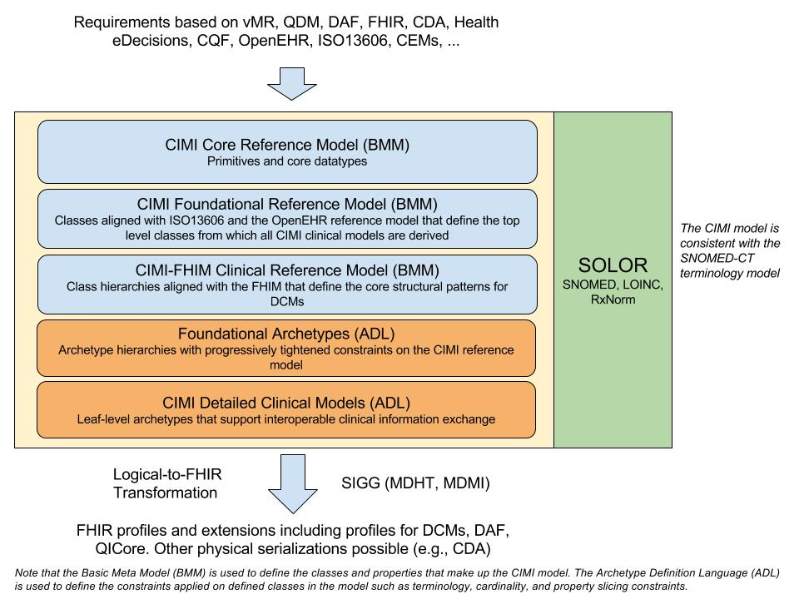

Figure - CIMI Architectural Framework

# Reference Model

The CIMI reference model defines the core structure and data types of all CIMI clinical models. Each reference model module is further described in the sections below.

## The CIMI Core Reference Model Module

The CIMI Core Reference model module introduces four core reference model hierarchies:

1. The Any hierarchy from which all CIMI primitive types are derived.
2. The DATA_VALUE hierarchy from which all CIMI complex types are derived.
3. The LOCATABLE hierarchy from which all other CIMI classes are derived.
4. The ASSOCIATION_CLASS hierarchy from which all CIMI association classes are derived (e.g., PARTICIPATION, PARTY_RELATIONSHIP, ClinicalStatementAssociation)

### CIMI primitives

Table 1 below aligns the set of CIMI primitive types and their mappings to UML and FHIR. In CIMI all primitive types derive from the Any abstract class:

Table : CIMI Primitive Mappings

|  |  |  |  |
| --- | --- | --- | --- |
| CIMI Primitives | UML Primitives | XML Primitives | FHIR Primitives |
| Boolean | Boolean | -- | boolean |
| Real | Real | -- | decimal |
| Byte | -- | byte | Byte |
| Integer | Integer | -- | integer |
| Character | Character | -- | -- |
| String | String | -- | string |
| URI | -- | anyUri | uri |
| List<T> | -- | -- | -- |
| Array<T> | -- | -- | -- |
| Any (root type) | -- | -- | Element |

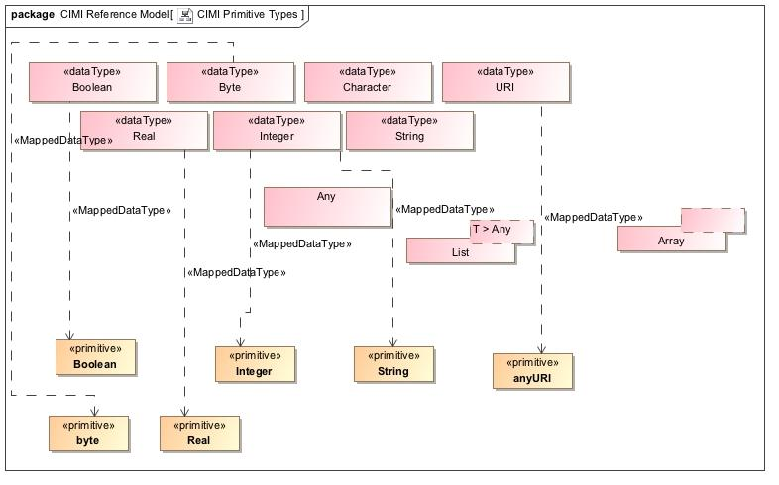

Figure - CIMI Primitive Types

### CIMI Complex Types

Table 2 below aligns the CIMI ‘complex’ data types and their mappings to FHIR. In CIMI, all complex data types derive from the DATA_VALUE abstract class:

Table : CIMI Data Type Mappings

|  |  |  |
| --- | --- | --- |
| CIMI Data Types | FHIR Primitives | FHIR Complex Types |
| DATE | date | -- |
| TIME | time | -- |
| DATE_TIME | dateTime | -- |
| COUNT | -- | Count |
| PROPORTION | -- | Ratio<Quantity> |
| QUANTITY | -- | Quantity |
| DURATION | -- | Duration |
| INTERVAL_VALUE<T> | -- | Period, Range |
| PLAIN_TEXT | string* | -- |
| CODED_TEXT | -- | Coding |
| URI_VALUE | uri | -- |
| EHR_URI | uri | -- |
| IDENTIFIER | -- | Identifier (partial match) |
| YESNO | boolean* | -- |
| PARSABLE | string* | -- |
| MULTIMEDIA | -- | Attachment (partial match) |
| ORDINAL | -- | -- |
| DATA_VALUE (root type) | -- | Element |

* *Extended FHIR primitive types*

CIMI and FHIR differ in the boundary between primitives and complex data types as shown in the table above. Moreover, a number of FHIR types do not have equivalents in CIMI. These include Annotation and SampledData, though both types can be accommodated within the CIMI CLUSTER hierarchy.

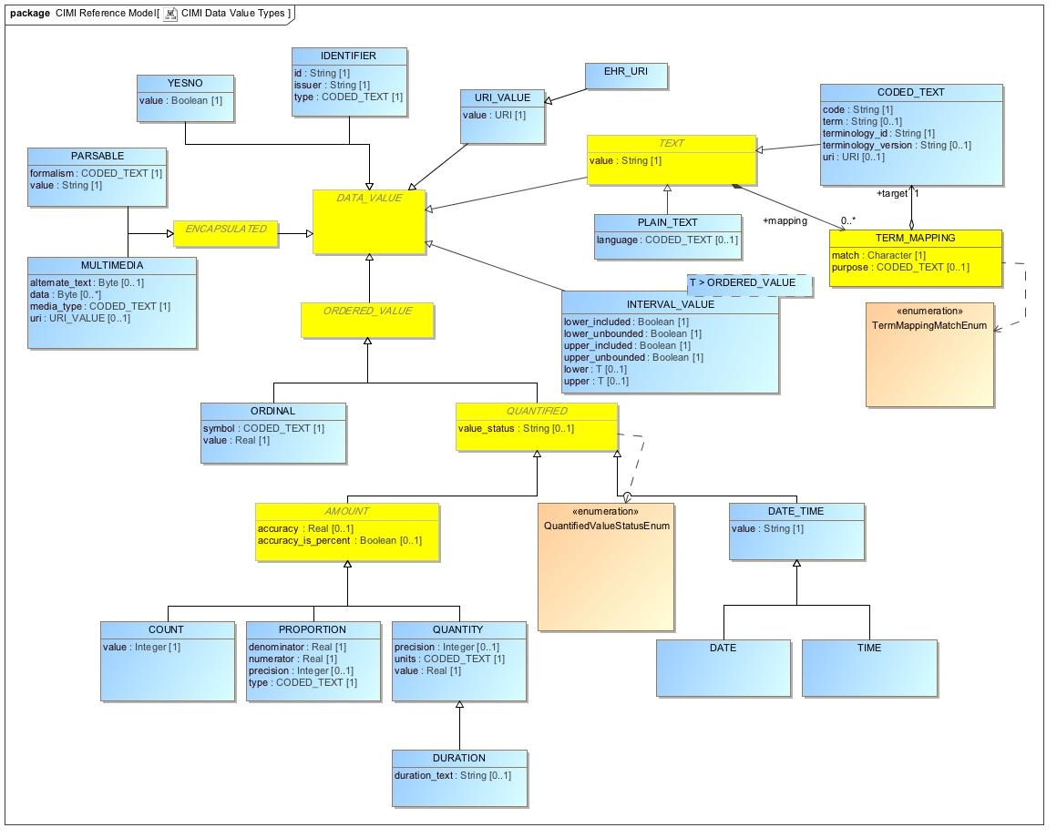

Figure - CIMI Data Value Types

### The LOCATABLE and ASSOCIATION_CLASS Root Types

All classes in CIMI, apart from CIMI primitives and complex types, derive from either the ASSOCIATION_CLASS or LOCATABLE classes. An ASSOCIATION_CLASS represents a qualified relationship between two LOCATABLEs. The source LOCATABLE is the class containing the association. The target LOCATABLE is specified by the *target attribute of the association class as introduced in specializations of this class.* For instance, *Interpretation* is a specialization of the ASSOCIATION_CLASS pattern. The source of the association, e.g. an Assertion class with an *interpretation* attribute, owns the association class. Interpretation then specifies one or more clinical statements as its *target*.

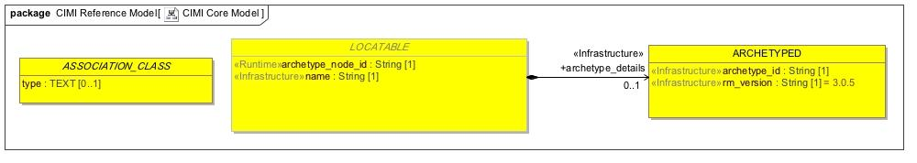

Figure - CIMI Core Model

The following sections introduce some of the reference model patterns found in CIMI that build upon the CIMI Core Reference Model Module.

## The CIMI Foundational Reference Model Module

The CIMI Foundational Reference Model is composed of the following top-level hierarchies; CLUSTER and VIRTUAL CLUSTER, COMPOSITION, CONTENT, PARTY, PARTICIPATION, and PARTY_RELATIONSHIP.

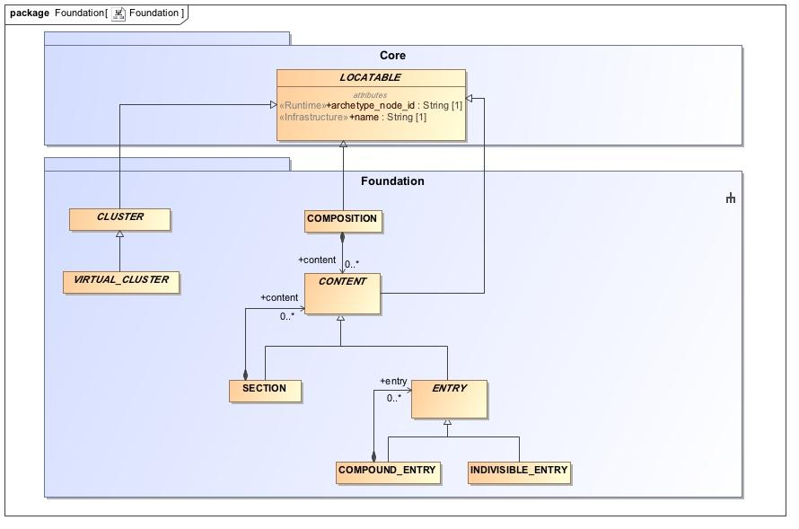

Figure - CIMI Foundational Package

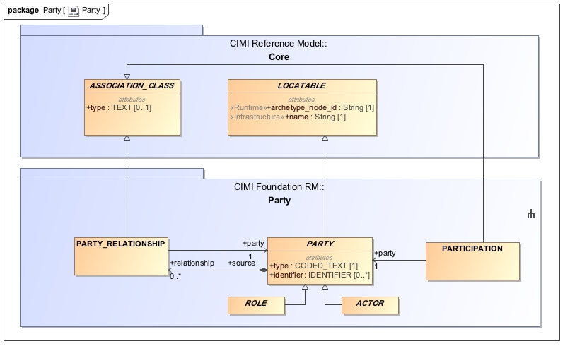

Figure - CIMI Party Package

Each hierarchy is described below.

#### The CLUSTER/VIRTUAL_CLUSTER hierarchies

The CLUSTER abstract class is the starting point for CIMI structures such as addresses, contact information, medications, and devices. Unlike CLUSTER, VIRTUAL_CLUSTER allows for the grouping of attributes to support model component reuse and consistency but whose containment structure may be ignored by tools, editors, and code generation frameworks.

The CLUSTER hierarchy differs from the DATA_VALUE hierarchy in that specializations of DATA_VALUE represent a concise set of data types (i.e., entirely defined by the values they take; e.g., a code, a quantity or a proportion) while specializations of CLUSTER are used to define the far more numerous and variable instance structures that are used to compose the reference model patterns (e.g., person names or international address structures).

#### The COMPOSITION hierarchy

At this time, the COMPOSITION hierarchy consists of a single class that can be used to represent clinical reports or patient records at the archetype level. A composition is composed of sections and content entries.

#### The CONTENT hierarchy

The CONTENT hierarchy plays a special role in CIMI because it is the parent hierarchy for Clinical Statements. The CONTENT class has the following subclasses: SECTION and ENTRY. ENTRY, in turn, has two specializations: COMPOUND_ENTRY and INDIVISIBLE_ENTRY. A COMPOUND_ENTRY can be composed of other COMPOUND_ENTRYs and INDIVISIBLE_ENTRYs thus supporting a recursive pattern which can be constrained accordingly at the archetype level. ENTRYs represent units of standalone clinical information. An example of a COMPOUND_ENTRY may be a laboratory panel or a complex orderable while an individual analyte or simple procedure may be represented by an INDIVISIBLE_ENTRY.

The SECTION content type may be used to represent sections in a document or a simple collection of entries without metadata. Note that the latter use of SECTION differs from COMPOUND_ENTRY which represents a logical grouping of entries with can hold metadata about the grouping. For instance, a laboratory panel is a type of COMPOUND_ENTRY that holds provenance information for the panel as a whole.

#### The PARTY, PARTICIPATION, and PARTY_RELATIONSHIP pattern

The CIMI Foundational Reference Model introduces the participation pattern. It defines PARTY, which may be either a ROLE or an ACTOR and a PARTY_RELATIONSHIP to represent a relationship between two parties such as an ACTOR playing one or more roles in the performance of an activity. Each class in the pattern has a type attribute to allow the binding of formal semantics at the archetype level – concept representing the type of actor or the type of role performed. These classes also serve as the root types for specializations introduced in other reference modules.

## The CIMI Clinical Reference Model Module

The CIMI Clinical Reference Model module includes the classes and structural patterns upon which all CIMI archetypes are built.

### The CIMI Party, Participation Patterns

The CIMI Clinical Reference Model Party pattern builds upon the CIMI Foundational Reference Model PARTY pattern as shown below. It adds a number of attributes to both ROLE and ACTOR and defines two role specializations: a HealthCareConsumerRole and a HealthCareProviderRole. It also defines two actor specializations at this time: a person and an organization. The association between a person or organization and the role they play in an activity is achieved by the use of PARTY_RELATIONSHIP and PARTICIPATION classes (or specializations thereof) defined in the CIMI Foundational Reference Model module.

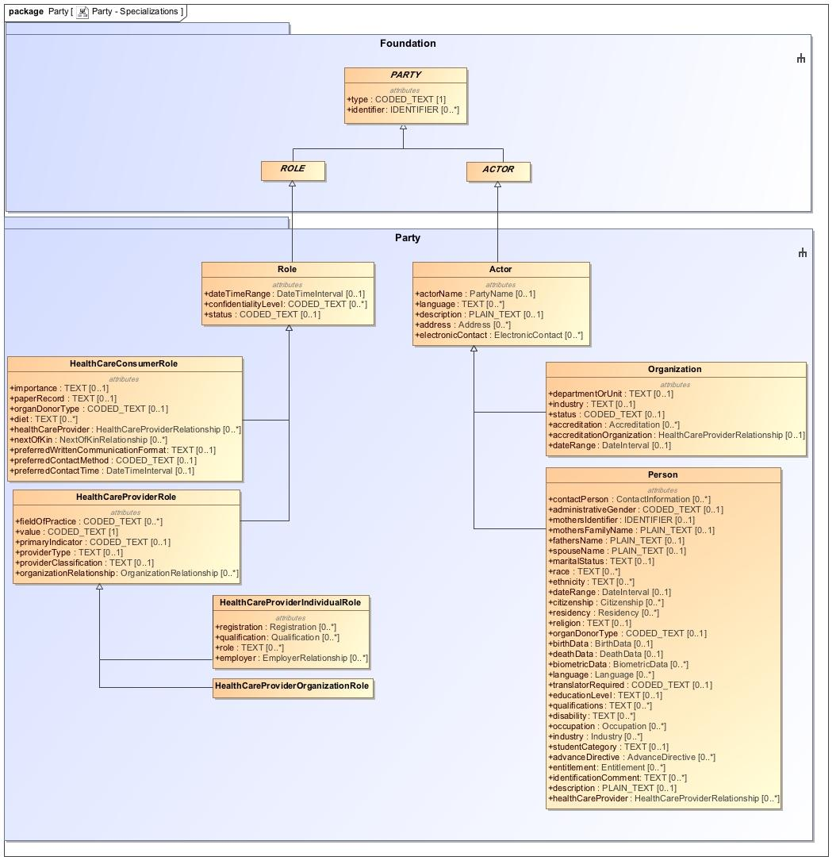

Figure - Specialization of the PARTY Class

### The CIMI Clinical Statement Pattern

The CIMI Clinical Statement Pattern forms the core of the CIMI model. The ClinicalStatement class is a specialization of the ENTRY class from the Foundation Reference Model module. It represents a statement about some aspect of a health care process. The CIMI ClinicalStatement pattern contains a statement topic (*StatementTopic)* and the situational context for that topic (*StatementContext*). The ClinicalStatement pattern also includes relevant attribution metadata for the information contained in a clinical statement (*please refer to the Attribution/Provenance Patterns section below*).

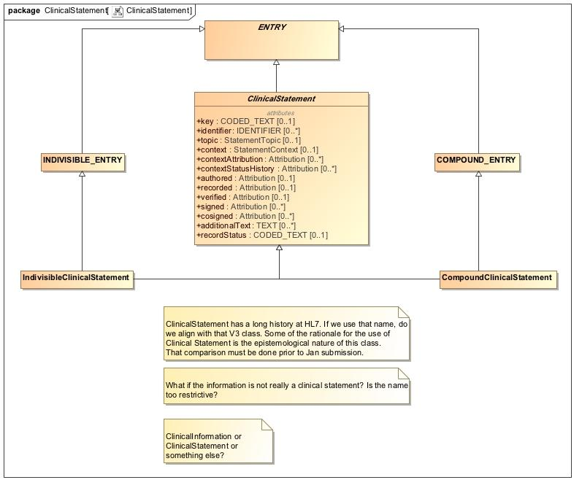

Figure - Clinical Statement Pattern

The StatementTopic abstract class has two specializations:

1. Finding, an abstract class, which is further specialized by the Assertion and EvaluationResult statement topics.
2. Act, an abstract class, which is further specialized by the Procedure and LaboratoryProcedure statement topics.

Note that for the January 2017 ballot cycle, we limit the scope of the model to the statement topics listed above. However, additional statement topics will be introduced over time.

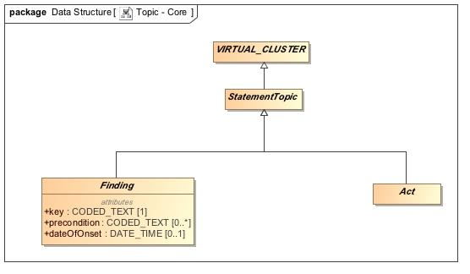

Figure - Clinical Statement Topics

The StatementContext abstract class has the following two specializations:

1. FindingContext - The FindingContext class aligns with the SNOMED Situation with Explicit Context for findings and provides the context for the EvaluationResult and Assertion topics of a clinical statement. For instance, a statement about findings may state that the finding was present or absent.
2. ActionContext - The ActionContext class aligns with the SNOMED Situation with Explicit Context for procedures and provides the context for the Act topic of a clinical statement. For instance, a statement about a procedure may specify that the procedure has been proposed, ordered, planned, performed or possibly not performed. Each action context, in turn, has its own lifecycle.

Consider a Proposal context having the following lifecycle states: initiated, reviewed, updated, approved, and rejected. Attribution information for each of these activities is captured by the ClinicalStatement.contextStatusHistory attribute while the latest status of the proposal action context is captured by the attribute ActionContext.currentStatus of type CODED_TEXT. The value of the currentStatus attribute is the Attribution.activity code associated the last status attribution in the context status history for the given context. The ClinicalStatement.contextAttribution provides attribution information for the context itself (e.g., who initiated the proposal, when, how, etc…) and typically corresponds to the first status in the context status history. This is illustrated in the diagram below. Each line represents an activity moving the proposal along one of its lifecycle states. The graph itself represents the set of allowed paths. The blue lines represent the path traversed in the lifecycle of this proposal. Each dotted line represents a valid transition though not one followed by the proposal.

*Review*

*Approve*

*Reject*

*Approve*

*Reject*

*Initiate*

Figure - Example Lifecycle of a Proposal

The ClinicalStatement.contextStatusHistory is the *ordered* list of attributions associated with each transition moving from start to finish. It consists of the following list:

|  |  |
| --- | --- |
| **State Transition attributions** | **Value of Attribution.activity attribute** |
| Initiate *(also the context attribution)* | “initiate” |
| Review | “review” |
| Approve | “approve” (also the context’s current status) |

Figure - State Transition History

The ClinicalStatement.contextAttribution refers to the *Initiate* Attribution in this context status history list.

The ActionContext.currentStatus refers to the activity code of the last transition followed by the proposal. In this case, it is the activity code of the Approve attribution or the “approve” code in this illustration.

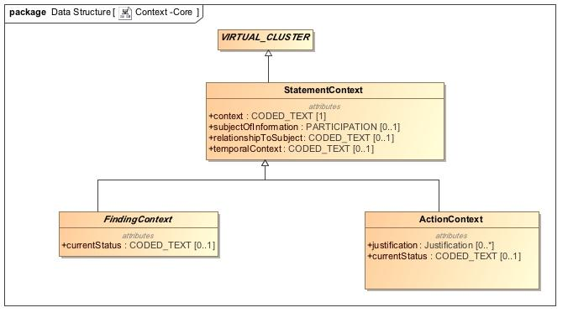

Figure - ClinicalStatement Contexts

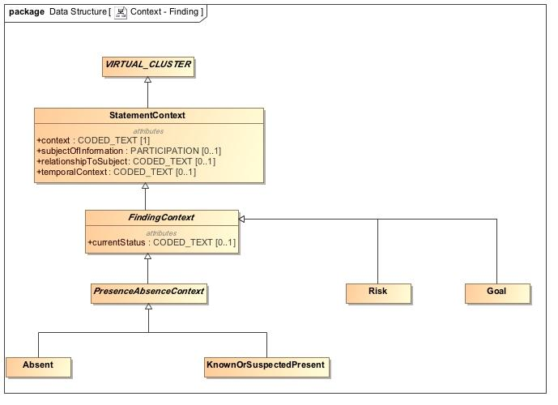

Figure - Finding Contexts

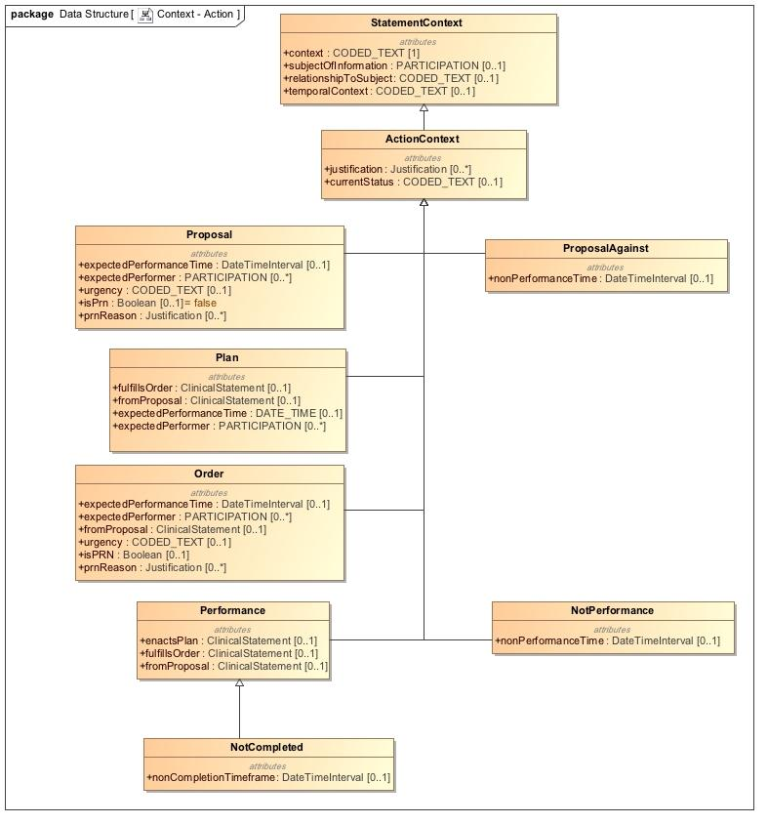

Figure - Action Contexts

StatementTopic and StatementContext are attribute groups (VIRTUAL_CLUSTERs) and have the following characteristics:

1. They are reusable components, which can be assembled to form clinical statements. For instance, one can coordinate the Procedure statement topic with the Proposal statement context to represent a ProcedureProposal. The Procedure statement topic may also be paired with the Order statement context to create a ProcedureOrder statement.
2. They represent groupings of attributes that are aligned with the SNOMED CT Concept Model. For instance, the Procedure statement topic is aligned with the SNOMED CT Procedure Concept Model. The Performance context aligns with the Situation with Explicit Context Concept (SWEC) Concept Model.
3. They provide for a mechanism to state presence or absence of a finding as well as performance or non-performance of an action. For instance, the pairing of the Procedure topic with the NonPerformance context allows for the expression of a procedure that was not performed.

The CIMI ClinicalStatement pattern aligns with the SNOMED CT Situation with Explicit Context Concept Model as defined in the SNOMED CT Editorial Guide[6]. The attributes are as follows:

* The ClinicalStatement.topic attribute aligns with the SNOMED CT Concept Model attribute as follows:
  + 246090004 | Associated finding (attribute) | if the ClinicalStatement topic is a StatementTopic of type Finding.
  + 363589002 | Associated procedure (attribute) | if the ClinicalStatement topic is a StatementTopic of type Act.
* The range of the topic (i.e., the attribute in the StatementTopic class that holds the topic concept) is defined by the SNOMED CT Concept Model attribute range as follows:
  + The Associated procedure attribute has a range of Procedure
  + The Associated Finding attribute has a range of
    - Clinical Finding or Event if the topic is an Assertion
    - or Observable entity if the topic is an EvaluationResult.
* The ClinicalStatement.context attribute aligns with the SNOMED CT Concept Model attribute as follows:
  + 408729009 | Finding context (attribute) | if the ClinicalStatement.topic is a StatementTopic of type Finding.
  + 408730004 | Procedure context (attribute) | if the ClinicalStatement.topic is of StatementTopic of type Act.
* The range of the StatementContext.context attribute is defined by the SNOMED CT Concept Model as follows:
  + “Finding context value” for the Finding context attribute.
  + “Context values for actions” for the Procedure context attribute.
* The StatementContext.relationshipToSubject aligns with the SNOMED CT Concept Model attribute 408732007 | Subject relationship context (attribute) |.
* The StatementContext.subjectOfInformation attribute is a PARTICIPATION whose type is constrained according to the range specified for the SNOMED CT concept model attribute 408732007 | Subject relationship context (attribute) |.
  + The range of Subject relationship context is Person.
* The StatementContext.temporalContext aligns with the SNOMED CT Concept Model attribute 408731000 | Temporal context (attribute) |.

### The CIMI Attribution/Provenance patterns

In the CIMI model, provenance information is represented by the Attribution class. The Attribution class provides a pattern for the capture of provenance information such as the *what, who, when, where, why*, and *how* associated with a particular activity – e.g., provenance attributes about the verification of a clinical statement.

CIMI currently includes two attribution patterns:

1. Attribution information as a part of the clinical statement – In this pattern, the ClinicalStatement pattern contains a number of attributes of type Attribution (e.g., ClinicalStatement.authored and ClinicalStatement.verified). This pattern provides a consistent way to capture attribution information that extends beyond simply the agent of an activity (e.g., the author). When attribution is part of the ClinicalStatement model, any change to the attribution for an activity will result in a version change.
2. Attribution information that is external to the clinical statement - CIMI allows the capture of provenance information that is external to the clinical statement through the Provenance class. The provenance class includes the Attribution class and pointers to one or more clinical statements (the Provenance.target attribute). This pattern allows the modification of provenance information of a clinical statement without impacting its version.

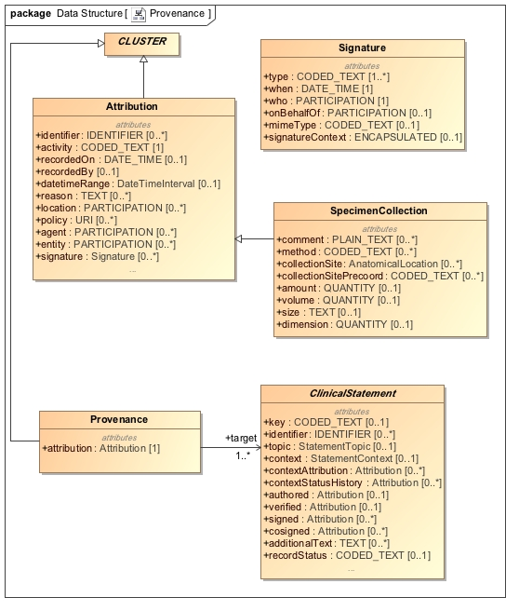

Figure - Provenance Patterns

### The CIMI Assertion and EvaluationResult Pattern

At this time, CIMI defines two specialization of the Finding Statement Topic: Assertion and EvaluationResult.

The assertion model is used to capture information about a unary clinical finding, whereas the evaluation result model is used to capture a value ascertained about an observable. An evaluation result consists of an observed characteristic (sometimes referred to as ‘the question’) and a value for the observed characteristic (sometimes referred to as ‘the answer’). At this time, no specializations for Assertion have been provided but we anticipate that this model will be specialized in the future. Two specializations of Evaluation Result are provided in the reference model: LaboratoryTestResult and PhysicalEvaluationResult. From these, a number of core archetypes are provided such as QuantitativeLaboratoryTestResult and CodedLaboratoryTestResult. These archetypes constraint the result attribute of EvaluationResult to a QUANTITY and a CODED_TEXT respectively. Please refer to the archetypes for more examples of such constraints.

For more information on the proper usage of these classes, please refer to the Style Guide section below.

Both models are shown below.

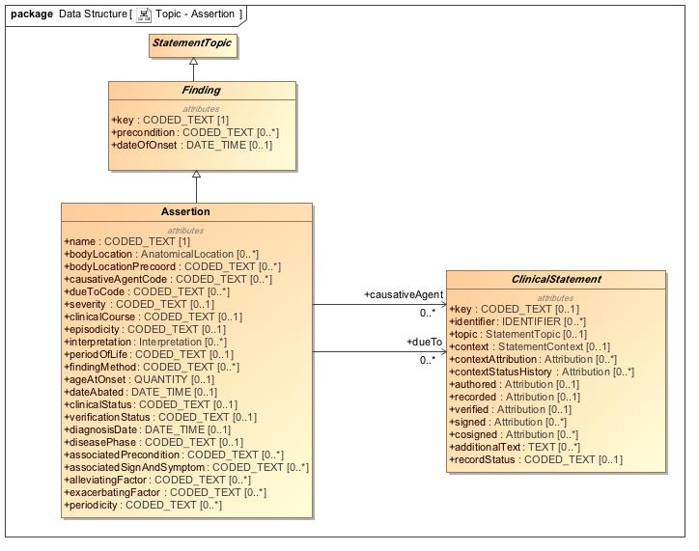

Figure - Assertion Statement Topic

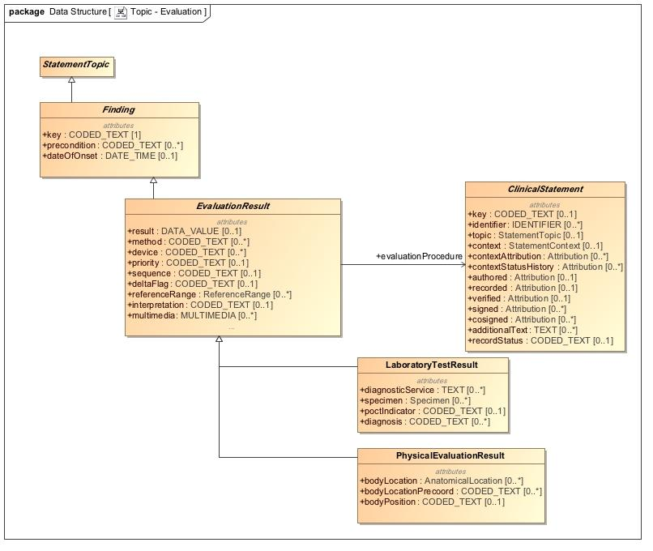

**Figure 14 – The EvaluationResult Statement Topics**

### The CIMI Procedure pattern

As part of this submission, we include an example of the Act statement topic, namely Procedure and its specialization LaboratoryProcedure. Note that both models are incomplete at this time but serve as examples for clinical statements about actions and the expression of ‘negation’ patterns in CIMI (e.g., ProcedureNotPerformed is composed of the Procedure statement topic and the NonPerformance statement context).

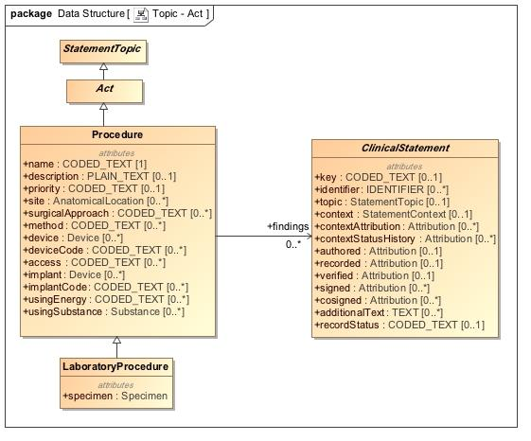

Figure - Action Topics

### CIMI Data Structures

CIMI Data Structures are reusable components that are derived from the CLUSTER supertype. They are used to define component structures necessary in the construction of CIMI patterns. Examples include structures such as Address, PartyName, BirthData, and so on. For more information on these structures, please refer to the diagrams below and to the CIMI Reference Model Specification.

### 

Figure - Material Entities

### 

Figure - Other Data Structures

### 

Figure - Address Structures

### 

Figure - Party and Related Structures

### Association Classes

The CIMI Clinical Reference Model module defines a number of association classes based on the ASSOCIATION_CLASS pattern described in the CIMI Core Reference Model module section of this document. Association classes allow the qualification of relationships and are useful when a relationship between a source and one or more targets specifies additional attributes. Examples of such association classes are the Justification and Interpretation classes, both of which derive from the ClinicalStatementAssociation class. The Association Class pattern is illustrated below:

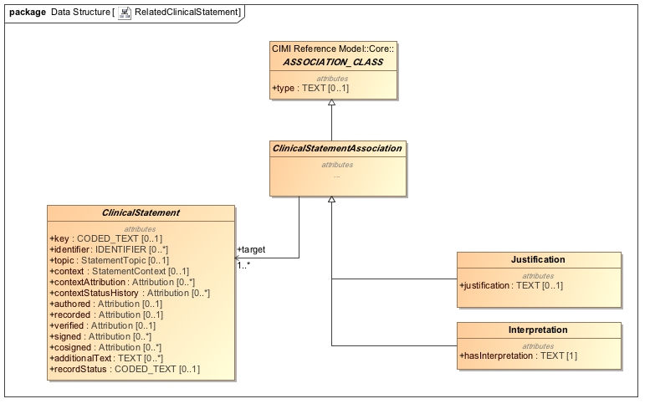

Figure - Association Class Specializations

While the ASSOCIATION_CLASS in the Core Reference Model does not define a target attribute, it is expected that specializations of the class provide a target attribute for the subtype of locatable most appropriate for the use case. This approach will be revisited when the CIMI Work Group adopts additional AML expressivity in the reference models.

# An Introduction to CIMI Archetype Hierarchies

Cimi archetypes include complete “detailed clinical models” fit for use as well as their ancestors in a hierarchy of constraints. At the top of this hierarchy are CIMI top-level archetypes, from which all CIMI archetypes are derived.

CIMI Top-Level archetypes define the following functions:

* The top level structural and type constraints for all downstream archetypes
* The top level terminology constraints for all downstream archetypes
* The top level compositional patterns (through the use_archetype constraint statement) based on reference model patterns. In this way, top-level archetypes function as ‘templates’ for downstream archetypes.

Each archetype in a hierarchy is by definition consistent with all of its ancestors.

In this section we introduce the archetype hierarchies and provide example archetypes for each of the functions described above.

## Top Level CIMI Archetypes

For this submission, the following archetype hierarchies have been developed:

### The attribution archetype hierarchy

The ***Attribution*** hierarchy includes a number of specializations of the Attribution reference model pattern useful for archetype development and for capturing provenance information about activities. These include archetypes for the following activities: *author, record, sign,* and *verify* which are referenced in clinical statement archetypes. These archetypes illustrate the *use_archetype* pattern, whereby an archetype can reference another archetype in its definition. *Please note, however, that Attribution archetypes do not yet specify the required terminology bindings for coded attributes. These bindings will be addressed in a later submission.*

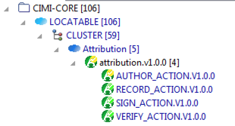

Figure - Attribution Archetype Hierarchy

The example below shows how the base clinical_statement archetype refines the reference model ClinicalStatement class by constraining the ClinicalStatement.authored attribute of type Attribution to those constraints specified by the author_action archetype:

archetype (adl_version=2.0.6; rm_release=2.0.2; generated)

CIMI-CORE-ClinicalStatement.clinical_statement.v1.0.0

definition

ClinicalStatement[id1] matches {

...

*authored* matches {

**use_archetype** *Attribution* [id8, **CIMI-CORE-Attribution.author_action.v1**]

}

recorded matches {

use_archetype Attribution [id9, CIMI-CORE-Attribution.record_action.v1]

}

verified matches {

use_archetype Attribution [id10, CIMI-CORE-Attribution.verify_action.v1]

}

signed matches {

use_archetype Attribution [id11, CIMI-CORE-Attribution.sign_action.v1]

}

cosigned matches {

use_archetype Attribution [id12, CIMI-CORE-Attribution.sign_action.v1]

}

...

}

### The StatementContext hierarchy

The StatementContext hierarchy specializes CIMI clinical statement contexts in conformance with the SNOMED CT Situation with Explicit Context. This hierarchy has two branches:

* Specializations of the *finding context* which include *Goal, Risk, Absent,* and *Known_Present.*
* Specializations of the *action context* which include *Non_Completion, Non_Performance, Order, Performance, Plan, Proposal, and Proposal against.*

Additional specializations of the statement_context archetype will be added over time.

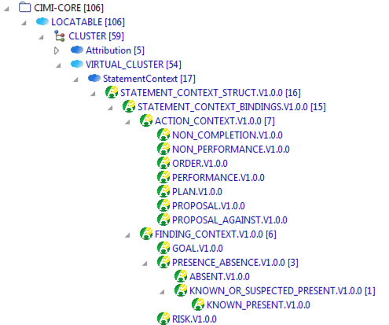

Figure - Statement Context Archetype Hierarchies

Statement context archetypes promote a compositional (and reusable) approach for specifying the context of a clinical statement’s topic such as whether a finding was present or absent or an action performed or not performed (see Clinical Statement Pattern below). They also provide important attribution information, which can be appropriately constrained in specializations. The statement_context archetype initially bind the meaning of StatementContext attributes to the corresponding SNOMED CT Situation With Explicit Context concept model attributes. It also defines high-level range constraints for the *context* attribute. The specializations of the statement_context archetype progressively constrain the set of allowable values for the *context* attribute. For instance, the ActionContext specifies that the *context* attribute’s range must be a descendant of the concept | Context values for actions | 288532009 (<=)(< Q). The Proposal archetype further constrains this range to a single code |Under consideration (qualifier value)| 385642001 (==).

### The Statement Topic Hierarchies

The Statement Topic hierarchy will probably be the most active hierarchy in CIMI. The StatementTopic class and archetype specializations represent the core clinical expressivity of a domain. At this time, only a few specializations have been introduced. More will be added over time. They are listed below:

* The ***Act*** archetype hierarchy introduces the top-level archetype for procedures and is aligned with the SNOMED CT Procedure concept model. A specialization of Procedure, Laboratory_Procedure is included as an example of a procedure specialization though it remains underspecified at this time.
* The **Findings** archetype hierarchies introduce two core specializations at this time: Assertion and EvaluationResult. EvaluationResult introduces two further specializations: Laboratory_Test_Result and Physical_Evaluation_Result. Additional specializations of PhysicalEvalutionResult have been added to illustrate the definition of archetype constraints in the context of a wound assessment. Please refer to the illustration below and to the archetype library for additional details.

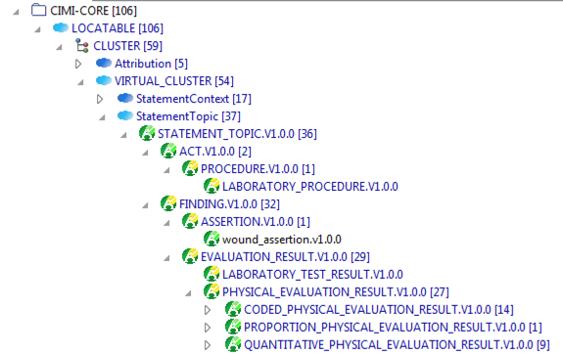

Figure - Top Level Statement Topic Hierarchies

### The Clinical Statement Hierarchies

Archetype constraints on the ClinicalStatement reference model pattern form the core of the CIMI model. As part of this submission we include a number of illustrative though partially complete clinical statement archetypes. They fall into two main categories:

1. Archetypes that support the wound assessment use case. They illustrate the use of archetypes to define panels and clinical statements about findings.
2. Archetypes that illustrate the compositional nature of the ClinicalStatement pattern. Two examples are provided: ProcedureProposal and ProcedureNotPerformed.

The top-level clinical statement hierarchy is illustrated below:

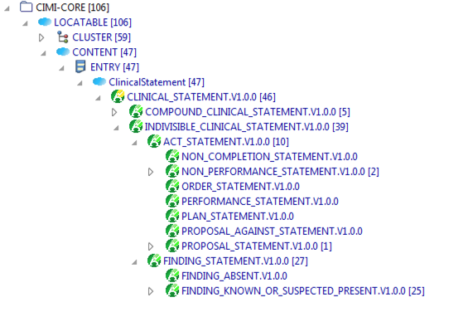

Figure - Top Level Indivisible Statement Hierarchies

Examples of Compound Clinical Statements:

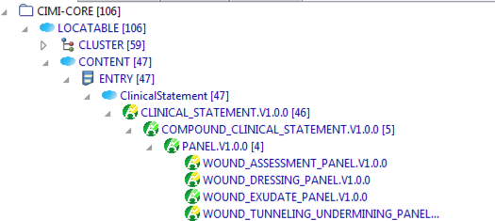

Figure - Top Level Compound Statement Hierarchies

The action clinical statement archetype hierarchy is developed by progressively constraining the context of the clinical_statement core archetypes along the indivisible and compound clinical statement axes as shown below:

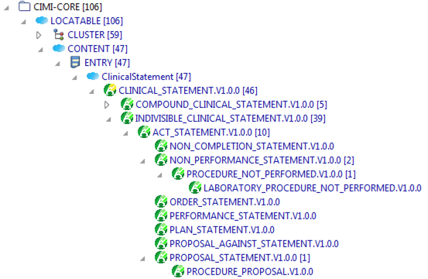

Figure - Act Clinical Statements

A similar approach is taken for clinical statements about findings:

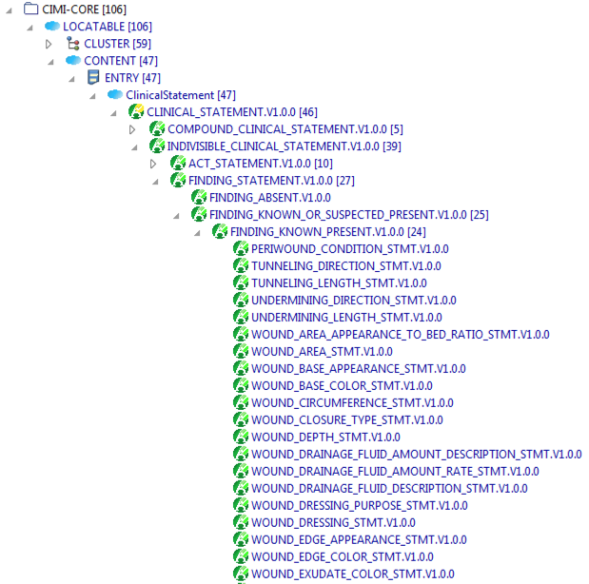

Figure - Finding Clinical Statements

### A Note About Other Cluster Archetype Hierarchies

At this time, the StatementTopic and StatementContext hierarchies are the only two CLUSTER archetype hierarchies defined. In the future, archetypes will be developed for all reference model classes originating from CLUSTER.

In the following sections, we elaborate on the functions of archetype hierarchies.

## Top Level Value Set Constraints

Top level archetypes often constrain the range of coded attributes by binding them to intentionally defined value sets. For instance, the statement_context archetype constrains its *context* attribute to the intentional value set resulting from the expression < 288529006 |Context values (qualifier value)|. Any specialization of this archetype must define value set constraints on the *context* attribute that are consistent with this intentional definition. That is, all downstream value set constraints must be subsets of the value set expansion that result from the evaluation of the above expression. The action_context archetype specifies the following constraint on the *context* attribute: < 288532009 |Context values for actions (qualifier value)|. The specified constraint is valid because the concept 288532009 is properly subsumed by the concept 288529006. In turn, the specialization *proposal* of action_context further constrains the attribute *context* to the following expression: = 385642001 |Under consideration (qualifier value)| (i.e., a value set consisting of a single code). This, too, is a valid constraint, since this one-code value set is subsumed by all parent value sets defined above it. This is illustrated below:

statement_context

context: < 288529006

action_context

context: < 288532009

proposal

context: = 385642001

**Archetype**

**Value Set**

**Bound to**

**Bound to**

**Bound to**

Figure - Progressive Value Set Constraints

## Archetypes that constrain attribute types

The CIMI EvaluationResult Statement Topic pattern specifies that the result of an evaluation has as its type the abstract class DATA_VALUE. Doing so enables modelers to constrain the type of the *EvaluationResult.result* attribute into any valid specialization of DATA_VALUE. Such an archetype pattern allows modelers to define families of models entirely within the archetype layer of the CIMI model such as a quantitative_physical_evaluation_result which constrains the result attribute to a QUANTITY type (a valid subtype of DATA_VALUE). Similarly, modelers may with to create a coded_physical_evaluation_result which constrains the result attribute of EvaluationResult (or any of its reference model specializations) to a CODED_TEXT. Further archetype specializations can be defined. Note that a subtype cannot relax a parent constraint. For instance, a specialization of coded_physical_evaluation_result cannot set the type of the result attribute as TEXT since TEXT is the supertype of CODED_TEXT and such a constraint would loosen rather than tighten the parent constraint. This is illustrated below:

physical_evaluation_result

result: DATA_VALUE

coded_physical_evaluation_result

result: CODED_TEXT

quantitative_physical_evaluation_result

result: QUANTITY

evaluation_result

result: DATA_VALUE

Figure - Type Constraints

## Archetypes as templates

As described earlier in this document, the ClinicalStatement reference model pattern is one of the core patterns of the CIMI model. However, the ClinicalStatement pattern only becomes meaningful through the archetype patterns derived from it.

The StatementTopic, StatementContext, and ClinicalStatement classes serve as the reference model patterns for three top level archetype hierarchies:

1. The StatementTopic archetype hierarchy is the parent hierarchy for all clinical statement topic archetypes such as the Procedure, Assertion, and EvaluationResult archetypes. Each archetype in this hierarchy further constrains the StatementTopic reference model pattern.
2. The StatementContext Archetype hierarchy is the parent hierarchy for all clinical statement context. Much like the statement topic hierarchy, the statement context archetype hierarchy defines the set of statement context archetypes such as the Performance, NonPerformance, Order, Plan, Proposal, Absent, KnownOrSuspectedPresent context archetypes which specialize the more general top-level StatementContext archetype.
3. The ClinicalStatement archetype hierarchy lays out the compositional framework for the definition of specific clinical statements through the inclusion of the correct specialization of the statement topic and statement context archetypes. For instance, while the clinical_statement archetype states that the topic must be constrained to be a statement_topic archetype and the context must be constrained to be a statement_context archetype, a specialization of the clinical_statement archetype, say procedure_proposal, may constrain the parent clinical_statement archetype pattern by specifying that the topic must be Procedure (a valid specialization of the StatementTopic pattern) and that the context must be the Proposal archetype (a valid specialization of the StatementContext pattern). Hence, rather than defining ClinicalStatement specializations in the reference model, all specializations are defined as constraints on the parent clinical_statement archetype within the archetype layer of the model. This approach is illustrated below:

Clinical statement

Statement topic

Statement context

Act

Procedure

Indivisible clinical statement

Act statement

Proposal statement

Procedure proposal

Action context

Proposal

use_archetype

use_archetype

use_archetype

use_archetype

use_archetype

use_archetype

Figure - The Clinical Statement Pattern in Archetypes

The act_statement archetype definition is shown below:

IndivisibleClinicalStatement[id1.1.1] matches {

**topic** matches {

**use_archetype** Act [id4.0.1,

**CIMI-CORE-Act.act.v1**]

}

**context** matches {

**use_archetype** ActionContext [id5.0.1,

**CIMI-CORE-ActionContext.action_context.v1**]

}

}

# The CIMI Style Guide

The purpose of the CIMI style guide is to provide guidance to clinical modelers on the use of the CIMI model to represent clinical information. The CIMI style guide documents preferred modeling styles and conventions, approaches to terminology bindings, and describes the usage of the key patterns to address important clinical use cases (e.g., how to model a panel or problem list in CIMI). Please note that for the January 2017 ballot cycle, we are only describing the Statement Topic Patterns as this is a work in progress. The Statement Context and Clinical Statement patterns are introduced in the Architecture section of this guide and will be described further in this style guide in the next ballot cycle ballot.

# Modeling Style

In this section, we provide a brief introduction to the following CIMI modeling principles:

* Quality criteria
* Scope of clinical models
* Model Granularity, Reuse, and Composition
* Iso-semantic models
* Terminology Binding, and
* General principles

## Quality Criteria

The following quality criteria have been proposed for all CIMI models:

CIMI models:

* Shall satisfy the URU principles – that is they will be
  + Understandable (cohesive and coherently expressed)
  + Reproducible Reliable and Reusable (consistency)
  + Useful (fit for purpose)
  + Up-to-date (currency)
* Shall be clinically accurate
* Shall be clinically valid, as demonstrated by prior or concurrent use
* Shall be evidence-based, as demonstrated by peer reviewed studies
* Shall be adequate to express required clinical statements
* Shall maintain contextual integrity (when transformed into iso-semantic models) (ditto)
* Shall maintain semantic fidelity (when transformed into iso-semantic models) (ditto)
* Shall be clear and precise, minimizing the potential for:
  + Misinterpretation and
  + Misuse or inconsistency in use
* Shall be suitable for easy implementation and avoid cognitive overload of users

These criteria will be assessed through clinical and technical reviews and through pilot implementations.

# Scope of Clinical Models

The following principles have been proposed to assist in determining the inclusion or exclusion of information within a CIMI clinical model

The following information will be *included* in CIMI clinical models:

* Information that is considered to be directly relevant to the clinical concept being modeled.
* Information that describes the who, what, when, where and how of the clinical concept being modeled.
* Information that may either be represented using pre-coordination or post-coordinated in the structure – for example, the body location of a diagnosis.
* Information that is not described in the exclusion list below.

The following information will be excluded from CIMI clinical models:

* Information that is specific to an implementation use-case - for example, recordkeeping metadata (unless the model is specifically designed for this purpose).
* Information that is used for administrative purposes only – e.g. financial details (unless the model is specifically designed to include such information)
* Information that is specific to a local environment (e.g. to satisfy local legislation requirements).
* Information that is considered not to be directly related to the clinical concept being modeled.
* Information that is better captured in terminologies and ontologies such as the classification of a medication in a medication hierarchy or concept definitional expressions.

# Model Granularity, Reuse, and Composition

The granularity of the CIMI model is defined in several layers. The Core Reference Model specifies the primitive and complex types. The Foundational Reference Model defines the foundational constructs from which all clinical patterns are derived. The Clinical Reference Model defines the specializations of the foundational construct relevant in the clinical domain. Archetypes then constrain these structures to define families of objects that differ purely on the constraints they apply to underlying patterns. In a good design, archetype constraints are applied progressively in order to ensure greater consistency at the leaf-level archetypes through the progressive tightening of constraints.

The CIMI model takes a compositional design approach where structures originating from different hierarchies are assembled to form the final product. The Clinical Statement pattern described in the architectural section is an example. The Object Oriented modeling principles of cohesion and coupling apply. Component structures are designed to maximize cohesion and loose coupling. Such an approach enhances consistency, ease of use, ease of maintenance, extensibility, and ease of archetype development through reuse.

Composition should be favored when:

* Specializations would require multi-inheritance or mixins - A ProcedureProposal has both Procedure and Proposal components.
* The components can be reused - A ProcedureProposal and a MedicationProposal both share the proposal attributes.
* The components favor cohesion and loose coupling - A statement context is a structure that aligns with the context of a Situation with Explicit Context and cleanly wraps its attributes into a single class that can be reused consistently in different use cases.
* The components are not foreign to the clinical modelers who use them to assemble their models.
* The patterns defined by these more granular components are understandable to clinical modelers. For instance, it is considered to be good clinical practice for instances of these data items to be observed, evaluated or performed together, using the same who, what, when, where and how information. For example systolic and diastolic blood pressures may will be included together within a single ‘Blood Pressure’ evaluation panel.

# Isosemantic Models

The CIMI Working Group recognizes that it is unlikely that a one-size-fits-all will accommodate the wide variety of clinical and implementation use cases. As such, the CIMI architecture supports alternate representations of the same model to address the requirements of specific use cases. While, generally, such variations in expressivity are not recommended (CIMI defines a ‘preferred’ set of models), it is sometimes inevitable. For instance, interface models may have different modeling requirements than persisted models or logical models.

The CIMI architecture should thus support the definition of iso-semantic models, sets of semantically equivalent models that differ in primarily in their structure and terminology pre-coordination.

CIMI also intends to supports the ability to transform models into their iso-semantic counterparts. In particular, CIMI aims to support:

* The ability to transform CIMI models to/from isosemantic representations in other languages/ standards (e.g. CDA, openEHR, ISO13606, DCM, CEM), through a common logical model intermediary and
* The ability to transform CIMI models between isosemantic representations that use a different split between terminology pre-coordination and structure.

Once identified, iso-semantic model sets will be defined by the following:

* A “preferred” model that provides the most fully articulated representation of the information
* Associated models with identical semantics but different structures
* Formal rules for transforming the associated model features into the preferred model features; e.g.,
  + Turning a pre-coordinated concept (e.g., suspected Lyme disease) into a set of explicitly bound attributes(Lyme disease + suspected);
  + Turning a concept binding (sphygmomanometer) into an associated class characterized by that binding (device + type = sphygmomanometer)

Iso-semantic models can be defined in:

1. The reference model - Such model typically differ in their core structure.
2. The archetype layer - Such models typically differ in the constraints they apply to an underlying structure that supports some variability (typically through a design by constraints modeling approach).

Iso-semantic models that vary in their degree of pre-coordination can generally be addressed at the archetype layer through attribute occurrence constraints. For instance, the Assertion reference model pattern specifies two attributes: a bodyLocation and a bodyLocationPrecoord. Two iso-semantic models can be derived - one obtained by constraining out bodyLocation and using a pre-coordinated term for the body location. Another variant of the same model may constrain out bodyLocationPrecoord and post-coordinate the body location in the model.

Iso-semantic reference model classes can be introduced using reference module extensions but this use case will not be described in this document.

A question may arise as to when the first approach is preferred over the second.

# Terminology Binding

*Terminology binding*refers to “the assertion of a relationship between the information model and the terminology” [CIMI Glossary]. This binding involves attaching a terminology concepts, reference sets or expressions to a node or link in an information model.

There are four main use cases that motivate terminology binding to CIMI models:

1. To support the management and quality control of clinical model libraries, including:
   1. Searching model libraries (using the meaning of the models and their contents)
   2. Identifying semantic overlap between models
   3. Identifying inconsistency of model interdependencies (e.g. the meaning of a constrained archetype is not subsumed by the meaning of the base archetype)
2. To determine the iso-semanticity of two or more instances of models that are semantically equivalent, but structurally different; and to be able to transform between these isosemantic representations, including:
   1. Models that use a different level of precoordination versus structure;
   2. Models that make different modeling design choices (e.g. Representing a laboratory test’s method as a data element, versus a CLUSTER containing data elements)
3. To enable querying over data instances of isosemantic model representations (as described above)
4. To support data validation and semantic interoperability (e.g. exchanging data between systems that use different native information structures)
   1. By confirming that instance data conforms to the semantic specification
   2. By supporting the construction of valid description logics for instance classification & application of decision support and other analytic tools.

It is proposed that these use cases be met by the fulfilment of the following requirements:

1. A standard, reproducible methodology for defining the meaning of each node in the model using an association with the a terminology;
2. A standard, reproducible methodology for defining the valid set of values of each coded data element in the model (either explicitly or as a constraint expression)
3. A standard, reproducible methodology for establishing semantic relationships between nodes in the same model.
4. Terminology bindings that allow the values to be represented in a way that is agnostic to the degree of pre-coordination versus structure.
5. Terminology bindings that enable the transformation between iso-semantic representations of the same model
6. Terminology bindings that allow consistency to be checked within models, and between models related by specialisation or slot filling.

## Terminology Binding Guidelines

All finalised CIMI Clinical Models shall:

* Include a semantic “concept binding” for each data element in the model to a terminology concept, expression or pattern, which represents the meaning of the data element.
* Include a “value binding” from each node of type CODED_TEXT to a terminology reference set that indicates the valid values for the node – either defined intentionally using a constraint expression, or extensionally as a list of terminology components.

All finalised CIMI Clinical Models may (where appropriate):

* Include a constructor binding on appropriate container-type nodes (e.g. ENTRY, CLUSTER), in the form of a terminology expression, to help determine its iso-semanticity with other model representations.

### Semantic Model Binding

If the CIMI attribute aligns with the SCT concept model, then the attribute will be bound to descendants of Concept model attribute ID 410662002 (note that children of Unapproved attribute (attribute) ID 408739003 should not be used). If there is no attribute binding (e.g. temporal attributes such as “start time”) then use descendents from the “observable entity” domain if an equivalence exists.

To support terminology bindings to SNOMED CT components that are not available in the international release, CIMI will develop a SNOMED CT extension in the CIMI Namespace (namespace id: 1000160). This namespace has been allocated and registered by the IHTSDO.

### Semantic Model Range Binding

Value bindings will use SNOMED CT wherever possible – however, where the values are outside the scope of SNOMED CT, other terminologies (e.g. LOINC answers) may be selected (on a case-by-case basis).

When a data element is further refined as a specialization (e.g. skin assessment site is a body location), the value set range must come from the range of the parent data element (e.g. skin assessment site is a subtype of body location) Subtype attribute binding can stay the higher level attribute.

### Value Set Binding

Bindings for a value sets have not been finalized or agreed upon by the CIMI working group. This will be discussed in a future ballot. Note Reviewers: we would love your input on this.

## Modeling Layers

In order to ensure consistency among models, all CIMI clinical models will be based on one or more predefined reference model patterns (top row in table) and corresponding top level archetypes (lowest row in table). An illustration of such modeling patterns is shown below. The first-layer of Clinical Models, developed based on these modeling patterns, will (wherever possible) be free of specific use-case context, specialty context, care-setting context and implementation-purpose context. Additional levels of context will be added progressively, to enable a maximum level of reuse and consistency between these context-dependent models.

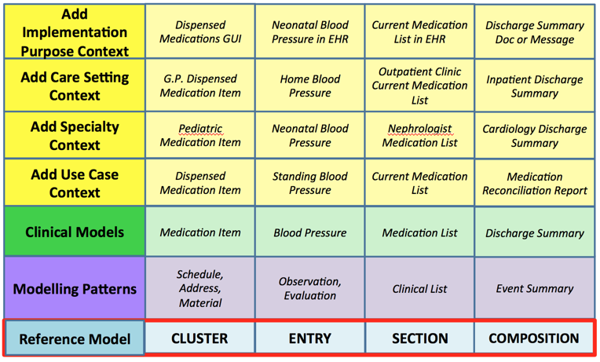

Figure - Illustration of CIMI Modeling Layers

# Topic Patterns

The topic patterns CIMI has developed to date include Evaluation, Assertion and Procedure. They are described below. Future patterns include medication administration, encounter, etc.

## Assertion

The Assertion Pattern is used to represent a clinical finding. Assertions may:

* assert the presence (or absence) of a condition in a patient, for example:
  + ChestPainAssertion asserts the presence of chest pain
  + ChestPainAbsenceAssertion asserts the absence of chest pain
  + EdemaAssertion asserts the presence of edema
* assert the presence (or absence) of an apparatus, for example:
  + VentilatorDeviceAssertion asserts the presence of an oximeter
* assert the presence of a therapeutic apparatus, such as:
  + compression stockings or a warm blanket
* assert the occurrence (or non-occurrence) of an event in which the patient was involved, for example:
  + an auto accident
  + a natural disaster

The assertion pattern is as follows:

* Key = a code meaning “assertion”
* Data = a code representing what’s being asserted (“rash”, “auto accident”, “hypertrophy”, etc.)

Another pattern that could have been selected is:

* Key = a code representing what’s being asserted (“rash”, “auto accident”, “hypertrophy”, etc.)
* Data = “present” or “yes”

The rationale for selecting the first pattern is twofold:

1. It was judged to be most consistent with the semantics of terminologies that inform CIMI semantics. The “key” and “result” form a “question”/”answer” or “test”/”result” pair. In cases of measurements, this is more obvious. For example, in a heart rate measurement model, the “key” or “test” is “heart rate measurement” (or the question is “what is the heart rate measurement?”) and the “result” captures “60 bpm”, “70 bpm”, etc. (the answer, or result). Given this, in the first pattern, the “key” or “test” is “assertion” (or the “question” is “what is being asserted?”), and the “result” holds the “result”/”answer” (the thing being asserted).
2. In the second pattern, if “rash” were the “key”, and “result” held “present’, then the meaning of the “key” (to fit the “question”/”answer” or “test”/”result” paradigm) is actually “evaluation of whether a rash is present or absent”, not “rash” as a condition in the patient. The latter, though, is the meaning of the concept in a terminology such as SNOMED CT. In contrast, in the first pattern, the code that populates “result” is consistent with the SNOMED meaning. Thus the first pattern and not the second facilitates mappings to standards.

The pattern followed the conclusions of the HL7 TermInfo effort. The HL7 TermInfo project[7] sought to specify guidelines for using SNOMED CT concepts within the HL7 Reference Information Model. The group followed the reasoning of 1) above. Hence, using the first pattern aligns the CEMs with the TermInfo effort.

### Assertion Subtypes

The assertion subtypes are not yet created for this ballot but we expect to create the following subtypes.

#### Clinical Assertions

Clinical Assertions assert the existence of clinical conditions, diseases, symptoms, etc. in the patient. The partial model ClinicalAssertion (whose key is “Assertion”) is used as the parent. A specific Clinical Assertion extends Assertion with any additional qualifiers necessary for the specific data element. It also constrains the data code of Assertion to a code representing the condition or disease being asserted. Figure XXX shows the example of LesionAssertion. Other examples are CoughAssertion, NauseaAssertion, and DiabetesMellitusTypeOneAssertion, etc.

#### Event Assertions

Event Assertions are used to assert that an event involving the patient occurred, e.g., auto accident, poisoning, burns, etc. It is expected that the concepts used to populate “data” would be mappable to concepts in the SNOMED event hierarchy.

#### Device Assertions

Device Assertions are used to assert the presence of an apparatus or piece of equipment relative to the care of the patient (e.g., warm blanket, IV pump, compression hose, etc.) or a condition of such apparatus or equipment (e.g., tube leak, ventilator piston centered, chest tube patent, etc.). A specific Device Assertion extends Assertion with any additional qualifiers necessary for the specific data element. It also constrains the data code of Assertion to a code representing the apparatus or equipment observed to be present.

## EvaluationResult

An evaluationResult model is a model that documents a characteristic of a patient or a patient-related situation based on an evaluation. An evaluation result may hold the name of a “test” in the key property (e.g., “heart rate evaluation”, “serum glucose lab test”, etc.) and the test result value in the “result” property. Viewed another way, the evaluation result key holds a "question" (e.g., "what is the heart rate?", "what is the serum glucose?") and the “result” holds the answer. Any archetype (a laboratory test, a vital sign, a questionnaire question, etc.) that fits this pattern of a name and a value is modeled with the EvaluationResult pattern.

The result attribute of the EvaluationResult model is typically a QUANTITY, or CODED_TEXT. The QUANTITY data type consists primarily of a numeric (real) value and a unit of measure. The unit of measure is captured by a code. QUANTITY evaluations are often constrained to a valid “unit of measurement” value set (e.g., “length units of measure”, “mass units of measure”, etc.).

The ORDINAL data type consists primarily of a code that has an inherent ordering within a set of codes. An example of an ORDINAL component is “severity”. The value set for severity includes codes for “mild”, “moderate”, and “severe”. The codes would have properties or relationships that capture the ordering among them, i.e., “mild” < “moderate” < “severe”.

Coded Text is used when the answer drawn from a set of coded values. Hair color, urine description, cardiac rhythm, and cervical consistency are examples. In each case, the coded values are adjectives that describe the property.

Most archetypes constraining EvaluationResult will specify an observable code for the characteristic to be evaluated (blood glucose, skin moisture, etc.) in the key property, and the appropriate range of answers for that characteristic’s result value, whether that is a set of coded concepts, a quantitative dimension, or some other type. They may also further constrain other properties (body site, specimen), and they may introduce subordinate evaluations (e.g., exercise state).

When using the EvaluationResult pattern it is important to note that it does not represent the procedure used to obtain the result. CIMI delineates the act from the description of the state uncovered by the act. The act of evaluating or assessing is captured by the Procedure pattern.

At least three use cases exist pertaining to use of the EvaluationResult pattern (for example, the capture of the result of a heart rate evaluation).

1. The most common use case is to capture the results of the evaluation and retrieve them for display, calculations, trending, decision support, etc. In this case, documenting the process of capturing the value may or may not be important and if relevant, it would be captured using the Procedure pattern (e.g., through the ProcedurePerformed clinical statement archetype).
2. In certain circumstances, the desire might be just to document that a heart rate evaluation was performed – regardless of the value of the resulting evaluation. In this case the Procedure pattern is used. For example, a protocol may dictate that heart rate evaluations be taken according to a time schedule, and an application monitoring protocol compliance may query to ensure that the evaluations were taken. In this case, the evaluation values are inconsequential. Note that in this case, one may query for evaluation procedures that match the given criteria or for any evaluation result indicating that the procedure was performed in cases when the evaluation procedure is not recorded. *However, it is very important to note that the absence of evaluation results does not necessarily indicate that a procedure was not performed.*
3. Finally, in certain circumstances it might be desirable to explicitly document that a heart rate evaluation was *not* performed. Again, an example may be that a protocol requires that heart rate evaluations be taken; users need a way to note exceptions to the protocol and monitors of the protocol need a way to detect the exceptions. In these cases, one should document this fact using a clinical statement such as ProcedureNotPerformed, which combines the Procedure topic with the NonPerformance context.

### Evaluation Subtypes

#### Laboratory Evaluation

A laboratory evaluation archetype contains properties specific to the lab evaluation process. These may include information about the physical process (e.g., specimen) as well as process management information (e.g., status).

#### Physical Evaluation

A physical evaluation archetype contains properties specific to the clinical evaluation process. These include information about the physical examination process (e.g., patient position, body site).

**Guideline: Assertion versus Evaluation**

In most cases, the decision between using the evaluation result pattern and the assertion pattern is intuitive and straightforward. “Urine color”, for example, is clearly best modeled as an evaluation result– the property being evaluated is the color of the patient’s urine, and the value (data) of the evaluation is the set of codes representing the colors that may be observed. To model urine color as an assertion would require the creation of a large number of precoordinated concepts – the key would be “assertion”, and data would be populated by a set of codes such as “amber urine” (meaning “the patient has amber urine”), “clear urine”, etc.

However, this highlights the fact that an evaluation result model may be transformed into an assertion model. (Conversely, an assertion model may be transformed into an evaluation model.) In the case of urine color, the decision is intuitive. But in other cases, the decision is less clear.

For example, “heart rhythms” (bradycardic, tachycardic, etc.) may be modeled as multiple assertion models (bradycardia, tachycardia, etc.) or as a “heart rhythms” evaluation model whose data is constrained to a value set (containing “bradycardic”, “tachycardic”, etc.).

The general guideline is if it’s most natural to think of the data element as a noun – as a condition or state that exists in the patient – model as an assertion or set of assertions. If the statement about the patient is most naturally thought of as a name/value pair (i.e., a noun representing the property and an adjective representing the value), such as “hair color” = (“black”, “brown”, “blonde”), then model it as an evaluation. However, it is important to note that both styles are allowed and the true determinant of their use is whether a result for a given criteria other than true/false, present/absent is specified.

This discussion highlights the importance of iso-semantic models. Even if one model or set of models can be agreed upon for the storage model (e.g., assertion models for “bradycardia” and “tachycardia” instead of an evaluation model with “bradycardic” and “tachycardic” as values), inevitably there will be use cases (data entry, messaging, reporting, etc.) for the other model, and a need to identify cases where different modeling patterns describe semantically identical phenomena: these patterns are iso-semantic. An essential (as of now unfulfilled) requirement is for a mechanism of identifying iso-semantic models, managing iso-semantic groups, and transforming between them.

## Procedures

Procedure models are used to represent actions taken related to the care of a patient such as peripheral IV placement, delivery of a warm blanket, dressing change, ambulation, patient education, etc.

The CIMI Procedure is a base class for a number of anticipated specializations such as surgical, imaging, and laboratory procedures. The CIMI Procedure Model is aligned with the SNOMED CT Procedure Concept Model when such an alignment exists.

A number of clinical statement archetypes that reference Procedure as the topic of the statement have been introduced to illustrate (1) a proposal for a procedure, (2) the performance of a procedure, and (3) a procedure that has not been performed. Note that these clinical statements are composed by the association of the appropriate context with the Procedure topic, namely, the Proposal, Performance, and NonPerformance statement contexts.

1. http://www.openehr.org/releases/AM/latest/docs/AOM2/AOM2.html
2. <http://www.openehr.org/releases/AM/latest/docs/ADL2/ADL2.html>
3. <http://www.omg.org/spec/AML/>
4. http://www.openehr.org/releases/BASE/latest/docs/bmm/bmm.html
5. http://www.openehr.org/releases/AM/latest/docs/ADL2/ADL2.html
6. https://confluence.ihtsdotools.org/display/DOCEG
7. Using SNOMED CT in HL7 Version 3; Implementation Guide, Release 1.5, DSTU Ballot 4 - May 2009 (expired)