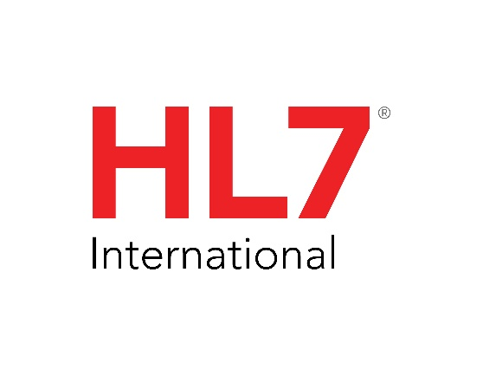

**ANSI/HL7 V2.9.1-2024**

**9/5/2024**

# Control: Conformance

2

|  |  |
| --- | --- |
| Chapter Chair | Frank Oemig Deutsche Telekom Healthcare Security Solutions GmbH |
| Chapter Chair | Robert Snelick National Institute of Standards and Technology (NIST) |
| Chapter Chair | Ioana Singureanu |
| Chapter Chair | Nathan Bunker American Immunization Registry Assoication (AIRA) |
| Sponsoring Work Group: | Conformance |
| List Server: | [cgit@lists.hl7.org](mailto:cgit@lists.hl7.org) |

Chapter 2B has been replaced by the [HL7 Version 2 Conformance Methodology Release 1](https://www.hl7.org/implement/standards/product_brief.cfm?product_id=533) standard (See  <https://www.hl7.org/implement/standards/product_brief.cfm?product_id=533>). As of v2.9.1, Chapter 2B has been deprecated and users of this standard (HL7 v2.9.1) should use the Conformance Methodology standard when creating implementation guides and profiles.

Conformance in HL7 v2 Background

There are many versions of the HL7 v2 standard. An explicit conformance methodology was introduced into the standard in version 2.5 and revised in subsequent versions of the standard. The conformance methodology was part of chapter 2 initially and later became a subchapter (Chapter 2B Conformance).  The HL7 v2 Conformance Methodology standard serves to replace (override) the conformance methodology in these earlier versions and it is intended to be applied to any HL7 v2 version. That is, if a developer is seeking to constrain a v2.5.1 message event, they should use the conformance methodology prescribed in the Conformance Methodology standard and not the conformance methodology given in v2.5.1