Technical Correction to the Datatype in OMC-9

V 2.9 HL7 Proposal
Change Request ID:
File Name: | OMC9FixV29
Description: | Technical Correction to the Datatype in OMC-9
Status: | proposed
HL7-Version | 2.9
Chapter/Section | 7.3
Sponsoring Person | Riki Merrick
Sponsoring Business Unit | Vernetzt, LLC / APHL
Date Originated: | 20191009
Date HL7 approved:
Backward Compatible:
Forward Compatible:
HL7 Status & Date

Justification Detail
NIST found an error in the datatype in V2.8.2 and it is still present in V2.9 that is about to be published and needs to be fixed:

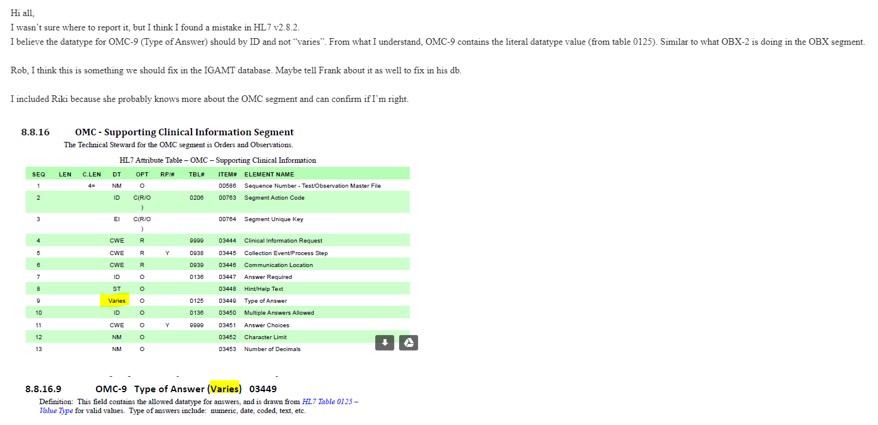
In the original change request, the attribute/field description indicated the attribute was an ID type (it was OMC-10 at the time), so appears there was a ‘mis-match’ in the original submission between the attribute table and the field/attribute description that didn’t get corrected everywhere.

Hyperlinks below to original submission:

• https://wiki.hl7.org/OO_CR139-771_-_Supporting_Clinical_Information
• https://wiki.hl7.org/w/images/wiki.hl7.org/archive/6/6e/20140312162736%21OO_CR139-771.docx

Proposal
See next page.

V3 Implications
none

v2.xml Implications
none

Changes in the document:

OMC - Supporting Clinical Information Segment
The Technical Steward for the OMC segment is Orders and Observations.
HL7 Attribute Table – OMC – Supporting Clinical Information
SEQ | LEN | C.LEN | DT | OPT | RP/# | TBL# | ITEM# | ELEMENT NAME
1 |  | 4= | NM | O |  |  | 00586 | Sequence Number - Test/Observation Master File
2 |  | 1..1 | ID | C(R/X) |  | 0206 | 00763 | Segment Action Code
3 |  |  | EI | C(R/X) |  |  | 00764 | Segment Unique Key
4 |  |  | CWE | R |  | 9999 | 03444 | Clinical Information Request
5 |  |  | CWE | R | Y | 0938 | 03445 | Collection Event/Process Step
6 |  |  | CWE | R |  | 0939 | 03446 | Communication Location
7 |  |  | ID | O |  | 0136 | 03447 | Answer Required
8 |  |  | ST | O |  |  | 03448 | Hint/Help Text
9 |  |  | Varies ID | O |  | 0125 | 03449 | Type of Answer
10 |  |  | ID | O |  | 0136 | 03450 | Multiple Answers Allowed
11 |  |  | CWE | O | Y | 9999 | 03451 | Answer Choices
12 |  |  | NM | O |  |  | 03452 | Character Limit
13 |  |  | NM | O |  |  | 03453 | Number of Decimals

And

OMC-9 Type of Answer (VariesID) 03449
Definition: This field contains the allowed datatype for answers, and is drawn from HL7 Table 0125 – Value Type for valid values. Type of answers include: numeric, date, coded, text, etc.

