Testscriptressourcen Beispiele
1. fixture:
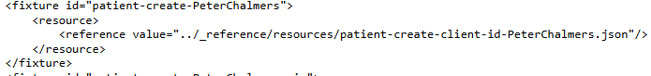
2. operator, path, value, warningOnly:
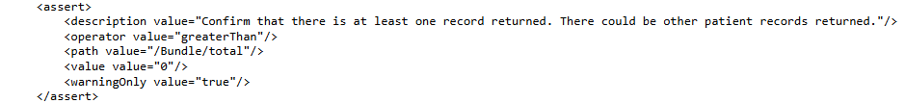
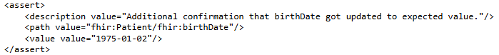
3. minimumId:
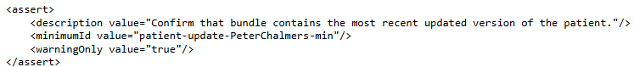
4. teardown:
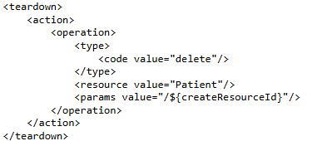
5. contentType:
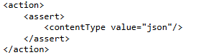
6. operation:
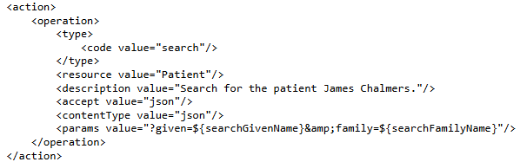
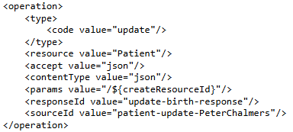
7. validateProfileId:
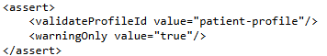
8. headerField:
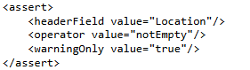
9. extension, expression:
