Import and run the code

**Clone the code**

Clone git repo using below command:

git clone <https://github.com/learnhl7-arun/hapi-fhir-fcon2k1.git>

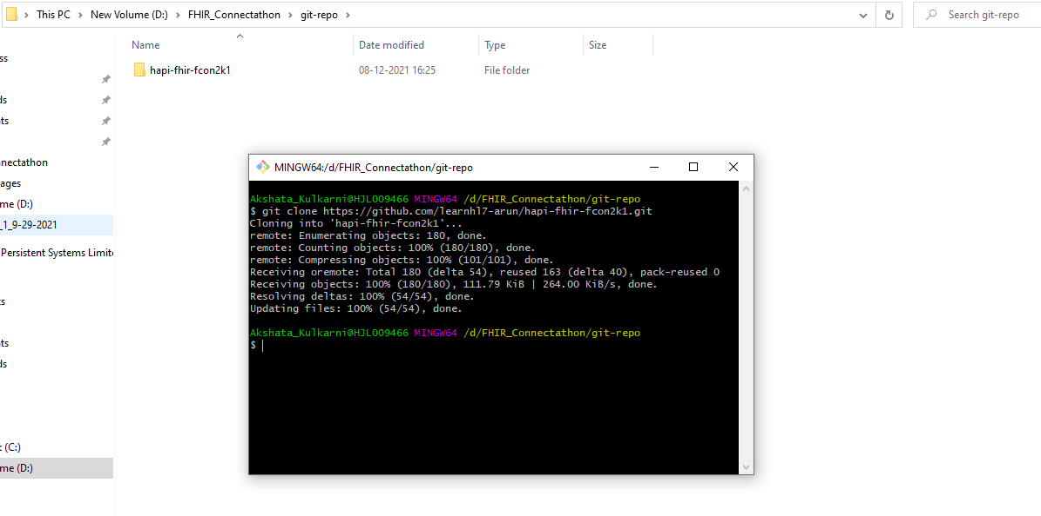

Make sure you have below folders

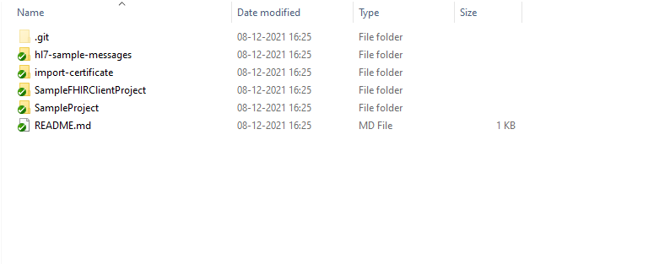

**Import the code**

* Create new folder for workspace. Open STS and navigate to your folder. Select the folder and then click on launch button

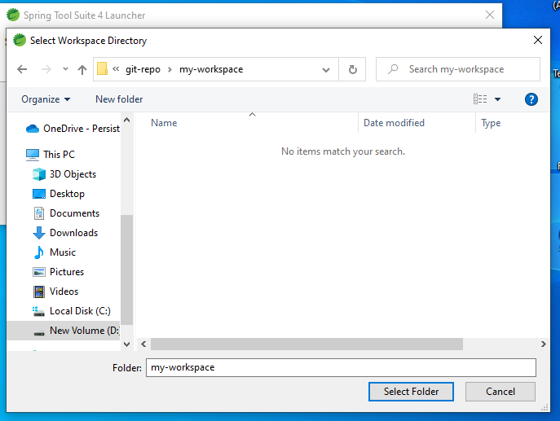

* Once the STS is opened you will see structure like below:

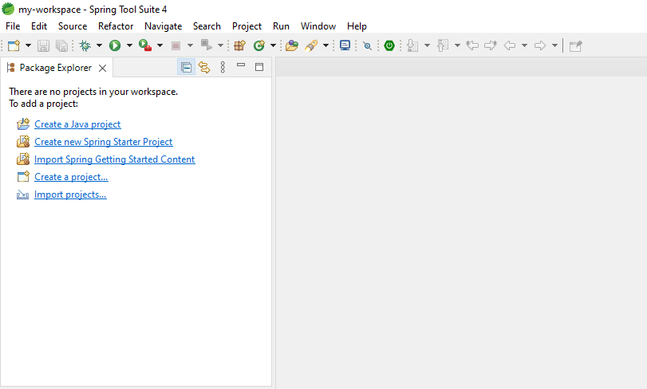

* Click on Import project from left and navigate to Maven -> Existing Maven Projects

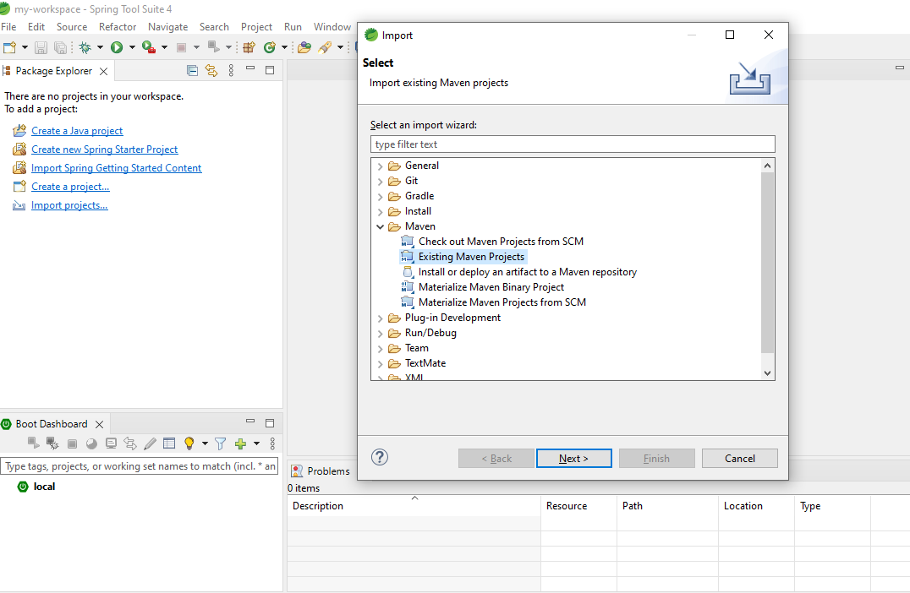

Click Next and browser to your folder where you have cloned the code. Select **SamplteFHIRClientProject** folder and click on Select Folder button.

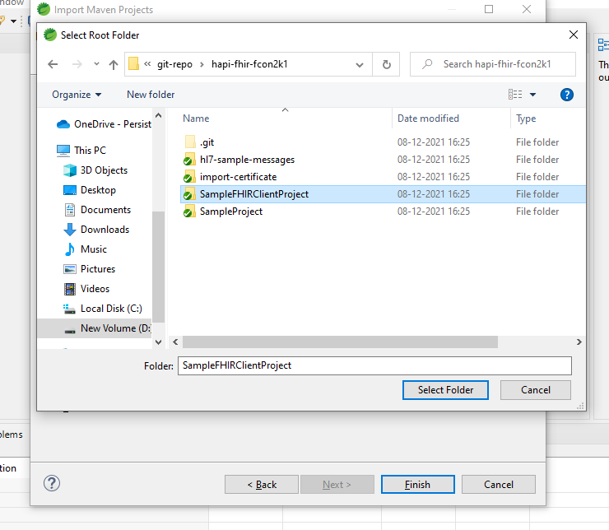

Click on Finish button.

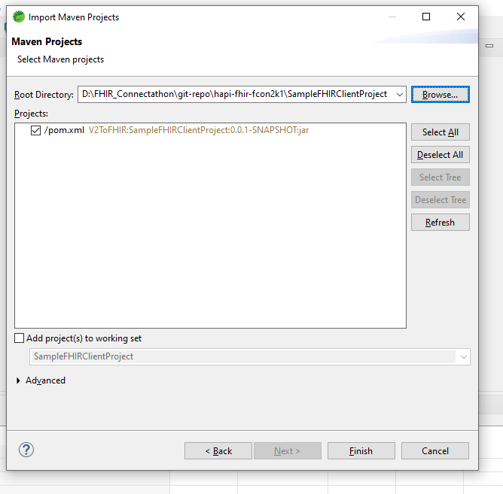

Once the project is imported you see the project in left corner:

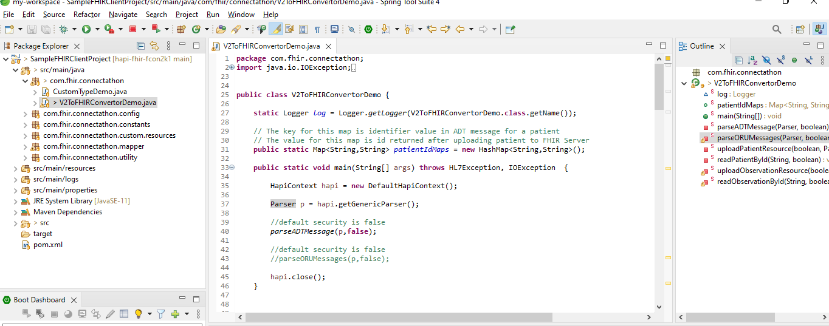

Open V2ToFHIRConvertorDemo.java and right click and select run as Java application as below

