* Inspiration:

With the development of humankind to the present，many beautiful things can be reappeared span time and space. For example, wonderful music can be replayed through phonograph, recorder and other devices. Fascinating pictures can be reproduced by camera, monitor and other tools. In the case of attractive odors, however, we haven't been able to reproduce them through time. We can only describe the smell through words, but can’t give a more direct explanation. So this year, our team aims to achieve the reappearance of attractive odors. That is the inspiration for our project this year.

* Introduction：

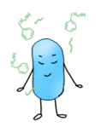*E.coli* can feel different attractive odors. (benzyl alcohol and geraniol was used in our project)

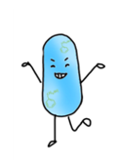 In order to memorize the smell it just felt, *E.coli* convert it into other metabolites that can be stored in the body.

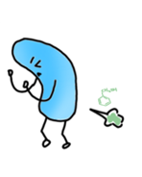When we wonder what the bacteria just smelled, adding the inducer and *E.coli* will release the odor it remembers.

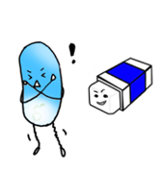In addition, we can also remove the existing memory of *E.coli* to achieve re-memory.

* Circuit：

Odor perception system（气味感受系统）:

Benzyl alcohol perception system（苯甲醇的感受系统）:

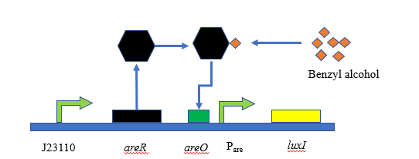

Benzyl alcohol can activate AreR protein, and then the activated AreR-benzyl alcohol complex will induce the transcription of the promoter Pare. In this way, the initial LuxI was expressed.（关于苯甲醇的气味感受系统的描述）

Geraniol perception system（香叶醇的感受系统）:

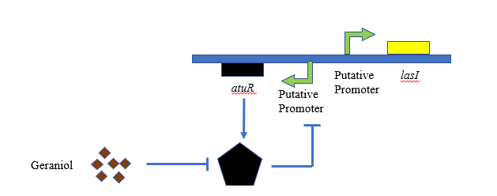

AtuR is a repressor protein which can inhibit the transcription of the LasI protein. When geraniol is added into the media, AtuR will be deactivated, and then lasI will be transcribed. （关于香叶醇的气味感受系统的描述）

Odor memory system（气味记忆系统）:

Benzyl alcohol memory system（苯甲醇记忆系统）:

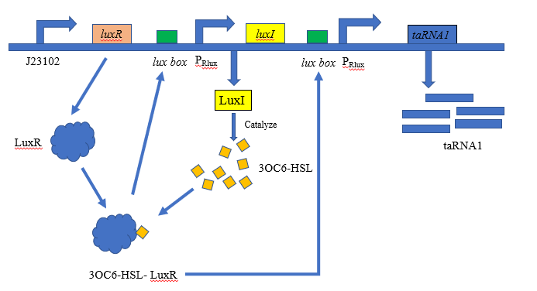

The memory system was based on bacterial quorum-sensing circuit and the signal of the Benzyl alcohol was then transferred to the memory system by the LuxI from the previous step.By utilizing this circuit, we can accumulate taRNA, a small non-coding trans-activator RNA which will play as a ‘key’ to the next module.（苯甲醇记忆系统的描述）

Geraniol memory system（香叶醇记忆系统）:

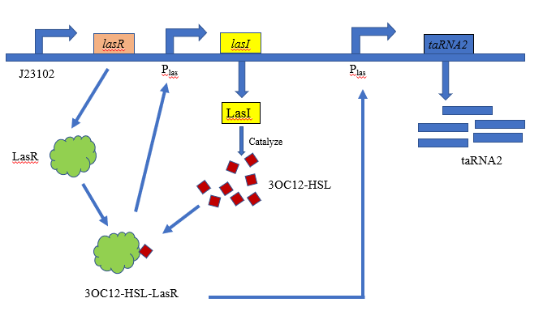

The principle and process of the memory system of geraniol are the same as benzyl alcohol but are based on las quorum sensing circuit which is orthologous to the lux circuit used in benzyl alcohol system. （香叶醇记忆系统的描述）

Odor release system（气味释放系统）:

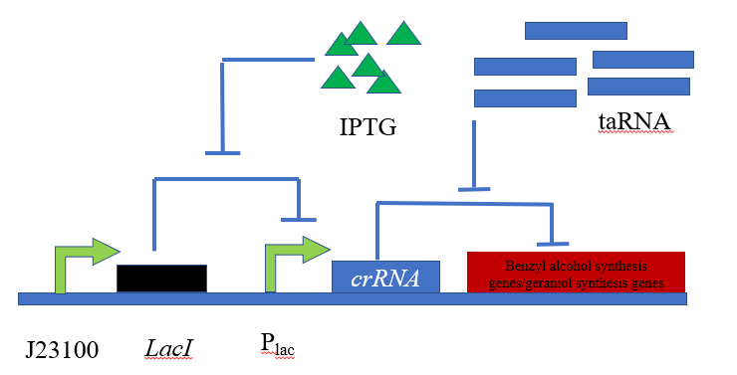

The odor release system was induced by IPTG, and initially inhibited by crRNA, a small non-coding cis-repressor RNA which can repress RBS sequence with its stem-loop structure. When IPTG was added into the medium, taRNA will unlock the hair-pin structure on the mRNA of the synthesis circuit of odor (Benzyl alcohol and geraniol).（气味释放系统的描述）

Memory remove system（记忆擦除系统）:

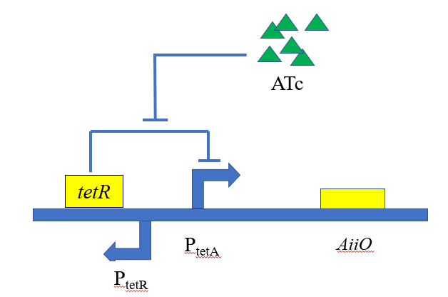

We induced the production of AiiO, an amidase which can hydrolyze AHL by adding ATC to achieve memory erasure.（记忆擦除系统的描述）

* Modelling

Have done work（已经做的工作）:

Benzyl alcohol perception and memory model:（苯甲醇感受和记忆模型）

Benzyl alcohol + perception system LuxI

AHL + LuxR Complex[AHL-LuxR]

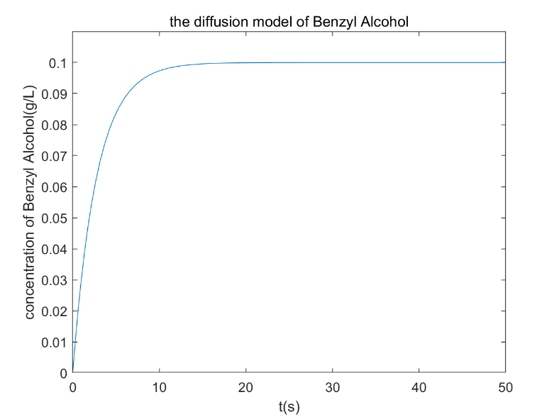

**Figure 1:** The diffusion model of Benzyl Alcohol.（图1的小标题）

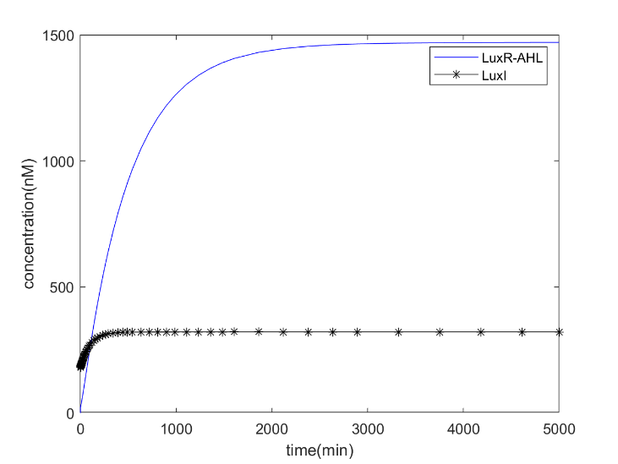

**Figure 2:** A model of the change in LuxR-AHL and LuxI concentration as soon as AHL reach the threshold(100nM). And that is why LuxI have a starting value. （图2的小标题）

In the Benzyl Alcohol perception model, we predict the time and amount of Benzyl Alcohol required to reach the quorum sensing threshold (ie, trigger the memory system).

In the Benzyl Alcohol memory model, we predict the changes of the AHL-luxR complex for better quantitative memory effects.（这是关于苯甲醇感受和记忆模型的描述）

Geraniol perception and memory model: （香叶醇感受和记忆模型）

Geraniol + perception system LasI

AHL + LuxR Complex[AHL-LuxR]

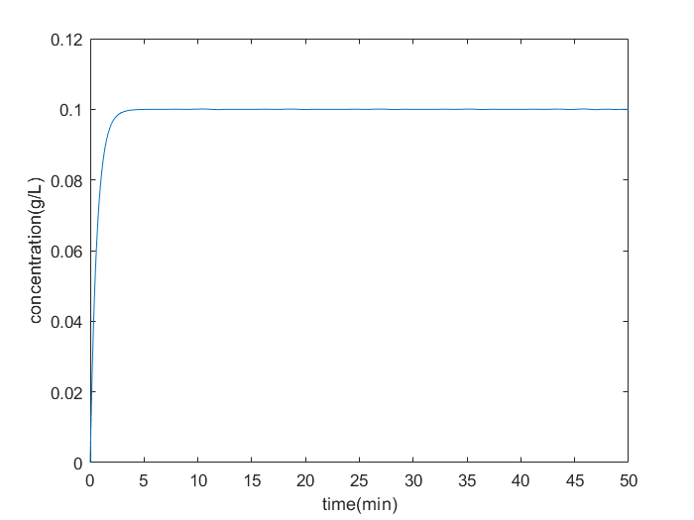

**Figure 1:** the diffusion model of Geraniol. （图1的小标题）

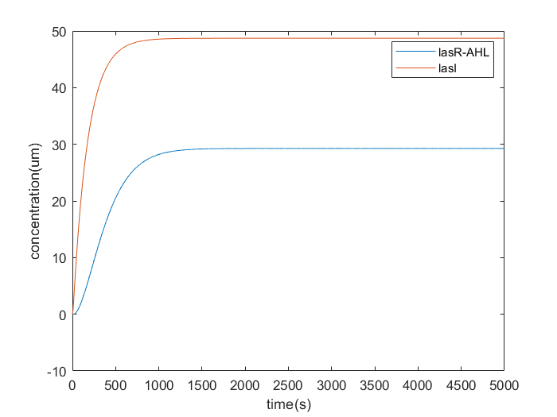

**Figure 2:** the concentration of the complex (LasR-AHL) and LasI. （图2的小标题）

（关于香叶醇感受和记忆模型的描述）

The function of the geraniol perception and memory models are as same as the models of benzyl alcohol perception and memory.

And the formulas and codes for the two parts of the model have been uploaded to GitHub <https://github.com/hzau-igem-2019/The-model-of-odor-perception-and-memory>.

Metabolic model for producing benzyl alcohol（苯甲醇产生的代谢模型）:

We used COBRApy and Escher to construct a genome wide metabolic model, using Flux balance analysis (FBA) to determine the growth rate of bacteria, and Flux variability analysis (FVA) to acquire the production of benzyl alcohol. Our part of the code has been passed to GitHub at <https://github.com/iGEM-HZAU/2019-Drylab-GSMM->.（这部分模型的介绍）

The results are as follows:（表格就是结果）

|  |  |  |  |
| --- | --- | --- | --- |
|  | Fluxex(Growth rate) | flux_variability_analysis of benzyl alcohol | |
| minimum | maximum |
| iJO1366 model | 0.982 | -- | -- |
| :: bzalc | 0.982 | 0.0 | 0.0 |
| :: bzalc,Δ*tyrB* | 0.982 | 0.0 | 0.0 |
| :: bzalc,Δ*tyrA* | 0.000 | 0.0 | 5.746739 |
| :: bzalc,Δ*aspC* | 0.000 | 0.0 | 5.746739 |
| :: bzalc, Δ*tyrB*,  Δ*tyrA*,Δ*aspC* | 0.000 | 0.0 | 5.746739 |
| :: bzalc, Δ*tyrB*,  Δ*tyrA*,Δ*aspC*,::Tyr&Asp | 0.434 | 0.0 | 3.863066 |
| :: bzalc,Δ*aspC*,::Tyr&Asp | 0.683 | 0.0 | 2.429991 |
| :: bzalc,Δ*tyrA*,::Tyr&Asp | 0.434 | 0.0 | 3.868292 |
| :: bzalc,Δ*tyrB*,::Tyr&Asp | 1.096 | 0.0 | 0.0 |
| :: bzalc,::Tyr&Asp | 1.096 | 0.0 | 0.0 |

::bzalc : add reactions of producing benzyl alcohol to iJO1366 model

Δ*tyrB* : knockout gene *tyrB* in iJO1366 model

Δ*tyrA* : knockout gene *tyrA* in iJO1366 model

Δ*aspC* : knockout gene *aspC* in iJO1366 model

::Tyr&Asp : add moderate tyrosine and aspartate in medium of the iJO1366 model

（以上是标注，字可以小一点）

（以下是总描述）

Through building metabolic model, We can predict that at least moderate tyrosine and aspartate need to be added to the medium and knockout the gene *aspC*, in order to ensure the normal growth of *E.coli* and the production of benzyl alcohol.

Future Work（未来的工作，是和已经完成的工作相对应）:

We will build odor release model and Memory remove model in order to consummate our project model. For the metabolic network model, we will construct a geraniol metabolism model to predict the growth of bacteria. The work described above will take about a week.

In addition, we also want to make a quantitative hardware device, if it can be combined with software will better. This is still in the thought stage, and we will plan to implement it as soon as possible.

* Human practice:

Overiew （综述）:

In this year, we divide our Human Practice activities into two parts. one part is about the popularization of science, and the other one is about our project.

In June, we hold the “the future scientist” which face to the children having interest in science. We have got a good reply both from the parents and the children. We truly believe that we will hold it in the next few years.

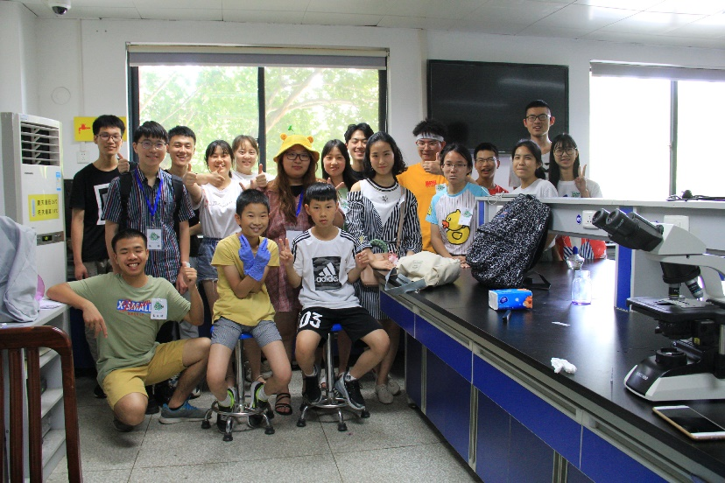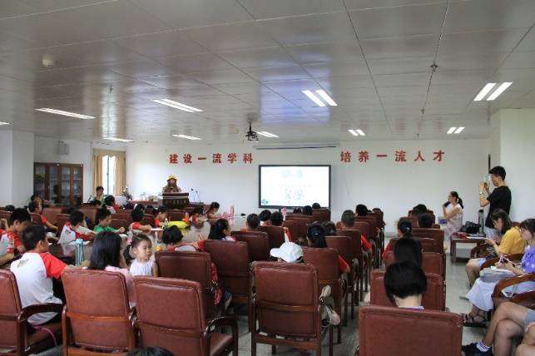

In July, we started an online popularization of science for those kids living in remote places. Volunteer online teaching broke the time and space boundaries in face-to-face classes. Children were interested in this new learning mode and it’s good for propaganda.

In August, we will hold a presentation for freshman, to collect the idea and find more possibility.

Vehicle（媒体工具）:

WeChat Official Account: We open this account on July 30th, and post our first passage on August 1st, and now we have more than 100 followers.

Qzone: Update at the same time as the WeChat.

About our project（关于我们的项目）:

1. questionnaire survey

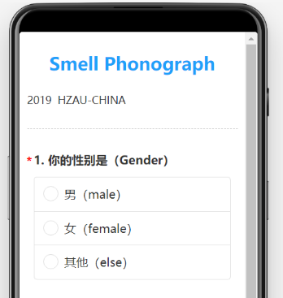

1. In September, thematic activities “when we grow up”
2. Experiment record, we will make a vlog.
3. In August, characteristic activity “your flavor, my mind”

Collaboration（交流）:

1. Our team cooperated closely with the IGEM high school team of Wuhan and have launched a series of interchange activities.

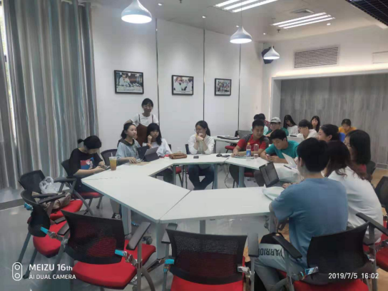

1. Ccic.

* Results:

Benzyl alcohol perception circuit, Benzyl alcohol release circuit, Geraniol perception circuit and memory remove circuit have been built and the sequencing results are correct.

We are building Benzyl alcohol memory circuit, Geraniol memory circuit, Geraniol release circuit.

However, due to lack of chemical reagents or time problems, we still haven’t phenotypic experiments or phenotypic experiments in not as expected.