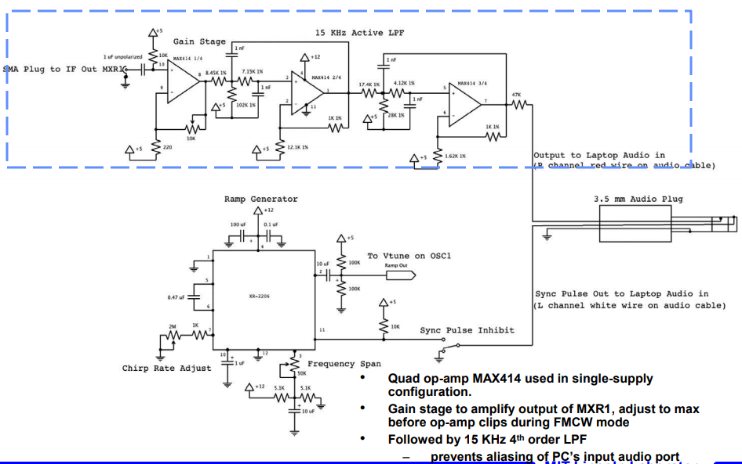

Red = output of Video Amp1 = output of low pass filter

White = Sync output of Modulator 1 = output of the chirp voltage source (part of func. Generator)

The frequency range is limited to 20 kHz due to the audio jack, but the low pass filter will only pass up to 16 kHz.

Process the received data (assume already go through the LPF):

1. Receive and convert to digital data

recObj = audiorecorder;

recordblocking(recObj, T);

play(recObj);

y = getaudiodata(recObj);

1. Apply Fourier transfer

S=fft(y,N); % apply Fourier transform

ST=fftshift(S); % Fourier transform with no displace

fshift=(-N/2:N/2)*(Fs/N); % x dimension

1. Select the max spectrum and beating frequency

[Y1,I1]=max(abs(ST)); % find the max value of ST

fb=abs(fshift(I1)); % the corresponding freq

1. Calculate the range

R=3e8*0.04*fb./(2*B);

To get the parameters, firstly I make sure which ones are constant.

$$light speed C=3*{10}^{8}$$

$$bandwidth B={10}^{8} Hz$$

$$period of frequency Tf=0.04$$

Then concern about the accuracy of range.

$$R=\frac{C*Tf*fb}{2*B}$$

The step size of beating frequency is decided by fshift

$$step size of fb=\frac{Fs}{N}$$

$$Fs is the sampling frequency$$

$$N is the sampling points$$

$$Define T as the sampling period$$

$$N=T*Fs$$

Next set the step size of R to 0.1.

$$\frac{C*Tf*Fs}{2*B*T*Fs}=0.1$$

$$T=0.6$$

To make the data more accurate, Fs has to be large but not to make the script slow.

$$Fs={10}^{6}\sim {10}^{7}$$

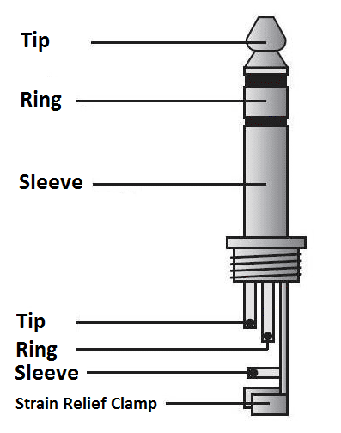

The standard stereo connector with 3 conductors

|  |  |  |  |  |
| --- | --- | --- | --- | --- |
| **Unbalanced Mono** |  | **Balanced Mono** |  | **Stereo** |
| *Tip* |  | Signal |  | Positive / Hot |  | Left channel |
| *Ring* |  | (Not connected) |  | Negative / Cold |  | Right channel |
| *Sleeve* |  | Ground / Return |  | Ground |  | Ground |