GANGWARS 1.4
User’s Manual

Synopsis:
Gangwars first appeared on LAN servers early 1998, and then released to the public on Mar 29 of the same year as a Quake 2 add on. Nobody back then caught up to the realism concept, and it went unnoticed. Four years go by, and a wide range of players have accepted the fun factor of ballistic weaponry and realism as 'the way to go'. Mega-joule plasma guns are no longer as threatening as a German H&K MP5; and this was obviously bound to happen. Demographics show that the average age of the online game player has skewed dramatically with time as the mature crowd settled in. Modifications based on realism, whether they'd be militaristic or law enforcement, have become the de facto templates to follow in the online gaming community. Gangwars was obviously targeting the wrong crowd in 1998, but the fun factor parameters have changed to its benefit and what better time to bring back an age-long concept holding key features of today's most wanted playability list, to a community saturated with cliché modifications trying to replicate Saving Private Ryan's Omaha beach session? It would be a sin not to release the mod now, when the Half-Life engine is most fertile and enjoyable.

Teams:
Upon connecting to a Gangwars server, you are expected to join one of the two teams – East Coast and West Coast. The east coast team members wear dark pants, and the west coast team members wear light pants. As a member of a team, you are expected to protect your teammates from the opposing attacks. You are also expected to exterminate all enemy team members.

Goal:
The goal of the game is to exterminate all enemy team members in the allotted round time. The enemy also shares the same goal, so offensive and defensive tactics are crucial. One important aspect of this goal is the hunting and killing of the enemy team’s boss. The boss is tracked by radar on your display and exterminating him prevents the enemy team from re-spawning (see Bosses and bags).

Bosses and bags:
A boss is a team member that has found the narcotics (boss) bag, and has decided to carry the bag around. The bags are usually around each team’s spawn points. Once a boss, you have the ability to heal yourself and nearby teammates, buy weapons and ammo at any time, and re-spawn your dead teammates as a result of a successful enemy kill. By being a boss, you also have the duty to flee enemy attacks as they can track you through radar. The right strategy is to have a good portion of the teammates protect their boss, while the remaining members hunt the enemy boss. When a boss is assassinated the narcotics (boss) bag drops to the ground and remains there for a short amount of time before re-spawning in the teams spawn point.

Navigation:
A radar display allows you to keep track of your boss as well as the enemy boss. The green arrow tracks your boss while the red arrow tracks the enemy boss. If there is no boss, then the arrow will point to the last location of the boss bag. All players can buy ammo and weapons near their spawns or their armory. If you are near an armory, your HUD money will turn green, indicating the possibility of making a new purchase. After a certain time, the armory may close, at this point your HUD will lose the ‘A’ character next to the timer. Once the armory is closed, you will not be able to purchase anything, unless you are a boss.

Roles:
Hunters and bodyguards are the two main roles of the ordinary team members. Bosses have the roles of being bosses, and their job is to heal and re-spawn their teammates. Hunters usually track the red arrow on their radar screen, trying to locate and exterminate the enemy boss. A good weapon of choice for hunters is a single-shot rifle. Hunters can also go solo, without any reinforcement, hide in strategic places, and wait for the enemy boss. The bodyguards are expected to track and stay with the green arrow, which points to the current position of their boss. The bodyguards require the use of heavy weaponry for maximum damage in their radius. The bodyguards will also benefit from automatic healing if they are close enough to their boss.

Weapons:
At the beginning of every round, you start with a pistol and a knife. Different weapons are adequate for different situations. Surely, the low firing rate, and short range of the pistol won’t take you too far before you lay dead somewhere. The first five seconds of every round allow all players on the server to take their time and buy enough ammo and weapons to have a good fight. The choice of weapons can make a difference depending on the environment and the goal you are trying to achieve. The most expensive guns are not always the best choices. You need to know your weapons and understand how they react to different aspects such as single shot, burst, automatic fire, jump fire, crouch fire, concentration fire, etc. Also, learn where to shoot the enemy - from the front, from the back, in the head, in the leg, etc. (See Appendix A)

Reloading weapons:
Knowing when to reload weapons is very important, as you need to understand that once you slide a clip out, the remaining bullets on that clip are forever lost. Make sure that reload only when necessary; with time this will not be an issue for you.

Healing:
Every injured teammate within a 15 feet radius of the boss will automatically be healed. The boss also heals himself at a slightly faster rate. When attacking an enemy boss, make sure that you don’t leave until you kill him; otherwise, your effort would be futile, since your target’s health regenerates at a relatively fast rate. This is where a single-shot rifle comes handy.

Money:
At the end of every round, you are awarded some money. The amount of money you will receive depends highly on your personal performance, and slightly on your team’s performance in that round. The money allows you to purchase higher caliber weaponry. (See Appendix A)

The HUD:
The Head Up Display shows your status. Please refer to the picture below for more information:

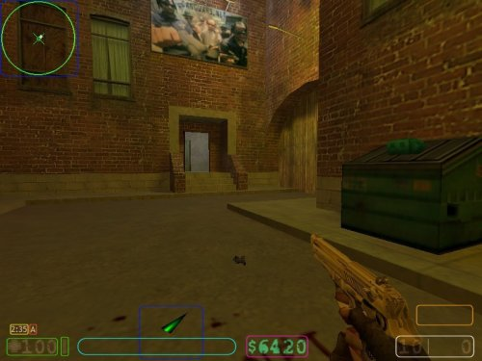

BLUE – 2d and 3d radars keep track of the bosses
RED – Armory icon ‘A’ - This icon goes off when armory is closed.
YELLOW – Time remaining in round
GREEN - Health
CYAN – Target ID
PURPLE – Available money - This icon goes green when purchase is available.
WHITE – Available ammo in weapon and clips
ORANGE – Shows the boss status
Client Commands:
The following menu commands are available to all clients connected to a Gangwars server:

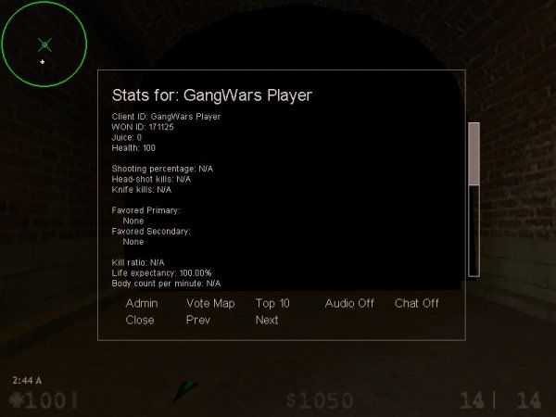

Admin
Switch to administrator menu. Must be logged in as administrator
The administrator commands will apply to the person whose stats are currently displayed.

Vote Map
Open the map voting menu

Top10
Show the server’s top 10 players

Audio On/Off
Toggle music/tracks On/Off

Chat On/Off
Turn client chatting chat On/Off

Prev
Show stats of previous player on server

Next
Show stats of next player on server

Close
Close the stats window
Client Console Commands:
The following commands are available to all players and are input from the game console:

cl_teamscores <0|1>
Switches between the two available score boards

cl_3dradar <0|1>
Toggle 3D radar ON/OFF

cl_2dradar <0|1>
Toggle 2D radar ON/OFF

cl_beats <0|1>
Toggle audio beats ON/OFF

cl_chat <0|1>
Toggle chat messages ON/OFF

shout <voice #>
Shout voice with appropriate

lockedstats
Browse stats of tracked person in observer mode

showstats
Browse client stats

topscores
Display server’s hall of fame

votemaps
Open map voting menu

adminmenu
Open server administration menu

listplayers
List players on server

chooseteam
Open team selection menu

timeleft
Display time left in round and map in console

juice
Display current juice value in console

top10
Display top 10 roster in console

buy
Open weapon purchase menu

buyammo1
Buy primary ammunition

buyammo2
Buy secondary ammunition

holler1
Open holler menu 1

holler2
Open holler menu 2
Administrator Commands:
The following commands are available from the GUI to authenticated administrators. The title of the menu refers to the client subject to harassment by the administrator:

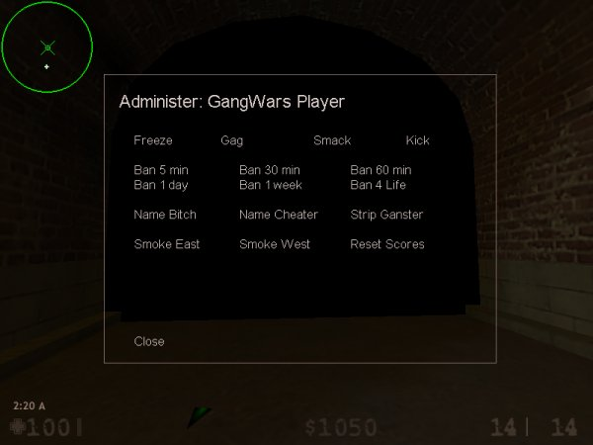

UnFreeze/Freeze
Freeze selected player. Player will not be able to move

UnGag/Gag
Gag selected player. Player will not be able to chat

Smack
Slap selected player with some damage

Kick
Requires Admin Level 1 and up
Kick player out of the server

Ban 5 min, 30 min, 60 min, 1 day, 1 week, for life
Requires Admin Level 2 and up
Ban selected player for the selected time period
Level 3 administrators with cannot be banned with this command

Name bitch
Rename selected player to “bitch”

Name cheater
Rename selected player to “cheater”

Smoke East
Requires Admin Level 3 and up
Kill all members of the East Coast team

Smoke West
Requires Admin Level 3 and up
Kill all members of the West Coast team

Reset Scores
Requires Admin Level 3 and up
Reset map and player scores

Close
Closet the admin window
Server Settings (CVARS):
The following are cvars available to authenticated server administrators with rcon or local access:

gw_pass0 <password>
Set admin level 0 password (slap)

gw_pass1 <password>
Set admin level 1 password (kick)

gw_pass2 <password>
Set admin level 2 password (kick ban)

gw_pass3 <password>
Set admin level 3 password (kick ban/exterminate)

gw_ping_min < # msec>
Minimum ping (in msec) required to stay on server

gw_ping_rounds <# rounds>
Number of rounds over which to resample pings

gw_ping_ban <# minutes>
Number of minutes the HPB will be banned, 0 for no ban

gw_mapvote_ratio <percent>
Minimum percentage of players voting the same map before a map change

gw_mapvote <0|1>
Toggle map voting ON/OFF

<password>
Authenticate user as level X if password put in console matches gw_passX

Form File Variables:
The following parameters are loaded on a map change from a form file (.frm) with the same title as the map bsp name. These parameters are loaded only on a map change are cannot be altered in the console since they are no cvars:

gw_bag1 <x, y, z>
East bag spawn location for the map

gw_bag2 <x, y, z>
West bag spawn location for the map

gw_pistols <flags>
Set the available pistols flags
Default is 7

gw_shotguns <flags>
Set the available shotguns flags
Default is 3

gw_subs <flags>
Set the available sub machineguns flags
Default is 15

gw_autos <flags>
Set the available automatic rifles flags
Default is 31

gw_items <flags>
Set the available item flags
Default is 0

gw_roundtime <seconds>
Set the length of round in seconds
Default is 300

gw_baselicense <reserved>
Reserved
Default is 8

gw_basemoney <dollars>
Set the start amount of money given to a client upon connection
Default is 800

gw_damage <factor>
Set the damage factor, the higher the number the more damage the weapons do
Default is 2

gw_grenade <reserved>
Reserved

gw_timelimit <minutes>
Set the length of map in minutes
Default is set by mp_timelimit

gw_nextmap <mapname>
Set the map to be played after current map
Default is set by mapcycle.txt

gw_headshot <factor>
Set the head shot damage factor
Default is 3

gw_grenades <reserved>
Reserved

gw_respawns <re-spawns>
Set the number of re-spawns per boss kill.
Default is 2

gw_respawntime <seconds>
Set the number of seconds before a lost bag is re-spawned in base
Default is 20

gw_respawn_min <reserved>
Reserved

gw_winmoney <dollars>
Set the amount of money a team gets upon a win of round
Default is 1100

gw_losemoney <dollars>
Set the amount of money a team gets upon a loss of round
Default is 900

gw_killmoney <dollars>
Set the amount of money a player gets upon a kill
Default is 250

gw_lastkillmoney <dollars>
Set the amount of money a player gets upon a round-winning kill
Default is 400

gw_respawnmoney <dollars>
Set the amount of money a boss gets upon a re-spawn
Default is 300

gw_drawmoney <dollars>
Set the amount of money a team gets upon a round draw
Default is 500

gw_maxmoney <dollars>
Set the maximum amount of money a player can carry
Default is 12000

gw_recoil <factor>
Set the weapons recoil factor [0-3]
Default is 1

gw_speed <factor>
Set the speed factor of the players; a speed of 0 means no slow down
Default is 1

gw_kickback <factor>
Set the damage kickback factor of hurt players
Default is 10

gw_fadeout <seconds>
Set the fadeout time upon round start and player death
Default is 5
APPENDIX A

Available weapons:

Weapon Name | id | Price | Clip | Max Clip | Zoom
Beretta 92F | 1 | 600 | 10 | 30 | N/A
Glock 22 | 2 | 300 | 14 | 42 | N/A
Magnum 44 | 3 | 950 | 6 | 30 | N/A
Kimel AP-9 | 4 | 1400 | 30 | 90 | N/A
Ingram Mac 10 | 5 | 1200 | 25 | 100 | N/A
IMI UZI 9mm | 6 | 1750 | 25 | 100 | N/A
MP5K-PDW | 7 | 1900 | 30 | 120 | N/A
AK-74 | 8 | 3400 | 30 | 90 | N/A
Matell M16 | 9 | 3600 | 30 | 90 | N/A
AK-47 | 10 | 4200 | 30 | 90 | LVL 1
KA DR200 | 11 | 4950 | 30 | 120 | LVL 1
H&K PSG-1 | 12 | 4500 | 5 | 20 | LVL 2
Mossberg 590 | 13 | 1700 | 8 | 40 | N/A
Benelli M4 S90 | 14 | 2100 | 7 | 49 | N/A

About:
Gangwars is a code modification for Half-Life developed topaz and aeroj. Both topaz and aeroj work for the Intelligent Machine Technology Division at ENSCO (www.ensco.com) and have developed Gangwars on their free time.
The source code to Gangwars will be available for download in the near future.
Credits to all counter-strike models, maps, and sounds are available in the game folder.

Thank you for playing our game!

Contact:

Gangwars Network
www.gangwars.net
Email: dev@gangwars.net

