About MonkeyStrike 1.2c:

MonkeyStrike 1.2c is an "unofficial" release.

The author of this file, and packager of the MonkeyStrike12c.ZIP file was not part of the original MonkeyStrike development team – just a fan who wanted to play it under Steam, setup a dedicated MonkeyStrike server, and make it easier for other fans to play MonkeyStrike under Steam.

This file was packaged on November 11th, 2005.
This file was packaged by weasel@ladt.us – not any member of original MonkeyStrike development team.

My apologies if anyone from the original team takes offense from this “release”. The “Official” MonkeyStrike web-site (http://www.monkeystrike.com) does not appear to be updated in at least one year. The last thing noted on that site is that the team is going to begin working on a different project – with a link to that project’s web site, which does not function.

MonkeyStrike 1.2c, is essentially:

- MonkeyStrike version 1.2, extracted from the previous "official" release file (MonkeyStrike12.exe).
- Updated the monkeystrike\gfx\shell\kb_act.lst file to allow Steam GUI to properly parse configuration settings. The old pre-Steam version of this file didn’t parse correctly under Steam and caused keyboard mapping settings to not be configurable under the GUI.
- Re-zipped and distributed as a .ZIP file instead of a .EXE file. This was done in part to allow easier server setups, but also because these days people are wary about downloading and running executable archives off the Internet.
Installation Instructions:

This version of MonkeyStrike is intended to operate with the Valve Software “Steam” software launching system. Obviously, you must already have Steam installed, with Half-Life already downloaded and executed at least once to ensure that the proper file structure already exists. Beyond that, MonkeyStrike is very simple to install. The basic process is the following:

- Unzip the contents of the MonkeyStrike12c.ZIP file to a temporary location. If you’re reading this file, you may have already done that.
- Find your Half-Life folder within your SteamApps folder. Usually that location is something like C:\Program Files\Steam\SteamApps\e-mail-address@domain.com\Half-Life. – where e-mail-address@domain.com would be the e-mail address that is used as your Steam logon.
- Copy the monkeystrike folder extracted from the MonkeyStrike12c.ZIP file to that folder.
- The before and after, should look something like this:

Before | After
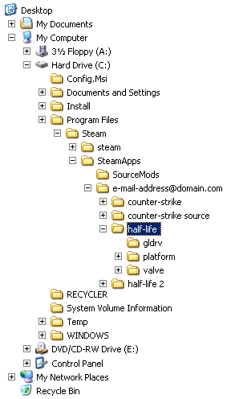 | 