**EECS2040 Data Structure Hw #4 (Chapter 5 Tree)**

**due date 5/16/2022, 23:59 by 109070025林泓錩**

**Part 1 (2% of final Grade)**

1. (4%) What is the maximum number of nodes in a k-ary tree of height h? Prove your answer.

**Ans:**

Maximum number = $\sum_{x=0}^{x=h-1}{k^x}$

Proof:

If h=1, the number of nodes = 1

If h=2, the number of nodes = 1+1*k

If h=3, the number of nodes = 1+1*k+k*k

Hence, If h=h, the number of nodes = 1+k+ $k^{2}$ +….+ $k^{h-1}$

1. (16%) For a simple tree shown below, 
2. Draw a list representation of this tree using a node structure with three fields: tag, data/down, and next.

**Ans:**

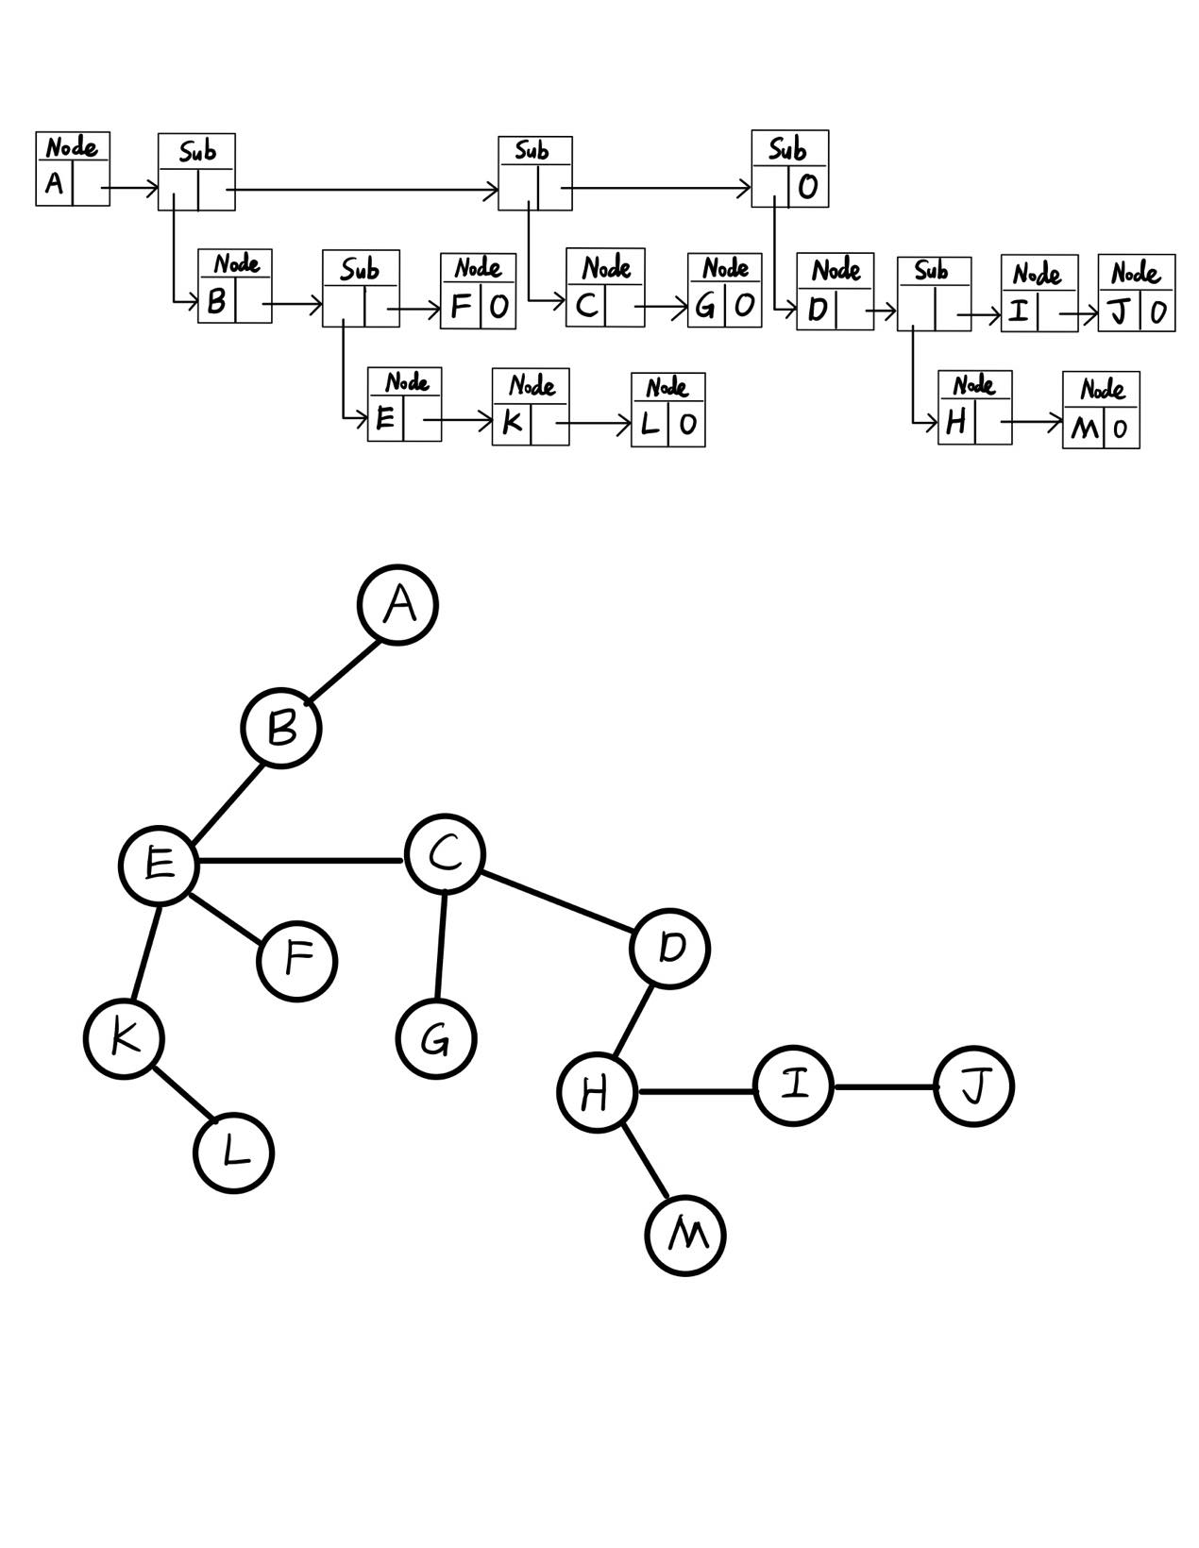

1. Write down a generalized list expression form for this tree.

**Ans:**

(A(B(E(K, L), F), C(G), D(H(M), I, J)))

1. Convert the tree into a left-child and right-sibling tree representation

**Ans:**

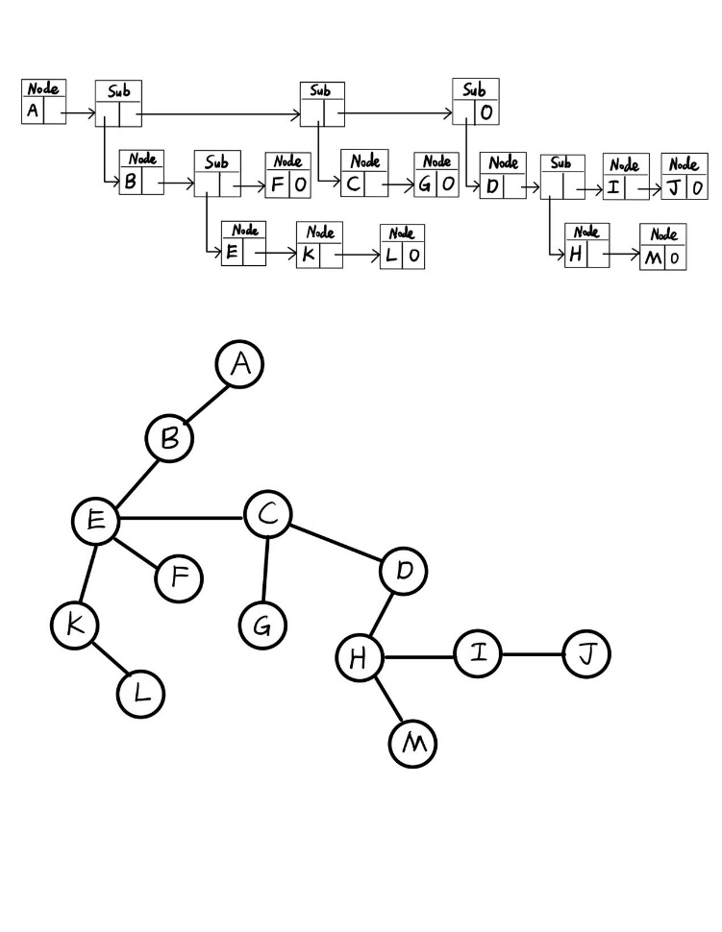

1. Draw a corresponding binary tree for this tree based on (c).

**Ans:**

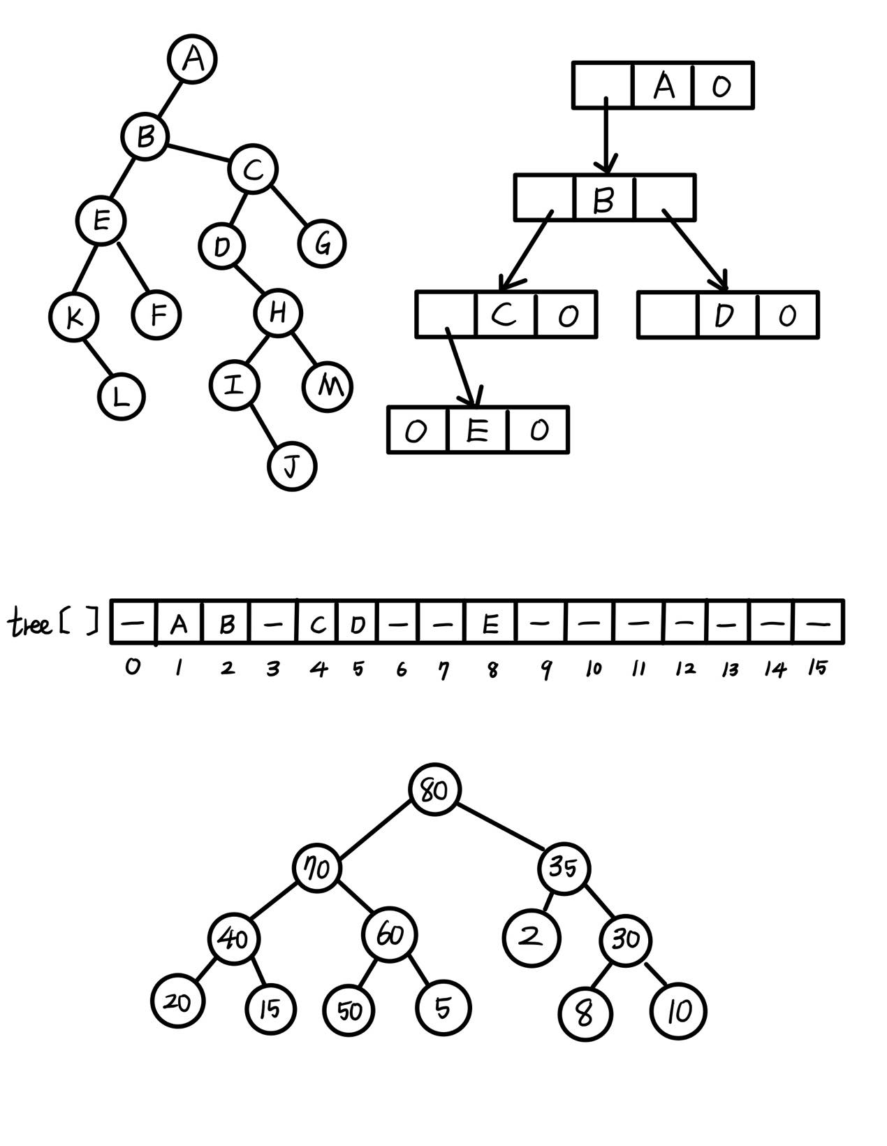

1. What is the depth of node L? What is the height of node B? What is the height of the tree?

**Ans:** The depth of node L is 3. The height of node B is 2. The height of the tree is 3.

1. Write out the preorder traversal of this tree.

**Ans:** ABEKLFCGDHMIJ

1. Write out the postorder traversal of this tree.

**Ans:** KLEFBGCMHIJDA

1. Write out the level order traversal of this tree.

**Ans:** ABCDEFGHIJKLM

1. (10%) Draw the internal memory representation of the binary tree below using (a) sequential and (b) linked representations.



(a)

**Ans:**



(b)

**Ans:**



1. (4%) Extend the array representation of a complete binary tree to the case of complete trees whose degree is d, d > 1. Develop formulas for the parent and children of the node stored in position i of the array.

**Ans:**

A complete d-ary tree with height h would have at most (dh – 1)/(d-1) nodes.

Number the nodes from 1 ~ n (corresponding to array position) where n is the number of nodes of the tree and n ≤ (dh – 1)/(d-1).So, it’s easy to show that for a node i, its children starts from di-(d-2), …, di, di+1.Its leftist child would be at di-(d-2), and its rightist child is at di + 1, if di-(d-2), …,di, di+1 ≤ n. Otherwise the corresponding child does not exist.

For node i, its parent would be at ⌊ $\frac{i+d-2}{d}$⌋

(check d = 2)

1. (16%) Write out the inorder, preorder, postorder, and levelorder traversals for the following binary trees.



**Ans:**

(a) Inorder : A-B*C*D+E

Preorder : +**-ABCDE

Postorder : AB-C*D*E+

Levelorder : +*E*D-CAB

(b) Inorder : HDJBEAFCG

Preorder : ABDHJECFG

Postorder : HJDEBFGCA

Levelorder : ABCDEFGHJ

1. (16%) Given a sequence of 13 integer number: 50, 5, 30, 40, 80, 35, 2, 20, 15, 60, 70, 8, 10.
2. Assume a **max heap** tree is **initialize** with these 13 numbers placed into nodes of the tree according to node numbering of complete binary tree by using the **bottom up heap**

**Ans:**



1. **construction initialization** process. Please draw the final Max heap tree after initialization process.

**Ans:**

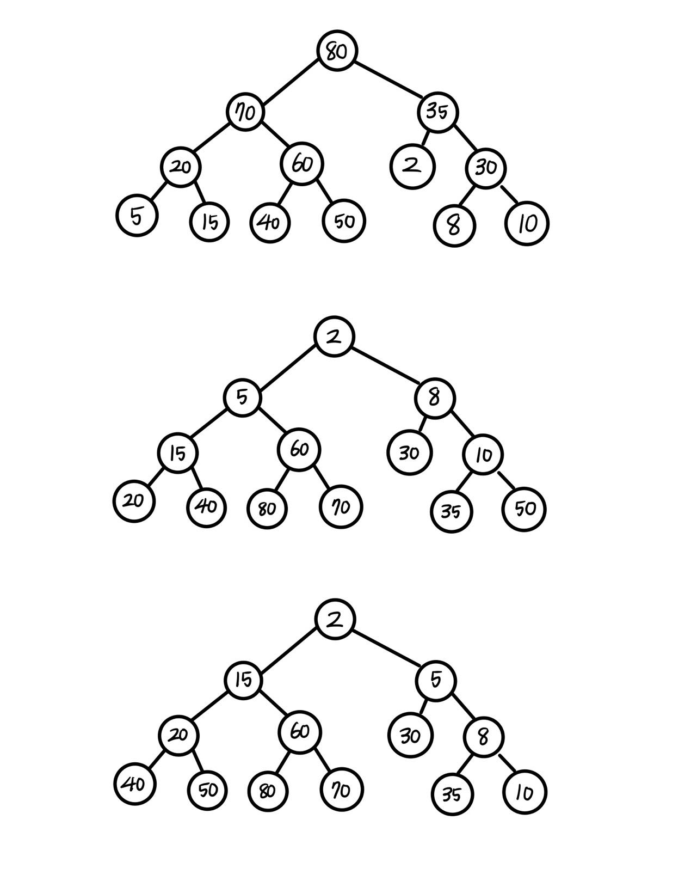

1. Construct a max heap by **inserting** the given 13 numbers one by one according to the sequence order into an initially empty max heap tree, instead of bottom up heap construction.

**Ans:**



1. Repeat (a) for min Heap.

**Ans:**



1. Repeat (b) for min Heap.

**Ans:**



1. (4%) For initializing a max heap from n key values stored in an array, instead of inserting key value one by one, assume that

The height of heap = h,

Number of subtrees with root at level j is <= 2j-1,

Time for each subtree is O(h-j). (# of bubbling down),

Time for level j subtrees is <= 2j-1(h-j) = t(j),

Then total time is t(1) + t(2) + … + t(h-1) = O(n).

Please prove the above argument.

**Ans:**

we initialize n keys in a array, and it has height ‘h’. We start sorting from level (h-1) to 1. Each level takes t(j), and total complexity is t(1) + t(2) + … + t(h-1) <= 1(h-1) + 2(h-2) + 22(h-3) +…+2(h-2)(1) = S

S = O(n)

1. (20%) Binary Search Tree
2. How many different binary search trees can store the keys {1,2,3}?

**Ans:**

5 different binary search trees 5 (2 trees with 1 as root, 1 tree with 2 as root, 2 trees with 3.

1. If we insert the entries (1,A), (2,B), (3,C), (4,D), and (5,E), where the number denotes the key value of the node, in this order, into an initially empty binary search tree, what will it look like? Please draw this BST.

**Ans:**

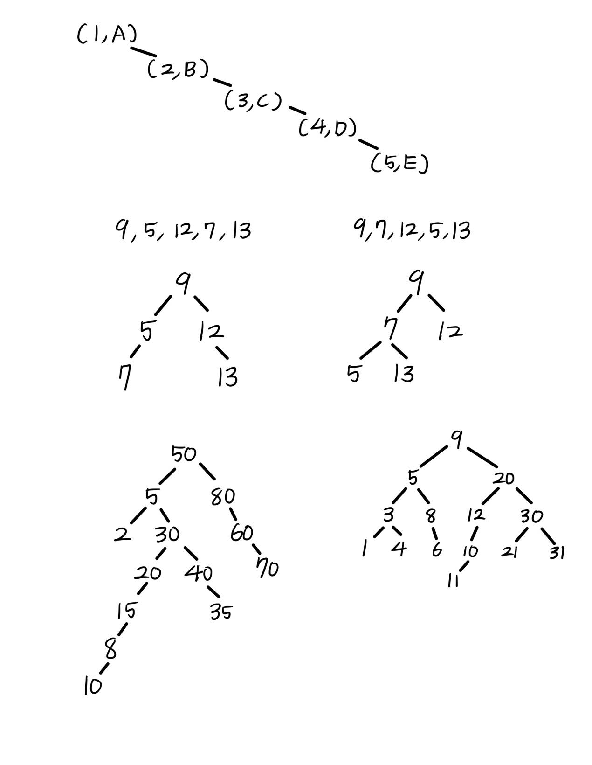

1. John claims that the order in which a fixed set of entries is inserted into a binary search tree does not matter—the same tree results every time. Give a small example that proves he is wrong.

**Ans:**

raw the binary search tree created by the input sequence: 9, 5, 12, 7, 13. Now draw the tree created when you switch the 5 and the 7 in the input sequence: 9, 7, 12, 5, 13.



1. Given a sequence of 13 integer number: 50, 5, 30, 40, 80, 35, 2, 20, 15, 60, 70, 8, 10, use the BST Insert function (manually) to insert the 13 number sequentially to construct a binary search tree. Draw the final 13-node BST.

**Ans:**



1. A binary search tree produces the following preorder traversal, where “null” indicates an empty subtree (i.e. the left/right child is the null pointer).

9,5,3,1,null,null,4,null,null,8,6,null,null,null,20,12,10,null,11,null,null,null,30,21,null,null,31,null,null

Draw the tree that produced this preorder traversal.

**Ans:**



1. (10%) An 8-run with total of 25 numbers are to be merged using Winner tree and Loser tree, respectively. The numbers of the 8 runs are shown below. The first numbers from each of the 8 runs have been placed in the leaf nodes of the tree as shown. Then these eight numbers enter the tournament to get the overall winner.



1. Draw the winner tree and indicate the overall winner of this tournament.

**Ans:**



Overrall Winner

8

6

17

8

6

6

9

1. Draw the loser tree and indicate (draw) the overall winner of this tournament.

0

Overrall Winner

6

Ans:



17

20

10

8

90

9

9