**EECS2040 Data Structure Hw #6 (Chapter 7 Sorting, Chapter 8 Hashing)**

**due date 6/19/2022 23:59 by 109070025 林泓錩**

1. (50%) Sorting:

Write a C++ program to perform 5 different sorting , insertion sort, median-of-three quick sort, iterative merge sort, recursive merge sort, and heap sort, on lists of characters, integer, floating point numbers, and C++ strings.

1. You need to write the 5 sorting function templates (refer to example programs in textbook or pptx)
2. Randomly generate a list of 20 characters as an input unsorted list.
3. Randomly generate a list of 20 integers as an input unsorted list.
4. Randomly generate a list of 20 floats as an input unsorted list.
5. Randomly generate a list of 20 string objects as an input unsorted list.

Show your results using the above 4 lists in your program.

**Sol:**

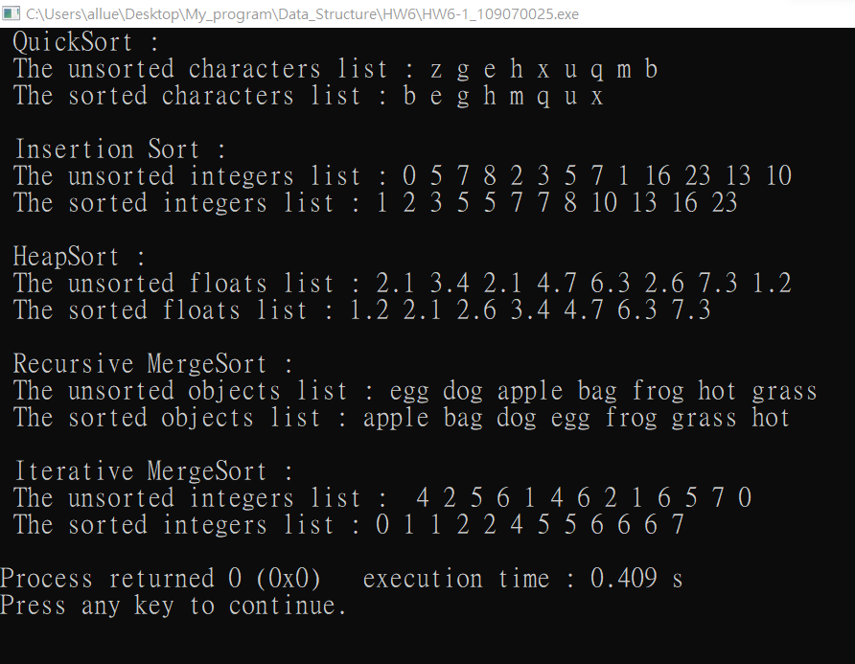

1. (50%) Hashing:

Write a C++ program to implement **two simple symbol tables** (dictionaries) using hash table with linear probing for collision and hash table with chaining. For simplicity,

1. Consider storing only the key (need not consider the (key, value) pair) in the symbol tables.
2. Furthermore, the key is a **variable-length character array** with the first character of the key is an alphabet, e.g., abc, abcde, b, bye, cool,…
3. Consider a **simple hash function using only the first character of key to hash**, so h(abcde) = h(abc), h(b) = h(bye),.., etc. Therefore, collision can happen frequently.
4. The initial hash table size can be set to 26 since we have 26 alphabets which are the hashed keys.

**Sol:**

