

**Smart Reads:Book**

**Recommendation System**

Discover the future of reading with our AI-driven book recommendation system. Dive into a world of personalized suggestions, tailored to your unique taste. Say goodbye to endless browsing and hello to your next favorite book.

**System Architecture: An End-to-End Overview**

## Data Sources

We gather data from sources like Goodreads, Amazon, and LibraryThing.

## Cloud Infrastructure

AWS S3 handles storage. Lambda

takes care of processing.

## End-to-End System

This ensures seamless data flow and

personalized recommendations.

**Data Processing with S3 and Lambda**

## Raw Data Ingestion

**1**

We ingest raw book data into S3 buckets for secure storage.

## ETL Processes

Lambda functions execute ETL (Extract, Transform, Load) processes.

**2**

## Data Cleaning

Techniques remove duplicates and standardize formats.

**3**



**Deep Learning Models: The Heart of Recommendations**



## Collaborative

**Filtering**

Find similar users to help find the right books.

## Content-Based

**Filtering**

Analyze book data to find similar book recommendations.

## Hybrid Approach

A mixture of collaborative and content filtering.



**AI Model Implementation**

**Details**

## Embedding Layers

We create vector representations for users and books.

## Loss Functions

We leverage BPR and Hinge Loss for optimization.

## Optimization Algorithms

Adam and SGD algorithms refine model accuracy.

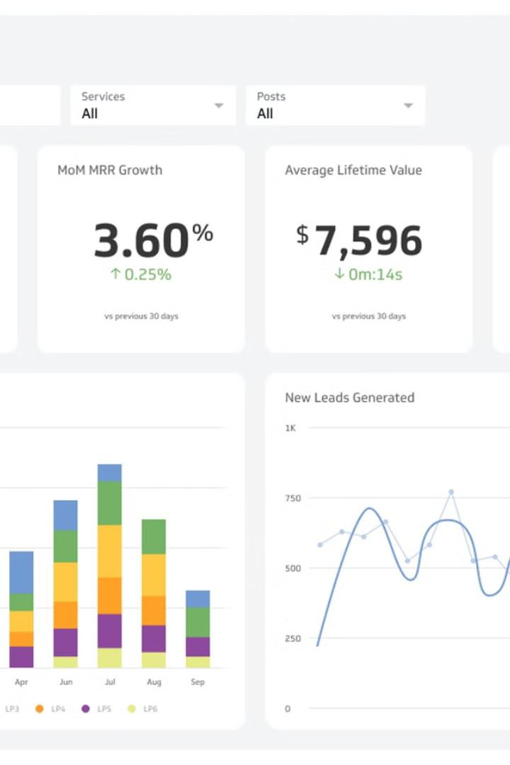

**Evaluation and Results:**

**Measuring Success**

# 20%

## Click-Through Rate

A 20% increase was achieved in click-through rate.

# 15%

## Conversion Rate

The conversion rate improved by 15%.

**Deployment and Scalability: Making it Real**

**API Endpoints**

**1**

**Scalable Inference**

**2**

**Monitoring & Logging**

**3**

Flask and FastAPI serve recommendations. AWS Lambda enables scalable inference. CloudWatch tracks performance. Sentry handles errors.



**Conclusion and Future**

**Directions**

**Key Achievements**

The project successfully delivers personalized book recommendations.

**Potential Enhancements**

Incorporate user reviews and sentiment analysis for better

insights.