知识库文档：SRMS_前同事问题解决步骤

本文档包含 28 个问答对，来源于原始文档的处理和整理。

## Q1: 相关问题

**A:** 文档来源：SRMS_前同事问题解决步骤  
  
SRMS (MRI) Issues  
Batch issues  
Unposted closed batch  
Batch period not identical  
Batch locked  
If batch is locked and unable to post, use the SQL below and change batch status to ‘L’  
Unlock the batch on SRMS and post afterwards  
update cmbtch set status = 'L' where cmbatchid = 'E7420124'  
d. Unlock and Post batch in SRMS  
Communication Centre issues  
Clear communication centre to retrieve back receipts/demand notes  
Execute the below SQL script by inputting user staff ID and current post time  
update [MRISystem].[dbo].[MRI_Server_Messages] set status = 0  
where userid like '%602880%' and posted_time <= '20180807 08:00'  
SRMS on Windows 10  
Internet Options > Security > Set to lowest Security Level  
Compatibility View Settings > Add MRI IP  
Date format problem – Go to Control Panel > Region > Set Format to English (United Kingdom)  
PPS Issues (Runs every night)  
Check if PPS total amount and Settled amount are balanced next morning  
Make sure settled amount are in different Income Cat.  
If PPS job process failed, re-run ‘PPS settlement’ on SRMS  
Solution 1  
ID: i0001 PW: mri  
Select ‘HOME’ site  
Click on ‘PRINT’ to re-run PPS settlement  
Solution 2  
If PPS Settlement Update does not work, execute below stored procedure manually  
EXEC sp_SMS_PPSSETTLEUPD_SCH_XML  
Solution 3  
i. If stored procedure does not work, insert event xml manually to scheduler job  
INSERT INTO [SCHEDULER_JOBS]  
(  
[USERID]  
,[EVENTXML]  
,[SUBMITED_BY]  
,[SUBMITED_DATE]  
,[STATUS]  
)  
VALUES  
(  
'I0001-HOIT',  
--'<MRIEVENT><RECURRENCE FREQUENCY="SINGULAR"><DATE>25/3/2011</DATE><TIME>16:12</TIME></RECURRENCE><ACTIONS><ACTION><TYPE>REPORT</TYPE><REPORT>~STYLE=@~SELECTTABLE=CMLEDG~HELPIMG=:: PPS Settlement Update~STYLEDESC=Default Style~REPORTNAME=PPS Settlement Update~SUBJECT=~MESSAGE=~ATTACHFORMAT=~FIXEDSEL=~DISABLESELECTLIST=~DISABLESELECTTABLE=~SELECTTYPE=A~REPORTID=SMS_PPSSET~DESCFIELDCOL=~PROGRAM=MRIRW~</REPORT></ACTION></ACTIONS></MRIEVENT>', --17 Oct updated.  
'<MRIEVENT><RECURRENCE FREQUENCY="SINGULAR"><DATE>25/3/2011</DATE><TIME>16:12</TIME></RECURRENCE><ACTIONS><ACTION><TYPE>REPORT</TYPE><REPORT>~STYLE=@~SELECTTABLE=CMLEDG~HELPIMG=:: PPS Settlement Update~STYLEDESC=Default Style~REPORTNAME=PPS Settlement Update~SUBJECT=~MESSAGE=~ATTACHFORMAT=~FIXEDSEL=~DISABLESELECTLIST=~DISABLESELECTTABLE=~SELECTTYPE=A~REPORTID=SMS_PPSSET4~DESCFIELDCOL=~PROGRAM=MRIRW~</REPORT></ACTION></ACTIONS></MRIEVENT>',  
'PPS_Settle_Update',  
GETDATE(),  
'N'  
)  
Autopay Issues (Runs every month on 29th)  
Check if all sites have autopay batch and APC files created  
If autopay file is missing, manual encrypt process needs to be done  
Manual generate APC file on SRMS  
Move all APC file to folder (\\11.0.1.80\temp\autopay\[period]\HSBC)  
Copy [copy_to_one_file.bat] to 1st folder  
Open file with notepad  
Edit the combined file name  
Copy*.APC autp1808.txt /b /y  
Run .bat to combine all autopay charges to one file  
GPG encryption process  
Remote to 11.0.1.83 (administrator/admin@itd)  
Copy the combined file from 11.0.1.80 (MRI DB) to 11.0.1.83 SMRIPPS D:\HSBC\IN  
Launch command prompt  
Go to D:\MRI\script folder, type ‘encrypt.bat autp[XXXXXX].txt  
Copy encrypted file from D:\HSBC\out folder to 11.0.1.80\temp\autopay\yyyymm\hsbc\1st  
Send manual generated GPG file to finance for bank submission  
Autopay Reject Issues (For I.O. Sites)  
I.O. sites require password to unzip the reject file and send to site by email  
Change bank file from .EX_ to .EXE  
Run EXE file and input password to extract file  
Remove .DAT extension from extracted file  
Copy file to autopay reject folder  
Send path to site to process autopay reject  
AutoPay HSBC Reject Email密码tinglwei4858291  
Ad-hoc Charges  
Create new batch in SRMS  
Create new table in temp [11.0.11.014][DAVID_UPLOAD]  
Copy batch ID to table along with ad-hoc charges  
Run below script and copy column 1 to execute stored procedure (change the highlighted field with new table name)  
select '--exec sp_SMS_CreateAdhocCharge ''' + CMBATCHID + ''', ' + '''' + BLDGID + ''', ' + '''' + LEASID + ''', ' + '''' + CONVERT(VARCHAR, INCCAT) + ''', ' + 'N''' + DESCRPTN + ''', ' + '''' + CONVERT(VARCHAR, TRANAMT) + ''', ' + 'N''' + ADDLDESC + '''' ,*  
from [11.0.11.104].[david_upload].[dbo].[70128_956_201808]  
Temp Table Example  
New Site Intake  
Finance in charge of creating BU/Building ID/Unit ID/Occupant ID/Recurring Charges  
IT in charge of creating monthly event for Recurring Charge/Demand Note  
PROJ_MISC table  
Setup autopay details in PROJ_MISC table  
Generate Recurring Charge (First time setup)  
Generate Statement of Account (First time setup)  
Re-print demand note  
Apply Prepayment Process  
Occurs every month on 2nd day  
Apply Prepayment reminder (automatically sent from SIMIS) for sites to post all batch with (900) advance payment transactions  
Create CM Journal Entries (Change Journal Date/Period)  
Change the highlighted fields and run SQL  
update mrievent set eventxml = '<MRIEVENT><RECURRENCE FREQUENCY="RECUR"><SPAN SPANNAME="WEEKLY"><FREQ>1</FREQ><WEEKDAY>~sunday~monday~wednesday~friday</WEEKDAY><EFFECTIVE>10/01/2011</EFFECTIVE><EXECTIME>23:59</EXECTIME></SPAN></RECURRENCE> <ACTIONS><ACTION><TYPE>REPORT</TYPE><REPORT>~UPDATE=Y~PROCDATE=28/02/2018~SELECTTABLE=PROJ~HELPIMG=:: Create CM Journal Entries~REPORTNAME=Create CM Journal Entries~REPORTID=MRI_CMCREAJE~MESSAGE=~ATTACHFORMAT=~SUBJECT=~SELECTTYPE=E~SELECTLIST=PROJ|50501|RS217|50220|50223|51816|FF212|RA101|RA102|RA103|RS741|RS244|RS842|RS920|RS246|RS701|SMS-I|SMS-S|SPM-I|SFM-I|50910|50945|50948|~SELECTLISTDATA=PROJ|50501|HSIN CHONG CENTER|RS217|AAT|50220|SYNERGIS|50223|Laundrimate Service Limited|51816|Marina Cove|FF212|MEI FOO PLAZA|RA101|- Name -|RA102|- Name -|RA103|- Name -|RS741|Stanley Plaza|RS244|ESF|RS842|HKUSPACE-Island East Campus|RS920|Hong Kong Academy of Medicine|RS246|HKUSPACE - Kowloon East Campus|RS701|Tak Tin Shopping Centre|SMS-I|SYNERGIS|SMS-S|SMS billing - Site invoice|SPM-I|Synergis Property Mgt Ltd.|SFM-I|Synergis Facility Mgt Ltd.|50910|URA-Shun Sing Mansion|50945|URA-HK H18|50948|33 Argyle Street|~DESCFIELDCOL=2~PROGRAM=MRICMCreajeWeb.CMCreaje~PERIOD=201802~</REPORT></ACTION></ACTIONS></MRIEVENT>' where eventid = '000000000001380'  
Log on Full Issue  
Error message when log on SRMS  
Force all users to log out from specific site (highlighted value as site ID)  
update mrisystem.dbo.MRI_Current_Sessions set logout_time = getdate()  
where userid like '%-TJ%' and logout_time is null --Force all user logout at the checking site

*关键词:* Journal, Building ID, Batch, Synergis, Occupant, 密码, SRMS, SQL, IE, Demand Note

──────────────────────────────────────────────────

## Q2: 关于的详细信息

**A:** 表格标题：  
表格内容：  
Site Name | New Password Eff. (01 June 2018) | New Password Eff. (01 Dec 2018)  
---|---|---  
Arden Court/Hacienda/Wo Ming Court | HSBC-Synergis#421 | HSBC-Synergis#815  
HSBC-Synergis#221  
HSBC-Synergis#028  
Hatton House | HSBC-Synergis#241 | HSBC-Synergis#805  
HSBC-Synergis#141  
HSBC-Synergis#051  
Linden Height | HSBC-Lindenh#137 | HSBC-Lindenh#043  
HSBC-Lindenh#210  
HSBC-Lindenh#700

*关键词:* Site Name, New Password Eff. (01 June 2018), New Password Eff. (01 Dec 2018),

──────────────────────────────────────────────────

## Q3: [数字]. Check Scheduler Job Table for stuck jobs

**A:** 文档来源：SRMS_前同事问题解决步骤  
  
select * from dbo.SCHEDULER_JOBS  
a. To stop stuck scheduler jobs, update job status to E  
UPDATE dbo.SCHEDULER_JOBS SET status = 'E' where ID = '171640'  
SRMS Training  
Copy and paste the below script or open the SQL script from above  
Edit the Date Join value and run script  
Copy result to excel sheet and send to L&D department  
/*  
|----------------------------  
| S R M S  
|----------------------------  
*/  
select  
a.staffno, a.surname, a.othrname, a.chinname, a.titlename, a.titleChName, a.pldeptname, a.pldeptchname, a.datejoin  
, b.business_unit, b.sitename, b.agmregion  
, c.telno, c.siteid  
, (select count(*) from sms_user where sms_userid collate Chinese_Taiwan_Stroke_CI_AS= a.staffno) as MRI_account  
from  
scdsvs01.msddb.dbo.staff a  
left join scdsvs01.siteprofile.dbo.siteprofile b on replace(b.sitename,' ', '') like '%' +replace(rtrim( a.pldeptname),' ','') +'%' and b.status=3 and b.sitename not like '%Car Park%'  
left join proj c on c.projid collate Chinese_Taiwan_Stroke_CI_AS= rtrim(b.business_unit)  
where  
a.staffno not in ('T2619','T4105','T0057','M3769','T2680','Z5034','T0324','T4069','R1396','R3695')  
--and a.staffno not in ('M3844','M9822','T0221','T2380','T4044') --16-Jul-2012 to 16-Jul-2012  
and a.DateJoin>='20160301' --##  
--and a.TitleName in ('ASSISTANT ESTATE OFFICER','ASSISTANT PROPERTY MANAGER','ESTATE OFFICER','PROPERTY MANAGER','SENIOR ESTATE OFFICER','CLERK')  
and b.agmregion in ('KTTW','HKELT','PMNTE','PMNTW','FM1','KLNTK','HK','KLN','NTE','NTW')  
and (select count(*) from sms_user where sms_userid collate Chinese_Taiwan_Stroke_CI_AS= a.staffno) > 0  
order by  
a.staffno  
--a.datejoin  
SOMS Training  
Copy and paste the below script  
Edit the Date Join value and run script  
Copy result to excel sheet and send to L&D department  
/*  
|----------------------------  
| S O M S  
|----------------------------  
*/  
select  
a.DATERESGN,  
a.staffno, a.surname, a.othrname, a.chinname, a.titlename, a.titleChName, a.pldeptname, a.pldeptchname, a.datejoin  
, b.business_unit, b.sitename, b.agmregion  
, c.telno, c.siteid  
, (select count(*) from sms_user where sms_userid collate Chinese_Taiwan_Stroke_CI_AS= a.staffno) as MRI_account  
from  
scdsvs01.msddb.dbo.staff a  
left join scdsvs01.siteprofile.dbo.siteprofile b on replace(b.sitename,' ', '') like '%' +replace(rtrim( a.pldeptname),' ','') +'%' and b.status=3 and b.sitename not like '%Car Park%'  
left join proj c on c.projid collate Chinese_Taiwan_Stroke_CI_AS= rtrim(b.business_unit)  
where  
a.staffno not in ('T2619','T4105','T0057','M3769','T2680','Z5034','T0324','T4069','R1396','R3695')  
and a.DateJoin>='20160301' --##  
AND a.DATERESGN = '20991231'  
AND business_unit IS NOT NULL  
and (select count(*) from sms_user where sms_userid collate Chinese_Taiwan_Stroke_CI_AS= a.staffno) > 0  
and a.TitleName in (  
'ADMINISTRATIVE ASSISTANT'  
,'ADMINISTRATIVE OFFICER'  
,'ASSISTANT ADMINISTRATIVE OFFICER'  
,'ASSISTANT ESTATE OFFICER'  
,'ASSISTANT FACILITY OFFICER'  
,'ASSISTANT PROPERTY OFFICER'  
,'ASSISTANT TECHNICAL OFFICER'  
,'ASSISTANT PROPERTY MANAGER'  
,'CLERK'  
,'CUSTOMER SERVICE ASSISTANT'  
,'CUSTOMER SERVICE ASSISTANT'  
,'CUSTOMER SERVICE ASSISTANT - HCCT'  
,'ESTATE ASSISTANT'  
,'ESTATE OFFICER'  
,'FACILITY ASSISTANT'  
,'FACILITY MANAGER'  
,'FACILITY OFFICER'  
,'MAINTENANCE MANAGER'  
,'OPERATION OFFICER'  
,'PROPERTY OFFICER'  
,'SENIOR ADMINISTRATIVE ASSISTANT'  
,'SENIOR ESTATE ASSISTANT'  
,'SENIOR ESTATE OFFICER'  
,'SENIOR FACILITY ASSISTANT'  
,'SENIOR FACILITY OFFICER'  
,'SENIOR OPERATION ASSISTANT'  
,'SENIOR OPERATION OFFICER'  
,'SENIOR PROPERTY ASSISTANT'  
,'SENIOR PROPERTY OFFICER'  
,'SENIOR TECHNICAL OFFICER'  
,'SENIOR PROPERTY MANAGER'  
,'TECHNICAL OFFICER')  
order by  
a.staffno  
--a.datejoin  
SOMS Issue  
SOMS – Add technician  
Use the below SQL to check if technician exists in database  
SELECT * from [SMSMRIPROD].[dbo].[TB_MM_TECH] where technicianid = 'MZ00025'  
Use the below SQL to add new technician to database  
[STAFF ID][STAFF NAME][FIRST NAME][LAST NAME]  
Insert into [SMSMRIPROD].[dbo].[TB_MM_TECH](TECHNICIANID,FILEASNAME,FIRSTNAME,LASTNAME)  
Values('MZ00025','HO CHI CHUNG','CHI CHUNG','HO');  
SOMS – New site setup  
Send template to site user to complete  
Fill in Step 1 to Step 3 (Follow the rules on template)  
Upload STEP 1 - location list to [SMSMRIPROD].[dbo].[TB_MM_LOCATION]  
Upload STEP 2 – trade type list to [SMSMRIPROD].[dbo].[TB_MM_TRADETYPE]  
[SMSMRIPROD].[dbo].[TB_MM_TRADETYPEL2]  
[SMSMRIPROD].[dbo].[TB_MM_TRADETYPEL3]  
[SMSMRIPROD].[dbo].[TB_MM_TRADETYPEL4]  
  
相关SQL语句：  
```sql  
select  
```

*关键词:* SQL, SRMS

──────────────────────────────────────────────────

## Q4: SRMS_前同事问题解决步骤中的图片1

**A:** 这是来自文档《SRMS_前同事问题解决步骤》的第1张图片。

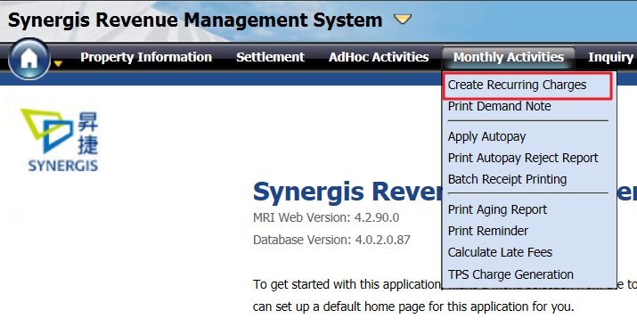

*关键词:* SRMS_前同事问题解决步骤, 图片, 图像

──────────────────────────────────────────────────

## Q5: SRMS_前同事问题解决步骤中的图片2

**A:** 这是来自文档《SRMS_前同事问题解决步骤》的第2张图片。

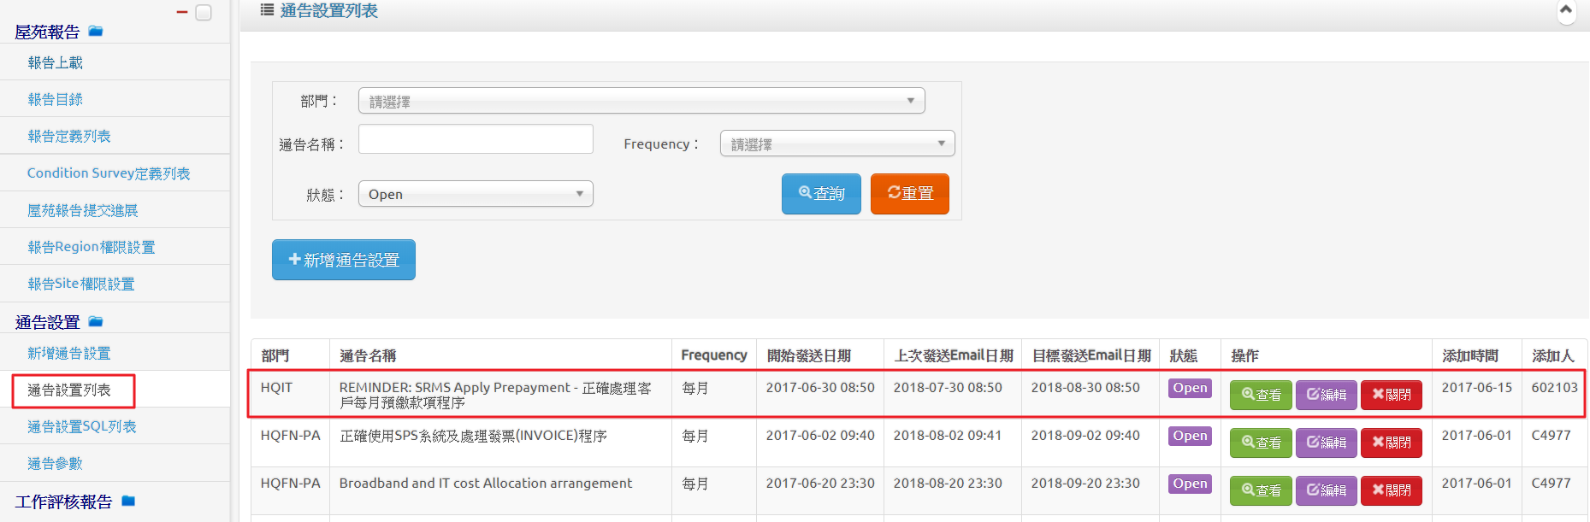

*关键词:* SRMS_前同事问题解决步骤, 图片, 图像

──────────────────────────────────────────────────

## Q6: SRMS_前同事问题解决步骤中的图片3

**A:** 这是来自文档《SRMS_前同事问题解决步骤》的第3张图片。

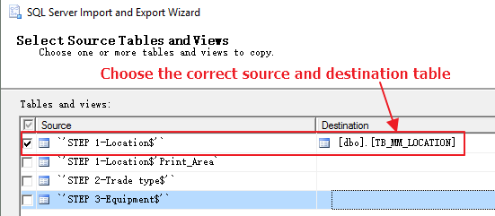

*关键词:* SRMS_前同事问题解决步骤, 图片, 图像

──────────────────────────────────────────────────

## Q7: SRMS_前同事问题解决步骤中的图片4

**A:** 这是来自文档《SRMS_前同事问题解决步骤》的第4张图片。

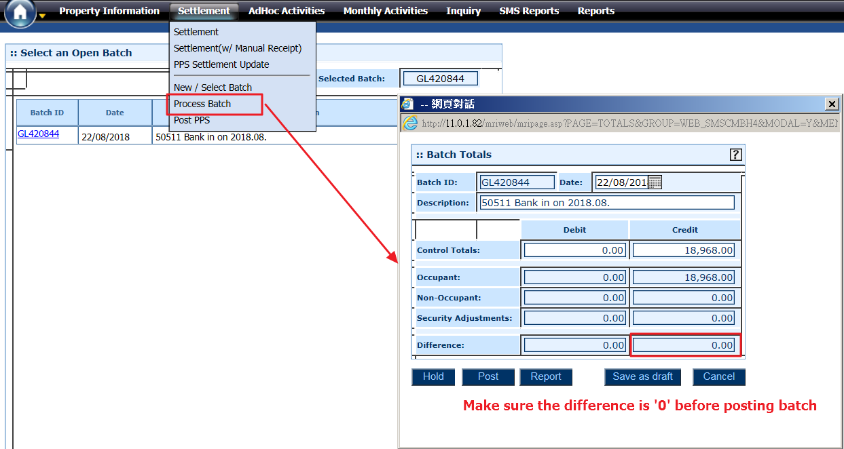

*关键词:* SRMS_前同事问题解决步骤, 图片, 图像

──────────────────────────────────────────────────

## Q8: SRMS_前同事问题解决步骤中的图片5

**A:** 这是来自文档《SRMS_前同事问题解决步骤》的第5张图片。

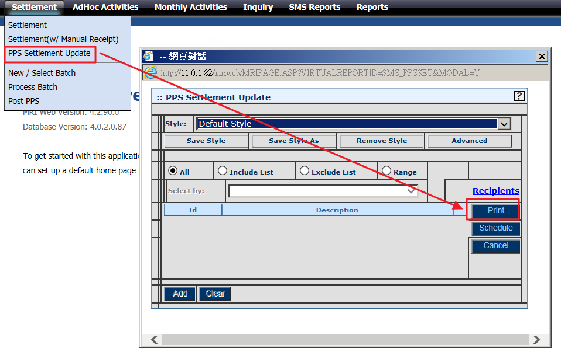

*关键词:* SRMS_前同事问题解决步骤, 图片, 图像

──────────────────────────────────────────────────

## Q9: SRMS_前同事问题解决步骤中的图片6

**A:** 这是来自文档《SRMS_前同事问题解决步骤》的第6张图片。

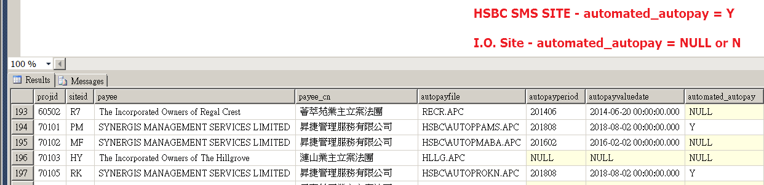

*关键词:* SRMS_前同事问题解决步骤, 图片, 图像

──────────────────────────────────────────────────

## Q10: SRMS_前同事问题解决步骤中的图片7

**A:** 这是来自文档《SRMS_前同事问题解决步骤》的第7张图片。

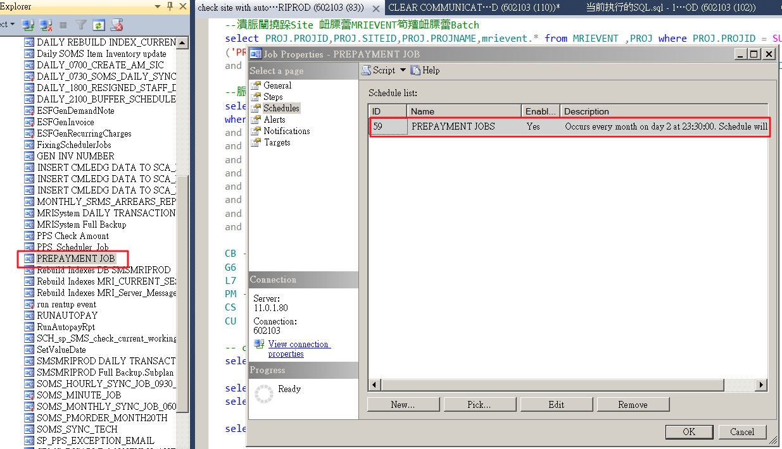

*关键词:* SRMS_前同事问题解决步骤, 图片, 图像

──────────────────────────────────────────────────

## Q11: SRMS_前同事问题解决步骤中的图片8

**A:** 这是来自文档《SRMS_前同事问题解决步骤》的第8张图片。

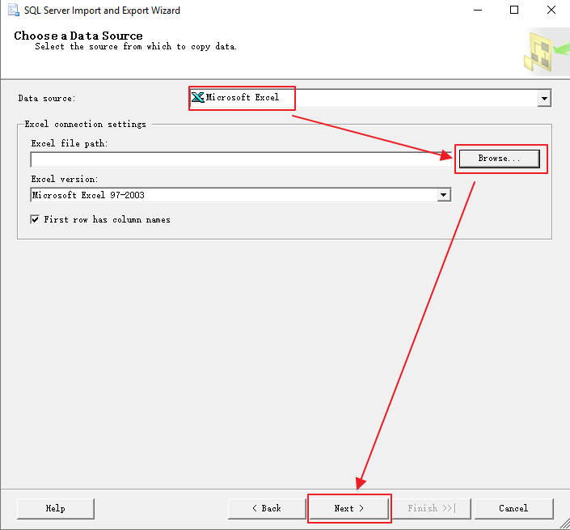

*关键词:* SRMS_前同事问题解决步骤, 图片, 图像

──────────────────────────────────────────────────

## Q12: SRMS_前同事问题解决步骤中的图片9

**A:** 这是来自文档《SRMS_前同事问题解决步骤》的第9张图片。

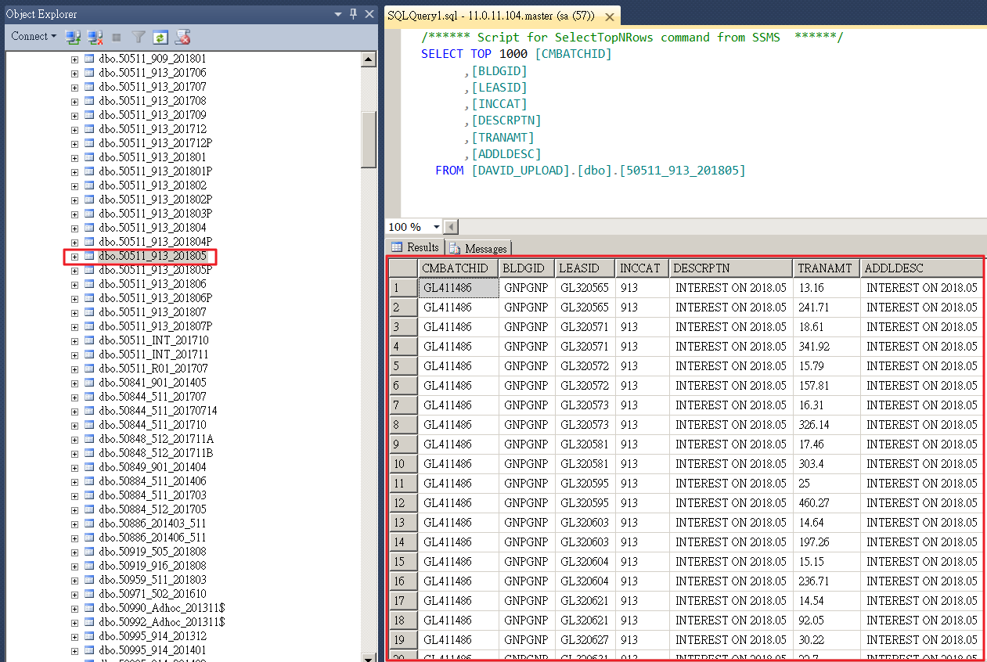

*关键词:* SRMS_前同事问题解决步骤, 图片, 图像

──────────────────────────────────────────────────

## Q13: SRMS_前同事问题解决步骤中的图片10

**A:** 这是来自文档《SRMS_前同事问题解决步骤》的第10张图片。

*关键词:* SRMS_前同事问题解决步骤, 图片, 图像

──────────────────────────────────────────────────

## Q14: SRMS_前同事问题解决步骤中的图片11

**A:** 这是来自文档《SRMS_前同事问题解决步骤》的第11张图片。

*关键词:* SRMS_前同事问题解决步骤, 图片, 图像

──────────────────────────────────────────────────

## Q15: SRMS_前同事问题解决步骤中的图片12

**A:** 这是来自文档《SRMS_前同事问题解决步骤》的第12张图片。

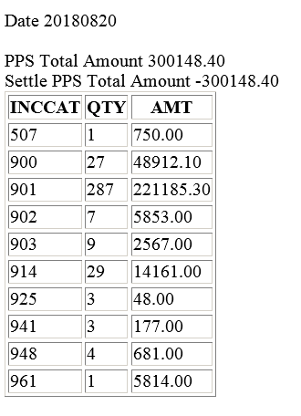

*关键词:* SRMS_前同事问题解决步骤, 图片, 图像

──────────────────────────────────────────────────

## Q16: SRMS_前同事问题解决步骤中的图片13

**A:** 这是来自文档《SRMS_前同事问题解决步骤》的第13张图片。

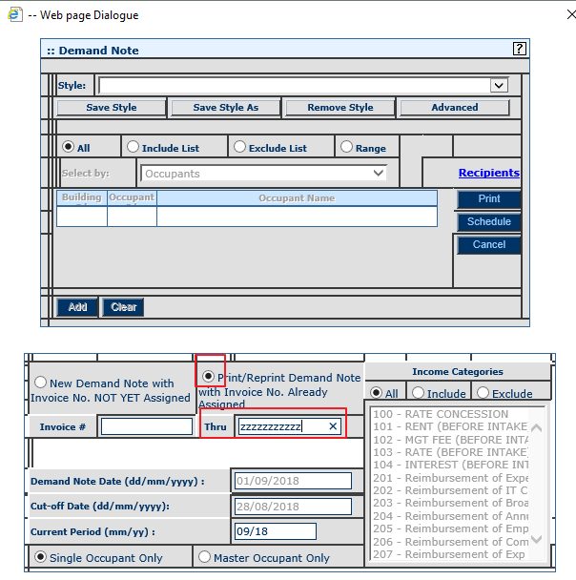

*关键词:* SRMS_前同事问题解决步骤, 图片, 图像

──────────────────────────────────────────────────

## Q17: SRMS_前同事问题解决步骤中的图片14

**A:** 这是来自文档《SRMS_前同事问题解决步骤》的第14张图片。

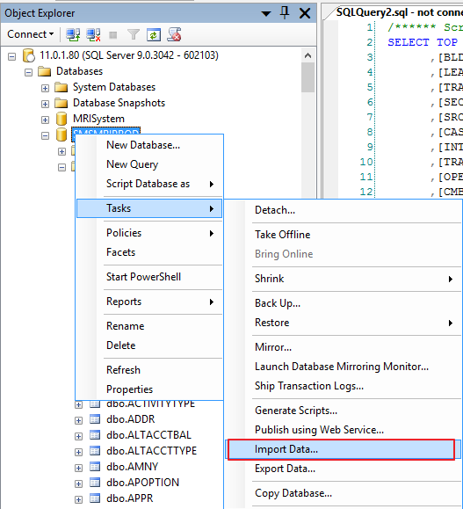

*关键词:* SRMS_前同事问题解决步骤, 图片, 图像

──────────────────────────────────────────────────

## Q18: SRMS_前同事问题解决步骤中的图片15

**A:** 这是来自文档《SRMS_前同事问题解决步骤》的第15张图片。

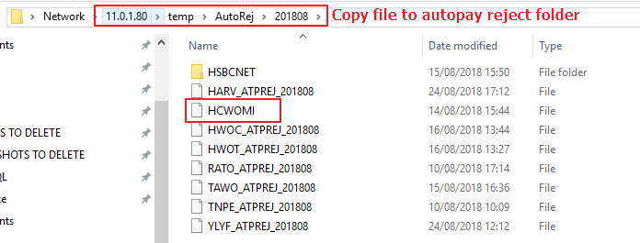

*关键词:* SRMS_前同事问题解决步骤, 图片, 图像

──────────────────────────────────────────────────

## Q19: SRMS_前同事问题解决步骤中的图片16

**A:** 这是来自文档《SRMS_前同事问题解决步骤》的第16张图片。

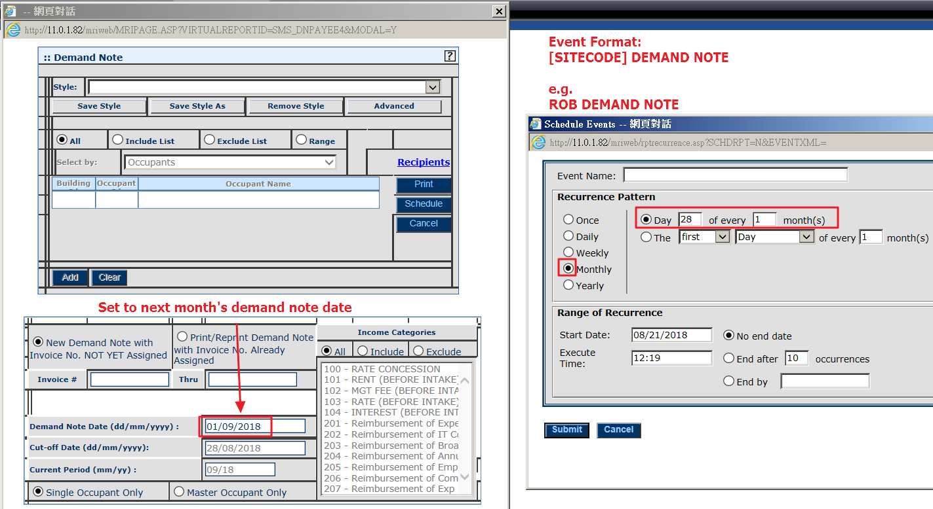

*关键词:* SRMS_前同事问题解决步骤, 图片, 图像

──────────────────────────────────────────────────

## Q20: SRMS_前同事问题解决步骤中的图片17

**A:** 这是来自文档《SRMS_前同事问题解决步骤》的第17张图片。

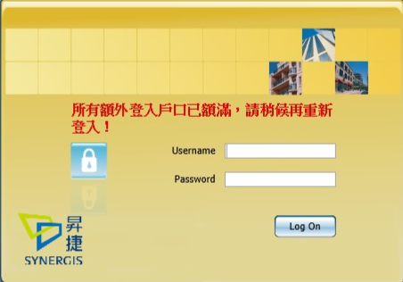

*关键词:* SRMS_前同事问题解决步骤, 图片, 图像

──────────────────────────────────────────────────

## Q21: SRMS_前同事问题解决步骤中的图片18

**A:** 这是来自文档《SRMS_前同事问题解决步骤》的第18张图片。

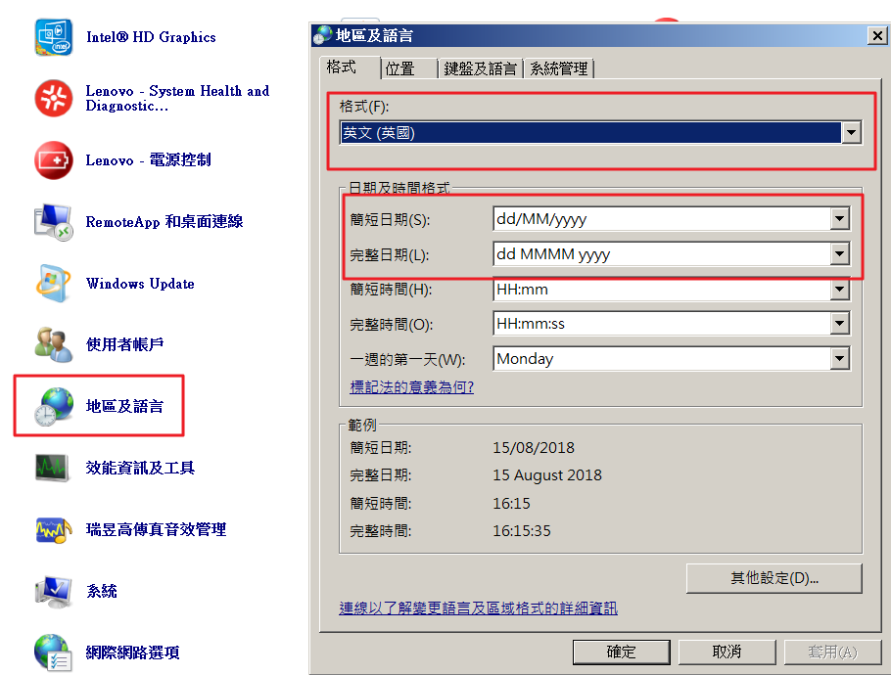

*关键词:* SRMS_前同事问题解决步骤, 图片, 图像

──────────────────────────────────────────────────

## Q22: SRMS_前同事问题解决步骤中的图片19

**A:** 这是来自文档《SRMS_前同事问题解决步骤》的第19张图片。

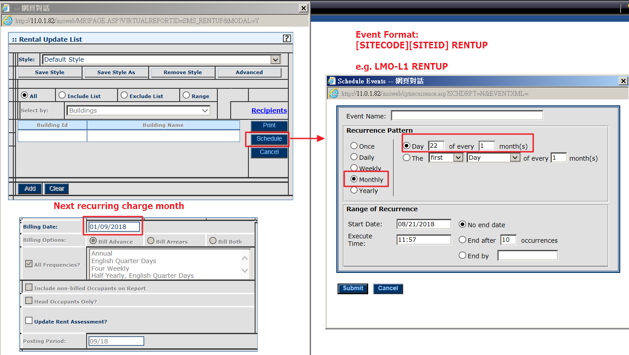

*关键词:* SRMS_前同事问题解决步骤, 图片, 图像

──────────────────────────────────────────────────

## Q23: SRMS_前同事问题解决步骤中的图片20

**A:** 这是来自文档《SRMS_前同事问题解决步骤》的第20张图片。

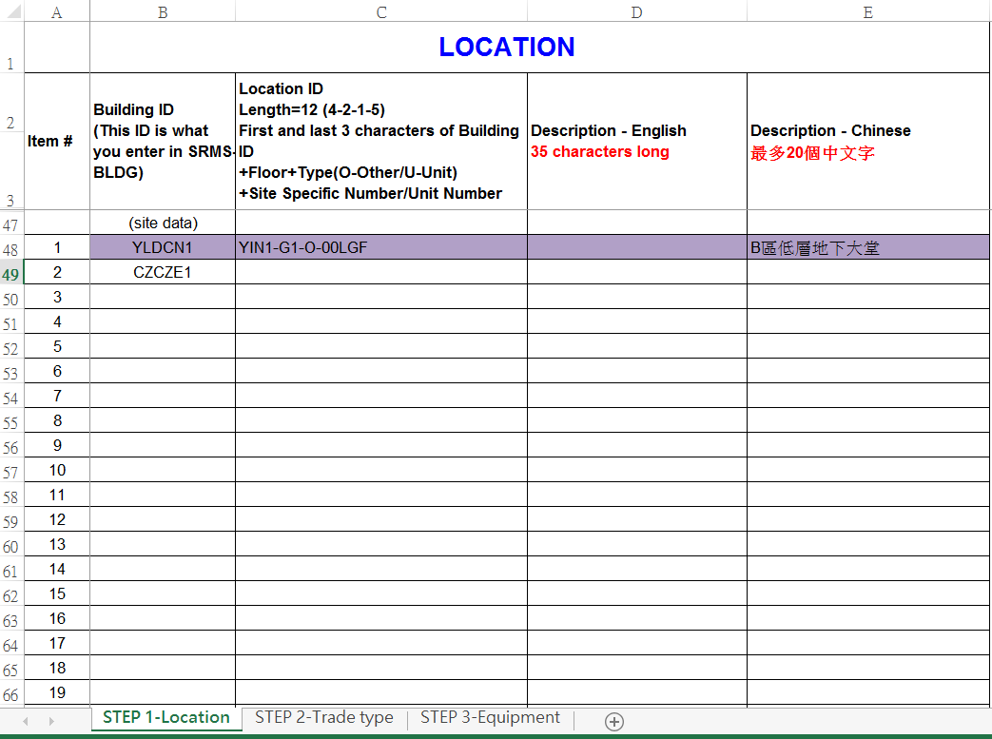

*关键词:* SRMS_前同事问题解决步骤, 图片, 图像

──────────────────────────────────────────────────

## Q24: SRMS_前同事问题解决步骤中的图片21

**A:** 这是来自文档《SRMS_前同事问题解决步骤》的第21张图片。

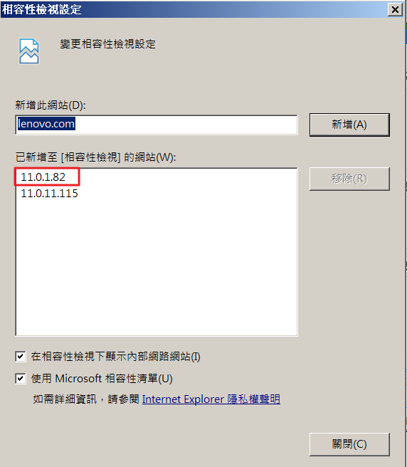

*关键词:* SRMS_前同事问题解决步骤, 图片, 图像

──────────────────────────────────────────────────

## Q25: SRMS_前同事问题解决步骤中的图片22

**A:** 这是来自文档《SRMS_前同事问题解决步骤》的第22张图片。

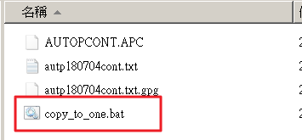

*关键词:* SRMS_前同事问题解决步骤, 图片, 图像

──────────────────────────────────────────────────

## Q26: SRMS_前同事问题解决步骤中的图片23

**A:** 这是来自文档《SRMS_前同事问题解决步骤》的第23张图片。

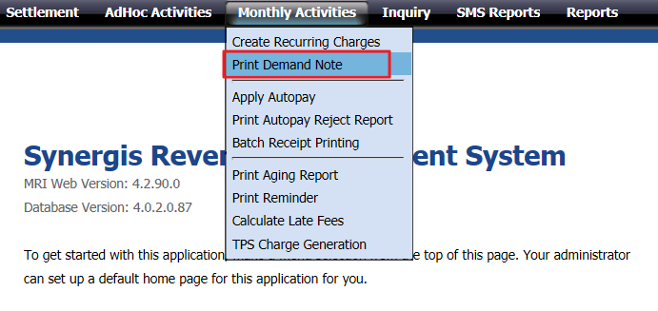

*关键词:* SRMS_前同事问题解决步骤, 图片, 图像

──────────────────────────────────────────────────

## Q27: SRMS_前同事问题解决步骤中的图片24

**A:** 这是来自文档《SRMS_前同事问题解决步骤》的第24张图片。

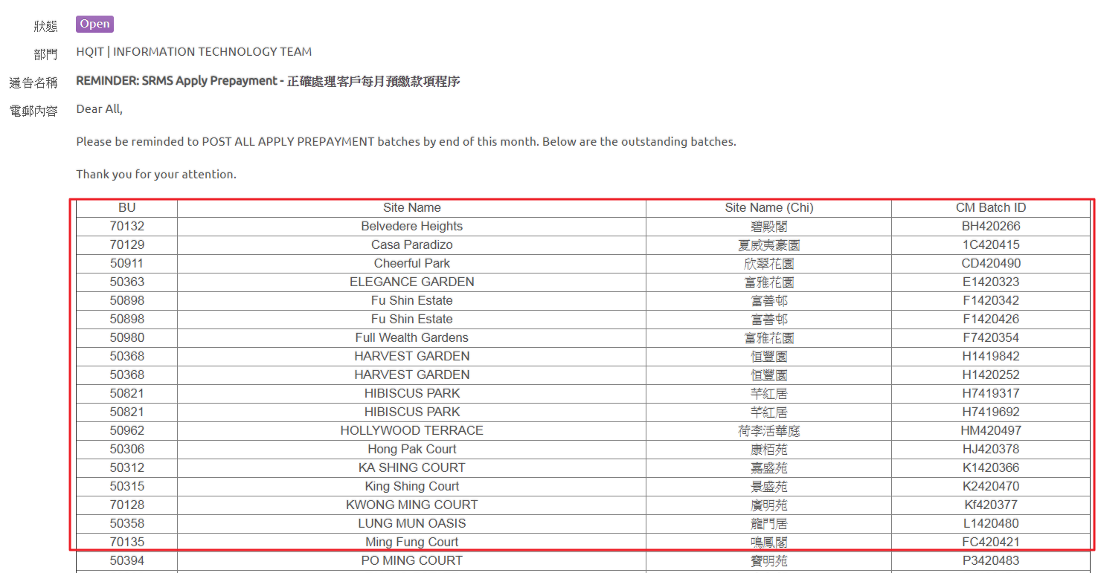

*关键词:* SRMS_前同事问题解决步骤, 图片, 图像

──────────────────────────────────────────────────

## Q28: SRMS_前同事问题解决步骤中的图片25

**A:** 这是来自文档《SRMS_前同事问题解决步骤》的第25张图片。

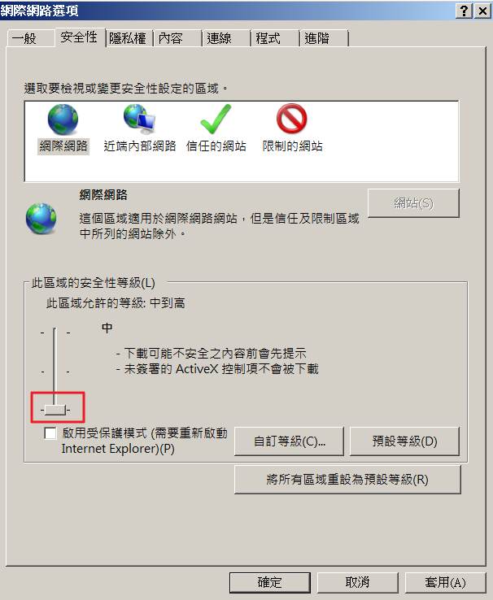

*关键词:* SRMS_前同事问题解决步骤, 图片, 图像

──────────────────────────────────────────────────