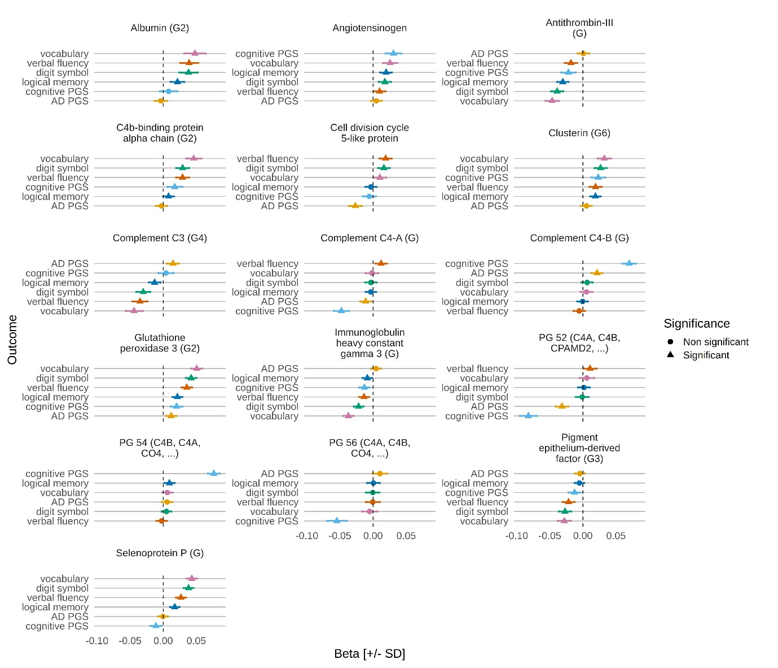

**Figure S6-1: Associations between cognitive outcomes and proteins/protein groups in MAJA models with basic adjustments.** Standardised effect sizes are shown for 16 proteins/protein groups with digit symbol (green), logical memory (dark blue), vocabulary (pink), verbal fluency (red), AD PRS (orange) and cognitive PRS (light blue) in GS. Protein/protein groups are included in the plot if they had a significant association (PIP ≥ 0.95 and the effect size ± standard deviation did not include zero) with one or more outcomes. Error bars represent effect size ± standard deviation [±SD].



**Figure S6-2: Cognitive outcome and covariate correlations.** The heatmap shows the Pearson correlations between the six cognitive outcomes and all covariates used in the fully adjusted models with complete data.