A PROJECT REPORT
ON
Hybrid 3D CNN–Swin Transformer for Pulmonary Nodule Malignancy Risk Prediction on LIDC-IDRI
(PulmoScan / LCP-CNN)
Submitted in partial fulfillment of the requirements for the award of the degree of
BACHELOR OF ENGINEERING
IN
COMPUTER SCIENCE AND ENGINEERING
Submitted by
H M Ajay (1XX20CS001)
Student Name 2 (1XX20CS002)
Student Name 3 (1XX20CS003)
Student Name 4 (1XX20CS004)

Under the Guidance of
Prof. Guide Name
Your College / Department of Computer Science and Engineering
Academic Year 2025–26

CERTIFICATE
This is to certify that the project work entitled “Hybrid 3D CNN–Swin Transformer for Pulmonary Nodule Malignancy Risk Prediction on LIDC-IDRI” is a bonafide work carried out by H M Ajay, Student Name 2, Student Name 3, Student Name 4 bearing USN 1XX20CS001, 1XX20CS002, 1XX20CS003, 1XX20CS004 in partial fulfillment for the award of Bachelor of Engineering in Computer Science and Engineering of the Affiliating University during the academic year 2025–26. It is certified that all corrections / suggestions indicated for Internal Assessment have been incorporated in the report. The project report has been approved as it satisfies the academic requirements in respect of project work prescribed for the said degree.

Guide: Prof. Guide Name
Head of the Department: _______________________
Principal: _______________________
External Examiner: _______________________

DECLARATION
We, H M Ajay, Student Name 2, Student Name 3, Student Name 4, students of Your College / Department of Computer Science and Engineering, hereby declare that the project work entitled “Hybrid 3D CNN–Swin Transformer for Pulmonary Nodule Malignancy Risk Prediction on LIDC-IDRI” submitted to the Affiliating University in partial fulfillment of the requirements for the award of Bachelor of Engineering in Computer Science and Engineering is a record of original work carried out by us under the guidance of Prof. Guide Name. We further declare that this project work or any part thereof has not been submitted to any other University / Institution for the award of any degree or diploma.

H M Ajay (1XX20CS001) ____________________
Student Name 2 (1XX20CS002) ____________________
Student Name 3 (1XX20CS003) ____________________
Student Name 4 (1XX20CS004) ____________________

ACKNOWLEDGEMENT
We express our sincere gratitude to our guide Prof. Guide Name for continuous support, valuable suggestions, and encouragement throughout this project. We thank the Head of the Department and the Principal for providing facilities to carry out this work. We also acknowledge The Cancer Imaging Archive (TCIA) and the LIDC-IDRI consortium for providing publicly available imaging data for research use. Finally, we thank our families and friends for their support during the course of this project.

ABSTRACT
Lung cancer remains a leading cause of cancer mortality worldwide. Low-dose CT screening increases early detection but produces many indeterminate pulmonary nodules that require risk stratification. Hand-crafted clinical models (e.g., Brock) ignore much of the volumetric imaging signal, while purely 2D CNN approaches discard 3D context. This project presents PulmoScan / LCP-CNN: a Stage-2 malignancy risk predictor that classifies nodule volumes of interest (VOIs) using a hybrid 3D convolutional neural network and Swin Transformer encoder.
We build a reproducible preprocessing pipeline for LIDC-IDRI: DICOM CT series are converted to Hounsfield Units, resampled to 1×1×1 mm isotropic NIfTI, and linked to LIDC XML annotations. Reader marks are mapped to patient-space centroids using original DICOM geometry (critical for correct VOI placement), clustered into physical nodules, and labeled with the LIDC malignancy rule (≥4 malignant, ≤2 benign, 3 excluded). Patient-level train/validation/test splits prevent leakage.
On a first serious batch of 153 annotated series (~199 labeled nodules after filtering), a 48³ VOI hybrid model trained on a Kubeflow A100 GPU achieved validation AUC ≈ 0.949 (early-stopped) and held-out test AUC ≈ 0.914, with AUPRC ≈ 0.958. The work focuses on Stage-2 classification; Stage-1 detection from raw unannotated CT is identified as future work. Research use only — not a medical device or clinical diagnosis.
Keywords: LIDC-IDRI, pulmonary nodule, malignancy, 3D CNN, Swin Transformer, deep learning, CT

TABLE OF CONTENTS
Certificate
Declaration
Acknowledgement
Abstract
List of Figures
List of Tables
Chapter 1 Introduction
Chapter 2 Literature Survey
Chapter 3 System Requirements & Analysis
Chapter 4 System Design
Chapter 5 Implementation
Chapter 6 Results & Discussion
Chapter 7 Conclusion & Future Work
References
Appendix A Commands & Reproducibility
LIST OF FIGURES
Figure 1. End-to-End System Overview (Stage-2 Malignancy Scoring)
Figure 2. Preprocessing Pipeline (CPU)
Figure 3. Hybrid 3D CNN–Swin Architecture
Figure 4. Training & Evaluation Flow (Kubeflow GPU)
Figure 5. Stage-1 vs Stage-2 Scope
LIST OF TABLES
Table 1. Hardware & Software Environment
Table 2. Dataset Split Summary (processed_v3)
Table 3. Labeling Rule (LIDC Malignancy)
Table 4. Training Configuration
Table 5. Validation Training Trajectory (selected epochs)
Table 6. Held-out Test Metrics

CHAPTER 1 — INTRODUCTION
1.1 Overview
Computed tomography (CT) is central to lung cancer screening and incidental nodule management. Many detected nodules are benign, yet uncertainty drives repeat imaging, PET, or biopsy—each with cost and risk. An image-native malignancy probability that uses the full 3D nodule context can support radiologists as a research decision-support signal (not a replacement for clinical judgment).
1.2 Problem Statement
Given a pulmonary nodule volume of interest extracted from chest CT, predict the probability that the nodule is malignant according to LIDC radiologist malignancy characteristics, under a strict patient-level evaluation protocol with no train/test patient leakage.
1.3 Objectives
• Design a hybrid 3D CNN + Swin Transformer classifier for nodule VOIs.
• Implement a reproducible LIDC-IDRI preprocessing pipeline (DICOM/XML → processed tree).
• Train and evaluate on patient-level splits; report AUC, sensitivity, specificity, and related metrics.
• Document limitations (Stage-2 scope, label subjectivity) and a roadmap for Stage-1 detection.
1.4 Scope
In scope: Stage-2 malignancy scoring on LIDC-annotated nodules; preprocessing; training on GPU; metrics and checkpoint export. Out of scope for this phase: automatic nodule detection on arbitrary raw CTs (Stage-1), multi-center clinical deployment, and regulatory clearance.
1.5 Organization of the Report
Chapter 2 reviews related work. Chapter 3 states requirements. Chapter 4 presents design and diagrams. Chapter 5 describes implementation. Chapter 6 reports experiments and results. Chapter 7 concludes.

CHAPTER 2 — LITERATURE SURVEY
2.1 Clinical Risk Models
Models such as Brock (PanCan) estimate malignancy from clinical and simple imaging covariates. They are interpretable but underuse voxel-level appearance (texture, spiculation patterns, volumetric morphology).
2.2 Deep Learning on LIDC / LUNA
LIDC-IDRI provides multi-reader nodule annotations including malignancy ratings (1–5). LUNA16 focuses on detection benchmarks derived from LIDC. Prior work uses 2D/2.5D/3D CNNs for classification and U-Nets for segmentation. Transformers and hybrid CNN–attention models improve long-range context on volumetric patches.
2.3 Motivation for a Hybrid CNN–Swin Design
3D CNNs capture local morphology efficiently; Swin-style shifted-window attention models broader spatial relationships within the VOI with manageable compute. A CNN backbone producing a feature volume fed to a Swin encoder with a [CLS] token yields both a probability and an attention map for explainability.

CHAPTER 3 — SYSTEM REQUIREMENTS & ANALYSIS
3.1 Functional Requirements
• Ingest LIDC DICOM CT and XML annotations.
• Produce isotropic NIfTI volumes and physical-nodule metadata.
• Train hybrid classifier with AMP on GPU.
• Evaluate patient-level test metrics (AUC, etc.).
• Export best checkpoint for inference/demo.
3.2 Non-Functional Requirements
Reproducibility (configs + manifests), memory-safe data loading (lazy mmap, num_workers=0 on constrained hosts), and clear research-only disclaimers.
3.3 Environment
Component | Details
Preprocess host | Windows / WSL2, CPU, pydicom + SimpleITK
Training host | Kubeflow GPU notebook (NVIDIA A100 MIG ~21 GB)
Python | Conda env pulmo, Python 3.10
Deep learning | PyTorch 2.1.2+cu118 (driver-matched)
Data source | TCIA LIDC-IDRI (~303 series first batch → 153 selected)
Code | lcp-cnn repository, branch cursor/lidc-fresh-preprocess-1296

Table 1. Hardware & Software Environment

CHAPTER 4 — SYSTEM DESIGN
4.1 Overall Architecture
The system separates CPU preprocessing from GPU training. Preprocessing writes a stable processed/ tree. Training lazily crops VOIs around centroids and optimizes binary malignancy probability.
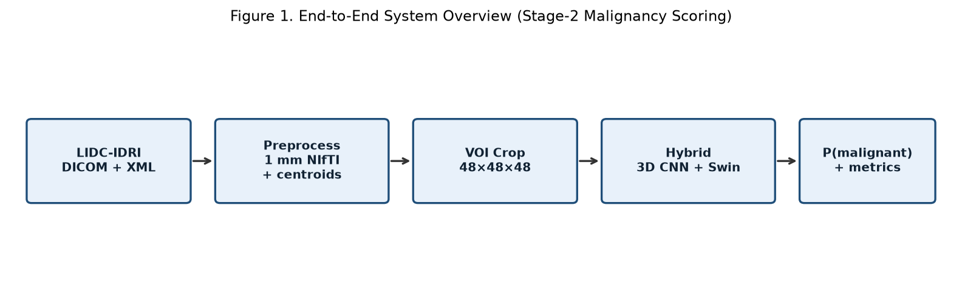
4.2 Preprocessing Design
TCIA downloads often include multiple series per patient (e.g., chest vs angio). We keep CT series with matching LIDC XML, prefer non-angio series, and one series per patient. A critical design choice is mapping LIDC edgeMap xCoord/yCoord using the original DICOM SimpleITK geometry before 1 mm resampling; treating those indices as 1 mm voxels misplaces VOIs and collapses AUC (observed in an earlier processed_v2 experiment).
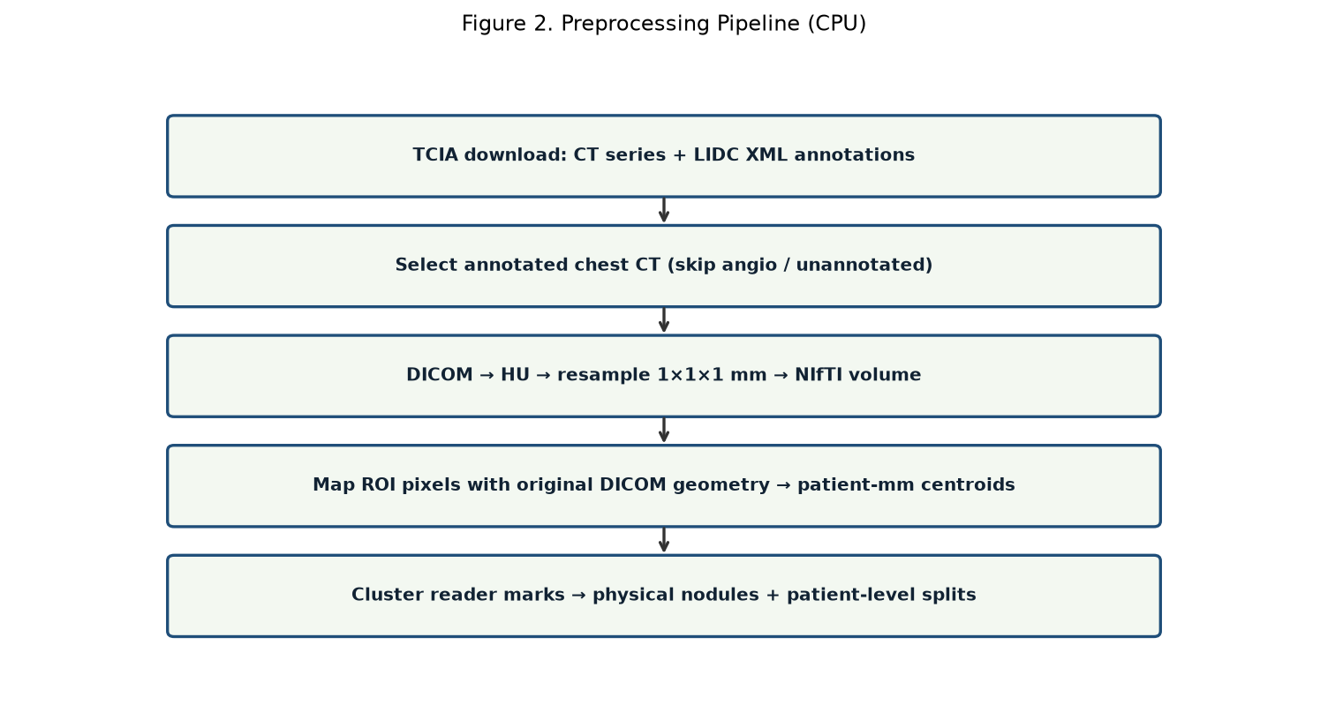
4.3 Model Design
Input VOI shape is 1×D×H×W (default 48³ for the primary experiment). A ResNet-style 3D CNN backbone emits a feature map; a Swin3D encoder with [CLS] pooling feeds an MLP head and sigmoid. Attention from [CLS] to spatial tokens supports qualitative explanation overlays.
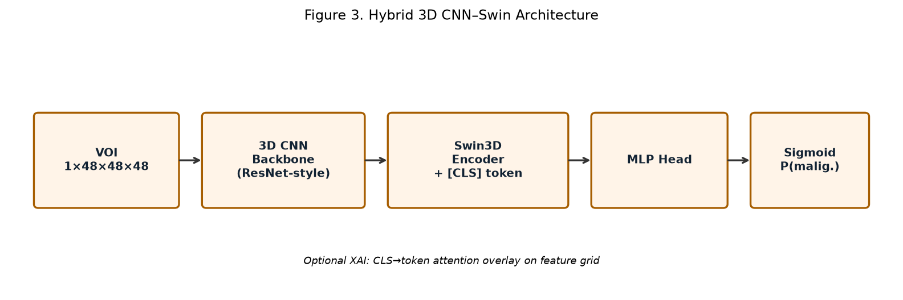
4.4 Training & Evaluation Design
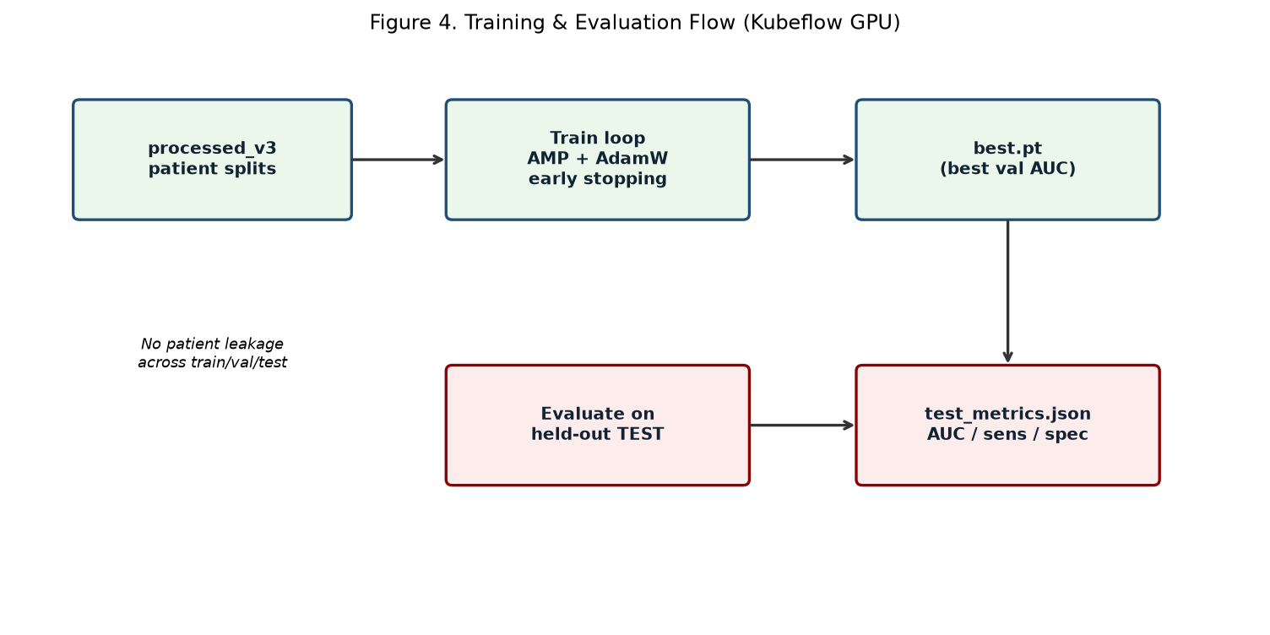
4.5 Stage Scope
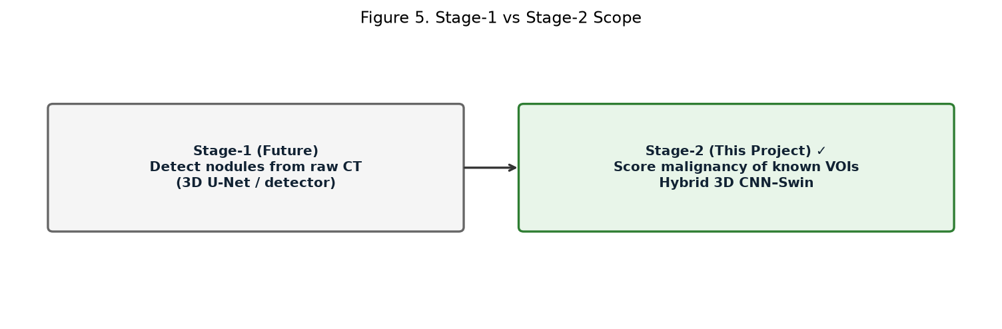
4.6 Data Schema (processed/)
volumes/<SeriesUID>.nii.gz; metadata/lidc/; metadata/physical_nodules/; manifests/dataset_manifest.json; manifests/patient_splits.json. Training reads manifests and crops using patient-mm centroids transformed through the NIfTI affine.

CHAPTER 5 — IMPLEMENTATION
5.1 Repository Layout
Package pulmoscan under src/: data (io, labels, dataset, preprocess_lidc), classification (backbone, swin3d, model, losses, train), evaluation, inference, xai. Configs live under configs/model|data|train. Scripts include run_local.py and report generation helpers.
5.2 Labeling Rule
Condition (mean LIDC malignancy) | Label
≥ 4.0 | Malignant (1)
≤ 2.0 | Benign (0)
Otherwise (e.g., ~3) | Excluded (uncertain)

Table 3. Labeling Rule (LIDC Malignancy)
5.3 Training Implementation Details
Hyperparameter | Primary run (v3 / 48³)
VOI size | 48 × 48 × 48
Batch size | 2
Optimizer | AdamW (lr 1e-4, weight decay 1e-4)
Loss | Weighted BCE (pos_weight from train counts)
AMP | Enabled (torch.cuda.amp on torch 2.1)
Epochs / early stop | Max 30 / patience 8 on val AUC
Params | ~12.16 M

Table 4. Training Configuration
5.4 Engineering Challenges & Fixes
• WSL venv missing ensurepip — install python3-venv.
• Kubeflow base Python 3.8 incompatible — conda env pulmo with Python 3.10.
• Default pip torch (CUDA 13) incompatible with driver 11.4 — install torch 2.1.2+cu118.
• torch.amp.GradScaler API mismatch on 2.1 — use torch.cuda.amp fallbacks.
• Wrong VOI centroids in v2 — remap LIDC pixels via original DICOM geometry; rebuild processed_v3.
• Jupyter download root is /workspace — copy artifacts there for FileLink/browser download.

CHAPTER 6 — RESULTS & DISCUSSION
6.1 Dataset Summary
Split | Nodules (n) | Malignant | Benign
Train | 132 | 45 | 87
Validation | 35 | 12 | 23
Test | 29 | 20 | 9
Total labeled | 196 | — | —

Table 2. Dataset Split Summary (processed_v3 verify/train summary)
Series selected for preprocessing: 153 (from ~303 TCIA completed items / multi-series patients). Uncertain malignancy scores were excluded by design.
6.2 Training Trajectory
Epoch | Train loss | Val AUC | Val Acc
1 | 0.997 | 0.574 | 0.657
2 | 0.847 | 0.743 | 0.771
4 | 0.868 | 0.835 | 0.800
6 | 0.787 | 0.853 | 0.800
9 | 0.654 | 0.920 | 0.771
12 | 0.359 | 0.931 | 0.886
20 | 0.521 | 0.949 | 0.943
28 (early stop) | 0.006 | 0.933 | 0.886

Table 5. Validation Training Trajectory (selected epochs)
Best validation AUC ≈ 0.949 at the checkpoint retained as best.pt. Early stopping halted at epoch 28. Validation n=35 is small, so epoch-to-epoch AUC noise is expected; held-out test is the primary reported figure.
6.3 Held-out Test Results
Metric | Value
AUC | 0.9139
AUPRC | 0.9583
Accuracy | 0.7586
Sensitivity | 0.7000
Specificity | 0.8889
Precision | 0.9333
Brier score | 0.2296
Confusion (TP/TN/FP/FN) | 14 / 8 / 1 / 6

Table 6. Held-out Test Metrics (best.pt on test split)
6.4 Discussion
Test AUC ≈ 0.914 meets the project’s stretch target (≥0.85) on this batch. Accuracy is lower than AUC because the operating threshold optimizing a particular criterion can differ from 0.5, and the test set is malignancy-heavy (20 vs 9). Compared with an earlier 7-patient exploratory run (~0.76 AUC, unstable) and a failed processed_v2 run (val AUC collapsing near chance due to misplaced VOIs), processed_v3 + 48³ hybrid training is the strongest result obtained in this work.
Limitations: LIDC malignancy is a radiologist characteristic, not histopathology; sample size remains modest; single-split evaluation without external cohort; Stage-1 detection not implemented. These limit clinical claims.

CHAPTER 7 — CONCLUSION & FUTURE WORK
7.1 Conclusion
This project delivered an end-to-end Stage-2 pipeline for pulmonary nodule malignancy risk prediction on LIDC-IDRI using a hybrid 3D CNN–Swin Transformer. Correct geometric linking of XML annotations to CT volumes proved essential. On processed_v3, the model achieved test AUC ≈ 0.914. The software artifacts (best.pt, metrics, configs, processed tree) support demonstration and further research. Research use only.
7.2 Future Work
• Scale dataset toward hundreds of patients; nested cross-validation / bootstrap CIs.
• Implement Stage-1 3D detection/segmentation for raw-CT demos without XML.
• Calibrate probabilities; compare against Brock/Lung-RADS baselines.
• Richer XAI and clinician-facing UI; prospective reader studies (beyond this academic scope).

REFERENCES
[1] Armato III, S.G., et al. The Lung Image Database Consortium (LIDC) and Image Database Resource Initiative (IDRI): A completed reference database of lung nodules on CT scans. Medical Physics, 2011.
[2] The Cancer Imaging Archive (TCIA): LIDC-IDRI collection. https://www.cancerimagingarchive.net/collection/lidc-idri/
[3] Setio, A.A.A., et al. Validation, comparison, and combination of algorithms for automatic detection of pulmonary nodules in computed tomography images: The LUNA16 challenge. Medical Image Analysis, 2017.
[4] Liu, Z., et al. Swin Transformer: Hierarchical Vision Transformer using Shifted Windows. ICCV, 2021.
[5] McWilliams, A., et al. Probability of cancer in pulmonary nodules detected on first screening CT. NEJM, 2013 (Brock/PanCan model context).
[6] PyTorch documentation; MONAI / SimpleITK / nibabel documentation for volumetric preprocessing and training.

APPENDIX A — COMMANDS & REPRODUCIBILITY
Preprocess (WSL / CPU):
python -m pulmoscan.data.preprocess_lidc --raw-root C:/lidc/raw --xml-root C:/lidc/tcia-lidc-xml --out C:/lidc/processed_v3 --fresh
Train (Kubeflow GPU, 48³):
python -m pulmoscan.classification.train --preset default --data-root /home/jovyan/data/processed_v3 --batch-size 2 --device cuda --output-dir /home/jovyan/artifacts/checkpoints_v3_48
Evaluate test:
python -m pulmoscan.evaluation.evaluate --data-root /home/jovyan/data/processed_v3 --checkpoint .../best.pt --split test --device cuda --out .../test_metrics.json
Disclaimer: This project is for academic research and education only. It is not a certified medical device and must not be used as the sole basis for clinical diagnosis or treatment decisions.
— End of Report —

