Lab 6 Writing Template
  - Introductions

Statement of Work
This writing template is designed to help you plan your Tech Memo for Lab 6.
At the completion of this worksheet you should have:
- An outline of the sections you plan to include
- A topic sentence for each paragraph of your memo
- Sketches or preliminary drafts of each figure
- Formatted versions of each equation you plan to include
Before you leave writing section today you need to check in with a professor or proctor to demonstrate that you have completed this checklist. You will also submit a rough draft of your working document with the information above.

Outline
There are a variety of ways that you can organize your tech memo. The list of sections below is a suggested place to start, but you should feel free to modify it to best fit your rhetorical purpose. Consult with a professor or proctor if you have any questions.
- Abstract
- Introduction
- Methods
- Results
- Conclusion
- References

Technical Tune-up
In this section we’ll talk about how to do two more things you’ll need to do in your tech memo and we haven’t yet covered in detail: topic sentences and equations.

Topic Sentences
Clear topic sentences are a critical part of making your technical writing accessible and easy to understand. Each paragraph should start with a clear topic sentence that states the main point of the paragraph. Then, the rest of the paragraph will provide supporting evidence. Once you finish that idea, you should start a new paragraph with a new topic sentence.
The general temptation for budding engineers is to put too much in a single paragraph. Make sure you limit yourself to only one big idea per paragraph. Once you’ve finished discussing that point, end that paragraph and start a new one.
In today’s section, you’ll use topic sentences as a way to outline your memo.
A topic sentence should provide:
- A clear and concise description of the main idea of the paragraph that follows.
- A transition (if necessary) from previous discussion.
For example, consider the following topics sentences for an introduction to the temperature sensing lab.
Each temperature sensor that will be tested has a varying response time based on its thermal mass.
This sentence might be followed with a specific discussion of the response times.
In addition to varying response times, the range of temperatures that can be measured with each sensor should also be considered when selecting a sensor for a particular application.
Note that this sentence provides a transition from previous discussion (response times) and then gives a clear statement of what will be discussed in the paragraph below.

Equations
Equations are an important part of technical writing as describing a concept with a mathematical description in an equation is often much clearer and more concise than trying to explain it in text. Whenever you prepare an equation in text, you should make sure they follow the following rules:
- Format equation with an equation editor (e.g., MS Word’s equation editor or LaTeX).
- Use italicized math font (e.g., Cambria Math in MS Work) and Greek characters where appropriate.
- Subscripts and superscripts should be used instead of carets ($^$) or underscores ($_$).
- Every equation should be referenced in the main text.
- Every variable should be defined.
- Every equation should be numbered.
For example, consider the example below.
$$y=m⋅x+b \left(1\right)$$
Equation 1 describes a line $y$, where $m$ is the slope and $b$ is the y-intercept.

Template
The sections below include template text to help you begin outlining your tech memo.

List of Figures

Figure 1
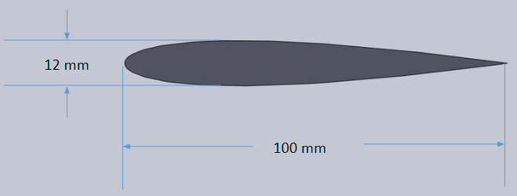
Figure 1: Insert image above and replace this text with your caption.
Replace image above and replace this text with your caption.
- What are the key features of your figure/plot?
- What should the reader take away?

Figure 2

Figure 2: Insert image above and replace this text with your caption.
Replace this text with supporting text for your paragraph.
- What are the key features of your figure/plot?
- What should the reader take away?

Figure 3

Figure 3: Replace image above and replace this text with your caption.
Replace image above and replace this text with your caption.
- What are the key features of your figure/plot?
- What should the reader take away?

Key Equations
$$ReplacewithEquation$$
Text to explain equation.
$$ReplacewithEquation$$
Text to explain equation.

Outline

Abstract
- Replace with paragraph 1 topic sentence
- Replace with paragraph 2 topic sentence
- Replace with paragraph 3 topic sentence
- …

Introduction
- Replace with paragraph 1 topic sentence
- Replace with paragraph 2 topic sentence
- Replace with paragraph 3 topic sentence
- …

Methods
- Replace with paragraph 1 topic sentence
- Replace with paragraph 2 topic sentence
- Replace with paragraph 3 topic sentence
- …

Results
- Replace with paragraph 1 topic sentence
- Replace with paragraph 2 topic sentence
- Replace with paragraph 3 topic sentence
- …

Conclusion
- Replace with paragraph 1 topic sentence
- Replace with paragraph 2 topic sentence
- Replace with paragraph 3 topic sentence
- …

