Lab 3 Writing Template
  - Mechanical Drawings and Electrical Schematics
Name:

Electrical Schematic
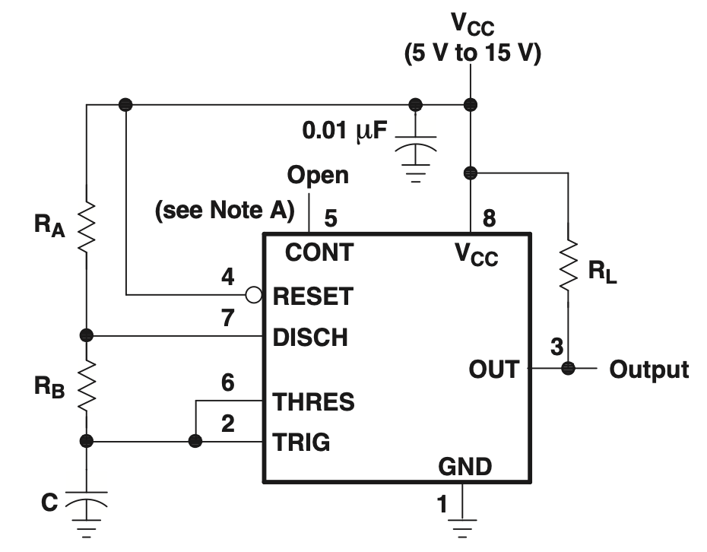
Figure 1: Placeholder schematic for 555 timer circuit from LM555 Datasheet. Replace with yours.
Insert the schematic for your 555 timer circuit here.
Text to explain what the schematic means. The text should address and highlight:
- What circuit does
- How the circuit works
- Choice of components and values
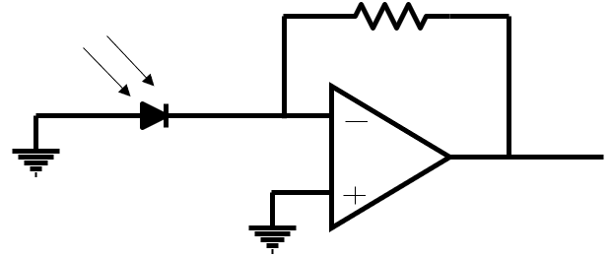
Figure 2: Placeholder schematic for transimpedance amplifier circuit. Replace with yours.
Insert the schematic for your transimpedance amplifier here.
Text to explain what the schematic means. The text should address and highlight:
- What circuit does
- How the circuit works
- Choice of components and values
Figure 3: Placeholder mechanical drawing of cuvette holder for turbidity meter. Replace with yours.
Text to explain what the mechanical drawing means. The text should address and highlight:
- General operation
- Key dimensions
- Particular specific notes relevant to using the design

