Project Proposal Template

One Page Description
Write your description here.

Budget
Description | Part # | Unit Cost | Tax | Shipping | Vendor Link | Datasheet Link

Mechanical Drawings
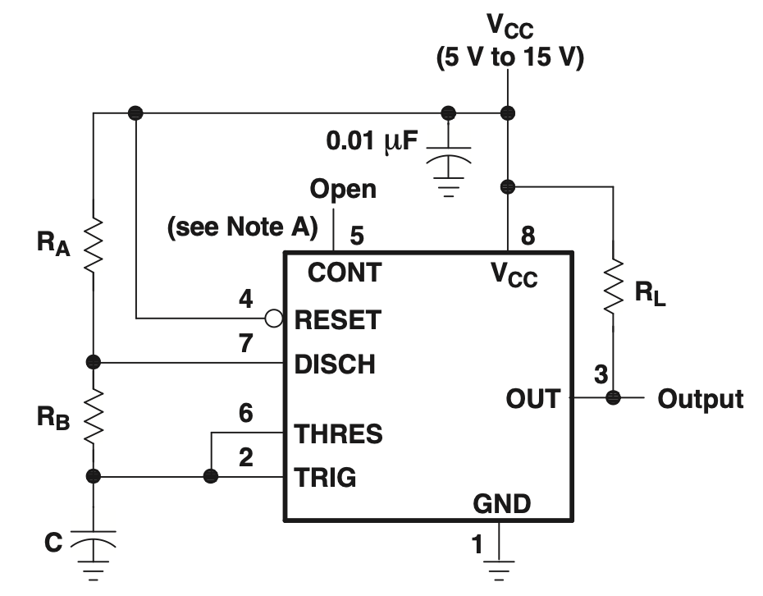
Placeholder image for mechanical drawing. Replace with yours.
Brief paragraph describing major mechanical design decisions. <200 words.
Describe any unusual features of the drawing and any calculations for unusual mechanical features.
Include mass, center of mass, buoyancy, center of buoyancy and (if necessary) ballast calculations

Electrical Schematics

Placeholder image for first schematic drawing. Replace with yours.

Placeholder image for second schmatic drawing. Use multiple drawings if it helps clarify.

