Road Scenario Extraction Using Natural Language Query
Hardik Gohel^{1[0009-0001-8199-9535]}, R. Sridharan^{1[0000-0002-0186-6442]}, Udaya Unnikrishnan² and Sarath Mohan²
¹ Department of Mechanical Engineering, National Institute of Technology Calicut, Kerala, India
² Tata Elxsi, Kozhikode, Kerala, India
Email: Sreedhar.nitc.ac.in, Contact No. +91 9495788136
Abstract: This study demonstrates how scene graphs can be used to find a specific clip using natural language queries from a collection of road scene clips. A framework has been developed to locate the desired clip from a pool of road scene clips. This framework includes scene graph generation, understanding the scene using a resultant scene graph function, summarizing the information from the resultant scene graph function, and finding the cosine similarity between the summarized information and the natural language query provided by the user. The framework was applied to locate the required clip from the collection of clips. The results highlight the need for improvement in summarization model, object detection and to decrease number of frames between first and last frame from which resultant scene graph data is extracted.
Keywords: Road Scene, Scene graph, Natural language query.
- Introduction
It is observed that road scene videos are long and to find scenarios from the video manually is a cumbersome task. There is a need for a tool that can automatically extract the scenarios from road scene videos using natural language queries. A video comprises frames, and understanding a video entails comprehending its frames. Each frame represents an image, and scene graphs serve as effective representations for understanding the relationships between objects within an image. A scene graph consists of nodes and arrows, where nodes represent objects and arrows denote relations between them.
Scene graph has garnered significant attention in research due to its robust semantic representation and its wide range of applications in scene comprehension. Scene Graph Generation (SGG) is the process of automatically converting an image or video into a semantic structural scene graph. This involves accurately categorizing observed items and their relationships [1]. An innovative framework for semantic image retrieval that utilizes the concept of a scene graph has been developed [2]. The scene graphs in this system depict various things, such as a "man" or a "boat," together with their corresponding properties, such as the color of the boat being "white." Additionally, these scene graphs also capture the relationships between items, such as the "man" standing on the "boat." These scene graphs are used as queries to retrieve photographs that are semantically connected. To achieve this objective, a conditional random field model is developed to analyze potential associations between scene graphs and test photos [2]. Another development in this field is a video-conditioned sentence generator that utilizes visual concepts extracted from videos to build an appropriate sentence representation. Subsequently, a relation-aware moment localizer based on Graph Neural Networks (GNN) is developed to effectively choose a specific segment of video clips, guided by the sentence that was formed. Ultimately, the pre-trained image-sentence embedding space is utilized to assess the matching scores between the created phrase and moment representations, using the knowledge transferred from the picture domain [3].
In the present study, Roadscene2vec tool [4] is employed to generate scene graphs from frames of road scene clip. Instead of a single video, short road scene clips are used, varying in the number of frames from 20 to 100. To understand what action has occurred in the clip, there is a need to understand what changes have occurred between the first frame and the last frame of the clip. To identify these changes, a function is built which takes the scene graph of the first frame and the last frame, and outputs the transitions that have taken place in the scene. This output consists of several sentences which describe objects and the relations between them. To facilitate comparison, these sentences are summarized into a concise form, enabling cosine similarity calculations between the summarized sentence and a natural query from the user. The clip with the highest cosine similarity is chosen as the final output.
The remainder of the paper is structured as follows. Section 2 describes the research methodology adopted in the research. This research methodology includes data collection, scene graph generation, resultant scene graph function, data preparation for summarization, fine tuning summarization model and framework. Section 3 contains the details of experiments conducted with the application developed for finding clip. section 4 presents results and discussion. Finally, the future research scope is presented in section 5.
- Methodology
  - Data Collection
Data is collected from the IEEE DataPort – Scene graph Risk Assessment Dataset comprising 1044 clips of lane changes generated using the Carla driving simulator. Each clip is in the form of video frames with a resolution of 1280 x 720 and a period of 1-5 seconds [5]. This dataset provides a front view from the ego car, similar to the perspective obtained from a car dashcam. The video clips contain various scenarios, such as the ego car being in close proximity to other cars, including near collisions, super near, very near and near situations. Since this dataset focuses on lane changes, the ego car is observed changing lanes in most of the video clips.
  - Scene Graph Generation
The scene graph generation process shown in Fig. 1. involves two steps in Roadscene2vec tool. In the first step, the set of objects in each image frame, along with their attributes are identified to extract scene graphs from image-based datasets. To extract the set of objects in the image along with their bounding boxes, the tool utilizes Mask RCNN model. In the second step, inverse-perspective mapping transformation of image is computed to obtain top down ‘birds-eye view’(BEV) projection of the image. By generating BEV projection and by projecting bounding box coordinate of original image into birds eye view, the position of each object with ego car is estimated.
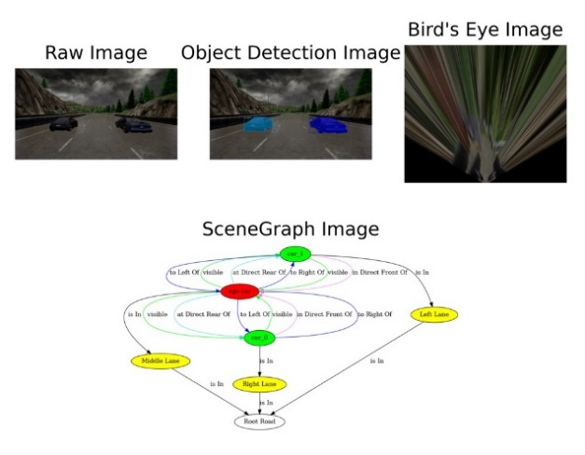

Fig. 1. Scene graph generation

Here, we are considering 12 relations in generating the scene graph as shown in Table 1 [4]. For how far the other objects are from ego car proximity threshold values are used as per Table 2 [4]. To find whether the other car is in front, rear, or side of ego car directional threshold values are used as per Table 3 [4]. The lane width of lane is 12 feet. If an object is more than 50% distance of lane width from the ego car’s center, it is considered to be in the left or right lane. The resulting scene graph is rule-based scene graph. These scene graphs are serialized and stored in pickle file.
Table 1. Relations consider in scene graph
Relations
Is In​ | At Side Rear Of​
In Direct Front Of​ | To Left Of​
In Side Front Of​ | To Right Of​
At Direct Rear Of​ | Near collision​
Super near​ | Very near​
near​ | visible​
Table 2. Proximity Threshold
Attributes​ | Distance in feet
Near collision​ | 4​
Super near​ | 7​
Very near​ | 10​
near​ | 16​
visible​ | 25​

Table 3. Directional Threshold
Attributes​ | Angle in degree​
Is In​ | [0,0]​
In Direct Front Of​ | [45,90],[90,135]​
In Side Front Of​ | [0,45],[135,180]​
At Direct Rear Of​ | [225,270],[270,315]​
At Side Rear Of​ | [180,225],[315,360]​
  - Resultant Scene Graph Function
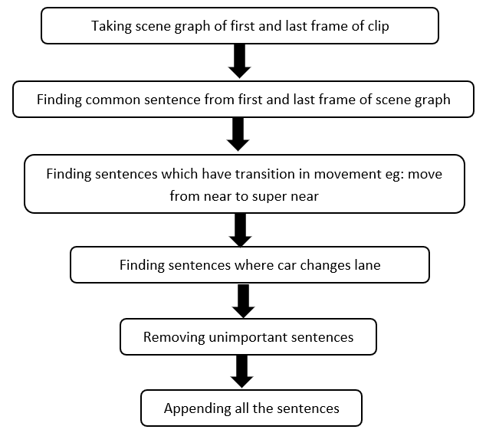
Understanding the events occurring in a road scene clip requires analyzing the changes between its first and last frame. A specific function was developed to compare the scene graphs of these frames and extract pertinent information about the scene. In this scene graph function, the first frame and last frame of the clip are taken. The Block diagram of the algorithm is shown in Fig. 2.

Fig. 2. Block diagram of the resultant scene graph function

Fig. 3. shows the resultant scene graph as an illustrative example. It can be observed that the first four sentences of the first scene graph and the last scene graph are same. But out of these four sentences, only the first sentence is important and hence only the first sentence is taken into consideration in the resultant scene graph. In all scene graphs, ego car is taken as reference point and it is always considered in the middle lane. Whenever there is a lane change by a car, as shown in this example of the resultant scene graph, it is the ego car that is changing lanes, not the other cars. Thus, in scene graph, the lane change aspect needs to be considered. All other sentences which are unique in the first scene graph are taken in the resultant scene graph.
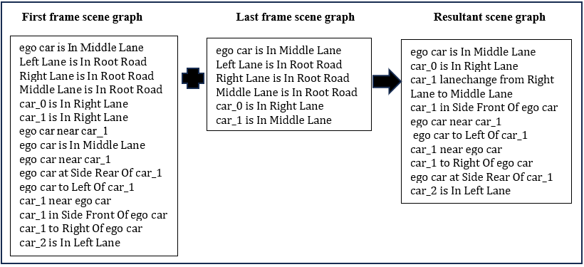
Fig. 3. Example of resultant scene graph creation
  - Data Preparation for Summarization
As we can observe in the resultant scene graph, there are several sentences. In order to get the crux of these sentences, summarization needs to be done. For the training summarization model, data was prepared because pre-trained models were not providing good results. The summarization task was done manually for the first 700 clips of 1044 clips. Table 4 shows the sample of summarization data.
Table 4. Sample of prepared summarization data
Input_text | Summary text
car_0 to Left Of ego car. car_0 is In Left Lane. car_2 is In Left Lane. car_0 in Side Front Of ego car. car_1 lanechange from Left Lane to Middle Lane. car_0 near ego car. car_3 is In Right Lane. car_5 is In Left Lane. ego car near car_0. ego car at Side Rear Of car_0. Right Lane is In Root Road. Middle Lane is In Root Road. ego car to Right Of car_0. ego car is In Middle Lane. Left Lane is In Root Road. | one car is near and to left in side front of ego car. three cars are in left lane. one car in right lane. one car lanechange from left lane to middle lane.
ego car near car_1. ego car at Side Rear Of car_1. car_1 lanechange from Right Lane to Middle Lane. car_2 is In Left Lane. car_4 is In Left Lane. car_3 is In Right Lane. Right Lane is In Root Road. car_1 to Right Of ego car. Middle Lane is In Root Road. car_0 is In Right Lane. ego car to Left Of car_1. ego car is In Middle Lane. car_1 near ego car. Left Lane is In Root Road. car_1 in Side Front Of ego car. | one car is near and to right in side front of ego car. two car are in left lane. two car are in right lane. one car lane change from right lane to middle lane.
car_2 is In Left Lane. car_4 is In Left Lane. car_5 is In Left Lane. Right Lane is In Root Road. car_0 lanechange from Middle Lane to Left Lane. Middle Lane is In Root Road. ego car is In Middle Lane. car_1 is In Left Lane. Left Lane is In Root Road. | four cars are in left lane. one car lanechange from middle lane to left lane.
  - Fine Tuning Summarization Model
The Pegasus large model [6] was used for summarizing the resultant scene graph data. The model was fine-tuned on dataset consisting of 700 data points which we prepared. Out of these, 650 data points were utilized for training and 50 data points were used for validation. The Pegasus large model has demonstrated favourable outcomes when trained on a limited dataset, hence it is employed for training in this particular scenario due to the dataset's modest size. The model underwent training for 50 epochs, with a weight decay of 0.01 and a batch size of 1 for both training and evaluation. The validation data's rouge1, rouge2, and rougeL scores are 0.000261, 0, and 0.000261, respectively. The Rouge score is not good. The Rouge score is higher when the output summary is similar to the reference summary. This shows that it is necessary to increase the dataset. However, upon human assessment, it was observed that the summarization process was producing errors in accurately determining the number of cars in the lane. For instance, let us say the reference summary states that there are four cars in the right lane. However, the model was giving output as five cars in the right lane. The model provides good results for summaries that contain scenarios like car is near, very near, etc.
  - Semantic Similarity between Summarized Text and Natural Language Query
For finding the semantic similarity between the summarized text of the resultant scene graph and the natural language query by the user, Sentence transformer 'all-MiniLM-L12-v2' model [7] is used from the hugging face platform for converting it into embeddings. This model map summarized sentences and queries into 384 dimensional dense vector. This model is based on sentence- BERT model [8]. The metric used here for finding semantic similarity is Cosine similarity [9].
  - Framework
Fig. 4. shows the framework used for finding the clip. The framework involves several steps to retrieve the desired clip. First, scene graphs are generated for each frame of clip using the Roadscene2vec tool, creating a pickle file. From these, scene graphs for the first and last frames of the clip are extracted to form a resultant scene graph. This scene is then summarized into sentences. A data frame is constructed, containing the clip filename and its resultant scene graph data. Cosine similarity between the user query and each clip's summary is computed, and the clip with the highest similarity score is outputted as filename.
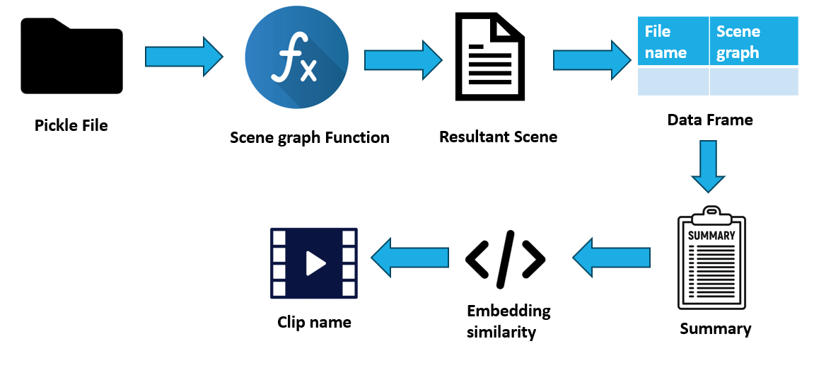
Fig. 4. Framework for finding the clip
- Experiment
An application was built using Streamlit in which the user can give input and output the file name of the clip in which a similar scenario is present. In this app, output will be a single output that matches the maximum to the user query. An experiment was conducted to check whether the output produced by the application was correct or not. The experiment was conducted on training data and validation data. For experimentation, 10 clips were taken from training data and 5 clips were taken from validation data.
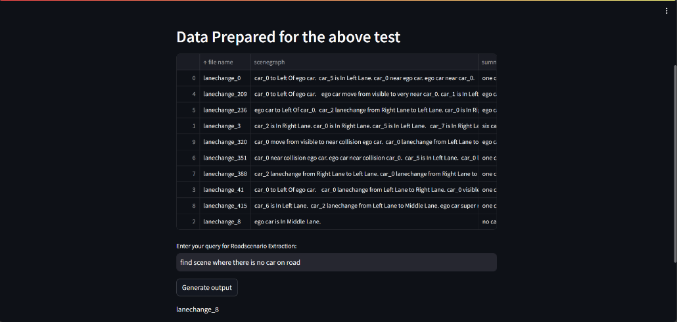
Fig. 5. Screenshot of application
  - Training Data
At first, the experiment was done on training data. Ten different scenarios were taken from 650 clips. Out of 10 clips, the correct output was obtained for 7 clips as shown in Table 5. It is observed that for query no. 1, 4, and 7, wrong outputs are obtained. If we consider the first query, it asked that one car is near ego car but application output is clip lanechange_209. In lanechange_209 clip, ego car is moving from visible to very near other car. Therefore query 1 application output is incorrect while the correct output is lanechange_0. In query 4, one car is visible from ego car while it is giving application output as lanechange_209. Similarly, in query 7 one car is very near ego car but still it is giving application output as lanechange_209.
Table 5. Query and their output from training data
Query no. | Query | Application Output | Correct  Output
1. | Find scene where one car is near and to left of ego car. | lanechange_209 | lanechange_0
2. | Find scene where six cars are in right lane | lanechange_3 | lanechange_3
3. | Find scene where no car on road | lanechange_8 | lanechange_8
4. | Find scene where one car is visible and to left of ego car | lanechange_209 | lanechange_41
5. | Find scene where ego car move from near to very near to other car. | lanechange_236 | lanechange_236
6. | Find scene where one car is near collision to ego car | lanechange_351 | lanechange_351
7. | Find scene where one car is very near to ego car | lanechange_209 | lanechange_388
8. | Find scene where one car is super near to ego car | lanechange_415 | lanechange_415
9. | Find scene where ego car move from visible to near collision to other car | lanechange_320 | lanechange_320
10. | Find scene where ego car move from visible to very near to other car | lanechange_209 | lanechange_209

  - Validation Data
For validation, out of 50 clips, 5 clips were taken for the experiment having different scenarios. Out of 5 clips, 3 application outputs were correct and 2 application outputs were incorrect. However, it was observed that as the summarization was not that good which can be seen through less rouge score from training the summarization model, it impacted the resultant scene graph. For example, query 4 is about one car is near ego car, but the application output is obtained as clip lanechange_658 which is about one car is visible from ego car. For query 5, five cars are in left lane but application output is lanechange_664 which is about four cars are in right lane.
Table 6. Query and their output from validation data
Query no. | Query | Application Output | Correct Output
1. | Find scene where ego car move from near to near collision to other car | lanechange_654 | lanechange_654
2. | Find scene where one car is visible from ego car | lanechange_658 | lanechange_658
3. | Find scene where four cars are in right lane | lanechange_664 | lanechange_664
4. | Find scene where one car is near and in front of ego car | lanechange_658 | lanechange_680
5. | Find scene where five cars are in left lane | lanechange_664 | lanechange_692

- Results and Discussion
From the experiments on clips for training data and validation data, it can be inferred that for training data clips, the framework is giving better results than that for validation data clips. Out of 10 clips of training data, 7 were found correct 2 had similar words visible and very near in their summary of the clips, and 1 had wrong output. If we consider the validation data, out of 5 clips 3 are correctly identified. But 2 clips had the wrong outputs. The reason behind this wrong output was poor summarization of validation data. It was observed that for data having several cars in it, the summarization model was sometimes not giving the correct number of cars in lanes.
- Recommendations for Future Research
There is a need to improve the summarization model because if the summarization is incorrect, then correct clip will not be found. To improve summarization, training data needs to be increased. The relation of other objects in the scene graph is with respect to ego car, due to which if a lane is changed by the ego vehicle, it shows lane change by another car. There is a need to determine a method so that the reference point remains constant and does not move with ego car. For a road scene video clip, the number of nodes changes with the video frame, if some car is in between first and last frame but not in first and last frame it will not be captured in resultant scengraph. Therefore, a small number of frames needs to be taken to obtain a better resultant scene graph. Object detection can also vary from one frame to the other. Hence, there is a need for improve object detection.
References
1. Li, H., Zhu, G., Zhang, L., Jiang, Y., Dang, Y., Hou, H., Shen, P., Zhao, X., Shah, S.A.A., Bennamoun, M.: Scene graph generation: A comprehensive survey. Neurocomputing. 566, 127052 (2024)
2. Johnson, J., Krishna, R., Stark, M., Li, L.-J., Shamma, D., Bernstein, M., Fei-Fei, L.: Image retrieval using scene graphs. In: Proceedings of the IEEE conference on computer vision and pattern recognition. pp. 3668–3678 (2015)
3. Gao, J., Xu, C.: Learning Video Moment Retrieval Without a Single Annotated Video. IEEE Trans. Circuits Syst. Video Technol. 32, 1646–1657 (2022). https://doi.org/10.1109/TCSVT.2021.3075470
4. Malawade, A.V., Yu, S.-Y., Hsu, B., Kaeley, H., Karra, A., Al Faruque, M.A.: roadscene2vec: A tool for extracting and embedding road scene-graphs. Knowledge-Based Systems. 242, 108245 (2022). https://doi.org/10.1016/j.knosys.2022.108245
5. Malawade, A.V., Yu, S.-Y., Hsu, B., Muthirayan, D., Khargonekar, P.P., Faruque, M.A.A.: Spatiotemporal Scene-Graph Embedding for Autonomous Vehicle Collision Prediction. IEEE Internet Things J. 9, 9379–9388 (2022). https://doi.org/10.1109/JIOT.2022.3141044
6. Zhang, J., Zhao, Y., Saleh, M., Liu, P.J.: PEGASUS: Pre-training with Extracted Gap-sentences for Abstractive Summarization, https://arxiv.org/abs/1912.08777, (2019)
7. all-MiniLM-L12-v2 Homepage, sentence-transformers/all-MiniLM-L12-v2 · Hugging Face, last accessed 2024/5/14
8. Reimers, N., Gurevych, I.: Sentence-BERT: Sentence Embeddings using Siamese BERT-Networks, https://arxiv.org/abs/1908.10084, (2019)
9. Lauriola, I., Lavelli, A., Aiolli, F.: An introduction to Deep Learning in Natural Language Processing: Models, techniques, and tools. Neurocomputing. 470, 443–456 (2022). https://doi.org/10.1016/j.neucom.2021.05.103

