Measuring reverberation in a room through a log sweep

1. Algorithm flowchart

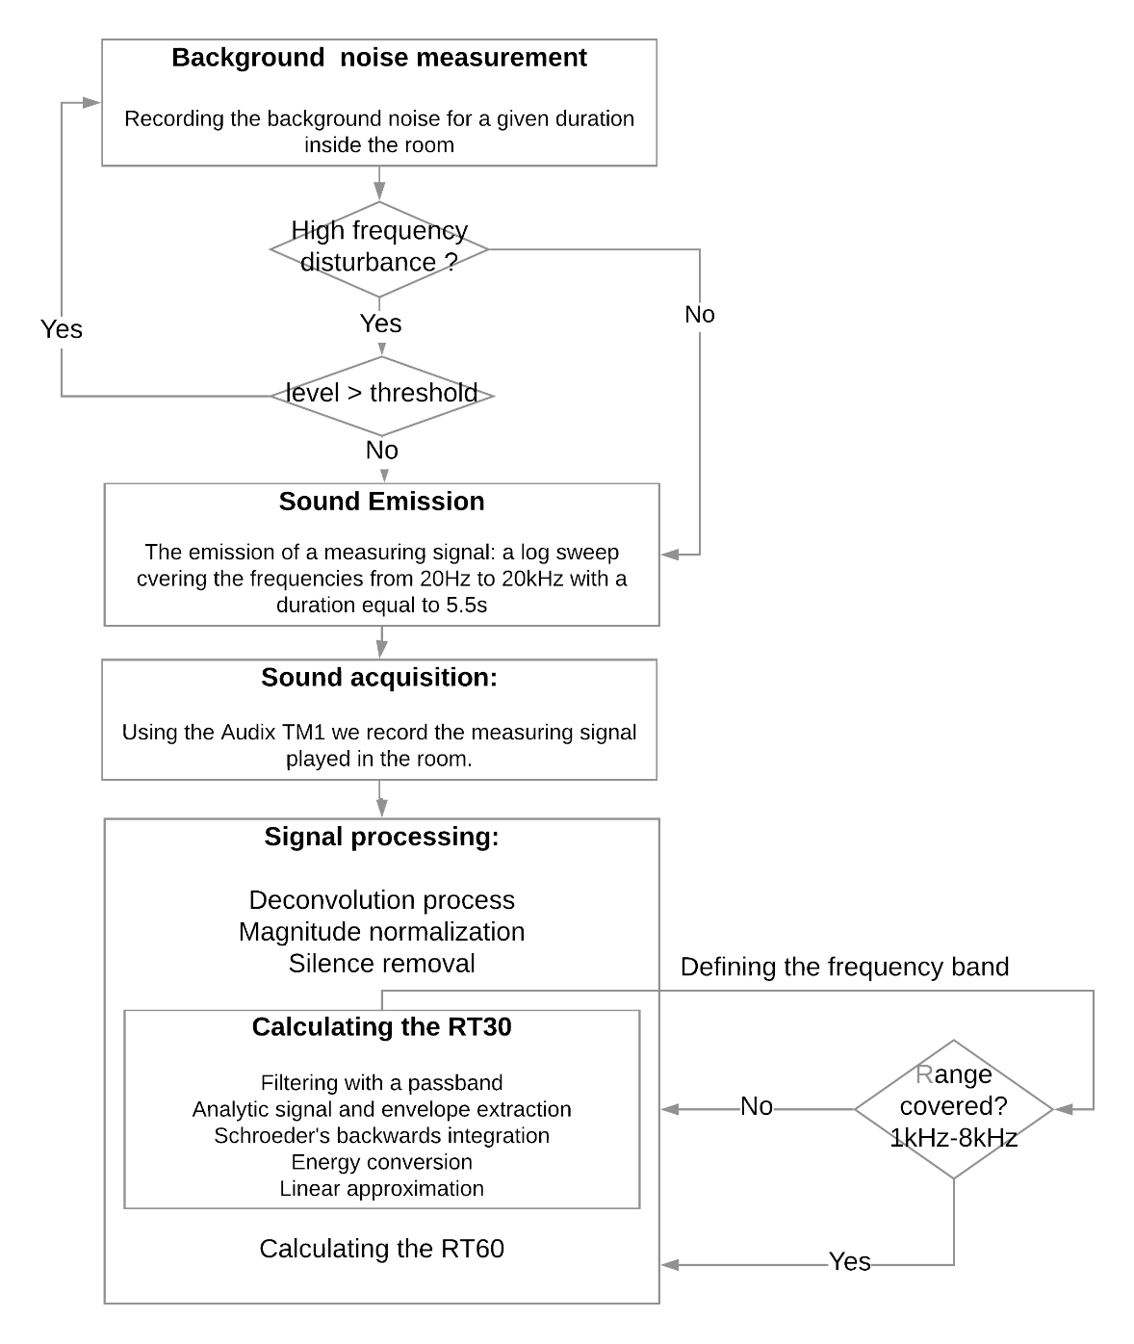

Fig.1 The flowchart of the algorithm using a log sweep

1. Detailed Description

**2-1. Extraction of the RIR: Deconvolution**

After recording the measuring signal playing in the room, it will be de-convolved with the emitted one in order to obtain the impulse response of the room.   
Using the following formula: a $*h=b$, $a$ being the log sweep, $h$ is the impulse response and $b$ is the recorded signal we can obtain the impulse response as $h=a^{-1}*b$. In other words, we are applying the convolution to the inverse of the measuring signal and its recording. Which is equivalent to multiplication in the frequency domain

**2-2. Pre-Processing the RIR: Magnitude normalization and Silence removal**

For a better performance :

* The amplitude of the signal will be normalized.
* Silence removal: The process consists of defining the envelope of the recorded signal (using a moving max filter: imdilate) and then fixing a coefficient for which all values below will be omitted.  
  Constraint on the coefficient for silence removal: removing the silence at the end of a wav file could mean removing echoes.  
  1. **Calculating the RT30:**
* Schroeder’s backwards integration of the envelope:

The Schroeder’s integration is used to obtain a flat decay curve and is calculated as follows: $Ysch=\int_{0}^{td}{{Amp}^{2}\left(τ\right)dτ}$.

* Energy decay curve:

Applying a logarithmic conversion of the integrated envelope.

* Linear approximation of the energy’s decay curve:

Using a linear approximation, we can assimilate the decay curve to a line represented by an equation of the form $Y=A*x+B$. We are more interested in the part containing the slope of the equation: $Y=A*x$.

* Finding the RT30:

According to the ISO3382-2 norm the RT30 is calculated by measuring the time of the energy decrease from -5db to -35 db. We can find the corresponding number of samples through: $Enlevel = A* x$, ($A$: the slope can be calculated with MATLAB, $x$ number of samples and $Enlevel$ is the energy level) and so the number of samples $x=EnLevel/A$.