**Software Documentation for the IT management system**

**Product Name: IT System**

Release Version:

Testing Started:

Testing Completed:

Technical Lead:

Product Owner: BBA

Primary Tester:

Developer:

Types of Test Performed:

**Browser Tested:**

1. Chrome

2. Mozilla Firefox

**Device Tested:**

1. Desktop

2. Laptop

3. Tab

4. Smartphone

**Instance Tested:**

1. Development

2. Testing

3. Production

4. UAT

**Table of Contents**

Revision History 4

Design Specification 5

Abstract 6

Chapter-1: Introduction 7

1.1 Review of the current IT System 7

1.2 Motivation 7

1.3 Goals 7

1.4 Solution Methodology 8

Chapter - 2. Background Study 9

2.1 IT Management System 9

2.2 Why should we use this software system ? 9

2.3 User Experience 9

2.4 Requisition Control 9

2.4.1 New Requisition 9

2.4.2 Requisition List 9

2.4.3 Requisition Information 9

2.5 Maintenance Control 9

2.5.1 Maintenance Request 9

2.5.2 Settings 9

2.5.3 Manage Products 9

2.6 Report & Analysis 10

2.7 IMS main modules 10

2.8 Benefits of IMS 10

Chapter – 3: Software Requirement Analysis 11

3.1 Introduction 11

3.2 Requirement 11

3.3 Software Requirement Specifications 11

3.3.1 SRS Scopes 11

3.3.2 Functional Requirements 11

3.3.3 Non-functional Requirement 11

3.4 Interface Requirement 12

3.4.1 User Interface 12

3.4.2 Hardware Interface 13

3.4.3 Software interface 13

3.4.4 Communication Interface 13

3.5 SRS table 13

3.6 Report Analysis 14

Chapter – 4: System Design 16

4.1 Algorithm Design 16

4.2 Process Flow Diagram 17

4.3 Data Flow Diagram 18

Chapter – 5: Testing Documentation 19

5.1 Introduction 19

5.2 Scopes 19

5.3 Quality Objective 19

5.4 Testing Methodology 20

5.4.1 Model 20

5.4.2 Strategies 20

5.4.3 Levels 20

5.4.4 Test Deliverables 20

5.4.5 Tools 21

5.5 Test Cases with Result 21

# Revision History

|  |  |  |  |
| --- | --- | --- | --- |
| Date | Version | Description | Author |
|  |  |  |  |
|  |  |  |  |
|  |  |  |  |
|  |  |  |  |

# Design Specification

**Overview:**

IT Management System is one of the most important part of the Management Control System. Server and client side section control the behavioral access of back-end and front-end development of IT management System.

**Back-end parts:**

1. Node.js

2. Database → Oracle

3. MS Server Version 2.0

**Front-end parts:**

1. React.js

2. Bootstrap

3. Domain → Friendly

# Abstract

IT management System provides the environment that can include the IT related terms like managing request for new products and maintain them, asking for new product entry and approval for these request and maintenance from the respective authority. For this prerequisites, the system should be designed as the expected outcome with optimized behavior. From this concerns, this IT management system is designed to perform all the tasks regarding to our demands and requirements. All user can perform their own tasks easily and can’t face much complexity while operating the IT Management System.

# Chapter-1: Introduction

In this chapter, we are going to discuss about the Current IT System, our motivation from the current system, our goals and how can find an optimal solution to achieve our objectives that are described in the section no 1.1, 1.2, 1.3, 1.4 respectively.

## 1.1 Review of the current IT System

In the current section in IT field, purchasing equipment or software, maintaining of these equipment, and providing them for developing purposes. In total, overall IT systems involve to perform relevant tasks to complete an operation.

## 1.2 Motivation

Our system should more efficient than other system in the market. In our System, the computerized method makes the system transparent and can be easily realized. There can be Less man power and less time for maintaining the entire IT system.

## 1.3 Goals

Our aims is to achieve a better IT system that has ability to fulfill our requirements.

• Platform Independent

• Auto Synchronizing

• Friendly Environment

• Domain and Hosting

• Requisition And Maintenance Control

• Requisition And Maintenance Records

• Product and others management

• Approval Request & Status

• Generate Each section Report

• Multi-functionality

## 1.4 Solution Methodology

For All Users:

Design

Authority

View

Design

Store Officer

Design

Requisitioner

Settings

For Product Entry:

Requisitioner

Form

Maintenance

Form

Availability in Requisition:

Approval

Approval Section:

# Chapter - 2. Background Study

## 2.1 IT Management System

IT management refers to the monitoring and administration of an organization's information technology systems: hardware, software and networks. IT management focuses on how to make information systems operate efficiently. Just as important, it's about helping people work better.

## 2.2 Why should we use this software system ?

For better user experience, managing all the things related to the IT system, we can use this software system. Instead of manual process of IT system, we use this software system that helps to make everything easier. All the IT related products and maintenance of them will be stored in customized manner.

## 2.3 User Experience

IT management System is used by the user’s to operate the IT system. An user can easily handle the software. Less complexity in the system can make user experience more better.

## 2.4 Requisition Control

### 2.4.1 New Requisition

A registered requisitioner can make a requisition request to the store officer. Requisitioner can make only one request at a time. After approving one requisition, user are allowed to make another request. In each requisition, there is created a pending list in requisitions. Store officer make these requisitions to send to the authority for approval.

### 2.4.2 Requisition List

A list is created in requisitioner by queuing manner. All requisition status is followed by the store officer requisition section either it is approved or denied by authority.

### 2.4.3 Requisition Information

Status should be presented in both store officer and requisitioner viewing.

## 2.5 Maintenance Control

### 2.5.1 Maintenance Request

Maintenance Request can be done by a requisitioner which is send to the store officer and the store officer send it to the authority for approval.

### 2.5.2 Settings

Store officer can manage category of products, respective brands, and the supplier of these products.

### 2.5.3 Manage Products

There can be shown a summary of the products and can manage each products easily.

## 2.6 Report & Analysis

Report can be generated for each section such as product base, supplier base, Requisitioner and maintenance base. So, the reports are generated individually in different sub-modules in the IT management system.

## 2.7 IMS main modules

* Login Functionality
* Dashboard
* Add New Requisition and Maintenance Request
* Requisition And Maintenance List
* Product Information
* Report analysis

## 2.8 Benefits of IMS

1. buying equipment

2. distributing, configuring and maintaining the equipment

3. providing enhancements and service updates to equipment

4. implementing processes to address problems

5. provisioning services

6. monitoring IT systems performance

7. determining whether objectives are being met

# Chapter – 3: Software Requirement Analysis

## 3.1 Introduction

A software requirement is a field within software engineering that deals with establishing

the needs of stakeholders that are to be solved by software. The IEEE Standard Glossary of

Software Engineering Terminology defines requirements.

## 3.2 Requirement

The IT Management System Requirements provides high-level of functional requirements.

## 3.3 Software Requirement Specifications

• Documentation (user and administration)

• Operational behavior

• Requisition & Maintenance Status

• Product Information

• Technical Support

### 3.3.1 SRS Scopes

In according the lease act, the following information should be provided and stored.

1. Unique Login Id

2. Requisition & Maintenance information

3. Summary dashboard

4. Settings for Product entry

### 3.3.2 Functional Requirements

Every section has a specific functionality that’s are given below:

• Login – user, admin, super admin, transport admin

• Dashboard – automatically generated.

• User’s Role - add Requisition.

• Report – download a copy of corresponding section.

### 3.3.3 Non-functional Requirement

For an specific criteria, there should be applied non-functional requirements which are

shortly described below:

**Reliability**

The operational interface can’t fail within a period of time.

**Availability**

The system is available or not while a user wants access the information.

**Security**

All user can login to the system with secured procedure. Each user has a unique

identification system. Admin can store user’s login information.

**Maintainability**

All source code and related document should be controlled under a version of the

system.

**Portability**

As the software run into several platform, the platform independence should be ensure.

Different OS can access the software easily.

**Usability**

The Software should be easy to use and given a positive experience by the

user’s.

## 3.4 Interface Requirement

Computer system including software and hardware can turn the system on by interfacing

them with human thought.

### 3.4.1 User Interface

• Login Screen

• Home Screen

• Dashboard

• New Requisition & Maintenance Request

• Requisition & Maintenance list

• Requisition Status

• Report analysis

### 3.4.2 Hardware Interface

• Server Config.

• CPU/Processor

• Windows with apache preloaded

• Client Config.

### 3.4.3 Software interface

• OS = Windows, Linux

• Language = PHP, JS

• DB = Oracle

### 3.4.4 Communication Interface

These interfaces include E-mail, Web Browser, Server Network and use http or ftp for

security purposes.

## 3.5 SRS table

It describes necessary behavior of the software system and shows in the table 3.1.

|  |  |  |
| --- | --- | --- |
| SI.No. | Requirement Name | Requirement Classified |
| 1. | **Requisitioner** |  |
| 2. | Login |  |
| 3. | New Requisition |  |
| 4. | Requisition List |  |
| 5. | Maintenance Request |  |
| 6. | Requisition & Maintenance Report |  |
| 7. | **Store Officer** |  |
| 8. | Requisitions Status |  |
| 9. | **Products** |  |
| 10. | Add Products |  |
| 11. | Manage Products |  |
| 12. | Maintenance List |  |
| 13. | **Report** |  |
| 14. | Product Base Report |  |
| 15. | Supplier Base Report |  |
| 16. | Requisition & Maintenance Base Report |  |
| 17. | **Settings** |  |
| 18. | Manage Category |  |
| 19. | Brands |  |
| 20. | Products |  |
| 21. | Suppliers |  |

## 3.6 Report Analysis

Independent to each other. At the end of the phase, the document of the requirement will be provided.

**Priority Checklist**

Level-1**:** Must Be Performed

Level-2: Must be perform for next level

Level -3: Not Mandatory

|  |  |  |  |
| --- | --- | --- | --- |
| S.No. | Requirement Name | Functional/Non-  functional | Priority |
| 1. | Login | Functional | 1 |
| 2. | Dashboard | Functional | 3 |
| 3. | New Requisition | Functional | 1 |
| 4. | Requisition List | Functional | 2 |
| 5. | Maintenance Request | Functional | 1 |
| 6. | Requisition & Maintenance Report | Functional | 3 |
| 7. | **Store Officer** | Functional | 1 |
| 8. | Requisitions Status | Functional | 2 |
| 9. | **Products** | Functional | 1 |
| 10. | Add Products | Functional | 1 |
| 11. | Manage Products | Functional | 2 |
| 12. | Maintenance List | Functional | 2 |
| 13. | **Report** | Functional | 2 |
| 14. | Product Base Report | Functional | 2 |
| 15. | Supplier Base Report | Functional | 2 |
| 16. | Requisition & Maintenance Base Report | Functional | 2 |
| 17. | **Settings** | Functional | 1 |
| 18. | Manage Category | Functional | 1 |
| 19. | Brands | Functional | 1 |
| 20. | Products | Functional | 1 |
| 21. | Suppliers | Functional | 1 |
| 22. | Reliability | Non-functional | 1 |
| 23. | Availability | Non-functional | 1 |
| 24. | Security | Non-functional | 1 |
| 25. | Maintainability | Non-functional | 1 |
| 26. | Portability | Non-functional | 1 |
| 27. | Usability | Non-functional | 1 |
| 28. | Database | Functional | 1 |

# Chapter – 4: System Design

## 4.1 Algorithm Design

|  |  |
| --- | --- |
| STEP – 1: START  STEP – 2: CHECK Authentication  STEP – 3: INITIALIZE settings  STEP – 4: ADD employee  STEP – 5: CALL Fun(X)  STEP – 6: if(X = ‘requisition’)  if(newRequisition)  ADD requisition  if(maintenance)  ADD maintenanceReq  SHOW maintenanceInfo  SHOW requisitionList  GENERATE requisitionReport,  maintenanceReport  if(X = ‘storeofficer’)  SELECT Y  if(Y = ‘requisition’)  SHOW requisitionList as Z  if(Z = ‘pending’)  SEND approvalRequest  if(Z = ‘approved’)  SEND doneMessage  if(Y = ‘products’)  ADD products  SHOW products | if(Y = ‘maintenance’)  if(pendingMain)  SEND approvalMain  SHOW maintenanceInfo  if(Y = ‘report’)  GENERATE requisitionReport,  maintenanceReport  if(Y = ‘settings’)  ADD categories  SHOW categories  ADD brands  SHOW brands  ADD products  SHOW products  ADD suppliers  SHOW suppliers  if(X = ‘authority’)  if(hasRequest)  DO approve OR deny  STEP -7: SHOW dashboard  STEP – 8: END |

## 4.2 Process Flow Diagram

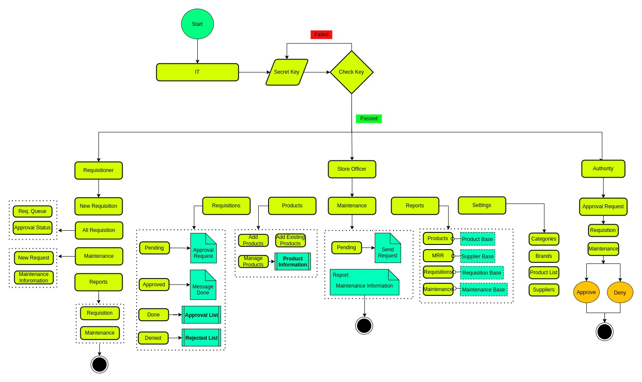

## 4.3 Data Flow Diagram

## 

# Chapter – 5: Testing Documentation

## 5.1 Introduction

The Test Plan is designed to prescribe the scope, approach, resources, and schedule of all testing activities of the IT Management System of BBA. The plan identify the items to be tested, the features to be tested, the types of testing to be performed, the personnel responsible for testing, the resources and schedule required to complete testing, and the risks associated with the plan.

## 5.2 Scopes

**1. In scope:**

|  |  |  |
| --- | --- | --- |
| Name | Applicable Roles | Description |
| New Requisition & Maintenance Request | Requisitioner | Make a requisition form or send a maintenance request to the store officer. |
| Requisition & Maintenance List | Requisitioner, Store officer | View all the requisition and maintenance status. |
| Requisition & Maintenance Information | Store Officer | View and can send the approval request to the authority |
| Report | Requisitioner, store officer | Manage to download a document file for the respective area of query |
| Manage Products and Settings | Store officer | Add the products with respected category and brands also with suppliers name. |
| Approval | Authority | Approve or deny the requisition and maintenance request from the store officer. |

**2. Out scope**

* User Interface (UI)
* Hardware
* System security and performance

## 5.3 Quality Objective

The test objectives are to verify the Functionality of the system IT Management System, the project should focus on testing the IT management operation such as New Requisition, manage products, all product info and maintenance of them to guarantee all these operation can work normally in real business environment.

## 5.4 Testing Methodology

### 5.4.1 Model

* **Waterfall model** – a dynamic approach where each step depends on the previous one, where the developers follow some sequence of steps progressively downwards forwards to achieve the goal. It is like a waterfall approach containing several phases.

### 5.4.2 Strategies

• Tester has access to the full view of code.

• It is known as transparent or glass box testing

• Avoiding errors and wasting time at an early stage

• White box testing contains various tests -

1. Basic Path testing
2. Loop testing
3. Condition testing
4. Memory perspective testing
5. Performance testing

### 5.4.3 Levels

* Integration testing
* System testing
* Cross Browser Compatibility testing
* User Acceptance Test (UAT)
* API testing

### 5.4.4 Test Deliverables

(a) Before Testing

* Test plans document
* Test case document

(b) After Testing

* Test Results/reports
* Defect Report
* Installation/ Test procedures guidelines

### 5.4.5 Tools

|  |  |  |
| --- | --- | --- |
| No. | Resources | Description |
| 1. | Server | Oracle Database Server |
| 2. | Network | LAN line. |
| 3. | Computer | PC and other OS configuration |

## **5.5 Test Cases with Result**

**For All User:**

Test Scenario 1: Login Functionality Check

*Positive test case*

|  |  |  |  |  |  |
| --- | --- | --- | --- | --- | --- |
| Case ID | Title | Description | Expected Result | Actual Result | Pass/Fail |
| 1 | Login | 1. Visit login page  2. Enter username  3. Enter password  4. Click login  5. Change password (if forgot)  6. Keep login | Data saved successfully | Go to the login page | P |

*Negative Test Case*

|  |  |  |  |  |  |
| --- | --- | --- | --- | --- | --- |
| Case ID | Title | Description | Expected Result | Actual Result | Pass/Fail |
| 1 | Login | Checked all the necessary given data | Data checked | Login Page | P |

**For Requisitioner:**

Test Scenario 2: Requisition Dashboard

*Positive test case*

|  |  |  |  |  |  |
| --- | --- | --- | --- | --- | --- |
| Case ID | Title | Description | Expected Result | Actual Result | Pass/Fail |
| 1 | Requisitions | Click to view all requisition status | Displayed | No error while displaying the information | P |
| 2 | Products | Click to view all product details | Displayed | No error while displaying the information | P |
| 3 | Approved | Click to view all approved requisitions | Displayed | No error while displaying the information | P |
| 4 | Denied | Click to view all denied requisitions | Displayed | No error while displaying the information | P |

*Negative Test Case*

|  |  |  |  |  |  |
| --- | --- | --- | --- | --- | --- |
| Case ID | Title | Description | Expected Result | Actual Result | Pass/Fail |
| 1 | Requisitions | Should display the respective area | Perfectly executed the instructions | No error occurred | P |
| 2 | Products | Should display the respective area | Perfectly executed the instructions | No error occurred | P |
| 3 | Approved | Should display the respective area | Perfectly executed the instructions | No error occurred | P |
| 4 | Denied | Should display the respective area | Perfectly executed the instructions | No error occurred | P |

Test Scenario 3: Add New Requisition

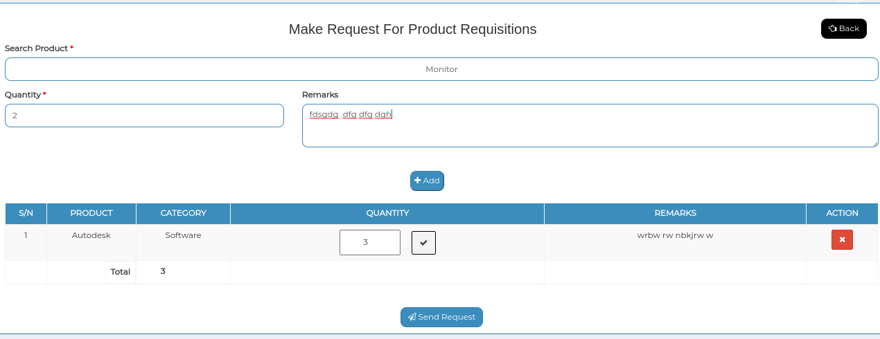

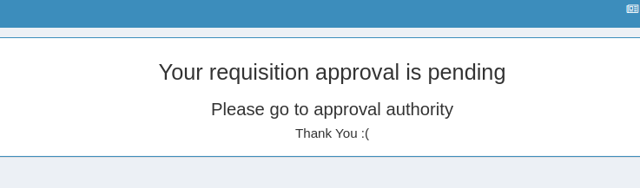

*Positive test case*

|  |  |  |  |  |  |
| --- | --- | --- | --- | --- | --- |
| Case ID | Title | Description | Expected Result | Actual Result | Pass/Fail |
| 1 | Make Request For Product Requisitions | 1. Enter searching product and select it  2. Enter quantity & remark of the product  3. click add to add more  4. send request button to send approval request for this requisition to the authority | Data saved successfully | No error occurred while adding information | P |

*Negative Test Case*

|  |  |  |  |  |  |
| --- | --- | --- | --- | --- | --- |
| Case ID | Title | Description | Expected Result | Actual Result | Pass/Fail |
| 1 | Make Request For Product Requisitions | 1. Data should properly selected & entered  2. button should perfectly work | No irrelevant data is accepted | No error | P |

**Test Scenario 4: All requisitions**

1. view

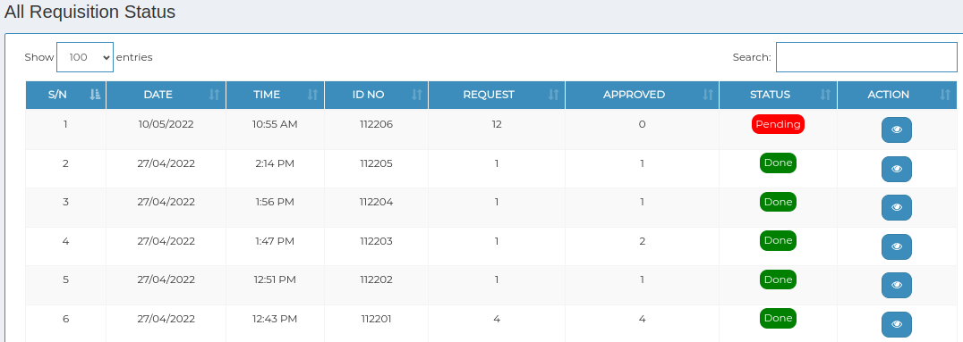

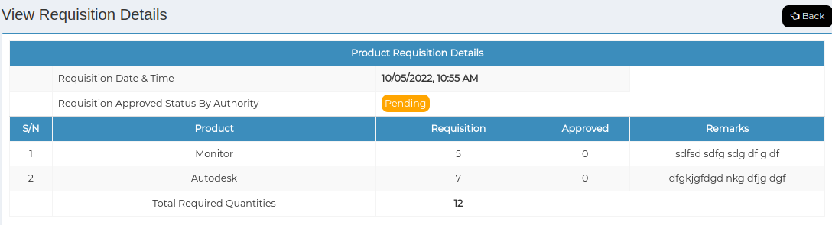

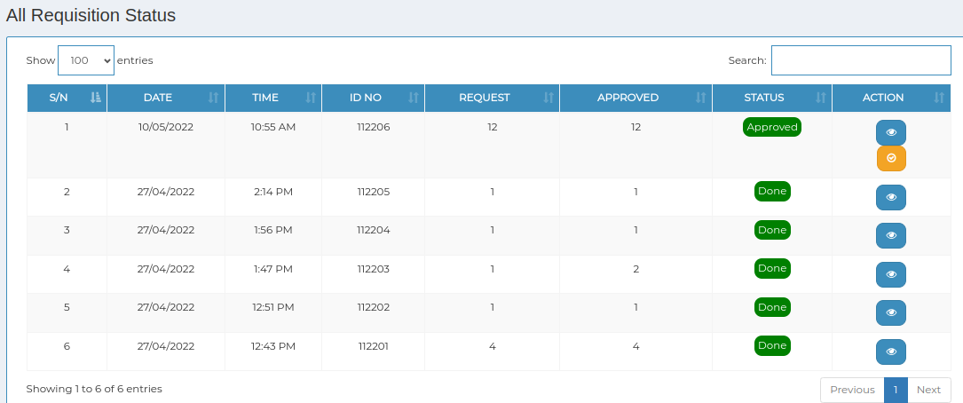

*Positive test case*

|  |  |  |  |  |  |
| --- | --- | --- | --- | --- | --- |
| Case ID | Title | Description | Expected Result | Actual Result | Pass/Fail |
| 1 | All requisition status | Display all the requisition status | Displayed | No error showing while displaying | P |
| 2 | View | Click to view the requisition information | Displayed individual requisition information | No error while displaying | P |

*Negative Test Case*

|  |  |  |  |  |  |
| --- | --- | --- | --- | --- | --- |
| Case ID | Title | Description | Expected Result | Actual Result | Pass/Fail |
| 1 | All requisition status | Information should perfectly displayed | No irrelevant data is displayed | Perfectly executed | P |
| 2 | view | Information of any requisition should displayed | No irrelevant data is displayed | Perfectly executed | P |

2. Products

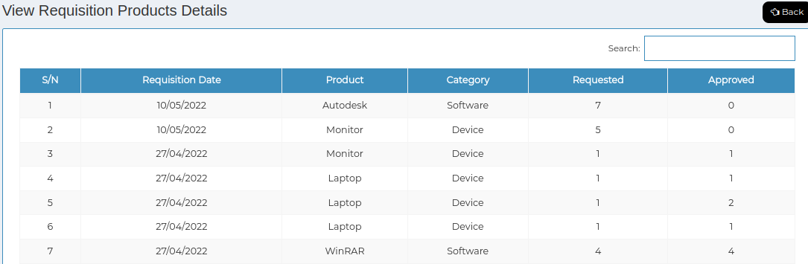

*Positive test case*

|  |  |  |  |  |  |
| --- | --- | --- | --- | --- | --- |
| Case ID | Title | Description | Expected Result | Actual Result | Pass/Fail |
| 1 | View Requisition Products Details | Display all the requisition product details | Displayed | No error showing while displaying | P |

*Negative Test Case*

|  |  |  |  |  |  |
| --- | --- | --- | --- | --- | --- |
| Case ID | Title | Description | Expected Result | Actual Result | Pass/Fail |
| 1 | View Requisition Products Details | Information of any requisition should displayed | No irrelevant data is displayed | Perfectly executed | P |

**Test Scenario 5: Maintenance**

1. Request

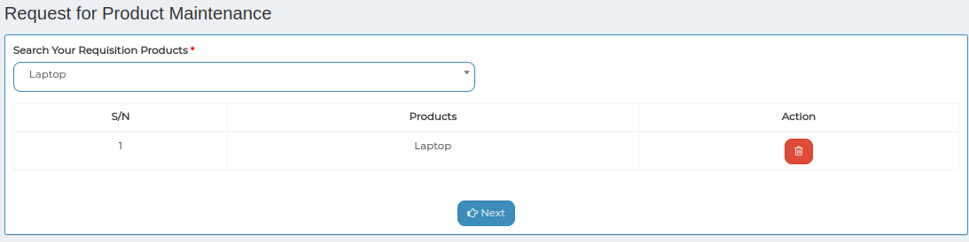

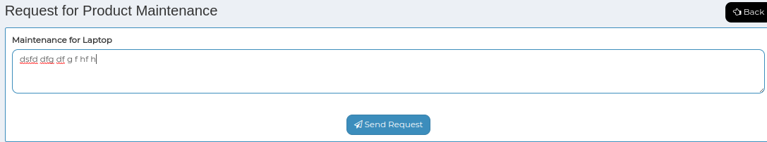

*Positive test case*

|  |  |  |  |  |  |
| --- | --- | --- | --- | --- | --- |
| Case ID | Title | Description | Expected Result | Actual Result | Pass/Fail |
| 1 | Request for Product Maintenance | Request for a new maintenance | Request placed | No error | P |

*Negative Test Case*

|  |  |  |  |  |  |
| --- | --- | --- | --- | --- | --- |
| Case ID | Title | Description | Expected Result | Actual Result | Pass/Fail |
| 1 | Request for Product Maintenance | Maintenance request should be performed | Request is sent to the authority | No error | P |

2. view

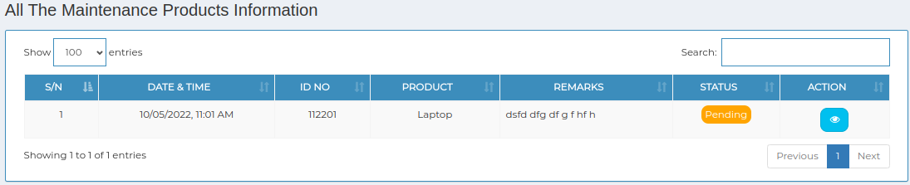

*Positive test case*

|  |  |  |  |  |  |
| --- | --- | --- | --- | --- | --- |
| Case ID | Title | Description | Expected Result | Actual Result | Pass/Fail |
| 1 | All The Maintenance Products Information | Display all the maintenance product information | Displayed | No error showing while displaying | P |

*Negative Test Case*

|  |  |  |  |  |  |
| --- | --- | --- | --- | --- | --- |
| Case ID | Title | Description | Expected Result | Actual Result | Pass/Fail |
| 1 | All The Maintenance Products Information | Information of maintenance product information should displayed | No irrelevant data is displayed | Perfectly executed | P |

**Test Scenario 6: Report**

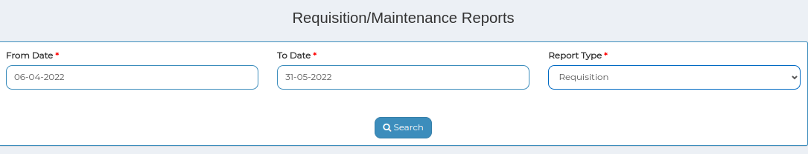

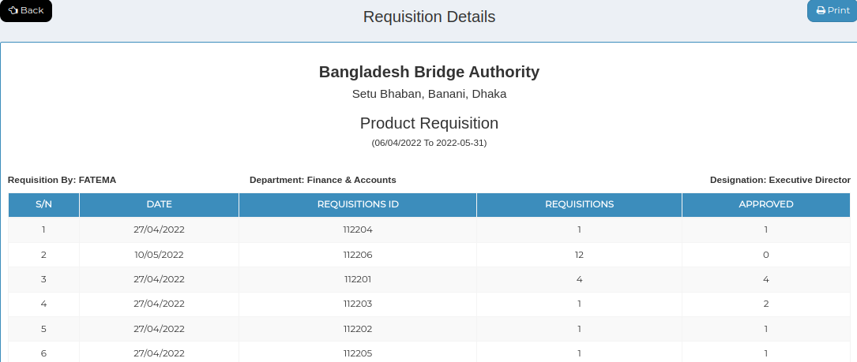

*Positive test case*

|  |  |  |  |  |  |
| --- | --- | --- | --- | --- | --- |
| Case ID | Title | Description | Expected Result | Actual Result | Pass/Fail |
| 1 | Requisition/Maintenance Reports | 1. Select from date and to date, report type | Data saved successfully | Perfectly executed | P |
| 2 | Requisition Details | Display all the maintenance product information | Displayed | No error showing while displaying | P |

*Negative Test Case*

|  |  |  |  |  |  |
| --- | --- | --- | --- | --- | --- |
| Case ID | Title | Description | Expected Result | Actual Result | Pass/Fail |
| 1 | Requisition/Maintenance Reports | Data should be selected | No irrelevant data is selected | Perfectly executed | P |
| 2 | Requisition Details | Information of maintenance product information should displayed | No irrelevant data is displayed | Perfectly executed | P |

**For Store Officer:**

**Test Scenario 7: Main Dashboard**

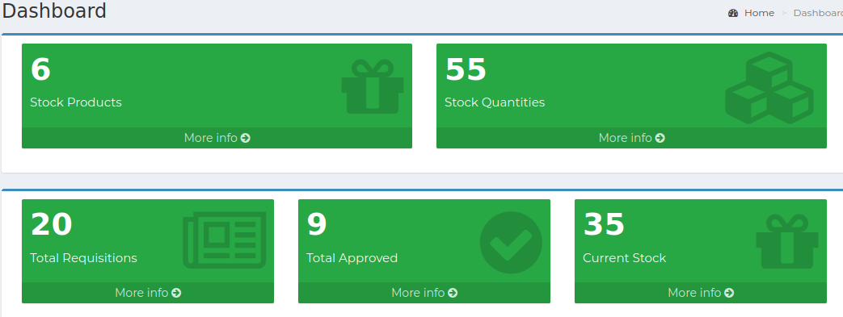

*Positive test case*

|  |  |  |  |  |  |
| --- | --- | --- | --- | --- | --- |
| Case ID | Title | Description | Expected Result | Actual Result | Pass/Fail |
| 1 | Stock products | Click to view stock product details | Displayed | No error | P |
| 2 | Stock Quantities | Click to view stock quantity details | Displayed | No error | P |
| 3 | Total Requisitions | Click to view total requisition details | Displayed | No error | P |
| 4 | Total approved | Click to view total approved details | Displayed | No error | P |
| 5 | Current stock | Click to view current stock details | Displayed | No error | P |

*Negative Test Case*

|  |  |  |  |  |  |
| --- | --- | --- | --- | --- | --- |
| Case ID | Title | Description | Expected Result | Actual Result | Pass/Fail |
| 1 | Stock products | Information which are displayed should be relevant | No irrelevant data is displayed | No error | P |
| 2 | Stock Quantities | Information which are displayed should be relevant | No irrelevant data is displayed | No error | P |
| 3 | Total Requisitions | Information which are displayed should be relevant | No irrelevant data is displayed | No error | P |
| 4 | Total approved | Information which are displayed should be relevant | No irrelevant data is displayed | No error | P |
| 5 | Current stock | Information which are displayed should be relevant | No irrelevant data is displayed | No error | P |

Test Scenario 8: Requisitions

1. Pending

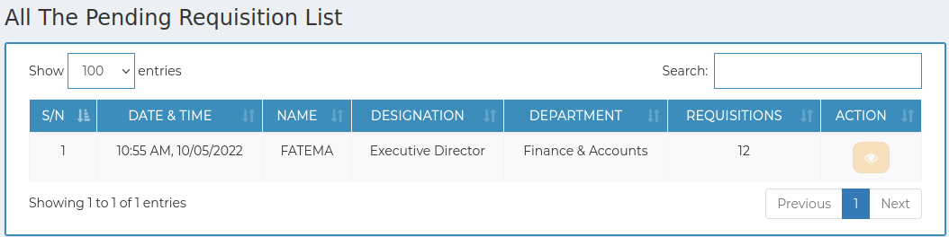

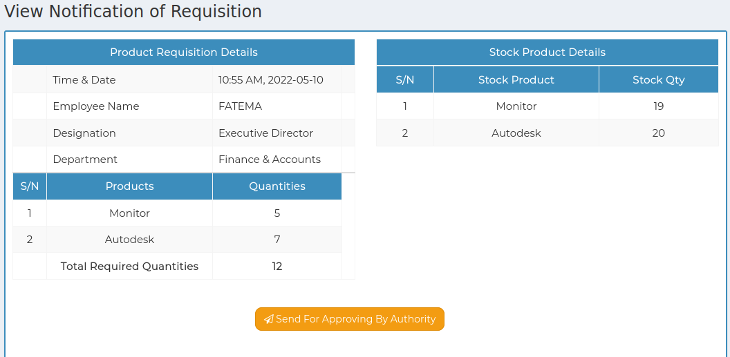

*Positive test case*

|  |  |  |  |  |  |
| --- | --- | --- | --- | --- | --- |
| Case ID | Title | Description | Expected Result | Actual Result | Pass/Fail |
| 1 | All The Pending Requisition List | Display all the pending requisition list | Displayed | No error | P |
| 2 | View Notification of Requisition | Display the latest requisition list status | Notified | No error | P |

*Negative Test Case*

|  |  |  |  |  |  |
| --- | --- | --- | --- | --- | --- |
| Case ID | Title | Description | Expected Result | Actual Result | Pass/Fail |
| 1 | All The Pending Requisition List | Information of pending product information should displayed | No irrelevant data is displayed | Perfectly executed | P |
| 2 | View Notification of Requisition | Requisition status should be notified | Perfectly executed | No error | P |

2. Approved

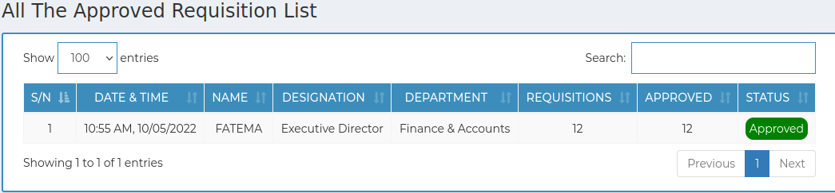

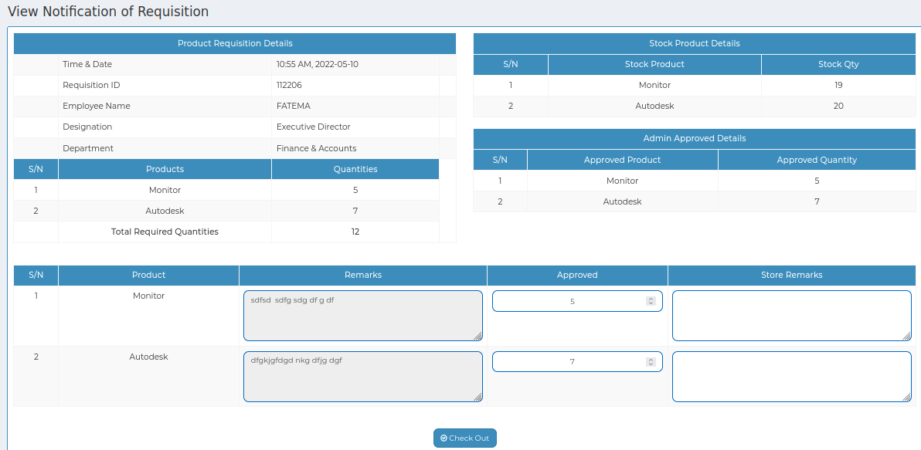

*Positive test case*

|  |  |  |  |  |  |
| --- | --- | --- | --- | --- | --- |
| Case ID | Title | Description | Expected Result | Actual Result | Pass/Fail |
| 1 | All The Approved Requisition List | Display all the approved requisition list | Displayed | No error | P |

*Negative Test Case*

|  |  |  |  |  |  |
| --- | --- | --- | --- | --- | --- |
| Case ID | Title | Description | Expected Result | Actual Result | Pass/Fail |
| 1 | All The Approved Requisition List | Information of approved requisition information should displayed | No irrelevant data is displayed | Perfectly executed | P |

3. Done

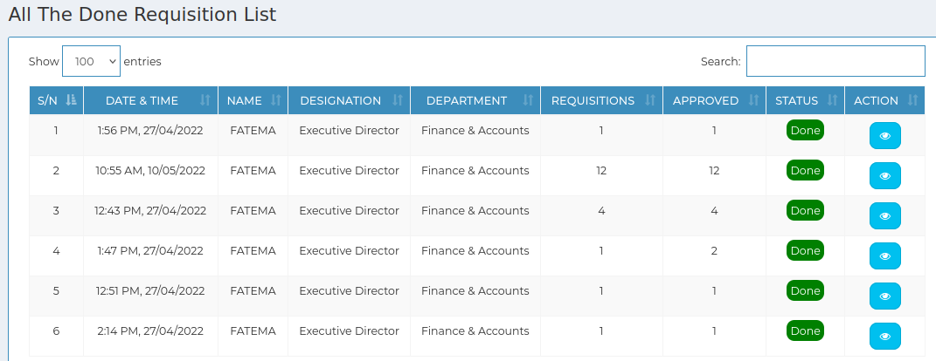

*Positive test case*

|  |  |  |  |  |  |
| --- | --- | --- | --- | --- | --- |
| Case ID | Title | Description | Expected Result | Actual Result | Pass/Fail |
| 1 | All The Done Requisition List | Display all the done requisition list | Displayed | No error | P |

*Negative Test Case*

|  |  |  |  |  |  |
| --- | --- | --- | --- | --- | --- |
| Case ID | Title | Description | Expected Result | Actual Result | Pass/Fail |
| 1 | All The Done Requisition List | Information of done requisition information should displayed | No irrelevant data is displayed | Perfectly executed | P |

4. Denied

//problem

*Positive test case*

|  |  |  |  |  |  |
| --- | --- | --- | --- | --- | --- |
| Case ID | Title | Description | Expected Result | Actual Result | Pass/Fail |
| 1 | All The denied Requisition List | Display all the denied requisition list | Displayed | No error | P |

*Negative Test Case*

|  |  |  |  |  |  |
| --- | --- | --- | --- | --- | --- |
| Case ID | Title | Description | Expected Result | Actual Result | Pass/Fail |
| 1 | All The denied Requisition List | Information of done requisition information should displayed | No irrelevant data is displayed | Perfectly executed | P |

Test Scenario 9: Products

1. Add product

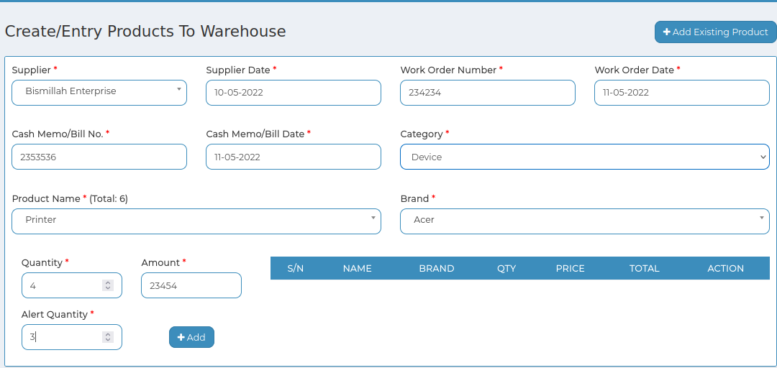

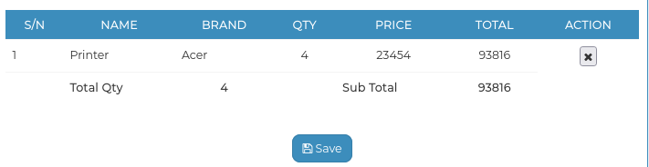

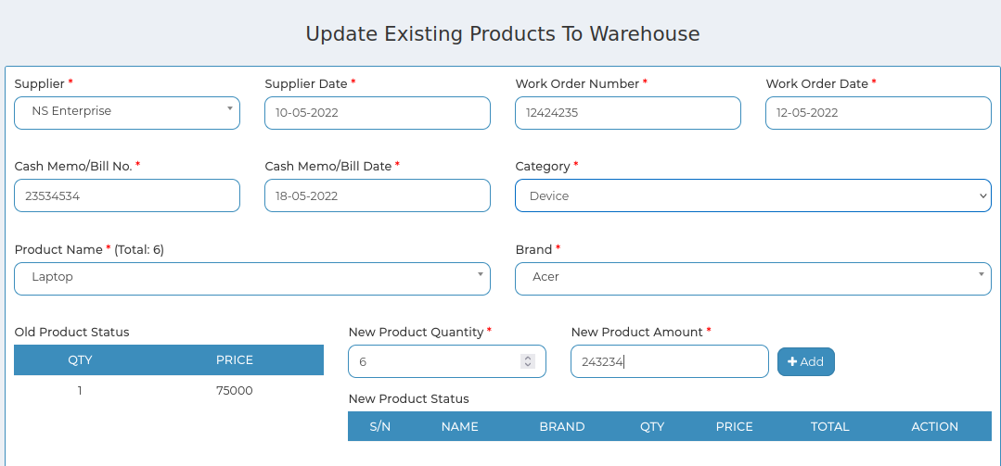

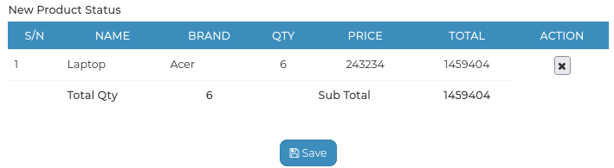

*Positive test case*

|  |  |  |  |  |  |
| --- | --- | --- | --- | --- | --- |
| Case ID | Title | Description | Expected Result | Actual Result | Pass/Fail |
| 1 | Create/Entry Products To Warehouse | 1. Select Supplier  2. Enter Supplier Date, work order no, work order date, cash memo/ bill no, Cash memo/ bill date  3 . Select Category, Product, Brand  4. Enter Quantity, Enter Amount, alert Quantity  5. Click add | Data saved successfully | No error while adding information | P |
| 2 | Update Existing Products To Warehouse | 1. click add existing products  2. Select Supplier  3. Enter Supplier Date, work order no,work order date, cash memo/ bill no, Cash memo/ bill date  4. Select Category, Product, Select Brand  5. Enter New Product Quantity, New Product Amount  6. Click add | Data saved successfully | No error while adding information | P |

*Negative Test Case*

|  |  |  |  |  |  |
| --- | --- | --- | --- | --- | --- |
| Case ID | Title | Description | Expected Result | Actual Result | Pass/Fail |
| 1 | Create/Entry Products To Warehouse | Data should be perfectly selected and entered | No irrelevant data is accepted | No error | P |
| 2 | Update Existing Products To Warehouse | Data should be perfectly selected and entered | No irrelevant data is accepted | No error | P |

2. Manage Products

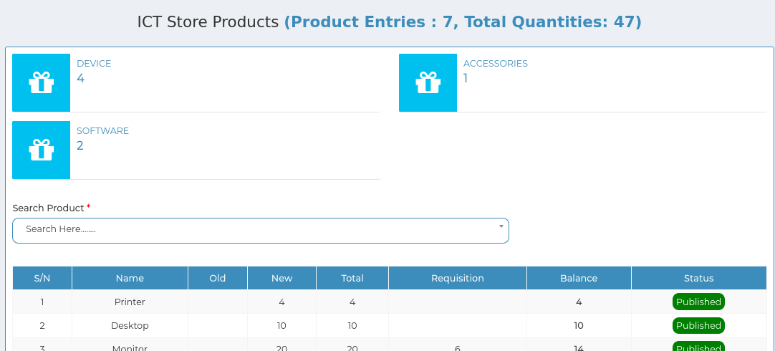

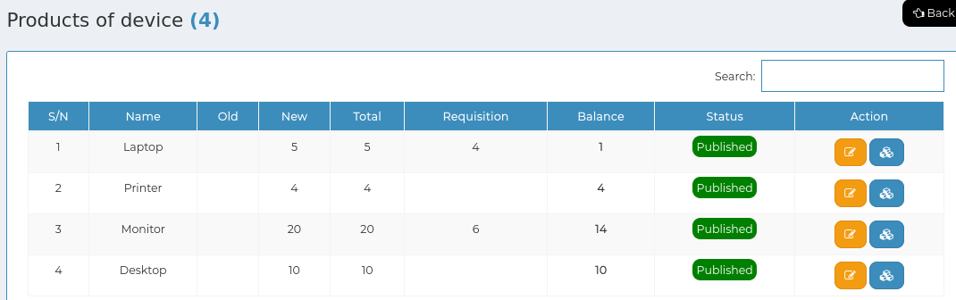

*Positive test case*

|  |  |  |  |  |  |
| --- | --- | --- | --- | --- | --- |
| Case ID | Title | Description | Expected Result | Actual Result | Pass/Fail |
| 1 | ICT Store Products | Click to see several type of product to see these details | No error occurred while displaying | Perfectly displayed | P |
| 2 | Products | Click search to see specific product details | No error occurred while displaying | Perfectly displayed | P |
| 3 | Update & Status | Click update to update existing database and click status to change it | No error occurred while updating or changing status | Perfectly displayed | P |

*Negative Test Case*

|  |  |  |  |  |  |
| --- | --- | --- | --- | --- | --- |
| Case ID | Title | Description | Expected Result | Actual Result | Pass/Fail |
| 1 | ICT Store Products | Product should be displayed individually | Displayed exact information | No error | P |
| 2 | Products | Search button should perfectly work | Displayed exact information | No error | P |
| 3 | Update & Status | Database should be updated | Updated | No error | P |

**Test Scenario 10: Maintenance**

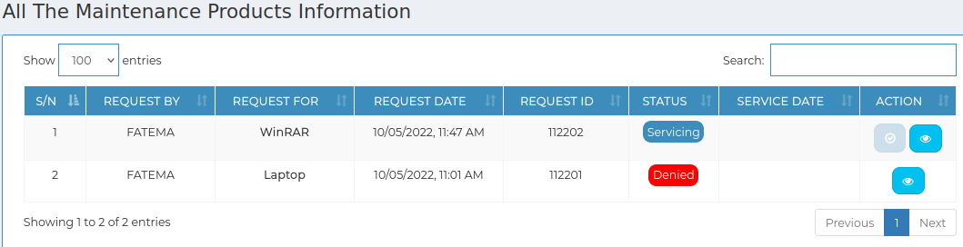

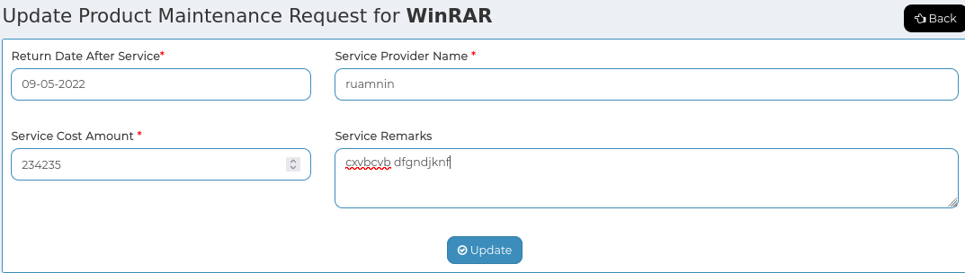

*Positive test case*

|  |  |  |  |  |  |
| --- | --- | --- | --- | --- | --- |
| Case ID | Title | Description | Expected Result | Actual Result | Pass/Fail |
| 1 | All The Maintenance Products Information | Display all the maintenance product information list | Displayed | No error | P |
| 2 | Update & view | Update the approved requisition and view the requisition details and can download it |  |  |  |

*Negative Test Case*

|  |  |  |  |  |  |
| --- | --- | --- | --- | --- | --- |
| Case ID | Title | Description | Expected Result | Actual Result | Pass/Fail |
| 1 | All The Maintenance Products Information | Information of maintenance product information should displayed | No irrelevant data is displayed | Perfectly executed | P |
| 2 | Update & view | Database should be updated & view button generate a print option | Updated | No error | P |

Test Case Scenario : Reports

1. Products

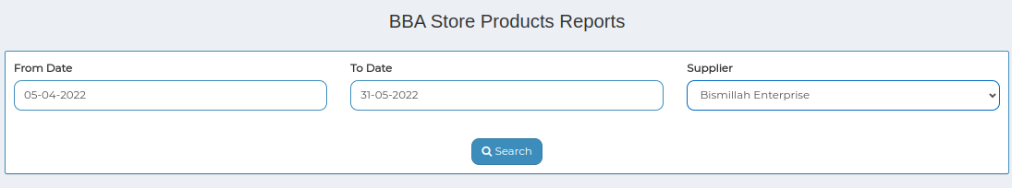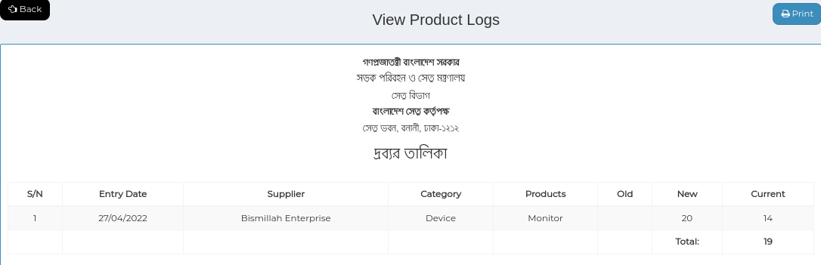

*Positive test case*

|  |  |  |  |  |  |
| --- | --- | --- | --- | --- | --- |
| Case ID | Title | Description | Expected Result | Actual Result | Pass/Fail |
| 1 | BBA Store Products Reports | 1. Select from date, to date & supplier name | Data entered successfully | No error while selecting | P |
| 2 | View Product Logs | Generate in a report | Information generated | No error | P |

*Negative Test Case*

|  |  |  |  |  |  |
| --- | --- | --- | --- | --- | --- |
| Case ID | Title | Description | Expected Result | Actual Result | Pass/Fail |
| 1 | BBA Store Products Reports | Data should be selected | No irrelevant data is accepted | No error | P |
| 2 | View Product Logs | Information is placed perfectly | No information is missing | No error | P |

2. MRR

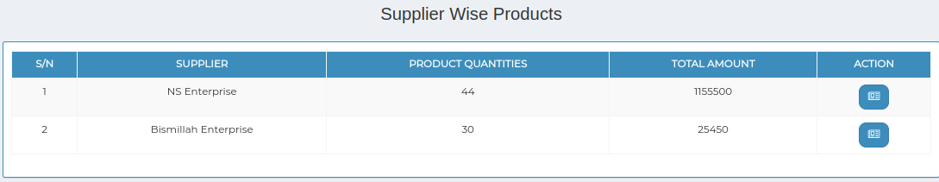

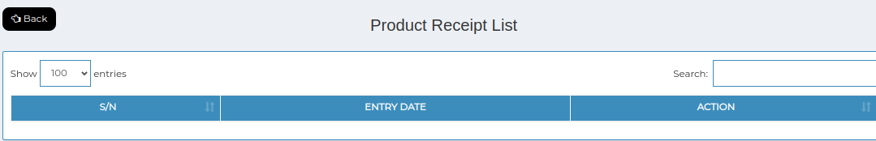

*Positive test case*

|  |  |  |  |  |  |
| --- | --- | --- | --- | --- | --- |
| Case ID | Title | Description | Expected Result | Actual Result | Pass/Fail |
| 1 | Supplier Wise Products | Display all the Supplier wise product information list | Displayed | No error | P |
| 2 | Product Receipt List | Display all the product receipt information list | Displayed | No error | P |

*Negative Test Case*

|  |  |  |  |  |  |
| --- | --- | --- | --- | --- | --- |
| Case ID | Title | Description | Expected Result | Actual Result | Pass/Fail |
| 1 | Supplier Wise Products | Information of supplier wise product information should displayed | No irrelevant data is displayed | Perfectly executed | P |
| 2 | Product Receipt List | Information of product receipt information should displayed | No irrelevant data is displayed | Perfectly executed | P |

3. Requisitions

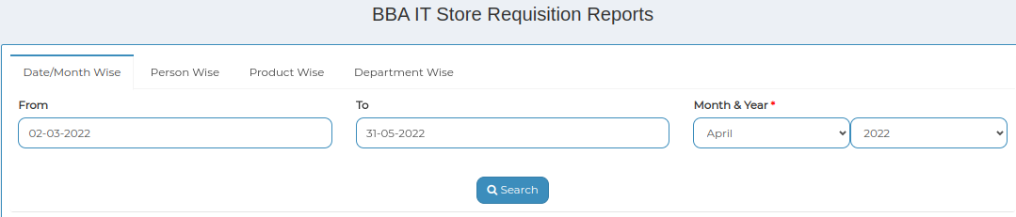

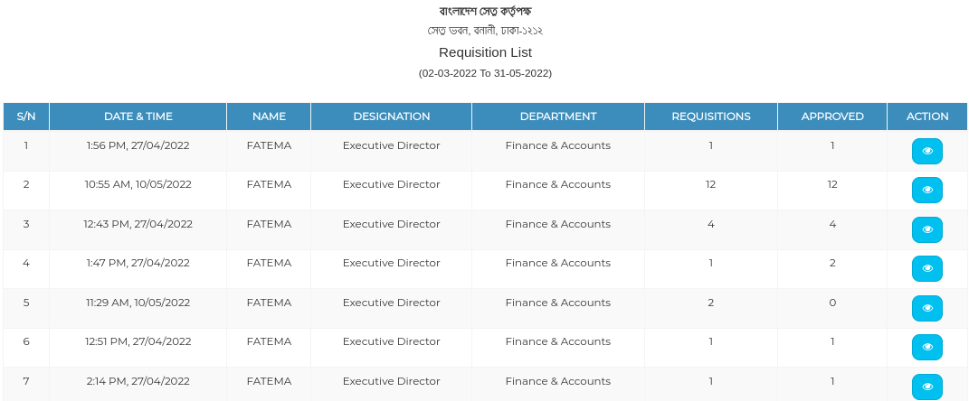

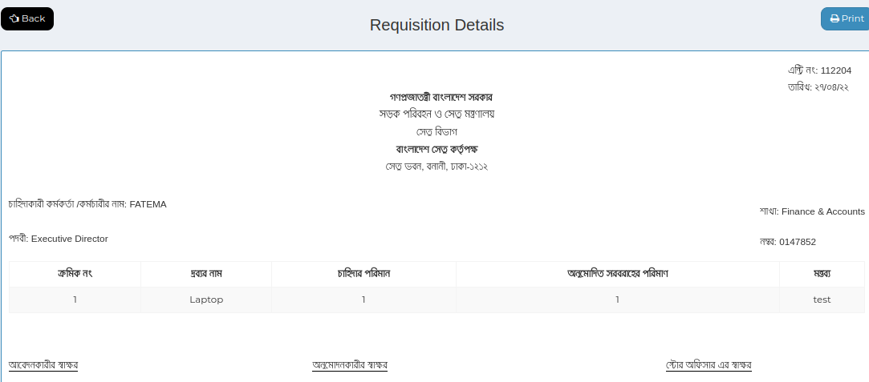

*Positive test case*

|  |  |  |  |  |  |
| --- | --- | --- | --- | --- | --- |
| Case ID | Title | Description | Expected Result | Actual Result | Pass/Fail |
| 1 | BBA IT Store Requisition Reports | 1. select date/month or person, product, department  2. click search | Perfectly selected data displayed the exact information | No error | P |
| 2 | Requisition Details | Display information details and can download | displayed | No error | P |

*Negative Test Case*

|  |  |  |  |  |  |
| --- | --- | --- | --- | --- | --- |
| Case ID | Title | Description | Expected Result | Actual Result | Pass/Fail |
| 1 | BBA IT Store Requisition Reports | Data should be selected | No irrelevant data is accepted | No error | P |
| 2 | Requisition Details | Information is placed perfectly | No information is missing | No error | P |

4. Maintenance

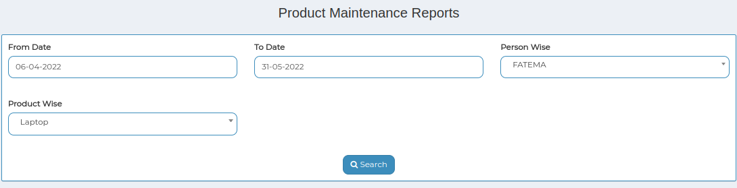

*Positive test case*

|  |  |  |  |  |  |
| --- | --- | --- | --- | --- | --- |
| Case ID | Title | Description | Expected Result | Actual Result | Pass/Fail |
| 1 | Product Maintenance Reports | 1. select date/month or person, product, department  2. click search | Perfectly selected data displayed the exact information | No error | P |
| 2 | Product Receipt List | Display information details and can download | displayed | No error | P |

*Negative Test Case*

|  |  |  |  |  |  |
| --- | --- | --- | --- | --- | --- |
| Case ID | Title | Description | Expected Result | Actual Result | Pass/Fail |
| 1 | Supplier Wise Products | Data should be selected | No irrelevant data is accepted | No error | P |
| 2 | Product Receipt List | Information is placed perfectly | No information is missing | No error | P |

Test Case Scenario 11: Settings

1. Categories

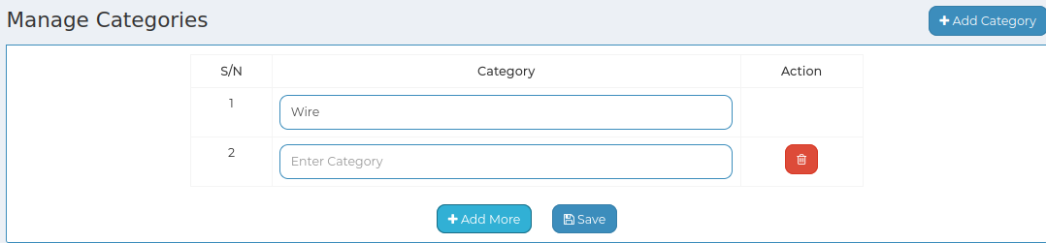

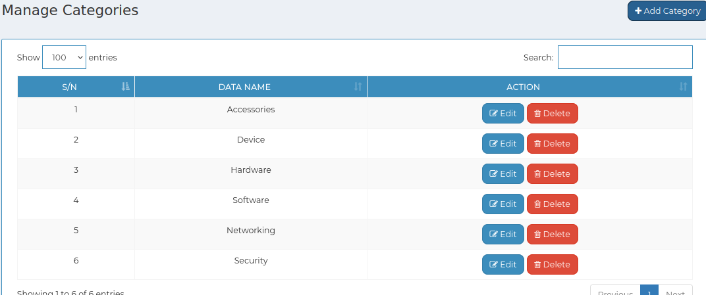

*Positive test case*

|  |  |  |  |  |  |
| --- | --- | --- | --- | --- | --- |
| Case ID | Title | Description | Expected Result | Actual Result | Pass/Fail |
| 1 | Add category | 1. click add category to enter new category  2. click add more to add new  3. Click save  4. type in the search bar to find specific category | Data saved successfully | No error while saving | P |
| 2 | Manage Categories | Display all the category information | No irrelevant data is displayed | No error while displaying | P |
| 3 | Update & Delete | Update existing information and delete a specific information | Updated | No error occurred while updating or deleting | P |

*Negative Test Case*

|  |  |  |  |  |  |
| --- | --- | --- | --- | --- | --- |
| Case ID | Title | Description | Expected Result | Actual Result | Pass/Fail |
| 1 | Add category | Data should be entered and save button should perfectly work | No irrelevant data is selected | No error | P |
| 2 | Manage Categories | Categories are displayed | No information is missing | No error | P |
| 3 | Update & Delete | Update existing database | Perfectly executed | No error | P |

2. Brands

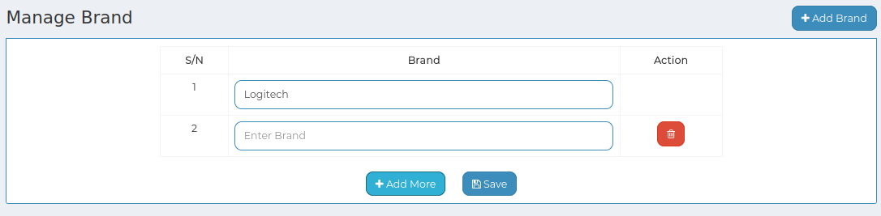

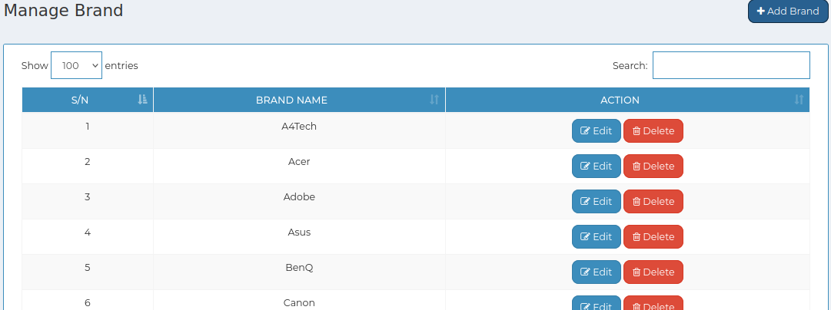

*Positive test case*

|  |  |  |  |  |  |
| --- | --- | --- | --- | --- | --- |
| Case ID | Title | Description | Expected Result | Actual Result | Pass/Fail |
| 1 | Add brands | 1. click add brands to enter new brands  2. click add more to add new  3. Click save  4. type in the search bar to find specific category | Data saved successfully | No error while saving | P |
| 2 | Manage Brand | Display all the brands information | No irrelevant data is displayed | No error while displaying | P |
| 3 | Update & Delete | Update existing information and delete a specific information | Updated | No error occurred while updating or deleting | P |

*Negative Test Case*

|  |  |  |  |  |  |
| --- | --- | --- | --- | --- | --- |
| Case ID | Title | Description | Expected Result | Actual Result | Pass/Fail |
| 1 | Add brands | Data should be entered and save button should perfectly work | No irrelevant data is selected | No error | P |
| 2 | Manage Brand | Brands are displayed | No information is missing | No error | P |
| 3 | Update & Delete | Update existing database | Perfectly executed | No error | P |

3. Product List

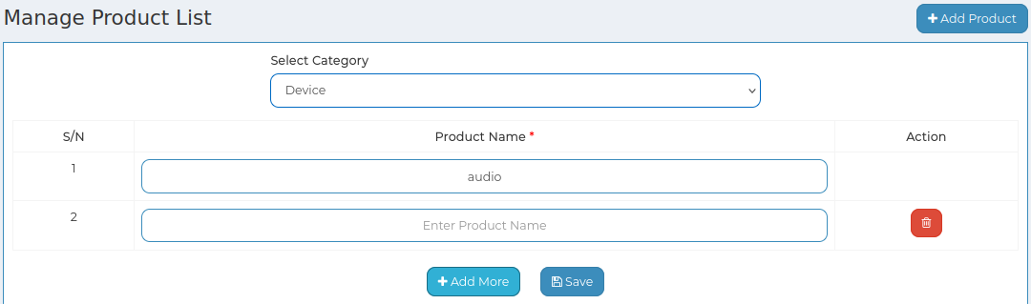

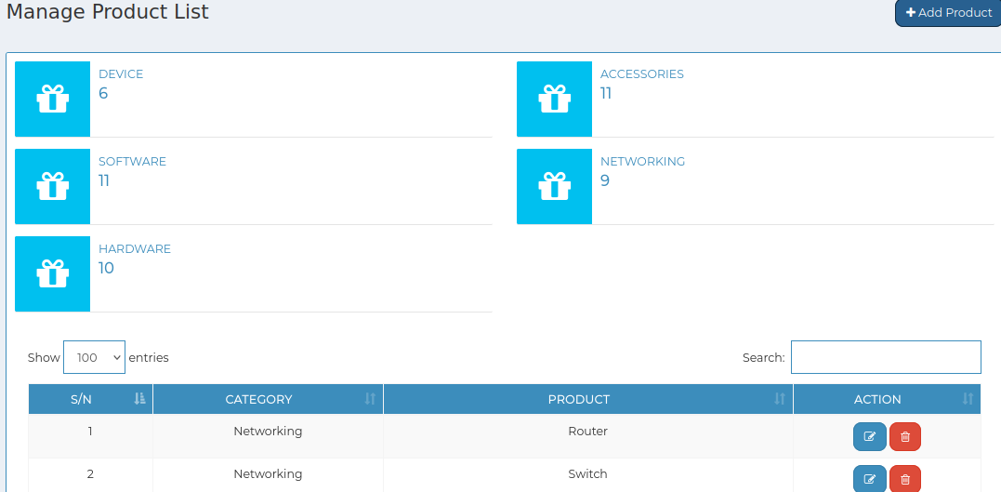

*Positive test case*

|  |  |  |  |  |  |
| --- | --- | --- | --- | --- | --- |
| Case ID | Title | Description | Expected Result | Actual Result | Pass/Fail |
| 1 | Add product | 1. click add product to enter new brands  2. select category  3. Enter product name  4. click add more to add new  5. Click save  6. type in the search bar to find specific category | Data saved successfully | No error while saving | P |
| 2 | Manage Product List | Display all the products information | No irrelevant data is displayed | No error while displaying | P |
| 3 | Update & Delete | Update existing information and delete a specific information | Updated | No error occurred while updating or deleting | P |

*Negative Test Case*

|  |  |  |  |  |  |
| --- | --- | --- | --- | --- | --- |
| Case ID | Title | Description | Expected Result | Actual Result | Pass/Fail |
| 1 | Add product | Data should be entered and save button should perfectly work | No irrelevant data is selected | No error | P |
| 2 | Manage Product List | Products are displayed | No information is missing | No error | P |
| 3 | Update & Delete | Update existing database | Perfectly executed | No error | P |

4. Suppliers

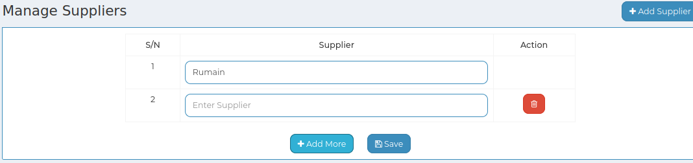

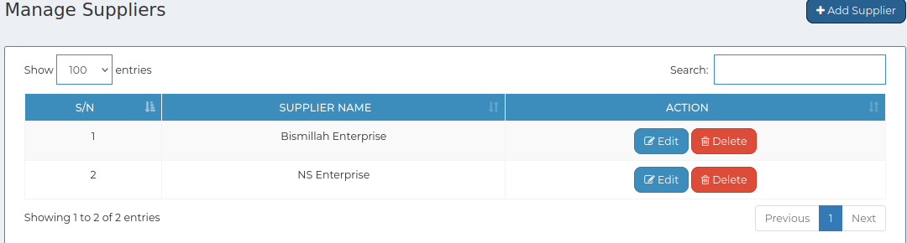

*Positive test case*

|  |  |  |  |  |  |
| --- | --- | --- | --- | --- | --- |
| Case ID | Title | Description | Expected Result | Actual Result | Pass/Fail |
| 1 | Add supplier | 1. click add product to enter new brands  2. Enter Supplier name  3. click add more to add new  4. Click save  6. type in the search bar to find specific category | Data saved successfully | No error while saving | P |
| 2 | Manage Suppliers | Display all the Suppliers information | No irrelevant data is displayed | No error while displaying | P |
| 3 | Update & delete | Update existing information and delete a specific information | Updated | No error occurred while updating or deleting | P |

*Negative Test Case*

|  |  |  |  |  |  |
| --- | --- | --- | --- | --- | --- |
| Case ID | Title | Description | Expected Result | Actual Result | Pass/Fail |
| 1 | Add supplier | Data should be entered and save button should perfectly work | No irrelevant data is selected | No error | P |
| 2 | Manage Suppliers | Suppliers are displayed | No information is missing | No error | P |
| 3 | Update & delete | Update existing database | Perfectly executed | No error | P |

**For Authority:**

**Test Scenario 12: Requisitions**

1. Pending

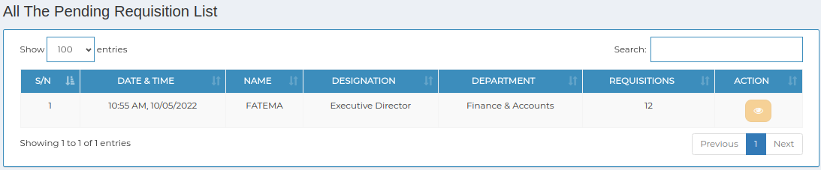

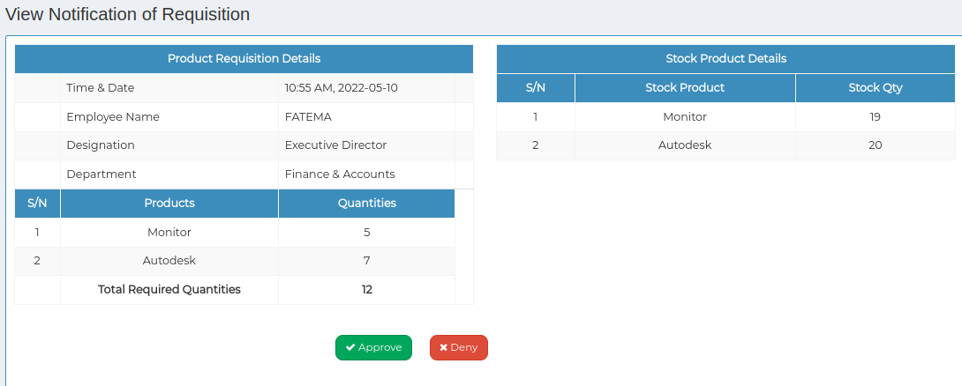

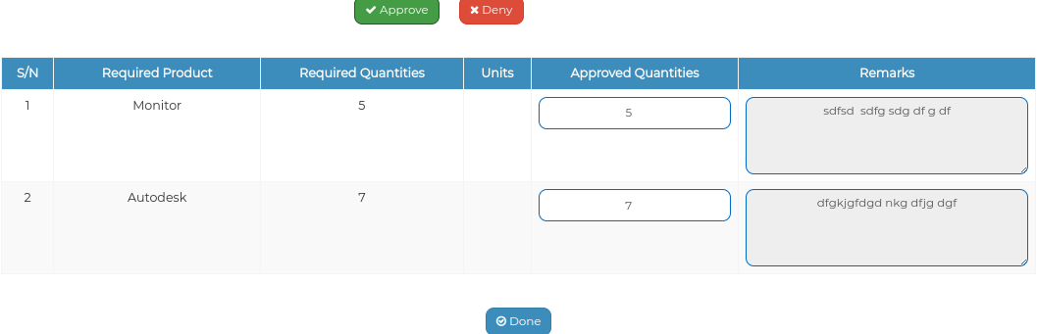

*Positive test case*

|  |  |  |  |  |  |
| --- | --- | --- | --- | --- | --- |
| Case ID | Title | Description | Expected Result | Actual Result | Pass/Fail |
| 1 | All The Pending Requisition List | Display all the pending requisition list | Displayed | No error | P |
| 2 | View Notification of Requisition | Display the latest requisition list status | Notified | No error | P |

*Negative Test Case*

|  |  |  |  |  |  |
| --- | --- | --- | --- | --- | --- |
| Case ID | Title | Description | Expected Result | Actual Result | Pass/Fail |
| 1 | All The Pending Requisition List | Information of pending product information should displayed | No irrelevant data is displayed | Perfectly executed | P |
| 2 | View Notification of Requisition | Requisition status should be notified | Perfectly executed | No error | P |

2. Approved

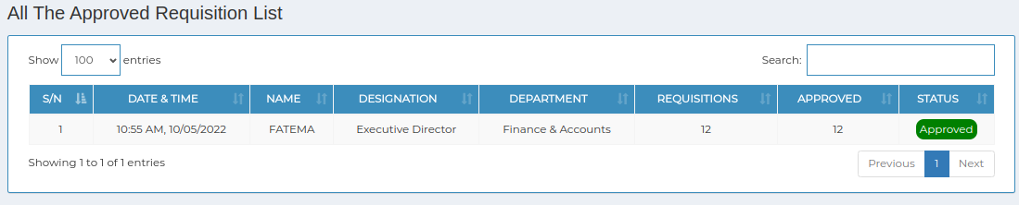

*Positive test case*

|  |  |  |  |  |  |
| --- | --- | --- | --- | --- | --- |
| Case ID | Title | Description | Expected Result | Actual Result | Pass/Fail |
| 1 | All The Approved Requisition List | Display all the approved requisition list | Displayed | No error | P |

*Negative Test Case*

|  |  |  |  |  |  |
| --- | --- | --- | --- | --- | --- |
| Case ID | Title | Description | Expected Result | Actual Result | Pass/Fail |
| 1 | All The Approved Requisition List | Information of approved requisition information should displayed | No irrelevant data is displayed | Perfectly executed | P |

3. Done

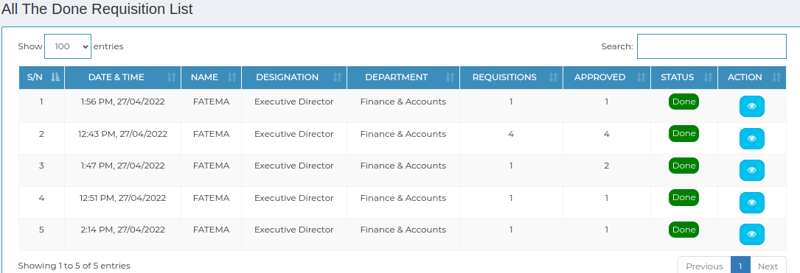

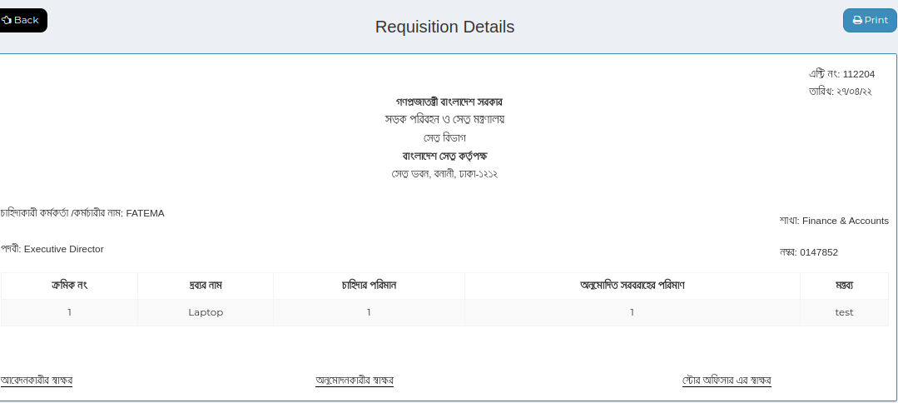

*Positive test case*

|  |  |  |  |  |  |
| --- | --- | --- | --- | --- | --- |
| Case ID | Title | Description | Expected Result | Actual Result | Pass/Fail |
| 1 | All The Done Requisition List | Display all the done requisition list | Displayed | No error | P |

*Negative Test Case*

|  |  |  |  |  |  |
| --- | --- | --- | --- | --- | --- |
| Case ID | Title | Description | Expected Result | Actual Result | Pass/Fail |
| 1 | All The Done Requisition List | Information of done requisition information should displayed | No irrelevant data is displayed | Perfectly executed | P |

4. Denied

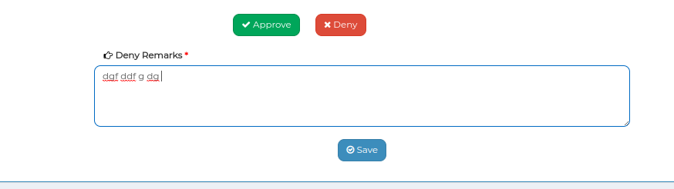

*Positive test case*

|  |  |  |  |  |  |
| --- | --- | --- | --- | --- | --- |
| Case ID | Title | Description | Expected Result | Actual Result | Pass/Fail |
| 1 | All The denied Requisition List | Display all the denied requisition list | Displayed | No error | P |

*Negative Test Case*

|  |  |  |  |  |  |
| --- | --- | --- | --- | --- | --- |
| Case ID | Title | Description | Expected Result | Actual Result | Pass/Fail |
| 1 | All The denied Requisition List | Information of done requisition information should displayed | No irrelevant data is displayed | Perfectly executed | P |

**Test Case scenario 13: Maintenance**

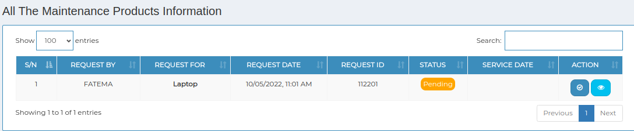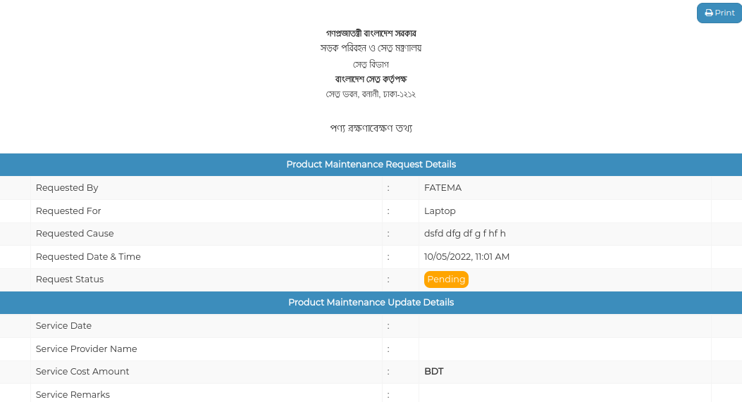

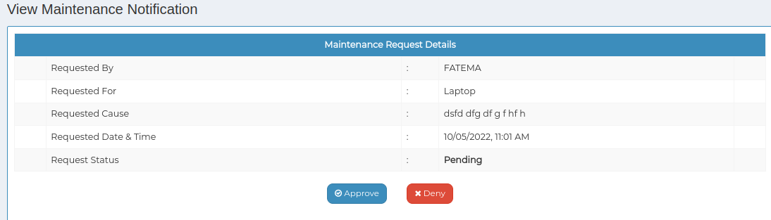

*Positive test case*

|  |  |  |  |  |  |
| --- | --- | --- | --- | --- | --- |
| Case ID | Title | Description | Expected Result | Actual Result | Pass/Fail |
| 1 | All The Maintenance Products Information | Display all the maintenance product information list | Displayed | No error | P |
| 2 | View Maintenance Notification | Display the latest maintenance list status | Notified | No error | P |

*Negative Test Case*

|  |  |  |  |  |  |
| --- | --- | --- | --- | --- | --- |
| Case ID | Title | Description | Expected Result | Actual Result | Pass/Fail |
| 1 | All The Maintenance Products Information | Information of maintenance product information should displayed | No irrelevant data is displayed | Perfectly executed | P |
| 2 | View Maintenance Notification | maintenance status should be notified | Perfectly executed | No error | P |