**Software Documentation for the Store Management**

**Product Name: Store Management System**

Release Version: 9.12.21.10

Testing Started: 17-01-2022

Testing Completed: 25-01-2022

Technical Lead: Milton Chowdhury

Product Owner: Bangladesh Bridge Authority

Primary Tester:

Developer:

1. Milton Chowdhury

Types of Test Performed**:**

**Browser Tested:**

1. Chrome
2. Mozilla Firefox

**Device Tested:**

1. Desktop
2. Laptop
3. Tab

**Instance Tested:**

1. Development
2. Staging
3. Production
4. UAT

Table of Contents

Revision History 5

Design Specification 6

Overview: 6

Chapter – 1: INTRODUCTION 8

1.1 Review of current system business operation 8

1.2 Motivation 8

1.3 Goal of our Project 8

1.4 Problem Analysis and Methodology 9

1.5 Objectives 9

Chapter – 2: BACKGROUND STUDY 10

2.1 What is store management system (SMS)? 10

2.2 Reasons Why we Need SM Software 10

2.2.1 Quick and Accurate User 10

2.2.2 Product Management 10

2.2.3 Decision Making Approach 11

2.3 Benefits of Using a SM System 11

Reports Analysis 11

2.4 SM Features 11

Chapter – 3: Software Requirement Analysis 13

3.1 Requirement Analysis 13

3.2 Software Requirement Specification 13

3.2.1 SRS Scopes 13

3.2.2 Non Functional Requirement: 14

3.3 Interface Requirement: 15

3.3.1 User Interfaces 15

3.3.2 Hardware Interfaces 15

3.3.3 Software Interfaces 16

3.3.4 Communications Interfaces 16

3.4 SRS Specification 16

3.5 Analysis 18

Chapter – 4: System Design 20

4.1 Algorithm Design 20

4.2 DFD (Data Flow Diagram) 22

Chapter – 5: Testing Documentation 23

5.1 Introduction 23

5.2 Scope 23

5.3 Quality Objective 24

5.4 Testing Methodology 24

5.5 Test Deliverables 25

5.6 Resources 26

­5.7 Web page Design & Test Cases 26

# **Revision History**

|  |  |  |  |
| --- | --- | --- | --- |
| **Date** | **Version** | **Description** | **Author** |
|  |  |  |  |
|  |  |  |  |
|  |  |  |  |
|  |  |  |  |

# **Design Specification**

# **Overview:**

Store Management is the one parts of Management Control System. There are two part of the system of client server environment- Front-end Part and Back-end Part.

**Back-end part comprises followings:**

1. User requests will handle through a PHP framework laravel Version …

2. …Web server…

3. PHP version …..

4. Database…………. (All information)

**Front-end part comprises followings:**

1. Vue JS

2. HTML

3. JavaScript version

All mail functionalities will be design through Process Flow, Data Flow and Entity Relationship Diagram. All UI/UX design will be created and implemented with process flow in the light of functional requirements specified the Functional Requirements.

**ABSTRACT**

This project develops a Store Management System (SMS) is commonly found today at most retail store registers cashier. The system also provides for processing the return of purchased items and reimbursement to the customer. While many SM Systems support multiple terminals that are networked together and interface with external systems (such as inventory control) the primary goal of this system is to develop a self-contained user terminal application that supports the purchase and return of store merchandise.

# **Chapter –** **1: INTRODUCTION**

SMS stands for Store Management System. This is a rather broad definition that can include merchandising aids, displays and the methods used to enable transactions. In our case, we're talking about the hardware and software that runs both the front counter and back office operations of a business. A Store Management System (SMS) is an application that executes a collection of protocols to co-ordinate the actions of multiple processes on a network, such that all components cooperate together to perform a single or small set of related tasks.

## 1.1 Review of current system business operation

Inventory software programs now on the market let it track usage, monitor changes in unit Costs, calculate when we need to reorder, and analyze inventory levels on an item-by-item basis. We can even control inventory right at the cash register with Store Management System (SM) software systems.

## 1.2 Motivation

Store Management System (SMS), commonly found in retail establishments and known as SM, often feature a complex arrangement of hardware, software and network connections. SM systems rely on predictable operation, and any number of problems can appear when hardware, software or users do not perform as expected. So this perspective things Motivates us to kind of software in real time business

## 1.3 Goal of our Project

* **Web Based or Mobile DSM**
* **Online Store**
* **Mobile Friendly**
* **Domain and Hosting**
* **Inventory Control**
* **Customer History**
* **Customizable Reporting**
* **Add-Ons**
* **Multi-Outlet**

## 1.4 Problem Analysis and Methodology

The user’s problem is that which branches and their associated systems function Independently thus creating difficulties in keeping track of any changes made to the local Databases. Therefore a system is needed that will be able to make changes Instantaneously in a synchronized manner.

## 1.5 Objectives

Store Management (SM) system provides businesses with the ability to computerize, systematize and correlate retail information. Where cash registers, including complex register systems, have limited information collection capacity, SM systems can gather, store and return detailed reports on inventory trends and customer information.

# Chapter – 2: BACKGROUND STUDY

SMS stands for Store Management System. This is a system that is used throughout the restaurant and retail industry. This computerized system allows business owners to track user, cash flow, food inventory and can help simplify our bookkeeping enormously.

## 2.1 What is store management system (SMS)?

SMS is an abbreviation for Store Management System. The term is applicable to a retail shop or store, the checkout/cashier counter in the store, or a location where such transactions can occur in this type of environment.

## 2.2 Reasons Why we Need SM Software

In the retail business, a good Store Management System is one of our biggest assets. If it works as advertised, it’ll be a lot like having our own team of experts working behind the scenes, making sure everything’s moving along quickly and efficiently. To remain on top in today’s highly competitive retail landscape, we need a DSM system to help we run our business the right way here’s why

### 2.2.1 Quick and Accurate User

It all comes down to user. If we aren’t making user we aren’t going to stay in business. User are the core of our business and how we handle this process is essential to our success. A DSM system makes sure that everything runs smoothly on every transaction.

### 2.2.2 Product Management

If user are number one, good inventory control is a close second. Without good inventory control we miss out on user, overstock unwanted product, and lose out on high profit margins. A DSM system will keep an accurate count of every product in our store. It allows we to see what items are selling, what’s sitting on the shelf, and what we need to order.

### 2.2.3 Decision Making Approach

If we’re not making day to day business decisions based on facts and data we are gambling with our money and time! To make the right decisions we need reliable data. Once we have done the work to setup a store management system and get all our inventory in we can start to reap the rewards. Our system should provide reports on user and inventory that will help we make purchasing decisions.

## 2.3 Benefits of Using a SM System

The right store management system will give we control over many different areas of our business operations increasing efficiency and profitability. A store management system will streamline business operations, including inventory and vendor management along with streamlining store management system processes.

### Reports Analysis

a store management system will allow we to preview, search and print daily user reports and journals by register, batch, and receipt number. We will be able to identify user trends by item, style, and vendor.

## 2.4 SM Features

**Here store management system features are:**

1. New requisition
2. Requisition status
3. Product Information
4. Report generating
5. Update information

# Chapter – 3: Software Requirement Analysis

A software requirement is a field within software engineering that deals with establishing the needs of stakeholders that are to be solved by software. The IEEE Standard Glossary of Software Engineering Terminology defines requirements.

## **3.1** **Requirement Analysis**

The Store Management System Requirements provides high-level of functional requirements. Admin can do all activities in this system and the seal person, who sells product, Inventory product, seals reports create etc.

## 3.2 Software Requirement Specification

Elements of the DSM Supplementary Specification:

• Documentation (user, installation, administration) and help

• licensing and other legal concerns

• Packaging

• Standards (technical, safety, quality)

• Physical environment concerns (for example, heat or vibration)

### 3.2.1 SRS Scopes

In recording the purchases made by requisitioners, the following information are stored:

1. Make a new requisition
2. Sending requisition for approval
3. Managing requisition list
4. Managing reports of these ongoing or completed requisition
5. Settings for all requisition information

### 3.2.2 Non Functional Requirement:

In systems engineering and requirements engineering, a non-functional requirement is a requirement that specifies criteria that can be used to judge the operation of a system, rather than specific behaviors.The plan for implementing functional requirements is detailed in the system design.

Reliability

The following requirements describe the expected reliability of the Operational Interface

Availability

The following requirements indicate the expected availability of the Operational Interface.

Security

The software system needs a robust security mechanism in place so that unauthorized users are not allowed access to Departmental store management system. All users of the system must be uniquely identified.

Maintainability

The following requirements increase the maintainability of the Operational Interface software.

Portability

Since the software must run on several popular hardware platforms and the goal is to achieve a Reasonable level of platform independence.

Usability

The system’s user interface intuitive, easy to use and provide an overall positive user experience.

## 3.3 Interface Requirement:

In computing, an interface is a shared boundary across which two separate components of a computer system exchange information. The exchange can be between software, computer hardware, peripheral devices, humans and combinations of these. Some computer hardware devices, such as a touchscreen, can both send and receive data through the interface, while others such as a mouse or microphone may only provide an interface to send data to a given system.

### 3.3.1 User Interfaces

1. Login Screen
2. Home Screen
3. Requisition Details
4. Add Products
5. Product management
6. Approval Status

### 3.3.2 Hardware Interfaces

1. Server Configuration: Minimum 2GB Hard Disk
2. P-III processor or equivalent
3. Ram 512 MB
4. Windows with Apache pre-loaded.
5. Client Configuration

### 3.3.3 Software Interfaces

1. Operating system = Windows-XP/2000/vista/widows 7
2. Language = PHP
3. Database = MYSQL

### 3.3.4 Communications Interfaces

Communications interfaces can be provided through e-mail, web browser, network server communications protocols, electronic forms, and so on. For this we can use communication standards such as FTP or HTTP to provide security using encryption algorithms and synchronization mechanisms.

## 3.4 SRS Specification

A software requirements specification describes the essential behavior of a software. Content of the SRS Specification is given in Table 3.4

Table 3.4: SRS Specification

|  |  |  |
| --- | --- | --- |
| **No** | **Requirement Name** | **Requirement Classified** |
| 1. | **Login** |  |
| 2. | **Dashboards** |  |
| 3. | New Requisition |  |
| 4. | Requisition list |  |
| 5. | **Products** |  |
| 6. | New Products |  |
| 7. | Existing Products |  |
| 8. | Product List |  |
| 9. | **Requisitions** |  |
| 10. | Pending |  |
| 11. | Approved |  |
| 12. | Done |  |
| 13. | Denied |  |
| 14. | Manual |  |
| 15. | **MRR** |  |
| 16. | **Reports** |  |
| 17. | Products |  |
| 18. | Requisitions |  |
| 19. | **Settings** |  |
| 20. | Categories |  |
| 21. | Product List |  |
| 22. | Units |  |
| 23. | Suppliers |  |

## 3.5 Analysis

The analysis phase defines the requirements of the system, independent of how these requirements will be accomplished. This phase defines the problem that the customer is trying to solve. The deliverable result at the end of this phase is a requirement document. Ideally, this document states in a clear and precise fashion what is to be built. This analysis represents the ``what'' phase. The requirement document tries to capture the requirements from the customer's perspective by defining goals and interactions at a level removed from the implementation details.

**Priority Check List:**

Priority check list have 3 levels.

1. Level 1- Must be perform
2. Level 2- Mid-level perform
3. Level 3- Not required

**Table 3.5: Analytical level of requirement**

|  |  |  |  |
| --- | --- | --- | --- |
| **No.** | **Requirements** | **Functional/Non- Functional** | **Priority** |
| 1. | **Login** | Functional | 1 |
| 2. | **Dashboards** | Functional | 2 |
| 3. | New Requisition | Functional | 1 |
| 4. | Requisition list | Functional | 2 |
| 5. | **Products** | Functional | 1 |
| 6. | New Products | Functional | 1 |
| 7. | Existing Products | Functional | 2 |
| 8. | Product List | Functional | 2 |
| 9. | **Requisitions** | Functional | 2 |
| 10. | Pending | Functional | 1 |
| 11. | Approved | Functional | 2 |
| 12. | Done | Functional | 1 |
| 13. | Denied | Functional | 2 |
| 14. | Manual | Functional | 3 |
| 15. | **MRR** | Functional | 2 |
| 16. | **Reports** | Functional | 2 |
| 17. | Products | Functional | 2 |
| 18. | Requisitions | Functional | 2 |
| 19. | **Settings** | Functional | 2 |
| 20. | Categories | Functional | 1 |
| 21. | Product List | Functional | 1 |
| 22. | Units | Functional | 1 |
| 23. | Suppliers | Functional | 1 |
| 24. | Reliability | Non-functional | 1 |
| 25. | Availability | Non-functional | 1 |
| 26. | Security | Non-functional | 1 |
| 27. | Maintainability | Non-functional | 1 |
| 28. | Portability | Non-functional | 1 |
| 29. | Usability | Non-functional | 1 |
| 30. | Database | Functional | 1 |

# Chapter – 4: System Design

## 4.1 Algorithm Design

|  |  |
| --- | --- |
| STEP – 1: START  STEP – 2: CHECK Authentication  STEP – 3: CALL Fun(X)  STEP – 4: if(X = ‘USER’)  SELECT Y  if(Y = ‘newRequisition’)  MAKE requisition    if(Y = ‘viewRequisition’)  SHOW requisitionList    if(Y = ‘Reports’)  SELECT date  SHOW reports  if(Y = ‘Profile’)  SHOW profileInfo  if(X = ‘StoreOfficer’)  SELECT Y  if(Y = ‘Products’)  SELECT Z  if(Z = ‘NewEntry’)  ADD proInfo  if(Z = ‘ExistingEntry’)  UPDATE proInfo  if(Z= ‘ProductList’)  SHOW productList    if(Y = ‘MRR’)  SHOW supplierPro  if(Y = ‘Reports’)  SELECT Z  if(Z = ‘Products’)  MAKE search  SHOW bbaPro  if(Z = ‘Requisitions’)  MAKE search  SHOW reqReports  if(Y = ‘Settings’)  SELECT Z  if(Z = ‘Categories’)  SHOW categories  if(Z = ‘ProductList’)  SHOW proList  if(Z= ‘Units’)  SHOW units  if(Z = ‘Suppliers’)  SHOW suppliers | if(X = ‘Authority’)  SELECT Y  if(Y = ‘Requisitions’)  SELECT Z  if(Z = ‘Pending’)  SHOW pendingReq  if(Z = ‘Approved’)  SHOW approvedReq  if(Z= ‘Done’)  SHOW doneReq  if(Z = ‘Denied’)  SHOW deniedReq  if(Y = ‘Store’)  SELECT Z  if(Z = ‘Products’)  SHOW bbaPro  if(Z = ‘Supplier’)  SHOW SupplierPro  if(Y = ‘MRR’)  SHOW supplierPro  if(Y = ‘SystemAccess’)  SELECT Z  if(Z = ‘CreateUser’)  CREATE newUser  if(Z = ‘ManageUsers’)  SHOW users  if(Z= ‘UserProfiles’)  SHOW userProfiles  if(Y = ‘Settings’)  SELECT Z  if(Z = ‘Designation’)  ADD newDes  SHOW designation  if(Z = ‘Department’)  ADD newDept  SHOW department  if(Z= ‘Signature’)  ADD newSig  SHOW signature  STEP – 5: SHOW dashboard  STEP – 6: END |

## 4.2 DFD (Data Flow Diagram)

**Requistion**

#**View**

**Product Status**

**Reports**

**Stock Status**

**MRR**

**Requistion**

**Supplier Manage**

**Store**

**Admin**

**Requisition**

**Setting**

**Reports**

**Stock Status**

**MRR**

**Requisition Approval**

**New Requisition**

#**Approve**

**Product Manage**

#**Deny**

**View Requisitions**

**Reports**

**Date WISE**

**Requisition Manage**

# Chapter – 5: Testing Documentation

## 5.1 Introduction

The Test Plan is designed to prescribe the scope, approach, resources, and schedule of all testing activities of the product Store Management System of BBA. The plan identify the items to be tested, the features to be tested, the types of testing to be performed, the personnel responsible for testing, the resources and schedule required to complete testing, and the risks associated with the plan.

## 5.2 Scope

In scope:

|  |  |  |
| --- | --- | --- |
| Name | Applicable Roles | Description |
| New Requisition | Requisitionar | A requisitionar can submit a requisition request after logging to the system. |
| View Requisition | Requisitionar | After submit a requisition request requisitionar can view the requisition’s that was submitted. |
| Product Record | Store Officer | A store office can do product entry to the system whether it will be a new product or existing product.  Store officer also can view, update, and delete all products from the system. |
| Variable Record | Store Officer | Store officer can create, update, delete variable i.e. Product Name, Unit, Category, Suppliers. |
| Reports | Requisitionar, Store Officer, Admin | **Requisitionar:** A requisitionar can view his/her requisition report of all time.  **Store Officer:** A store office can generate, view, update all the reports i.e. Products, Requisition, MRR.  **Admin:** A admin can view reports like Products, Requisition, MRR |
| New Account | Admin | **Admin:** An admin can create new account for a user. |
| Update Account | Requisitionar, Admin | **Requisitionar:** A requisitionar can update his respective account excluding user role and username field.  **Admin:** An admin can update all the information of all the accounts |
| Delete Account | Admin | **Admin:** An admin can delete all account excluding admin. |
| Change Password | Requisitionar, Admin | **Requisitionar:** A requisitionar can change respective account password.  **Admin:** An admin can change all accounts password. |

Out scope:

* User Interface
* Hardware Interface
* System security and performance

## 5.3 Quality Objective

The test objectives are to **verify** the Functionality of the system Store Management System, the project should focus on testing the **store operation** such as Account Management, Product Management, and Requisition Management…etc. to **guarantee** all these operation can work **normally** in real business environment.

## 5.4 Testing Methodology

1. Test Levels:

* Integration Testing
* System Testing
* Cross Browser Testing
* User Acceptance Testing
* API Testing

1. Bug Triage

* All Known Bugs – N/A in latest release.

1. Suspension Criteria and Resumption Requirements:

If the team members report that there are **40%** of test cases **failed**, suspend testing until the development team fixes all the failed cases.

1. Test Completeness

* Specifies the criteria that denote a **successful** completion of a test phase
* **Run** rate is mandatory to be **100%**unless a clear reason is given.
* **Pass** rate is **80%,**achieving the pass rate is **mandatory**

## 5.5 Test Deliverables

1. **Before testing**

* Test plans document.
* Test case document

1. After the testing cycles is over

* Test Results/reports
* Defect Report
* Installation/ Test procedures guidelines

## **5.6 Resources**

Testing Tools

|  |  |  |
| --- | --- | --- |
| No | Resources | Description |
| 1 | Server | Need a database server which need to install Oracle Database |
| 2 | Network | Setup a LAN Gigabit and 1 internet line with the speed at least 5 Mb/s |
| 3 | Computer | At least Windows 7, Ram 2GB, CPU 2.2GHZ |

## ­5.7 Web page Design & Test Cases

1. Web design encompasses many different skills and disciplines in the production and maintenance of websites. The different areas of web design include web graphic design; interface design; authoring, including standardized code and proprietary software; user experience design; and search engine optimization. Often many individuals will work in teams covering different aspects of the design process, although some designers will cover them all.
   1. Test Cases with Result
2. **For All User:**
3. Test Scenario 1: Login Functionality Check
5. *Positive test case*

|  |  |  |  |  |  |
| --- | --- | --- | --- | --- | --- |
| 1. Case ID | 1. Title | 1. Description | 1. Expected Result | 1. Actual Result | 1. Pass/Fail |
| 1. 1 | 1. Login | 1. 1. Visit login page 2. 2. Enter username 3. 3. Enter password 4. 4. Click login 5. 5. Change password (if forgot) 6. 6. Keep login | 1. Data saved successfully | 1. Go to the login page | 1. P |

1. *Negative Test Case*

|  |  |  |  |  |  |
| --- | --- | --- | --- | --- | --- |
| 1. Case ID | 1. Title | 1. Description | 1. Expected Result | 1. Actual Result | 1. Pass/Fail |
| 1. 1 | 1. Login | 1. Checked all the necessary given data | 1. Data checked | 1. Login Page | 1. P |

2. **For Requisitioner:**
3. Test Scenario 2: Requisition Dashboard

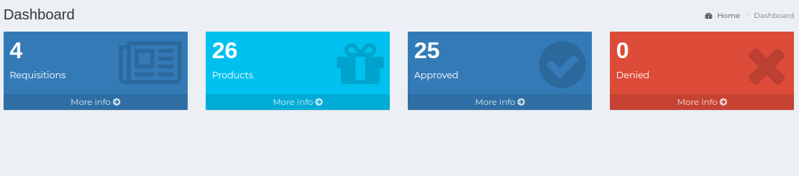

1. *Positive test case*

|  |  |  |  |  |  |
| --- | --- | --- | --- | --- | --- |
| 1. Case ID | 1. Title | 1. Description | 1. Expected Result | 1. Actual Result | 1. Pass/Fail |
| 1. 1 | 1. Requisitions | 1. Click to view all requisition status | 1. Displayed | 1. No error while displaying the information | 1. P |
| 1. 2 | 1. Products | 1. Click to view all product details | 1. Displayed | 1. No error while displaying the information | 1. P |
| 1. 3 | 1. Approved | 1. Click to view all approved requisitions | 1. Displayed | 1. No error while displaying the information | 1. P |
| 1. 4 | 1. Denied | 1. Click to view all denied requisitions | 1. Displayed | 1. No error while displaying the information | 1. P |

1. *Negative Test Case*

|  |  |  |  |  |  |
| --- | --- | --- | --- | --- | --- |
| 1. Case ID | 1. Title | 1. Description | 1. Expected Result | 1. Actual Result | 1. Pass/Fail |
| 1. 1 | 1. Requisitions | 1. Should display the respective area | 1. Perfectly executed the instructions | 1. No error occurred | 1. P |
| 1. 2 | 1. Products | 1. Should display the respective area | 1. Perfectly executed the instructions | 1. No error occurred | 1. P |
| 1. 3 | 1. Approved | 1. Should display the respective area | 1. Perfectly executed the instructions | 1. No error occurred | 1. P |
| 1. 4 | 1. Denied | 1. Should display the respective area | 1. Perfectly executed the instructions | 1. No error occurred | 1. P |

1. Test Scenario 3: Add New Requisition
3. 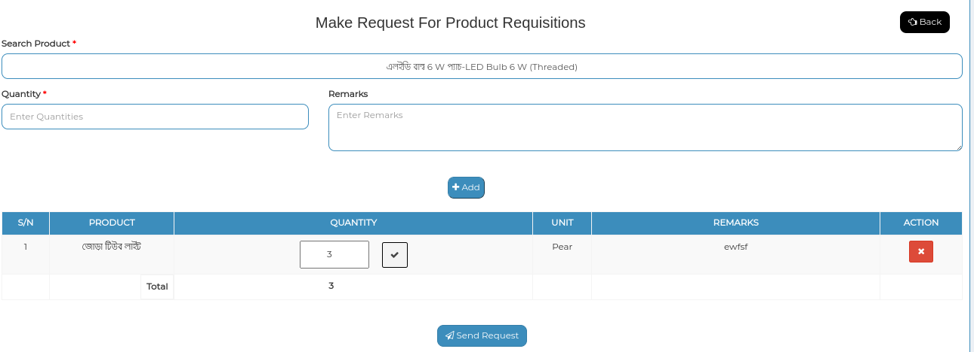
4. 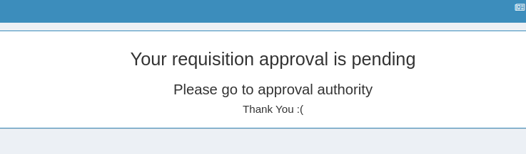
5. *Positive test case*

|  |  |  |  |  |  |
| --- | --- | --- | --- | --- | --- |
| 1. Case ID | 1. Title | 1. Description | 1. Expected Result | 1. Actual Result | 1. Pass/Fail |
| 1. 1 | 1. Make Request For Product Requisitions | 1. 1. Enter searching product and select it 2. 2. Enter quantity & remark of the product 3. 3. click add to add more 4. 4. send request button to send approval request for this requisition to the authority | 1. Data saved successfully | 1. No error occurred while adding information | 1. P |

1. *Negative Test Case*

|  |  |  |  |  |  |
| --- | --- | --- | --- | --- | --- |
| 1. Case ID | 1. Title | 1. Description | 1. Expected Result | 1. Actual Result | 1. Pass/Fail |
| 1. 1 | 1. Make Request For Product Requisitions | 1. 1. Data should properly selected & entered 2. 2. button should perfectly work | 1. No irrelevant data is accepted | 1. No error | 1. P |

2. **Test Scenario 4: All requisitions**
3. 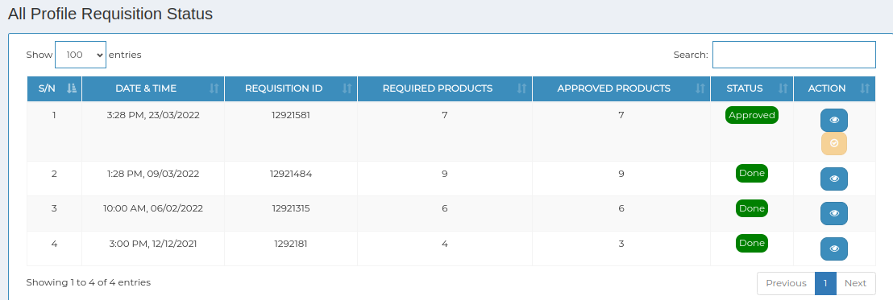
4. 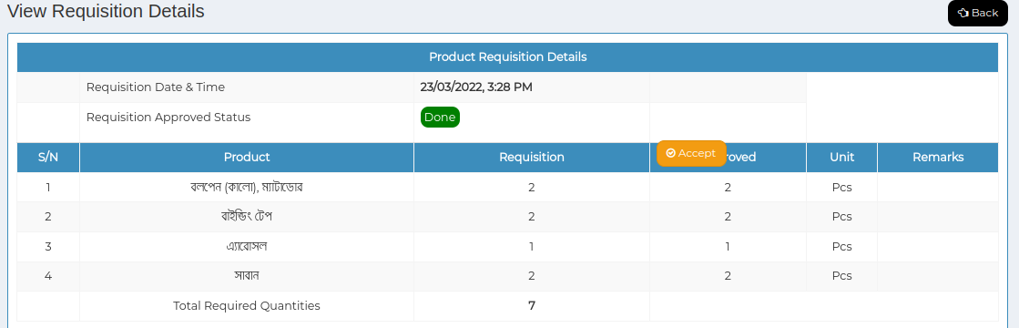
5. *Positive test case*

|  |  |  |  |  |  |
| --- | --- | --- | --- | --- | --- |
| 1. Case ID | 1. Title | 1. Description | 1. Expected Result | 1. Actual Result | 1. Pass/Fail |
| 1. 1 | 1. All requisition status | 1. Display all the requisition status | 1. Displayed | 1. No error showing while displaying | 1. P |
| 1. 2 | 1. View | 1. Click to view the requisition information | 1. Displayed individual requisition information | 1. No error while displaying | 1. P |

1. *Negative Test Case*

|  |  |  |  |  |  |
| --- | --- | --- | --- | --- | --- |
| 1. Case ID | 1. Title | 1. Description | 1. Expected Result | 1. Actual Result | 1. Pass/Fail |
| 1. 1 | 1. All requisition status | 1. Information should perfectly displayed | 1. No irrelevant data is displayed | 1. Perfectly executed | 1. P |
| 1. 2 | 1. view | 1. Information of any requisition should displayed | 1. No irrelevant data is displayed | 1. Perfectly executed | 1. P |

1. **Test Scenario 5: Reports**
2. 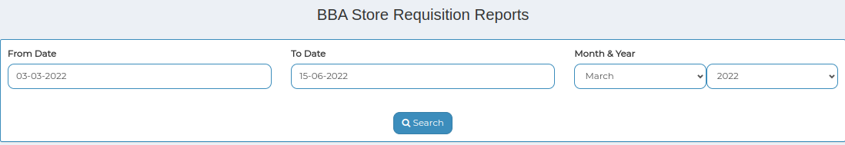
3. 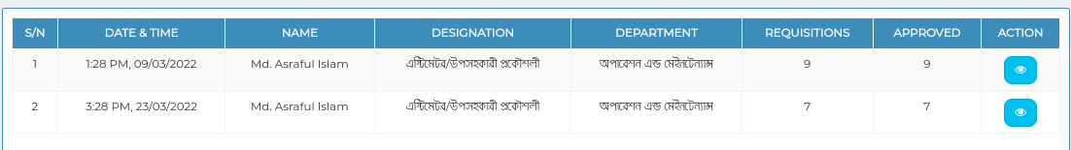
5. *Positive test case*

|  |  |  |  |  |  |
| --- | --- | --- | --- | --- | --- |
| 1. Case ID | 1. Title | 1. Description | 1. Expected Result | 1. Actual Result | 1. Pass/Fail |
| 1. 1 | 1. Requisition Reports | 1. 1. Select from date and to date, report type | 1. Data saved successfully | 1. Perfectly executed | 1. P |
| 1. 2 | 1. Requisition Details | 1. Display all the product information | 1. Displayed | 1. No error showing while displaying | 1. P |

1. *Negative Test Case*

|  |  |  |  |  |  |
| --- | --- | --- | --- | --- | --- |
| 1. Case ID | 1. Title | 1. Description | 1. Expected Result | 1. Actual Result | 1. Pass/Fail |
| 1. 1 | 1. Requisition Reports | 1. Data should be selected | 1. No irrelevant data is selected | 1. Perfectly executed | 1. P |
| 1. 2 | 1. Requisition Details | 1. product information should displayed | 1. No irrelevant data is displayed | 1. Perfectly executed | 1. P |

1. **Test Scenario 6: Profile**

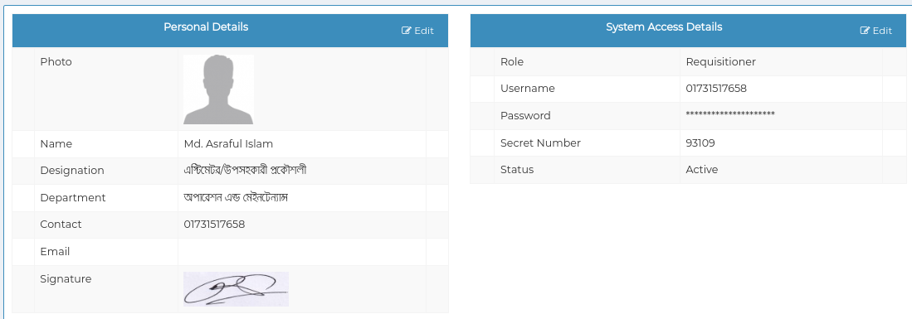

2. *Positive test case*

|  |  |  |  |  |  |
| --- | --- | --- | --- | --- | --- |
| 1. Case ID | 1. Title | 1. Description | 1. Expected Result | 1. Actual Result | 1. Pass/Fail |
| 1. 1 | 1. Profile information | 1. Profile information is displayed | 1. No error while displaying data | 1. Perfectly executed | 1. P |

1. *Negative Test Case*

|  |  |  |  |  |  |
| --- | --- | --- | --- | --- | --- |
| 1. Case ID | 1. Title | 1. Description | 1. Expected Result | 1. Actual Result | 1. Pass/Fail |
| 1. 1 | 1. Profile information | 1. Data should be perfectly displayed | 1. No irrelevant data is displayed | 1. Perfectly executed | 1. P |

1. **For Store Officer:**
2. **Test Scenario 6: Main Dashboard**
3. 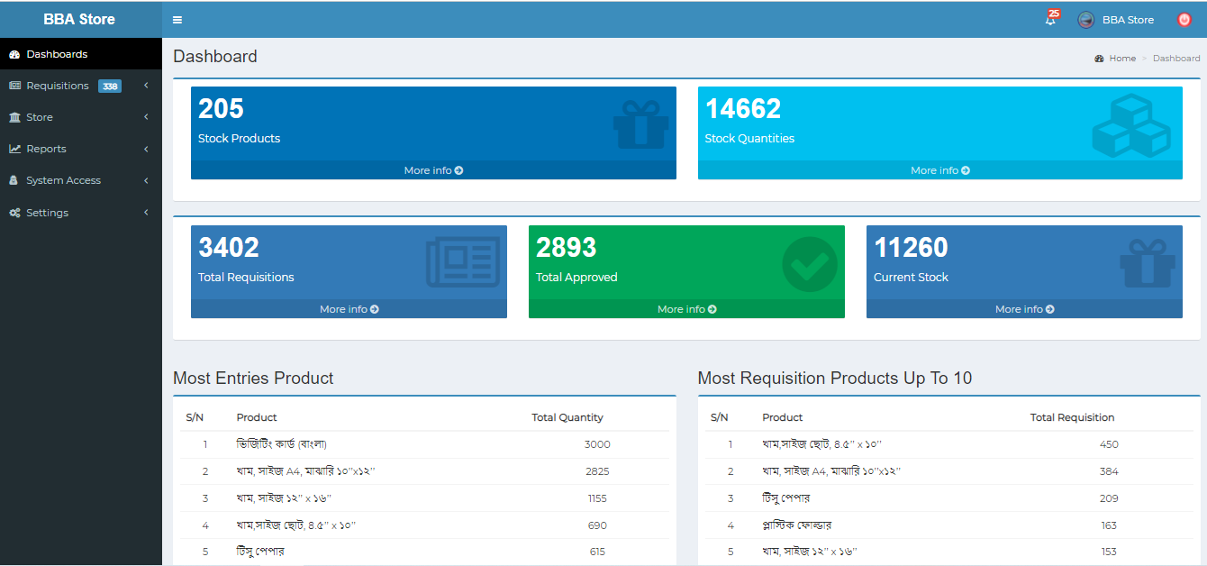
4. *Positive test case*

|  |  |  |  |  |  |
| --- | --- | --- | --- | --- | --- |
| 1. Case ID | 1. Title | 1. Description | 1. Expected Result | 1. Actual Result | 1. Pass/Fail |
| 1. 1 | 1. Stock products | 1. Click to view stock product details | 1. Displayed | 1. No error | 1. P |
| 1. 2 | 1. Stock Quantities | 1. Click to view stock quantity details | 1. Displayed | 1. No error | 1. P |
| 1. 3 | 1. Total Requisitions | 1. Click to view total requisition details | 1. Displayed | 1. No error | 1. P |
| 1. 4 | 1. Total approved | 1. Click to view total approved details | 1. Displayed | 1. No error | 1. P |
| 1. 5 | 1. Current stock | 1. Click to view current stock details | 1. Displayed | 1. No error | 1. P |

1. *Negative Test Case*

|  |  |  |  |  |  |
| --- | --- | --- | --- | --- | --- |
| 1. Case ID | 1. Title | 1. Description | 1. Expected Result | 1. Actual Result | 1. Pass/Fail |
| 1. 1 | 1. Stock products | 1. Information which are displayed should be relevant | 1. No irrelevant data is displayed | 1. No error | 1. P |
| 1. 2 | 1. Stock Quantities | 1. Information which are displayed should be relevant | 1. No irrelevant data is displayed | 1. No error | 1. P |
| 1. 3 | 1. Total Requisitions | 1. Information which are displayed should be relevant | 1. No irrelevant data is displayed | 1. No error | 1. P |
| 1. 4 | 1. Total approved | 1. Information which are displayed should be relevant | 1. No irrelevant data is displayed | 1. No error | 1. P |
| 1. 5 | 1. Current stock | 1. Information which are displayed should be relevant | 1. No irrelevant data is displayed | 1. No error | 1. P |

1. Test Scenario 7: Products
2. 1. Add product & Existing Product
3. 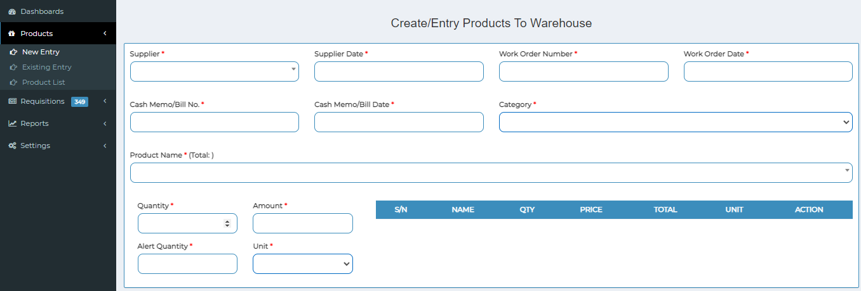
4. 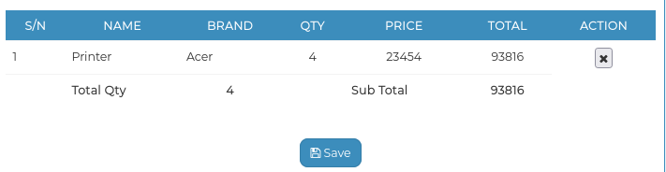
5. 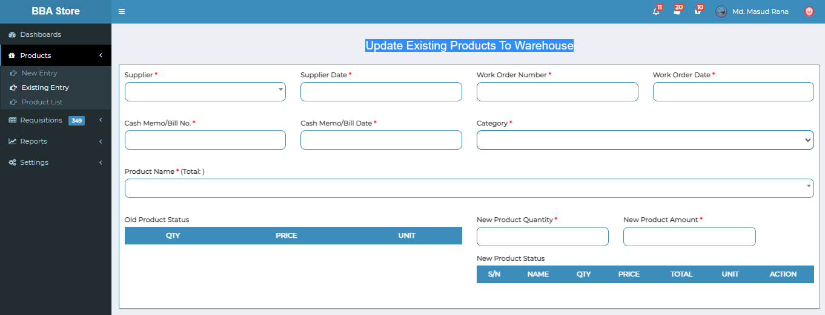
6. 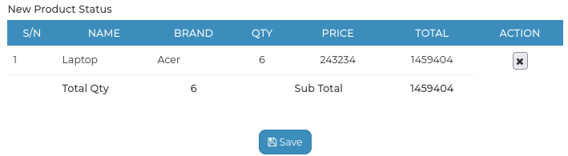
7. *Positive test case*

|  |  |  |  |  |  |
| --- | --- | --- | --- | --- | --- |
| 1. Case ID | 1. Title | 1. Description | 1. Expected Result | 1. Actual Result | 1. Pass/Fail |
| 1. 1 | 1. Create/Entry Products To Warehouse | 1. 1. Click settings>product 2. list>add product 3. 2. Select category 4. 3. Enter bangla and English 5. name of the product 6. 4. Click product>new entry 7. 5. Select supplier 8. 6. Enter supplier date, work order number & date, cash memo/bill no, cash memo/bill date 9. 7. Select product category, product name 10. 8. Enter quantity, amount, alert quantity, unit 11. 9. Click add 12. 10. Click save | 1. Data saved successfully | 1. No error while adding information | 1. P |
| 1. 2 | 1. Update Existing Products To Warehouse | 1. 1. Select supplier 2. 2. Enter supplier date, work order number & date, cash memo/bill no, date 3. 3. Select product category & name 4. 4. Enter quantity, amount, alert quantity, unit 5. 5. Click add 6. 6. Click save | 1. Data saved successfully | 1. No error while adding information | 1. P |

1. *Negative Test Case*

|  |  |  |  |  |  |
| --- | --- | --- | --- | --- | --- |
| 1. Case ID | 1. Title | 1. Description | 1. Expected Result | 1. Actual Result | 1. Pass/Fail |
| 1. 1 | 1. Create/Entry Products To Warehouse | 1. Data should be perfectly selected and entered | 1. No irrelevant data is accepted | 1. No error | 1. P |
| 1. 2 | 1. Update Existing Products To Warehouse | 1. Data should be perfectly selected and entered | 1. No irrelevant data is accepted | 1. No error | 1. P |

1. 2. Products
2. 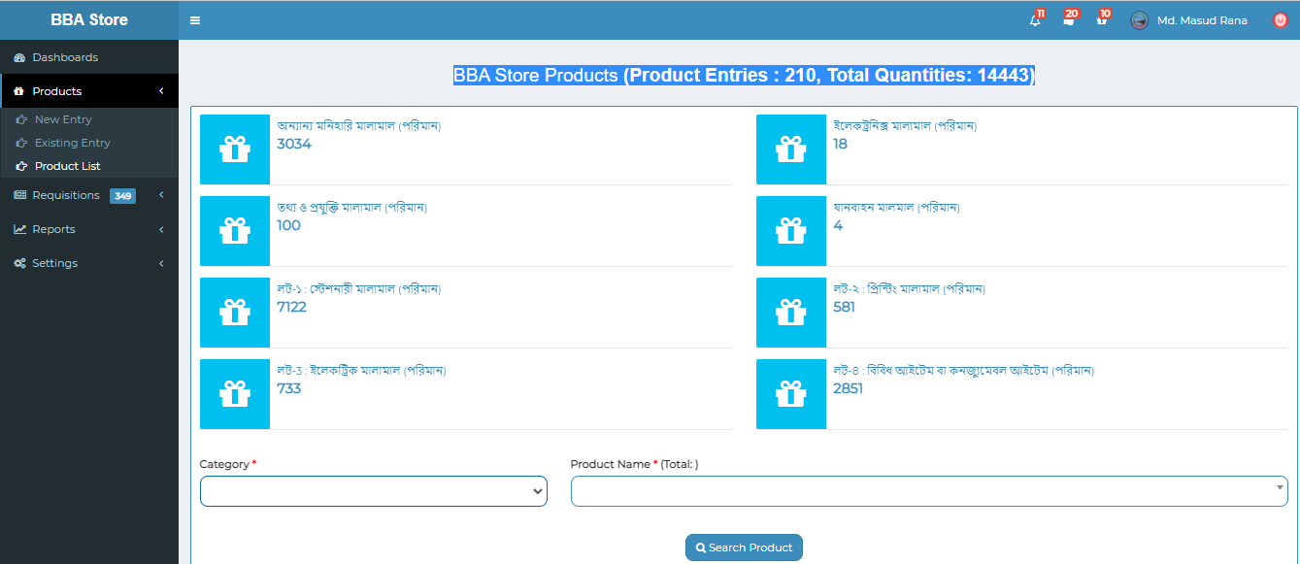
3. 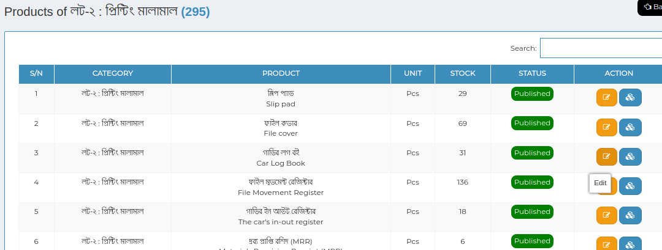
4. *Positive test case*

|  |  |  |  |  |  |
| --- | --- | --- | --- | --- | --- |
| 1. Case ID | 1. Title | 1. Description | 1. Expected Result | 1. Actual Result | 1. Pass/Fail |
| 1. 1 | 1. BBA Store Products | 1. Click to see several type of product to see these details | 1. No error occurred while displaying | 1. Perfectly displayed | 1. P |
| 1. 2 | 1. Products | 1. Click search to see specific product details | 1. No error occurred while displaying | 1. Perfectly displayed | 1. P |
| 1. 3 | 1. Update & Status | 1. Click update to update existing database and click status to change it | 1. No error occurred while updating or changing status | 1. Perfectly displayed | 1. P |

1. *Negative Test Case*

|  |  |  |  |  |  |
| --- | --- | --- | --- | --- | --- |
| 1. Case ID | 1. Title | 1. Description | 1. Expected Result | 1. Actual Result | 1. Pass/Fail |
| 1. 1 | 1. BBA Store Products | 1. Product should be displayed individually | 1. Displayed exact information | 1. No error | 1. P |
| 1. 2 | 1. Products | 1. Search button should perfectly work | 1. Displayed exact information | 1. No error | 1. P |
| 1. 3 | 1. Update & Status | 1. Database should be updated | 1. Updated | 1. No error | 1. P |

1. Test Scenario 8: Requisitions
2. 1. Pending
3. 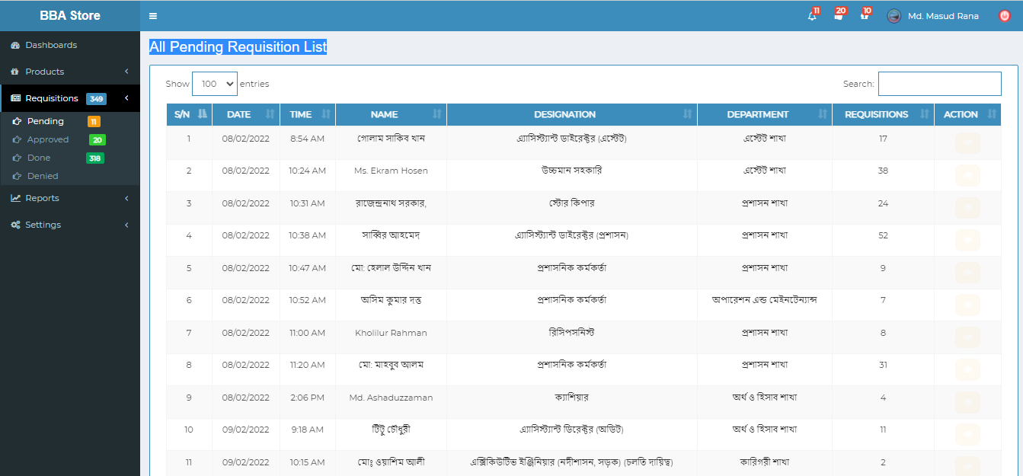
5. 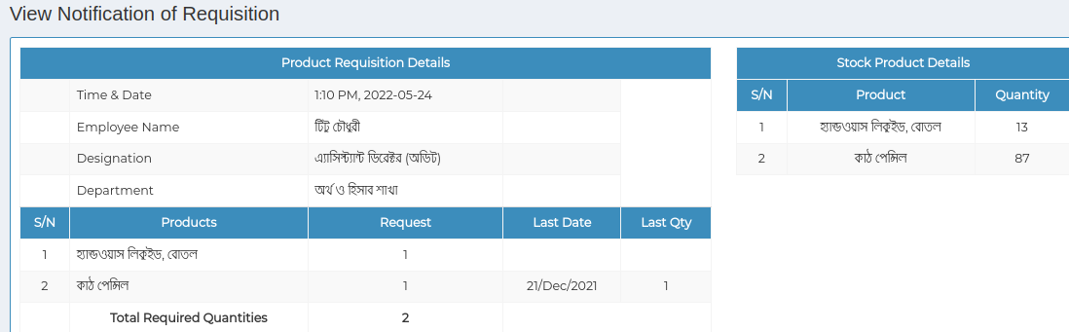
6. *Positive test case*

|  |  |  |  |  |  |
| --- | --- | --- | --- | --- | --- |
| 1. Case ID | 1. Title | 1. Description | 1. Expected Result | 1. Actual Result | 1. Pass/Fail |
| 1. 1 | 1. All The Pending Requisition List | 1. Display all the pending requisition list | 1. Displayed | 1. No error | 1. P |
| 1. 2 | 1. View Notification of Requisition | 1. Display the latest requisition list status | 1. Notified | 1. No error | 1. P |

1. *Negative Test Case*

|  |  |  |  |  |  |
| --- | --- | --- | --- | --- | --- |
| 1. Case ID | 1. Title | 1. Description | 1. Expected Result | 1. Actual Result | 1. Pass/Fail |
| 1. 1 | 1. All The Pending Requisition List | 1. Information of pending product information should displayed | 1. No irrelevant data is displayed | 1. Perfectly executed | 1. P |
| 1. 2 | 1. View Notification of Requisition | 1. Requisition status should be notified | 1. Perfectly executed | 1. No error | 1. P |

1. 2. Approved
2. 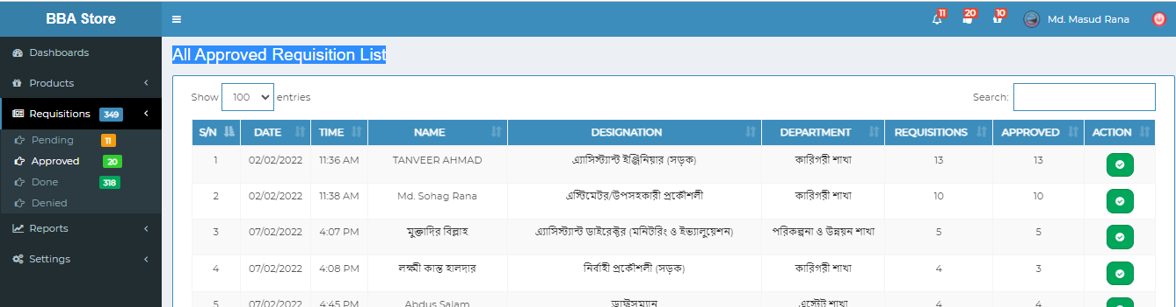
3. 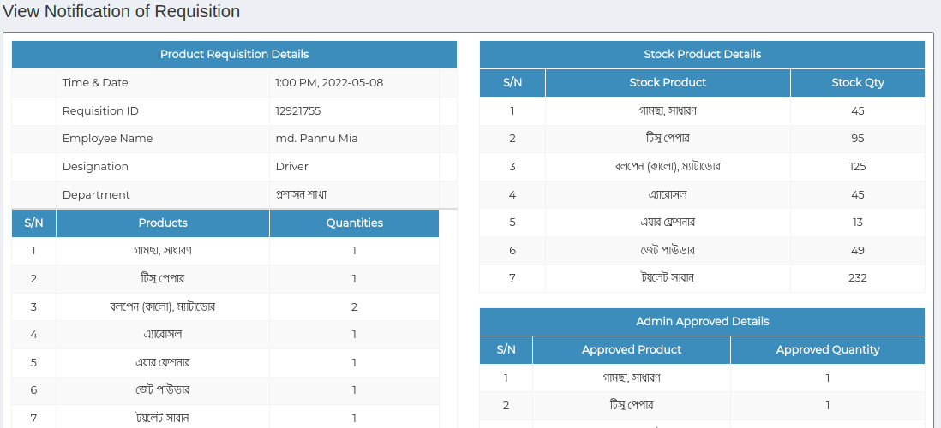
4. *Positive test case*

|  |  |  |  |  |  |
| --- | --- | --- | --- | --- | --- |
| 1. Case ID | 1. Title | 1. Description | 1. Expected Result | 1. Actual Result | 1. Pass/Fail |
| 1. 1 | 1. All The Approved Requisition List & details | 1. Display all the approved requisition list | 1. Displayed | 1. No error | 1. P |

1. *Negative Test Case*

|  |  |  |  |  |  |
| --- | --- | --- | --- | --- | --- |
| 1. Case ID | 1. Title | 1. Description | 1. Expected Result | 1. Actual Result | 1. Pass/Fail |
| 1. 1 | 1. All The Approved Requisition List & details | 1. Information of approved requisition information should displayed | 1. No irrelevant data is displayed | 1. Perfectly executed | 1. P |

1. 3. Done
2. 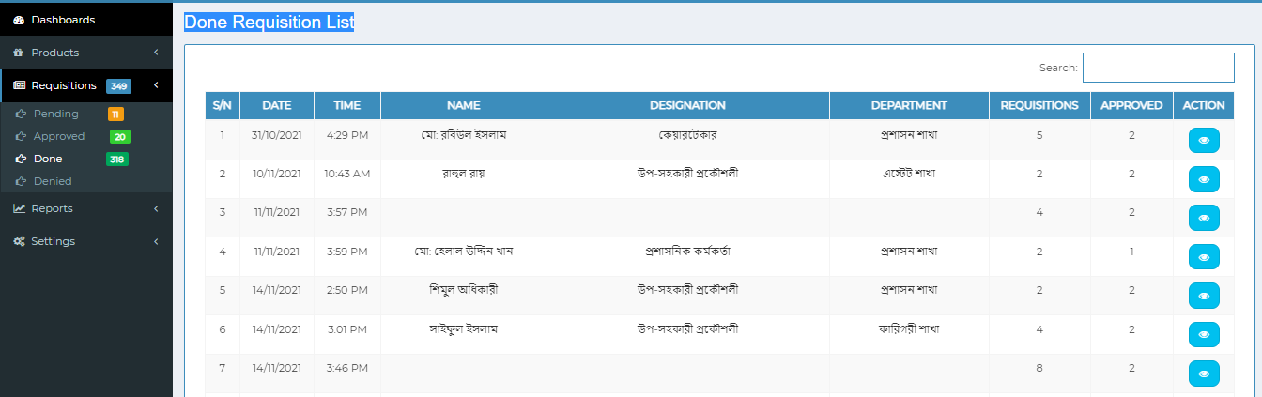
3. 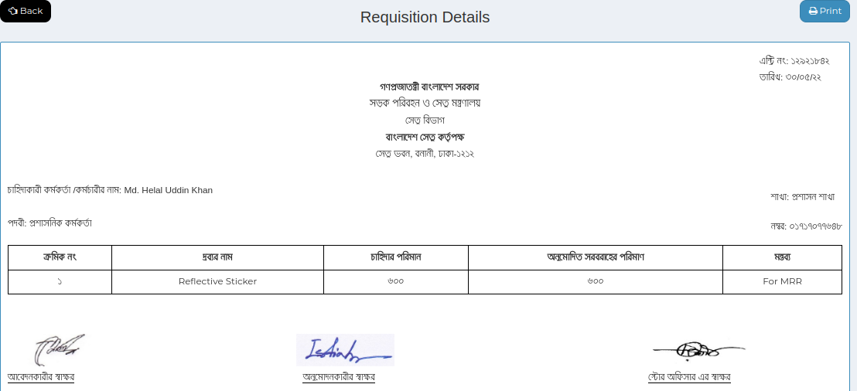
4. *Positive test case*

|  |  |  |  |  |  |
| --- | --- | --- | --- | --- | --- |
| 1. Case ID | 1. Title | 1. Description | 1. Expected Result | 1. Actual Result | 1. Pass/Fail |
| 1. 1 | 1. All The Done Requisition List & details | 1. Display all the done requisition list | 1. Displayed | 1. No error | 1. P |

1. *Negative Test Case*

|  |  |  |  |  |  |
| --- | --- | --- | --- | --- | --- |
| 1. Case ID | 1. Title | 1. Description | 1. Expected Result | 1. Actual Result | 1. Pass/Fail |
| 1. 1 | 1. All The Done Requisition List & details | 1. Information of done requisition information should displayed | 1. No irrelevant data is displayed | 1. Perfectly executed | 1. P |

1. 4. Denied
2. 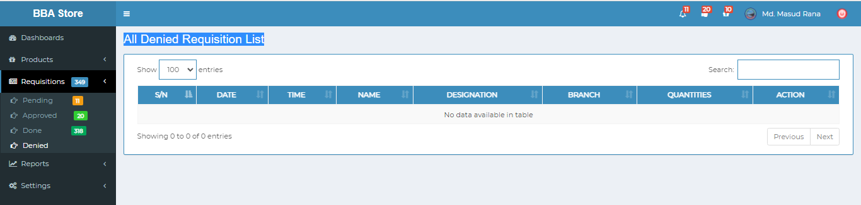
3. *Positive test case*

|  |  |  |  |  |  |
| --- | --- | --- | --- | --- | --- |
| 1. Case ID | 1. Title | 1. Description | 1. Expected Result | 1. Actual Result | 1. Pass/Fail |
| 1. 1 | 1. All The denied Requisition List | 1. Display all the denied requisition list | 1. Displayed | 1. No error | 1. P |

1. *Negative Test Case*

|  |  |  |  |  |  |
| --- | --- | --- | --- | --- | --- |
| 1. Case ID | 1. Title | 1. Description | 1. Expected Result | 1. Actual Result | 1. Pass/Fail |
| 1. 1 | 1. All The denied Requisition List | 1. Information of done requisition information should displayed | 1. No irrelevant data is displayed | 1. Perfectly executed | 1. P |

1. 5. Manual
2. 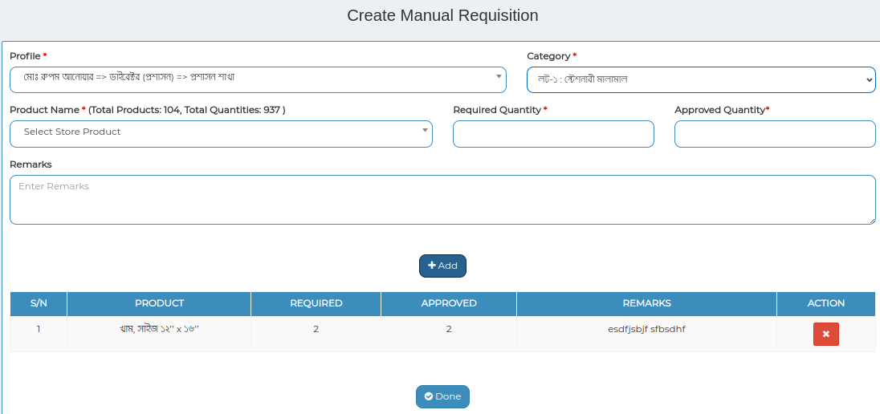
3. *Positive test case*

|  |  |  |  |  |  |
| --- | --- | --- | --- | --- | --- |
| 1. Case ID | 1. Title | 1. Description | 1. Expected Result | 1. Actual Result | 1. Pass/Fail |
| 1. 1 | 1. Create manual requisition | 1. 1. Select profile, category, product name 2. 2. Enter required & approved quantity 3. 3. Enter remarks & click to addition 4. 4. Click done to save all of these information | 1. Data saved successfully | 1. No error | 1. P |

1. *Negative Test Case*

|  |  |  |  |  |  |
| --- | --- | --- | --- | --- | --- |
| 1. Case ID | 1. Title | 1. Description | 1. Expected Result | 1. Actual Result | 1. Pass/Fail |
| 1. 1 | 1. Create manual requisition | 1. Information should perfectly selected & save button should work fine | 1. No irrelevant data is selected | 1. Perfectly executed | 1. P |

1. Test Scenario 9: MRR
2. 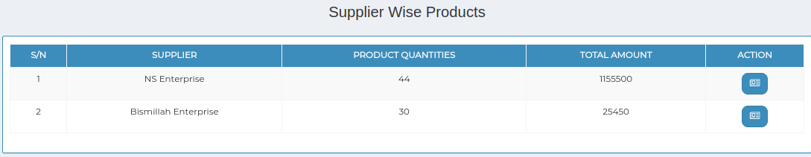
3. 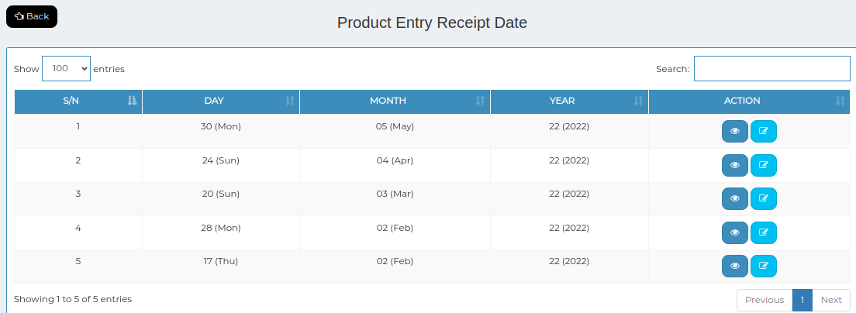
4. *Positive test case*

|  |  |  |  |  |  |
| --- | --- | --- | --- | --- | --- |
| 1. Case ID | 1. Title | 1. Description | 1. Expected Result | 1. Actual Result | 1. Pass/Fail |
| 1. 1 | 1. Supplier Wise Products | 1. Display all the Supplier wise product information list | 1. Displayed | 1. No error | 1. P |
| 1. 2 | 1. Product Receipt List | 1. Display all the product receipt information list | 1. Displayed | 1. No error | 1. P |
| 1. 3 | 1. Update & Status | 1. Click update to update existing database and click status to change it | 1. No error occurred while updating or changing status | 1. Perfectly displayed | 1. P |

1. *Negative Test Case*

|  |  |  |  |  |  |
| --- | --- | --- | --- | --- | --- |
| 1. Case ID | 1. Title | 1. Description | 1. Expected Result | 1. Actual Result | 1. Pass/Fail |
| 1. 1 | 1. Supplier Wise Products | 1. Information of supplier wise product information should displayed | 1. No irrelevant data is displayed | 1. Perfectly executed | 1. P |
| 1. 2 | 1. Product Receipt List | 1. Information of product receipt information should displayed | 1. No irrelevant data is displayed | 1. Perfectly executed | 1. P |
| 1. 3 | 1. Update & Status | 1. Database should be updated | 1. Updated | 1. No error | 1. P |

1. Test Scenario 10: Reports
2. 1. Products
3. 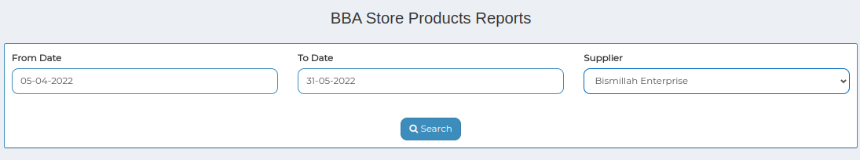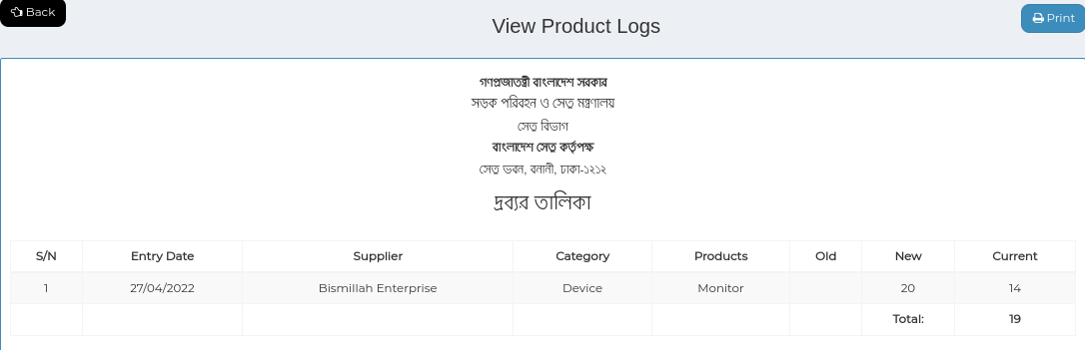
4. *Positive test case*

|  |  |  |  |  |  |
| --- | --- | --- | --- | --- | --- |
| 1. Case ID | 1. Title | 1. Description | 1. Expected Result | 1. Actual Result | 1. Pass/Fail |
| 1. 1 | 1. BBA Store Products Reports | 1. 1. Select from date, to date & supplier name | 1. Data entered successfully | 1. No error while selecting | 1. P |
| 1. 2 | 1. View Product Logs | 1. Generate in a report | 1. Information generated | 1. No error | 1. P |

1. *Negative Test Case*

|  |  |  |  |  |  |
| --- | --- | --- | --- | --- | --- |
| 1. Case ID | 1. Title | 1. Description | 1. Expected Result | 1. Actual Result | 1. Pass/Fail |
| 1. 1 | 1. BBA Store Products Reports | 1. Data should be selected | 1. No irrelevant data is accepted | 1. No error | 1. P |
| 1. 2 | 1. View Product Logs | 1. Information is placed perfectly | 1. No information is missing | 1. No error | 1. P |

1. 2. Requisitions
2. 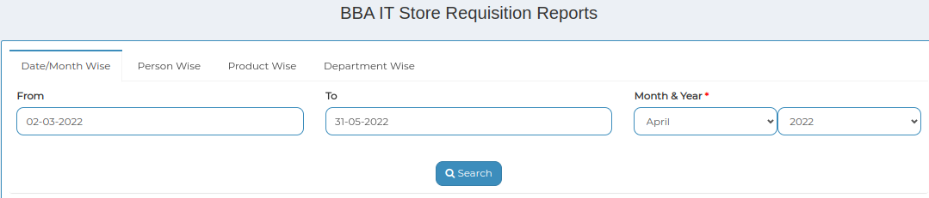
3. 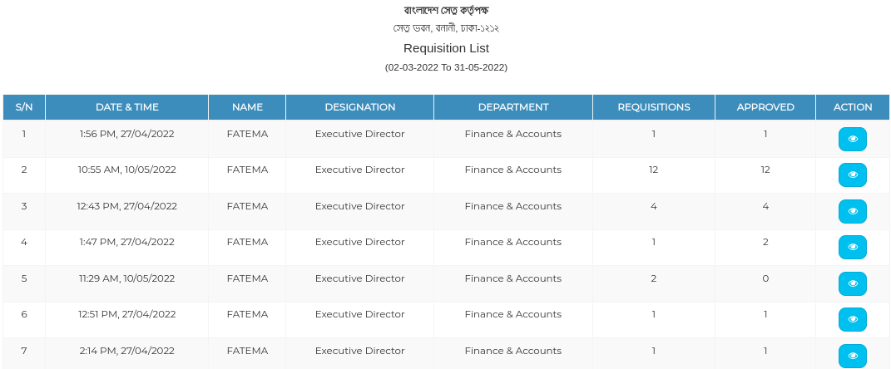
4. 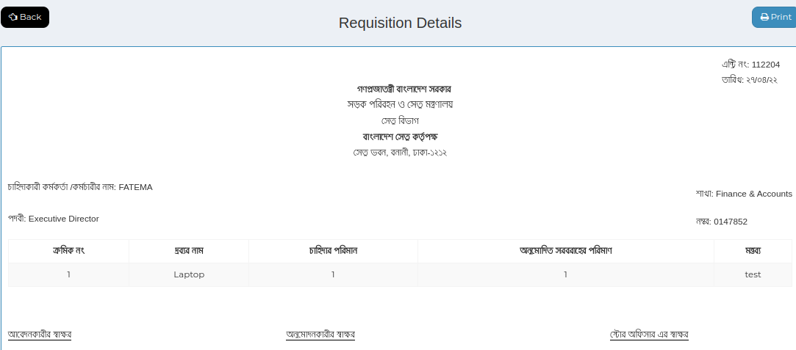
5. *Positive test case*

|  |  |  |  |  |  |
| --- | --- | --- | --- | --- | --- |
| 1. Case ID | 1. Title | 1. Description | 1. Expected Result | 1. Actual Result | 1. Pass/Fail |
| 1. 1 | 1. BBA Store Requisition Reports | 1. 1. select date/month or person, product, department 2. 2. click search | 1. Perfectly selected data displayed the exact information | 1. No error | 1. P |
| 1. 2 | 1. Requisition Details | 1. Display information details and can download | 1. displayed | 1. No error | 1. P |

1. *Negative Test Case*

|  |  |  |  |  |  |
| --- | --- | --- | --- | --- | --- |
| 1. Case ID | 1. Title | 1. Description | 1. Expected Result | 1. Actual Result | 1. Pass/Fail |
| 1. 1 | 1. BBA Store Requisition Reports | 1. Data should be selected | 1. No irrelevant data is accepted | 1. No error | 1. P |
| 1. 2 | 1. Requisition Details | 1. Information is placed perfectly | 1. No information is missing | 1. No error | 1. P |

1. Test Case Scenario 11: Settings
2. 1. Categories
3. 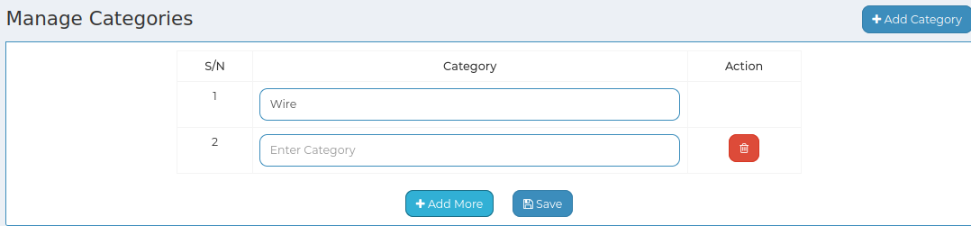
4. 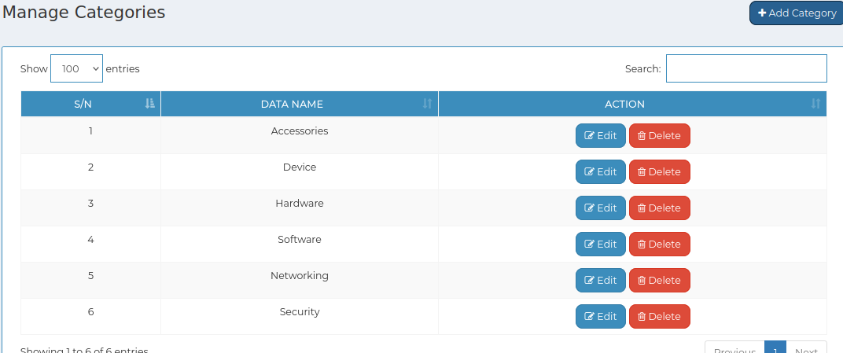
5. *Positive test case*

|  |  |  |  |  |  |
| --- | --- | --- | --- | --- | --- |
| 1. Case ID | 1. Title | 1. Description | 1. Expected Result | 1. Actual Result | 1. Pass/Fail |
| 1. 1 | 1. Add category | 1. 1. click add category to enter new category 2. 2. click add more to add new 3. 3. Click save 4. 4. type in the search bar to find specific category | 1. Data saved successfully | 1. No error while saving | 1. P |
| 1. 2 | 1. Manage Categories | 1. Display all the category information | 1. No irrelevant data is displayed | 1. No error while displaying | 1. P |
| 1. 3 | 1. Update & Delete | 1. Update existing information and delete a specific information | 1. Updated | 1. No error occurred while updating or deleting | 1. P |

1. *Negative Test Case*

|  |  |  |  |  |  |
| --- | --- | --- | --- | --- | --- |
| 1. Case ID | 1. Title | 1. Description | 1. Expected Result | 1. Actual Result | 1. Pass/Fail |
| 1. 1 | 1. Add category | 1. Data should be entered and save button should perfectly work | 1. No irrelevant data is selected | 1. No error | 1. P |
| 1. 2 | 1. Manage Categories | 1. Categories are displayed | 1. No information is missing | 1. No error | 1. P |
| 1. 3 | 1. Update & Delete | 1. Update existing database | 1. Perfectly executed | 1. No error | 1. P |

1. 3. Product List
2. 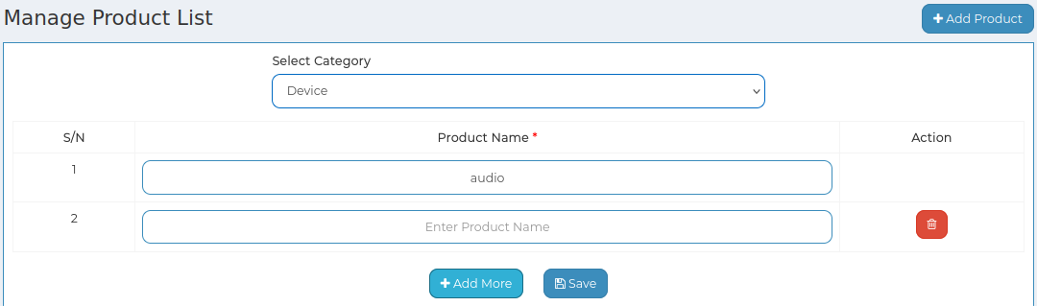
3. 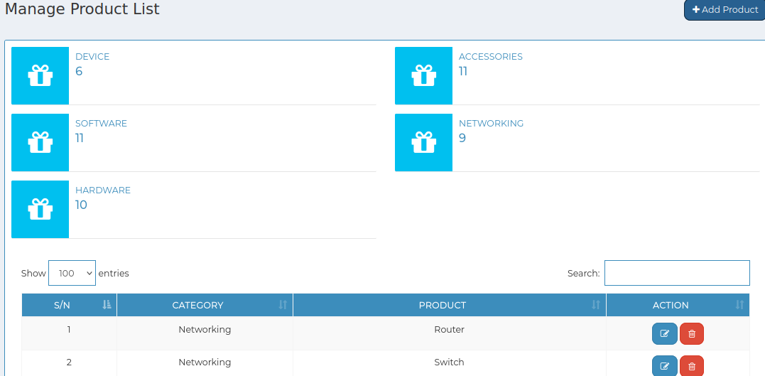
4. *Positive test case*

|  |  |  |  |  |  |
| --- | --- | --- | --- | --- | --- |
| 1. Case ID | 1. Title | 1. Description | 1. Expected Result | 1. Actual Result | 1. Pass/Fail |
| 1. 1 | 1. Add product | 1. 1. click add product to enter new brands 2. 2. select category 3. 3. Enter product name 4. 4. click add more to add new 5. 5. Click save 6. 6. type in the search bar to find specific category | 1. Data saved successfully | 1. No error while saving | 1. P |
| 1. 2 | 1. Manage Product List | 1. Display all the products information | 1. No irrelevant data is displayed | 1. No error while displaying | 1. P |
| 1. 3 | 1. Update & Delete | 1. Update existing information and delete a specific information | 1. Updated | 1. No error occurred while updating or deleting | 1. P |

1. *Negative Test Case*

|  |  |  |  |  |  |
| --- | --- | --- | --- | --- | --- |
| 1. Case ID | 1. Title | 1. Description | 1. Expected Result | 1. Actual Result | 1. Pass/Fail |
| 1. 1 | 1. Add product | 1. Data should be entered and save button should perfectly work | 1. No irrelevant data is selected | 1. No error | 1. P |
| 1. 2 | 1. Manage Product List | 1. Products are displayed | 1. No information is missing | 1. No error | 1. P |
| 1. 3 | 1. Update & Delete | 1. Update existing database | 1. Perfectly executed | 1. No error | 1. P |

1. 2. Units
2. 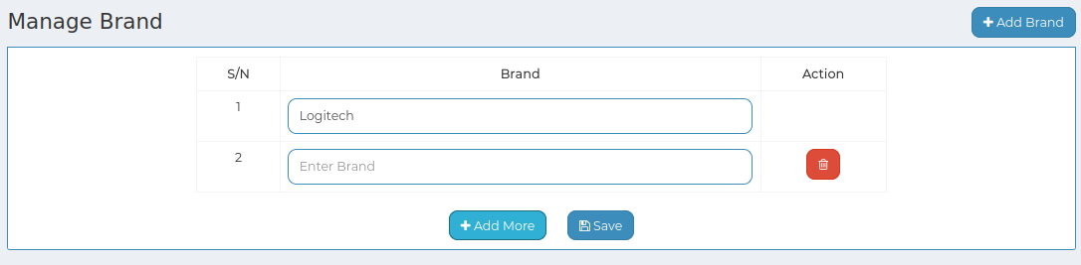
3. 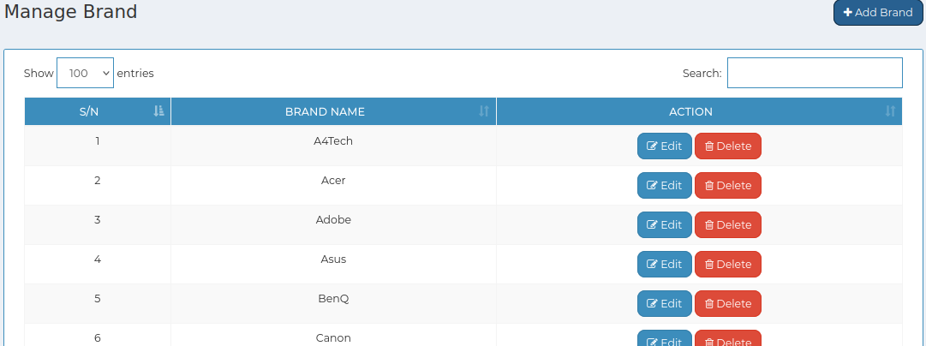
4. *Positive test case*

|  |  |  |  |  |  |
| --- | --- | --- | --- | --- | --- |
| 1. Case ID | 1. Title | 1. Description | 1. Expected Result | 1. Actual Result | 1. Pass/Fail |
| 1. 1 | 1. Add units | 1. 1. click add unit to enter new brands 2. 2. Enter unit 3. 3. click add more to add new 4. 4. Click save | 1. Data saved successfully | 1. No error while saving | 1. P |
| 1. 2 | 1. Manage units | 1. Display all the units information | 1. No irrelevant data is displayed | 1. No error while displaying | 1. P |
| 1. 3 | 1. Update & Delete | 1. Update existing information and delete a specific information | 1. Updated | 1. No error occurred while updating or deleting | 1. P |

1. *Negative Test Case*

|  |  |  |  |  |  |
| --- | --- | --- | --- | --- | --- |
| 1. Case ID | 1. Title | 1. Description | 1. Expected Result | 1. Actual Result | 1. Pass/Fail |
| 1. 1 | 1. Add units | 1. Data should be entered and save button should perfectly work | 1. No irrelevant data is selected | 1. No error | 1. P |
| 1. 2 | 1. Manage units | 1. Brands are displayed | 1. No information is missing | 1. No error | 1. P |
| 1. 3 | 1. Update & Delete | 1. Update existing database | 1. Perfectly executed | 1. No error | 1. P |

1. 4. Suppliers
2. 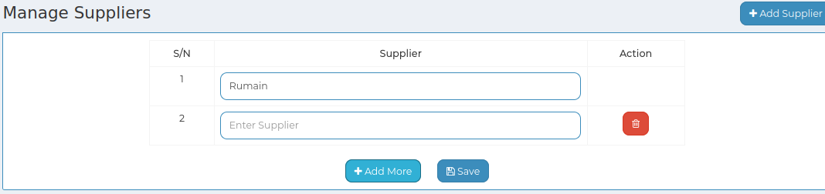
3. 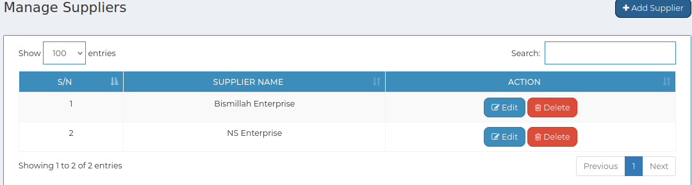
4. *Positive test case*

|  |  |  |  |  |  |
| --- | --- | --- | --- | --- | --- |
| 1. Case ID | 1. Title | 1. Description | 1. Expected Result | 1. Actual Result | 1. Pass/Fail |
| 1. 1 | 1. Add supplier | 1. 1. click add product to enter new brands 2. 2. Enter Supplier name 3. 3. click add more to add new 4. 4. Click save 5. 6. type in the search bar to find specific category | 1. Data saved successfully | 1. No error while saving | 1. P |
| 1. 2 | 1. Manage Suppliers | 1. Display all the Suppliers information | 1. No irrelevant data is displayed | 1. No error while displaying | 1. P |
| 1. 3 | 1. Update & delete | 1. Update existing information and delete a specific information | 1. Updated | 1. No error occurred while updating or deleting | 1. P |

1. *Negative Test Case*

|  |  |  |  |  |  |
| --- | --- | --- | --- | --- | --- |
| 1. Case ID | 1. Title | 1. Description | 1. Expected Result | 1. Actual Result | 1. Pass/Fail |
| 1. 1 | 1. Add supplier | 1. Data should be entered and save button should perfectly work | 1. No irrelevant data is selected | 1. No error | 1. P |
| 1. 2 | 1. Manage Suppliers | 1. Suppliers are displayed | 1. No information is missing | 1. No error | 1. P |
| 1. 3 | 1. Update & delete | 1. Update existing database | 1. Perfectly executed | 1. No error | 1. P |

**For Authority:**

Test Scenario 12: Requisitions

1. Pending

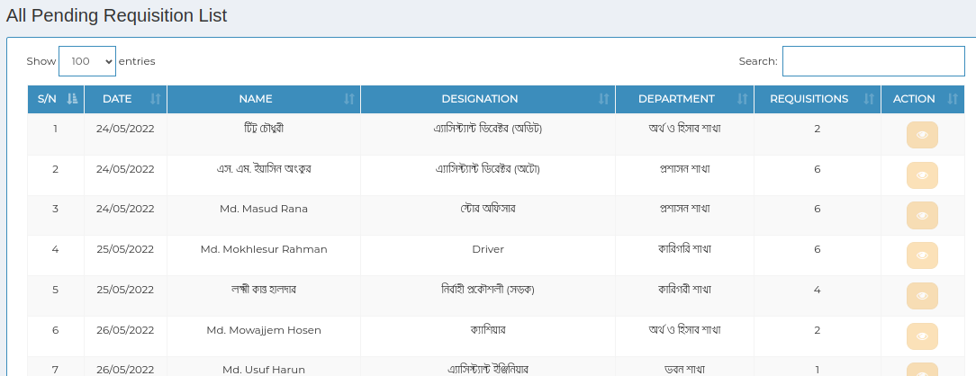

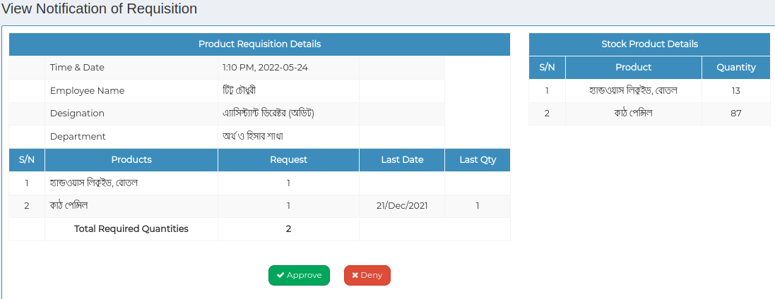

1. *Positive test case*

|  |  |  |  |  |  |
| --- | --- | --- | --- | --- | --- |
| 1. Case ID | 1. Title | 1. Description | 1. Expected Result | 1. Actual Result | 1. Pass/Fail |
| 1. 1 | 1. All The Pending Requisition List | 1. Display all the pending requisition list | 1. Displayed | 1. No error | 1. P |
| 1. 2 | 1. View Notification of Requisition | 1. Display the latest requisition list status | 1. Notified | 1. No error | 1. P |

1. *Negative Test Case*

|  |  |  |  |  |  |
| --- | --- | --- | --- | --- | --- |
| 1. Case ID | 1. Title | 1. Description | 1. Expected Result | 1. Actual Result | 1. Pass/Fail |
| 1. 1 | 1. All The Pending Requisition List | 1. Information of pending product information should displayed | 1. No irrelevant data is displayed | 1. Perfectly executed | 1. P |
| 1. 2 | 1. View Notification of Requisition | 1. Requisition status should be notified | 1. Perfectly executed | 1. No error | 1. P |

1. 2. Approved

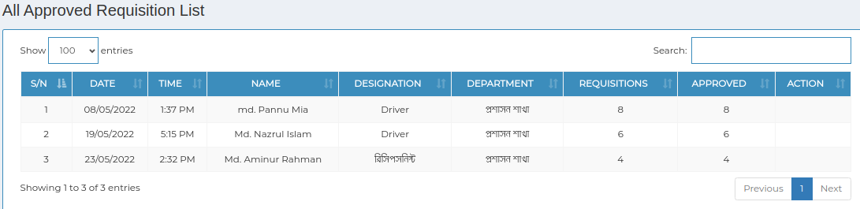

1. *Positive test case*

|  |  |  |  |  |  |
| --- | --- | --- | --- | --- | --- |
| 1. Case ID | 1. Title | 1. Description | 1. Expected Result | 1. Actual Result | 1. Pass/Fail |
| 1. 1 | 1. All The Approved Requisition List | 1. Display all the approved requisition list | 1. Displayed | 1. No error | 1. P |

1. *Negative Test Case*

|  |  |  |  |  |  |
| --- | --- | --- | --- | --- | --- |
| 1. Case ID | 1. Title | 1. Description | 1. Expected Result | 1. Actual Result | 1. Pass/Fail |
| 1. 1 | 1. All The Approved Requisition List | 1. Information of approved requisition information should displayed | 1. No irrelevant data is displayed | 1. Perfectly executed | 1. P |

1. 3. Done
2. 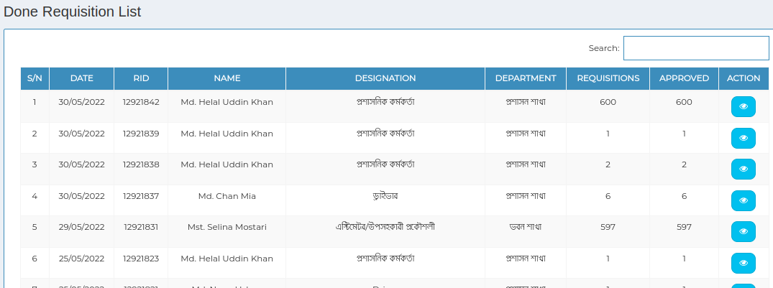
3. 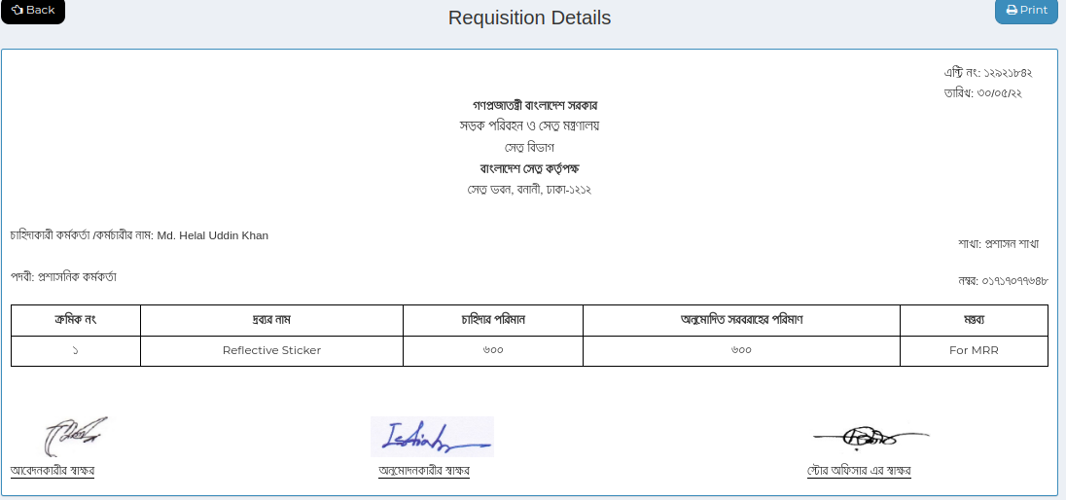
4. *Positive test case*

|  |  |  |  |  |  |
| --- | --- | --- | --- | --- | --- |
| 1. Case ID | 1. Title | 1. Description | 1. Expected Result | 1. Actual Result | 1. Pass/Fail |
| 1. 1 | 1. All The Done Requisition List | 1. Display all the done requisition list | 1. Displayed | 1. No error | 1. P |

1. *Negative Test Case*

|  |  |  |  |  |  |
| --- | --- | --- | --- | --- | --- |
| 1. Case ID | 1. Title | 1. Description | 1. Expected Result | 1. Actual Result | 1. Pass/Fail |
| 1. 1 | 1. All The Done Requisition List | 1. Information of done requisition information should displayed | 1. No irrelevant data is displayed | 1. Perfectly executed | 1. P |

1. 4. Denied
2. 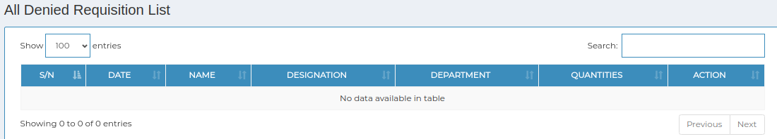
3. *Positive test case*

|  |  |  |  |  |  |
| --- | --- | --- | --- | --- | --- |
| 1. Case ID | 1. Title | 1. Description | 1. Expected Result | 1. Actual Result | 1. Pass/Fail |
| 1. 1 | 1. All The denied Requisition List | 1. Display all the denied requisition list | 1. Displayed | 1. No error | 1. P |

1. *Negative Test Case*

|  |  |  |  |  |  |
| --- | --- | --- | --- | --- | --- |
| 1. Case ID | 1. Title | 1. Description | 1. Expected Result | 1. Actual Result | 1. Pass/Fail |
| 1. 1 | 1. All The denied Requisition List | 1. Information of done requisition information should displayed | 1. No irrelevant data is displayed | 1. Perfectly executed | 1. P |

1. **Test Case scenario 13: System Access**

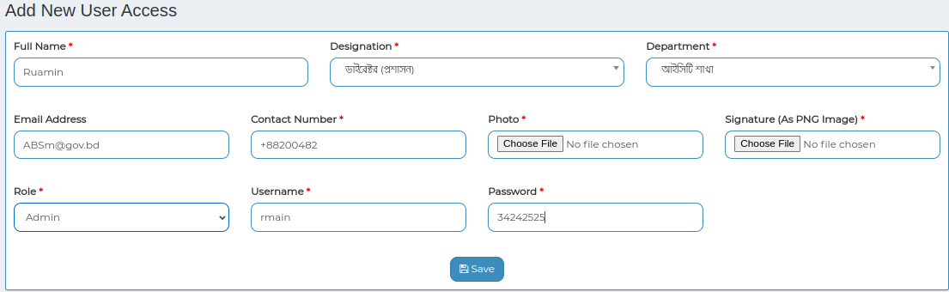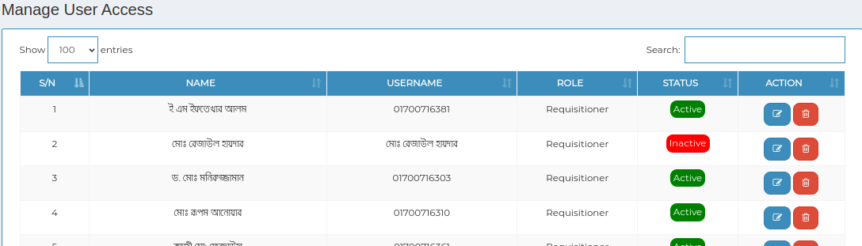

1. 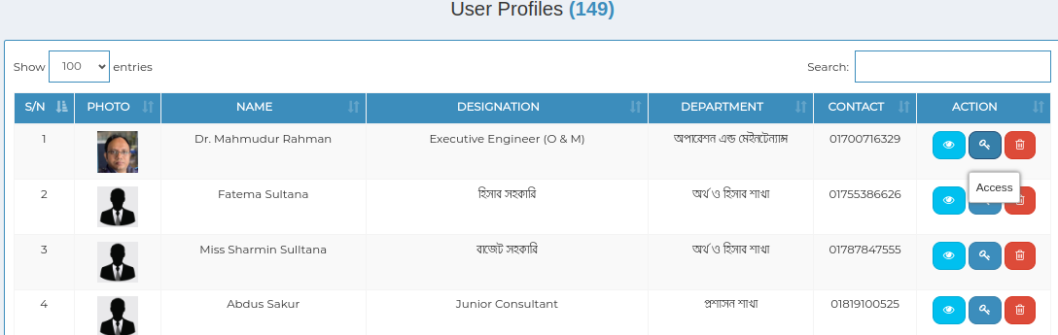
2. *Positive test case*

|  |  |  |  |  |  |
| --- | --- | --- | --- | --- | --- |
| 1. Case ID | 1. Title | 1. Description | 1. Expected Result | 1. Actual Result | 1. Pass/Fail |
| 1. 1 | 1. Add new users | 1. 1. Enter full name 2. 2. Select designation & department 3. 3. Enter mail & contact information, choose photo & signature 4. 4. Select role & enter username, passwords 5. 5. Click save | 1. Data saved successfully | 1. No error while saving data | 1. P |
| 1. 2 | 1. Manage users | 1. 1. Display all user access name 2. 2. status can change & update or delete operation through the button | 1. Displayed | 1. No error | 1. P |
| 1. 3 | 1. User profiles | 1. 1. Display all user profiles 2. 2. Action button can do delete or view the users profile | 1. Displayed | 1. No error | 1. P |

1. *Negative Test Case*

|  |  |  |  |  |  |
| --- | --- | --- | --- | --- | --- |
| 1. Case ID | 1. Title | 1. Description | 1. Expected Result | 1. Actual Result | 1. Pass/Fail |
| 1. 1 | 1. Add new users | 1. Data selection or entry should be valid | 1. No irrelevant data is inputted | 1. No error while saving | 1. P |
| 1. 2 | 1. Manage users | 1. Ensuring display all the information | 1. No irrelevant data is displayed | 1. Perfectly executed | 1. P |
| 1. 3 | 1. User profiles | 1. Ensuring display all the information | 1. No irrelevant data is displayed | 1. Perfectly executed | 1. P |

1. **Test Case scenario 14: Settings**
2. 1. Designation

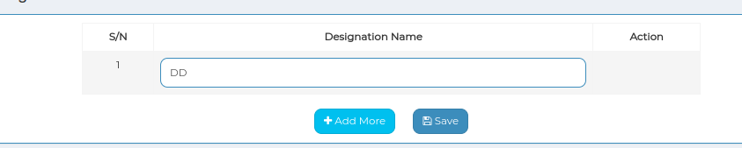

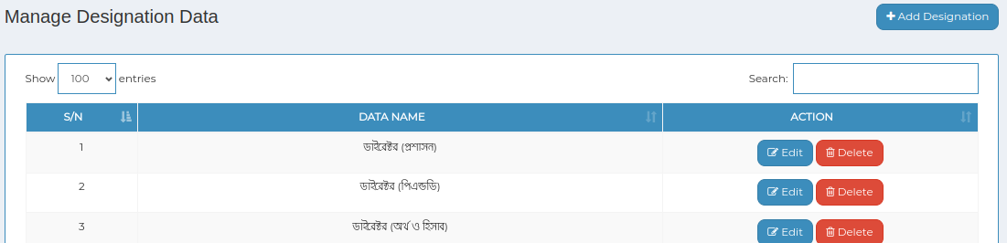

1. *Positive test case*

|  |  |  |  |  |  |
| --- | --- | --- | --- | --- | --- |
| 1. Case ID | 1. Title | 1. Description | 1. Expected Result | 1. Actual Result | 1. Pass/Fail |
| 1. 1 | 1. Add Designation | 1. 1. Enter designation name 2. 2. Click add more for add another one 3. 3. Click save | 1. Data saved successfully | 1. No error | 1. P |
| 1. 2 | 1. Manage Designation Data | 1. 1. Display all the user designation information 2. 2. Delete & update button update the existing database | 1. 1. Displayed 2. 2. Executed | 1. No error | 1. P |

1. *Negative Test Case*

|  |  |  |  |  |  |
| --- | --- | --- | --- | --- | --- |
| 1. Case ID | 1. Title | 1. Description | 1. Expected Result | 1. Actual Result | 1. Pass/Fail |
| 1. 1 | 1. Add Designation | 1. Data should be entered | 1. No error while saving data | 1. Perfectly executed | 1. P |
| 1. 2 | 1. Manage Designation Data | 1. Update or delete button works fine | 1. No error | 1. Perfectly executed | 1. P |

1. 2. Department

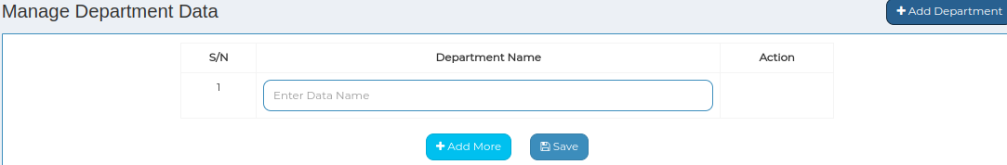

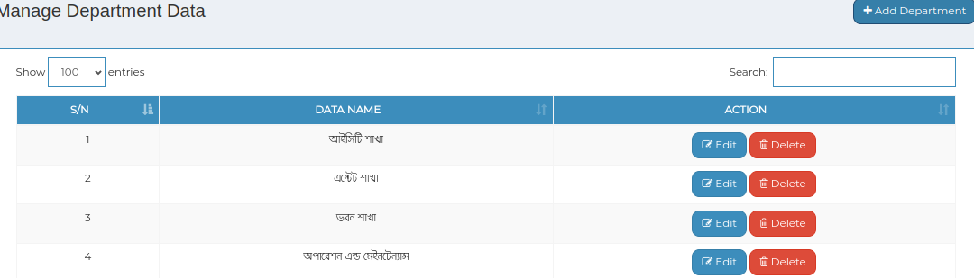

1. *Positive test case*

|  |  |  |  |  |  |
| --- | --- | --- | --- | --- | --- |
| 1. Case ID | 1. Title | 1. Description | 1. Expected Result | 1. Actual Result | 1. Pass/Fail |
| 1. 1 | 1. Add Department | 1. 1. Enter Department name 2. 2. Click add more for add another one 3. 3. Click save | 1. Data saved successfully | 1. No error | 1. P |
| 1. 2 | 1. Manage Department Data | 1. 1. Display all the user designation information 2. 2. Delete & update button update the existing database | 1. 1. Displayed 2. 2. Executed | 1. No error | 1. P |

1. *Negative Test Case*

|  |  |  |  |  |  |
| --- | --- | --- | --- | --- | --- |
| 1. Case ID | 1. Title | 1. Description | 1. Expected Result | 1. Actual Result | 1. Pass/Fail |
| 1. 1 | 1. Add Department | 1. Data should be entered | 1. No error while saving data | 1. Perfectly executed | 1. P |
| 1. 2 | 1. Manage Department Data | 1. Update or delete button works fine | 1. No error | 1. Perfectly executed | 1. P |

1. 3. Signature

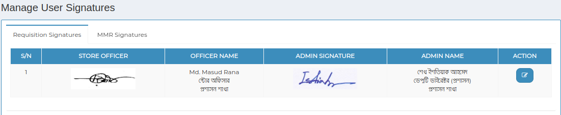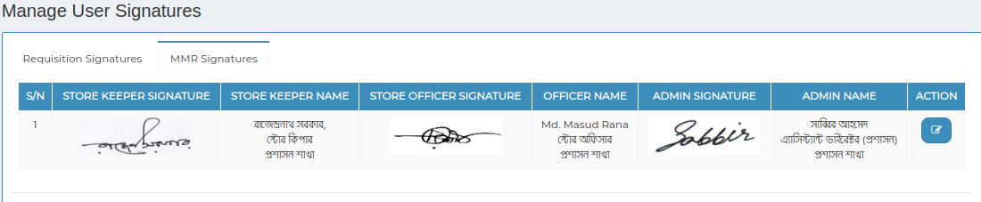

1. *Positive test case*

|  |  |  |  |  |  |
| --- | --- | --- | --- | --- | --- |
| 1. Case ID | 1. Title | 1. Description | 1. Expected Result | 1. Actual Result | 1. Pass/Fail |
| 1. 1 | 1. Manage User Signatures | 1. 1. Display requisition & MMR signatures 2. 2. Click update to update existing database | 1. Displayed & updated successfully | 1. No error | 1. P |

1. *Negative Test Case*

|  |  |  |  |  |  |
| --- | --- | --- | --- | --- | --- |
| 1. Case ID | 1. Title | 1. Description | 1. Expected Result | 1. Actual Result | 1. Pass/Fail |
| 1. 1 | 1. Manage User Signatures | 1. Update button should perfectly work | 1. No error while updating | 1. Perfectly executed | 1. P |