**Software Documentation for the MIS & PAYROLL**

**Product Name: MIS & PAYROLL**

Release Version:

Testing Started:

Testing Completed:

Technical Lead:

Product Owner: BBA

Primary Tester:

Developer:

Types of Test Performed:

**Browser Tested:**

1. Chrome

2. Mozilla Firefox

**Device Tested:**

1. Desktop

2. Laptop

3. Tab

4. Smartphone

**Instance Tested:**

1. Development

2. Testing

3. Production

4. UAT

**Table of Contents**

Revision History 5

Design Specification 6

Abstract 7

Chapter-1: Introduction 8

1.1 Review of the MIS System 8

1.2 Motivation 8

1.3 Aims and Objective 8

1.4 Solution Methodology 9

Chapter - 2. Background Study 10

2.1 Management Information System 10

2.2 Why should we use this software system ? 10

2.3 User Experience 10

2.4.4 Benefits 10

2.4.5 Role of the MIS 11

2.4.6 Impact of the MIS 11

2.4.7 Report & Analysis 12

2.5 Management as Control System 12

2.6 MIS main modules 13

Chapter – 3: Software Requirement Analysis 14

3.1 Introduction 14

3.2 Problem Analysis 14

3.3 Requirement 14

3.4 Software Requirement Specifications 14

3.4.1 SRS Scopes 14

3.4.2 Functional Requirements 15

3.4.3 Non-functional Requirement 16

3.5 Interface Requirement 16

3.5.1 User Interface 17

3.5.2 Hardware Interface 17

3.5.3 Software interface 17

3.5.4 Communication Interface 17

3.6 SRS table 17

3.6 Report Analysis 18

Chapter – 4: System Design 20

4.1 Algorithm Design 20

4.2 Process Flow Diagram 21

4.3 Data Flow Diagram 22

Chapter – 5: Testing Documentation 23

5.1 Introduction 23

5.2 Scopes 23

5.3 Quality Objective 23

5.4 Testing Methodology 24

5.4.1 Model 24

5.4.2 Strategies 24

5.4.3 Levels 24

5.4.4 Test Deliverables 25

5.4.5 Tools 25

5.5 Test Cases with Result 25

# Revision History

|  |  |  |  |
| --- | --- | --- | --- |
| Date | Version | Description | Author |
|  |  |  |  |
|  |  |  |  |
|  |  |  |  |
|  |  |  |  |

# Design Specification

**Overview:**

Management Information System is the most important part of the Management Control System. This system controls all financial terms and conditions related the control system. Frontend section operate UI specification and Backend section control all functional requirement of the software system. Both two client and server side communication make the system easier to the user.

**The Back-end part:**

1. Node.js

2. Database → Oracle

3. MS Server Version 2.0

**The Front-end part:**

1. React.js

2. Bootstrap

3. Domain → Friendly

# Abstract

All the financial ties are discussed for finding the best results. The system covers information on all employees, their personal and official information, information on salaries and even information about taking loans against salary and repaying those loans. This software is designed to make the existing manual system automatic with the help of computerized equipment and full-edged computer software, fulfilling their requirements, so that their valuable data and information can be stored for a longer period with easy access and manipulation of the same. From employee salary statements to their increments or investments. Loans can be defined in many ways like house loan, car loan and so on. So our main goal is to design such a system so that it can be easily maintained with a software system. There are currently a number of management systems in common that we will follow but some terms we are trying to design a system that fulfill our requirements. So, The required software is easily available and easy to work with. This web application can maintain and view computerised records without getting redundant entries. The project describes how to manage user data for good performance and provide better services for the client.

# Chapter-1: Introduction

In this chapter we will focus on the status of the current management system and some of the goals for the progress of this system. That is why we will continue to move towards the future by overviewing some current systems. In the following sections, these terms have been discussed in details.

## 1.1 Review of the MIS System

MIS refers to computer software that is used to store, organize and analyze information. Management information systems are used to track sales, inventory, equipment and related business information. In the past, management information systems ran on mainframe computers. In a corporate setting, the ultimate goal of the use of a management information system is to increase the value and profits of the business. This is done by providing managers with timely and appropriate information allowing them to make effective decisions within a shorter period of time.

## 1.2 Motivation

Understanding how systems are built ground up knowing the business requirements and what users need from a system. MIS helps us to understand technology from the point of view of different stakeholders such as end users, business, etc.  To learn a lot more about Information Systems like databases, languages, data mining, business terminology. MIS is a mix of many knowledge areas and you get to know Information systems from various perspectives. the business aspect of technology and how technology can be used to achieve a business goal.

## 1.3 Aims and Objective

Our aims is to achieve a good transport system that has ability to fulfill our requirements.

* Platform Independent
* Auto Synchronizing
* Friendly Environment
* Domain and Hosting
* Human Resource Controlling
* Allowance Monitoring
* Deduction Scaling
* Salary statements
* Loan details
* Generate Each section Report
* Multi-functionality

## 1.4 Solution Methodology

1. Design HR section

Employees personal, professional, increments, suspend information

1. Design Allowance section to employees allowance information
2. Design House Rent
3. Design Loan & Salary statements for interest, percentage on salary etc

HR

Employees, Professional

Increments, Suspend

Allowance

House Rent

Deduction

Loan

Salary

# Chapter - 2. Background Study

## 2.1 Management Information System

Management Information System is flow-processing procedures based on computer data, and integrated with other procedures in order to provide information in a timely and effective manner to support decision-making and other management functions. This finding is also present when we consider that the number of contemporary business data and information exponential grow, and efficient business decision-making is possible only if the necessary information is fast, accurate and qualitative and managed by adequate staff but for the most cases not appropriate efficiency is the result of a lack of good management information systems. The rapid development of information technology coupled with the development of telecommunications technology has streamlined every area of life and human activity. Through good organization of this technology to achieve quality decision making at all levels of management from the top level to the lowest. Information technology in organizing the best and optimal database offers great opportunities for a quick and qualitative manipulation to raise the quality of preparation of decisions

## 2.2 Why should we use this software system ?

The purpose of this software is to define the functionality and specifications of the design of a web application for Managing Employees and their payroll. The expected audiences of this software system are the developers and the admin of the web application. Now with the help of this system the admin has the information on his finger tips and can easily prepare a good record based on their requirements. Finally, we can say that this system will not only automate the process but save the valuable time of the manager or the admin, which can be well utilized buy his institute. This will be an additional advantage and management of power based on their free time from his normal duty.

## 2.3 User Experience

This software system is built keeping in mind that it is to be used by only one user that is the admin. It is built for use in small scale organization where the number of employees is limited. According to the requested requirement the admin can add, manipulate, update and delete all employee data in his organization. The admin can add new departments and delete them. The Admin can also add predefined pay grades for the employees. The required records can be easily viewed by the admin anytime time he wants in an instant. The payment of the employee is based on monthly basis. Numerous validations implemented would enable the admin to enter accurate data. The main objective of this framework is to save time, make the system cost effective and management records

efficiently.

### 2.4.4 Benefits

* Save time - Manually it takes a lot of time while storing the lease information
* Resources - except this software system, the gathering of lease information will be

difficult as there need a lot of man power resources in rural and urban areas.

* Reusable - the system can be reused in the similar types of management.
* It is cost effective as the user control the web application himself and does not go for

professional service.

* It saves time as it speeds up every aspect of the employee database management and

payroll process with a range of automated features.

* It is secure as the employee database and the payroll process is managed by the admin

in house rather than sending private information to a third party.

* Validating procedures and checks restrict user from making mistakes.
* The software is easy to use and is user friendly so no expertise is required.
* The calculations are automated so no chance of error.

### 2.4.5 Role of the MIS

The role of the MIS in an organization can be compared to the role of heart in the body. The information is the blood and MIS is the heart. In the body the heart plays the role of supplying pure blood to all the elements of the body including the brain. The heart works faster and supplies more blood when needed. It regulates and controls the incoming impure blood, processes it and sends it to the destination in the quantity needed. It fulfills the needs of blood supply to human body in normal course and also in crisis. The MIS plays exactly the same role in the organization. The system ensures that an appropriate data is collected from the various sources, processed, and sent further to all the needy destinations. The system is expected to fulfill the information needs of an individual, a group of individuals, the management functionaries: the managers and the top management.

The MIS satisfies the diverse needs through a variety of systems such as Query Systems, Analysis Systems, Modeling Systems and Decision Support Systems the MIS helps in Strategic Planning, Management Control, Operational Control and Transaction Processing.

### 2.4.6 Impact of the MIS

Since the MIS plays a very important role in the organization, it creates an impact on the organization’s functions, performance and productivity. The impact of MIS on the functions is in its management. With a good support, the management of marking, finance, production and personnel become more efficient. The tracking and monitoring of the functional targets becomes easy. The

functional, managers are informed about the progress, achievements and shortfalls in the probable trends in the various aspects of business. This helps in forecasting and long- term perspective planning. The MIS creates another impact in the organization which relates to the understanding of the business itself. The MIS begins with the definition of a data entity and its attributes. It uses a dictionary if data, entity and attributes, respectively, designed for information generation in the organization. Since all the information system use the dictionary, there is common understanding of terms and terminology in the organization bringing clarity in the communication and a similar understanding an even of the organization. The MIS calls for a systemization of the business operation for an affective system design.

### 2.4.7 Report & Analysis

The software system has been developed to overcome the problems faced in the practicing of manual system. This software is built to eliminate and in some cases reduce the hardships faced by the existing system. Moreover this system is designed for particular need of the company to carry out its operations in a smooth and effective manner. This web application is reduced as much as possible to avoid errors while entering data. It also provides error message while entering invalid data. It is user-friendly as no formal knowledge is required to use the system. Human resource challenges are faced by every organization which has to be overcome by the organization. Every organization has different employee and payroll management needs. Therefore I have design exclusive Employee and payroll Management System that are adapted to the organization’s Managerial Requirements.

## 2.5 Management as Control System

Planning, organizing, staffing, coordinating, directing and controlling are the various Steps in a management process. All the steps prior to a control are necessary but are not necessarily self-assuring the results unless it is followed by a strong control mechanism. The management experts have viewed these steps as Management Control System. A definition of control is the process through which managers assure that actual activities conform to the planned activities, leading to the achievement of the stated common goals. A reliable and effective control system has the following features.

**Early Warning Mechanism.**

This is a mechanism of predicting the possibility of achieving the goals and the standards before it is too late and allowing the manager to take corrective actions.

**Performance Standard**

The performance standard must be measurable and acceptable to all the organization. The system should have meaningful standards relating to the work areas, responsibility, and managerial functions and so on.

**Strategic Controls**

In every business there are strategic areas of control knows as the critical success factors. The system should recognize them and have controls instituted on them.

**Feedback**

The control system would be effective; it continuously monitors the performance and sends the information to the control centre for action. It should not only highlight the progress but also the deviations.

**Accurate and Timely**

The feedback should be accurate in terms of results and should be communicated on time for corrective action.

**Realistic**

The system should be realistic so that the cost of control is far less than the benefits. The standers are realistic and are believed as achievable. Sufficient incentive and rewards are to be provided to motivate the people.

**The Information Flow**

The system should have the information flow aligned with the organization structure and the decision makers should ensure that the right people get the right information for action and decision making.

**Exception Principle**

The system should selectively approve some significant deviations from the performance standards on the principle of management by exception. A standard is control system has a set of objectives, standards to measure, a feedback mechanism and an action centre as elements of the system.

## 2.6 MIS main modules

1. HR

i. Employees

ii. Professionals

iii. Increments

iv. Suspend

1. Allowance
2. Deduction
3. House Rent
4. Loan
5. Salary

i. Salary Process

ii. Pay slip

iii. Salary statement

# Chapter – 3: Software Requirement Analysis

## 3.1 Introduction

A software requirement is a field within software engineering that deals with establishing

the needs of stakeholders that are to be solved by software. The IEEE Standard Glossary of

Software Engineering Terminology defines requirements.

The software system of human resource management and payroll is expected to be able to meet several needs as follows:

1. Record employee data in real time and easy to access with the Internet network.
2. Facilitate electronic forms (e-forms) of supporting data on payroll processes such as leave forms, late or sick permission, loans, compliment, outside service, overtime, and evaluation with notifications connected via e-mail.
3. Provide a smart reminder when an employee will expire. Integrated with attendance machines, so attendance data can be processed directly in the human resource management system and payroll.
4. Make payroll reports for each period to be given to finance and accounting. Send pay-slip to employee e-mails every period.

## 3.2 Problem Analysis

The process of manually calculating salary causes some problems in the management. Problems faced by several section today are:

1. A large number of company employees who constantly growing raises wage calculation process becomes longer and not effective.
2. The possibility of human error in the calculation of salaries
3. To search for data takes a long time because data is not stored properly.

## 3.3 Requirement

The Transport Management System Requirements provides high-level of functional requirements.

## 3.4 Software Requirement Specifications

* Documentation (user and administration)
* Operational behavior
* Technical Support

### 3.4.1 SRS Scopes

The MIS & payroll system is part of the human resource management system. Activities carried out from the payroll system are processes of data from the BBA management of human resources. The input source of the payroll process is data that comes from many actors. Based on the results of interviews, documentation and observations of the author, the following analysis of the scope of the problems that occur in the human resource management system and payroll.

**Performance**

Data collection is late in entering HR Payroll, so it requires integration of payroll systems with

human resource management systems so as to speed up the salary calculation process.

**Information**

There are some data that are not filled, tucked, and not inputted, so data input is needed

automatically through a website-based system with verification notifications via e-mail.

**Economics**

Storage of information supporting data on the payroll process that still uses hardcopy meets the

storage filling cabinet, so that it is necessary to store information on supporting data for the payroll process in an online database.

**Control or Security**

The HR payroll section is often overtime at the payroll period because the database is not yet

integrated so it needs to be re-validated to avoid human error, so that the employee self-service

approach allows employees to do all matters relating to human resource management online.

**Efficiency**

Management of the payroll process supporting data cannot be managed by each employee at any

time, so a system is needed for employees to do all matters relating to human resource

management online without the need for departmental admin assistance.

**Services**

Providing employee salaries often experiences delays because the supporting data for the salary

calculation process are still done manually, so that an information system for human resource

management and payroll is needed that is able to provide the payroll process supporting data

quickly and accurately.

### 3.4.2 Functional Requirements

Every section has a specific functionality that’s are given below:

* Login Functionality
* Report – download a copy of corresponding section
* Loan, deduction, rent fee calculation
* Salary Management Process

### 3.4.3 Non-functional Requirement

For an specific criteria, there should be applied non-functional requirements which are

shortly described below:

**Reliability**

The operational interface can’t fail within a period of time.

**Availability**

The system is available or not while a user wants access the information.

**Security**

All user can login to the system with secured procedure. Each user has a unique

identification system. Admin can store user’s login information.

**Maintainability**

All source code and related document should be controlled under a version of the

system.

**Portability**

As the software run into several platform, the platform independence should be ensure.

Different OS can access the software easily.

**Usability**

The Software should be easy to use and given a positive experience by the

user’s.

## 3.5 Interface Requirement

Computer system including software and hardware can turn the system on by interfacing

them with human thought.

### 3.5.1 User Interface

1. Login Screen
2. Home Screen
3. HR control section
4. Allowance, deduction, House Rent
5. Loan, Salary

### 3.5.2 Hardware Interface

* Server Configuration
* CPU/Processor
* Windows with apache preloaded
* Client Configuration

### 3.5.3 Software interface

* OS = Windows, Linux
* Language = PHP, JS
* DB = Oracle

### 3.5.4 Communication Interface

These interfaces include E-mail, Web Browser, Server Network and use http or ftp for

security purposes.

## 3.6 SRS table

It describes necessary behavior of the software system and shows in the table

|  |  |  |
| --- | --- | --- |
| S.No. | Requirement Name | Requirement Classified |
| 1. | Employees |  |
| 2. | Professionals |  |
| 3. | Increments |  |
| 4. | Suspend |  |
| 5. | Allowance |  |
| 6. | Deduction |  |
| 7. | House Rent |  |
| 8. | Loan |  |
| 9. | Salary Process |  |
| 10. | Pay Slip |  |
| 11. | Salary Statement |  |

## 3.6 Report Analysis

Independent to each other. At the end of the phase, the document of the requirement will be provided.

**Priority Checklist**

* Level-1**:** Must Be Performed
* Level-2: Must be perform for next level
* Level -3: Not Mandatory

|  |  |  |  |
| --- | --- | --- | --- |
| SI.No. | Requirement Name | Functional/Non-  functional | Priority |
| 1. | Dashboard | Functional | 3 |
| 2. | **HR** | Functional | 1 |
| 3. | Employees | Functional | 2 |
| 4. | Professionals | Functional | 1 |
| 5. | Increments | Functional | 1 |
| 6. | Suspend | Functional | 1 |
| 7. | **Allowance** | Functional | 1 |
| 8. | **Deduction** | Functional | 1 |
| 9. | **House Rent** | Functional | 1 |
| 10. | **Loan** | Functional | 1 |
| 11. | **Salary** | Functional | 2 |
| 12. | Salary Process | Functional | 2 |
| 13. | Pay Slip | Functional | 2 |
| 14. | Salary Statement | Functional | 2 |
| 15. | Reliability | Non-functional | 1 |
| 16. | Availability | Non-functional | 1 |
| 17. | Security | Non-functional | 1 |
| 18. | Maintainability | Non-functional | 1 |
| 19. | Portability | Non-functional | 1 |
| 20. | Usability | Non-functional | 1 |
| 21. | Database | Functional | 1 |

# Chapter – 4: System Design

## 4.1 Algorithm Design

|  |  |
| --- | --- |
| STEP – 1: START  STEP – 2: CHECK Authentication  STEP – 3: CALL Fun(X)  STEP – 4: if(X = ‘HR’)  SELECT Y  if(Y = ‘Employees’)  SHOW employeeInfo  DO personal, professional  increment, training  if(Y = ‘Professionals’)  ADD professional  SHOW professionalInfo  if(Y = ‘Increments’)  ADD increment  SHOW incrementInfo  if(Y = ‘Suspend’)  ADD suspend  SHOW suspendInfo  if(X = ‘Allowance’)  ADD allowance  SHOW allowanceInfo  if(X = ‘Deduction’)  ADD deduction  SHOW deductionInfo | if(X = ‘House-rent’)  ADD houserent  SHOW houserentInfo  if(X = ‘Loan’)  SELECT loanTypes  ADD loanType  SHOW loanTypes  ADD loan  SHOW loanInfo  if(X = ‘Salary’)  SELECT Y  if(Y = ‘Salary-process’)  SELECT month  DO process  if(Y = ‘Salary-statement’)  SELECT allEmp OR  individualEmp  SHOW statements  STEP – 5: SHOW dashboard  STEP – 6: END |

## 4.2 Process Flow Diagram

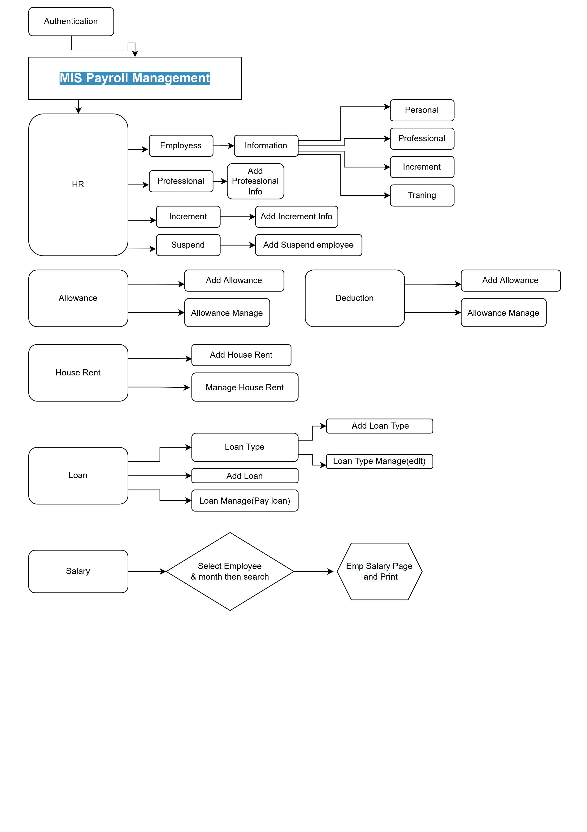

## 4.3 Data Flow Diagram

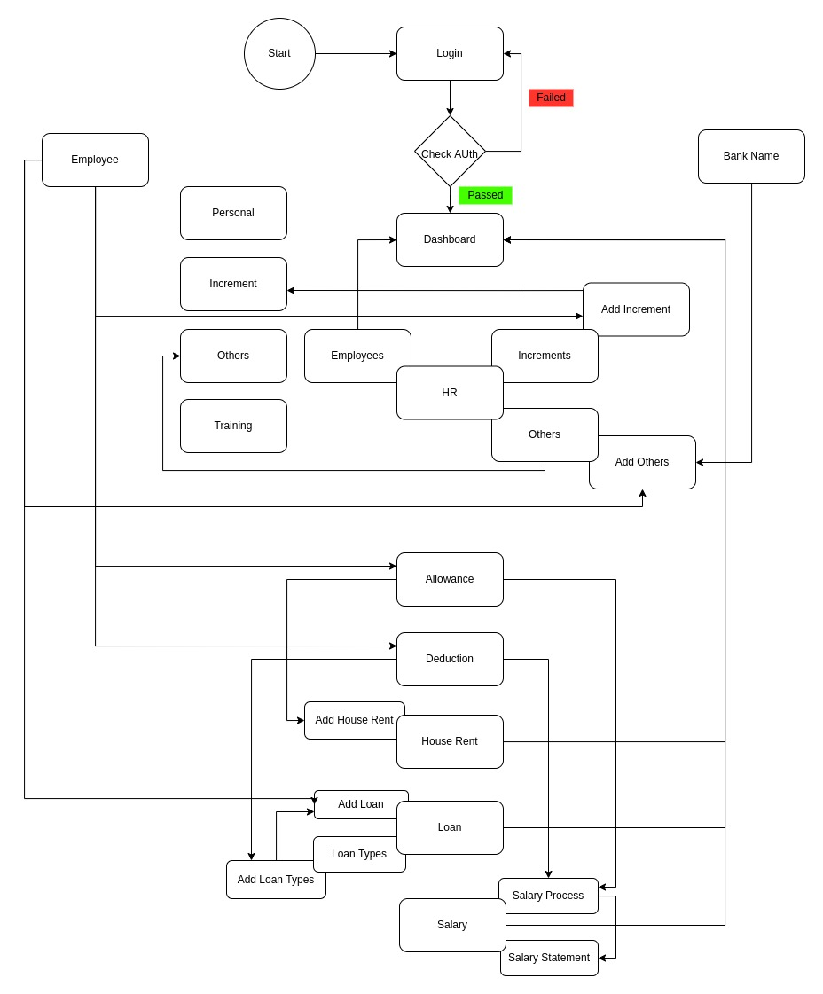

# Chapter – 5: Testing Documentation

## 5.1 Introduction

The Test Plan is designed to prescribe the scope, approach, resources, and schedule of all testing activities of the transport Management System of BBA. The plan identify the items to be tested, the features to be tested, the types of testing to be performed, the personnel responsible for testing, the resources and schedule required to complete testing, and the risks associated with the plan.

## 5.2 Scopes

**1. In scope:**

**For Admin**

|  |  |  |
| --- | --- | --- |
| Name | Applicable Roles | Description |
| Employees information, Professionals, Increments, Suspend | Admin, user | Add employees personal & official information |
| Allowance | Admin | Add an employee for allowance and details |
| Deduction | Admin | Deduct amount from an employees salary for a reason |
| House Rent | Admin | Rent fee adding for an employees |
| Loan | Admin | Adding loan information for an employee |
| Salary Process, Statement | Admin | Describe salary detailed information for a selected employee |

**2. Out scope**

* User Interface (UI)
* Hardware
* System security and performance

## 5.3 Quality Objective

The test objectives are to verify the Functionality of the system Lease Management System, the project should focus on testing the transportation system such as vehicle requisition, vehicle information, add new vehicle information to guarantee all these operation can work normally in real business environment.

## 5.4 Testing Methodology

### 5.4.1 Model

* **Waterfall model** – a dynamic approach where each step depends on the previous one, where the developers follow some sequence of steps progressively downwards forwards to achieve the goal. It is like a waterfall approach containing several phases.

### 5.4.2 Strategies

• Tester has access to the full view of code.

• It is known as transparent or glass box testing

• Avoiding errors and wasting time at an early stage

• White box testing contains various tests -

1. Basic Path testing
2. Loop testing
3. Condition testing
4. Memory perspective testing
5. Performance testing

### 5.4.3 Levels

* Integration testing
* System testing
* Cross Browser Compatibility testing

User Acceptance Test (UAT)

* API testing

### 5.4.4 Test Deliverables

(a) Before Testing

* Test plans document
* Test case document

(b) After Testing

* Test Results/reports­
* Defect Report
* Installation/ Test procedures guidelines

### 5.4.5 Tools

|  |  |  |
| --- | --- | --- |
| No. | Resources | Description |
| 1. | Server | Oracle Database Server |
| 2. | Network | LAN line. |
| 3. | Computer | PC and other OS configuration |

## **5.5 Test Cases with Result**

**Test Scenario 1: Dashboard**

1. Dashboard

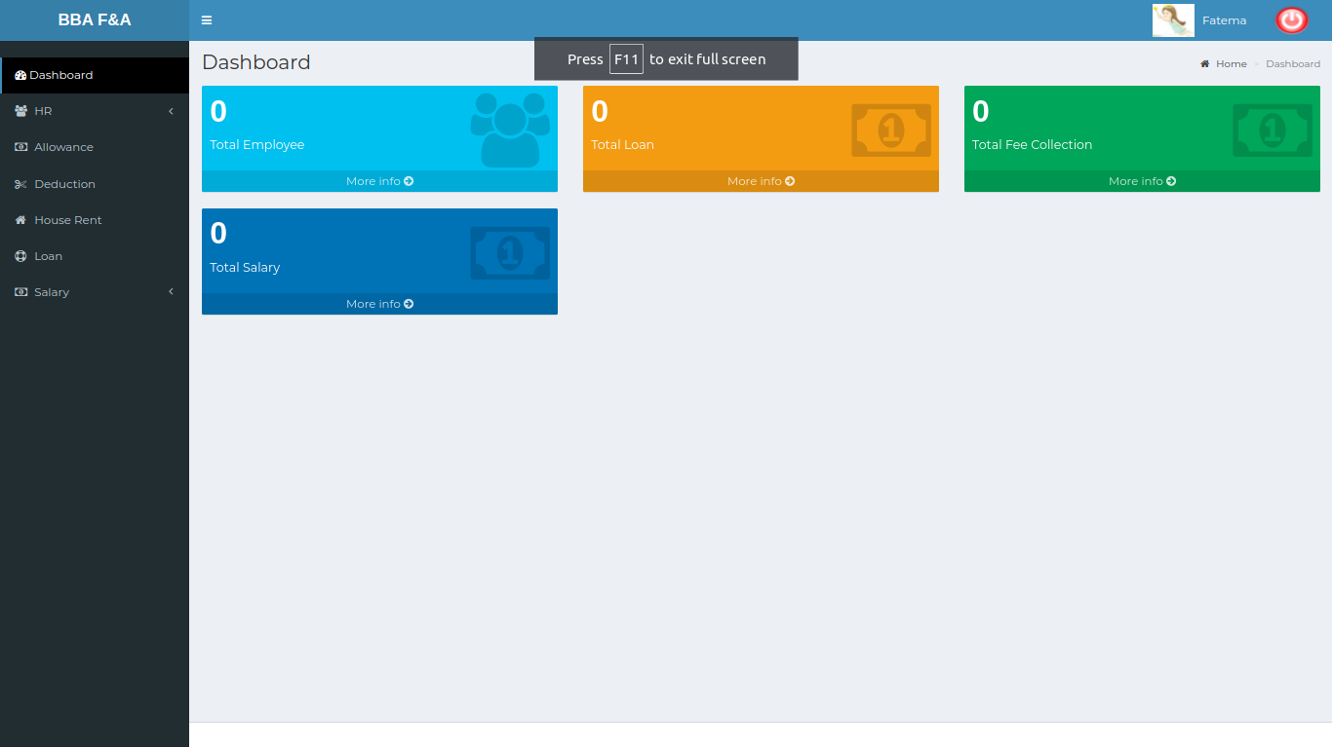

*Positive test case*

|  |  |  |  |  |  |
| --- | --- | --- | --- | --- | --- |
| Case ID | Title | Description | Expected Result | Actual Result | Pass/Fail |
| 1 | Total Employee | Click more info to see employee information |  |  |  |
| 2 | Total Loan | Click more info to see loan information |  |  |  |
| 3 | Total Fee Collection | Click more info to see fee collection |  |  |  |
| 4 | Total Salary | Click more info to see salary information |  |  |  |

*Negative Test Case*

|  |  |  |  |  |  |
| --- | --- | --- | --- | --- | --- |
| Case ID | Title | Description | Expected Result | Actual Result | Pass/Fail |
| 1 | Total Employee | Check Total employee information is enlisted or not |  |  |  |
| 2 | Total Loan | Ensure total loan information is listed or not |  |  |  |
| 3 | Total Fee Collection | Check fee collection are shown or not |  |  |  |
| 4 | Total Salary | Check total salary availability |  |  |  |

**Test Scenario 2: Human Resource**

1. Employees Information

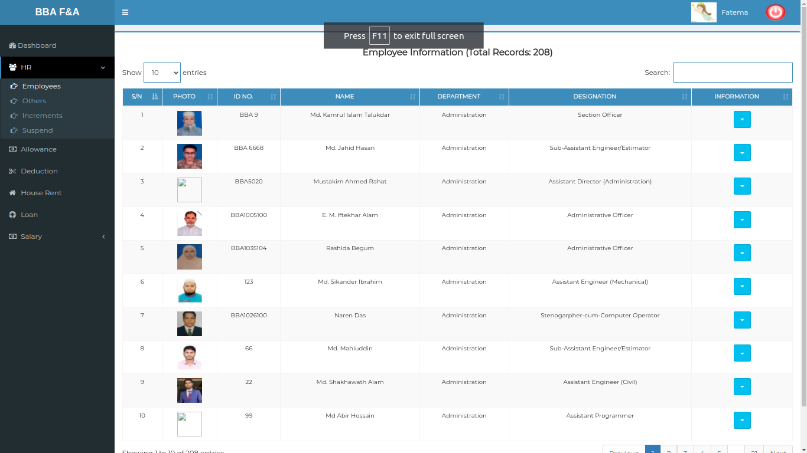

*Positive test case*

|  |  |  |  |  |  |
| --- | --- | --- | --- | --- | --- |
| Case ID | Title | Description | Expected Result | Actual Result | Pass/Fail |
| 1 | Employee Information | Display All the employee Information | All information displayed | No information is missing | P |

*Negative Test Case*

|  |  |  |  |  |  |
| --- | --- | --- | --- | --- | --- |
| Case ID | Title | Description | Expected Result | Actual Result | Pass/Fail |
| 1 | Employee Information | Check All the employee information are available or not | All employee information is available | No error is occurred while data is displaying | P |

2. Employee Personal Information Details

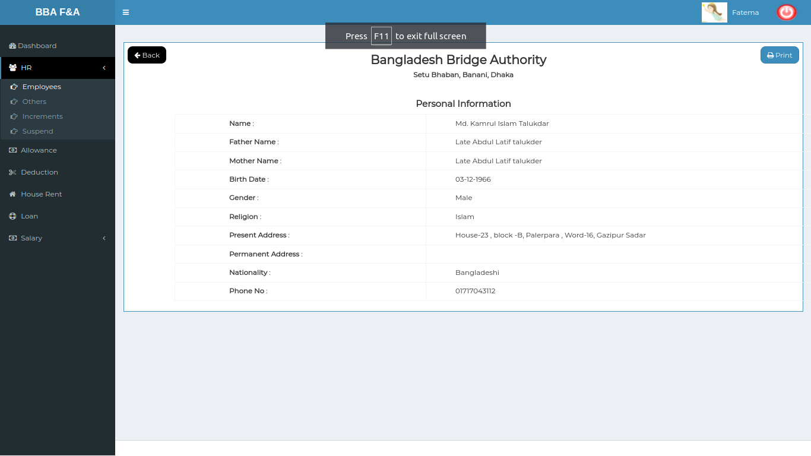

*Positive test case*

|  |  |  |  |  |  |
| --- | --- | --- | --- | --- | --- |
| Case ID | Title | Description | Expected Result | Actual Result | Pass/Fail |
| 1 | Personal Information | Display Personal Information | All personal information displayed | No information is missing | P |

*Negative Test Case*

|  |  |  |  |  |  |
| --- | --- | --- | --- | --- | --- |
| Case ID | Title | Description | Expected Result | Actual Result | Pass/Fail |
| 1 | Personal Information | Information should be downloaded in document format | All employee information is available | No error is occurred while data is displaying | P |

3. Professional Information Details

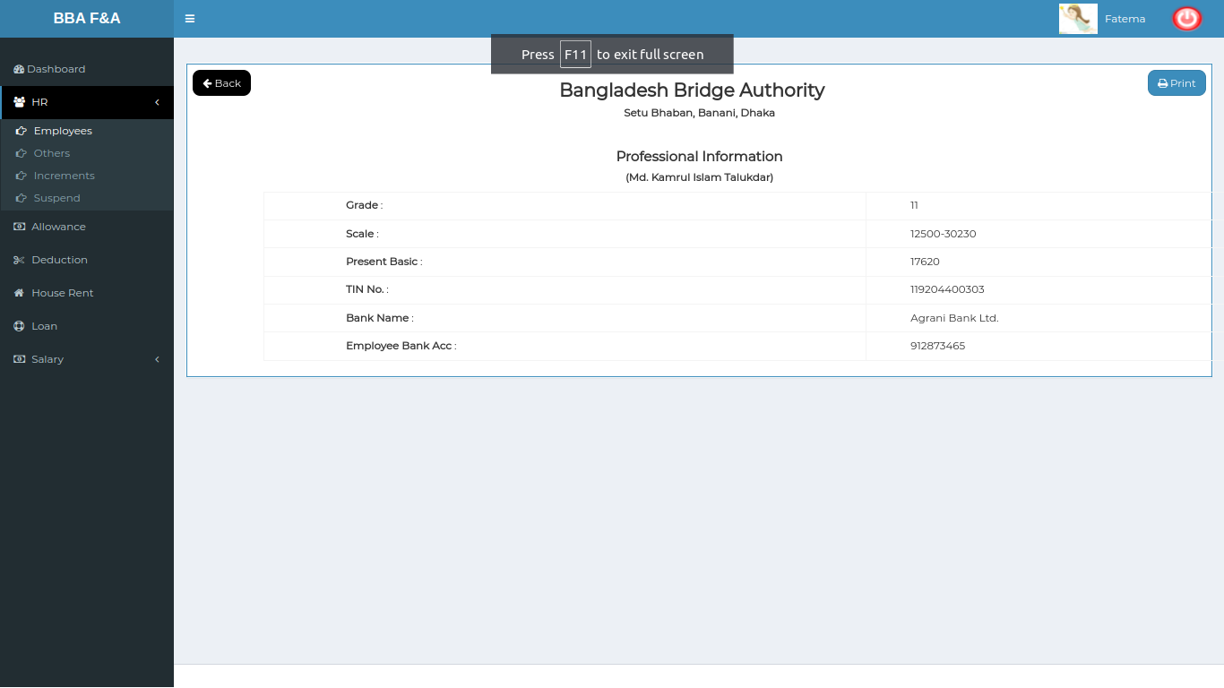

*Positive test case*

|  |  |  |  |  |  |
| --- | --- | --- | --- | --- | --- |
| Case ID | Title | Description | Expected Result | Actual Result | Pass/Fail |
| 1 | Professional Information | Display professional information | All professional information displayed | No information is missing | P |

*Negative Test Case*

|  |  |  |  |  |  |
| --- | --- | --- | --- | --- | --- |
| Case ID | Title | Description | Expected Result | Actual Result | Pass/Fail |
| 1 | Professional Information | Information can download in document format | All employee professional information is available | No error is occurred while data is displaying | P |

4. Increments information

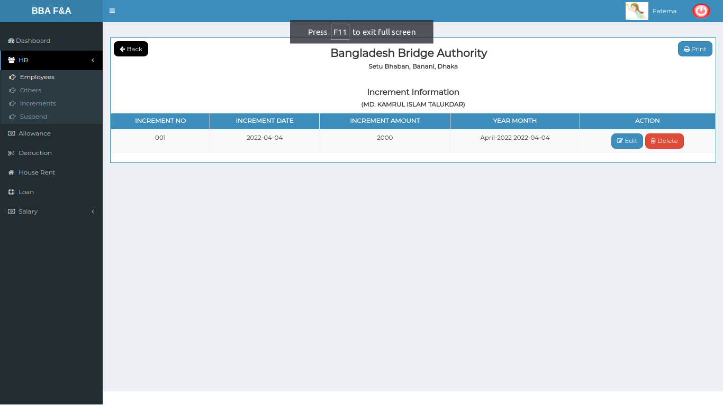

*Positive test case*

|  |  |  |  |  |  |
| --- | --- | --- | --- | --- | --- |
| Case ID | Title | Description | Expected Result | Actual Result | Pass/Fail |
| 1 | Increment Information | Show the all incremental Information | All increment information displayed | No information is missing | P |

*Negative Test Case*

|  |  |  |  |  |  |
| --- | --- | --- | --- | --- | --- |
| Case ID | Title | Description | Expected Result | Actual Result | Pass/Fail |
| 1 | Increment Information | Information can print in document format | All employee professional information is available | No error is occurred while data is displaying | P |

5. Training Information Details

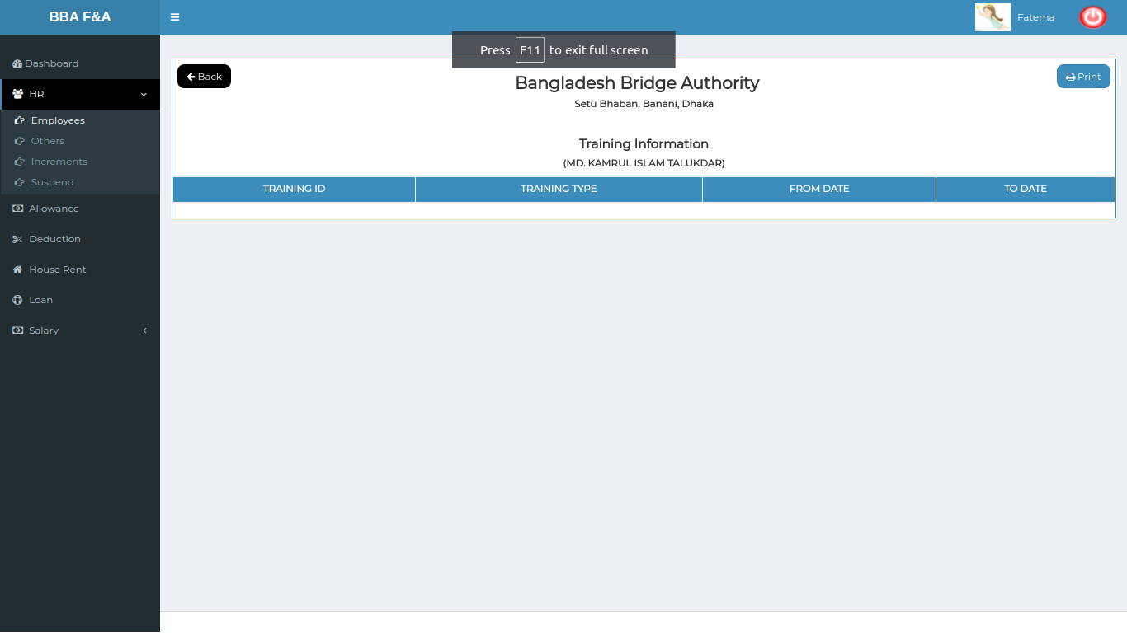

*Positive test case*

|  |  |  |  |  |  |
| --- | --- | --- | --- | --- | --- |
| Case ID | Title | Description | Expected Result | Actual Result | Pass/Fail |
| 1 | Training Information | List all the training information list | All training information displayed | No information is missing | P |

*Negative Test Case*

|  |  |  |  |  |  |
| --- | --- | --- | --- | --- | --- |
| Case ID | Title | Description | Expected Result | Actual Result | Pass/Fail |
| 1 | Training Information | Information Can download in document format | All training information is available | No error is occurred while data is displaying | P |

6. Others information

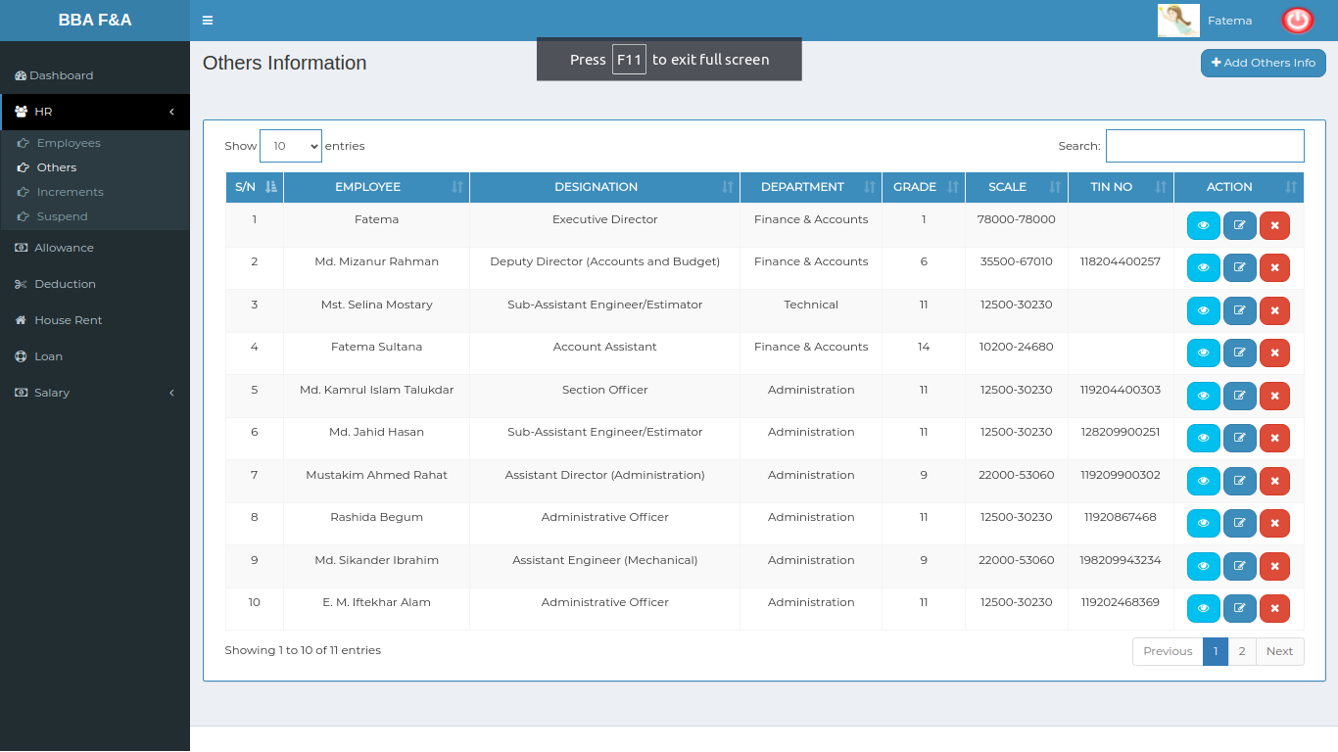

*Positive test case*

|  |  |  |  |  |  |
| --- | --- | --- | --- | --- | --- |
| Case ID | Title | Description | Expected Result | Actual Result | Pass/Fail |
| 1 | Others information | Display the all others information | All others information displayed | No information is missing | P |

*Negative Test Case*

|  |  |  |  |  |  |
| --- | --- | --- | --- | --- | --- |
| Case ID | Title | Description | Expected Result | Actual Result | Pass/Fail |
| 1 | Others information | Information list contain several action button | All training information is available | No error is occurred while data is displaying | P |

7. View Detailed Information

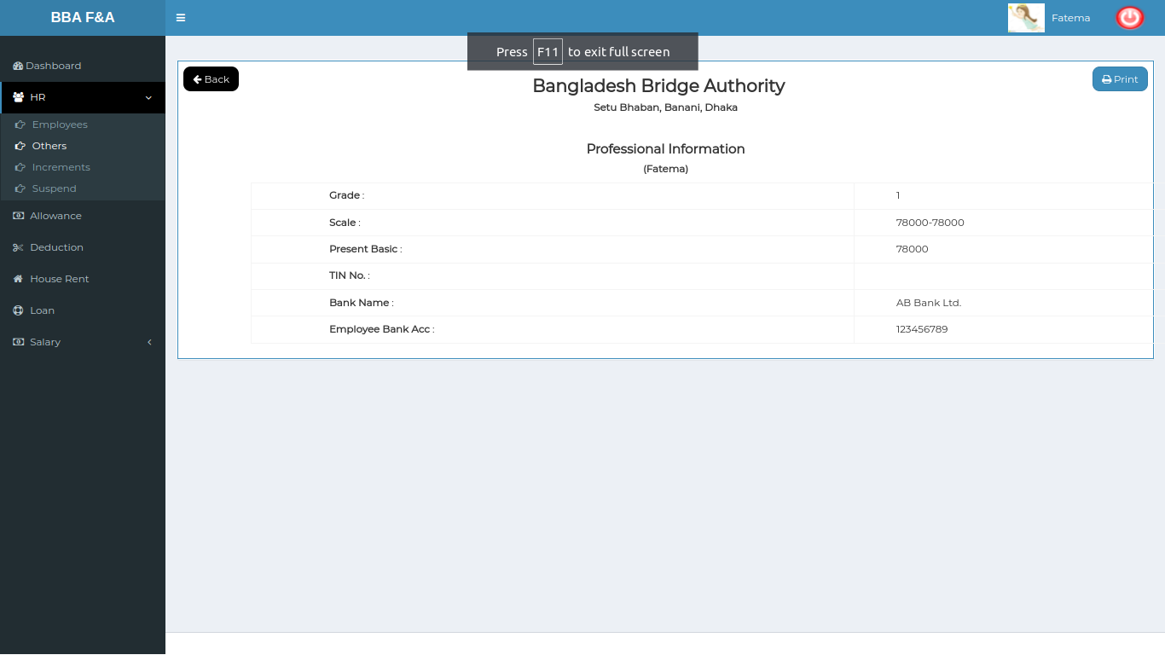

*Positive test case*

|  |  |  |  |  |  |
| --- | --- | --- | --- | --- | --- |
| Case ID | Title | Description | Expected Result | Actual Result | Pass/Fail |
| 1 | Professional Information | Display the professional information for a specific employee | professional information are displayed | No information is missing | P |

*Negative Test Case*

|  |  |  |  |  |  |
| --- | --- | --- | --- | --- | --- |
| Case ID | Title | Description | Expected Result | Actual Result | Pass/Fail |
| 1 | Professional Information | The document could be printed | All professional information is available | No error is occurred while data is displaying | P |

8.Update others information

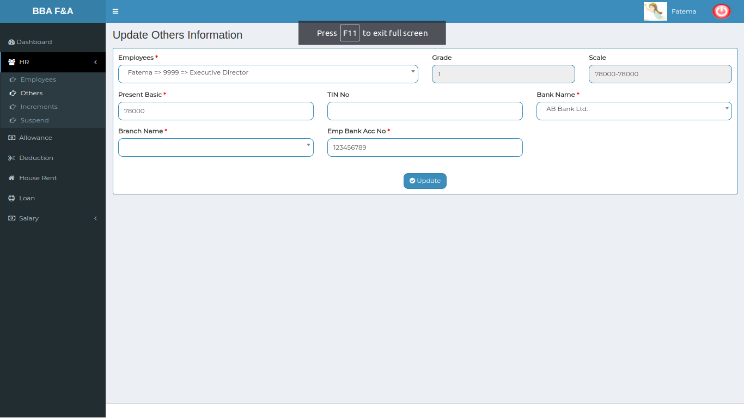

*Positive test case*

|  |  |  |  |  |  |
| --- | --- | --- | --- | --- | --- |
| Case ID | Title | Description | Expected Result | Actual Result | Pass/Fail |
| 1 | Update others information | 1. update others info button for adding employee professional information  2. Select employee, bank name, branch name, Employee bank account no  3. update present basic,TIN no  4. Click add | Update the existing information by current data | Successfully updated | P |

*Negative Test Case*

|  |  |  |  |  |  |
| --- | --- | --- | --- | --- | --- |
| Case ID | Title | Description | Expected Result | Actual Result | Pass/Fail |
| 1 | Update others information | 1. Selected information should be properly selected  2. TIN no should be verified  3. add button should work fine to store the professional information in the database | Can’t accept irrelevant data & store the update information | No error occurred while updating | P |

9. Delete Other information

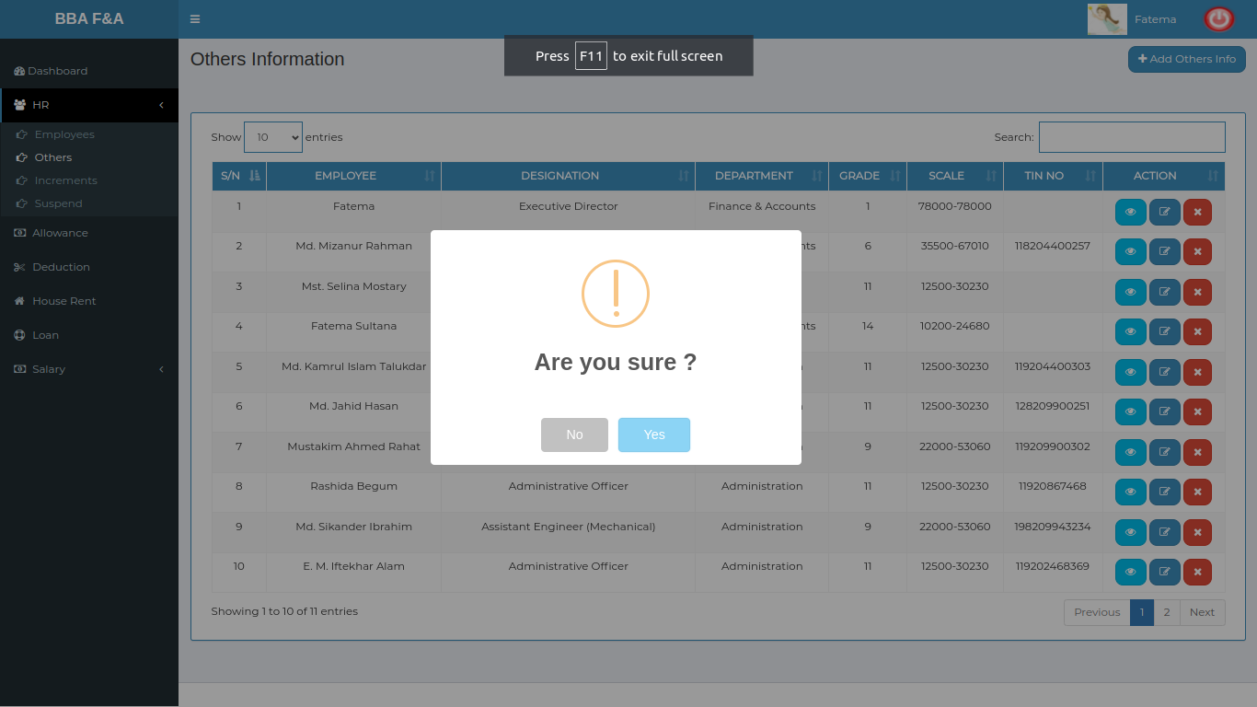

*Positive test case*

|  |  |  |  |  |  |
| --- | --- | --- | --- | --- | --- |
| Case ID | Title | Description | Expected Result | Actual Result | Pass/Fail |
| 1 | Delete others information | Information should delete by pressing delete button | Delete information from the list | Successfully deleted | P |

*Negative Test Case*

|  |  |  |  |  |  |
| --- | --- | --- | --- | --- | --- |
| Case ID | Title | Description | Expected Result | Actual Result | Pass/Fail |
| 1 | Delete others information | Pressing yes can delete the other information | Delete the exact information from database | No more the data in the list | P |

10. Add others information

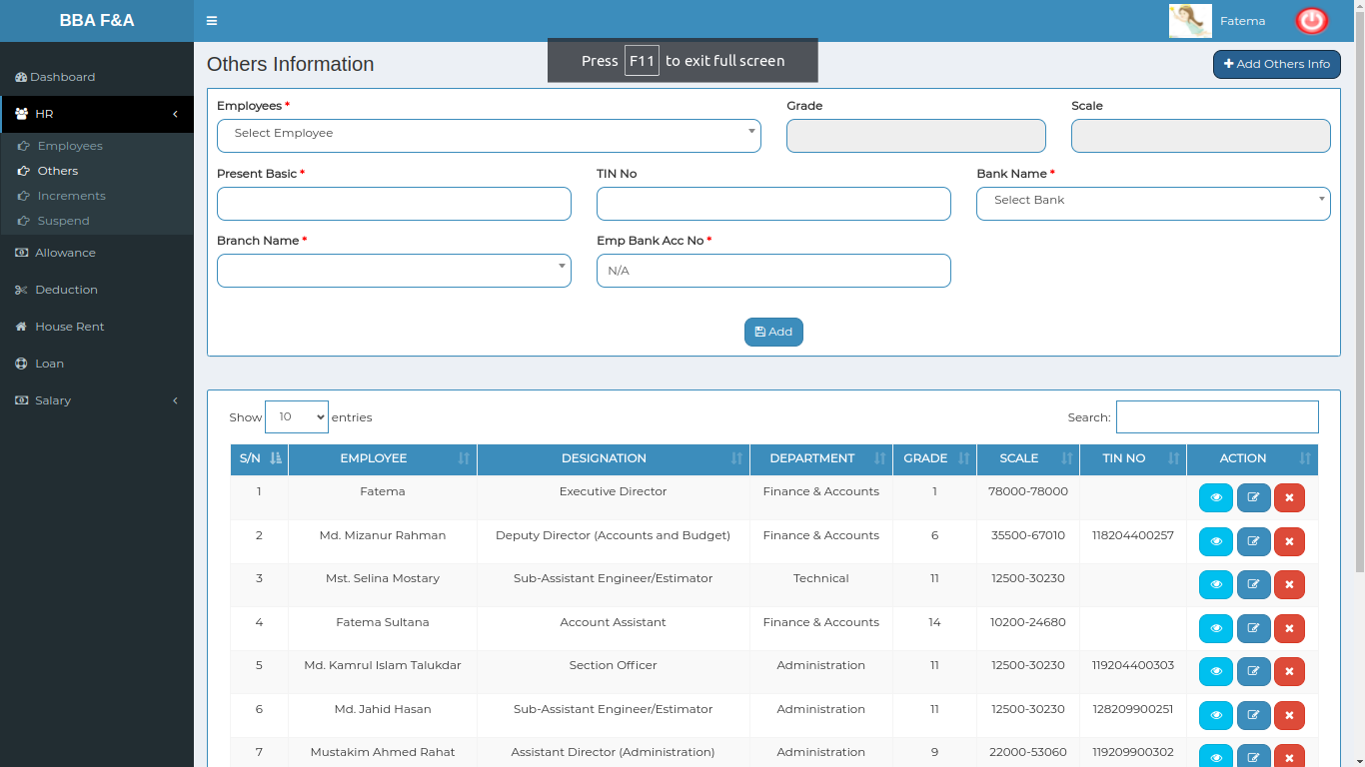

*Positive test case*

|  |  |  |  |  |  |
| --- | --- | --- | --- | --- | --- |
| Case ID | Title | Description | Expected Result | Actual Result | Pass/Fail |
| 1 | Add other s Information | 1. Add others info button for adding employee professional information  2. Select employee, bank name, branch name, Employee bank account no  3. Enter present basic,TIN no  4. Click add | Added the selected & entered information | Successfully saved | P |

*Negative Test Case*

|  |  |  |  |  |  |
| --- | --- | --- | --- | --- | --- |
| Case ID | Title | Description | Expected Result | Actual Result | Pass/Fail |
| 1 | Add other s Information | 1. Selected information should be properly selected  2. TIN no should be verified  3. add button should work fine to store the professional information in the database | Can’t accept irrelevant data & store the latest information | No error occurred while adding | P |

11. Increments Information

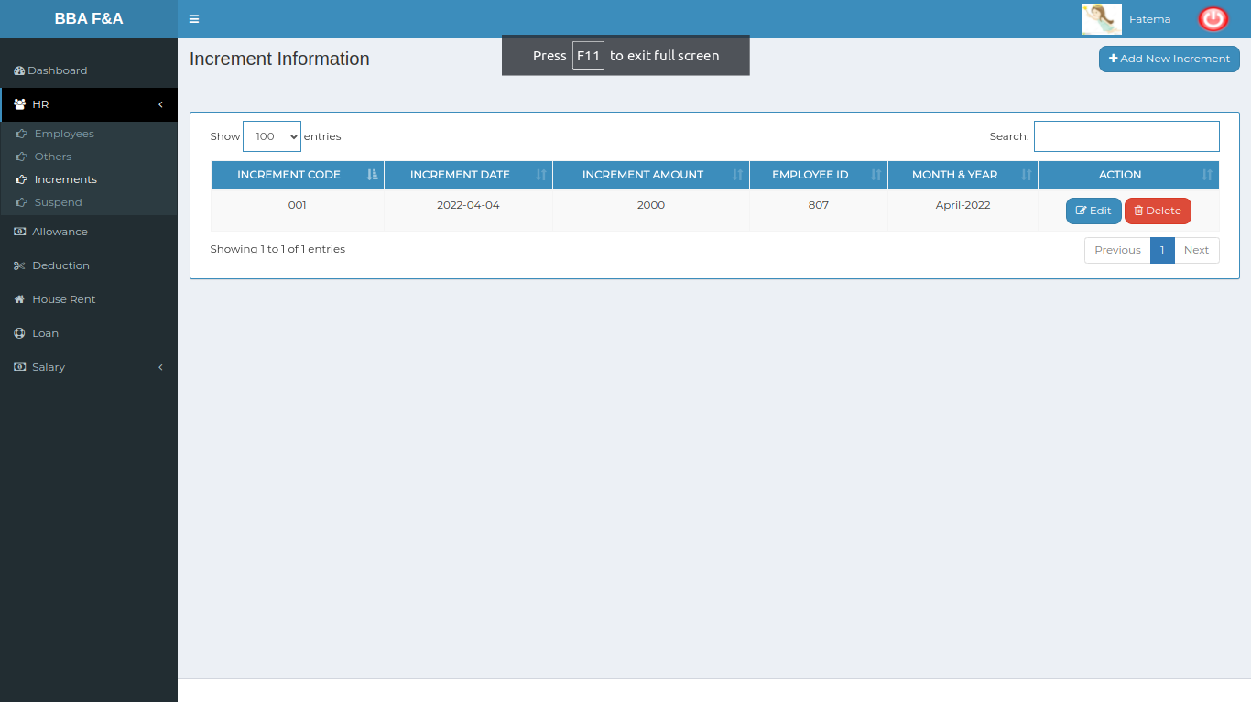

*Positive test case*

|  |  |  |  |  |  |
| --- | --- | --- | --- | --- | --- |
| Case ID | Title | Description | Expected Result | Actual Result | Pass/Fail |
| 1 | Increment Information | 1. Click add increment info to add incremental information of an employee  2. Presence of auto filled increment code  3. Enter increment date  4. Select Employee  5. Enter increment amount, Description details  6. Click add | Added the selected & entered information | Successfully saved | P |

*Negative Test Case*

|  |  |  |  |  |  |
| --- | --- | --- | --- | --- | --- |
| Case ID | Title | Description | Expected Result | Actual Result | Pass/Fail |
| 1 | Increment Information | 1. Date and employee should be selected  2. The text field should be filled up with appropriate text  3. add button should be worked fine | Can’t accept irrelevant data & store the latest information | No error occurred while adding | P |

12. Update Increments Information

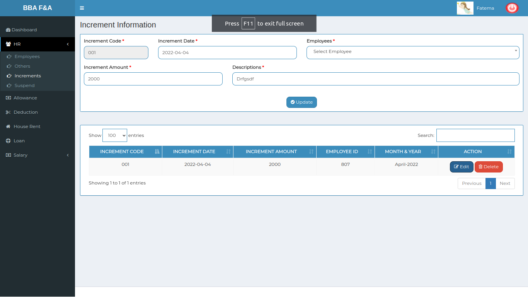

*Positive test case*

|  |  |  |  |  |  |
| --- | --- | --- | --- | --- | --- |
| Case ID | Title | Description | Expected Result | Actual Result | Pass/Fail |
| 1 | Update Information | 1. Click add increment info to add incremental information of an employee  2. Presence of auto filled increment code  3. Enter increment date  4. Select Employee  5. Enter increment amount, Description details  6. Click add | Update the existing information by current data | Successfully updated | P |

*Negative Test Case*

|  |  |  |  |  |  |
| --- | --- | --- | --- | --- | --- |
| Case ID | Title | Description | Expected Result | Actual Result | Pass/Fail |
| 1 | Update Information | 1. Date and employee should be selected  2. The text field should be filled up with appropriate text  3. add button should be worked fine | Can’t accept irrelevant data & store the update information | No error occurred while updating | P |

13. Delete Increments Information

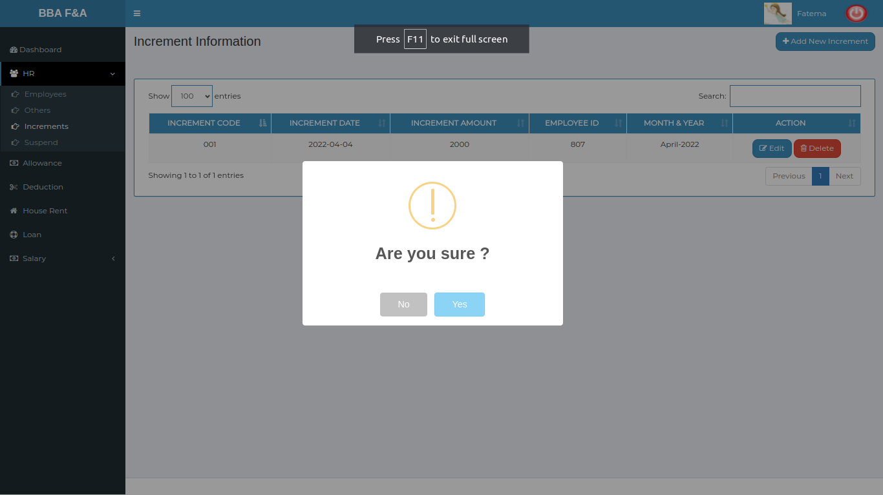

*Positive test case*

|  |  |  |  |  |  |
| --- | --- | --- | --- | --- | --- |
| Case ID | Title | Description | Expected Result | Actual Result | Pass/Fail |
| 1 | Delete incremental Information | Delete an increment information from the list | Delete information from the list | Successfully deleted | P |

*Negative Test Case*

|  |  |  |  |  |  |
| --- | --- | --- | --- | --- | --- |
| Case ID | Title | Description | Expected Result | Actual Result | Pass/Fail |
| 1 | Delete incremental Information | Pressing Yes can do the process successfully | Delete the exact information from database | No more the data in the list | P |

14. Add new increment information

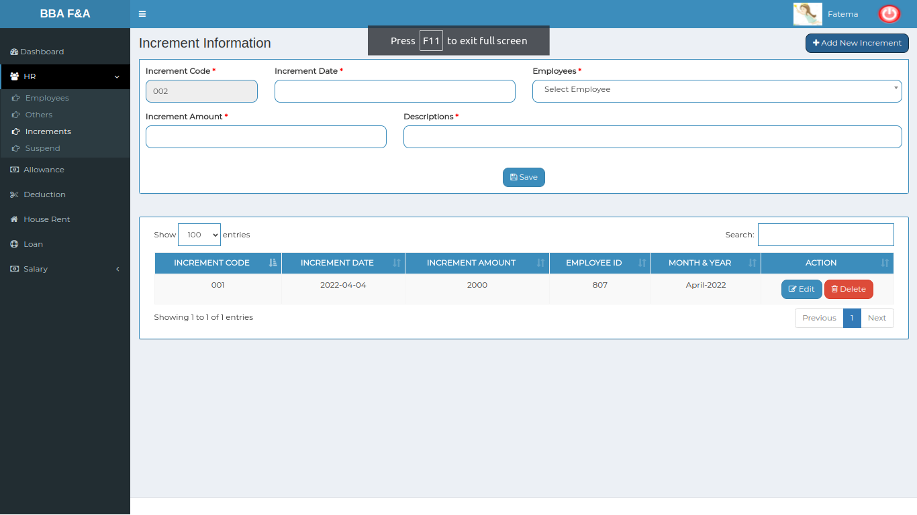

*Positive test case*

|  |  |  |  |  |  |
| --- | --- | --- | --- | --- | --- |
| Case ID | Title | Description | Expected Result | Actual Result | Pass/Fail |
| 1 | Add Increment Information | 1. Click add increment info to add incremental information of an employee  2. Presence of auto filled increment code  3. Enter increment date  4. Select Employee  5. Enter increment amount, Description details  6. Click add | Added the selected & entered information | Successfully saved | P |

*Negative Test Case*

|  |  |  |  |  |  |
| --- | --- | --- | --- | --- | --- |
| Case ID | Title | Description | Expected Result | Actual Result | Pass/Fail |
| 1 | Add Increment Information | 1. Date and employee should be selected  2. The text field should be filled up with appropriate text  3. update button should be worked fine | Can’t accept irrelevant data & store the latest information | No error occurred while adding | P |

**Test Scenario 3: Allowance**

1. Allowance Selection

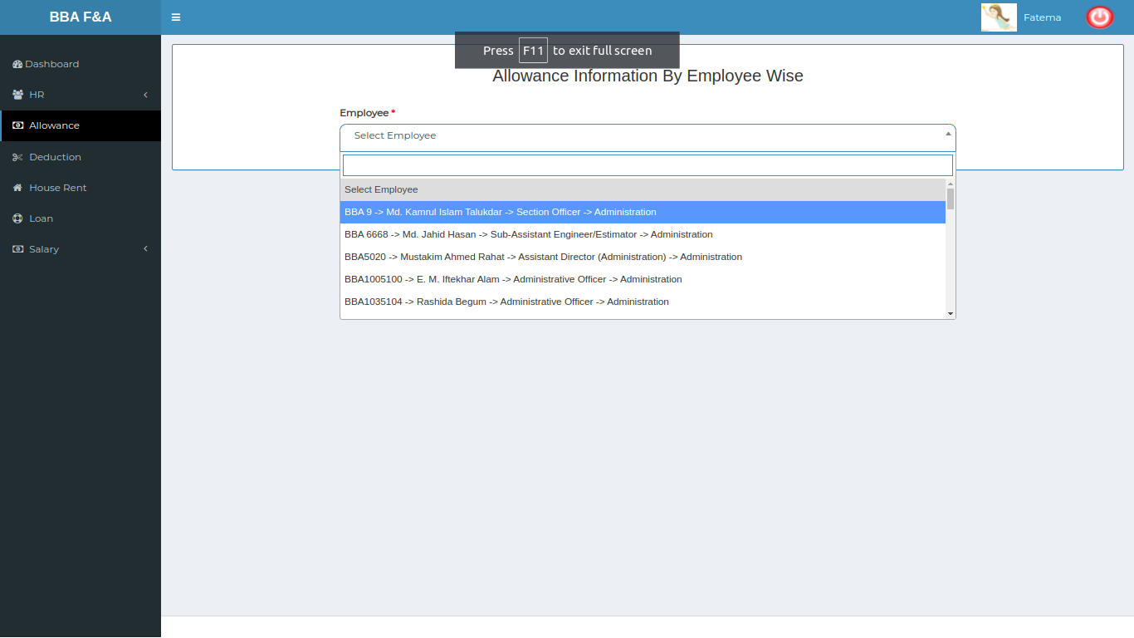

*Positive test case*

|  |  |  |  |  |  |
| --- | --- | --- | --- | --- | --- |
| Case ID | Title | Description | Expected Result | Actual Result | Pass/Fail |
| 1 | Employee Selection | Select an employee to add or update allowance information | Perfectly selected an employee | Data is mounted and selected | P |

*Negative Test Case*

|  |  |  |  |  |  |
| --- | --- | --- | --- | --- | --- |
| Case ID | Title | Description | Expected Result | Actual Result | Pass/Fail |
| 1 | Employee Selection | Employee should be selected | Information is available | No error occurred while accessing | P |

2. Update Allowance Information

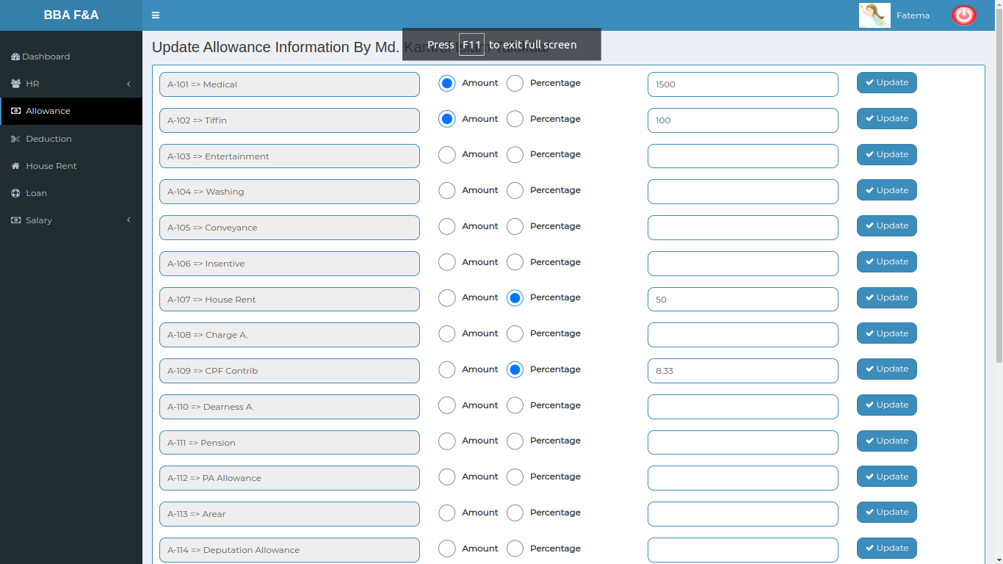

*Positive test case*

|  |  |  |  |  |  |
| --- | --- | --- | --- | --- | --- |
| Case ID | Title | Description | Expected Result | Actual Result | Pass/Fail |
| 1 | Medical | 1. Select amount or percentage  2. Enter Amount or percentage  3. For updating, update amount or percentage  4. Click save | Added the selected & entered information and update the existing information | Successfully saved | P |
| 2 | Tiffin | 1. Select amount or percentage  2. Enter Amount or percentage  3. For updating, update amount or percentage  4. Click save | Added the selected & entered information and update the existing information | Successfully saved | P |
| 3 | Entertainment | 1. Select amount or percentage  2. Enter Amount or percentage  3. For updating, update amount or percentage  4. Click save | Added the selected & entered information and update the existing information | Successfully saved | P |
| 4 | Washing | 1. Select amount or percentage  2. Enter Amount or percentage  3. For updating, update amount or percentage  4. Click save | Added the selected & entered information and update the existing information | Successfully saved | P |
| 5 | Conveyance | 1. Select amount or percentage  2. Enter Amount or percentage  3. For updating, update amount or percentage  4. Click save | Added the selected & entered information and update the existing information | Successfully saved | P |
| 6 | Insentive | 1. Select amount or percentage  2. Enter Amount or percentage  3. For updating, update amount or percentage  4. Click save | Added the selected & entered information and update the existing information | Successfully saved | P |
| 7 | House Rent | 1. Select amount or percentage  2. Enter Amount or percentage  3. For updating, update amount or percentage  4. Click save | Added the selected & entered information and update the existing information | Successfully saved | P |
| 8 | Charge A | 1. Select amount or percentage  2. Enter Amount or percentage  3. For updating, update amount or percentage  4. Click save | Added the selected & entered information and update the existing information | Successfully saved | P |
| 9 | CPF Contrib | 1. Select amount or percentage  2. Enter Amount or percentage  3. For updating, update amount or percentage  4. Click save | Added the selected & entered information and update the existing information | Successfully saved | P |
| 10 | Dearness A. | 1. Select amount or percentage  2. Enter Amount or percentage  3. For updating, update amount or percentage  4. Click save | Added the selected & entered information and update the existing information | Successfully saved | P |
| 11 | Pension | 1. Select amount or percentage  2. Enter Amount or percentage  3. For updating, update amount or percentage  4. Click save | Added the selected & entered information and update the existing information | Successfully saved | P |
| 12 | PA Allowance | 1. Select amount or percentage  2. Enter Amount or percentage  3. For updating, update amount or percentage  4. Click save | Added the selected & entered information and update the existing information | Successfully saved | P |
| 13 | Arear | 1. Select amount or percentage  2. Enter Amount or percentage  3. For updating, update amount or percentage  4. Click save | Added the selected & entered information and update the existing information | Successfully saved | P |
| 14 | Deputation Allowance | 1. Select amount or percentage  2. Enter Amount or percentage  3. For updating, update amount or percentage  4. Click save | Added the selected & entered information and update the existing information | Successfully saved | P |
| 15 | Servant Allowance | 1. Select amount or percentage  2. Enter Amount or percentage  3. For updating, update amount or percentage  4. Click save | Added the selected & entered information and update the existing information | Successfully saved | P |
| 16 | Mobile Bill | 1. Select amount or percentage  2. Enter Amount or percentage  3. For updating, update amount or percentage  4. Click save | Added the selected & entered information and update the existing information | Successfully saved | P |
| 17 | Others | 1. Select amount or percentage  2. Enter Amount or percentage  3. For updating, update amount or percentage  4. Click save | Added the selected & entered information and update the existing information | Successfully saved | P |
| 18 | Domestic Aid | 1. Select amount or percentage  2. Enter Amount or percentage  3. For updating, update amount or percentage  4. Click save | Added the selected & entered information and update the existing information | Successfully saved | P |
| 19 | Education | 1. Click save | Added the selected & entered information and update the existing information | Successfully saved | P |
| 20 | Basic | 1. Select amount or percentage  2. Enter Amount or percentage  3. For updating, update amount or percentage  4. Click save | Added the selected & entered information and update the existing information | Successfully saved | P |
| 21 | Vehicle for Privileged Officers | 1. Select amount or percentage  2. Enter Amount or percentage  3. For updating, update amount or percentage  4. Click save | Added the selected & entered information and update the existing information | Successfully saved | P |
| 22 | Telephone Allowance | 1. Select amount or percentage  2. Enter Amount or percentage  3. For updating, update amount or percentage  4. Click save | Added the selected & entered information and update the existing information | Successfully saved | P |

*Negative Test Case*

|  |  |  |  |  |  |
| --- | --- | --- | --- | --- | --- |
| Case ID | Title | Description | Expected Result | Actual Result | Pass/Fail |
| 1 | Medical | 1. Check the term selected or not  2. value should be valid  3. Save button should be perfectly worked | Can’t accept irrelevant data & store the latest information | No error occurred while adding or updating | P |
| 2 | Tiffin | 1. Check the term selected or not  2. value should be valid  3. Save button should be perfectly worked | Can’t accept irrelevant data & store the latest information | No error occurred while adding or updating | P |
| 3 | Entertainment | 1. Check the term selected or not  2. value should be valid  3. Save button should be perfectly worked | Can’t accept irrelevant data & store the latest information | No error occurred while adding or updating | P |
| 4 | Washing | 1. Check the term selected or not  2. value should be valid  3. Save button should be perfectly worked | Can’t accept irrelevant data & store the latest information | No error occurred while adding or updating | P |
| 5 | Conveyance | 1. Check the term selected or not  2. value should be valid  3. Save button should be perfectly worked | Can’t accept irrelevant data & store the latest information | No error occurred while adding or updating | P |
| 6 | Insentive | 1. Check the term selected or not  2. value should be valid  3. Save button should be perfectly worked | Can’t accept irrelevant data & store the latest information | No error occurred while adding or updating | P |
| 7 | House Rent | 1. Check the term selected or not  2. value should be valid  3. Save button should be perfectly worked | Can’t accept irrelevant data & store the latest information | No error occurred while adding or updating | P |
| 8 | Charge A | 1. Check the term selected or not  2. value should be valid  3. Save button should be perfectly worked | Can’t accept irrelevant data & store the latest information | No error occurred while adding or updating | P |
| 9 | CPF Contrib | 1. Check the term selected or not  2. value should be valid  3. Save button should be perfectly worked | Can’t accept irrelevant data & store the latest information | No error occurred while adding or updating | P |
| 10 | Dearness A. | 1. Check the term selected or not  2. value should be valid  3. Save button should be perfectly worked | Can’t accept irrelevant data & store the latest information | No error occurred while adding or updating | P |
| 11 | Pension | 1. Check the term selected or not  2. value should be valid  3. Save button should be perfectly worked | Can’t accept irrelevant data & store the latest information | No error occurred while adding or updating | P |
| 12 | PA Allowance | 1. Check the term selected or not  2. value should be valid  3. Save button should be perfectly worked | Can’t accept irrelevant data & store the latest information | No error occurred while adding or updating | P |
| 13 | Arear | 1. Check the term selected or not  2. value should be valid  3. Save button should be perfectly worked | Can’t accept irrelevant data & store the latest information | No error occurred while adding or updating | P |
| 14 | Deputation Allowance | 1. Check the term selected or not  2. value should be valid  3. Save button should be perfectly worked | Can’t accept irrelevant data & store the latest information | No error occurred while adding or updating | P |
| 15 | Servant Allowance | 1. Check the term selected or not  2. value should be valid  3. Save button should be perfectly worked | Can’t accept irrelevant data & store the latest information | No error occurred while adding or updating | P |
| 16 | Mobile Bill | 1. Check the term selected or not  2. value should be valid  3. Save button should be perfectly worked | Can’t accept irrelevant data & store the latest information | No error occurred while adding or updating | P |
| 17 | Others | 1. Check the term selected or not  2. value should be valid  3. Save button should be perfectly worked | Can’t accept irrelevant data & store the latest information | No error occurred while adding or updating | P |
| 18 | Domestic Aid | 1. Check the term selected or not  2. value should be valid  3. Save button should be perfectly worked | Can’t accept irrelevant data & store the latest information | No error occurred while adding or updating | P |
| 19 | Education | 1. Check the term selected or not  2. Save button should be perfectly worked | Can’t accept irrelevant data & store the latest information | No error occurred while adding or updating | P |
| 20 | Basic | 1. Check the term selected or not  2. value should be valid  3. Save button should be perfectly worked | Can’t accept irrelevant data & store the latest information | No error occurred while adding or updating | P |
| 21 | Vehicle for Privileged Officers | 1. Check the term selected or not  2. value should be valid  3. Save button should be perfectly worked | Can’t accept irrelevant data & store the latest information | No error occurred while adding or updating | P |
| 22 | Telephone Allowance | 1. Check the term selected or not  2. value should be valid  3. Save button should be perfectly worked | Can’t accept irrelevant data & store the latest information | No error occurred while adding or updating | P |

**Test Scenario 3: Deduction**

1. Deduction Selection

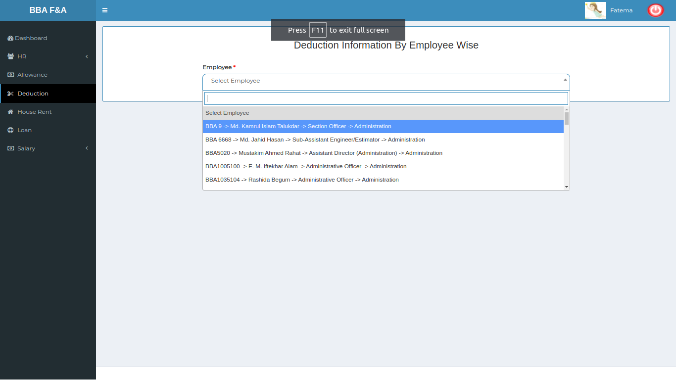

*Positive test case*

|  |  |  |  |  |  |
| --- | --- | --- | --- | --- | --- |
| Case ID | Title | Description | Expected Result | Actual Result | Pass/Fail |
| 1 | Employee Selection | Select an employee | Perfectly selected an employee | Data is mounted and selected | P |

*Negative Test Case*

|  |  |  |  |  |  |
| --- | --- | --- | --- | --- | --- |
| Case ID | Title | Description | Expected Result | Actual Result | Pass/Fail |
| 1 | Employee Selection | Employee should be selected | Information is available | No error occurred while accessing | P |

2. Update Deduction Information

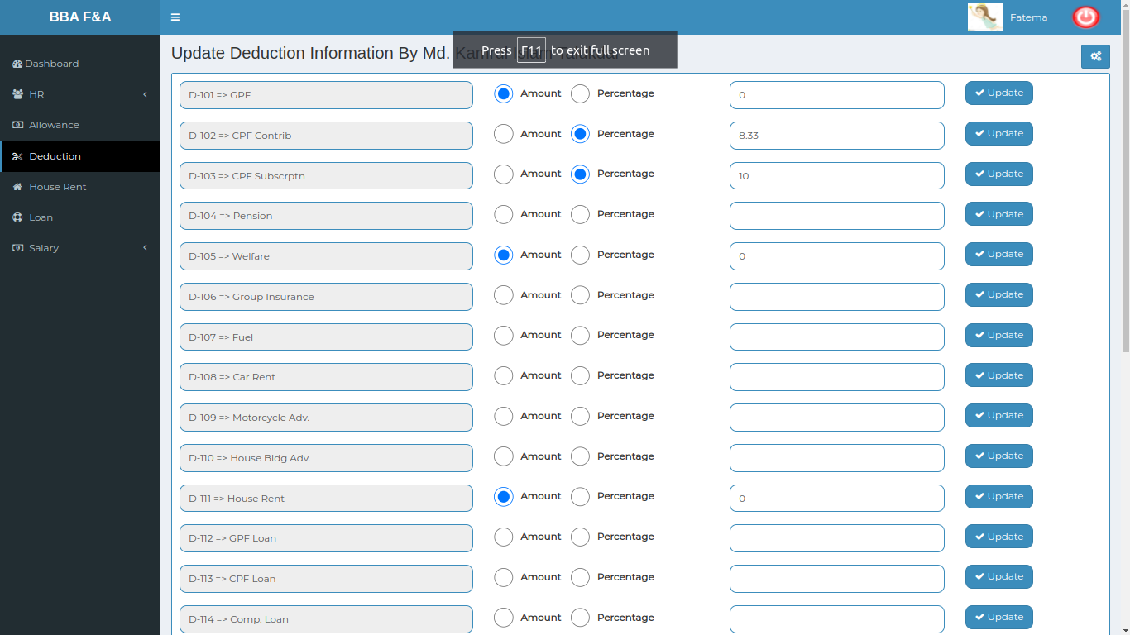

*Positive test case*

|  |  |  |  |  |  |
| --- | --- | --- | --- | --- | --- |
| Case ID | Title | Description | Expected Result | Actual Result | Pass/Fail |
| 1 | GPF | 1. Select amount or percentage  2. Enter Amount or percentage  3. For updating, update amount or percentage  4. Click save | Added the selected & entered information and update the existing information | Successfully saved | P |
| 2 | CPF Contribution | 1. Select amount or percentage  2. Enter Amount or percentage  3. For updating, update amount or percentage  4. Click save | Added the selected & entered information and update the existing information | Successfully saved | P |
| 3 | CPF Subscription | 1. Select amount or percentage  2. Enter Amount or percentage  3. For updating, update amount or percentage  4. Click save | Added the selected & entered information and update the existing information | Successfully saved | P |
| 4 | Pension | 1. Select amount or percentage  2. Enter Amount or percentage  3. For updating, update amount or percentage  4. Click save | Added the selected & entered information and update the existing information | Successfully saved | P |
| 5 | Welfare | 1. Select amount or percentage  2. Enter Amount or percentage  3. For updating, update amount or percentage  4. Click save | Added the selected & entered information and update the existing information | Successfully saved | P |
| 6 | Group Insurance | 1. Select amount or percentage  2. Enter Amount or percentage  3. For updating, update amount or percentage  4. Click save | Added the selected & entered information and update the existing information | Successfully saved | P |
| 7 | Fuel | 1. Select amount or percentage  2. Enter Amount or percentage  3. For updating, update amount or percentage  4. Click save | Added the selected & entered information and update the existing information | Successfully saved | P |
| 8 | Car Rent | 1. Select amount or percentage  2. Enter Amount or percentage  3. For updating, update amount or percentage  4. Click save | Added the selected & entered information and update the existing information | Successfully saved | P |
| 9 | Motorcycle Adv. | 1. Select amount or percentage  2. Enter Amount or percentage  3. For updating, update amount or percentage  4. Click save | Added the selected & entered information and update the existing information | Successfully saved | P |
| 10 | House Bldg Adv. | 1. Select amount or percentage  2. Enter Amount or percentage  3. For updating, update amount or percentage  4. Click save | Added the selected & entered information and update the existing information | Successfully saved | P |
| 11 | House Rent | 1. Select amount or percentage  2. Enter Amount or percentage  3. For updating, update amount or percentage  4. Click save | Added the selected & entered information and update the existing information | Successfully saved | P |
| 12 | GPF Loan | 1. Select amount or percentage  2. Enter Amount or percentage  3. For updating, update amount or percentage  4. Click save | Added the selected & entered information and update the existing information | Successfully saved | P |
| 13 | CPF Loan | 1. Select amount or percentage  2. Enter Amount or percentage  3. For updating, update amount or percentage  4. Click save | Added the selected & entered information and update the existing information | Successfully saved | P |
| 14 | Comp. Loan | 1. Select amount or percentage  2. Enter Amount or percentage  3. For updating, update amount or percentage  4. Click save | Added the selected & entered information and update the existing information | Successfully saved | P |
| 15 | Telephone Bill | 1. Select amount or percentage  2. Enter Amount or percentage  3. For updating, update amount or percentage  4. Click save | Added the selected & entered information and update the existing information | Successfully saved | P |
| 16 | Gas Bill | 1. Select amount or percentage  2. Enter Amount or percentage  3. For updating, update amount or percentage  4. Click save | Added the selected & entered information and update the existing information | Successfully saved | P |
| 17 | Electric Bill | 1. Select amount or percentage  2. Enter Amount or percentage  3. For updating, update amount or percentage  4. Click save | Added the selected & entered information and update the existing information | Successfully saved | P |
| 18 | WASA Bill | 1. Select amount or percentage  2. Enter Amount or percentage  3. For updating, update amount or percentage  4. Click save | Added the selected & entered information and update the existing information | Successfully saved | P |
| 19 | Ctax | 1. Select amount or percentage  2. Enter Amount or percentage  3. For updating, update amount or percentage  4. Click save | Added the selected & entered information and update the existing information | Successfully saved | P |
| 20 | Income Tax | 1. Select amount or percentage  2. Enter Amount or percentage  3. For updating, update amount or percentage  4. Click save | Added the selected & entered information and update the existing information | Successfully saved | P |
| 21 | Other Deduction | 1. Select amount or percentage  2. Enter Amount or percentage  3. For updating, update amount or percentage  4. Click save | Added the selected & entered information and update the existing information | Successfully saved | P |
| 22 | Vehicle Loan for Privileged Officer | 1. Select amount or percentage  2. Enter Amount or percentage  3. For updating, update amount or percentage  4. Click save | Added the selected & entered information and update the existing information | Successfully saved | P |
| 23 | Welfare Loan | 1. Select amount or percentage  2. Enter Amount or percentage  3. For updating, update amount or percentage  4. Click save | Added the selected & entered information and update the existing information | Successfully saved | P |
| 24 | Revenue Stamp | 1. Select amount or percentage  2. Enter Amount or percentage  3. For updating, update amount or percentage  4. Click save | Added the selected & entered information and update the existing information | Successfully saved | P |
| 25 | Service Charge | 1. Select amount or percentage  2. Enter Amount or percentage  3. For updating, update amount or percentage  4. Click save | Added the selected & entered information and update the existing information | Successfully saved | P |

*Negative Test Case*

|  |  |  |  |  |  |
| --- | --- | --- | --- | --- | --- |
| Case ID | Title | Description | Expected Result | Actual Result | Pass/Fail |
| 1 | GPF | 1. Check the term selected or not  2. value should be valid  3. update button should be perfectly worked | Can’t accept irrelevant data & store the latest information | No error occurred while adding or updating | P |
| 2 | CPF Contribution | 1. Check the term selected or not  2. value should be valid  3. update button should be perfectly worked | Can’t accept irrelevant data & store the latest information | No error occurred while adding or updating | P |
| 3 | CPF Subscription | 1. Check the term selected or not  2. value should be valid  3. update button should be perfectly worked | Can’t accept irrelevant data & store the latest information | No error occurred while adding or updating | P |
| 4 | Pension | 1. Check the term selected or not  2. value should be valid  3. update button should be perfectly worked | Can’t accept irrelevant data & store the latest information | No error occurred while adding or updating | P |
| 5 | Welfare | 1. Check the term selected or not  2. value should be valid  3. update button should be perfectly worked | Can’t accept irrelevant data & store the latest information | No error occurred while adding or updating | P |
| 6 | Group Insurance | 1. Check the term selected or not  2. value should be valid  3. update button should be perfectly worked | Can’t accept irrelevant data & store the latest information | No error occurred while adding or updating | P |
| 7 | Fuel | 1. Check the term selected or not  2. value should be valid  3. update button should be perfectly worked | Can’t accept irrelevant data & store the latest information | No error occurred while adding or updating | P |
| 8 | Car Rent | 1. Check the term selected or not  2. value should be valid  3. update button should be perfectly worked | Can’t accept irrelevant data & store the latest information | No error occurred while adding or updating | P |
| 9 | Motorcycle Adv. | 1. Check the term selected or not  2. value should be valid  3. update button should be perfectly worked | Can’t accept irrelevant data & store the latest information | No error occurred while adding or updating | P |
| 10 | House Bldg Adv. | 1. Check the term selected or not  2. value should be valid  3. update button should be perfectly worked | Can’t accept irrelevant data & store the latest information | No error occurred while adding or updating | P |
| 11 | House Rent | 1. Check the term selected or not  2. value should be valid  3. update button should be perfectly worked | Can’t accept irrelevant data & store the latest information | No error occurred while adding or updating | P |
| 12 | GPF Loan | 1. Check the term selected or not  2. value should be valid  3. update button should be perfectly worked | Can’t accept irrelevant data & store the latest information | No error occurred while adding or updating | P |
| 13 | CPF Loan | 1. Check the term selected or not  2. value should be valid  3. update button should be perfectly worked | Can’t accept irrelevant data & store the latest information | No error occurred while adding or updating | P |
| 14 | Comp. Loan | 1. Check the term selected or not  2. value should be valid  3. update button should be perfectly worked | Can’t accept irrelevant data & store the latest information | No error occurred while adding or updating | P |
| 15 | Telephone Bill | 1. Check the term selected or not  2. value should be valid  3. update button should be perfectly worked | Can’t accept irrelevant data & store the latest information | No error occurred while adding or updating | P |
| 16 | Gas Bill | 1. Check the term selected or not  2. value should be valid  3. update button should be perfectly worked | Can’t accept irrelevant data & store the latest information | No error occurred while adding or updating | P |
| 17 | Electric Bill | 1. Check the term selected or not  2. value should be valid  3. update button should be perfectly worked | Can’t accept irrelevant data & store the latest information | No error occurred while adding or updating | P |
| 18 | WASA Bill | 1. Check the term selected or not  2. value should be valid  3. update button should be perfectly worked | Can’t accept irrelevant data & store the latest information | No error occurred while adding or updating | P |
| 19 | Ctax | 1. Check the term selected or not  2. value should be valid  3. update button should be perfectly worked | Can’t accept irrelevant data & store the latest information | No error occurred while adding or updating | P |
| 20 | Income Tax | 1. Check the term selected or not  2. value should be valid  3. update button should be perfectly worked | Can’t accept irrelevant data & store the latest information | No error occurred while adding or updating | P |
| 21 | Other Deduction | 1. Check the term selected or not  2. value should be valid  3. update button should be perfectly worked | Can’t accept irrelevant data & store the latest information | No error occurred while adding or updating | P |
| 22 | Vehicle Loan for Privileged Officer | 1. Check the term selected or not  2. value should be valid  3. update button should be perfectly worked | Can’t accept irrelevant data & store the latest information | No error occurred while adding or updating | P |
| 23 | Welfare Loan | 1. Check the term selected or not  2. value should be valid  3. update button should be perfectly worked | Can’t accept irrelevant data & store the latest information | No error occurred while adding or updating | P |
| 24 | Revenue Stamp | 1. Check the term selected or not  2. value should be valid  3. update button should be perfectly worked | Can’t accept irrelevant data & store the latest information | No error occurred while adding or updating | P |
| 25 | Service Charge | 1. Check the term selected or not  2. value should be valid  3. update button should be perfectly worked | Can’t accept irrelevant data & store the latest information | No error occurred while adding or updating | P |

**Test Scenario 4: Loan**

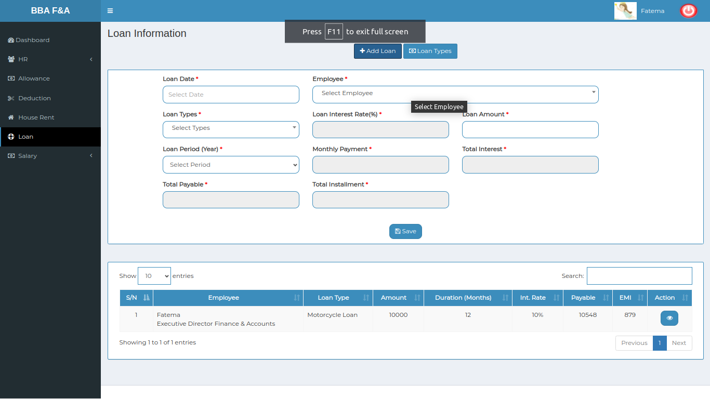

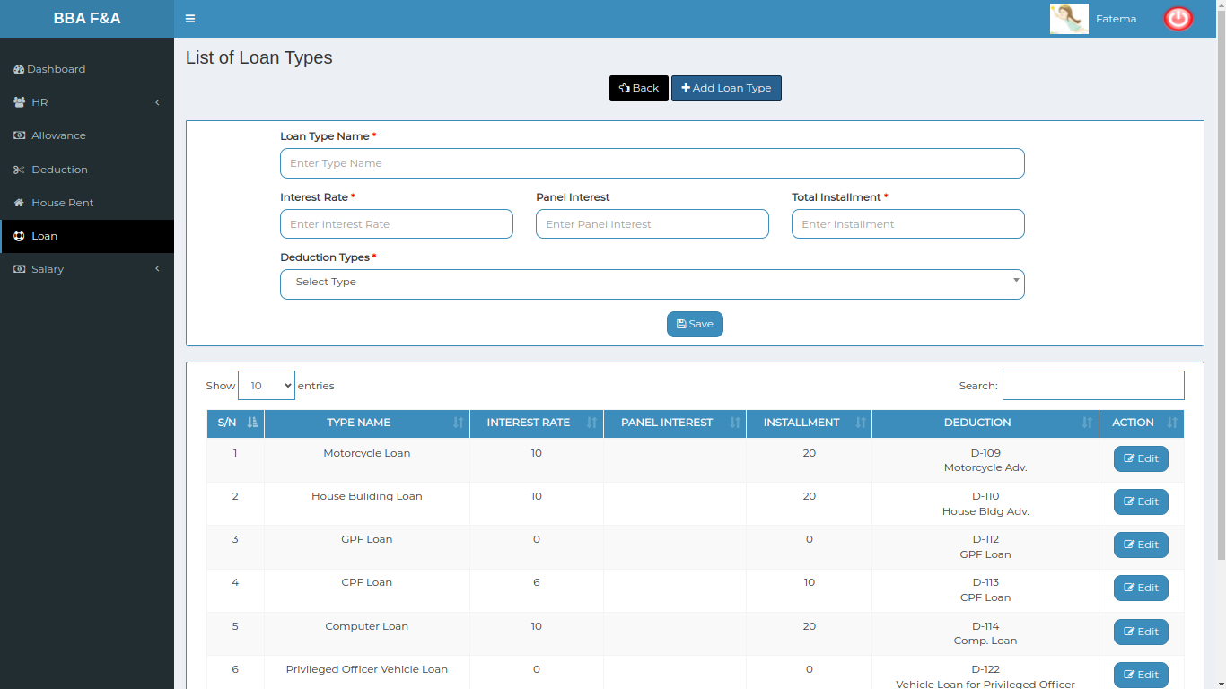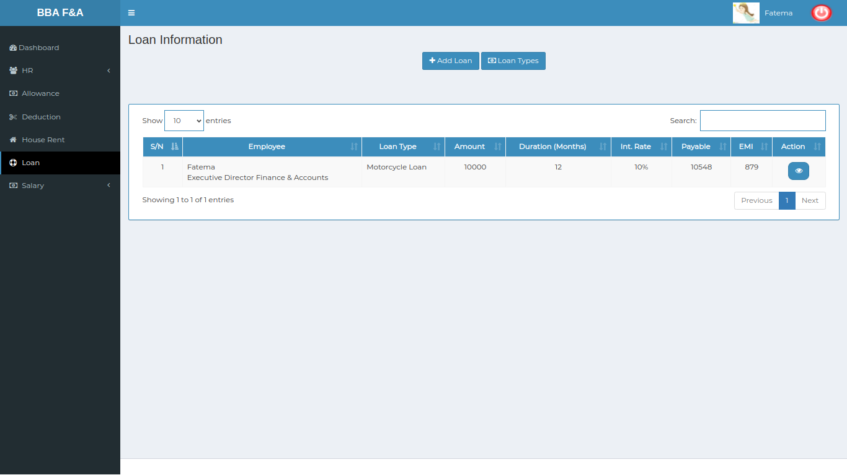

*Positive test case*

|  |  |  |  |  |  |
| --- | --- | --- | --- | --- | --- |
| Case ID | Title | Description | Expected Result | Actual Result | Pass/Fail |
| 1 | Add Loan | 1. Select employee & loan types  2. Enter loan amount, loan period, total installment & Given installment  3. Click save | Added the selected & entered information | Successfully saved | P |
| 2 | Loan Types | 1. Enter Loan Type, Interest rate, Panel interest  2. Select deduction types  3. Click save  4. click edit button to update loan types | Added the selected & entered information and update the existing information | Successfully saved | P |
| 3 | Loan Information | 1. Type in searching field to find specific employee Loan information  2. Click pay button to pay amount  3. Enter pay loan amount & pay loan installment  4. Click pay | Added the selected & entered information | Successfully saved | P |

*Negative Test Case*

|  |  |  |  |  |  |
| --- | --- | --- | --- | --- | --- |
| Case ID | Title | Description | Expected Result | Actual Result | Pass/Fail |
| 1 | Add Loan | 1. Employee & loan types should be selected  2. Loan amount, period, total installment & given installment should be entered  3. save button should work fine | Can’t accept irrelevant data & store the latest information | No error occurred while adding or updating | P |
| 2 | Loan Types | 1. Loan type and interest should be entered  2. deduction type should be selected  3. save button should work fine  4. edit button can update loan types smoothly | Can’t accept irrelevant data & store the latest information | No error occurred while adding or updating | P |
| 3 | Loan Information | Pay button should work fine & amount should be properly calculated | Can’t accept irrelevant data & store the latest information | No error occurred while adding or updating | P |

**Test Scenario 5: Salary**

1. Salary Process

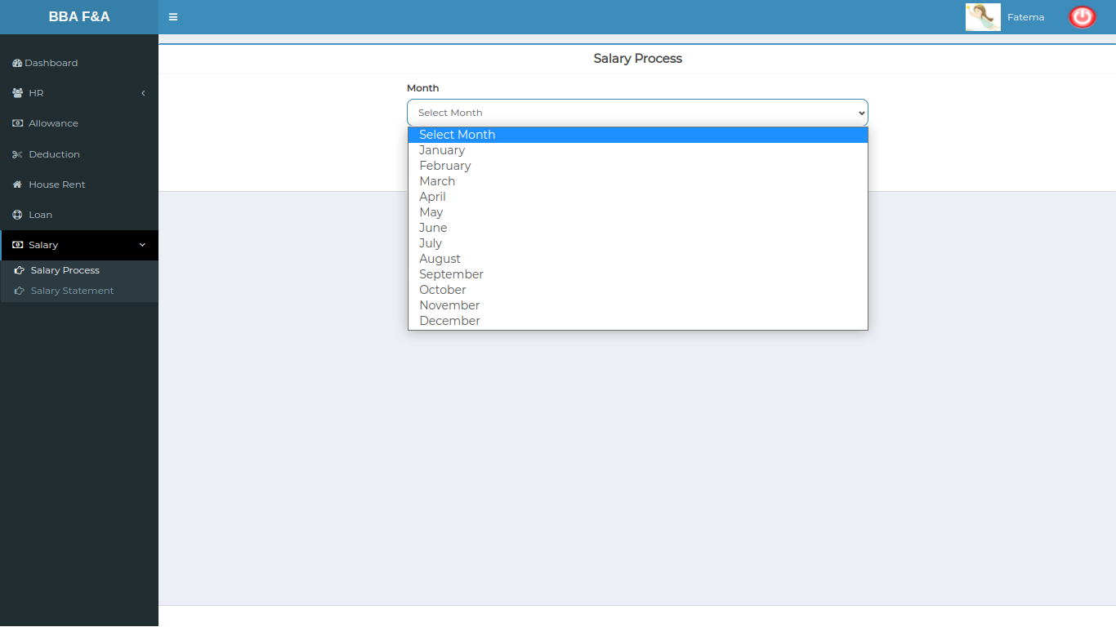

*Positive test case*

|  |  |  |  |  |  |
| --- | --- | --- | --- | --- | --- |
| Case ID | Title | Description | Expected Result | Actual Result | Pass/Fail |
| 1 | Salary Process | 1. Select month  2. Click process | Salary is processed | Processed successfully | P |

*Negative Test Case*

|  |  |  |  |  |  |
| --- | --- | --- | --- | --- | --- |
| Case ID | Title | Description | Expected Result | Actual Result | Pass/Fail |
| 1 | Salary Process | Current Month Should be selected | Selected data | Saved successfully | P |

2. Salary Statement

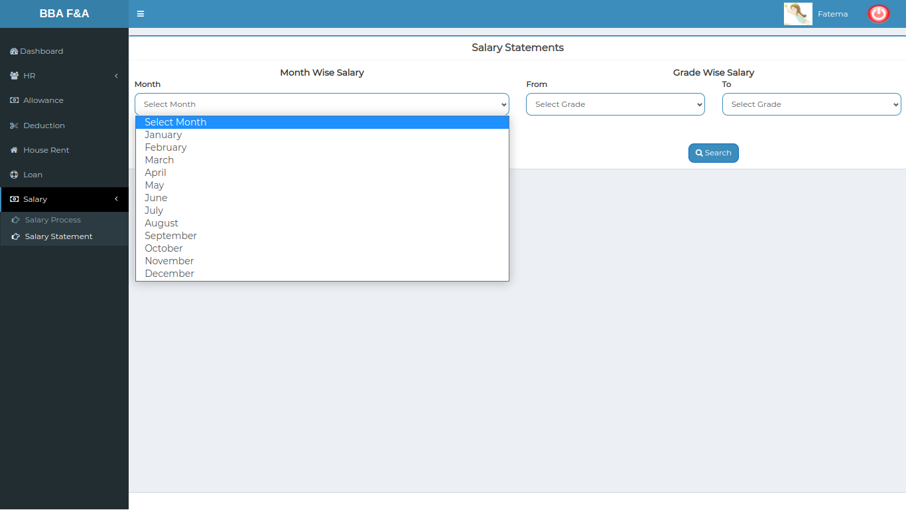

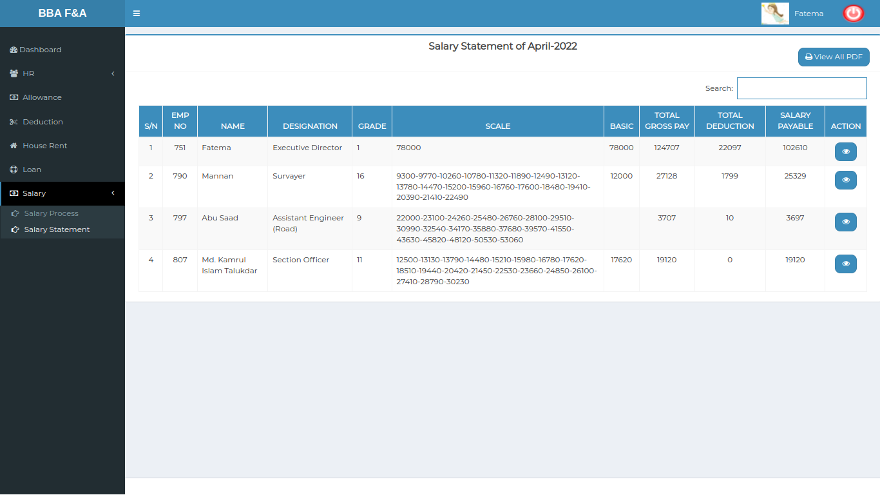

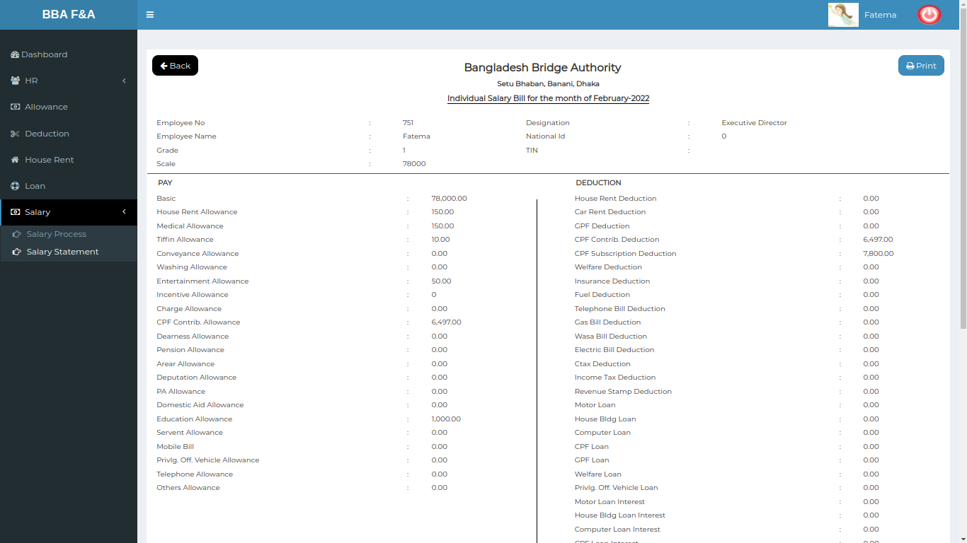

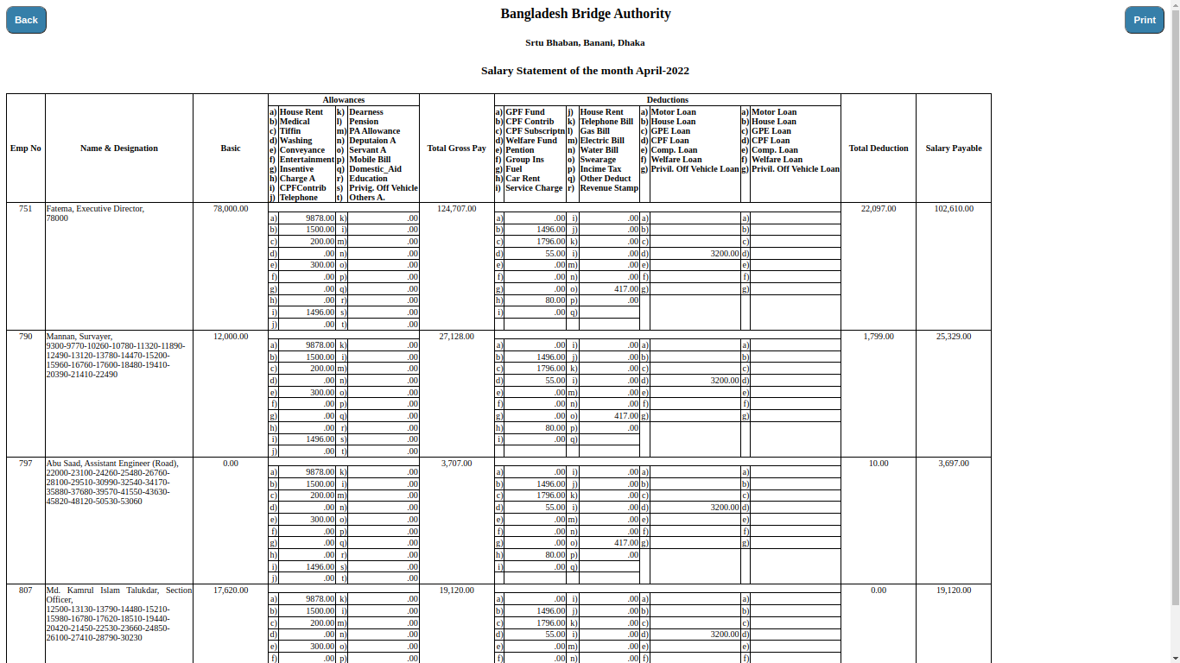

*Positive test case*

|  |  |  |  |  |  |
| --- | --- | --- | --- | --- | --- |
| Case ID | Title | Description | Expected Result | Actual Result | Pass/Fail |
| 1 | Month Selection | 1. Select month  2. Click search | Statement executed for the selected month | Processed successfully | P |
| 2 | Salary Statement | Salary statement is listed | Listed statement | Show successfully | P |
| 3 | Individual Salary Report | Click view to see individual salary report | Generated report | Report have all information | P |
| 4 | Final Salary | Click view all pdf to see all employee salary statement in document | Save in pdf format | Can download or save it | P |

*Negative Test Case*

|  |  |  |  |  |  |
| --- | --- | --- | --- | --- | --- |
| Case ID | Title | Description | Expected Result | Actual Result | Pass/Fail |
| 1 | Month Selection | Month should be selected | Selected data no error | Saved successfully | P |
| 2 | Salary Statement | Process can be done for all employee salaries | No error occurred | Successfully operated | P |
| 3 | Individual Salary Report | Individual statement can be printed in document format | Report has exact information | No information is missing | P |
| 4 | Final Salary | Final Salary should be generated in PDF format | Report has a download option | Successfully saved it | P |