**Software Documentation for the FDR management system**

**Product Name: Fixed Deposit Receipt**

Release Version:

Testing Started:

Testing Completed:

Technical Lead:

Product Owner: BBA

Primary Tester:

Developer:

Types of Test Performed:

**Browser Tested:**

1. Chrome

2. Mozilla Firefox

**Device Tested:**

1. Desktop

2. Laptop

3. Tab

4. Smartphone

**Instance Tested:**

1. Development

2. Testing

3. Production

4. UAT

**Table of Contents**

Revision History 4

Design Specification 5

Abstract 6

Chapter-1: Introduction 7

1.1 Review of the Fixed deposit receipt management system 7

1.2 Motivation 7

1.3 Aims and Objective 7

1.4 Solution Methodology 7

Chapter - 2. Background Study 9

2.1 FDR 9

2.2 Why should we use this software system ? 9

2.3 User Experience 9

2.4.4 Benefits 9

2.4.5 Role of the Account & Budget Information 10

2.4.6 Report & Analysis 10

2.5 FDR main modules 10

2.6 FDR Management Highlights 11

2.7 Things to Check in a Fixed Deposit Receipt 11

2.8 Frequently Asked Questions on Fixed Deposit Receipt 11

Chapter – 3: Software Requirement Analysis 13

3.1 Introduction 13

3.2 Problem Analysis 13

3.3 Requirement 13

3.4 Software Requirement Specifications 13

3.4.1 SRS Scopes 13

3.4.2 Functional Requirements 13

3.4.3 Non-functional Requirement 13

3.5 Interface Requirement 14

3.5.1 User Interface 14

3.5.2 Hardware Interface 14

3.5.3 Software interface 15

3.5.4 Communication Interface 15

3.6 SRS table 15

3.6 Report Analysis 15

Chapter – 4: System Design 17

4.1 Algorithm Design 17

4.2 Process Flow Diagram 17

4.3 Data flow Diagram 18

Chapter – 5: Testing Documentation 19

5.1 Introduction 19

5.2 Scopes 19

5.3 Quality Objective 19

5.4 Testing Methodology 20

5.4.1 Model 20

5.4.2 Strategies 20

5.4.3 Levels 20

5.4.4 Test Deliverables 20

5.4.5 Tools 21

Test Cases with Result 21

Test Scenario 1: Dashboard 21

Test Scenario 2: Settings 22

Test Scenario 3: FDR create 24

Test Scenario 4: BBA FDR 25

Test Scenario 5: Depreciation FDR 27

Test Scenario 6: Report 29

# Revision History

|  |  |  |  |
| --- | --- | --- | --- |
| Date | Version | Description | Author |
|  |  |  |  |
|  |  |  |  |
|  |  |  |  |
|  |  |  |  |

# Design Specification

**Overview:**

Fixed Deposit Management system involves into the Management Control System that is the vital part of Account & Finance Management System. It is operated through client & server side communication. For developing the system, back-end & front-end part generalize the whole functionality.

**The Back-end part:**

1. Node.js

2. Database → Oracle

3. MS Server Version 2.0

**The Front-end part:**

1. React.js

2. Bootstrap

3. Domain → Friendly

# Abstract

A fixed deposit receipt (FDR) is a financial instrument provided by banks in Bangladesh which provides investors with a higher rate of interest than a regular savings account, until the given maturity date. Fixed Deposit Receipt (FDR) As one of the most common savings and investment options used by individuals, fixed deposits are risk free and offer guaranteed returns. Fixed deposits provide investors with an interest rate that is higher than what is offered on normal savings accounts. Our aim is to design such software system that performs all the terms and conditional statement of fixed deposit receipt management system.

# Chapter-1: Introduction

In this chapter we will focus on the status of the current management system and some of the goals for the progress of this system. That is why we will continue to move towards the future by overviewing some current systems. In the following sections, these terms have been discussed in details.

https://www.bankbazaar.com/fixed-deposit/fd-receipt.html

## 1.1 Review of the Fixed deposit receipt management system

The control of expenditure is usually the most important aspect for any viable undertaking as institutions are always under pressure to achieve their targets within limited resources. Budgetary control allows for monitoring of proper use of available funds at a reasonable frequency. It enables periodic statements of accounts to be prepared comparing budgets and actual results. Budgets are a core feature of control systems. The Organization will prepare budget that translates work plans into projections of expenditure. These will be prepared on an annual basis and updated regularly during the year.

## 1.2 Motivation

Implementation of a company’s strategic plan often begins by determining management’s basic expectations about future economic, competitive, and technological conditions, and their effects on anticipated goals, both long-term and short-term. Many firms at this stage conduct a situational analysis that involves examining their strengths and weaknesses and the external opportunities available and the threats that they might face from competitor.

## 1.3 Aims and Objective

Our aims is to achieve a good transport system that has ability to fulfill our requirements.

* Platform Independent
* Auto Synchronizing
* Friendly Environment
* Domain and Hosting
* Generate Each section Report
* Multi-functionality
* BBA & Depreciation FDR availability
* Report Generating

## 1.4 Solution Methodology

* Design Bank Information
* FDR design to create BBA & Depreciation FDR
* Design & Describe BBA & Depreciation FDR
* Generate a design for reporting a specific FDR

# Chapter - 2. Background Study

https://www.paisabazaar.com/fixed-deposit/fixed-deposit-receipt/

## 2.1 FDR

As one of the most common savings and investment options used by individuals, fixed deposits are risk free and offer guaranteed returns. Fixed deposits provide investors with an interest rate that is higher than what is offered on normal savings accounts. The maturity value of a fixed deposit is based on the date of maturity chosen by the individual. Individuals opt for fixed deposits as they are not risky and also provide assured returns, even if these returns are not very high such as those provided by mutual investments and equities.

Applicants can procure Fixed Deposits by visiting their bank or even on their bank’s website as many banks have enabled the facility of providing fixed deposits online. Once applicants apply for their fixed deposit scheme and all formalities are complete, they will receive a fixed deposit receipt as an acknowledgment. This is an important document and should be kept safely.

## 2.2 Why should we use this software system ?

The purpose of this software is to define the functionality and specifications of the design of a web application for Managing Employees and their payroll. The expected audiences of this software system are the developers and the admin of the web application. Now with the help of this system the admin has the information on his finger tips and can easily prepare a good record based on their requirements. Finally, we can say that this system will not only automate the process but save the valuable time of the manager or the admin, which can be well utilized buy his institute. This will be an additional advantage and management of power based on their free time from his normal duty.

## 2.3 User Experience

This software system is built keeping in mind that it is to be used by only one user that is the admin.

### 2.4.4 Benefits

* Save time - Manually it takes a lot of time while storing the lease information
* Resources - except this software system, the gathering of lease information will be

difficult as there need a lot of man power resources in rural and urban areas.

* Reusable - the system can be reused in the similar types of management.
* It is cost effective as the user control the web application himself and does not go for

professional service.

* It saves time as it speeds up every aspect of the employee database management and

payroll process with a range of automated features.

* Validating procedures and checks restrict user from making mistakes.
* The software is easy to use and is user friendly so no expertise is required.
* The calculations are automated so no chance of error.

### 2.4.5 Role of the Account & Budget Information

A Fixed Deposit Receipt contains all the details related to the deposit option procured by the individual. These details include:

* Name of the applicant
* Age of the applicant
* Account Number of the applicant
* Amount of principal that has been placed
* Rate of Interest that is applicable
* Date of Maturity
* Amount of interest that the individual will receive on maturity
* Instructions regarding maturity date such as account transfer or rollover amount

The Fixed deposit receipt acts as an acknowledgment and proof of the ownership of the fixed deposit account by a particular individual.. Apart from this, this receipt contains every single detail pertaining to the fixed deposit such as interest applicable, term and so on. Hence this receipt is a very important document and must be in the possession of the applicant.

### 2.4.6 Report & Analysis

The software system has been developed to overcome the problems faced in the practicing of manual system. This software is built to eliminate and in some cases reduce the hardships faced by the existing system. Moreover this system is designed for particular need of the company to carry out its operations in a smooth and effective manner. This web application is reduced as much as possible to avoid errors while entering data. It also provides error message while entering invalid data. It is user-friendly as no formal knowledge is required to use the system. Human resource challenges are faced by every organization which has to be overcome by the organization. Every organization has different employee account and budget management needs. Therefore I have design exclusive Employee and payroll Management System that are adapted to the organization’s Managerial Requirements.

## 

## 2.5 FDR main modules

The following features are the main things of account and budget management system.

1. Settings - Bank Information
2. FDR create
3. BBA FDR
4. Depreciation FDR
5. Report

## 2.6 FDR Management Highlights

A Fixed Deposit Receipt is proof that the depositor has kept a certain amount for a specified time period at the prevailing fixed rate of interest locked in the bank. This receipt or document contains every single detail of the scheme. The contents of the Fixed Deposit Receipt have been mentioned below:

* Declaration by the bank
* Name and age of the depositor
* Account number linked to the FD
* Total amount deposited (Principal amount)
* Tenure/Term of the deposit
* The applicable rate of interest on the deposit
* Booking date
* Maturity date
* Interest that the depositor will get on maturity
* Nominee
* Deposit and scheme related instructions

## 2.7 Things to Check in a Fixed Deposit Receipt

When individuals receive their Fixed Deposit Receipt, the following are the things that they need to check for:

* Term and interest rate offered
* Auto renewal and date of maturity
* Penalty for Prepayment
* Nomination
* Declaration to save TDS (Tax Deducted at Source)

## 2.8 Frequently Asked Questions on Fixed Deposit Receipt

1. Can a fixed deposit be procured online?

Yes, numerous banks offer customers the option to procure a fixed deposit scheme through their online banking facilities.

1. Does the fixed deposit receipt provide information related to nomination?

Yes, the fixed deposit receipt contains all details of the nominees provided by the individual. These nominees receive the funds in case of the holder’s untimely death.

1. Does the fixed deposit receipt provide information about tax declaration?

Yes, the fixed deposit receipt contains information regarding the tax that may or may not be deducted and also declaration to save tax, if any.

1. Do applicants receive tax benefits when they procure a fixed deposit?

Yes, applicants receive tax benefits when they procure a plan with tenure of over five years. These details may vary from bank to bank and is more prudent for the individual to enquire at the bank again.

# Chapter – 3: Software Requirement Analysis

## 3.1 Introduction

A software requirement is a field within software engineering that deals with establishing

the needs of stakeholders that are to be solved by software. The IEEE Standard Glossary of

Software Engineering Terminology defines requirements.

## 3.2 Problem Analysis

The process of manually calculating salary causes some problems in the management. Problems faced by several section today are:

1. A large number of company employees who constantly growing raises wage calculation process becomes longer and not effective.
2. The possibility of human error in the calculation of salaries
3. To search for data takes a long time because data is not stored properly.

## 3.3 Requirement

The Transport Management System Requirements provides high-level of functional requirements.

## 3.4 Software Requirement Specifications

* Documentation (user and administration)
* Operational behavior
* Technical Support

### 3.4.1 SRS Scopes

The FDR management system is the part of account and finance module.

### 3.4.2 Functional Requirements

Every section has a specific functionality that’s are given below:

* Login Functionality
* FDR creation
* Report – download a copy of corresponding section

### 3.4.3 Non-functional Requirement

For an specific criteria, there should be applied non-functional requirements which are

shortly described below:

**Reliability**

The operational interface can’t fail within a period of time.

**Availability**

The system is available or not while a user wants access the information.

**Security**

All user can login to the system with secured procedure. Each user has a unique

identification system. Admin can store user’s login information.

**Maintainability**

All source code and related document should be controlled under a version of the

system.

**Portability**

As the software run into several platform, the platform independence should be ensure.

Different OS can access the software easily.

**Usability**

The Software should be easy to use and given a positive experience by the

user’s.

## 3.5 Interface Requirement

Computer system including software and hardware can turn the system on by interfacing

them with human thought.

### 3.5.1 User Interface

1. Login Screen
2. Home Screen
3. Settings for bank Information
4. FDR properties
5. Report on FDR

### 3.5.2 Hardware Interface

* Server Configuration
* CPU/Processor
* Windows with apache preloaded
* Client Configuration

### 3.5.3 Software interface

* OS = Windows, Linux
* Language = PHP, JS
* DB = Oracle

### 3.5.4 Communication Interface

These interfaces include E-mail, Web Browser, Server Network and use http or ftp for

security purposes.

## 3.6 SRS table

It describes necessary behavior of the software system and shows in the table

|  |  |  |
| --- | --- | --- |
| S.No. | Requirement Name | Requirement Classified |
| 1. | Settings |  |
| 2. | Bank |  |
| 3. | Create FDR |  |
| 4. | BBA FDR |  |
| 5. | Depreciation FDR |  |
| 6. | Report |  |

## 3.6 Report Analysis

Independent to each other. At the end of the phase, the document of the requirement will be provided.

**Priority Checklist**

* Level-1**:** Must Be Performed
* Level-2: Must be perform for next level
* Level -3: Not Mandatory

|  |  |  |  |
| --- | --- | --- | --- |
| SI.No. | Requirement Name | Functional/Non-  functional | Priority |
| 1. | **Dashboard** | Non-functional | 3 |
| 2. | **Settings** | Non-functional | 2 |
| 3. | Bank | Functional | 1 |
| 4. | **Create FDR** | Functional | 1 |
| 5. | **BBA FDR** | Functional | 1 |
| 6. | **Depreciation FDR** | Functional | 1 |
| 7. | **Report** | Functional | 1 |
| 8. | Reliability | Non-functional | 1 |
| 9. | Availability | Non-functional | 1 |
| 10. | Security | Non-functional | 1 |
| 11. | Maintainability | Non-functional | 1 |
| 12. | Portability | Non-functional | 1 |
| 13. | Usability | Non-functional | 1 |
| 14. | Database | Functional | 1 |

# Chapter – 4: System Design

## 4.1 Algorithm Design

|  |  |
| --- | --- |
| STEP – 1: START  STEP – 2: CHECK Authentication  STEP – 3: CALL Fun(X)  STEP – 4: if(X = ‘settings’)  SELECT Y  if(Y = ‘Bank’)  ADD bank  SHOW bankInformation  if(X = ‘FDR create’)  CREATE FDR  SHOW fdrInformation | if(X = ‘BBA FDR’)  SHOW bbafdrInformation  if(X = ‘Depreciation FDR’)  SHOW depfdrInformation  if(X = ‘Report’)  GENERATE report    STEP – 5: SHOW dashboard  STEP – 6: END |

## 4.2 Process Flow Diagram

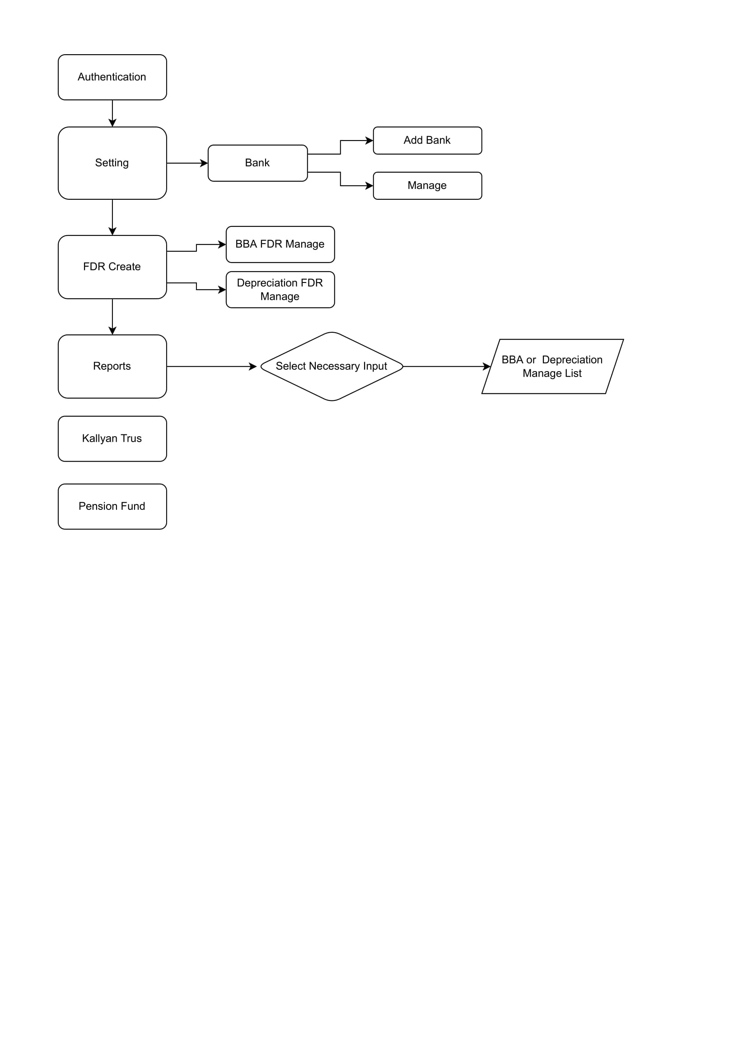

## 4.3 Data flow Diagram

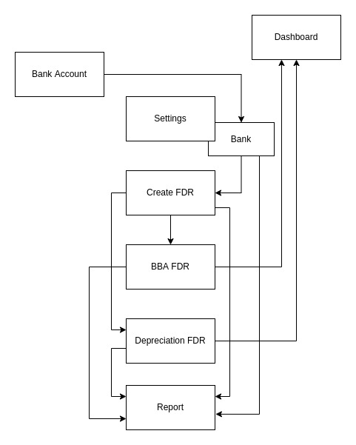

# Chapter – 5: Testing Documentation

## 5.1 Introduction

The Test Plan is designed to prescribe the scope, approach, resources, and schedule of all testing activities of the transport Management System of BBA. The plan identify the items to be tested, the features to be tested, the types of testing to be performed, the personnel responsible for testing, the resources and schedule required to complete testing, and the risks associated with the plan.

## 5.2 Scopes

**1. In scope:**

**For Admin**

|  |  |  |
| --- | --- | --- |
| Name | Applicable Roles | Description |
| Settings - Bank | Admin | Add bank information to access them while creating FDR |
| Create FDR | Admin | Create FDR with all information along with bank account details |
| BBA FDR | Admin | Display all BBA FDR with all information along with bank account details |
| Depreciation FDR | Admin | Display Depreciation FDR with all information along with bank account details |
| Report | Admin | Generating report along with the Selected FDR account details |

**2. Out scope**

* User Interface (UI)
* Hardware
* System security and performance

## 5.3 Quality Objective

The test objectives are to verify the Functionality of the Central Contributory Provident Fund System, the project should focus on testing the transportation system such as vehicle requisition, vehicle information, add new vehicle information to guarantee all these operation can work normally in real business environment.

## 5.4 Testing Methodology

### 5.4.1 Model

* **Waterfall model** – a dynamic approach where each step depends on the previous one, where the developers follow some sequence of steps progressively downwards forwards to achieve the goal. It is like a waterfall approach containing several phases.

### 5.4.2 Strategies

• Tester has access to the full view of code.

• It is known as transparent or glass box testing

• Avoiding errors and wasting time at an early stage

• White box testing contains various tests -

1. Basic Path testing
2. Loop testing
3. Condition testing
4. Memory perspective testing
5. Performance testing

### 5.4.3 Levels

* Integration testing
* System testing
* Cross Browser Compatibility testing
* User Acceptance Test (UAT)
* API testing

### 5.4.4 Test Deliverables

(a) Before Testing

* Test plans document
* Test case document

(b) After Testing

* Test Results/reports­
* Defect Report
* Installation/ Test procedures guidelines

### 5.4.5 Tools

|  |  |  |
| --- | --- | --- |
| No. | Resources | Description |
| 1. | Server | Oracle Database Server |
| 2. | Network | LAN line. |
| 3. | Computer | PC and other OS configuration |

# Test Cases with Result

## Test Scenario 1: Dashboard

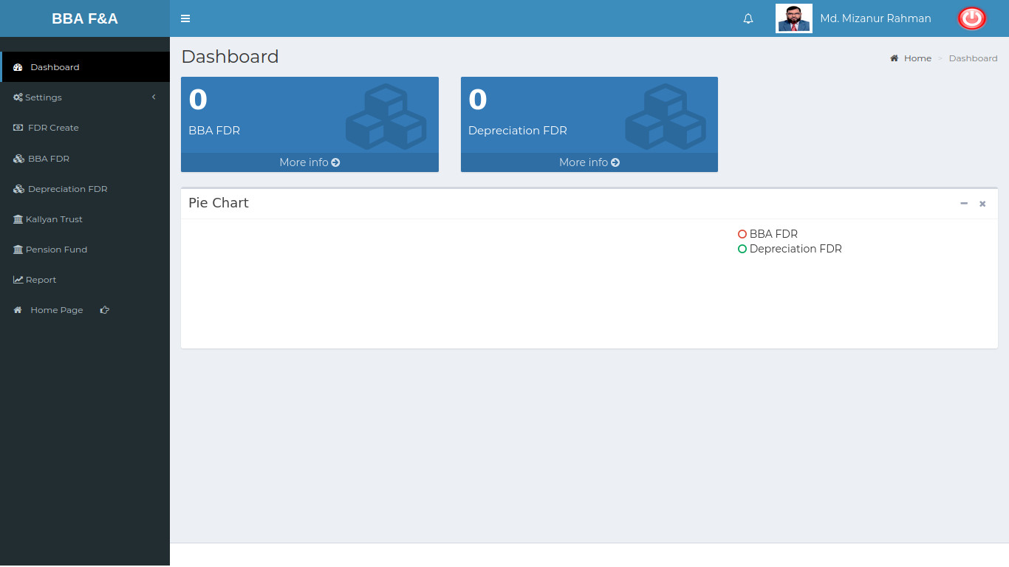

Positive Test Case:

|  |  |  |  |  |  |
| --- | --- | --- | --- | --- | --- |
| No. | Title | Description | Expected Result | Actual Result | Pass/ Fail |
| 1 | BBA FDR | Click more info to view full information about BBA FDR |  |  |  |
| 2 | Depreciation FDR | Click more info to view full information about Depreciation FDR |  |  |  |
| 3 | Chart | Show the pie chart about BBA and Depreciation FDR |  |  |  |

Negative Test Case:

|  |  |  |  |  |  |
| --- | --- | --- | --- | --- | --- |
| No. | Title | Description | Expected Result | Actual Result | Pass/ Fail |
| 1 | BBA FDR |  |  |  |  |
| 2 | Depreciation FDR |  |  |  |  |
| 3 | Chart |  |  |  |  |

## Test Scenario 2: Settings

1. Bank

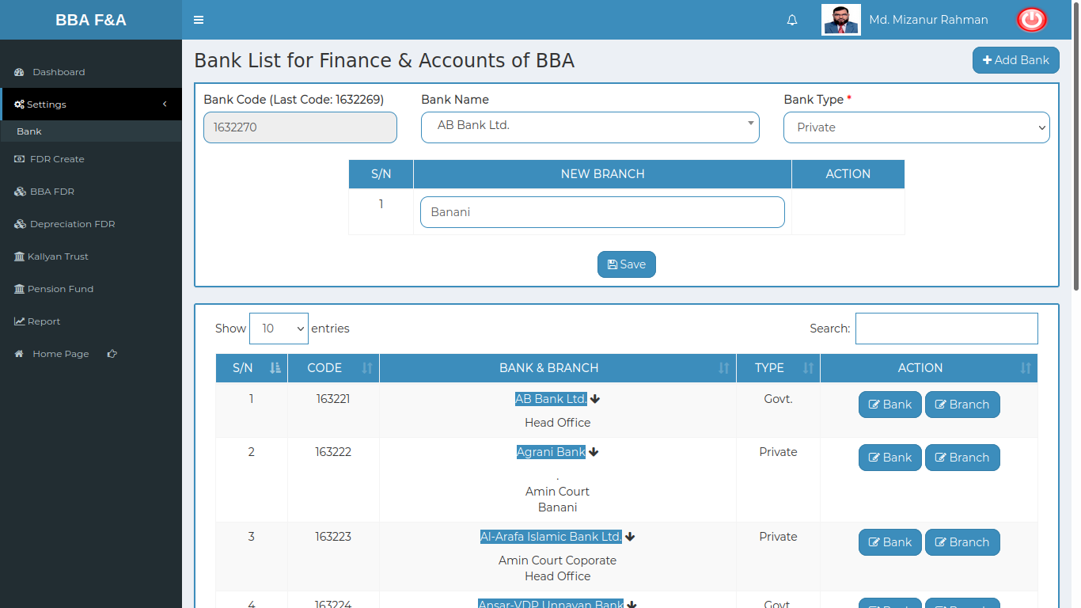

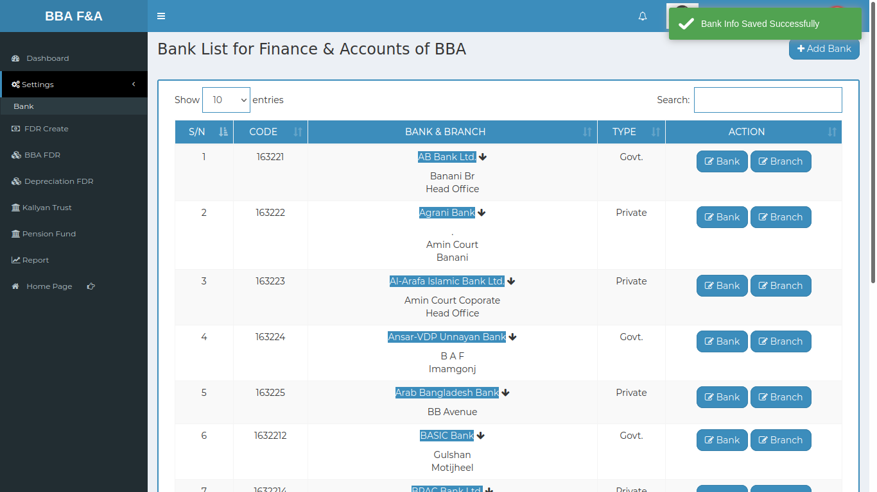

|  |  |
| --- | --- |
|  |  |
|  |  |

Positive Test Case:

|  |  |  |  |  |  |
| --- | --- | --- | --- | --- | --- |
| No. | Title | Description | Expected Result | Actual Result | Pass/ Fail |
| 1 | Add bank | 1. Select bank Name  2. Select bank type  3. Enter branch Name  4. Click Save | Bank information stored successfully | Show in the bank information list | P |
| 2 | Bank List for Finance & Accounts of BBA | 1. Type bank name to find information  2. Action button does update information | Searching information & all bank list should be enlisted | Showing the expected result | P |
| 3 | Update Bank Information | 1. Select bank type  2. click update | Bank information mounted | Data is updated | P |
| 4 | Update Branch Information | 1. Select branch by button  2. Enter new branch name  3. Click update | Branch information mounted | Data is updated | P |

Negative Test Case:

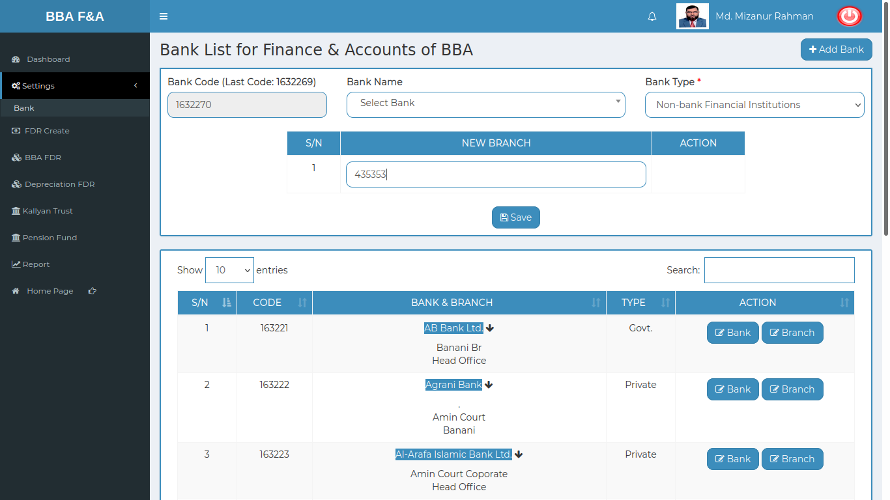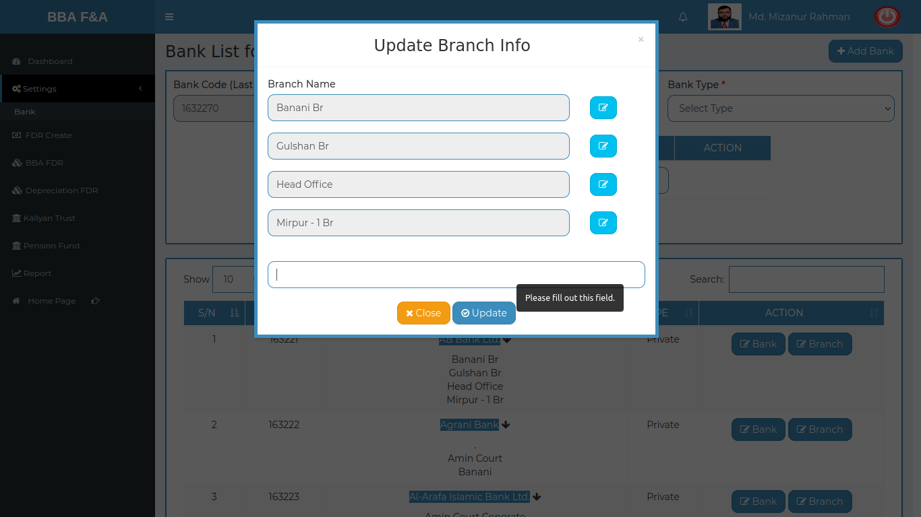

|  |  |  |  |  |  |
| --- | --- | --- | --- | --- | --- |
| No. | Title | Description | Expected Result | Actual Result | Pass/ Fail |
| 1 | Add bank | 1. Bank name and bank type should be selected  2. Branch name should be entered  3. Save button should perfectly worked | Must selected data and entered bank info | No error while storing bak information | p |
| 2 | Bank List for Finance & Accounts of BBA | 1. Type in search bar to find information  2. Action button should perfectly worked | Show the bank list | No error occurred while searching and displaying result | P |
| 3 | Update Bank Information | Bank information should be updated by update button | Data is perfectly mounted | Works fine and update database | P |
| 4 | Update Branch Information | Branch info should be updated. | Data is perfectly mounted | Works fine and update database | P |

## Test Scenario 3: FDR create

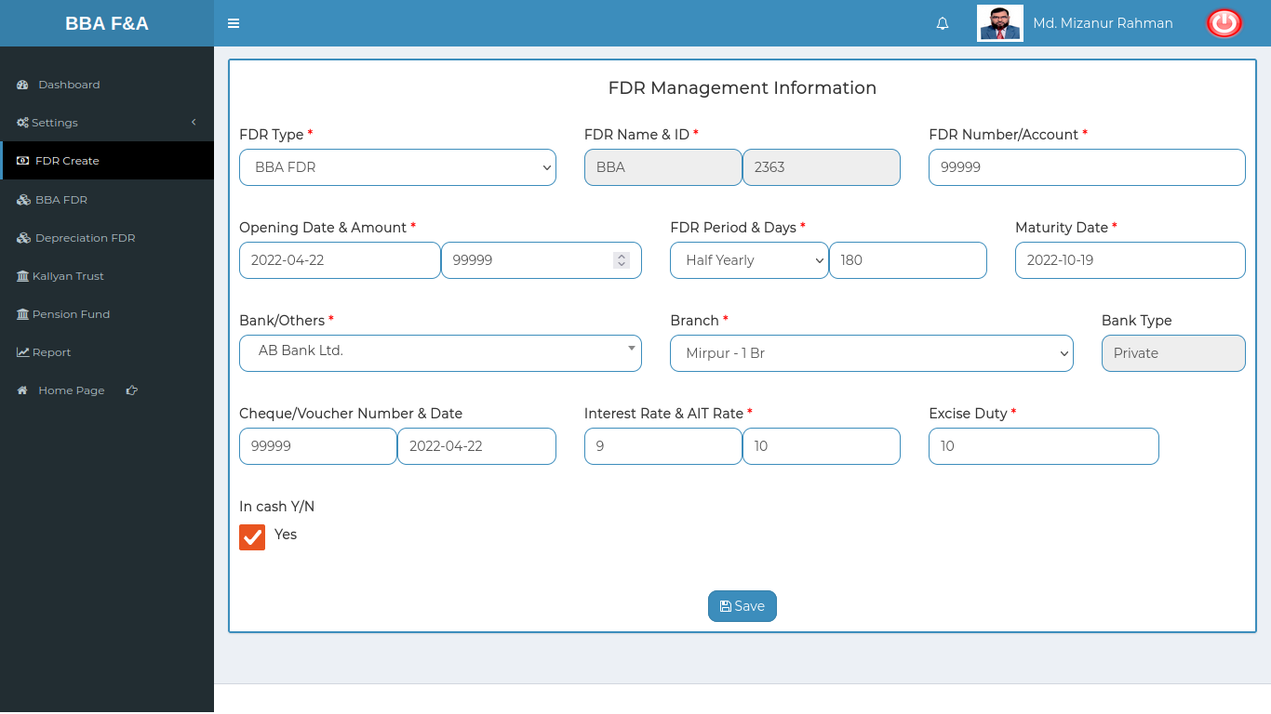

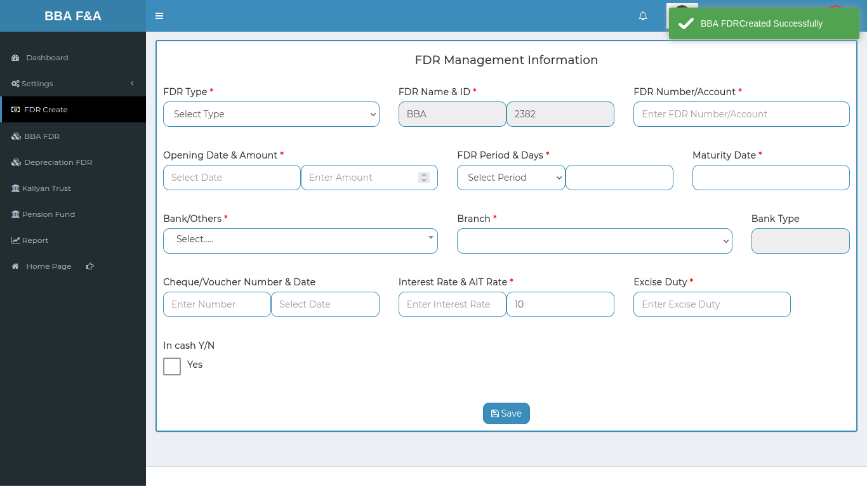

Positive Test Case:

|  |  |  |  |  |  |
| --- | --- | --- | --- | --- | --- |
| No. | Title | Description | Expected Result | Actual Result | Pass/ Fail |
| 1 | Add FDR information | 1. Select FDR type  2. Enter FDR No or account no  3. Select date & enter amount  4. Select date as FDR period  5. Enter FDR days as period  6. Enter maturity date of FDR  7. Select bank and branch name  8. Enter cheque or voucher no  9. Select date & Enter Interest & AIT rate  10. Enter excise duty  11. choose in cash  12. Click save | Data is perfectly stored in the database | No error while save information in the database | P |

Negative Test Case:

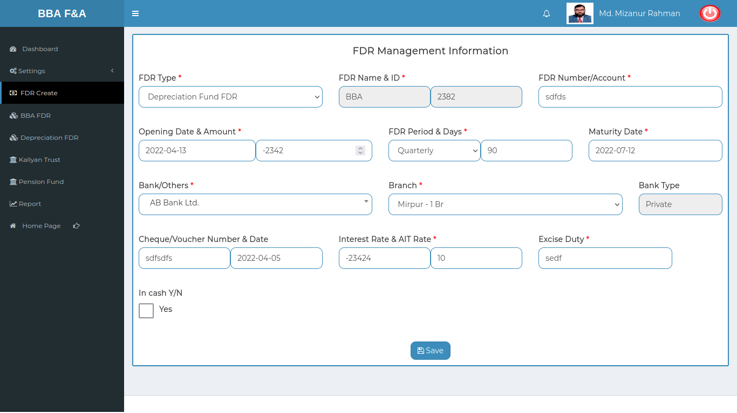

|  |  |  |  |  |  |
| --- | --- | --- | --- | --- | --- |
| No. | Title | Description | Expected Result | Actual Result | Pass/ Fail |
| 1 | Add FDR information | 1. Data should be perfectly mounted from the database  2. Selected and entered information should be perfectly stored  3. date should be in valid format  4. Save button should work fine | Information stored by the help of all other information | No error occurred while accessing database | P |

## Test Scenario 4: BBA FDR

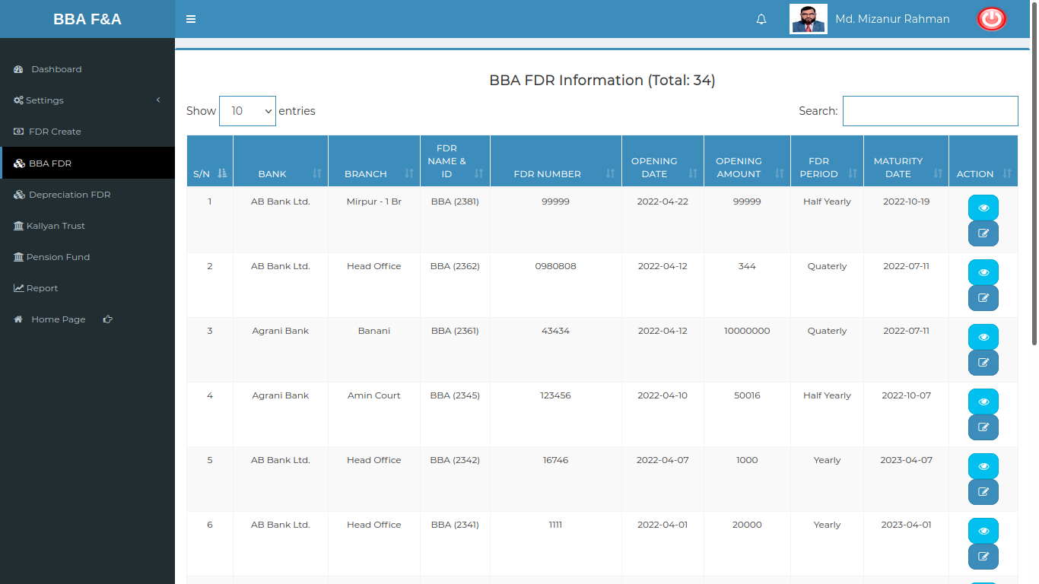

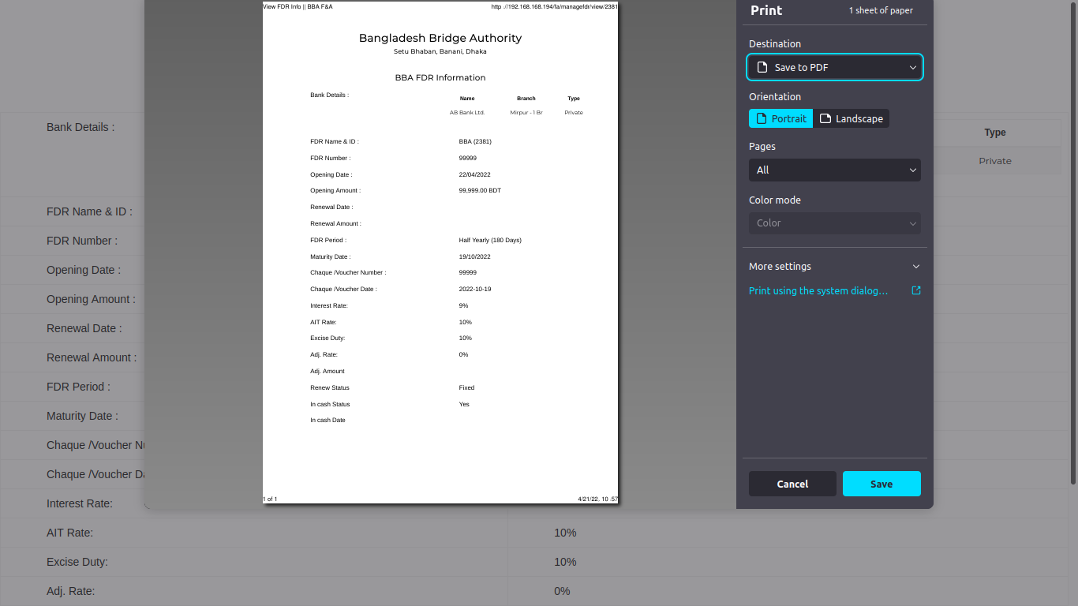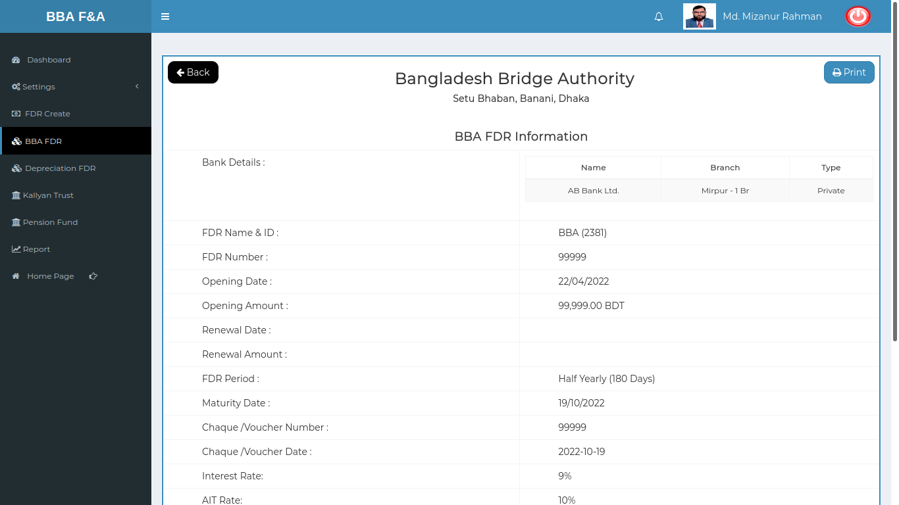

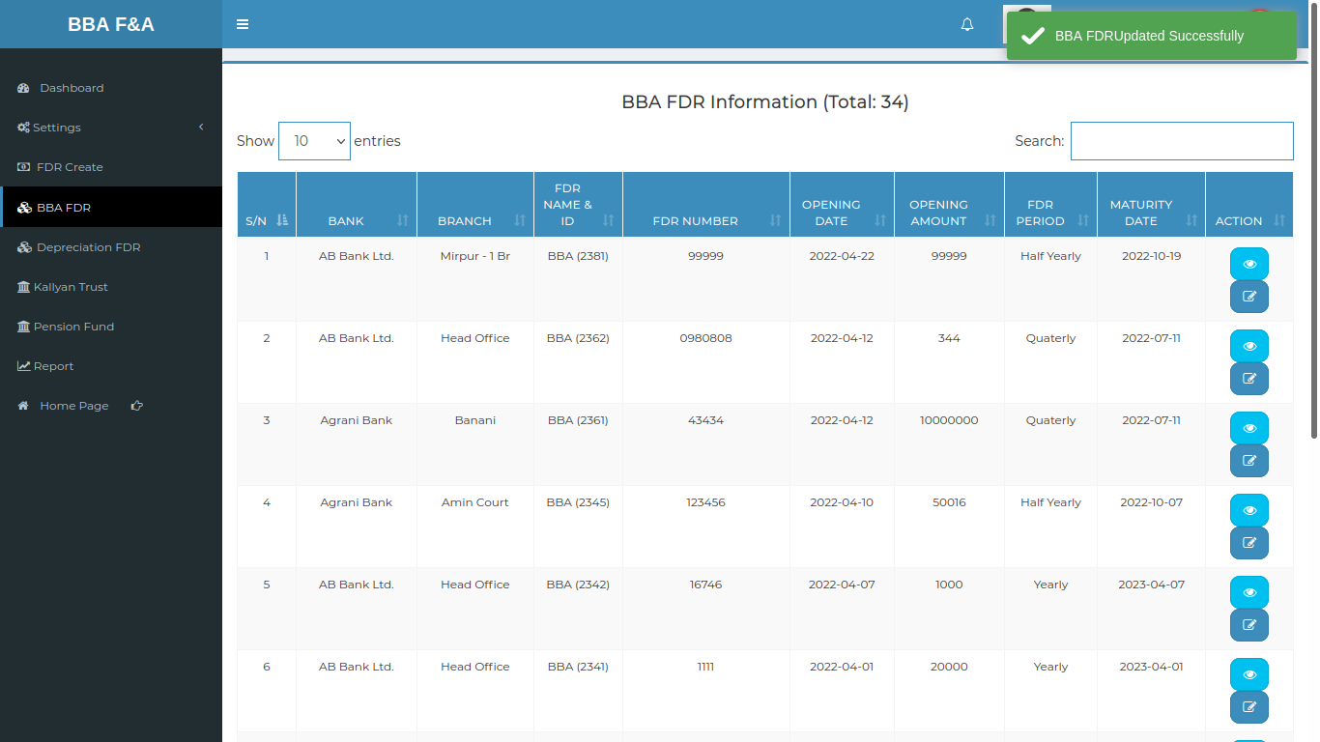

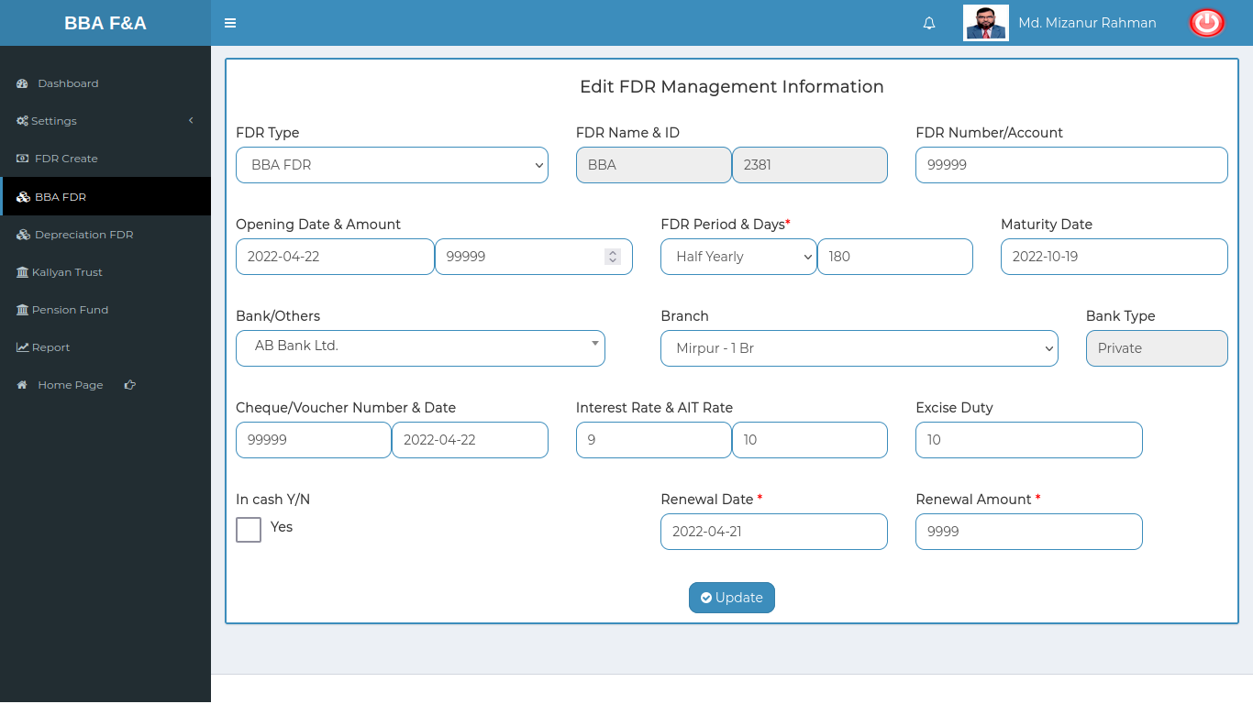

Positive Test Case:

|  |  |  |  |  |  |
| --- | --- | --- | --- | --- | --- |
| No. | Title | Description | Expected Result | Actual Result | Pass/ Fail |
| 1 | FDR List | 1. Type search to find FDR information for an employee  2. Action does operation in any selected employee | Show the FDR information | No information is missing | P |
| 2 | View FDR | 1. Click view to see report of an specific employee  2. Click print to generate the report in document report | Show specific information | Show information without any data missing | P |
| 3 | Update FDR | 1. Existing information can be updated by selecting specific information which need to be updated  2. Click update or close the window for cancel update operation | Existing data are replaced by current giving data | Data saved successfully and update database |  |

Negative Test Case:

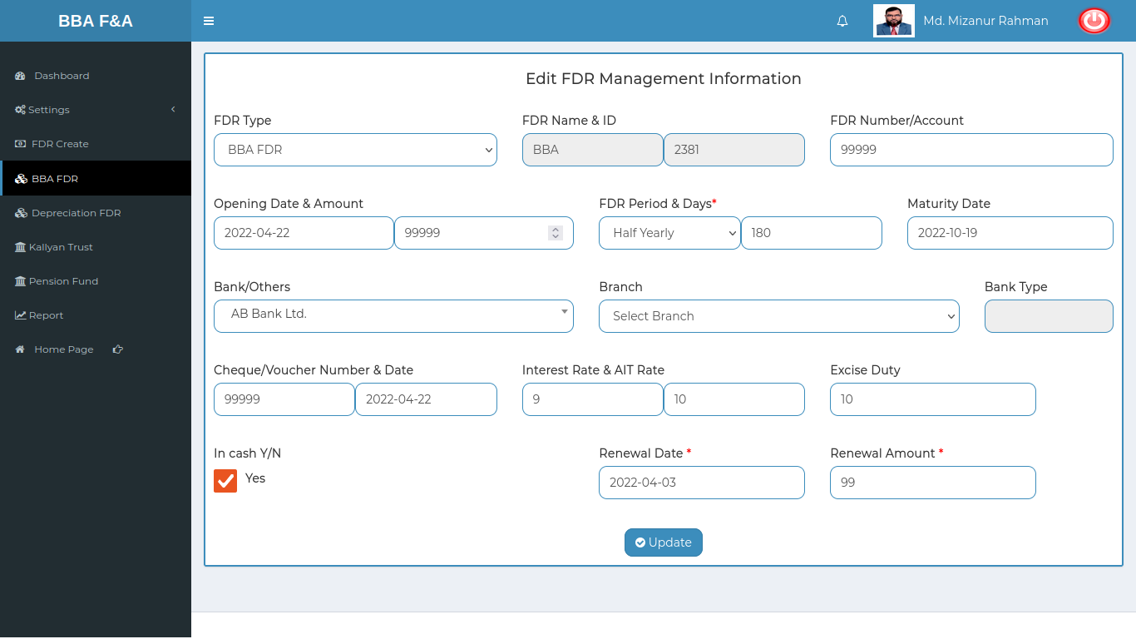

|  |  |  |  |  |  |
| --- | --- | --- | --- | --- | --- |
| No. | Title | Description | Expected Result | Actual Result | Pass/ Fail |
| 1 | FDR List | Display all the FDR information without any missing information | List is complete | No missing | P |
| 2 | View FDR | 1. Checked all the employee FDR information are perfectly generated in report  2. Print button should generate the report in document format and can download the file | Information generated for a specific employee | No data is missing or no error is occurred | P |
| 3 | Update FDR | 1. Existing information checked whether the information are accurate or not.  2. checked update button does the updating information or not | Information updated successfully | No error occurred while updating information |  |

## Test Scenario 5: Depreciation FDR

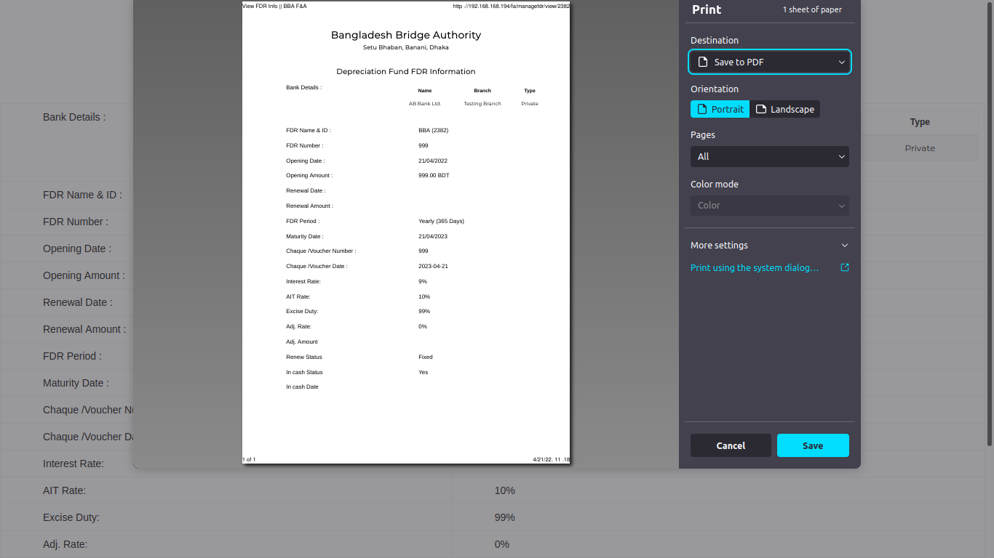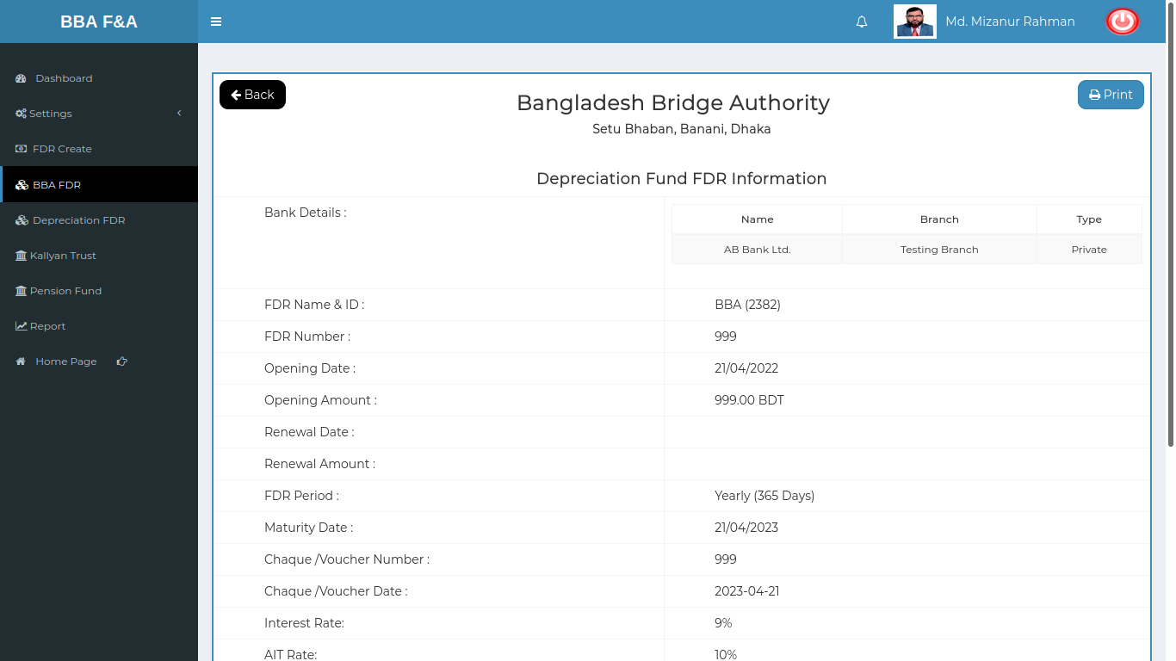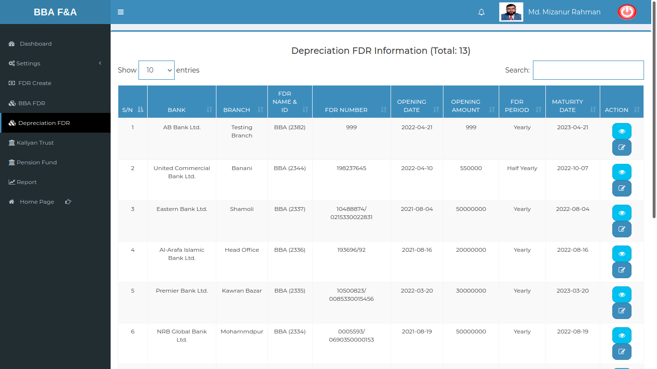

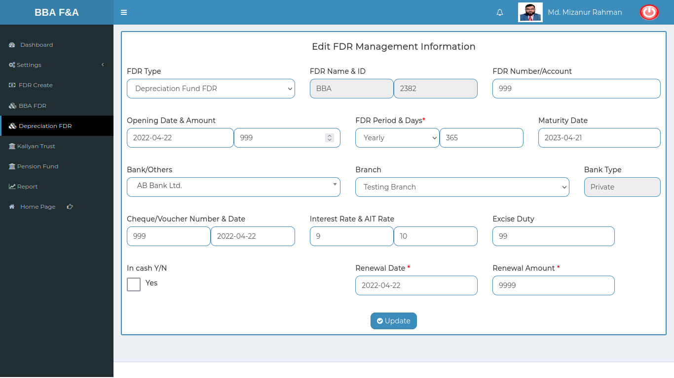

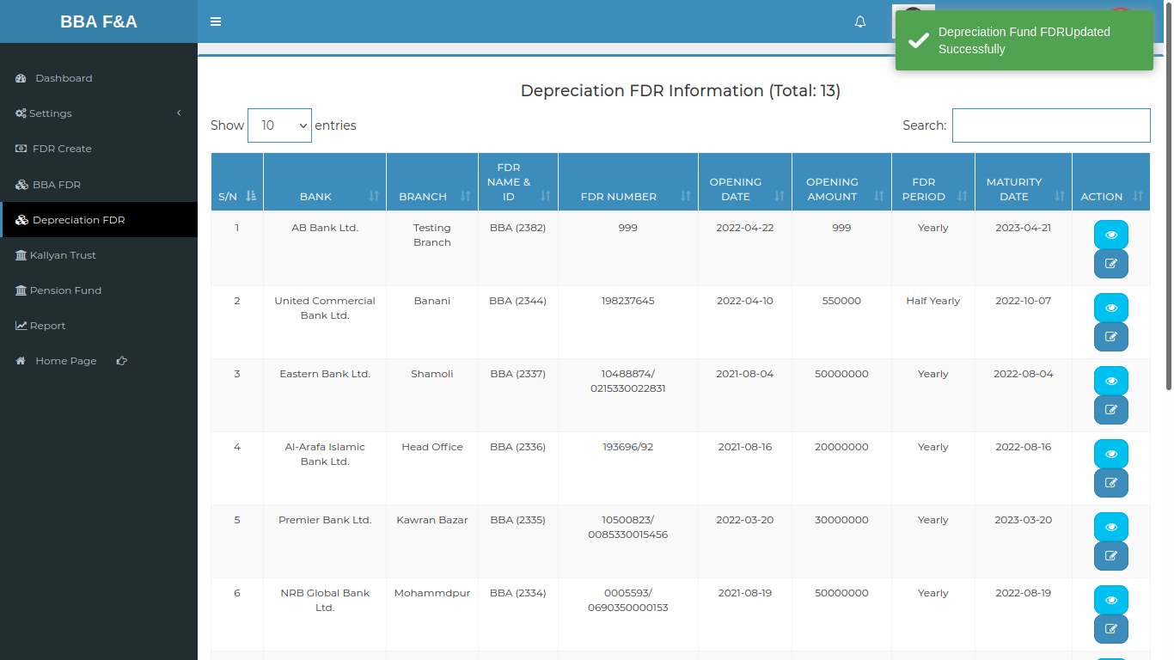

Positive Test Case:

|  |  |  |  |  |  |
| --- | --- | --- | --- | --- | --- |
| No. | Title | Description | Expected Result | Actual Result | Pass/ Fail |
| 1 | Depreciation FDR List | 1. Type search to find Depreciation information for an employee  2. Action does operation in any selected employee | Show the FDR information | No information is missing | P |
| 2 | View Depreciation FDR | 1. Click view to see report of an specific employee  2. Click print to generate the report in document report | Show specific information | Show information without any data missing | P |
| 3 | Update Depreciation FDR | 1. Existing information can be updated by selecting specific information which need to be updated  2. Click update or close the window for cancel update operation | Existing data are replaced by current giving data | Data saved successfully and update database |  |

Negative Test Case:

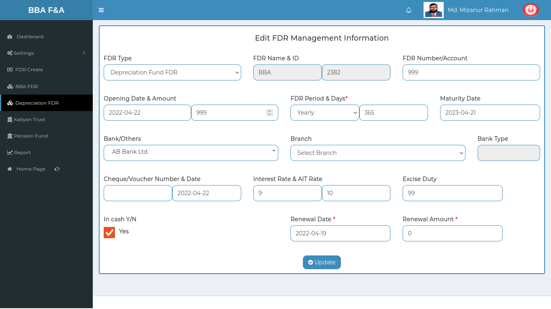

|  |  |  |  |  |  |
| --- | --- | --- | --- | --- | --- |
| No. | Title | Description | Expected Result | Actual Result | Pass/ Fail |
| 1 | Depreciation FDR List | Display all the Depreciation information without any missing information | List is complete | No missing | P |
| 2 | View Depreciation FDR | 1. Checked all the employee Depreciation information are perfectly generated in report  2. Print button should generate the report in document format and can download the file | Information generated for a specific employee | No data is missing or no error is occurred | P |
| 3 | Update Depreciation FDR | 1. Existing information checked whether the information are accurate or not.  2. checked update button does the updating information or not | Information updated successfully | No error occurred while updating information |  |

## Test Scenario 6: Report

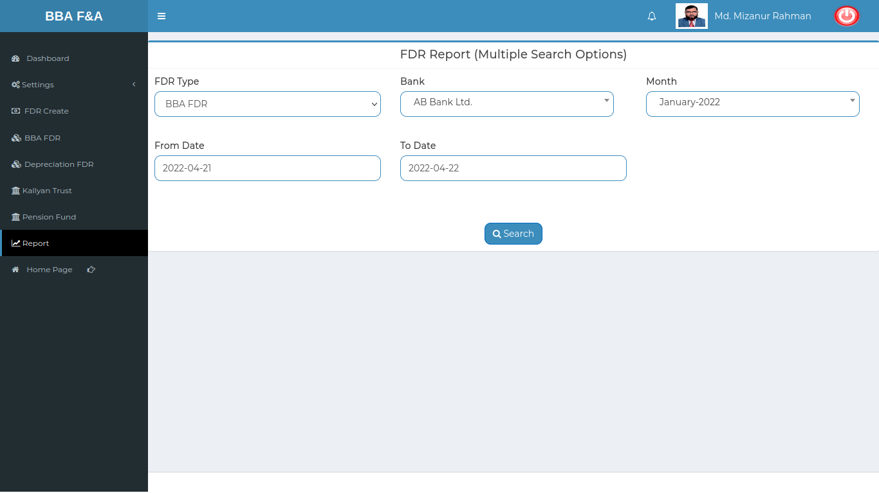

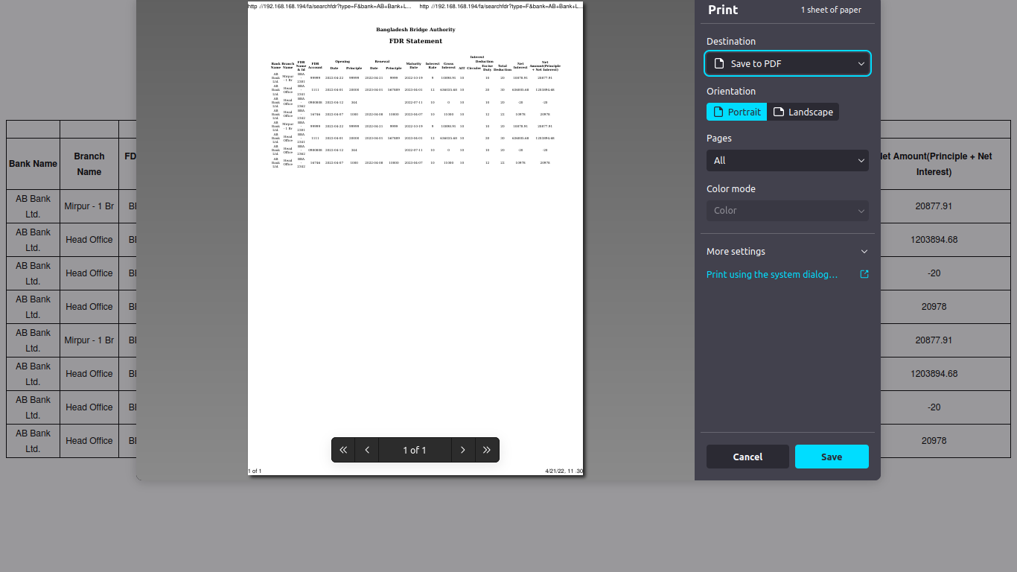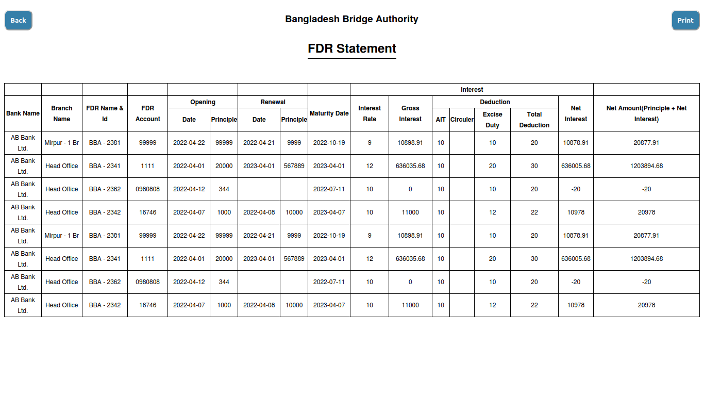

Positive Test Case:

|  |  |  |  |  |  |
| --- | --- | --- | --- | --- | --- |
| No. | Title | Description | Expected Result | Actual Result | Pass/ Fail |
| 1 | FDR report Selection | 1. Select FDR type, bank name, month name  2. select from date and to date  3. click search | Report is selected | No issues happen | P |
| 2 | FDR statement | 1. Generate FDR statement as report  2. The report has a print function to download as a document format  3. click save to download it | Statement is generated and save it as document format | Perfectly generated & show as a Portable document format | P |

Negative Test Case:

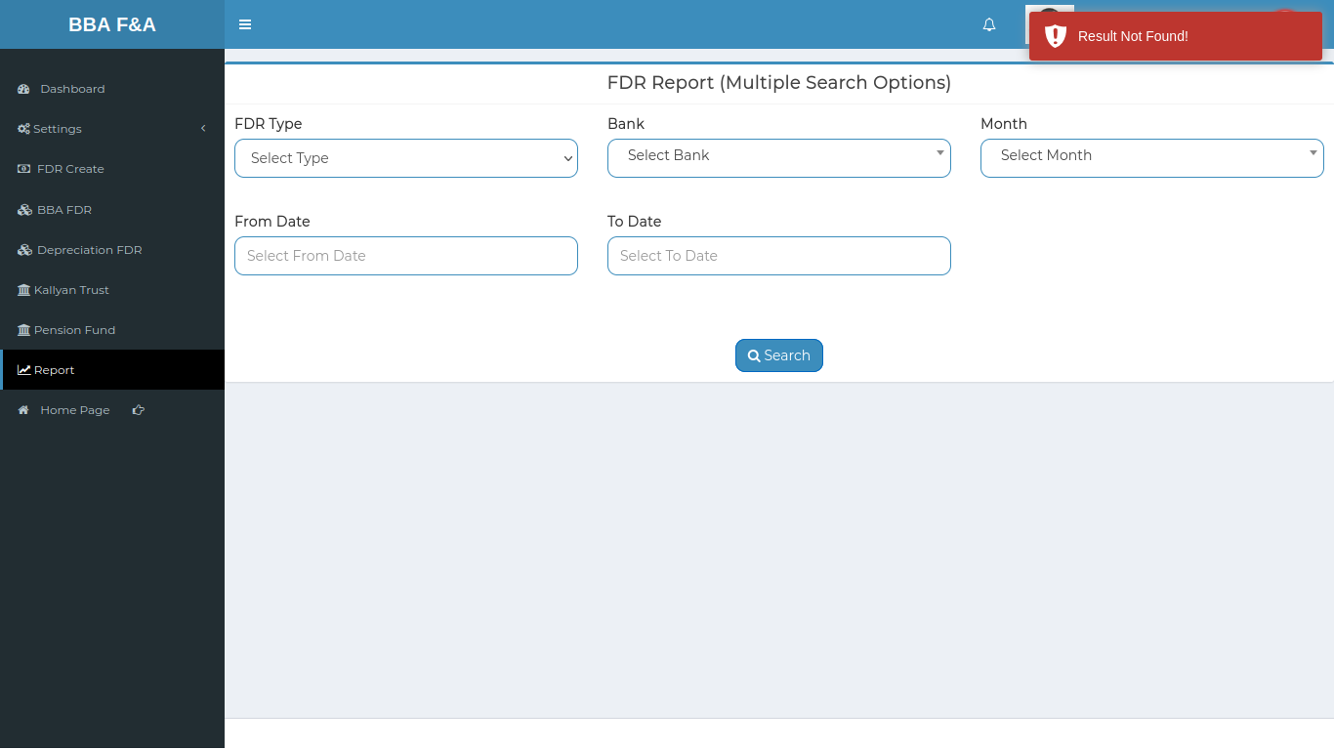

|  |  |  |  |  |  |
| --- | --- | --- | --- | --- | --- |
| No. | Title | Description | Expected Result | Actual Result | Pass/ Fail |
| 1 | FDR report Selection | 1. Ensure selecting all the necessary information to generate reporting  2. The date should be valid and exist information in the databases | All information showed | Works fine & no error | P |
| 2 | FDR statement | 1. Statement should represent all the FDR information  2. print function should done the report as portable document format  3. save button should done the downloading process | Statement generated no information is missing | Generate perfectly all information show in the report | p |