RNA-seq Experiment Report

# Overview

The goal of this experiment was to compared the transcriptomics of myofibroblasts and senescent fibroblasts. To achieve this goal, RNA-seq experiment was carried out on human fetal foreskin fibroblasts 2 (HFFF2) treated with 2ng/ml TGF-beta-1 to induce myofibroblast differentiation or 10Gy gamma irradiation to induce senescence. RNA was isolated 7 days upon this treatments.

This report goes through some of the RNA-Seq analysis in R experiment starting with a read count matrix (processed using salmon). This report includes:

* Exploring count data after importing them into R and
* Normalizing RNA-seq counts
* Conducting quality assessment of counts

# Data and Metadata

We begin with our counts table and our samples metadata:

# Quality control of the imported counts

We can look at a few different plots to check that the data is good quality, and that the samples are behaving as we would expect. First, we can check how many reads we have for each sample.

## Library Sizes

The library sizes generally look good for each of our samples, but are not completely uniform:

Thus, there are some outliers when we look at the distribution of counts:

# Normalization

In order to test for differential expression, we operate on raw counts. However for other downstream analyses – e.g. for visualization or clustering – it is useful to work with transformed versions of the count data.

We used the variance stabilizing transformation (DESeq2::vst()) function to compensate for different library sizes. This transformation performs an approximately log2 transformation of the count data, as well as aims to make it homoscedastic; meaning that the variance does not depend on the mean. This is a common transformation as many common statistical methods for exploratory analysis of multidimensional data, especially methods for clustering and ordination (e.g., principal-component analysis and the like), work best for (at least approximately) homoscedastic. DESeq2’s transformation calculates variance by mean in a condition-blind manner.

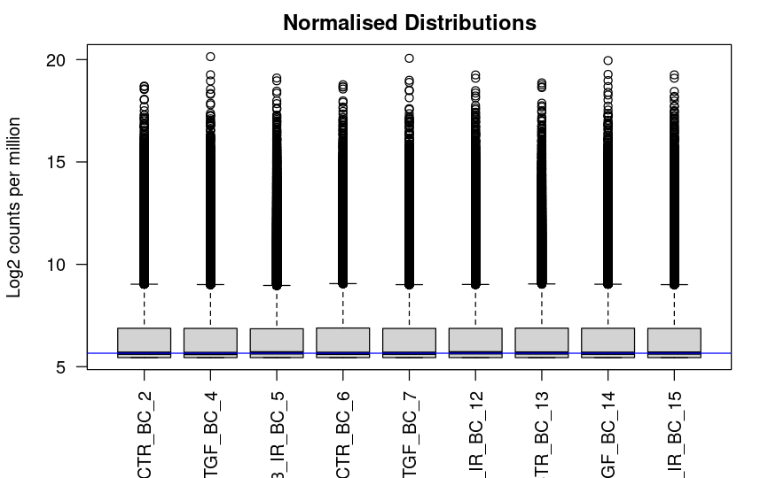

PCA

PCA of normalized samples colored by group (using plotPCA()):

Our groups have different coloring due to their labels having different capitalization. After correction, we can see an updated plot:  
  
There appears to be little to no batch effect:

We also used prcomp() to try only using top genes for PCA:

Table of PCA results using prcomp() and the top 500 ranked genes only:  


# Reference:

Based on Introduction or [RNA-Seq analysis in R workshop](https://sbc.shef.ac.uk/training/rna-seq-in-r-2022-06-13/) offered by Sheffield Bioinformatics Core.

Original study: Mellone M, Hanley CJ, Thirdborough S, Mellows T, Garcia E, Woo J, Tod J, Frampton S, Jenei V, Moutasim KA, Kabir TD, Brennan PA, Venturi G, Ford K, Herranz N, Lim KP, Clarke J, Lambert DW, Prime SS, Underwood TJ, Vijayanand P, Eliceiri KW, Woelk C, King EV, Gil J, Ottensmeier CH, Thomas GJ. Induction of fibroblast senescence generates a non-fibrogenic myofibroblast phenotype that differentially impacts on cancer prognosis. Aging (Albany NY). 2016 Dec 15;9(1):114-132. doi: 10.18632/aging.101127. PMID: 27992856; PMCID: PMC5310659.