**Teensy Breakout for Assad Lab**

Alpha 1a (6/2018)

|  |  |  |  |  |  |
| --- | --- | --- | --- | --- | --- |
| **Name** | **Value** | **Package** | **Description** | **Part Number** | **Notes** |
| CIN | 1 u | C-USC0805K |  | 0805 | LDO Cap |
| COUT | 2.2 uF | CPOL-USE2.5-5 |  | E2,5-5 | LDO Cap 2.2 uF min. Tantalum or aluminum electrolytic. No low ESR or ceramic |
|  |  |  |  |  |  |
| D1, D2, D3, D4 |  | SMB | Fast recovery Schottky diode | [MBRS360BT3GOSCT-ND](https://www.digikey.com/product-detail/en/on-semiconductor/MBRS360BT3G/MBRS360BT3GOSCT-ND/2623453) | Flyback diode for coils |
|  |  |  |  |  |  |
| R1-R12, R27-R40, R55, R56 | 100 | 1206 |  |  | LED current limit |
| R13, R18, R41, R46 | 10k | 0805 |  |  | Lick hysteresis 1% |
| R14-R16, R19-R21, R42-R44, R47-R49 | 1k | 0805 |  |  | Lick hysteresis 1% |
| R17, R22, R45, R50 | 10M | 0805 |  |  | Lick pull-up |
| R23, R24, R51, R52 | 500 | 1206 |  |  | FET gate drive |
| R25, R26, R53, R54 | 50k | 1206 |  |  | FET gate pull-down |
|  |  |  |  |  |  |
| IC1, IC2, IC3, IC4 | SN74LS06 | 14-SOIC | Hex Inverter open collector | [296-14876-1-ND](https://www.digikey.com/product-detail/en/texas-instruments/SN74LS06DR/296-14876-1-ND/562582) | Indicator LED driver (might not work from lower voltage VCC!!!) |
| U1, U2 | LP339D | 14-SOIC | Comparator | [296-14609-1-ND](https://www.digikey.com/product-detail/en/texas-instruments/LP339DR/296-14609-1-ND/555655) |  |
|  |  |  |  |  |  |
| T1, T2, T3, T4 | NCV8406 | SOT-223 | Low side driver transistor with protection | [NCV8406ASTT1GOSCT-ND](https://www.digikey.com/product-detail/en/on-semiconductor/NCV8406ASTT1G/NCV8406ASTT1GOSCT-ND/5213327) |  |
|  |  |  |  |  |  |
| J1 |  |  | Power Jack 2.1mm |  | Sparkfun |
|  |  |  | BNC straight connector | [A32262-ND](https://www.digikey.com/product-detail/en/te-connectivity-amp-connectors/5227222-3/A32262-ND/811160) |  |
|  |  |  |  |  |  |
| U3 | 5V | SOT-223 | MIC5209 LDO regulator | [576-1276-ND](http://www.digikey.com/product-detail/en/microchip-technology/MIC5209-5.0YS/576-1276-ND/771745) |  |
|  | ~~5V~~ | ~~SOT-223~~ | ~~MIC5239 LDO regulator (30V, 500mA)~~ | [~~MIC5239-5.0YS-TR~~](https://www.digikey.com/product-detail/en/microchip-technology/MIC5239-5.0YS-TR/576-2397-1-ND/1030761) |  |
|  | ~~5V~~ | ~~SOT-223~~ | ~~LM2940 LDO regulator (26V, 1A)~~ | [~~LM2940IMPX-5.0/NOPBCT-ND~~](https://www.digikey.com/product-detail/en/texas-instruments/LM2940IMPX-5.0-NOPB/LM2940IMPX-5.0-NOPBCT-ND/3526933) | ~~Has over current, over temp and reverse polarity protection. Requires 22uF or larger Cout for stability~~ |

|  |  |  |  |  |  |
| --- | --- | --- | --- | --- | --- |
| **Teensy 3.5 Pin** | **Board Name** | **Notes** | **Teensy 3.5 Pin** | **Board Name** | **Notes** |
| 4 | DIO_7 | Digital BNC | 23 | DIO_11 | Analog/Digital BNC |
| 5 | DIO_6 | Digital BNC | 24 | SOLN_1 | Not broken out |
| 6 | DIO_0 | Digital BNC | 25 | LICK_DETECT_0 | Not broken out |
| 7 | DIO_1 | Digital BNC | 26 | LICK_DETECT_1 | Not broken out |
| 8 | DIO_2 | Digital BNC | 27 | DIO_27 | Digital IDC connector |
| 9 | DIO_3 | Digital BNC | 28 | DIO_28 | Digital IDC connector |
| 10 | DIO_4 | Digital BNC | 29 | DIO_29 | Digital IDC connector |
| 11 | DIO_5 | Digital BNC | 30 | DIO_30 | Digital IDC connector |
| 12 | SOLN_0 | Not broken out | 31 | DIO_31 | Analog/Digital IDC |
| 14 | AIN0 | Analog/Digital BNC | 32 | DIO_32 | Analog/Digital IDC |
| 15 | AIN1 | Analog/Digital BNC | 33 | DIO_33 | Analog/Digital IDC |
| 16 | AIN2 | Analog/Digital BNC | 34 | DIO_34 | Analog/Digital IDC |
| 17 | AIN3 | Analog/Digital BNC | 35 | DIO_35 | Analog/Digital IDC |
| 18 | AIN4 | Header for Acc. | 36 | DIO_36 | Analog/Digital IDC |
| 19 | AIN5 | Header for Acc. | 37 | DIO_37 | Analog/Digital IDC |
| 20 | DIO_8 | Analog/Digital BNC | 38 | DIO_38 | Analog/Digital IDC |
| 21 | DIO_9 | Analog/Digital BNC | 39 | DIO_39 | Analog/Digital IDC |
| 22 | DIO_10 | Analog/Digital BNC |  |  |  |

**Legend**

Front Panel, digital ground

Front Panel, analog ground

Board 16-pin connector

Not broken out

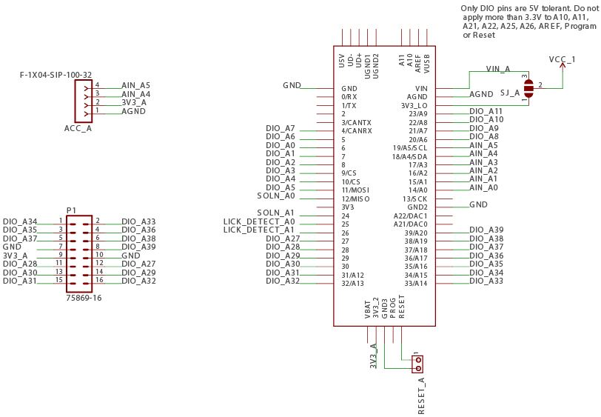

**Jumpers:**

**SJ1** – Connects the onboard voltage regulator to the VCC1 line. VCC1 powers the buffer circuits, lick detection and Teensy A (left side components). If the Teensys are powered by USB, SJ1 should be left open. The purpose of this jumper is to allow a separate voltage regulator to be used if more current is needed than what’s available from the Teensy directly. **Default condition: Leave jumper unsoldered.**

**SJ_A and SJ_B** – These are three way jumpers, for Teensy A and Teensy B, respectively. They connect VCC1 or VCC2 to either the respective Vin or 3V3 lines on each Teensy. If a 3.3V regulator is used on the PCB, these jumpers allow the Teensy internal regulator to be bypassed and power the circuitry directly.

**Default condition: Bridge the middle terminal to VIN.**

**VCC1_VCC2** – Connect the power rails for the left and right side of the board. When using two Teensys and each one is plugged in with a USB cable, this jumper can be left open. If power is delivered from the on-board regulator, the jumper should be closed.

**Default condition: Leave jumper unsoldered**

**If Teensys get power from the board (either via Vin or 3V3), there is a trace that must be cut on each Teensy.**

