Lab 4 – Get Connected

1. Log into the Azure Portal
Provide credentials for this

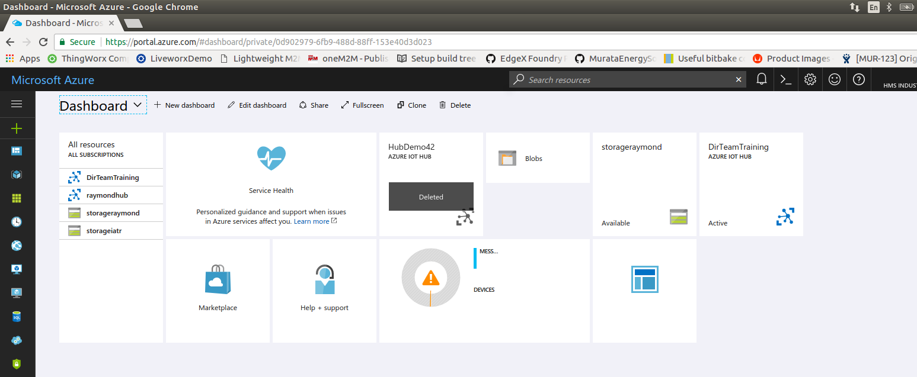
From the dashboard, Select DirTeam Training Azure IOT HUB

From the Shared access policies option, select the iothub owner, and copy the conection string. This wil l be used later for login with iotHub Explorer.

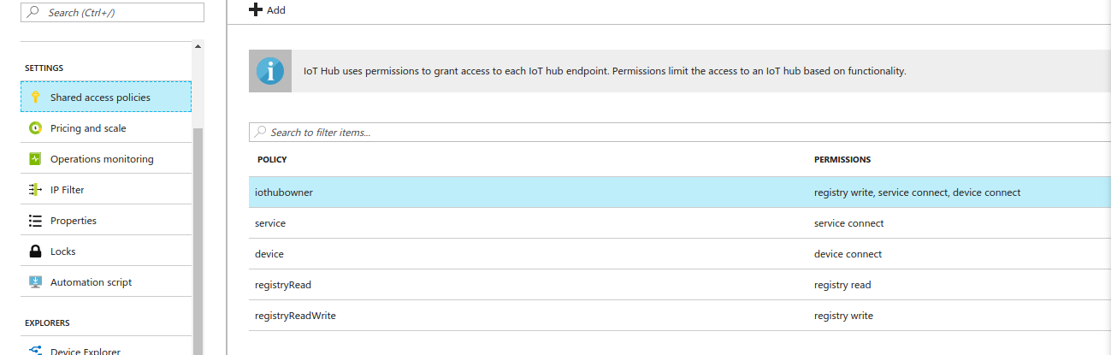

2. Create a device - Enter the device explorer.

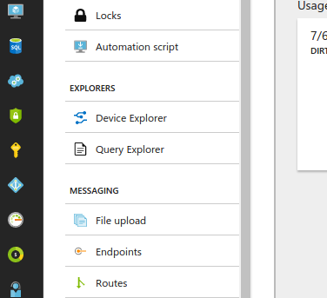

Select +, to add a device
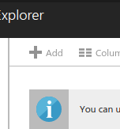

Enter a device ID – This must be unique across the hub (do not copy your neighbor)
Save the device.

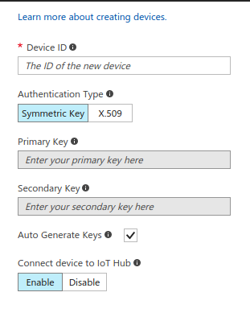

Select your device, and view the device ID, and keys. Copy the connection string.

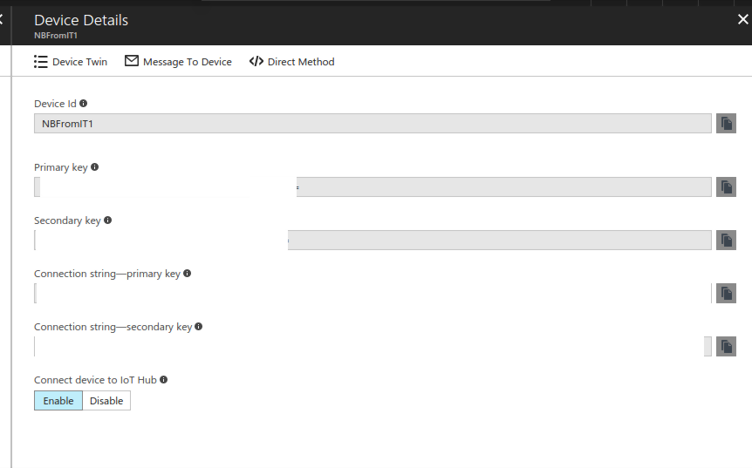

7. Build the basic IoThub client examples
There are several client samples, and for this training we will use the MQTT sample, and it will require some modifications before it can run.

Copy the device connection string from the portal, to the initialize the variable called connectionstring with the full string. Note the string should be enclosed in quotation marks.
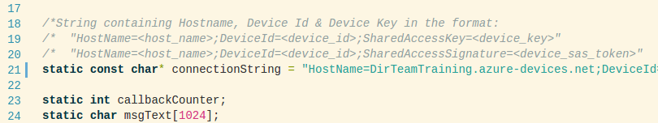

The IoT hub SDK includes support for TLS. For simplicity, we will use the TLS libraries provided by the SDK, and not the libraries resident on the NB301. There is one extra step that is needed, and that is to add the certificate

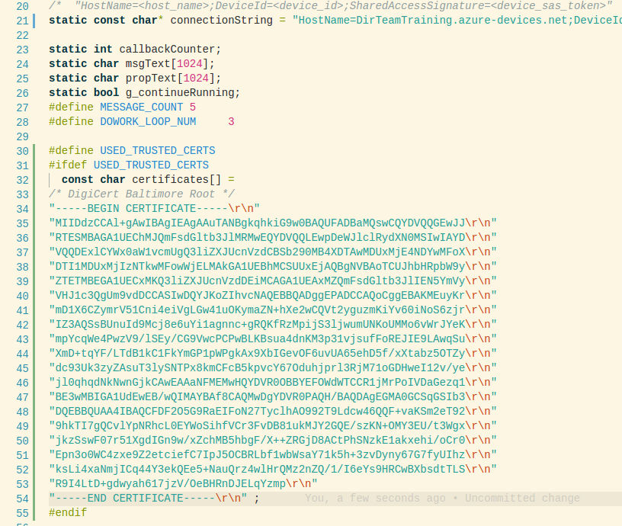

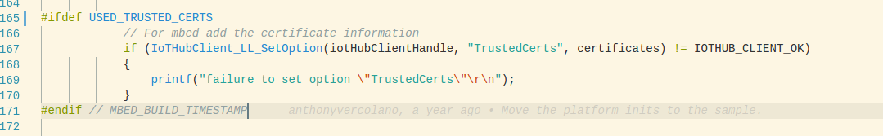

7. View the MQTT messages with iotHub-explorer

Install iotHub-Explorer with the node package manager

Enter command sudo npm install -g iothub-explorer

log into iotHub-Explorer - The connection string will need to be enclosed in quotes.

Enter command iotHub-explorer login <connection string>

