Lab 1. - Kick the Tires
This lab will cover the basics of remote login, and viewing the web-server

1. Start a terminal session
By entering Ctl-Alt-T , or selecting the terminal from the task bar. This may require first hitting the super (windows) key.

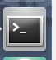

2.Watch for a link

Enter command watch ifconfig
This command will display the status of all network interfaces, and you to watch the connection to the NB301. Power-on, and connect the USB cable to the NB301. This will provide a virtual Ethernet link on top of USB using the Remote Network Driver Interface Specification (RNDIS). For Windows a special driver will need to be installed. For Ubuntu, this driver is already installed. Note the IP address should be in the 169.254.200.X subnet. This subnet is reserved for link-local address by the IETF. The NB301 will have IP address 169.254.200.200.

To exit the watch Enter Ctrl+C
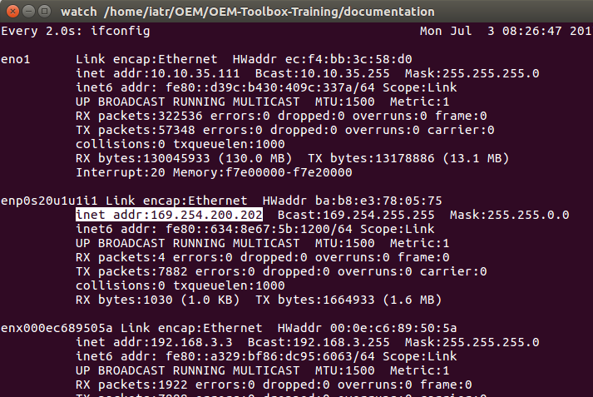

3. Make an SSH connection.
Secure shell (SSH) is an encrypted client-server application that will be used for remote login. The NB301 is running the development images will allow ssh access. The Production image will not allow this access.

Enter the command ssh root@169.254.200.200
This will provide remote login as root. The terminal should change to confirm the login

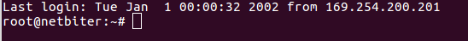

4. Read the Activation Code
For access to the Web-server and remote login as other users, the Activation Code is needed as a password. This code can be read from the file nb_device.xml.

Enter the command cat /var/run/nb_device.xml

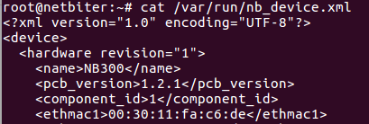

Near the bottom of the page, the activation code can be read from between the tags. Copy this value, it will be needed later.
Does the device_id look familiar?

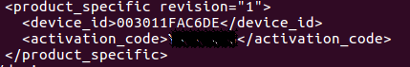

5. Bring up the web-server (chrome)
In a browser, enter the ip address (169.254.200.200) of the NB301.
Username: admin
password: <activation code>

6. Explore all menu options from the Sidebar.
In the status window, open the developer tools → network, note which type of files are loaded and how frequently.
Note the system time. Is this current?
Check out the Logs menu option. Note there is a button to download logs

