Lab 2 - Start Developing
The EC350 has a super-capacitor to backup the real-time clock, but this will only hold a charge for so long. Eventually, it will loose power. The EC350 will need to sync its self with a trusted source. This lab will write a program to synchronize with a time server. It will cover the basics of compiling C code, testing, cross comping for the EC350, and using the CAPI to update the system time. This lab will show modern code development practices and open-source libraries.

1. Start a terminal session
By entering Ctl-Alt-T , or selecting the terminal from the task bar. This may require first hitting the super (windows) key.

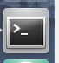

2. Make a workspace

Enter command cd Documents
This command will change directory to the Documents folder.

Enter command mkdir workspace
Enter command cd workspace
These commands make a folder called “workspace and enter that folder”

3. Copy the source repository
Visit https://github.com/HMSAB/OEM-Toolbox-Training; this is going to be the starting point for our program.

Enter command git clone https://github.com/HMSAB/OEM-Toolbox-Training.git

This command will make a local copy of the remote repository. There are several projects included in this repository. This lab will focus on update-time.
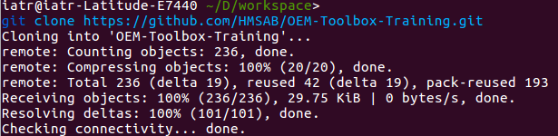

Enter command cd OEM-Toolbox-Training/update-time/
Enter command ls
This command will display the contents of the folder. You should see two folders for source code src and inc, and three files: CMakeLists.txt, toolchainNB.cmake, readme.md.
- CmakeLists.txt – a file for the CMake program a modern open-source tool for C-programs
- toolchainNB.cmake – a file for EC350 specific compiler settings
- readme.md – markdown file (github style) for basic directions

3. View the source in the editor
Enter command code .
This command will start vs code. A popular open-source code IDE.

Close the Welcome Window, and open main.c from the file explorer

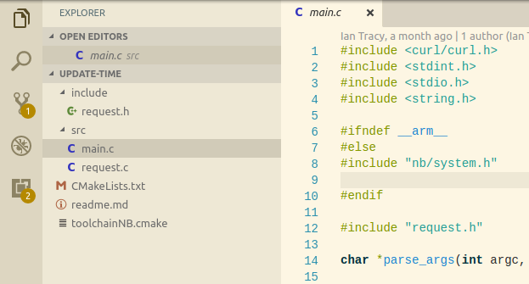

Start a terminal in VSCode; Enter Ctrl+~
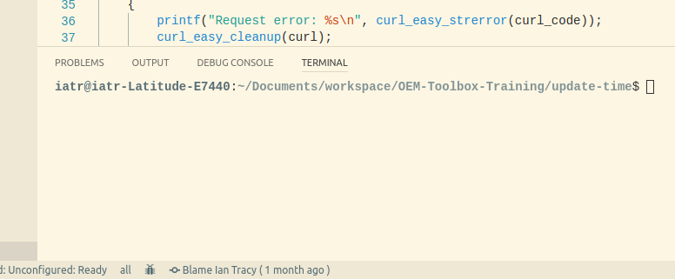
Having a terminal in VSCode will save you from alternating between the editor and the terminal.

4. Build the program
Make a directory for the build

Enter mkdir build && cd build
Run CMake

Enter cmake ../
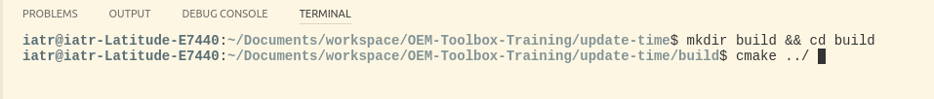
Cmake will perform many tasks that used to be done manually.
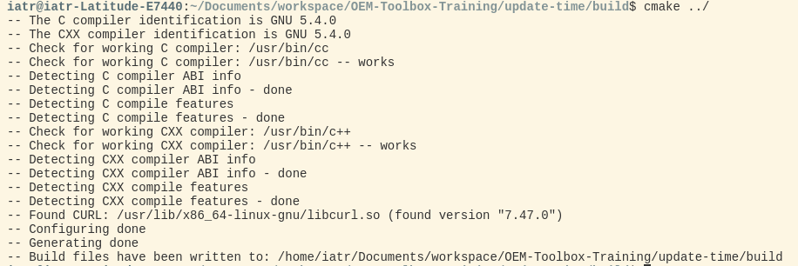
Cmake will find the compiler and find required libraries, but it did not actually build the program. For that, one more step is required.

Enter make
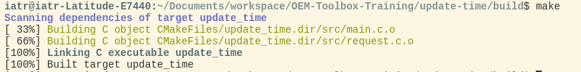

5. Run the program
The update time program requires one additional parameter; the URL of the server to query.

Enter ./update_time https://<sever name>

6. Cross-compile
First, you must source the environmental setup file that comes with the SDK.

Enter source <SDK_DIR>/nvironment-setup-cortexa8hf-neon-oe-linux-gnueabi
Clear all build and settings files from the build directory. Ensure you are in the build directory for this command.

Enter rm -rf *
Run Cmake again, but this time we will specify the tool-chain file for the OEM-Toolbox

Enter cmake ../ -DCMAKE_TOOLCHAIN_FILE=../toolchainNB.cmake
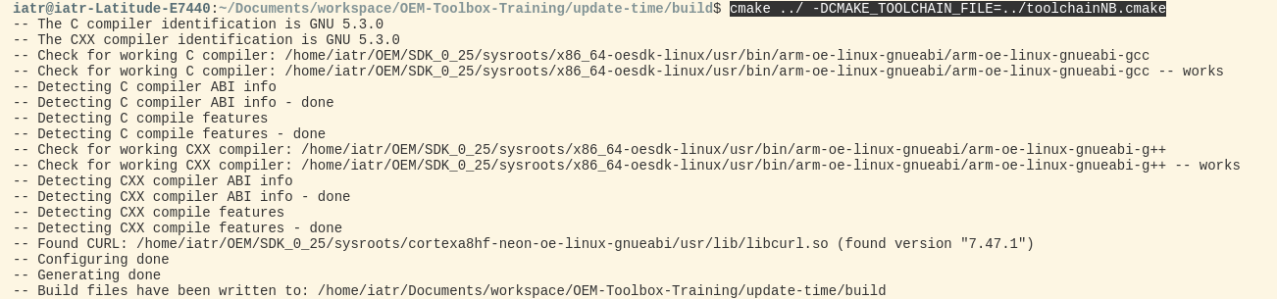

Enter make
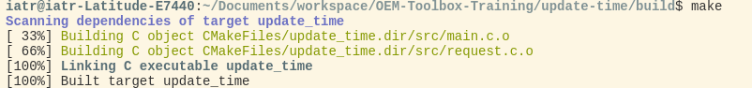
This time, the executable was built for the ARM EABI instruction set and not for X86.

Enter file update_time

6. Copy the file to the EC350
The EC350 will only allow secure copy via SSH; for this …

Enter scp update_time root@169.254.200.200:

7. SSH to the EC350, and run
The terminal in VSCode can be used, but perhaps a new terminal is best.
Enter ssh root@169.254.200.200:
Enter ./update_time <time server url>

Challenge Task
So far, update_time is only printing the time to the console. The EC350 still thinks it’s 2005! To set the system time, there is an C-API call. Find and add that call to the update time program.
C-API header files can be found in
<SDK root>/sysroots/cortexa8hf-neon-oe-linux-gnueabi/usr/include/nb/

You will need to add the call to main.c, cross compile, secure copy, and then run. Verify the results in the web-server.

