Lab 4 – Get Connected

1. Log into the Azure Portal
Provide credentials for this

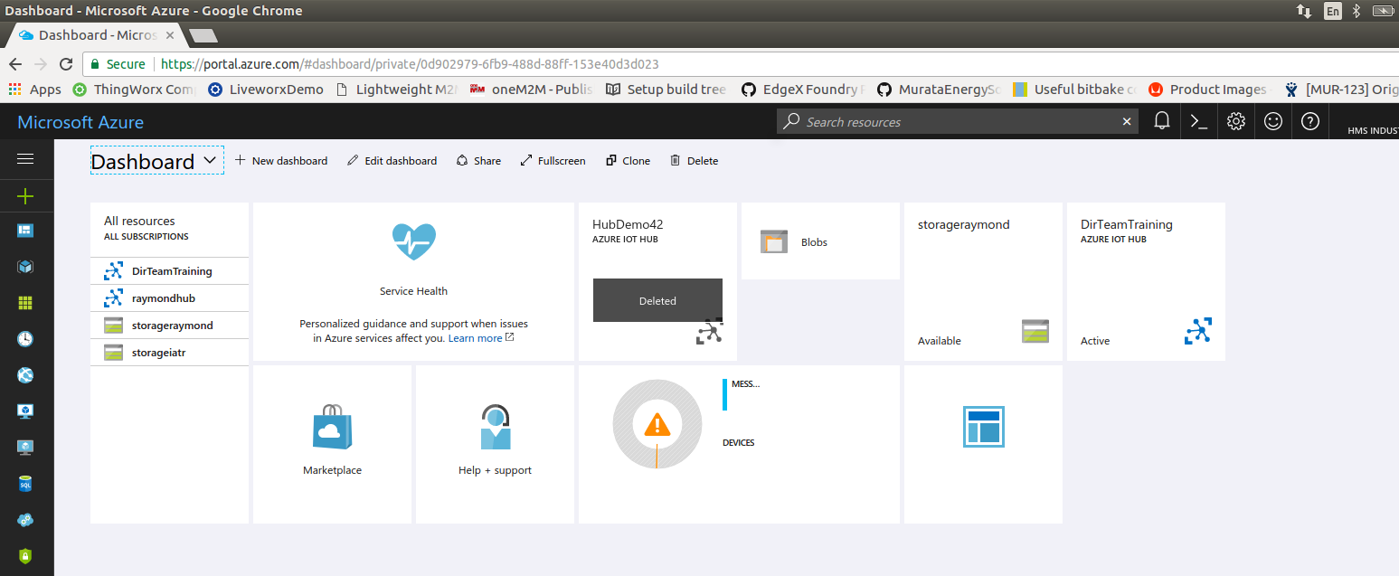
From the dashboard, Select DirTeam Training Azure IOT HUB

From the Shared access policies option, select the iothub owner, and copy the connection string. This will be used later for login with iotHub Explorer.

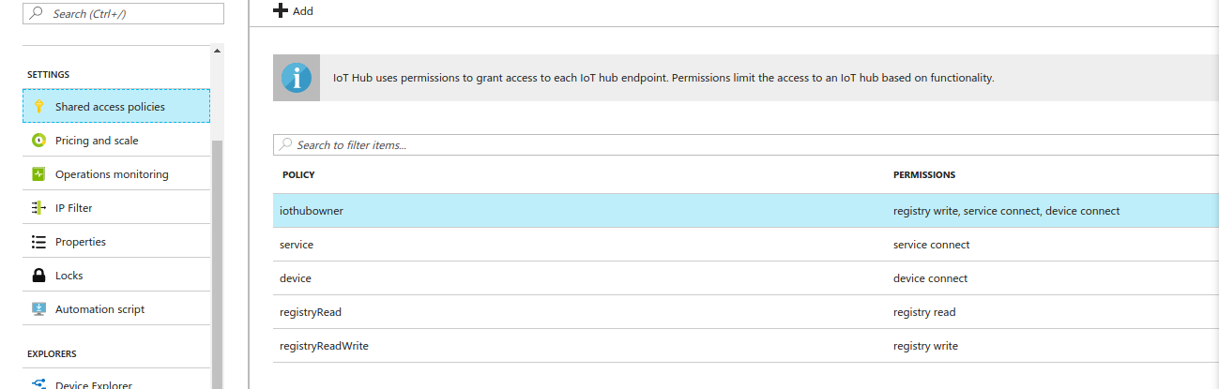

2. Create a device - Enter the device explorer.

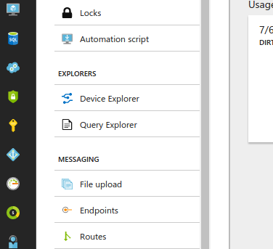

Select +, to add a device
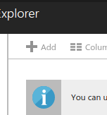

Enter a device ID – This must be unique across the hub (do not copy your neighbor)
Save the device.

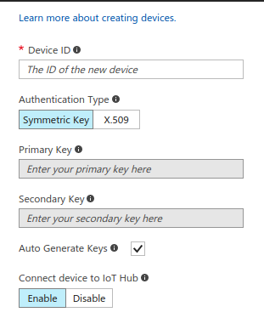

Select your device, and view the device ID, and keys. Copy the connection string.

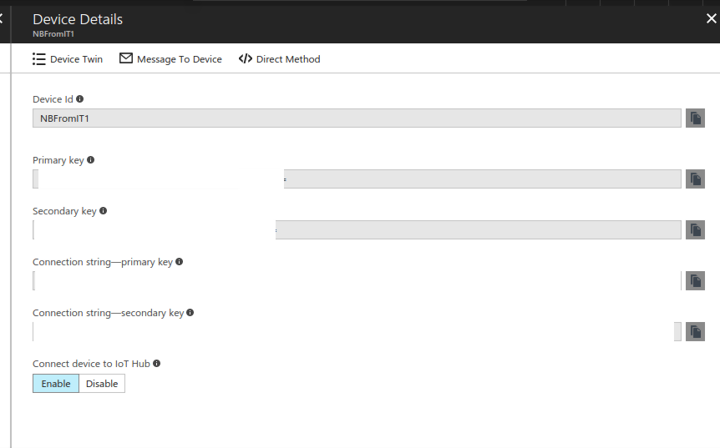

3. Download and prepare the IoThub client examples
To get started with IoThub, copy the C-SDK from github. In the documents folder
Enter command git clone https://github.com/Azure/azure-iot-sdks.git

There are several client samples, and for this training we will use the MQTT sample, and it will require some modifications before it can run. Within the SDK folder structure this sample can be found in the following directory:
azure-iot-sdk-c/iothub_client/samples/iothub_client_sample_mqtt

/Documents/azure/azure-iot-sdk-c/iothub_client/samples/iothub_client_sample_mqtt
Enter command cd /Documents/azure-iot-sdk-c/iothub_client/samples/iothub_client_sample_mqtt

Before we can use the samples, some modifications will be needed. In the sample directory enter the following command to bind up the sample source in VSCode.

Enter code .

In the file iothub_client_sample_mqtt.c copy the device connection string from the portal, to the initialization of the variable called connectionstring. Note the string should be enclosed in quotation marks.
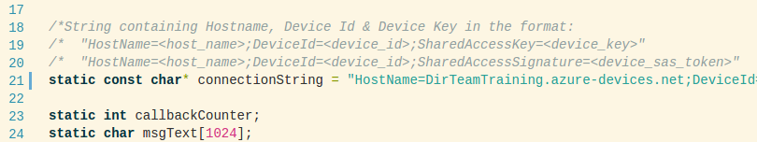

The IoT hub SDK includes support for TLS. For simplicity, we will use the TLS libraries provided by the SDK, and not the libraries resident on the NB301. There is one extra step that is needed, and that is to add the certificate of the Azure Server’s certificate authority to the trust store of the NB device. The CA required is DigiCert’s Baltimore Root. In the file certs/certs.c this certificate can be found in ASN.1 DER format.

In the file iothub_client_sample_mqtt.c , add the code seen from line 30 (#define USED_TRUSTED_CERTS) , until line 55 ( #endif )from the following figure.
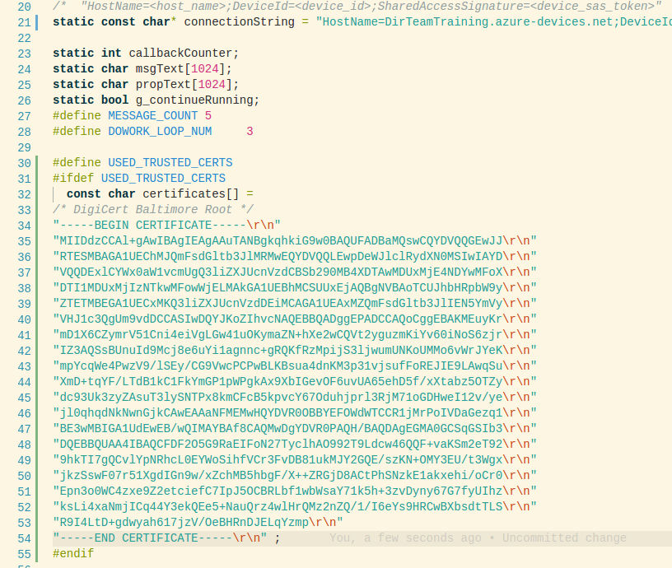

Certificates will be used by the following call. This call is already is compiled in when MBED_BUILD_TIMESTAMP is defined. Replace MBED_BUILD_TIMESTAMP with USED_TRUSTED_CERTS.

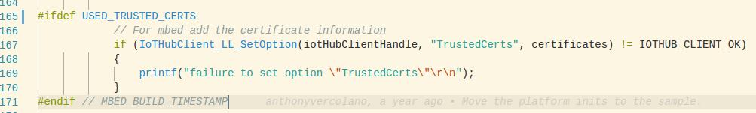

5. Build and deploy the mqtt sample.

Copy the OEM-Toolbox cmake toolchain file to Azure SDK build directory. First, change directories to the build folder for linux devices.
Enter command cd ~/Documents/azure-iot-sdk-c/build_all/linux

Then, copy the toolchain file from a OEM-Toolbox training project.

Enter command cp ~/Documents/workspace/OEM-Toolbox-Training/update-time/toolchainNB.cmake ./

source the environmental seuup variable

Enter command source <SDK DIR>/environment-setup-cortexa8hf-neon-oe-linux-gnueabi

Finally run the following command to build.

Enter command ./build.sh --toolchain-file toolchain-oemNetbiter.cmake
The results of the build should be found in the following directory:
/Documents/azure-iot-sdk-c/cmake/iotsdk_linux/iothub_client/samples/iothub_client_sample_mqtt

Copy iothub_client_sample_mqtt to the NB301, and run.

6. View the MQTT messages with iotHub-explorer

Install iotHub-Explorer with the node package manager

Enter command sudo npm install -g iothub-explorer

log into iotHub-Explorer - The connection string will need to be enclosed in quotes.

Enter command iotHub-explorer login <connection string>

List log into iotHub-Explorer - The connection string will need to be enclosed in quotes. To confirm your device ID:
Enter command iotHub-explorer list
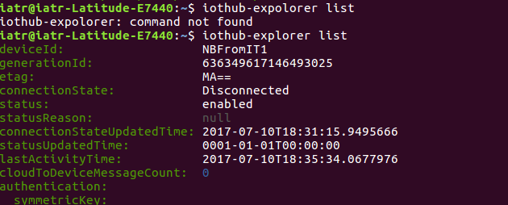
View Messages by using the following command. This command will require your connection string again.
Enter command iotHub-explorer monitor-events <deviceId> --login <connection string>

