M200ATESTgeneticdrift

Hayley Stansell

November 23, 2015

This is an R Markdown document. Markdown is a simple formatting syntax for authoring HTML, PDF, and MS Word documents. For more details on using R Markdown see <http://rmarkdown.rstudio.com>.

When you click the **Knit** button a document will be generated that includes both content as well as the output of any embedded R code chunks within the document. You can embed an R code chunk like this:

#M200A GENETIC DRIFT EXERCISES,Dr. Kirk Lohmueller, Fall 2015  
#Hayley Stansell  
#  
#  
getwd()

## [1] "C:/Users/Hayley/eeb201hayleystansell"

#  
?rbinom

## starting httpd help server ... done

rbinom(3,10,0.1)

## [1] 0 2 0

#3 random vars from a binom dist. 1st draw = 1/10 success, 2nd = 2/10 success, 3rd = 0/10 success  
#[1] 1 2 0  
rbinom

## function (n, size, prob)   
## .External(C_rbinom, n, size, prob)  
## <bytecode: 0x000000000642f238>  
## <environment: namespace:stats>

#just the function w/ nothing returns a summary of rbinom  
#  
#

You can also embed plots, for example:

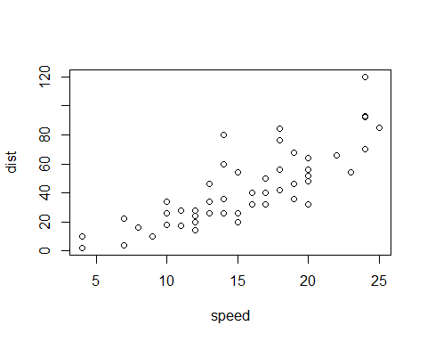

Note that the echo = FALSE parameter was added to the code chunk to prevent printing of the R code that generated the plot.