**Step 1**

Download the contest framework from here.

**Step 2**

Extract the contents of the archive to a folder of your preference.

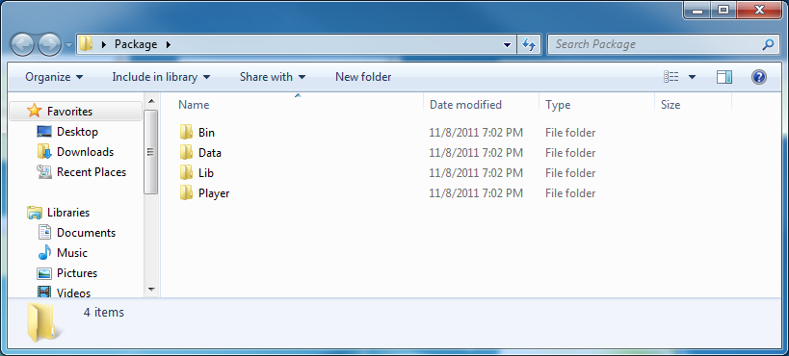

**Step 3**

To launch your first game, run the file Run.bat from the Player folder

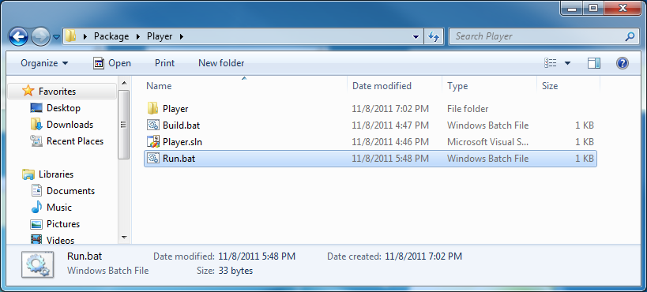

This will launch the Match Maker, the tool that allows you to setup your match parameters (ex. maps, opponents).

For now, click on **Start new game…**

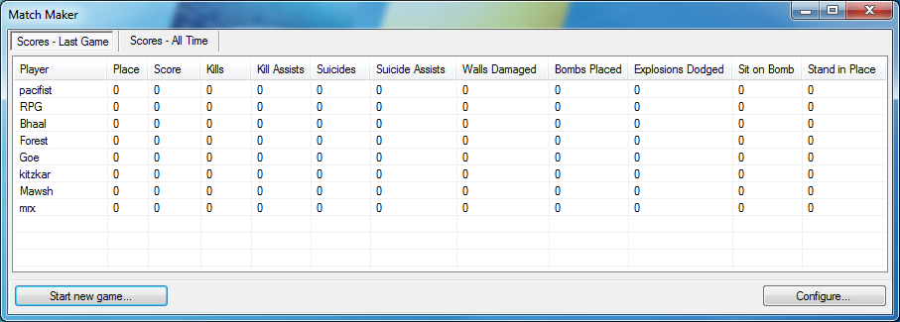

And then **Start**

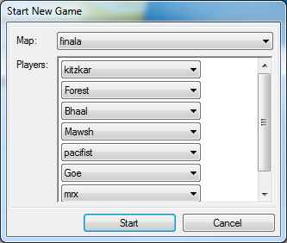

Your first match will begin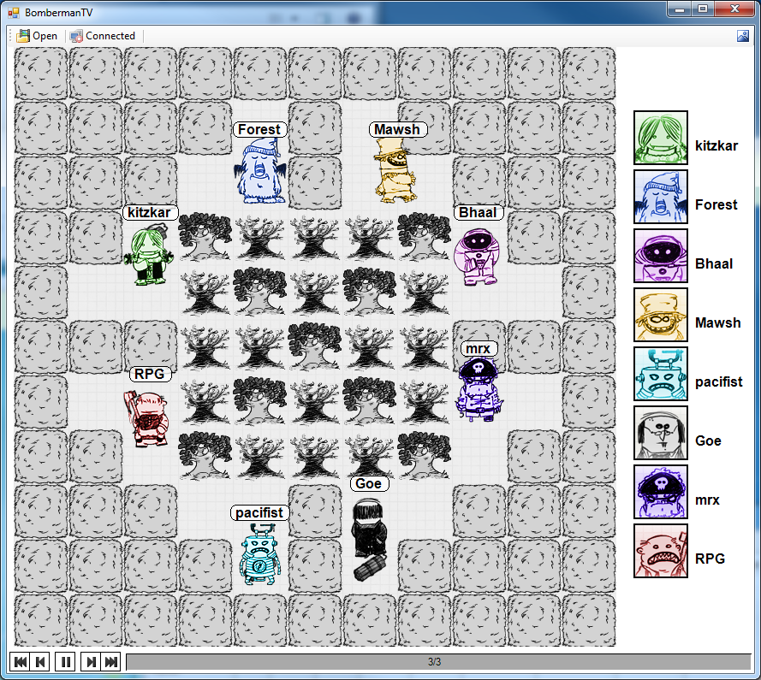

You can pause and resume the game, view logs or even stop execution completely by using this interface

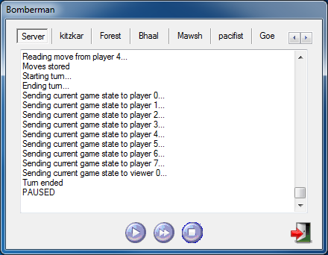

**Step 4**

It’s easy to run your own code. To do this, open **Player.sln**, then compile the solution and run the executable.

When run like this, the executable will try to connect to an active match.

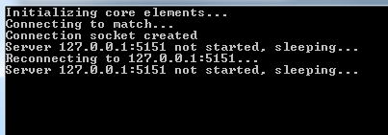

You can now start a new match with the Match Maker. When doing this, choose **– External –** for one of the players and then click on **Start**.

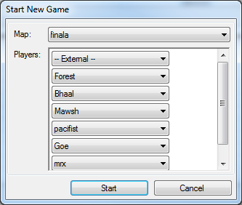

Your player is the one with the label **External**. It does nothing now and will probably get killed by the other AIs – but all that will change after you start implementing your own code.

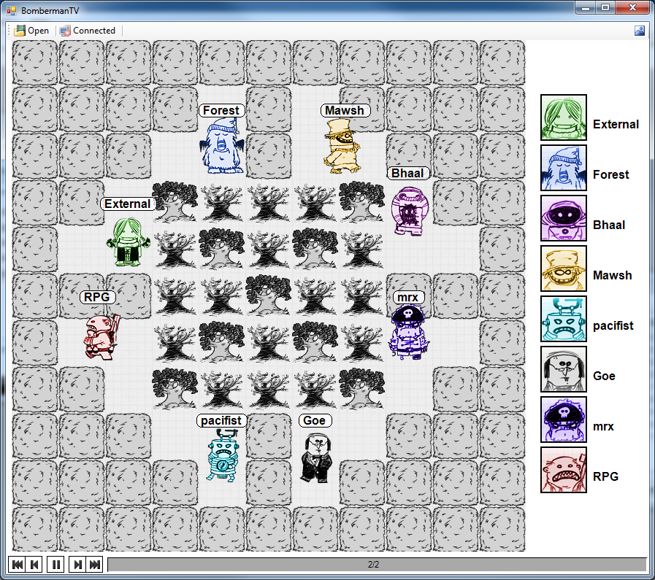

**Step 5**

You can now begin writing you own AI player. The only file you are allowed to modify is **main.cpp** (this is the only file you will submit for the contest).

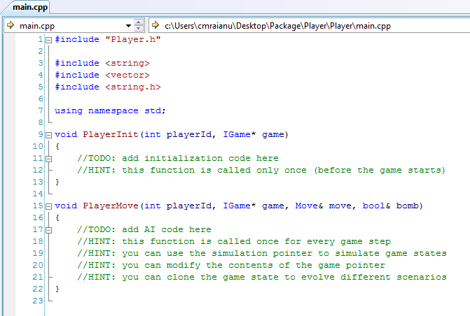

Check the included header files for more details about the framework. Read the implementation and submission rules (link) to get more details about what’s allowed and not and how to submit your solution.

**Step 6**

The above method works fine for debugging your AI. If you want to test it in the full contest environment, there are a few extra steps.

First, you must make sure that your code compiles with no warnings with Build.bat (you might need to edit the path inside this file). This will build the release version of your solution. Make sure you use the original solution and project files for this operation since this will be the one used for the official contest.

Then you need to uncheck the Debug Mode option in the Match Maker.

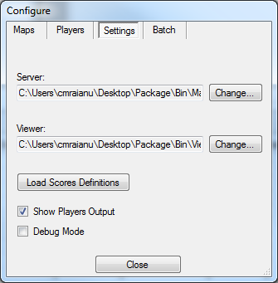

And finally, run a regular match. Your AI will be the one called **Player**.

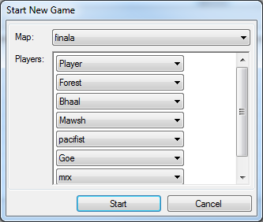

More details about compiling and submitting your solution can be found here.