**AVL & Dynamic Programming**

Advanced Algorithms – Assign#3 **Due date: Oct. 13th**

1. Show the result of inserting the nodes 13, 8, 5, 9, 4, 6, 12, 2, 1 and 3 in the order given to an initially empty AVL tree. Show your steps after each insertion. It is not enough to just show the final output.
2. Write pseudo code that verifies that an AVL tree is a valid AVL tree. Your algorithm should verify (i) Tree is a binary search tree, (ii) height stored in each node is correct, and (iii) each node maintains height-balance property. Optionally include code as well. Also include the time complexity of your pseudo code.

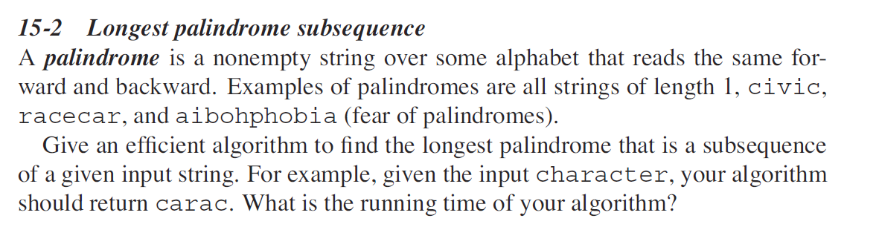

Also show the dry run of your algorithm labelling the steps.

**Submission**:

Please upload your solution files to d2l by the due date.