**Dynamic Programming - Graphs**

Advanced Algorithms – Assign#4

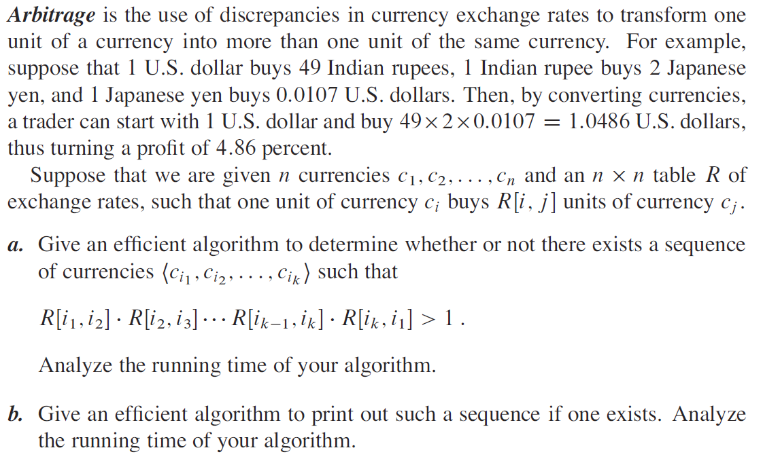

1. Include a dry run of your algorithm with some sample data and show your work.
2. Implement the algorithm in a programming language of your choice, and be sure to include screenshots of sample executions of your program in a test case report.

**Submission**:

Please upload your solution files to d2l by the due date.