## 31-7-20 Thierry, Stijn

List with mitigation strategies:

* Random dropping
* Isolation (Quarantine)
* Drop all contacts for Least Used links
  + Drops the links, not the nodes

Log:

* Added a part to the code which implements the mitigation strategies after a certain percentage of infections (10%) instead of giving the code a predetermined start time. (This does not work yet for isolation)
* Generated starting results using Tbegin values found in T10_values.txt

General remarks and ideas:

* Do we want to use 1 starting node or keep averaging over all start positions ?
* Deleted links is not the same anymore, how are we going to make a fair comparison? (Maybe use the same percentage of deleted links? But this would not be possible to predetermine for isolation)

## 30-7-20 Meeting Mels, Thierry, Stijn

* General approach :
  + Reordering data and snipping excess tables to use in the python file
  + Mitigation strategies at 10% infection
  + Rescaling the time axis to one scale
  + Beta is 1 and gamma (recovery) zero (at this point)
* Next steps (goal, working towards a new meeting with supervisor soon):
  + Trimming approach (its an option, discussable)
    - Throw all unused timesteps away
    - Pros:
      * The systems become more general, the same happens without delay times due to longer periods without any infections.
    - Cons:
      * You change the behaviour of your data set molding it to something new
      * If you use a non-zero gamma, it would impossible to use
  + Working towards first results
    - List with mitigation strategies
    - Generate first results and see from there

## 18-07: Mels + Cleo

* Cleo: Adjusted followup.py to use Least used Links and Max used Links in a certain time window T_begin till T_end
* Mels: Adjusted followup.py to use isolation in a certain time window.
* Cost of mitigation = **percentage of links** cut (from total # of links in the mitigation time window)!
* Cleo: created script to determine T10%, T20% etc: the timestep at which for instance 10% of nodes is infected. In her paper she used this to compare the time windows over different datasets (for instance by running mitigation from T10% to 2*T10%.
* Mels: added a trimming program that can delete unused timestamps, see the next figures

****Top left:*** *Haggle 'vanille'.* ***top right:*** *Haggle trimmed 'vanille'.* ***Bottom:*** *Isolation started at Tbegin = 3000 and with initial infection window of Tisolation = 5000 of both respectively Haggle and Haggle trimmed. (all figures can be found in the folder: images)*

For next time: Decide in which time windows to plot the mitigation strategies and plot this for different percentages of links cut!

06-07: Thierry + Cleo

run and rescale datasets to Tmax = 1.

This is the figure, the npy arrays in the folder are the arrays for beta = 1 and no recovery. Analysis and plot was done in a separate file.

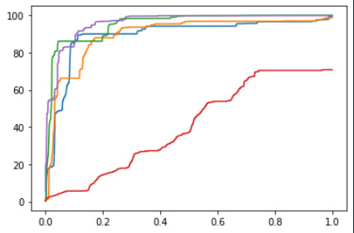

## 25-05: Della + Cleo

* Adjusted HS2012, HS2011, HS2013 so we could run this took a very long time ☹
* The data HS datasets should now be imported in the same fashion as the ordered MIT data set. The nodes are ordened from 0 to a maximum number.

1. HS2011 (29) http://www.sociopatterns.org/datasets/high-school-dynamic-contact-networks
2. HS2012 (29) http://www.sociopatterns.org/datasets/high-school-dynamic-contact-networks
3. HS2013 (30) (S1 dataset) https://journals.plos.org/plosone/article?id=10.1371/journal.pone.0136497
4. RM/MIT (25/26) http://konect.uni-koblenz.de/networks/mit
5. Hypertext2009 (27,28) http://konect.uni-koblenz.de/networks/sociopatterns-hypertext
6. Primary School (31) seems devided into two seperate days: https://journals.plos.org/plosone/article?id=10.1371/journal.pone.0023176
7. Workplace (32) Link not in article: https://arxiv.org/abs/1409.7017
8. Haggle (33,34)
9. Infectious (28) Link is not in article: https://www-sciencedirect-com.tudelft.idm.oclc.org/science/article/pii/S0022519310006284#s0010
10. Virtual contacts:
11. Man Email (35,36)
12. Email EU (37)
13. DNC Email (38)
14. COllegemsg (39)