Game Design Document

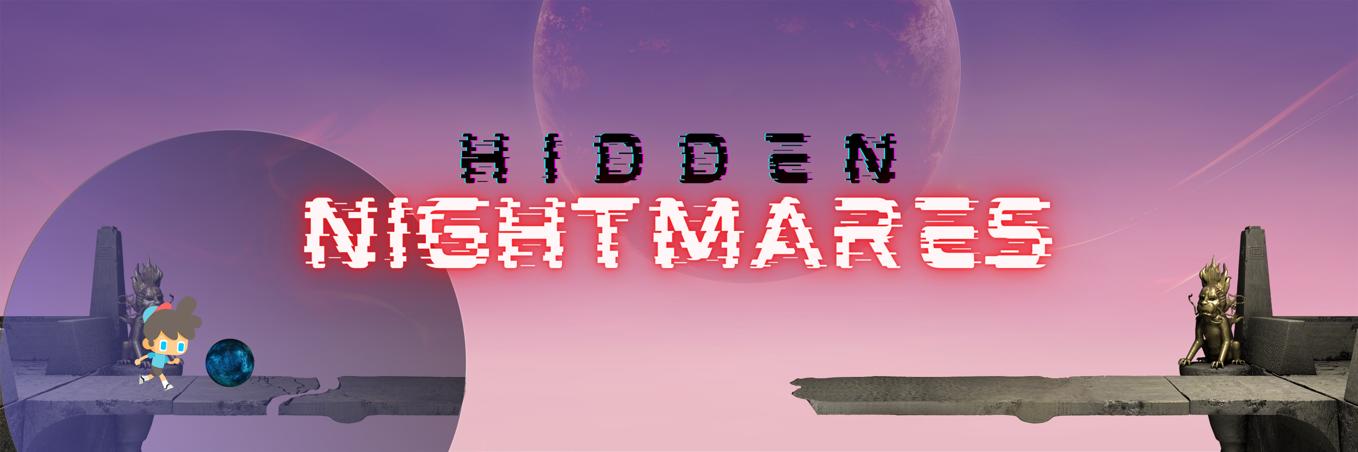

**Hidden Nightmares**

**Group #5**

**Dated: 28th May 2021**

|  |  |  |  |
| --- | --- | --- | --- |
| No. | ID | Name | Email |
| 1 | 17846 | Mohammad Memon | m.memon.17846@khi.iba.edu.pk |
| 2 | 17885 | Hassaan Nadeem | hassan.nadeem2567@gmail.com |
| 3 | 18051 | Vinay Kumar | vinaymandhan28@gmail.com |
| 4 | 14829 | Abdul Samad Qureshi | abdulqureshi381@gmail.com |

Game Design

Summary

Hidden Nightmares is a side scroller platformer genre game where you play as a young boy to unravel a story to reveal his truth. You are equipped with power to see beyond the dimension that we live in opening you to many obstacles and great secrets.

Made on Unity 2020.2.4.f for Android.

Controls

Touch the buttons on screen.

Left Arrow: Move Left

Right Arrow: Move Right

Up Arrow: Jump

Dimension: Change Dimension (only when ORB is near)

Settings: Opens Pause Menu.

Story

A 15 year old boy with special abilities (not known to him, which were given to him by his father when his father experimented on him while he was an infant) in a medieval world is preparing for a festival in his village when an event occurs that brings the Destroyer in the world. This attack brings different enemies into the world. The Destroyer wants to finish off the father of the boy as the father and the Destroyer has a history. Father of the boy is kidnapped by the destroyer who wants to use his father's intelligence to create a weapon to give the destroyer to extract energy from planets leaving behind the planet dead. Boy has to explore his abilities that were hidden from him on his quest to save his father. The ability being the power to exist in an alternate reality where things are different but the same in a way where he can obtain tools by solving puzzles from the alternate world into his world and explore around the normal around and alternate world.

Mechanics

The main character who has to go to different locations marked on the map and has to complete different puzzle levels. Since he has the ability to go to another dimension it will help him to view the level in another perspective.

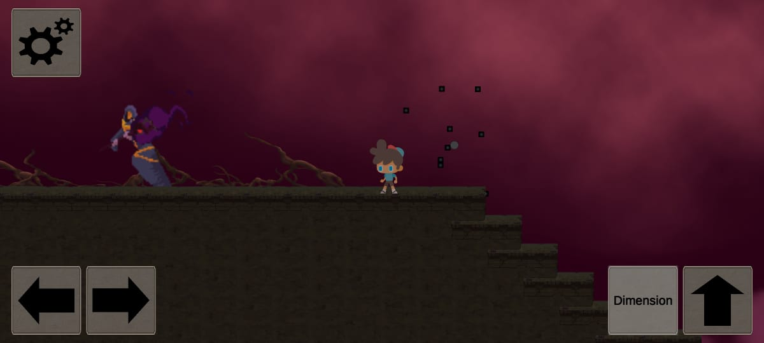

The character can move at any solid platform.

The Dimension button only works near a dimension changing orb and that changes the color of the environment and new objects and platforms become visible only till a particular range that the orb can reach.

NPC Character can be interacted with, and they reveal dialogues which drive the story forward and will lead the player to new secrets.

Dynamics/Advanced Rules

There are puzzles in the sense that navigating through the level is a puzzle in itself and on the contrary, there are minigames which are interactive puzzles as a player has to interact with an object to access the puzzles (required not optional for level progression). The level will end when you successfully reach this point and successfully complete the puzzle. There are 2 mini games in 2 out of the 4 zones.

Objects

1. Keys to open doors (in the later levels)

2. Switches to move platforms (later levels)

3. Hidden switches to move camera around to reveal areas.

4. Vines and ladders to climb.

5. Objects to enable mini games.

6. Orb to enable dimensions.

Death: The player sprite gets destroyed if he touches the acid and other environmental obstacles, and also by falling out of the map.

Level Design

Setting

As we move towards story development, we will explain what the jumping platforms/interactive puzzles and the key - door stages mean. Since the story is hidden, the player will not know why he is doing all this.

1st Zone: This level serves as a intro for the player. The theme is happy, the puzzles are straight forward. The level is supposed to be linear and only contain a few things to allow the player to catch up.

2nd Zone: This is supposed to be a nightmarish realm where more focus is on the second dimension than on the real world. The puzzles will be difficult. The focus on this level is the twisted realm. The player will be focused on staying alive as the obstacles will be made in such a way as to throw the player off, resulting in his/her death.

This is a fast change of pace from a happy environmental location to a darker zone. This is to emphasize on the second dimension that the boy can go through. As the story goes on, the player will get to know why he has these visions.

3rd Zone: It is after zone 3 that the player will start to understand the motivation behind every action. The puzzles are all the past obstacles that the boy could never overcome. The interactive puzzles are all the tasks and promises he failed to fully carry out and the key - door mechanic is a hint for something that is yet to come.

4Th Zone: This level is a challenging level. It has a challenging mini game, a layout that you will need to think about before going on. This will test your skills and prepare you for the end of the story.