1. **WITHDRAW_MONEY Use Case Description: Main Flow**

|  |  |
| --- | --- |
| **User Action** | **System Response** |
| User types in PIN to main screen | System checks validity of PIN and presents options to user on another screen |
| User reaches to the main menu | System displays options: Change PIN, Check Balance and Withdraw Money |
| User select the Withdraw Money | System displays options for withdrawal amount and a field to enter the amount |

**C. User Story of an ATM user trying to withdraw money**

As an ATM user, I want to see the list of amounts so that I can select the required amount to withdraw money

As an ATM user, I want to key in the amount so that I can withdraw the flexible amount as I wanted

1. **Use case diagram for ATM System**  
   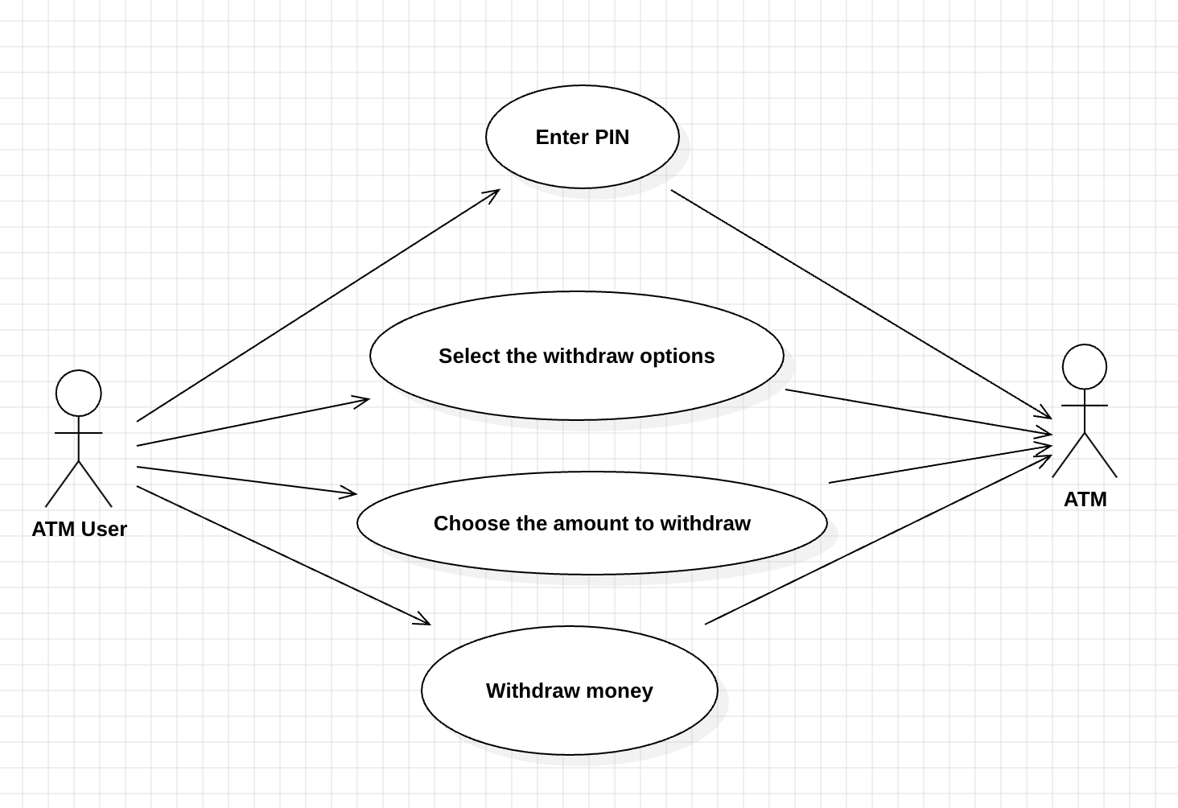
2. **Project Management Tracking System**

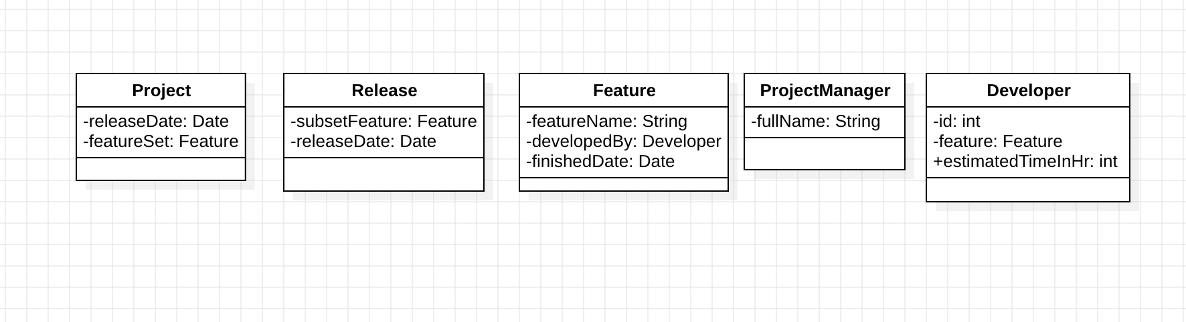

1. **Properties Management System**

