1. 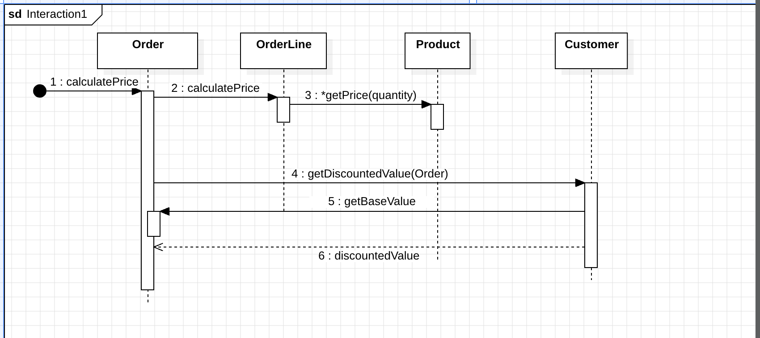
2. 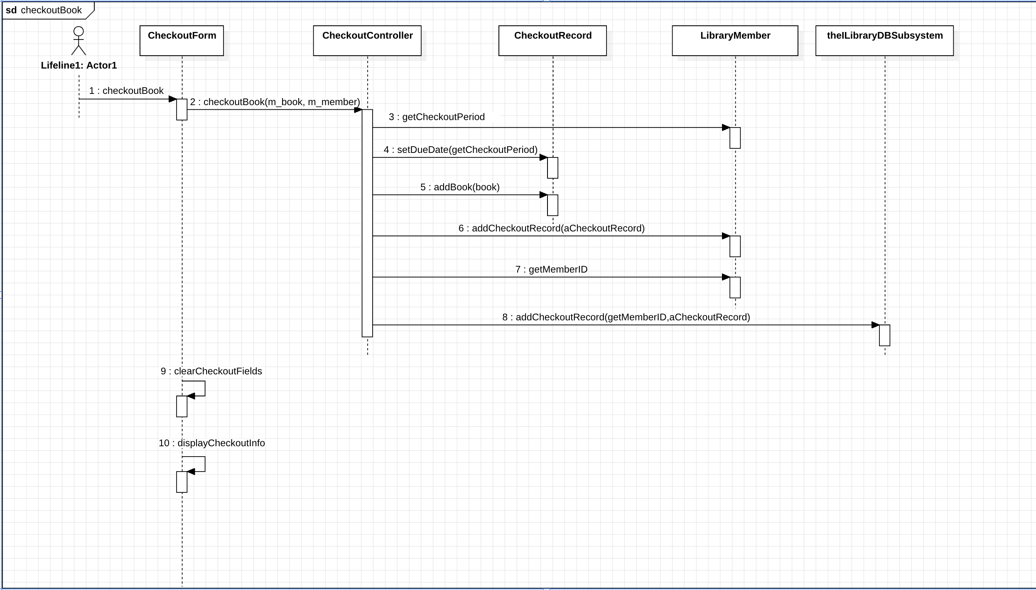
3. Labs -> https://github.com/HNINNANDAR/CS401July/tree/main/src/Lesson4/Labs/payroll_calculation
4. 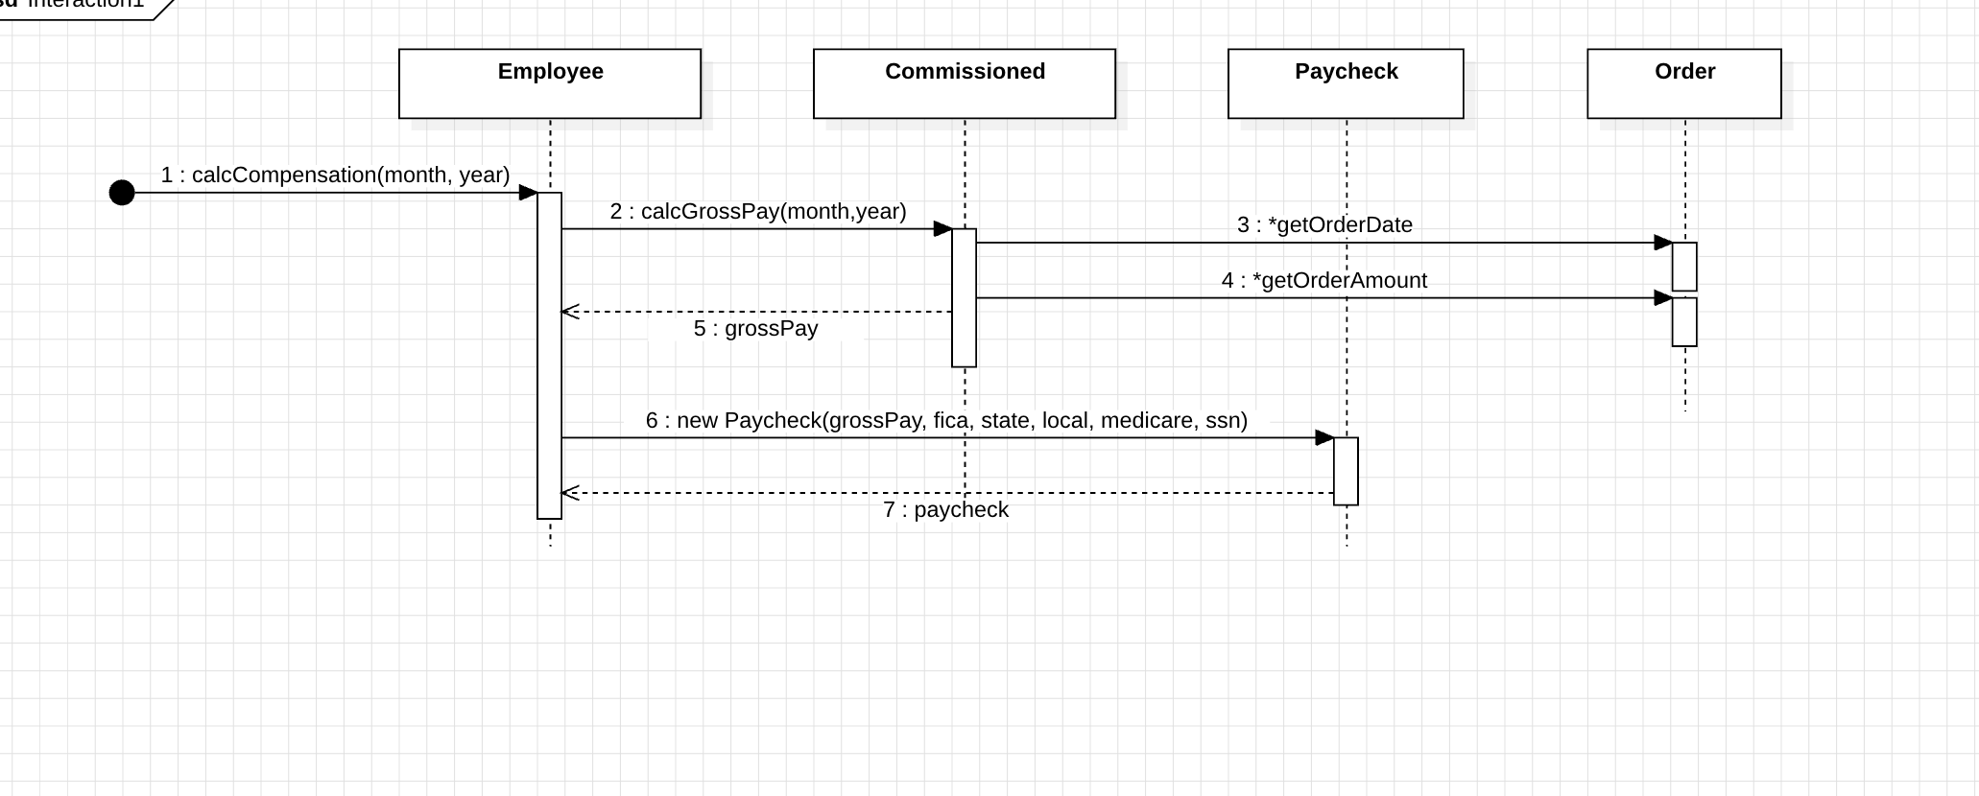
5. Lab -> https://github.com/HNINNANDAR/CS401July/tree/main/src/Lesson4/Labs/prob4E