Assignment - 1.2

1. pwd - Print working directory. The pwd (print working directory) command displays the name of the current working directory.  In below screenshot /home/acadgild is the current working directory. pwd has options, pwd[-LP] where –L print value of $pwd if it names the current directory and –P prints the physical directory.

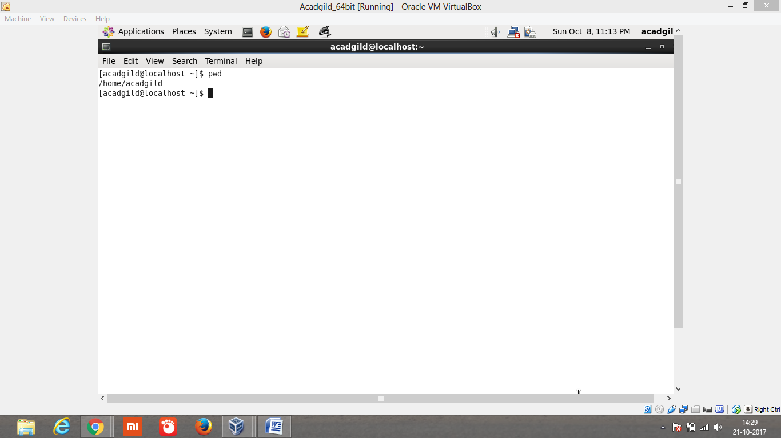

1. vi – vi is text editor in linux. On entering vi +Enter linux will take the user to insert mode. User can insert the data and save into the file. To save and quit the vi editor type press ESC :q!<Enter>.

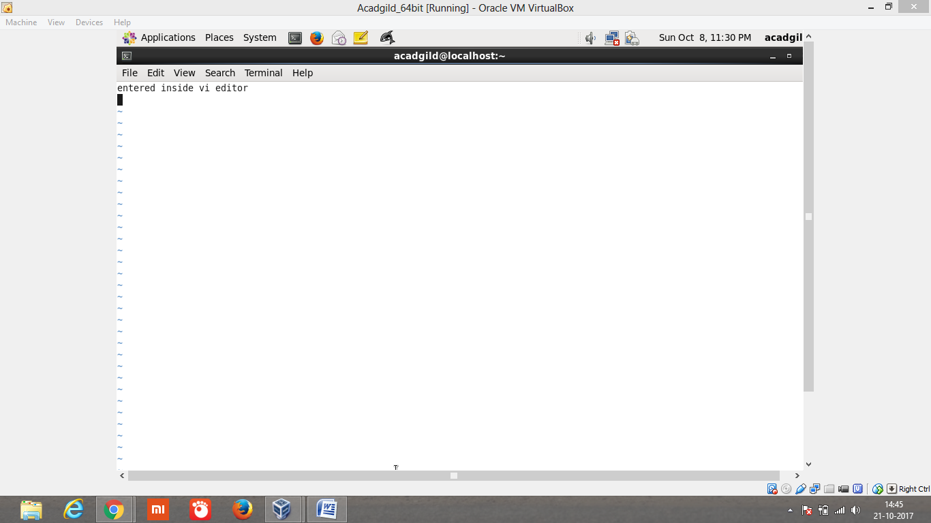

1. touch - The **touch** command is the easiest way to create new, empty files. It is also used to change the timestamps (i.e., dates and times of the most recent access and modification) on existing files and directories. In the below screenshot 1st we list the files present in the system. Then we create the new file **demofile** using **touch** command. List the created file with timestamp. Then we changed the timestamp for the created file using **touch –t 11111111 demofile** which changes the date,month,year of the file.

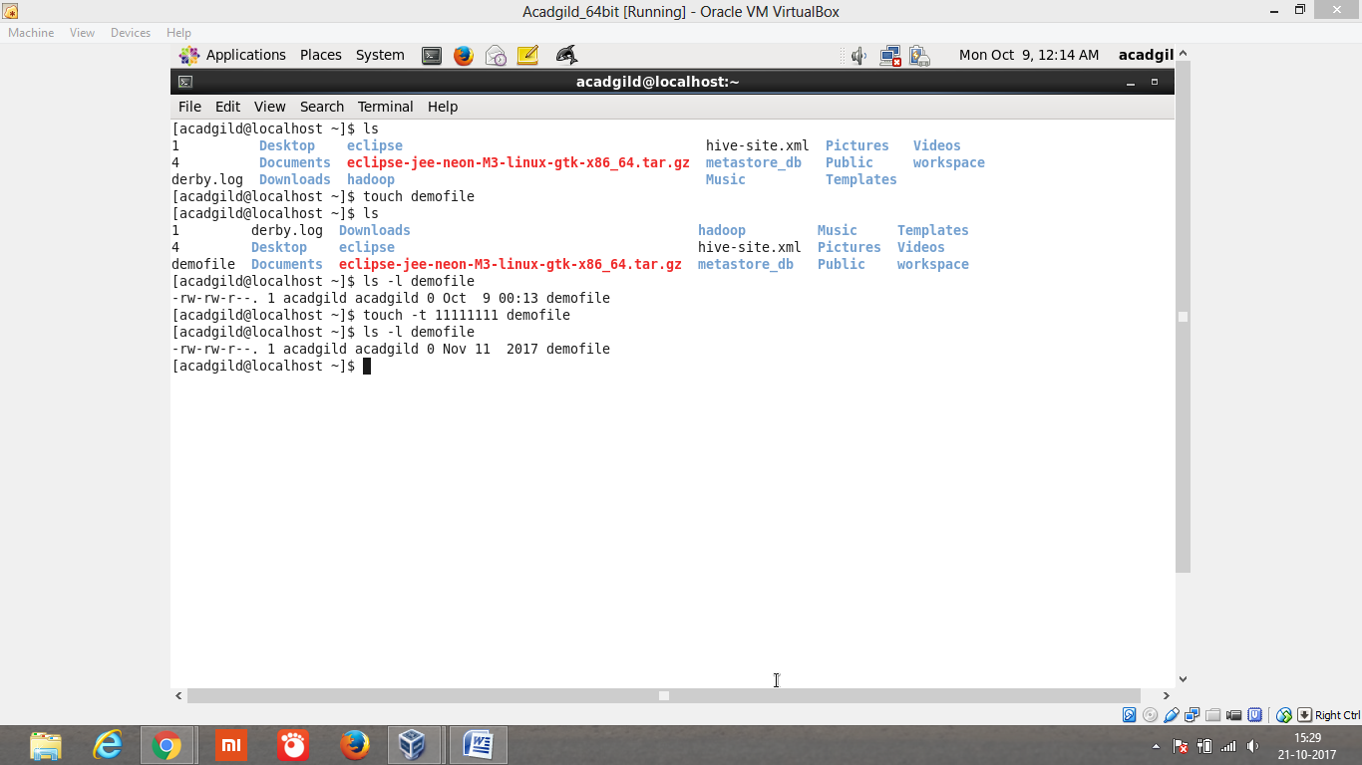

1. mkdir – make/create directory which is used to create the directory. in the below screenshot we list the files and directories using **ls** command. Then will create the new directory called **manjunath** using **mkdir manjunath.** To check whether directory is created/not will list again using **ls** command.

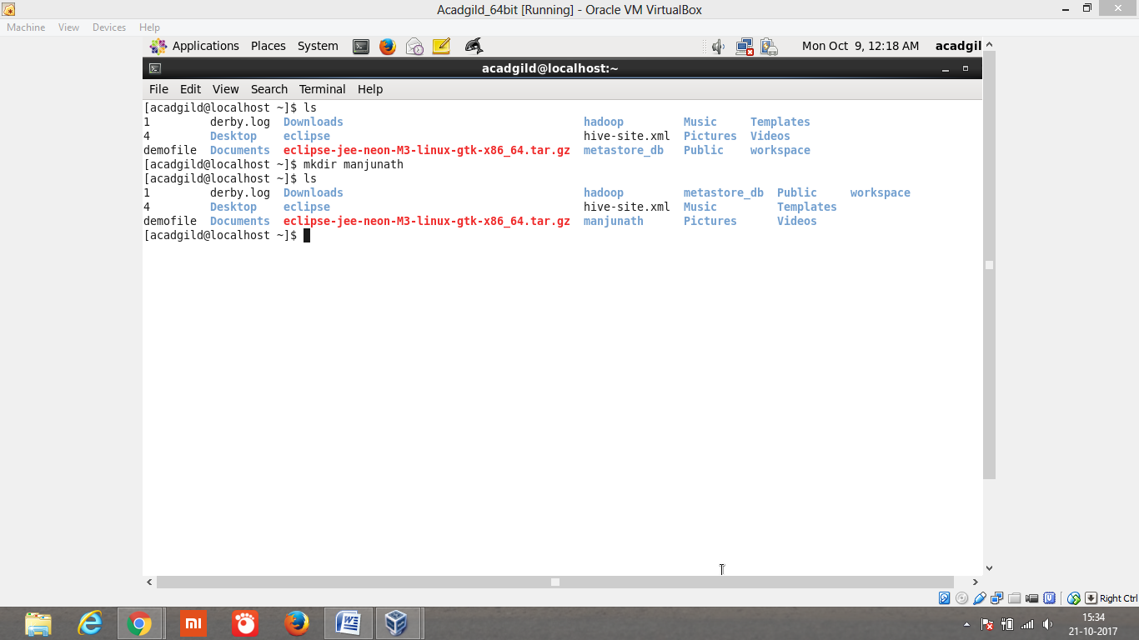

1. **rm** - Removes the specified files from the file system. In the below screenshot there are 3 files **file1, file2 and file3.**  File3 is deleted using **rm** command. Then we list same file, now it shows only existing files. File3 is deleted.

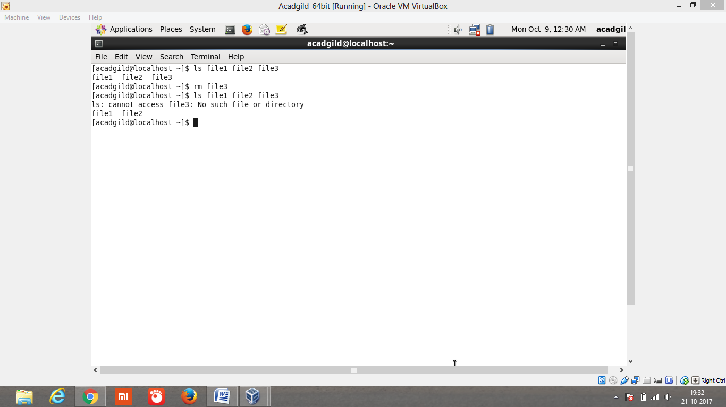

1. ls - If you run **ls** without any additional parameters, the program will list the contents of the current directory in short form.

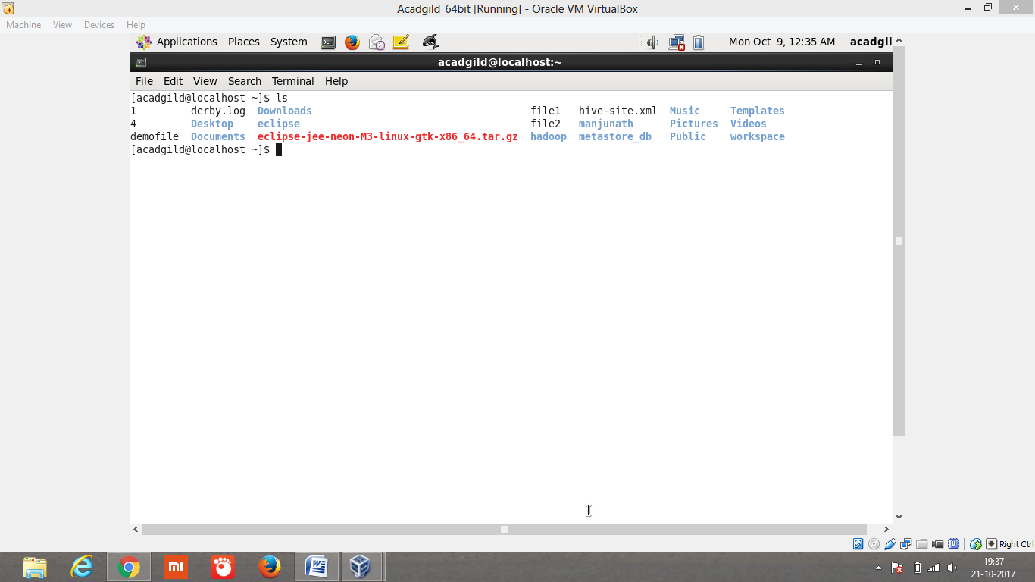

1. Echo allows a user to repeat, or "echo," a string variable to standard output. In the below screenshot echo print the “Hello echo” message. And also print the value of x.

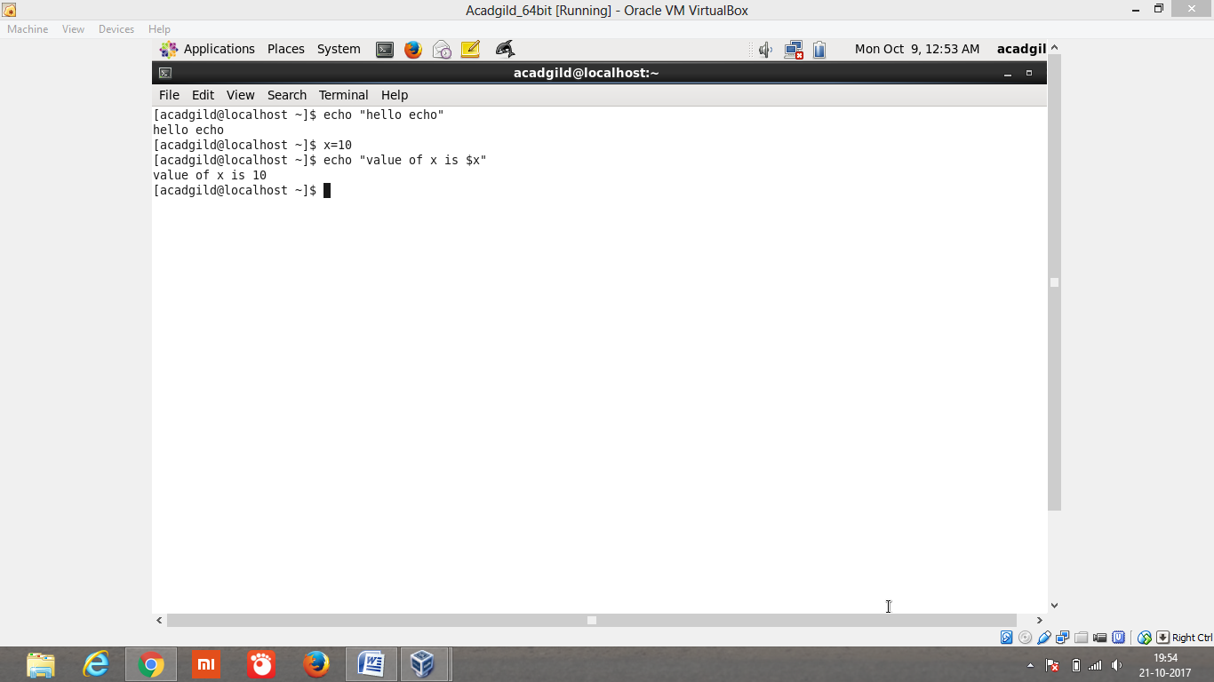

1. Cat commands are used for displaying the contents of a file. Cat has many features, but here we demonstrate the cat command to display the content of the file. In the below screenshot we list the file1 using **ls file1 ->cat file1 (no contents) ->vi file1 (edit the file1 and added some content) ->cat file1 (displays the content after adding using vi).**

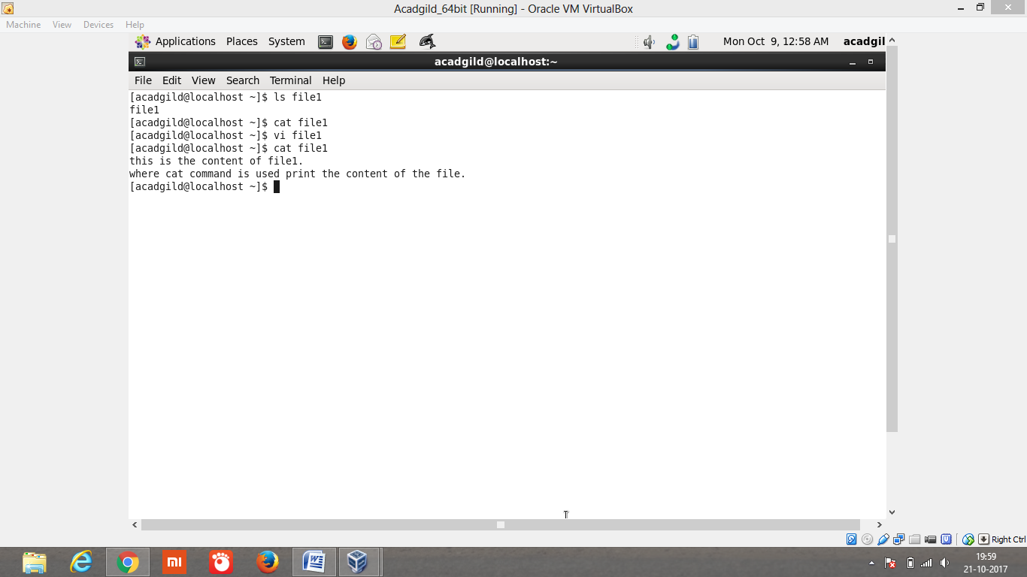

1. Who – The  **who** command prints information about all users who are currently logged in. In the below screenshot it shows there are 2 process running in currently. And also shows the system boot time **who –b.**

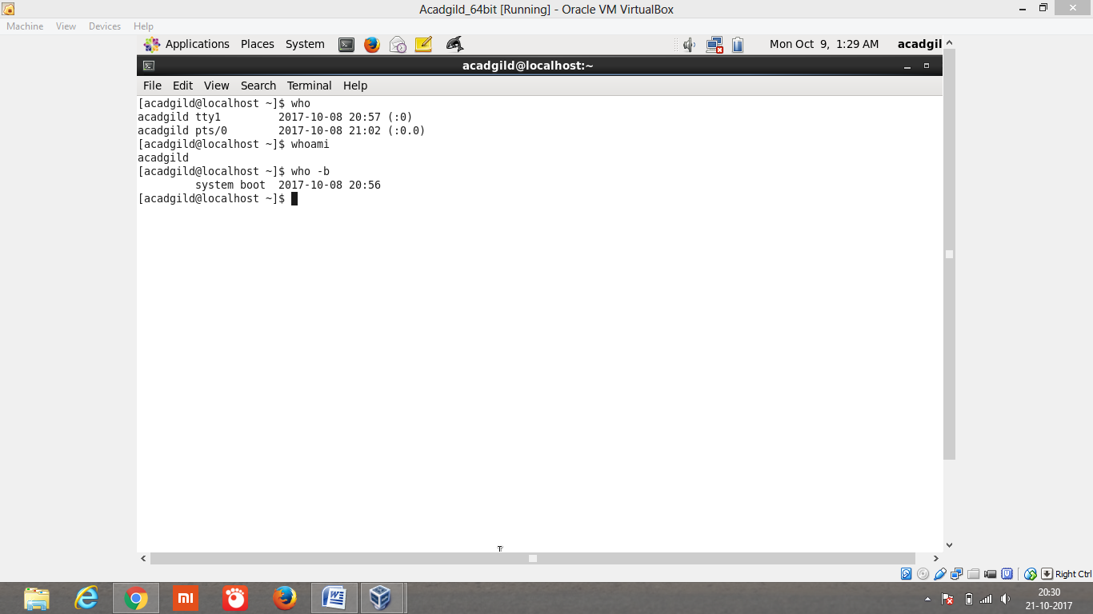

1. Cd - Changes the current directory. **cd** without any parameters changes to the user's home directory. in the below screenshot default directory has been changed to manjunath.

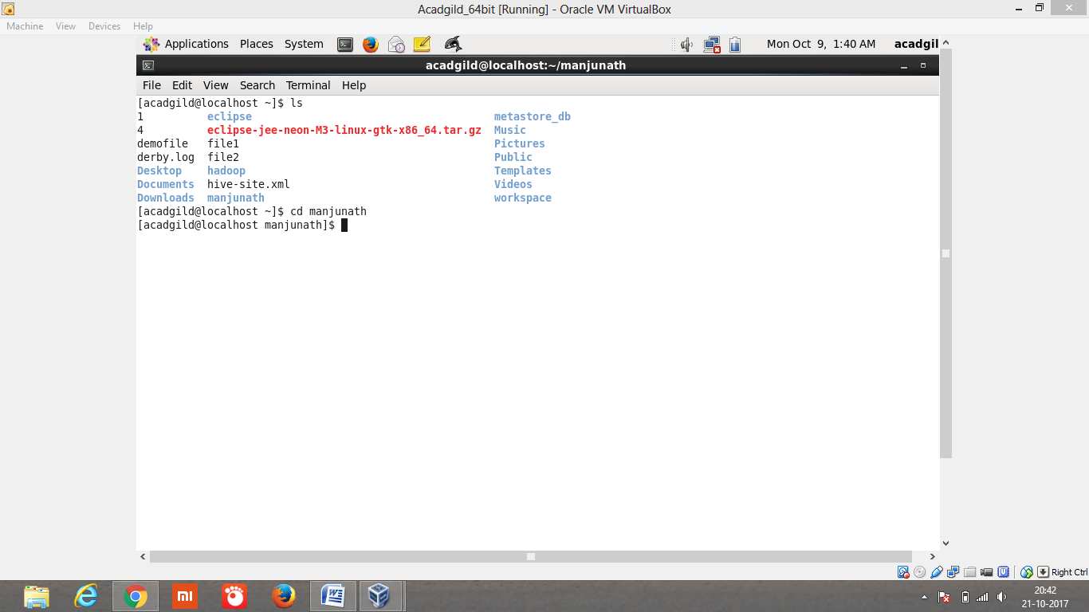

1. Date - Date sets a system's date and time and also displays the current system time. If run as root, it can also be used to change the system time.

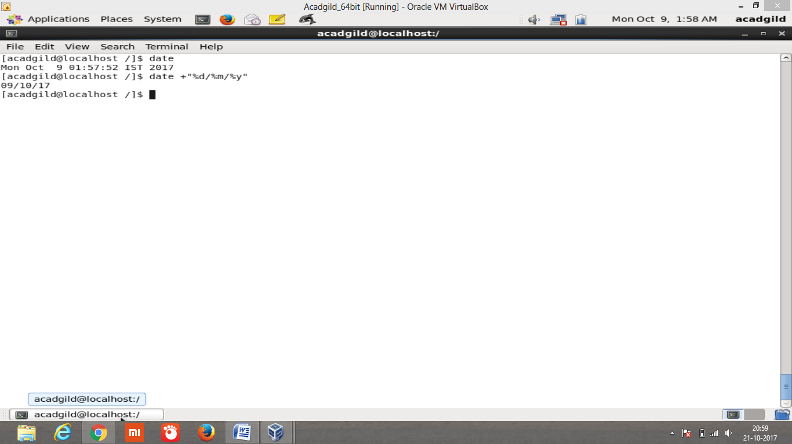

1. Cal – cal displays the calendar in terminal. By default **cal** displays the current month. But in the below screenshot i’m displaying entire 2017 year months with current date highlighting.

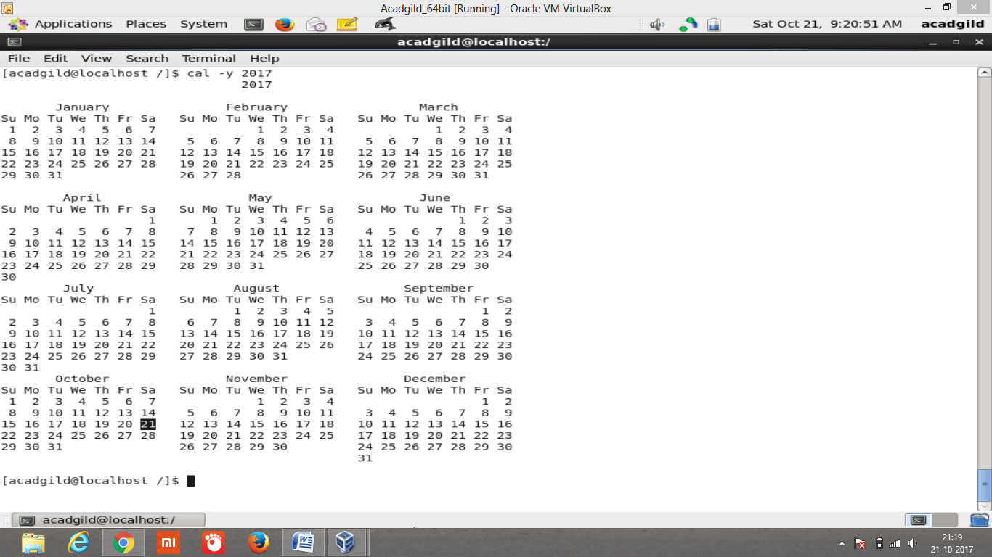

1. mv - The **mv** command is used to move or rename files.  Below screenshot displays **file2** moved to the directory **manjunath.**

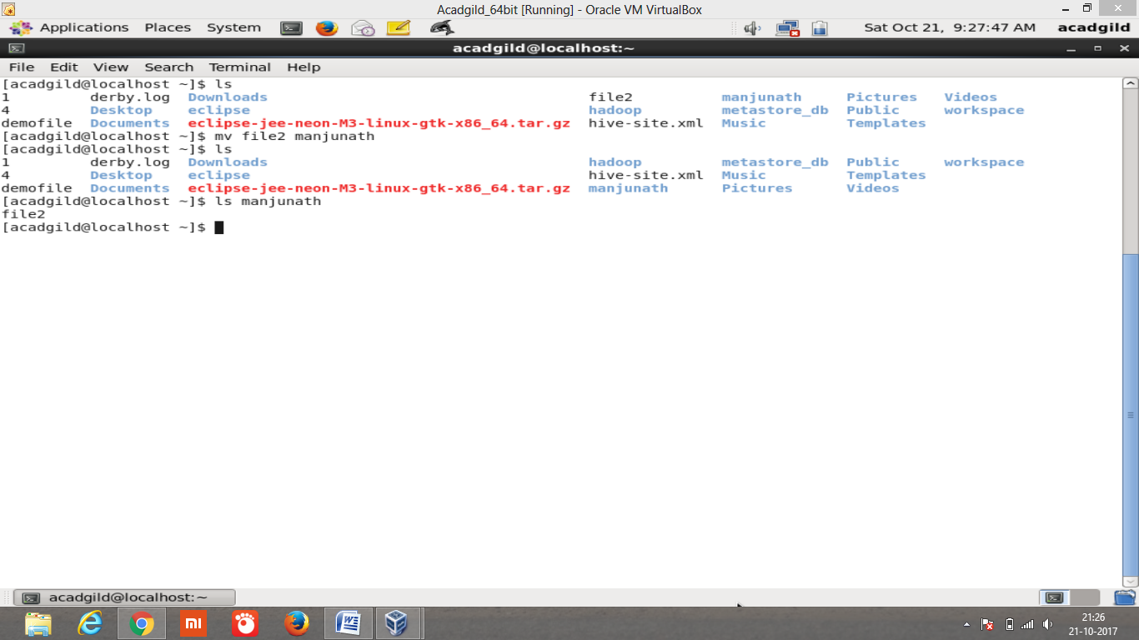

1. cp – copy command is used to copy the files and directories. Below screenshot shows that **fileone** has some content, **filethree** is an empty file. **Cp fileone filethree** copies content of **fileone to filethree.**

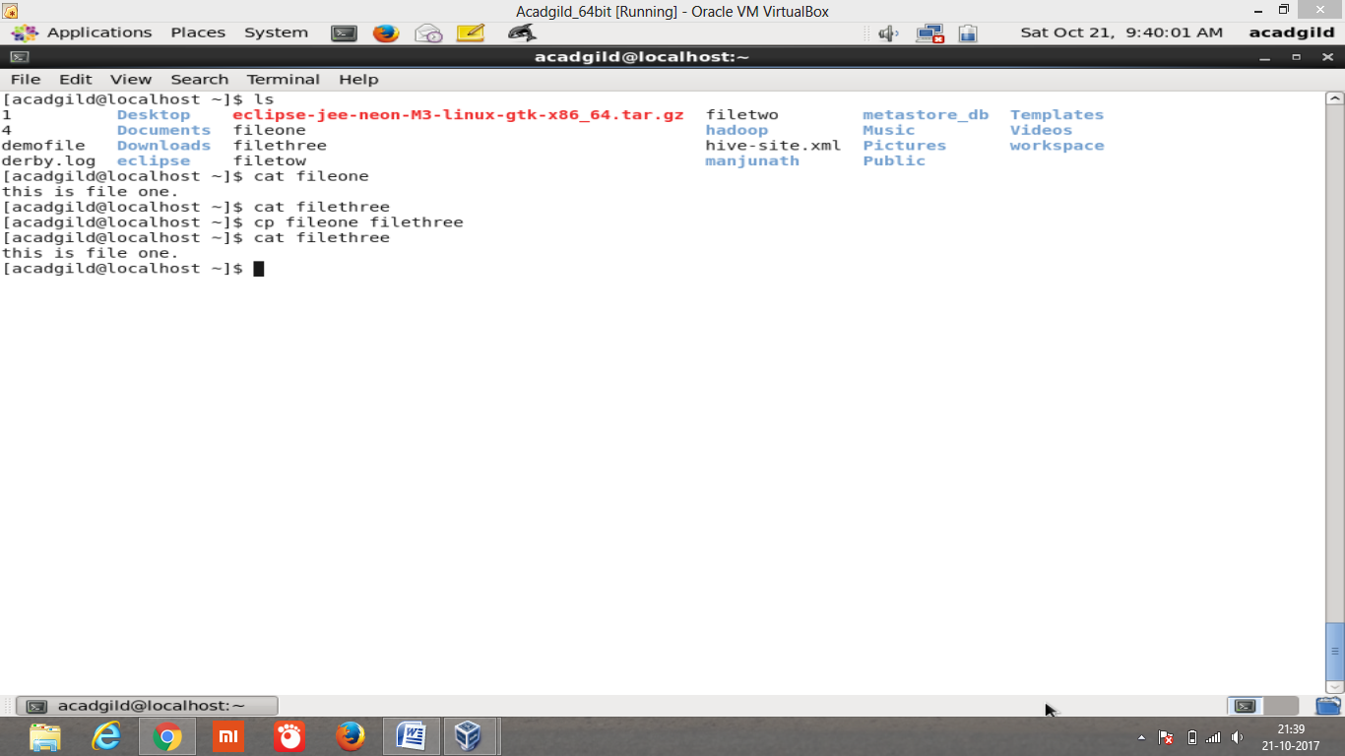

1. “which” commands searches the path of executable in system paths set in $PATH environment variable. Below screenshot displays paths of each executable where it exists in the system.

