Cloud Computing with AWS - Final Project

**Final Project- Deploy a Highly Availabile Wordpress Application**

**Problem Statement:**

In this final project, you will create a highly available (HA), scalable and fault-tolerant deployment of the WordPress application. You will deploy the WordPress application in such a way that the application server, load balancer and database will scale independently of one another. You will also deploy the application's components like the webserver and database into two availability zones to distribute it and guard against failure of the anyone availability zone. The WordPress application will be deployed in a stateless fashion so that we can add or remove web application servers in response to the requests flowing into the system. Finally, we create a CloudFront distribution as CDN and change the configuration of WordPress.

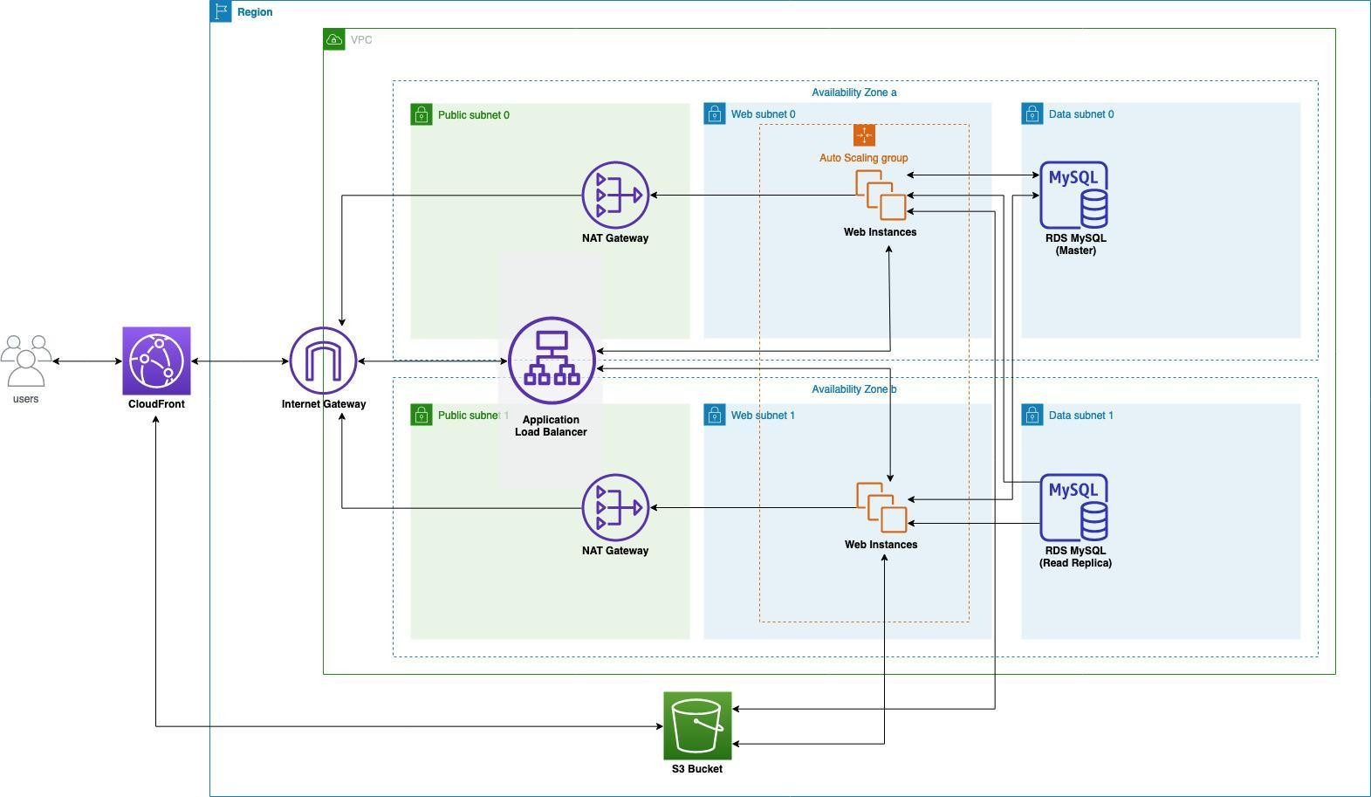

**Project Details**

### Step 1: Create Wordpress AMI (Amazon Machine Image)

* Visit EC2 instance page, select the public WordPress instance created in last assignment. In case you deleted. You need to follow the all steps to create EC2 instance with wordpress assignment. That we are going to use to create Amazon Machine Image.
* Click Actions → Image and templates → Create image
* Enter the Image name and click Create image

### Step 2: Create Application Load Balancer

* Make sure you are in right region to complete this project and stick with the same region all the time till end of this project.
* Visit EC2/Load Balancing/Load Balancers
* Click Create Load Balalncer
* In Step 1: Select load balancer type, find Application Load Balancer and click Create
* In Basic Configuration section, enter the name wordpress-alb
* In Availability Zones, for VPC, choose Vpc created in last assignment or create new one.
* For Availability Zones, select PublicSubnet0 and PublicSubnet1
* In Step 2: Configure Security Settings, click Next
* In Step 3: Configure Security Groups, for Assign a security group, choose Create a new security group
* For Security group name, enter alb-sg and click Next Configure Routing
* In Step 4: Configure Routing
* For Target Group, select New target group
* For Name, enter wordpress-tg
* For Target type, select Instance and click Next: Register Targets
* In Register Targets stage, click Next: Review
* In Review stage, click Create

### Step 3: Create Auto Scaling Group

* Visit EC2/Network & Security/Security Groups Click Create security group

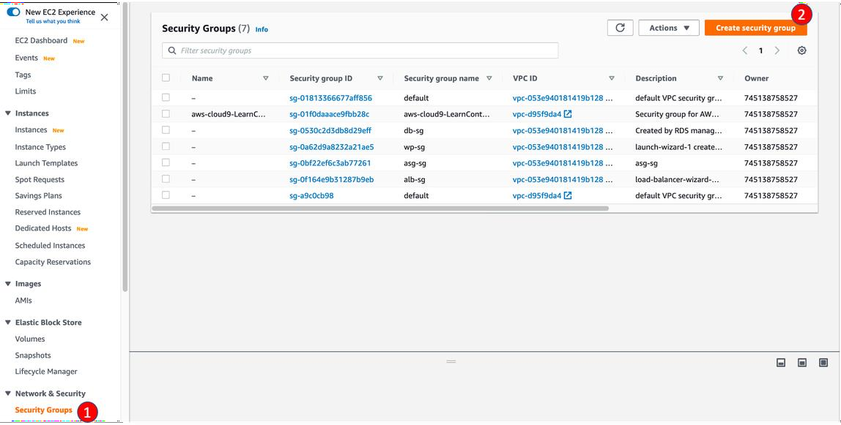

* For **Security group name**, enter asg-sg
* For **Description**, enter asg-sg
* In **Inbound rules** section
* Click **Add rule**
* For **Type**, select **HTTP**
* For **Source**, select **Custom** and find **alb-sg**
* Click **Add rule again**
* For **Type**, select **MYSQL/AURORA**
* For **Source**, select **Custom** and find **db-sg**
* Click **Create security group**

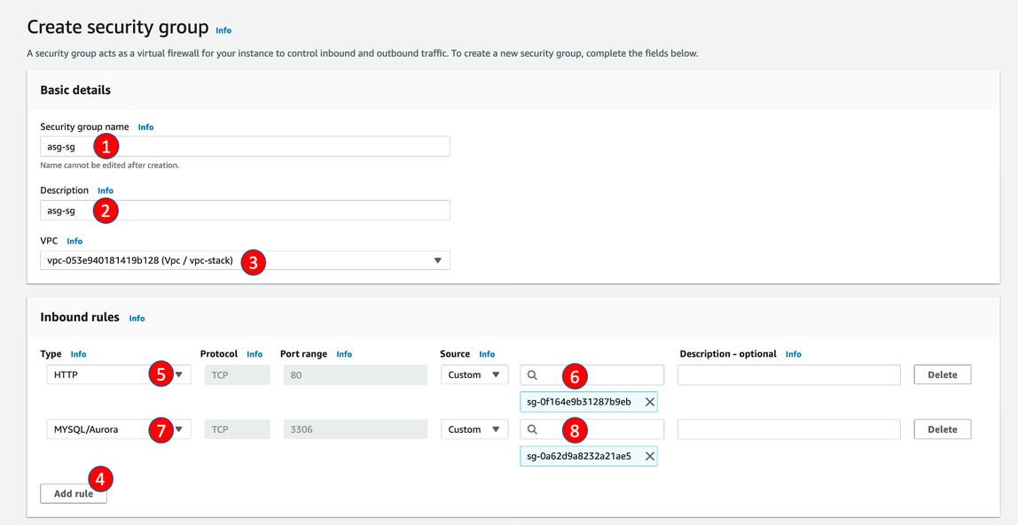

# Visit EC2/Network & Security/Security Groups

* Find **db-sg** and click its **Security group ID**
* Click **Edit inbound rules**
* Click **Add rule**
* For **Type**, select **MYSQL/AURORA**
* For **Source**, select **Custom** and find **asg-sg**
* Click **Save Rules**

# Visit EC2/Auto Scaling/Launch Configurations

* Click **Create Launch configuration**
* For **name**, enter wordpress

## For **AMI**, choose AMI created in last step

* For **Instance type**, search and select **t2.micro**

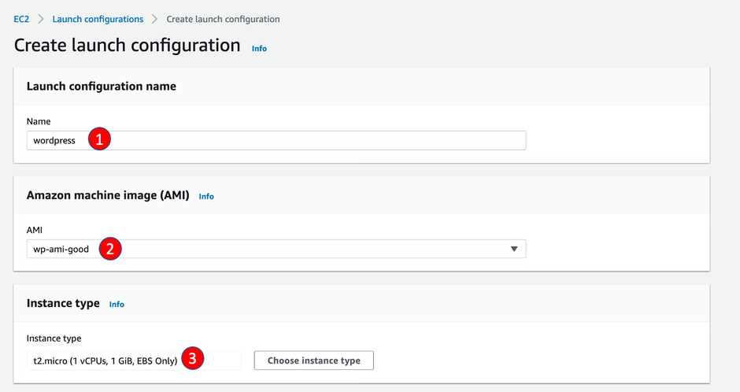

* In **Additional configuration** section, click **Advanced details**
* For **User data**, select **As text** and enter the script below

#!/bin/bash yum update -y

sudo service httpd restart

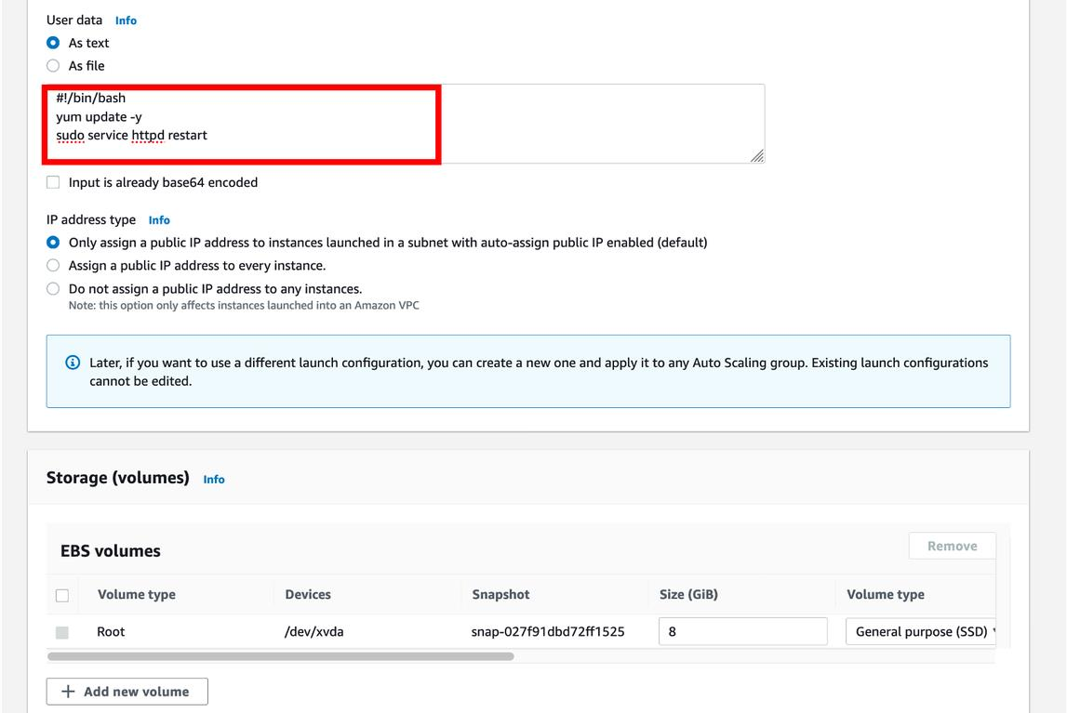

* For **Security group**,select **Select an existing security group** and select **asg-sg** just created
* For **Key pair options**, select **Choose an existing key pair**
* For **Existing key pair**, select the key created in Lab 1
* Finally, click **Create launch configuration**

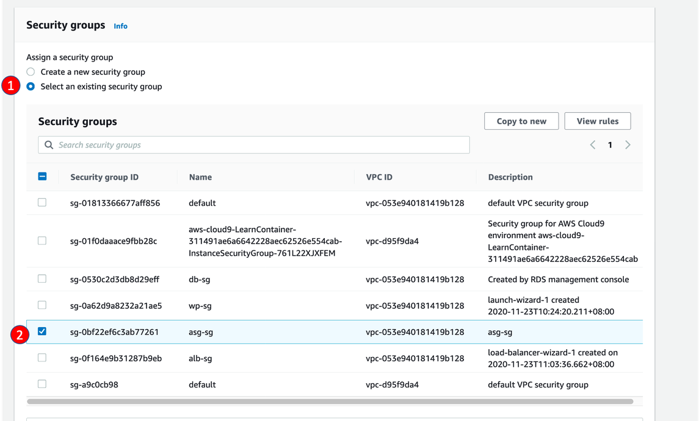

# Visit EC2/Auto Scaling/Auto Scaling Groups

* Click **Create an Auto Scaling Group**
* For **Auto Scaling group name**, enterwordpress-sg
* For **Launch template** section, click **Switch to launch configuration** and select the launch configuration created in last step and click **Next**

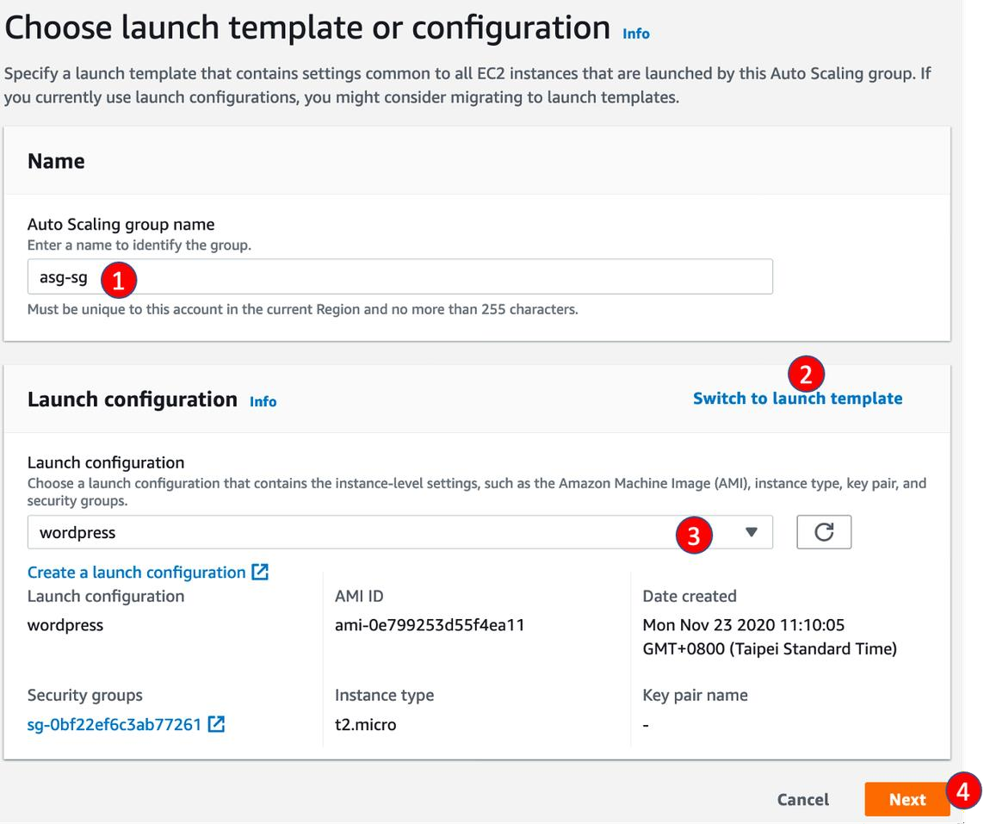

* In **Configure setting** stage,
* For **Vpc**, select **Vpc / vpc-stack**, created by CloudFormation
* For **Subnets**, select **WebSubnet0 / vpc-stack** and **WebSubnet1 / vpc-stack**, then click **Next**
* In **Configure advanced options** stage
* For **Load balancing**, select **Attach to an existing load balancer**
* For **Existing load balancer target groups**, select **alb-tg**

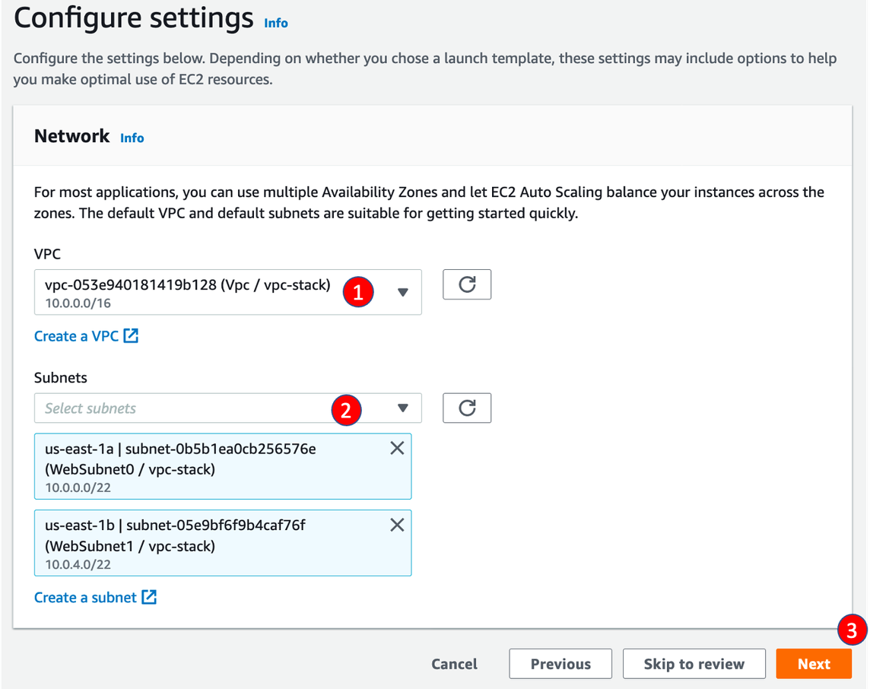

# In Configure group size and scaling policies stage

* In **Group size - optional** Section
* For **Desired capacity, Minimum capacity, Maximum capacity**, enter **2,2,3** then click **Next**
* In **Add notifications** and **Add tags** sections, click **Next**

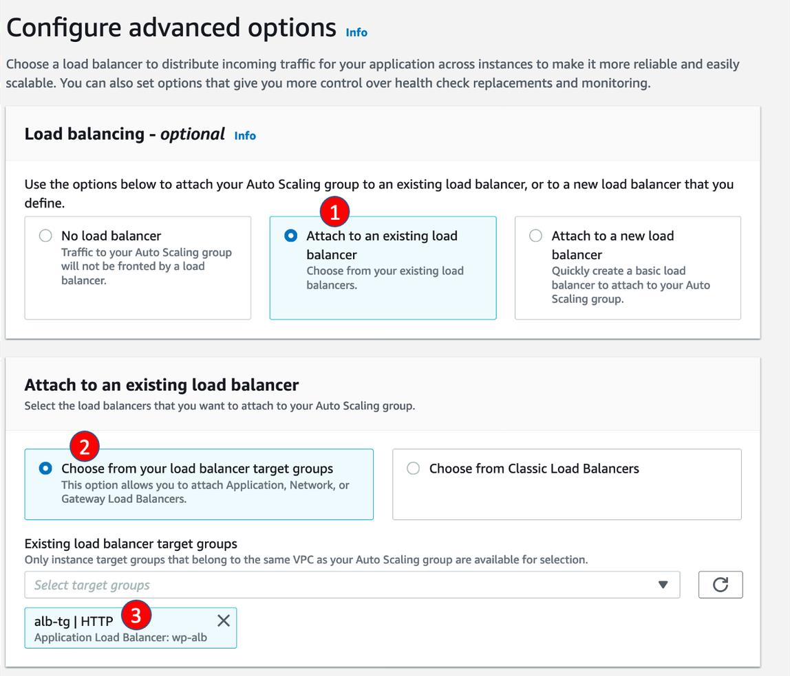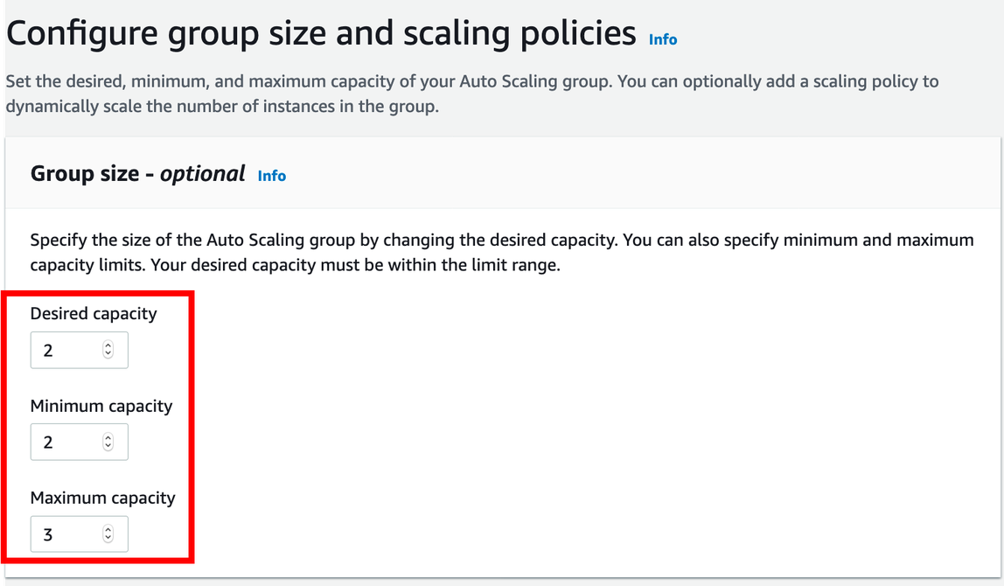

* In **Review** sections, click **Create Auto Scaling group**

### Step 4: Create CloudFront Distribution

Create distribution manually

* Visit CloudFront console, and click Create distributions, choose Web for delivery method

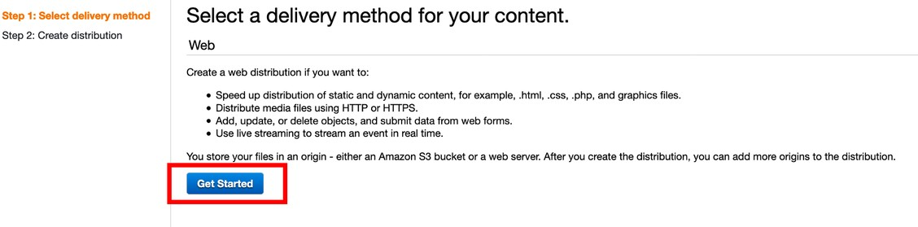

* For **Origin Domain Name**, select **wordpress-alb**

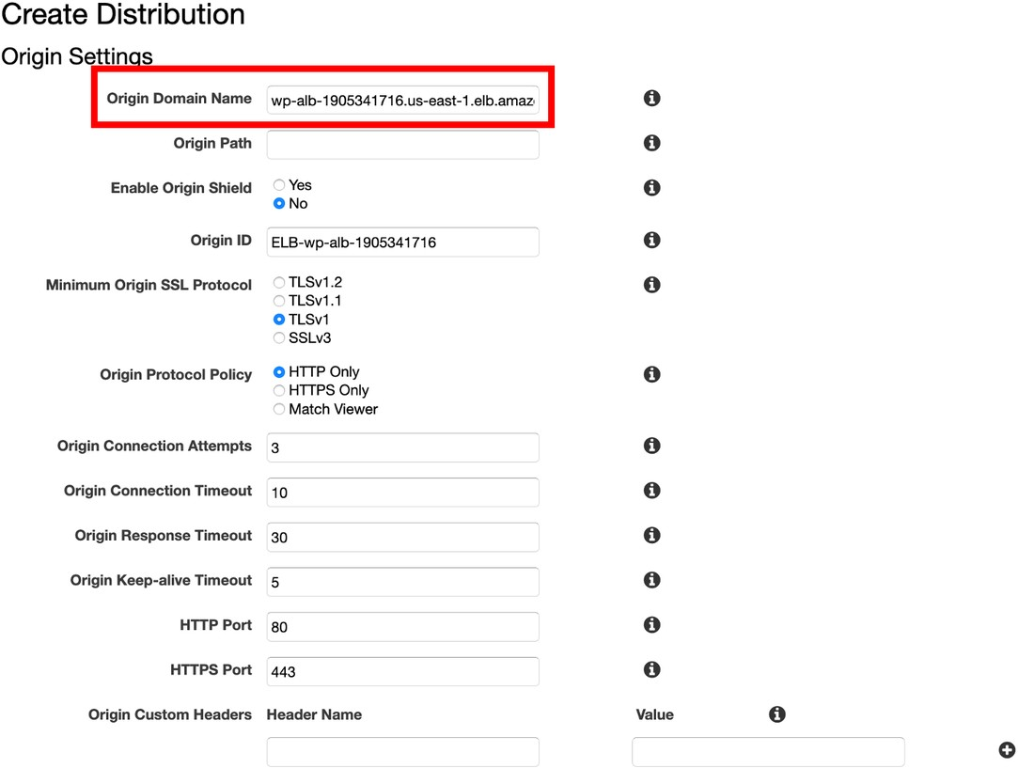

# In Default Cache Behavior Settings

* For **Origin Protocol Policy**, select ** Redirect HTTP to HTTPS**

# For Allowed HTTP Methods, select GET, HEAD, OPTIONS, PUT, POST, PATCH, DELETE

* For **Cached HTTP Methods**, select **GET, HEAD, OPTIONS**

# For Cache and origin request settings, select Use legacy cache settings

* For **Cache Based on Selected Request Headers, select Whitelist**
* For **Whitelist Headers**, search and add **Host** and **Origin**

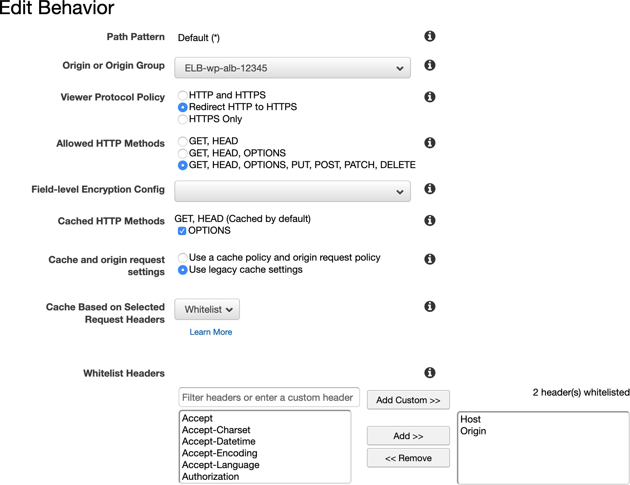

* For **Object Caching**, select **Customize**
* For **Minimum TTL**, enter 0
* For **Maximum TTL**, enter 31536000
* For **Default TTL**, enter 300
* For **Forward Cookies**, select **comment_author_*, comment_author_email_*, comment_author_url_*, wordpress_*, wordpress_logged_in, wordpress_test_cookie, wp- setting-**

# For Query String Forwarding and Caching, select Forward all, cache based on all

* For **Smooth Streaming**, select **No**
* For **Restrict Viewer Access**, select **No**
* For **Compress Objects Automatically**, select **Yes**
* Finally, **Create Distribution**

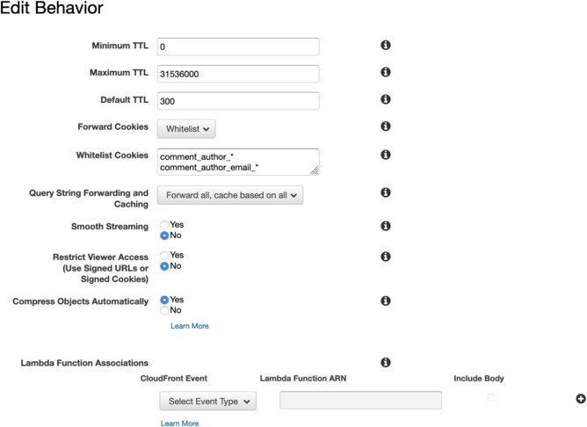

## Visit CloudFront Distribution page

* Click the **distribution ID** created in last step
* Click **Origins and Origin Groups **tab, and click **Create Origin**
* For **Origin Domain Name**, select **S3 bucket** created in Lab 1 and Click **Create**

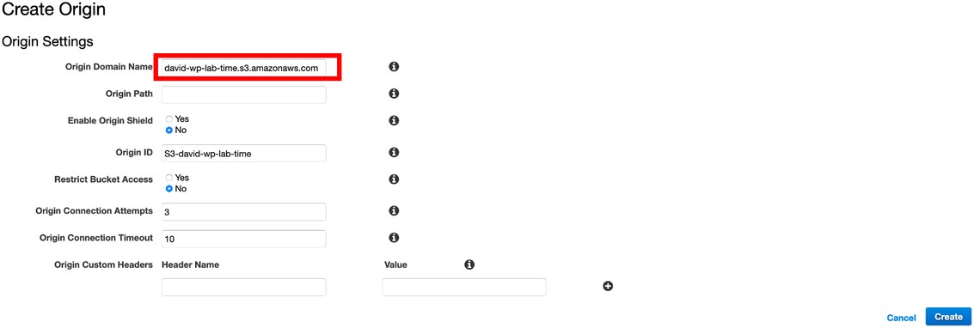

## Next, move to **Behavior** in your Distribution and click **Create Behavior**, follow the table below to create 4 new behaviors:

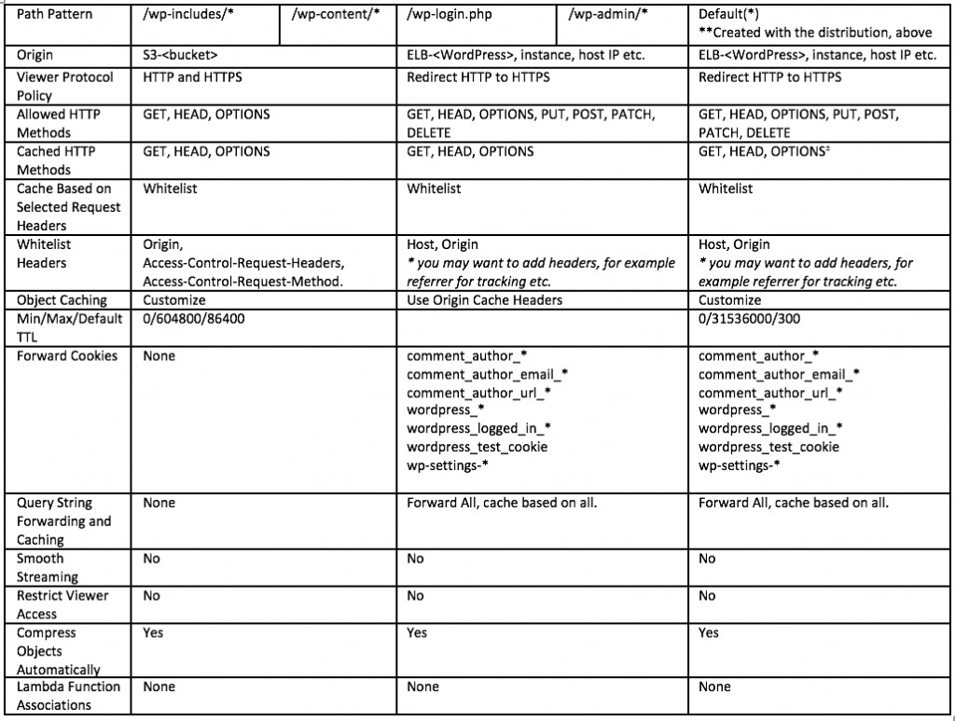

**Step 5: Modify Wordpress configuration**

## Find the Domain name of ALB Created in Step 1, paste it on browser to visit your WordPress page, scroll down and click **Log in** to enter the admin page

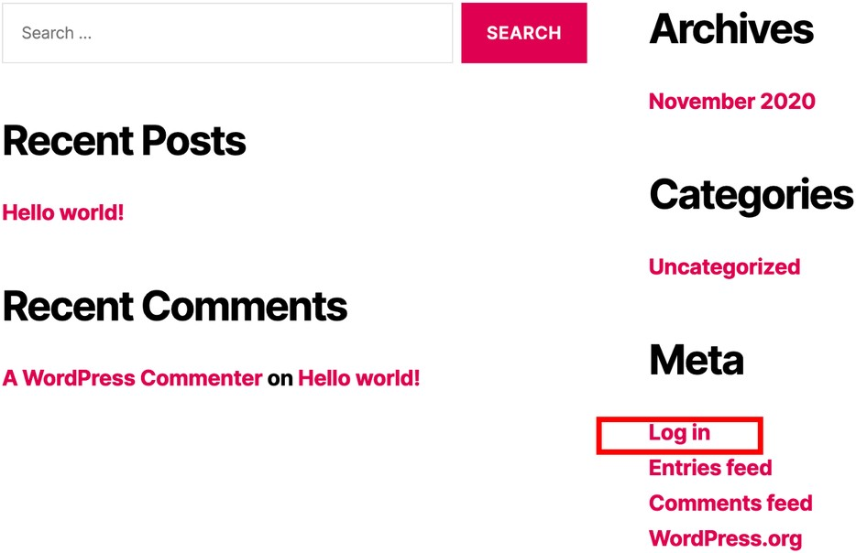

* In admin page, click **Performance/General Settings** on the left menu

## Scroll down to find the **CDN** section

* For **CDN type**, select **Amazon CloudFront Over S3**

# Click Save Settings and Purge Caches

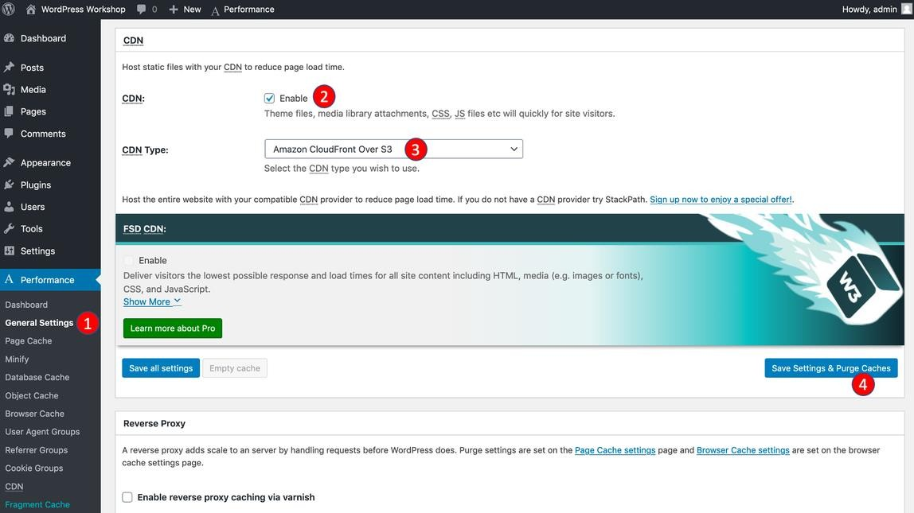

* Click **Performance/CDN** on the left menu, scroll down and find **Configuration:Objects** section
* For **Access key ID** and **Secret key**, paste your IAM user credentials

## For **Bucket**, enter your S3 bucket name created in Lab 1

* For **Replace site’s hostname with**, enter the CloudFront Domain created in last step and click **Save Settings and Purge Caches**

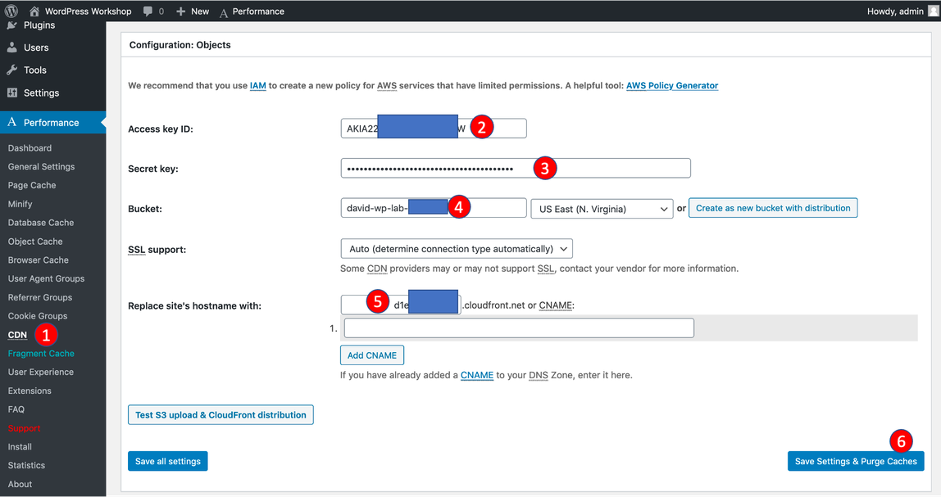

* Click **Setting/General** on the left menu
* For **WordPress Address (URL)** and **Site Address (URL)**, enter your CloudFront domain and click **Save Changes**

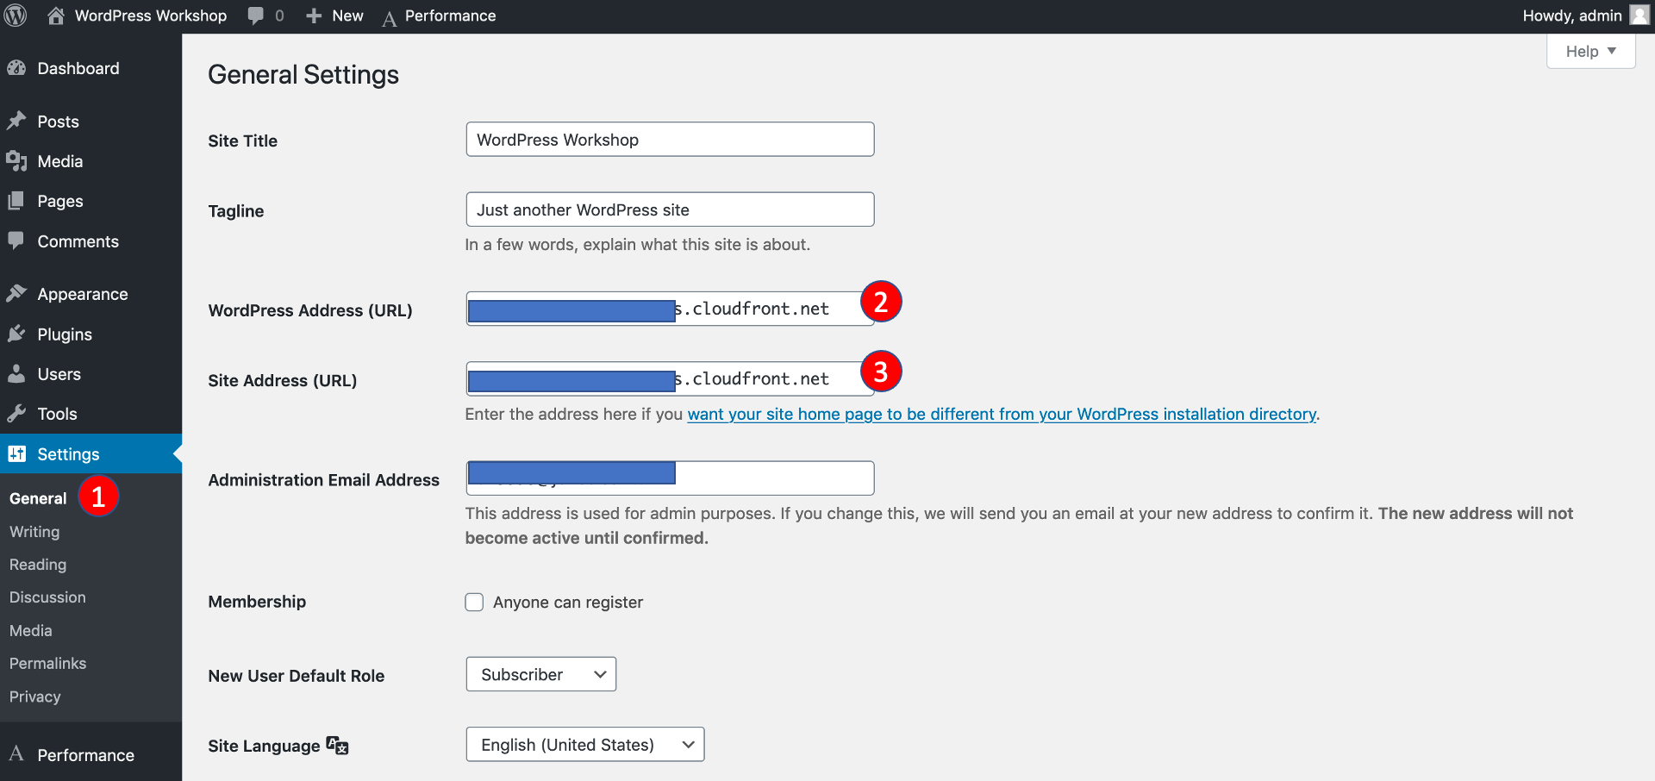

### Step 6: Create Read Replica for Amazon RDS instance

* Visit **RDS console**
* Click **Databases** in left menu,
* Click **Actions** -> **Create read replica**

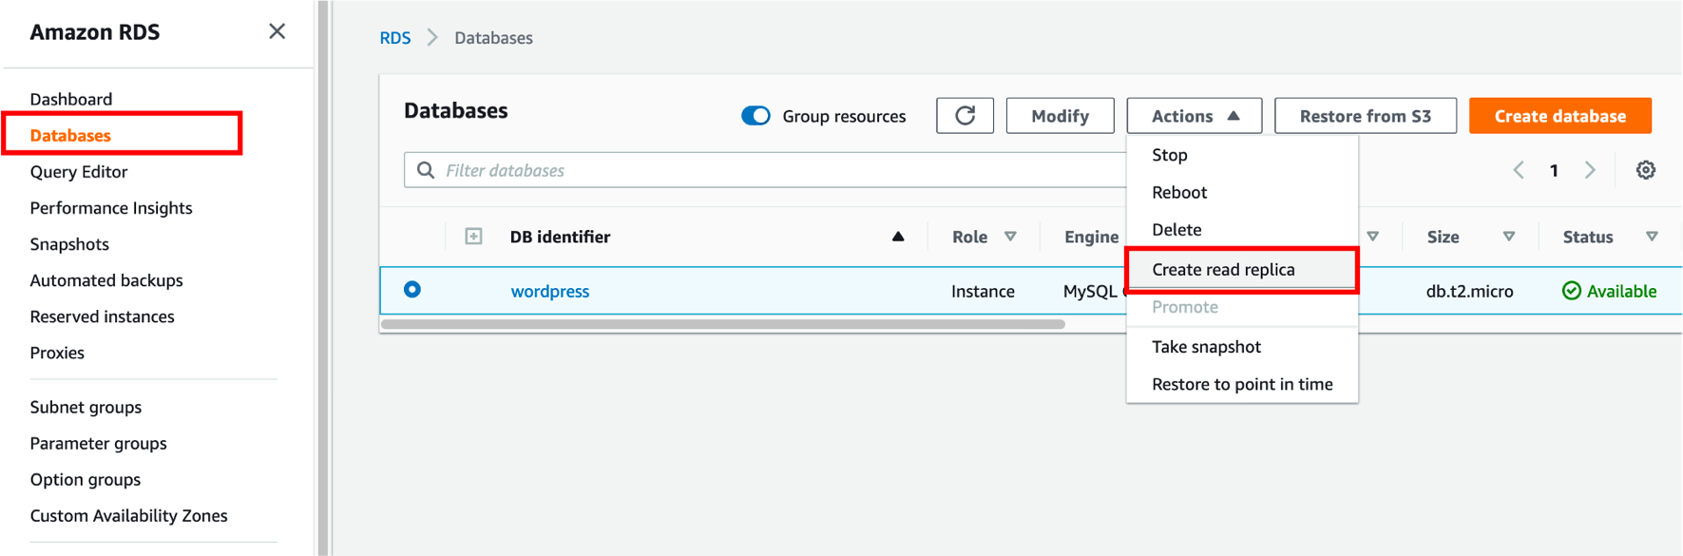

* Enter the wp-read-replica for **DB instance identifier**
* Click **Create**

## Go back to databases page, you will see the read replica instance now. After minutes, it will be created successfully.

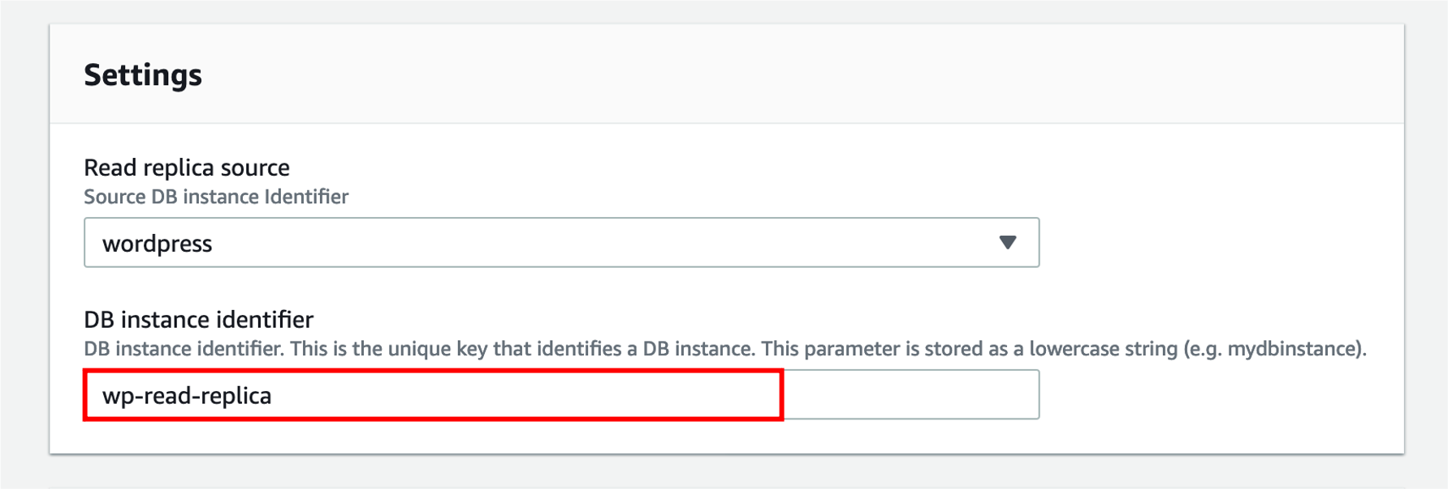

REFERENCE

## [Deploy WordPress with Amazon RDS](https://aws.amazon.com/getting-started/hands-on/deploy-wordpress-with-amazon-rds/?nc1=h_ls)

* [Hosting WordPress on AWS](https://github.com/aws-samples/aws-refarch-wordpress)

## [How to Accelerate Your WordPress Site with Amazon CloudFront](https://aws.amazon.com/blogs/startups/how-to-accelerate-your-wordpress-site-with-amazon-cloudfront/)

* [Best Practices for WordPress on AWS](https://d1.awsstatic.com/whitepapers/wordpress-best-practices-on-aws.pdf)

## [Deploy and Scale a LAMP stack application on Amazon Lightsail](https://www.lightsailworkshop.com/introduction.html) Attachment

* [example-wp-config.php](https://general-webapp.workshop.aws/Reference/_index.en.files/example-wp-config.php) (2 kb)



* [putty_setup.pdf](https://general-webapp.workshop.aws/Reference/_index.en.files/putty_setup.pdf) (957 kb)