# Using language strings in TML X451/X0 HMI

Please refer the [link](http://doc.qt.io/qt-5/qtquick-internationalization.html) for details about qt translations/internationalization.

This document describes the steps for generating translations files for TML X451 HIGH and X0 HIGH HMI projects. Please follow the below steps to generate translations for any new text added in HMI.

1. Always use the string ID from language files in instead of strings directly. String ID can be referred from **Language.csv** file



For Example: TEXT_PHONE_ACTIVE_CALL_Title is the string ID and “Active Call” is the string value to be used.

1. Mark all the static text for translation using **qsTr()** or **tr()** respectively.
   1. Using **qsTr()** in qml files.

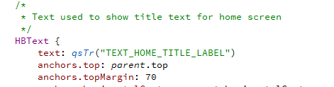

* 1. Using **tr()** in cpp files



1. Generate the translation files.
   1. Copy the tools required for auto generating translations into the languages folder. This is already available in the **languages** folder.

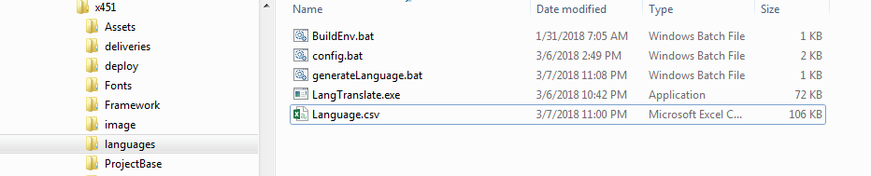

* 1. Update the required paths in **config**.bat

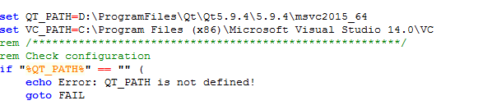

* 1. Run BuildEnv.bat file
  2. Invoke **generateLanguage**.**bat** to generate the **\*.ts** and **\*.qm** files for all the strings that are marked for translation.

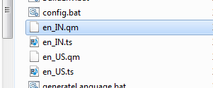

* 1. Copy the **\*.qm** files to languages directory in your build path.