- Documentation folder: Reports of the Project in .docx and .pdf formats

- Slides folder: Presentation slides for the Project

- Database folder: Install the database using the bacpac file as shown below
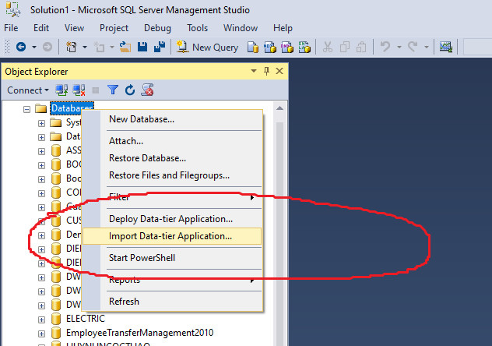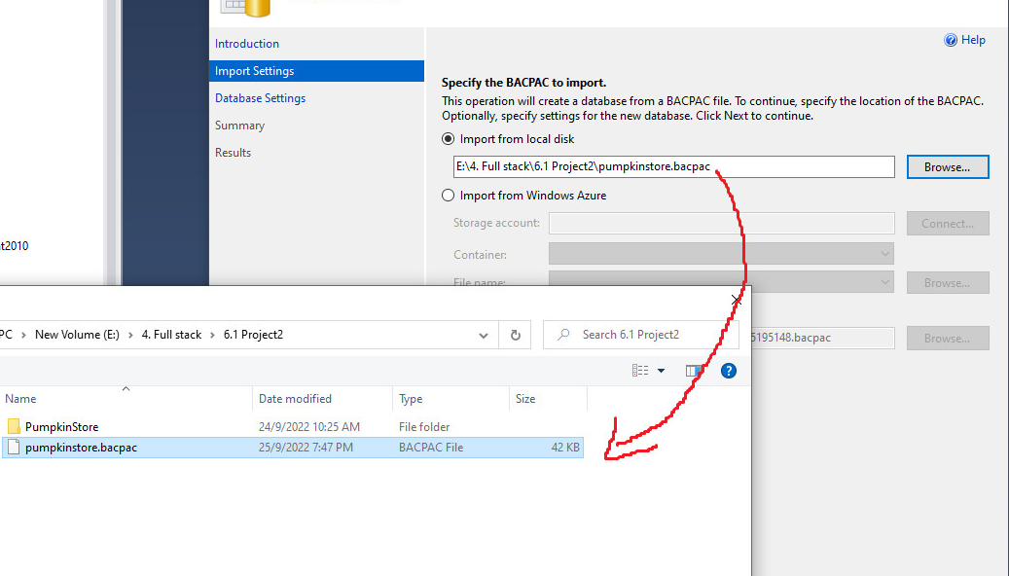
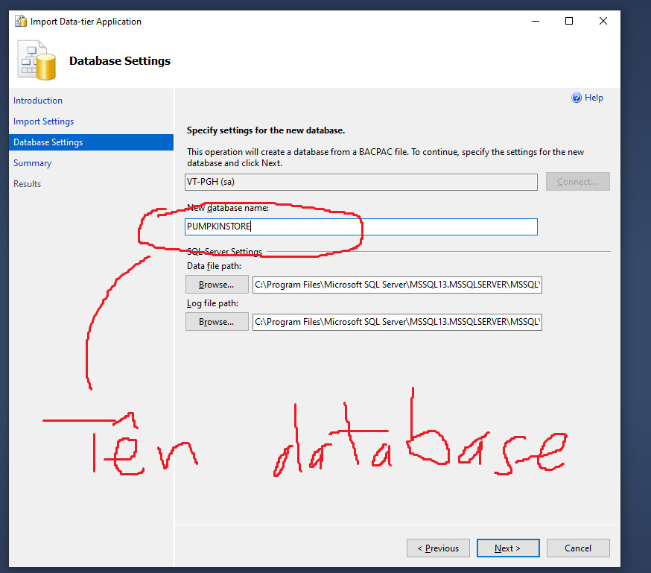

- SourceCode folder (PumpkinStore folder): Source code of the Project
- Step 1: Open project with Spring Tool Suite
- Step 2: "(Re)Start" project
- Step 3: Open Chrome and and enter the web address: “http://localhost:8080/home”

- Sign in admin:
- Username: pumpkinshouse07@gmail.com
- Password: 123456

- Sign in user: You register yourself

- Team information:
1. Huynh Ngoc Thao (Team Leader)
2. Nguyễn Sang
3. Phạm Thị Tuyền

Lop ngan han JavaFullstack - Softech Aptech Danang - Vietnam

