1.

|  |  |  |
| --- | --- | --- |
|  | Sudoku Puzzle | Autonomous vacuum cleaner |
| Observable? | Fully | Partially |
| Deterministic? | Deterministic | Deterministic |
| Episodic? | Sequential | Episodic |
| Static? | Static | Static |
| Discrete? | Discrete | Discrete |
| Single-agent? | Single-agent | Single-agent |

2.

a) Performance: number of steps taken

Environment: the location of the tiles

Actuator: tile mover

Sensors: camera

b) Performance: dirt cleaned, movements, energy consumption

Environment: rooms, dirt

Actuator: wheels, vacuum motor

Sensors: dirt sensor, location sensor

3.

a) Yes. It maximize the performance measure in this circumstance.

b)Yes. It also maximize the performance measure.

4. Each room can be dirty or cleaned, so there are a total of 2^24 combinations.

A vacuum cleaner can be in any of the 24 rooms, which counts for 24 location possibilities.

So, there are a total of 24*2^24 states in total.

5.Because breadth-first search always expand the most shallow path while depth-first always expand one path, we can easily construct such a tree that the goal state is shallow and there is one path which is very deep.

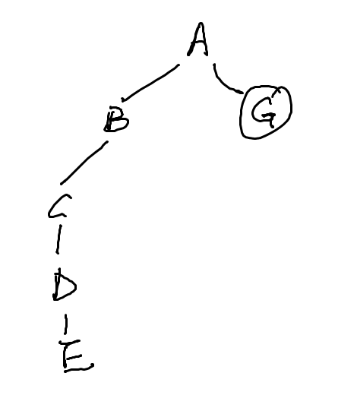For this particular search tree, the order of breadth-first search is A-B-G, therefore it takes a space of 3 nodes, while depth-first search goes A-B-C-E…

