Name: Wenhao Li ID:#14328112

1.

a) Yes. Greedy best search uses heuristic function h(n) for evaluation. A\* search uses f(n)=g(n)+h(n). If g(n) is set to 0, it becomes greedy best search.

b) Yes. If f(n) is set to 0 for A\* search, it becomes depth-first search.

c) Yes. If h(n) is set to 0 for A\* search, it becomes uniform-cost search.

d) No. If greedy best search stuck in a loop while depth-first breaks the tie randomly and happened to not getting stuck in loops, it may expand fewer nodes.

2.

a)

(1) S-C-E-F-A

(2)S-C-A-L-G

(3)6

b)

(1)S-C-A-L-G

(2)S-C-A-L-G

(3)6

c)

(1)S-C-A-F-K

(2)S-F-K-G

(3)8

(4)No

d)

(1)S-C-A-L-G

(2)There is no solution

3.

a)

(1) (4,A)-(3,A)-(2,A)-(2,B)-(2,C)-(2,D)

(2) (4,A)-(3,A)-(2,A)-(2,B)-(2,C)-(2,D)-(1,D)-(1,E)-(1,F)-(2,F)-(3,F)-(3,E)

(3) 11

b)

(1) (4,A)-(3,A)-(2,A)-(2,B)-(2,C)-(2,D)

(2) (4,A)-(3,A)-(2,A)-(2,B)-(2,C)-(2,D)-(1,D)-(1,E)-(1,F)-(2,F)-(3,F)-(3,E)

(3) 11

c)

(1) (4,A)-(3,A)

(2) There is no solution.

4.

a)

(1) 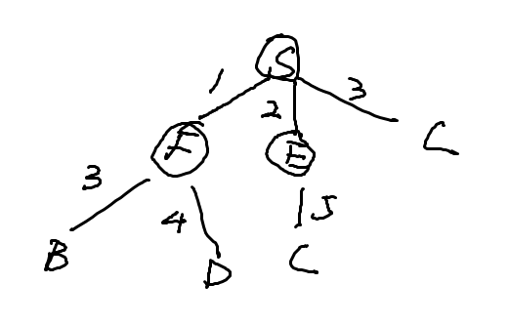

(2)S-F-E-C

(3)S-F-B-G

(4)5

b)

(1) 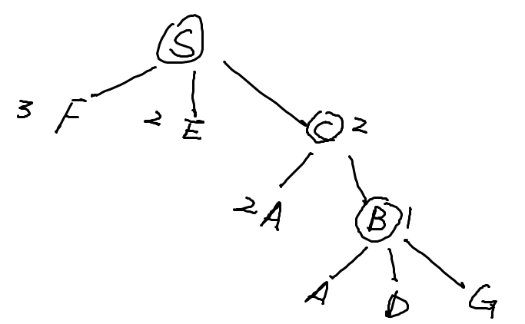

(2)S-C-B-G

(3)S-C-B-G

(4)6

c)

(1) 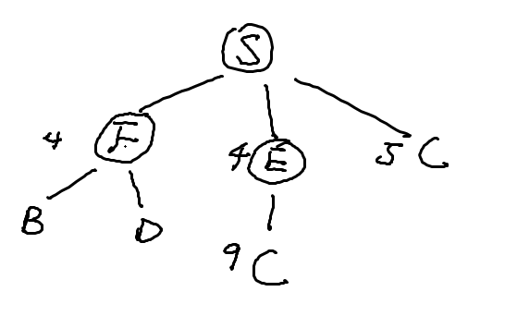

(2)S-E-F-B

(3)S-F-B-G

(4)5

(5) Yes.

d)

(1) S-C-B

(2) S-C-B-G

(3) 5