Tally Sheet:

Problem | Max Score | Your Score
1 | 20
2 | 20
3 | 20
4 | 20
5 | 20
Total | 100

Problem 1 (20 points). Suppose a router has built up the routing table shown below. The router can deliver packets directly over interfaces 0 and 1, or it can forward packets to routers R2, R3, or R4. Assume the router does the longest prefix match.

SubnetNumber | SubnetMask | NextHop
128.96.64.0 | 255.255.192.0 | Interface 0
128.96.96.0 | 255.255.224.0 | Interface 1
128.96.80.0 | 255.255.240.0 | R2
128.96.88.0 | 255.255.248.0 | R3
default |  | R4

Which next hop will the router choose for an incoming packet addressed to each of the following destinations:

a) 128.96.127.27 =>

Interface 1

b) 128.96.95.55 =>
Interface 0

c) 128.96.80.67 =>
R2

d) 128.96.72.128 =>

interface 0

e) 128.96.128.53 =>
R4

Problem 2 (20 points). Consider the following routing table using CIDR. Address bytes are in hexadecimal. The notation “/12” in C4.50.0.0/12 denotes a netmask with 12 leading 1 bits: FF.F0.0.0. Note that the last three entries cover every address and thus serve in lieu of a default route. Assume the router does the longest prefix match.

Net/Mask Length | Nexthop
C4.50.0.0/12 | A
C4.5E.80.0/17 | B
C4.5E.C0.0/18 | C
C4.5E.E0.0/19 | D
80.0.0.0/1 | E
40.0.0.0/2 | F
00.0.0.0/2 | G

State to what next hop packets with the following destination addresses will be delivered:

Destination Address | Nexthop
C4.5E.D3.87 | C
C4.50.22.09 | A
C4.5E.F4.80 | D
C4.5E.99.15 | B
C4.5E.B9.10 | B

D
E
5
1
4
1
2
F
4
6
5
1
A
B
C

Figure for problem 2.

Problem 3 (20 points). Give the steps for the link state protocol route calculation (Dijkstra’s Forward Search algorithm) as it builds the routing database for node F in the network shown above. Note: not all rows might have to be filled out.

Step | Confirmed | Tentative
1 | (F,0,-)
2 | (F,0,-) | (C,6,C) (E,4,E)
3 | (F,0,-)(E,4,E) | (B,8,E)(C,5,E)(D,9,E)
4 | (F,0,-)(E,4,E)(C,5,E) | (B,6,E)(D,9,E)
5 | (F,0,-)(E,4,E)(C,5,E) (B,6,E) | (D,7,E)(A,11,E)
6 | (F,0,-)(E,4,E)(C,5,E) (B,6,E) (D,7,E) | (A,9,E)
7 | (F,0,-)(E,4,E)(C,5,E) (B,6,E) (D,7,E) (A,9,E)
8
9

Problem 4 (20 points). Two host nodes (A and B) are connected via one link and a basic sliding window protocol (no flow control, congestion control or congestion avoidance implemented) is running on both nodes. Consider the sliding window diagram depicted below. A number on the receiver side (B) indicates that the receiver accepted the received packet, while X indicates that the receiver rejected/dropped the received packet.
time
0 sec
1 sec
2 sec
3 sec
4 sec
5 sec
6 sec
7 sec
8 sec
9 sec
10 sec
12 sec
11 sec
1
ack1
3
X
X
2
X
4
5
A
B
X
1
2
3
4
5
2
3
4
5
ack3
ack4
ack5

a) What is the size of the sender window (SWS)?

SWS = 4

b) What is the size of the sender window (RWS)?

RWS = 2

c) What is the timeout set for on the sender side?

timeout = 6

d) Why is the sender not sending any more packets after 10 secs?
Because there are no more packets to send.

Problem 5 (20 points).

Consider the TCP trace in Figure 1.

(a) Identify time intervals representing slow start:

T=0 to T=0.5 and T=5.5 to T=5.8

(b) Identify time intervals representing linear-increase:
T=1.9 to T=5.4 and after T=5.8

(c) Identify time intervals representing multiplicative-decrease:

T=1.9 and T=5.5

(d) Explain what is going on from T = 0.5 to T = 1.9.

There are no ACK coming back because of coarse-grained packet timeout, so the periods is idle and congestion window stays flat.

(e) The TCP version that generated the trace in Figure 1includes a feature absent from the TCP that generated Figure 2. What is this feature?

Fast retransmission.

(f) Both traces lack a feature. What is it? Fast recovery.

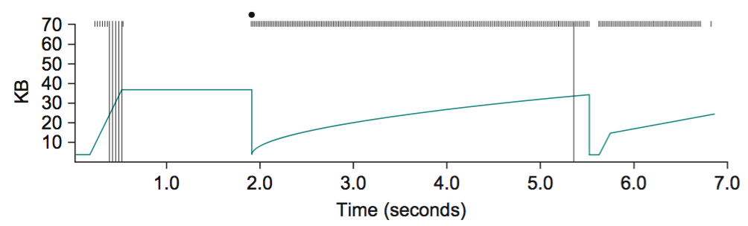
Figure 1

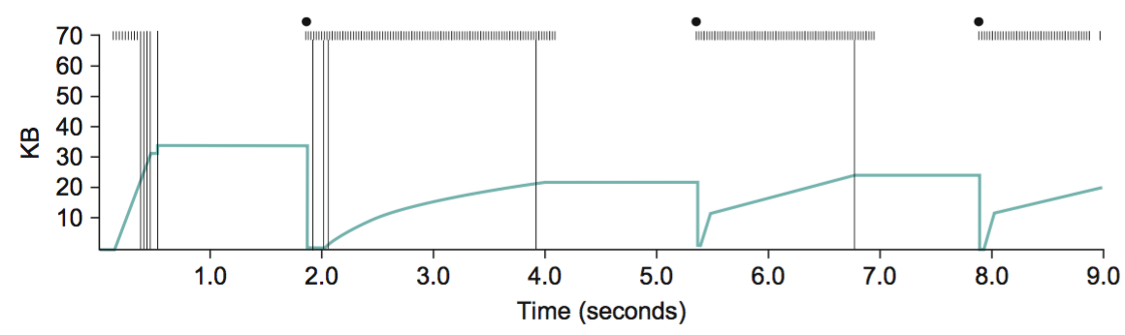
Figure 2

