CS4850/7850 Homework 1 Due: Friday, February 7, at beginning of class

Name: _

PawPrint _

Please use this page as cover page for your submission

1. (20 points) Calculate the total time required to transfer a 1000-KB file in the following cases, assuming an RTT of 50 ms, a packet size of 1 KB data, and an initial 2×RTT of “handshaking” before data is sent:

- The bandwidth is 1.5 Mbps, and data packets can be sent continuously.
Setup time=2*RTT=50ms*2=0.1s
Transmit time=1000*2^10*8/(1.5*10^6)=5.461s
Propagation=RTT/2=25ms=0.025s
Total time=0.1+5.461+0.025=5.586s

- The bandwidth is 1.5 Mbps, but after we finish sending each data packet we must wait one RTT before sending the next.
Latency increased=1000KB/1KB*0.05s=50s
Total time=5.586s+50s=55.586s

- The bandwidth is “infinite,” meaning that we take transmit time to be zero, and up to 20 packets can be sent per RTT.
(1000+2+0.5)*RTT=50.125s

(d) The bandwidth is infinite, and during the first RTT we can send one packet (2^{1−1),} during the second RTT we can send two packets (2²⁻¹), during the third we can send four (2³⁻¹), and so on.
1000=1+2+4+8+16+32+64+128+256+489
(10+2+0.5)*RTT=0.625s

2. (10 points)What differences in traffic patterns account for the fact that STDM is a cost-effective form of multiplexing for a voice telephone network and FDM is a cost-effective form of multiplexing for television and radio networks, yet we reject both as not being cost effective for a general-purpose computer network?
Both STDM and FDM is wasting resources if the allocated bandwidth is not used by the user. While statistical multiplexing used by computer network can fully maximize all the resource on demand.

3. (15 points) Calculate the latency (from first bit sent to last bit received; in μs) for the following:
(a) 100-Mbps Ethernet with a single store-and-forward switch in the path and a packet size of 12,000 bits. Assume that each link introduces a propagation delay of 10 μs (1 μs = 10⁻⁶ s) and that the switch begins retransmitting immediately after it has finished receiving the packet.
Transimit time=12000/(100*10^6)*2=0.24ms
Propagation=0.01ms*2=0.02ms
Total latency=0.24+0.02=0.26ms

(b) Same as (a) but with three switches.
Transimit time=12000/(100*10^6)*4=0.48ms
Propagation=0.01ms*4=0.04ms
Total latency=0.48+0.04=0.52ms

(c) Same as (a), but assume the switch implements “cutthrough” switching; it is able to begin retransmitting the packet after the first 200 bits have been received.
Transmit time of 200 bits=200/(100*10^6)=0.002ms
Transmit time of the packet=12000/(100*10^6)=0.12ms
Propagation=0.02ms
Total latency=0.002+0.12+0.02=0.142ms

4. (12 points) For the following, assume that no data compression is done, although in practice this would almost never be the case. For (a) to (c), calculate the bandwidth necessary for transmitting in real time:
(a) Video at a resolution of 640×480 (i.e., frame size of 640 pixels × 480 pixels), 3 bytes/pixel, 30 frames/second (calculate the bandwidth in Mbps).
640*480*3*30=27648000 bytes/s
27648000*8/10^6=221.184 Mbps

(b) Video at a resolution of 160×120 (i.e., frame size of 160 pixels × 120 pixels), 1 byte/pixel, 5 frames/second (calculate the bandwidth in Kbps).
160*120*1*5=96000 bytes/s
96000*8/10^3=768 Kbps

(c) CD-ROM music, assuming one CD holds 75 minutes’ worth and takes 650 MB (calculate the bandwidth in Mbps).
650*2^20/(75*60)=151461 bytes/s
151461*8/10^3=1.211 Mbps

- Assume a fax transmits an 8×10-inch black-and-white image at a resolution of 72 pixels per inch. How long would this take over a 14.4-Kbps modem? Assume each black-and-white pixel is represented by 1 bit
8*72*10*72=414720 pixels
414720*1/(14.4*10^3)=28.8 s

5. (15 points) Suppose a 128-Kbps point-to-point link is setup between the Earth and a rover on Mars. The distance from the Earth to Mars (when they are closest together) is approximately 55 Gm, and data travels over the link at the speed of light: 3 × 10⁸ m/s.
  - (a) Calculate the minimum RTT for the link.
  - 55*2*10^9/(3*10^8)=366.7 s

  - (b) Calculate the “data-in-flight” for the down-link in MB.
  - 366.7/2*128*10^3/8/2^20=2.80 MB

(c) A camera on the rover takes pictures of its surroundings and sends these to Earth. How quickly after a picture is taken can it reach Earth Mission Control? Assume that each image size is 5 MB.
Transmit time=5*2^20*8/(128*10^3)=327.68s
Propagation=RTT/2=183.4s
Total Time=327.68+183.4=511.1s

6. (10 points) The Unix/Windows utility ping can be used to find the RTT to various Internet hosts. Read the man page for ping, and use it to find the RTT to www.princeton.edu in New Jersey and www.cisco.com in California. Measure the RTT values at different times of day, and
compare the results. What do you think accounts for the differences?
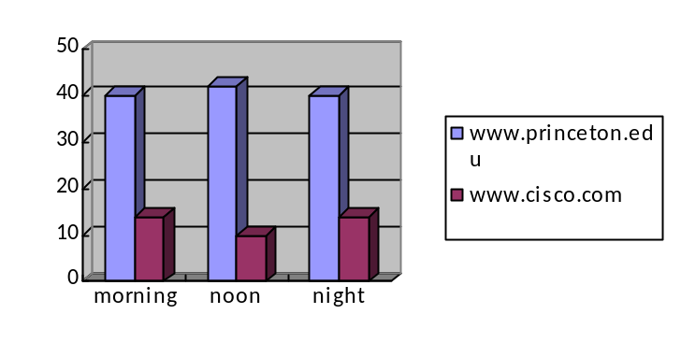
This was measured on my own computer, using Mizzou’s wired ethernet. We can see the result is pretty stable throughout the whole day. The website of Princeton is consistently slower than that of cisco, probably due to further geographical distance, so there are more switches and routers buffering the packets, and less server in Princeton than cisco responding to all the requests.

7. (10 points) The Unix utility traceroute, or its Windows equivalent tracert, can be used to find the sequence of routers through which a message is routed. Use this to find the path from your site to some others. How well does the number of hops correlate with the RTT times from ping? How well does the number of hops correlate with geographical distance?
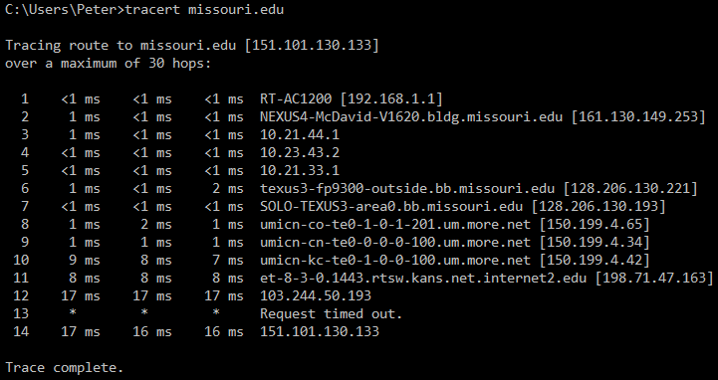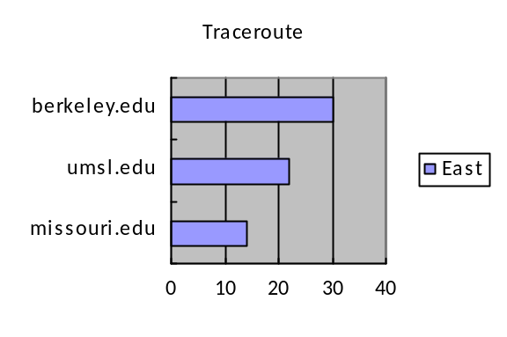
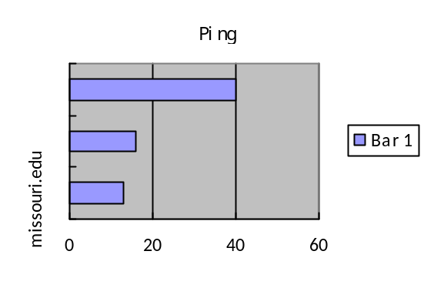Basically, the further the geographical distance, the higher number of hops in the router and the higher ping time.

