CS4850/7850 Homework 4 Due: Monday, April 6, before class starts

1. (10 points) Suppose a TCP message that contains 1024 bytes of data and 20 bytes of TCP header is passed to IP for delivery across two networks interconnected by a router (i.e., it travels from the source host to a router to the destination host). The first network has an MTU of 1024 bytes; the second has an MTU of 576 bytes. Each network’s MTU gives the size of the largest IP datagram that can be carried in a link-layer frame. Fill out the table below giving the sizes and offsets of the sequence of fragments delivered to the network layer at the destination host. Assume all IP headers are 20 bytes. Note: fragment size should NOT include the length of its IP header. Also, remember that a datagram is fragmented on 8-byte boundaries.

Segment # | Size | Offset
1 | 1020 | 0
2 | 64 | 125
3 | 572 | 0
4 | 468 | 69
5 | 64 | 125

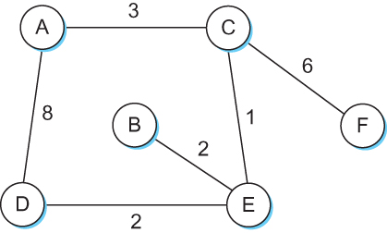
2. (15 points) For the network shown below, fill out the given global distance–vector tables when

(a) Each node knows only the distances to its immediate neighbors.

Information Stored at Node | Distance to Reach Node
Information Stored at Node | A | B | C | D | E | F
A | 0 | ∞ | 3 | 8 | ∞ | ∞
B | ∞ | 0 | ∞ | ∞ | 2 | ∞
C | 3 | ∞ | 0 | ∞ | 1 | 6
D | 8 | ∞ | ∞ | 0 | 2 | ∞
E | ∞ | 2 | 1 | 2 | 0 | ∞
F | ∞ | ∞ | 6 | ∞ | ∞ | 0

(b) Each node has reported the information it had in the preceding step to its immediate neighbors.

Information Stored at Node | Distance to Reach Node
Information Stored at Node | A | B | C | D | E | F
A | 0 | ∞ | 3 | 8 | 4 | 9
B | ∞ | 0 | 3 | 4 | 2 | ∞
C | 3 | 3 | 0 | 3 | 1 | 6
D | 8 | 4 | 3 | 0 | 2 | ∞
E | 4 | 2 | 1 | 2 | 0 | 7
F | 9 | ∞ | 6 | ∞ | 7 | 0

(c) Step (b) happens a second time.

Information Stored at Node | Distance to Reach Node
Information Stored at Node | A | B | C | D | E | F
A | 0 | 6 | 3 | 6 | 4 | 9
B | 6 | 0 | 3 | 4 | 2 | 9
C | 3 | 3 | 0 | 3 | 1 | 6
D | 6 | 4 | 3 | 0 | 2 | 9
E | 4 | 2 | 1 | 2 | 0 | 7
F | 9 | 9 | 6 | 9 | 7 | 0

3. (10 points) Suppose a router has built up the following routing table:

SubnetNumber | SubnetMask | NextHop
128.96.39.0 | 255.255.255.128 | Interface 0
128.96.39.128 | 255.255.255.128 | Interface 1
128.96.40.0 | 255.255.255.128 | R2
192.4.153.0 | 255.255.255.192 | R3
(default) |  | R4

The router can deliver packets directly over interfaces 0 and 1, or it can forward packets to routers R2, R3, or R4. Fill out the table below showing to which NextHop packets with the given packet addresses are sent:

Packet Destination Address | NextHop
128.96.39.10 | Interface 0
128.96.40.12 | R2
128.96.40.151 | R4
192.4.153.17 | R3
92.4.153.90 | R4

4. (10 points) An organization has been assigned the prefix 212.1.1/24 (class C) and wants to form subnets for four departments, with hosts as follows:

A 75 hosts
B 35 hosts
C 20 hosts
D 18 hosts
There are 148 hosts in all.

Fill out the table below by giving a possible arrangement of subnet IDs and subnet masks to make this possible.

Departments | Subnet ID | Subnet Mask
A: 75 hosts | 212.1.1.0 | 255.255.255.128
B: 35 hosts | 212.1.1.128 | 255.255.255.192
C: 20 hosts | 212.1.1.192 | 255.255.255.224
D: 18 hosts | 212.1.1.224 | 255.255.255.224

5. (5 points) Consider the following routing table using CIDR. Address bytes are in hexadecimal. The notation “/12” in C4.50.0.0/12 denotes a netmask with 12 leading 1 bits: FF.F0.0.0. Note that the last three entries cover every address and thus serve in lieu of a default route.

Net/Mask Length | Nexthop
C4.50.0.0/12 | A
C4.5E.10.0/20 | B
C4.60.0.0/12 | C
C4.68.0.0/14 | D
80.0.0.0/1 | E
40.0.0.0/2 | F
00.0.0.0/2 | G

State to what next hop packets with the following destination addresses will be delivered:

Destination Address | Nexthop
C4.5E.13.87 | B
C4.5E.22.09 | A
C3.41.80.02 | E
5E.43.91.12 | F
C4.6D.31.2E | C
C4.6B.31.2E | D

T
6. (20 points) Consider the following network:

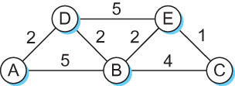

Fill out the table below by giving the steps in the forward search algorithm as it builds the routing database for node A (Note: not all rows might have to be filled out).

step | confirmed | tentative
1 | (A,0,-)
2 | (A,0,-) | (B,5,B)(D,2,D)
3 | (A,0,-) (D,2,D) | (B,4,D)(E,7,D)
4 | (A,0,-) (D,2,D) (B,4,D) | (E,6,D)(C,8,D)
5 | (A,0,-) (D,2,D) (B,4,D) (E,6,D) | (C,7,D)
6 | (A,0,-) (D,2,D) (B,4,D) (E,6,D) (C,7,D)

7. (5 points) Read the man page or other documentation for the Unix/Windows utility netstat. Use netstat to display the current IP routing table(s) on your host. Explain the purpose of each entry (only consider the IPv4 routing table). What is the practical minimum number of entries? Also, please explain the meaning/use of the following special addresses: 255.255.255.255 and 127.0.0.1
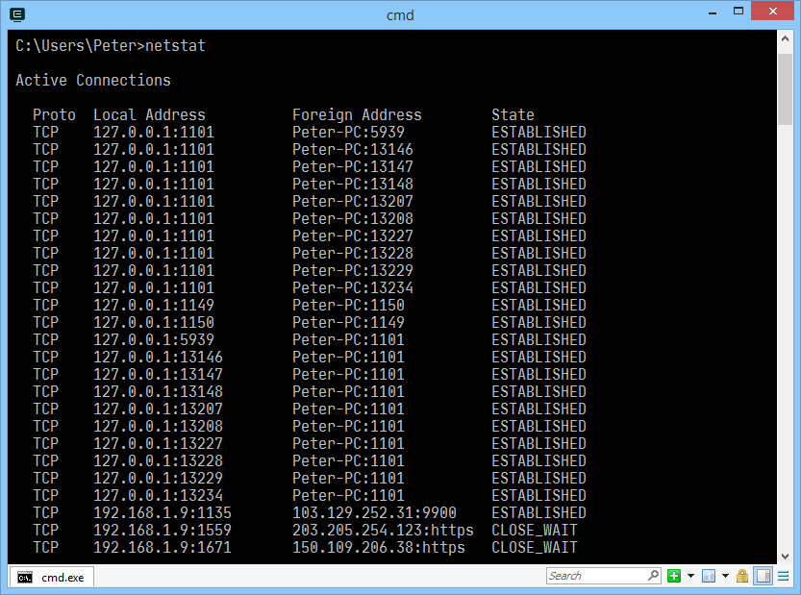
Netstat is a command to list all active network connection on this computer.
[Proto]: The name of the protocol. Either TCP or UDP.
[Local Address]: The IP address of the this computer and the coresponding port number.
[Foreign address]: The IP address used for remote computer to connect to this computer.
[State]: The state of this connection, used for TCP only.

255.255.255.255 is a broadcast address, which will be received by all devices connected to the same network. An application is the use of DHCP clients requesting IP address from the DHCP server.

127.0.0.1 is the address of localhost, used to access the network services running on the same computer, without going through any network interfaces.

