CS4850/7850 Homework 3 Due: Wednesday, Mach 4, at beginning of class

Name: _

PawPrint _

Please use this page as cover page for your submission and STAPLE it.

1. (20 points) Suppose that A is connected to B via a direct link. A is able to accept and transmit one packet per second (this includes transfer time and propagation delay) in each direction (both directions are independent). Assume A and B use the sliding window protocol with SWS=RWS=3, timeout of 5 sec, cumulative acknowledgments (no ACKs are sent on duplicated or out-of-order frames), and the MaxSeqNum is infinite.

If a timeout occurs on node A while an ACK is received, the ACK will be processed first. Otherwise, if a timeout occurs on node A, the packet that timed-out will be re-sent immediately, even if there are other packets in the sender buffer ready to be sent. If there are multiple ready-to-send packets in the sender buffer, the sender will send the packet with the lowest packet number first.

Complete the following timeline and clearly mark when and which packet is received by B, when and which ACK is received by A, and when and which packet times out at A if: Node A is sending 7 packets (packets 1 through 7) to node B; the first packet (packet # 1) transmitted from A to B is lost.
A
B
time
0 sec
1 sec
2 sec
3 sec
4 sec
5 sec
6 sec
7 sec
8 sec
9 sec
10 sec
12 sec
11 sec
X
1
2

2. (10 points) What kind of problems can arise when two hosts on the same Ethernet share the same hardware address? Describe what happens and why that behavior is a problem.
Because the switches uses a learning algorithm to look up the hardware address and the corresponding port to be forwarded. So each time the conflicting hosts send out a frame, the forwarding table get flipped. When next time the returning data frame, it may be directed to the wrong hosts.

3. (20 points) Using the example network given in figure below, complete the virtual circuit table below for all the switches after each of the following connections is established. Assume that the sequence of connections is cumulative; that is, the first connection is still up when the second connection is established, and so on. Also assume that the VCI assignment always picks the lowest unused VCI on each link, starting with 0, and that a VCI is consumed for both directions of a virtual circuit.

(a) Host A connects to host C.
(b) Host D connects to host B.
(c) Host D connects to host I.
(d) Host A connects to host B.
(e) Host F connects to host J.
(f ) Host H connects to host A.

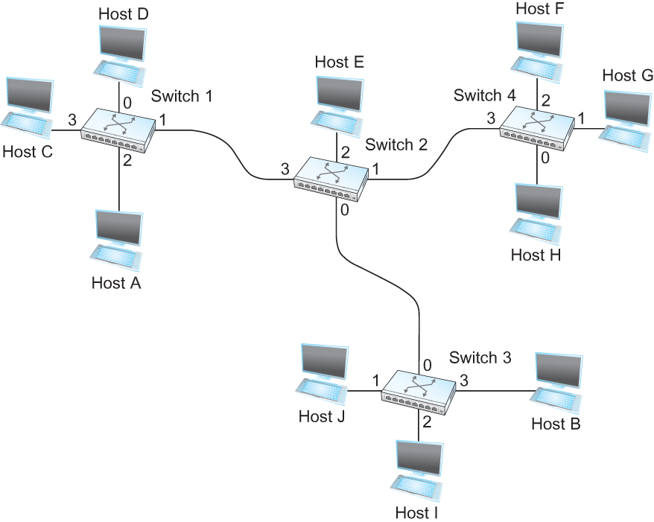

Part | PATH | SWITCH | PORT(IN) | VCI(IN) | PORT(OUT) | VCI(OUT)
a.) | A-2 | 1 | 2 | 0 | 3 | 0
b.) | D-S1 | 1 | 0 | 0 | 1 | 0
 | S1-S2 | 2 | 3 | 0 | 0 | 0
 | S2-S3 | 3 | 0 | 0 | 3 | 0
c.) | D-S1 | 1 | 0 | 1 | 1 | 1
 | S1-S2 | 2 | 3 | 1 | 0 | 1
 | S2-S3 | 3 | 0 | 1 | 2 | 0
d.) | A-S1 | 1 | 2 | 1 | 1 | 2
 | S1-S2 | 2 | 3 | 2 | 0 | 2
 | S2-S3 | 3 | 0 | 2 | 3 | 1
e.) | F-S4 | 4 | 2 | 0 | 3 | 0
 | S4-S2 | 2 | 1 | 0 | 0 | 3
 | S2-S3 | 3 | 0 | 3 | 1 | 0
f.) | H-S4 | 4 | 0 | 0 | 3 | 1
 | S4-S2 | 2 | 1 | 1 | 3 | 0
 | S2-S1 | 1 | 1 | 0 | 2 | 0
4. (20 points) For the network given in the figure below, fill out the datagram forwarding table for each node given below. The links are labeled with relative costs; your tables should forward each packet via the lowest-cost path to its destination. Identify the “Next Hop” by the name of the directly connected node the source would send the datagram to; that is the “Next Hop” for node A for example is either ‘C’ or ‘D’.

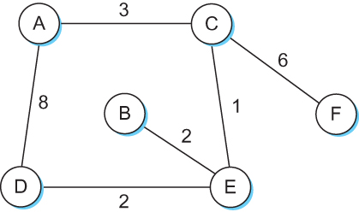

Node A
Destination | Next Hop
A | -
B | C
C | C
D | C
E | C
F | C
Node B
Destination | Next Hop
A | E
B | -
C | E
D | E
E | E
F | E
Node C
Destination | Next Hop
A | A
B | E
C | -
D | E
E | E
F | F

Node E
Destination | Next Hop
A | C
B | B
C | C
D | C
E | -
F | C
Node F
Destination | Next Hop
A | C
B | C
C | C
D | C
E | C
F | -
Node D
Destination | Next Hop
A | E
B | E
C | E
D | -
E | E
F | E

5. (10 points) Consider the arrangement of learning bridges B1, B2, B3, and B4 shown in the figure below. Assuming all are initially empty, give the forwarding tables for each of the bridges B1 to B4 after the following transmissions:

- A sends to C.
- C sends to A.
- D sends to C.

Identify ports with the unique neighbor reached directly from that port; that is, the ports for B1 are to be labeled “A” and “B2.”
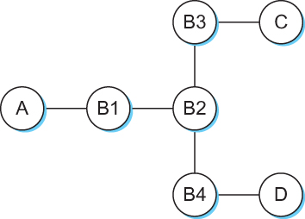

B1:
Destination | Port
C | B2
A | A

B2:
Destination | Port
C | B3
A | B1

B3:
Destination | Port
C | C
A | B2

B4:
Destination | Port

6. (10 points) Consider hosts X, Y, Z,W and learning bridges B1, B2, B3, with initially empty forwarding tables, as in the figure below.

- Suppose X sends to W. Which bridges learn where X is? Does Y’s network interface see this packet?
All B1, B2, B3 learn where X is.
Yes.
(b) Suppose Z now sends to X. Which bridges learn where Z is? Does Y’s network interface see this packet?
All B1, B2, B3 learn where Z is.
No.
(c) Suppose Y now sends to X. Which bridges learn where Y is? Does Z’s network interface see this packet?
B1 and B2 learn where Y is.
No.
(d) Finally, suppose W sends to Y. Which bridges learn where W is? Does Z’s network interface see this packet?
B2 and B3 learn where W is.
Yes.

