|  |
| --- |
| O Pathway Tool |
| User instructions |

|  |
| --- |
| Tom Mikkola  7.4.2022 |

2

Content

Forewords 2

Getting started 2

Layout 3

Side panel 4

Details panel 6

Plot panel 8

Default settings 11

Modelling 12

Importing data 13

Exporting data 17

How to 21

Plot figure without imported data 21

Plot figure with data input by hand 22

Plot a test from imported data 23

Plot comparison figure 24

Plot statistics figure 25

Export data to new file 26

Export data to imported file 27

Troubleshooting 28

“Invalid values. Please check the units…” 28

# Forewords

Thank you for trying out the O2 Pathway Tool! This tool has been designed and programmed as a health technology engineering student’s bachelor’s thesis work. Idea for the tool came from the professionals of Helsingin Urheilulääkäriasema (Helsinki Sports and Exercise Medicine Clinic). The main idea of the tool is to model oxygen pathway as an integrated system both visually and numerically. The tool can be used with measured data or completely without data. The modelling is based on Fick’s equations and laws with a few approximations that are shown to be reasonable.

Unfortunately, there is no technical support or upkeep of the source code. However, the source code of this tool is free to use and modify to fit you needs.

# Getting started

When you are reading this document there is a high possibility you have already downloaded the tool from GitHub. If this is not the case here are the necessary steps to get started:

1. Download the latest release of the O2 Pathway Tool from [GitHub](https://github.com/TomMikkola/O2PathwayTool/releases)
   1. Click on the “Assets”-link to see the “O2PathwayTool.zip”-file
2. Save the .zip-file to wanted location on your operating system
3. Unpack the file
4. Inside the folder of the unpacked file, double left click on the “O2PathwayTool.exe”-file to run the tool

TIP

You can create a desktop shortcut from the “O2PathwayTool.exe”-file. On Windows systems this is done by right clicking the file and selecting “Create a desktop shortcut”

# Layout

O2 Pathway tool’s layout is constructed of three main components:

1. Side panel
2. Details panel
3. Plot panel

1

3

2

You can **control the visibility** of these panels from the main menu bar’s “**View**”-menu (top part of the tool). You can also **adjust the size of the panels** by holding your cursor above the edge of the panel and dragging it to fit your needs. When holding the cursor above the edge of the panel, the shape of the cursor changes to inform you about this functionality.

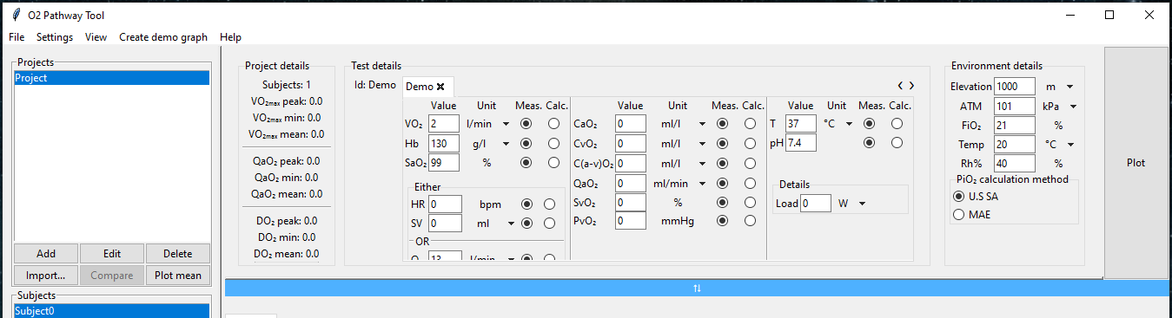

If the panel’s content can not fit the resized panel, a blue bar is shown. When you double left click on the bar, the panel is returned to its default size.

TIP

The current state of the layout is stored when closing the tool, so you can continue automatically with the same set-up you ended working with.

## Side panel

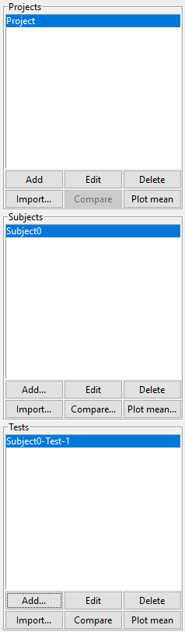The side panel is constructed of three modules:

1. Project module

1

1. Subject module
2. Test module

These modules hold and let you control its respective content. Every component holds a list of created instances which you can add, edit, or delete if needed. The buttons in every module have the same functionalities.

2

3

Creating an instance

Once the “**Add**”-button is pressed, a popup window appears to give you a choice of adding an instance to the list or adding the selected subject’s content to the details panel (more info about this can be found here).

Constructing a test

In addition to work with imported or created instances you can also construct a plottable instance yourself by combining data from different instances. This functionality enables you to add data from different projects, subjects, or tests to be plotted in the same figure.

Editing an instance:

Names of the instances are formed by the imported data or by indexed default names. You can edit the name at any time by selecting the instance to be edited and clicking “**Edit**”-button.

Deleting an instance

If you want to delete an instance, simply select the instance to be deleted and click “**Delete**”-button

Importing instances

The “**Importing…**”-button opens the data import wizard. More about the import wizard can be found here.

Comparing instances

To compare instances, first you must choose at least two instances from the list. Multiple choosing can be done by:

1. Holding **CTRL-key** + **LEFT** clicking individual instances
2. Holding **SHIFT-key** + **LEFT** clicking an instance to select every instance between the first and the last selection

After selection click “**Compare**”-button to open the comparison options popup. From the options popup you can choose what content to compare. After clicking the “**Compare”**-button in the popup, the wanted content is moved to the details panel where you can still modify them and create a figure.

Plotting statistics

You can create a statistics figure of a single instance’s content or multiple instances’ content. First you must select wanted instances and click “**Plot mean…**” and a statistics options popup appears. There are three possible statistical methods that can be used:

1. Mean/SD - Standard deviation
2. Median/IQR - Interquartile range
3. Mean/CI95 - Confidence interval of 95%

Every statistic figure is constructed of three tabs and numerical values for each tab are calculated. After creating the statistic figure, the calculated values are shown in the plot panels load details module (more about the details module can be found here).

## Details panel

The details panel acts as a constructor which enables you to gather the wanted information to be plotted. The content can be added from the side panel and its modules. The details panel is constructed of four modules:

1. Project details
2. Test details
3. Environment details
4. The “**Plot**”-button

1

2

3

4

You can control the visibility of the whole details panel and each of its modules from the “**View**”-option of the main menu bar (top part of the tool).

Project details

Project details module holds statistical information of the currently selected project. The subject count updates automatically when new subject is added to the project. The peak, min and max values are updated, when the “**Calculate**”-button is clicked or after a project statistics figure is plotted. Calculation of project statistics is based on the values of maximum loads of subjects’ tests in selected project.

Test details

Test details is constructed of two modules

1. Details
2. Load notebook

Every test’s loads are handled in the tool as tabs. Every tab contains the details of the corresponding load. Here you can edit the values, used units and mark the parameter as measured or calculated for every load. These values are used to model the oxygen pathway and create a figure. Even if the data is imported you can safely edit the parameters. The tool will not override imported data, so the changes made to the parameters are stored only in the details module and once you select another test the changes are lost. If you are inputting values by hand, please make sure you use **dot** rather than a **comma**.

If you have saved a value for the peak core temperature and peak pH, the change is distributed automatically linearly between loads.

If you are constructing a test by hand, you can **add a load** by clicking the “**Add**”-button. After clicking the button, a new tab is appended to the notebook with a default indexed name. You can **edit the name** of the load at any time by clicking the “**Edit**”-button. To **delete** **a load**, click the small cross in the tab. Deletion of a tab is confirmed with a popup window.

**! IMPORTANT !**

If you have imported data and realize that the default units are different from the ones used in the data, you can change the units to the whole project by changing the default settings in the “**Settings**”-menu in the main menu bar (in the top part of the tool). The change in the settings is automatically updated for the whole tool. More about the default settings can be found in the next chapter.

Environmental details

Environmental details let you modify the conditions the test was performed in. These values are used test wise, so they are implemented on every load.

! IMPORTANT !

The environmental options are not taken into account in the current version of the O2 Pathway Tool. These options work the same way as the test default values, but are not used in the model.

The “Plot”-button

To **create a figure** with the values input or imported to the test details and environmental details, click the “**Plot**”-button. After clicking the button, the O2 Pathway Tool validates the given values and does the calculations. If the values are not valid or the used units are incorrect an error message is shown below the main menu bar. The error message contains information about the load that the tool was unable to calculate. If values are valid a figure is shown in the plot panel (more about this can be found here)

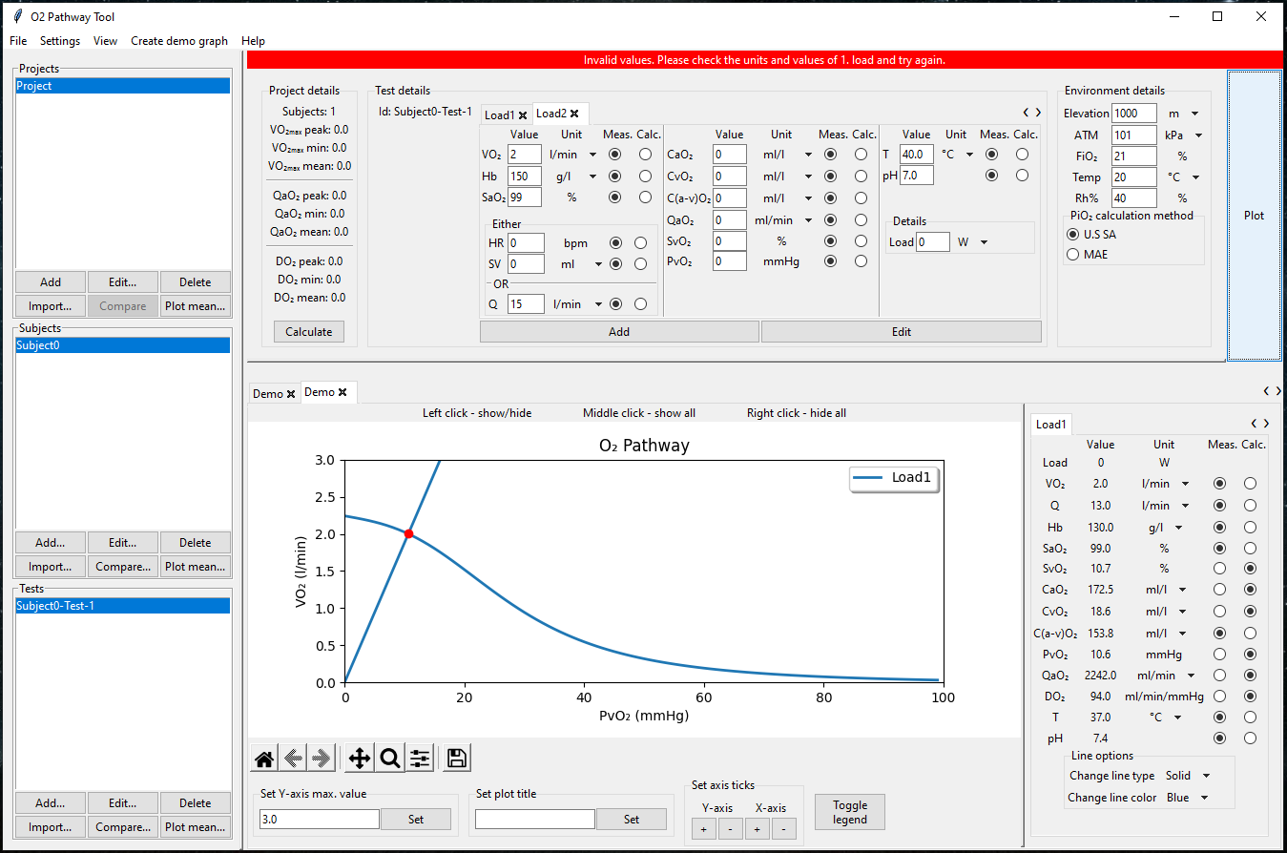

## Plot panel

Plotting panel is the main purpose of the O2 Pathway Tool. Plotting panel holds the visual output and the numerical values of the modelling process. Every model is created on a tab as well as every load. There is no limit for the number of tabs that can be created, and you can cycle through them by left clicking the tab. If your tabs exceed the width of the window, you can **scroll** them through by using the mouse wheel or by clicking the “**<**”- or “**>**”-buttons. **Removing** a tab works the same way as in the test details, by clicking the small cross inside the tab. Removal of a tab is confirmed by a popup window, so you cannot accidentally remove a tab and lose its information.

The panel is constructed of three main modules:

1. The figure
2. Figure options
3. Load details

3

2

1

The figure

The figure has two lines, the diffusion line and convection curve. Drawing of the lines is based on the Fick’s law of diffusion and equation listed here. The crossing of these lines is programmatically detected and is marked by a red dot. Every load is plotted as a unit meaning, that if you modify for example the color of a line representing a specific load the change is implemented on both the diffusion line and convection curve. There is no limit for the number of load units that can be used.

You can **toggle the visibility** **of a line** by left clicking the line itself or its corresponding line in the figure legend. Right clicking anywhere on the figure hides every line. Middle clicking anywhere on the figure shows every line.

The units of the y-axis and its label are determined automatically by the units used when creating the figure. You can **change the unit** **of y-axis** by selecting the wanted unit for VO2 from the unit dropdown menu in the adjacent load details.

The **maximum value of the y-axis** is determined by the maximum value of the convective oxygen delivery. After the maximum value is calculated, its value is rounded to the closest 500 ml/l or 0.5 l/min value. The number of ticks is set automatically, but you can modify it in the figure options below the figure.

The **title of the figure** can also be changed from the figure options below the figure.

Figure options

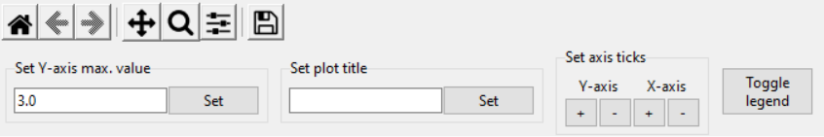Figure options enables you to modify the figure. The basic tools are:

Home button: Return to the default settings if you have moved or zoomed the figure



Arrow buttons: Cycle through different changes. Every move or zoom action creates a new view, which you can cycle with these buttons.

Move: While holding left click on the figure, move the mouse to drag the figure to wanted location.



Zoom: To zoom on certain location on the figure, draw a rectangle on the area you want to focus on by holding the left click on the figure and moving the mouse



Adjust the figure: If the proportions are not suitable or a title is not fully visible, you can adjust the aspect ratio and positioning of the whole figure.



Save the figure: Use this if you want to save only the figure as an image file. The image is saved as a .png-file to the working directory of the tool in your operating system.

Other tools are:

1. Y-axis max value setter – Input the wanted maximum value of the y-axis and click “**Set**”
2. Plot title setter – Input the wanted title for the figure and click “**Set**”
3. Increment/Decrement of axis ticks – Add or remove ticks by clicking the “**+**” or “**-**”-buttons
4. Legend hider – Click to toggle the visibility of the figure legend

4

3

2

1



Load details

The load details contain all the numerical (calculated or measured) values of the currently selected load. You can cycle through the load tabs to see their respective details. If the number of tabs exceed the width of the window, you can scroll through the tabs by using the mouse wheel or clicking the “**<**”- or “**>**”-buttons.

You cannot change the values of the parameters, but you can still modify the unit and mark the parameter as calculated or measured. When **updating the unit** from the dropdown menu next to the numerical value, the tool automatically converts the value of the parameter to the corresponding unit.

You can **modify the load’s line type and color** in the figure by the options in the load details. In the current version of the tool, there are four different line types and 10 different color options. The options are as follows:

|  |  |
| --- | --- |
| Line types | |
| Solid |  |
| Dotted |  |
| Dashed |  |
| Dashdot |  |

|  |  |
| --- | --- |
| Line colors | |
| Blue | Orange |
| Green | Red |
| Purple | Brown |
| Pink | Gray |
| Olive | Cyan |

# Default settings

In order to save your preferred settings for the default values and units used in the model, you can set and modify the default settings in the “**Settings**”-menu in the top menu bar (in the top part of the tool). The default settings window is constructed of two modules

1. List of options

2

1

1. Details

Test options

You can set a test mode that is used by default in every test. Currently O2 Pathway Tool supports “**Loads**” as in exercise test done by bicycle ergometer and “**Velocity/Incline**” as in exercise test done by a treadmill. The selection will affect the details panel’s content.

Default settings allows you to set default unit and value for every parameter. The options for parameter units are listed in the dropdown menus, which can be opened by clicking the wanted unit. You can also enter default values for core temperature and pH at rest and their peak value. These values are distributed automatically for loads linearly. Once you click “**Save**”-button the values and units are stored and updated in the details panel. You can close the settings window by clicking the “**Cancel**”**-**button.

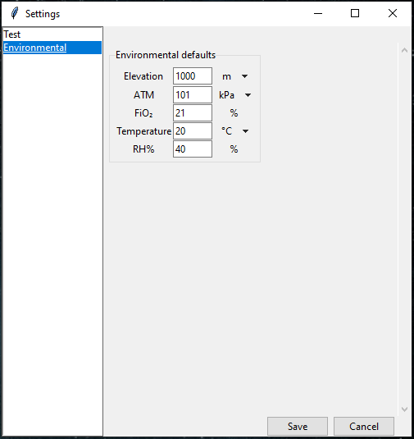Environmental options

The same functionalities apply to environmental options as well.

! IMPORTANT !

The environmental options are not taken into account in the current version of the O2 Pathway Tool. These options work the same way as the test default values, but are not used in the model.

# Modelling

O2 Pathway Tool combines the well-known Fick’s principle of mass conservation and law of diffusion to model oxygen pathway as an integrated system. In addition to the Fick’s equations, calculation of parameters not input by user are calculated with simple equations demonstrated by Legendre et al. The model has two approximations to simplify the calculating process:

1. Mitochondrial is taken to be zero
2. PcapO2 is replaced with a constant k

These approximations are shown to be reasonable by the research community. Used equations are demonstrated in the table below.

|  |  |  |  |
| --- | --- | --- | --- |
| **Variable** | **Abbreviation** | **Unit** | **If the calculation option exists, what an equation the calculation is based on** |
| Pulmonary O2 uptake | V̇O2 | ml/min | Fick equation: V̇O2 = Q̇ x C(a-v)O2 |
| Heart rate | HR | bpm |  |
| Stroke volume | SV | ml | Fick equation: SV = V̇O2 / HR / C(a-v)O2 |
| Cardiac output | Q̇ | l/min | Fick equation: Q̇ = V̇O2 / C(a-v)O2 |
| Hemoglobin concentration | [Hb] | g/l |  |
| Arterial O2 saturation | SaO2 | % |  |
| Arterial O2 content | CaO2 | ml O2 / l blood | CaO2 = 1.34 x [Hb] x SaO2 / 100 |
| Venous O2 saturation | SvO2 | % | SvO2 = (CaO2 - C(a-v)O2) x 100 / 1,34 / [Hb] |
| Venous O2 content | CvO2 | ml O2 / l blood | CvO2 = 1.34 x [Hb] x SvO2 / 100 |
| Arterial-venous O2 difference | C(a-v)O2 | ml O2 / l blood | 1. Fick equation: C(a-v)O2 = V̇O2 / Q̇ 2. C(a-v)O2 = CaO2 - CvO2 |
| Convective O2 delivery | Q̇aO2 | ml/min | Q̇aO2 = Q̇ x CaO2 |
| Blood temperature | *T* | °C | *T* at rest = 37 °C, *T* during submaximal exercise = approximated*, *T* at peak exercise = 39 °C |
| pH | pH | - | pH at rest = 7.2, pHduring submaximal exercise = approximated**, *T* at peak exercise = 39 °C |
| Partial venous O2 pressure | PvO2 | mmHg | Equations described in Legendre et al. 2021 |
| Diffusive O2 conductance | DO2 | ml/min/mmHg | Fick's law of diffusion: DO2 = V̇O2 / 2 / PvO2 |

* approximation based on Munch et al. J Physiol 2014; 592:377-390 and/or Trangmar et al. 2017;5:e13108

** approximation based on Mortensen et al. J Physiol 2005; 566:273-285 and/or Munch et al. J Physiol 2014; 592:377-390 and/or Trangmar et al. 2017;5:e13108

# Importing data

O2 Pathway Tool features a data importation tool that is intended to enable generic data import from any shape of data. The importing wizard can be started by clicking an “**Import…**”-button or selecting “**File**” -> ”**Import…**”-menu from the main menu bar (in the top part of the tool).

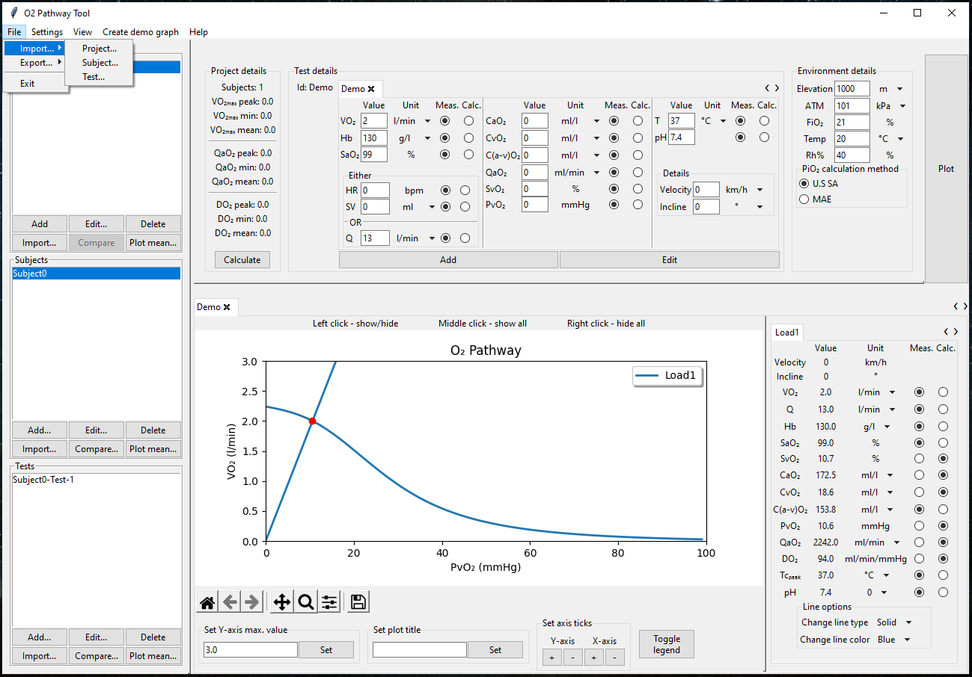

Once the wizard is launched, it will ask you to point out the file you want to import. After selecting the file to be imported, the wizard processes the file and opens it in a new window. The main idea behind the data importing wizard is to enable you to tell the tool where the wanted information is located. This way you can import any shape of data into the tool. You can import data from all of the rows/columns of the file or only specific rows/columns.

The import wizard is constructed of the following sections:

1. List of import steps
2. Sheet selection drop down menu
3. Mass selection tools
4. Datatable
5. Current selection indicator
6. Navigation buttons

3

6

1

5

2

4

List of import steps

Import step list shows you the steps that are included in the importing wizard. You can advance in the list by the navigation buttons or by clicking any list item. The current location in the list is indicated by a left pointing arrow. Successfully imported parameters are indicated by a checkmark. If you have mistakenly imported wrong data, you can return to the parameter and input correct data at any time. You do not have to go through them all if you do not have any data for the parameter. The tool is designed to be used from the standpoint of non-invasively measured data, which is why the following information is needed:

1. ID
2. Load
3. VO2
4. HR & SV **or** Q
5. Hb
6. SaO2

Some parameters can be calculated with the help of other parameters, so there might be a way to use the tool if some of the parameters listed above are missing. To check which parameters can be calculated with the help of other parameters, please refer to this table.

! IMPORTANT !

To use the data importing wizard you have to start from and import at least steps “ID” and “Load”. Without these parameters the tool is not able to create subjects and tests successfully and data importing errors might occur.

Sheet selection menu

If your file to be imported contains more than one sheet, they are listed in sheet selection drop down menu. The wizard opens the first sheet by default. You can import data from different sheets, but please make sure the data in different sheets is the same shape. The data is fetched based on the row(s)/column(s) listed in the “Load”-phase.

Mass selection

If your data contains so many rows/columns that it is very laborious to select by hand, you can use the mass selection tools. To use mass selection tools, first select if you are selecting rows of columns from the drow down menu. Then input the start and end row/column and click “**Set**”-button, to make the selection with the given values.

Datatable

Datatable is the O2 Pathway Tool’s copy of the imported file. It should contain the same information as the imported file. You can select rows and columns by left clicking the index bars shown in the picture below.

There are multiple ways you can make your selection:

1. Left click single row/column index
2. While holding left click, move the mouse over wanted row/column indexes to select multiple rows/columns
3. Hold down CTRL-button and left click on wanted indexes to select multiple rows/columns
4. Left click the start row/column index and while holding down SHIFT-button, left click the end row/column index to select multiple rows/columns
5. Right clicking anywhere on the datatable to deselect everything

These functionalities enable you to freely select the necessary rows/columns to import data from.

Examples

Select data from columns 1 and 4

1. Left click on the index of column 1
2. Hold down CTRL-button
3. Left click on the index of column 4

Select data from columns 1 to 4

1. Kuva, joka sisältää kohteen pöytä

   Kuvaus luotu automaattisestiLeft click on the index of column 1
2. Hold down SHIFT-button
3. Left click on the index of column 4

Alternatively

1. Kuva, joka sisältää kohteen pöytä

   Kuvaus luotu automaattisestiLeft click on the index of column 1
2. Hold down left click
3. Move cursor on the index of column 4

When selecting the “**ID**”-parameter and a single row or column is selected, a popup window appears

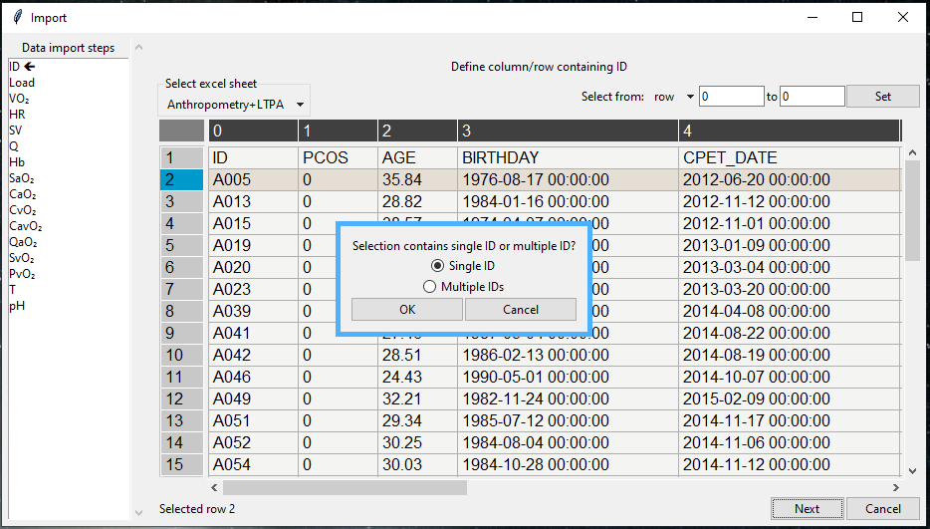

The purpose of this popup window is to determine the shape of your data. Information about the shape of the data is crucial for the importer to work as intended, so this question is mandatory and if cancelled the data cannot be imported. If multiple rows/columns are selected the shape of the data is automatically determined.

Current selection indicator

The current selection indicator shows you the currently selected row(s)/column(s). You can ensure from the indicator that the tool has selected the wanted row(s)/column(s) for example after the mass selection tool.

Navigation buttons

Navigation buttons act as a secondary way to control the data importing process. You can proceed or return to previous phase by clicking the “**Next**”- and “**Prev**”-buttons. If you do not have any data for the current phase’s parameter, you can move to the next phase by clicking “**Skip**”-button. After you have input all the data you intended, you can finish the process by clicking the “**Done**”-button any time. You can as well cancel the importing process at any time by clicking the “**Cancel**”-button.

# Exporting data

There are four options for exporting data for you to choose from in the current version of the O2 Pathway Tool:

1. Exporting active project’s content into a new excel file
2. Exporting active project’s content into imported file
3. Exporting only created content into a new excel file
4. Exporting only created content into imported file

Note

O2 Pathway Tool does not override your data, it creates a copy of your imported file. The imported file is overridden only if you save results with the same filename as the imported file in the exporting process.

These options enable you to model oxygen pathway project wise or just for selected subjects or tests. The exporting options can be found from the “**File**” -> ”**Export**”-menu in the main menu bar (in the top part of the tool).

Exporting active project’s content into a new file

If you have a large dataset and want to model the oxygen pathway for every subject in your dataset, you can let the tool do it for you. This way you do not have to create a figure for every single test by hand. The exporting process is straightforward:

1. Select “**Project to new file…**”-option from the “**File**” -> ”**Export**”-menu
2. Choose the parameters you want to export
3. Click “**Export**”-button
4. Define location and name for the file to be saved

Once the file is saved O2 Pathway Tool creates a new excel file with the chosen parameters. The file contains separate sheets for every subject containing the calculations and figures for every test. Statistics are also calculated during the exporting process and the results are saved in separate sheets in the file.

31

2

1

Above is a screenshot of an example export file. Points of interest are marked with squares:

1. Load details and results of calculations
2. Figure of the test
3. Sheets created for statistics and subjects

Exporting active project’s content into imported file

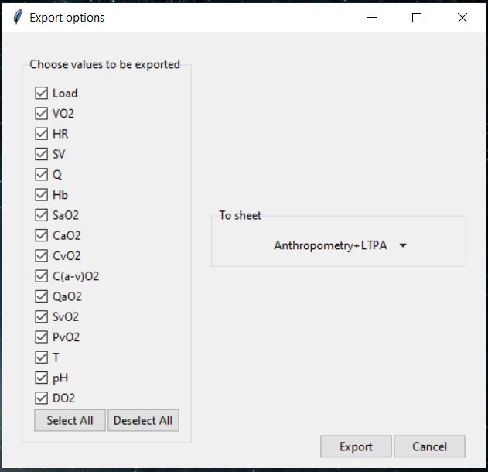Exporting to the same file used in importing is also straightforward and follows the same steps as exporting to a new file:

1. Select “**Project to new file…**”-option from the “**File**” -> ”**Export**”-menu
2. Choose the parameters you want to export
3. Choose the sheet you want to append the data to
4. Click “**Export**”-button
5. Define location and name for the file to be saved

Once the file is saved O2 Pathway Tool creates a new file with the same data as in the file used to import data with the calculations appended to the sheet of your choosing. Load indexes, used units and measured/calculated values are stored in the name of the column/row.

In addition to appended data, statistics are added to their respective sheets as well as figures for every subject of the dataset in the sheet “**Plots**”. Figures are saved with the test name for identification purposes.

Exporting only created content into a new excel file

When exporting only created content, the exporting process is basically the same as in exporting the whole project’s content. The only difference is that in this case only the figures you have created in the tool are to be exported.

The exporting process works as follows:

1. Create figures as many as needed (instructions on how, please refer to this)
2. Select “**Project to new file…**”-option from the “**File**” -> ”**Export**”-menu
3. Choose the parameters you want to export
4. Click “**Export**”-button
5. Define location and name for the file to be saved

The saved excel file is constructed in the same way as exporting the whole project’s content. Sheets are created for every test and selected parameters are saved load by load with figures shown next to the details.

Exporting only created content into imported file

When exporting only created content into the same file used to import data, the exporting process is very similar to exporting the whole project’s content. The only difference is that the calculations and figures are appended as separate sheets to the imported file.

The exporting process works as follows:

1. Create figures as many as needed (instructions on how, please refer to this)
2. Select “**Project to new file…**”-option from the “**File**” -> ”**Export**”-menu
3. Choose the parameters you want to export
4. Click “**Export**”-button
5. Define location and name for the file to be saved

# How to

Here is listed a few step-by-step examples to show you how to operate O2 Pathway Tool.

## Plot figure without imported data

1. Start the O2 Pathway Tool by running the “O2PathwayTool.exe”-file
2. 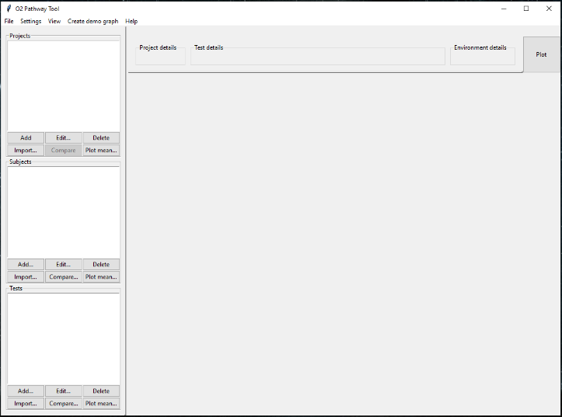From the main menu bar click the “Create demo graph”-option
3. Kuva, joka sisältää kohteen teksti, näyttökuva, tietokone, sisä

   Kuvaus luotu automaattisestiA demo figure is shown and the values used to create the figure are shown in the details panel

## Plot figure with data input by hand

1. 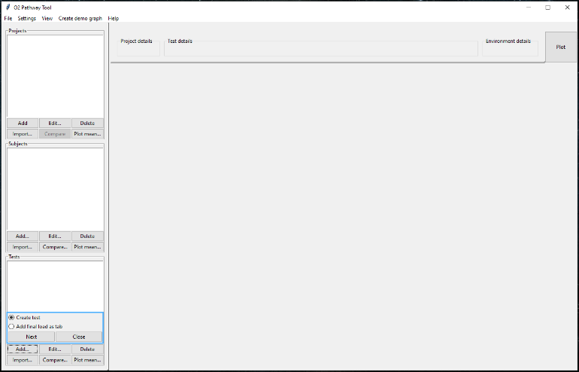Start the O2 Pathway Tool by running the “O2PathwayTool.exe”-file
2. Click the “**Add**”-button in the side panels test module
3. Click the “**Next**”-button in the popup window



1. Input values to test details module
   1. The necessary values are grouped in the first column of the test details module
   2. You can still input other values as well. If other values are given, they are used in the model.
2. Kuva, joka sisältää kohteen teksti, näyttökuva, tietokone, kannettava

   Kuvaus luotu automaattisestiClick the “**Plot**”-button



1. Kuva, joka sisältää kohteen teksti, näyttökuva, tietokone

   Kuvaus luotu automaattisestiIf the values given are valid, the figure is shown in the plot panel

## Plot a test from imported data

1. 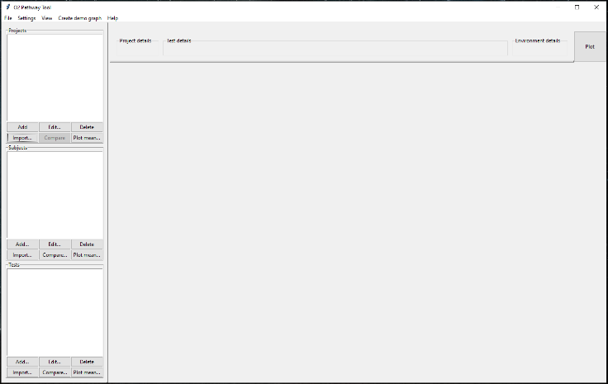Start the O2 Pathway Tool by running the “O2PathwayTool.exe”-file
2. Click the “**Import…**”-button in the side panels projects module
3. 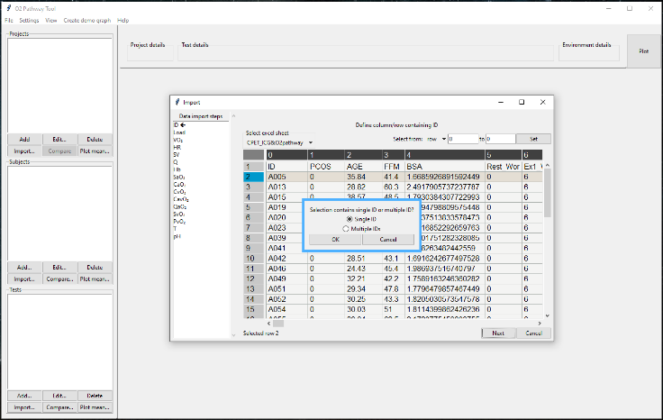Define the file to be imported from the popup window
4. Data importing wizard is started

a

* 1. Click on the row/column containing the wanted ID

c

* 1. Confirm selection by clicking the “**Next**”-button

b

* 1. Confirm single ID input

1. 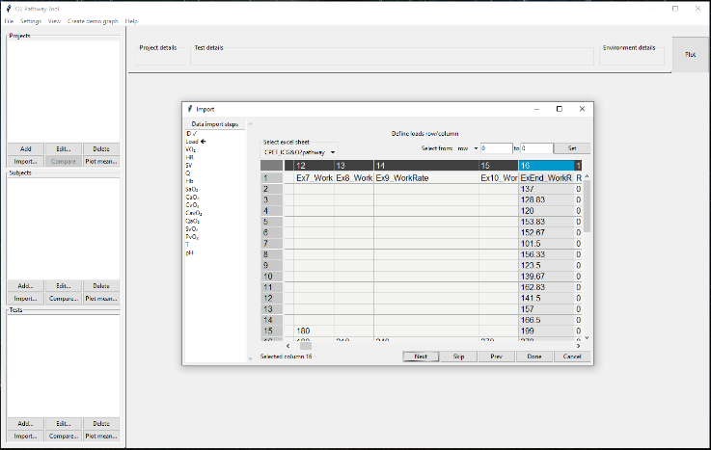Define the loads
   1. Click the wanted index (different ways to how are demonstrated here)

a

* 1. Click the “**Next**”-button

1. Repeat step 5 until SaO2 and click “**Done**”-button

b

* 1. You can move between phases by left clicking the parameter list
  2. You can skip a parameter by clicking the “**Skip**”-button

1. Kuva, joka sisältää kohteen teksti, näyttökuva, tietokone

   Kuvaus luotu automaattisestiClick a subject to make it active in the side panel

9

10



1. Double left click on a test in the side panel

7

1. The imported data is shown in the test details module

8



1. Click the “**Plot**”-button and the figure is created

## Plot comparison figure

1. Start the O2 Pathway Tool by running the “O2PathwayTool.exe”-file
2. Import data (instructions on how are shown here)
3. 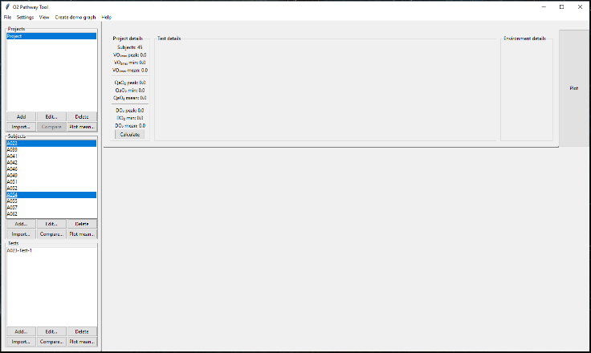Select first subject for comparison by left clicking it in the side panel’s subject module



1. While holding down the CTRL-button, select second subject for comparison by left clicking it in the side panel’s subject module
2. Kuva, joka sisältää kohteen teksti, näyttökuva, tietokone, kannettava

   Kuvaus luotu automaattisestiClick the “**Compare**”-button

6a

7

1. Select the tests to compare and click “**Compare**”-button
   1. Test details module is updated with separate loads for every selected subject

6

1. Click the “**Plot**”-button
2. Kuva, joka sisältää kohteen teksti, näyttökuva, tietokone, sisä

   Kuvaus luotu automaattisestiThe comparison figure is shown in the plot panel

## Plot statistics figure

1. Start the O2 Pathway Tool by running the “O2PathwayTool.exe”-file
2. Import data (instructions on how are shown here)

4

1. Kuva, joka sisältää kohteen teksti

   Kuvaus luotu automaattisestiChoose a project by left clicking it in the side panel’s project module

5

1. Click the “**Plot mean…**”-button
2. Select statistical method to be used and click “**Plot**”-button
3. 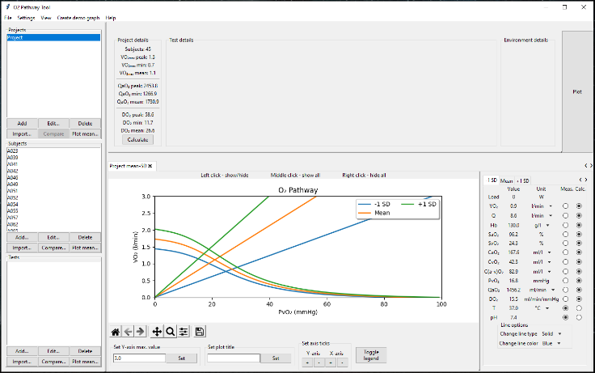The statistics figure is shown in the plot panel and three load tabs have been created with the corresponding numerical values

## Export data to new file

1. Start the O2 Pathway Tool by running the “O2PathwayTool.exe”-file
2. Import data (instructions on how are shown here)
3. 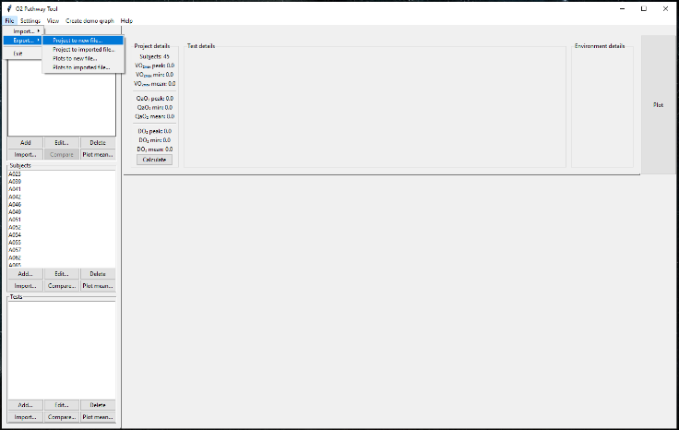Select the project which data you want to export from the side panel’s project module
4. Select exporting method from the “**File**”-menu in the main menu bar

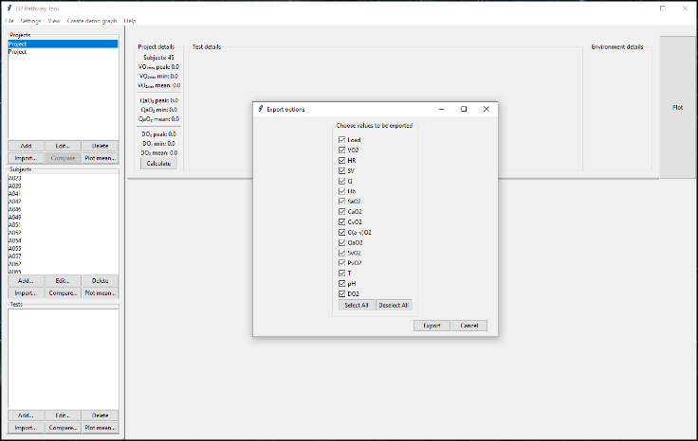

1. Select parameters to be exported
   1. You can deselect all by clicking the “**Deselect All**”-button
   2. You can select all by clicking the “**Select All**”-button
2. Click “**Export**”-button



1. Wait for the file explorer popup window to appear and define the exporting location
   1. 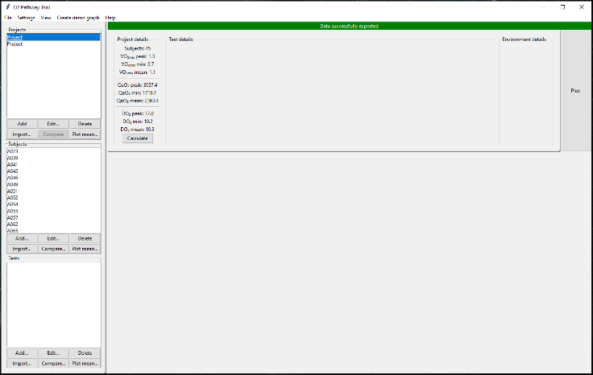Name the file
   2. Click “**Save**”-button
   3. Successful export is indicated with a green message in the top part of the window
2. 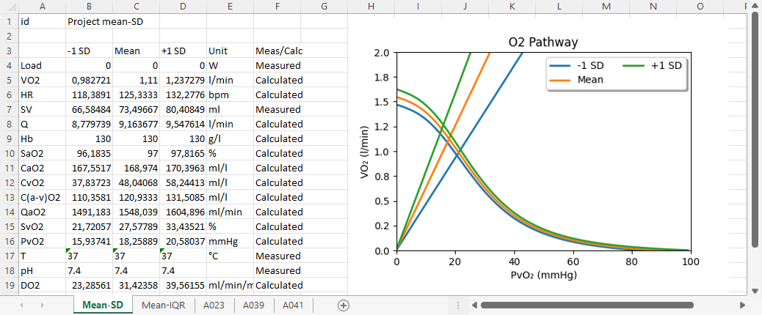An excel file is created (in this example case whole project’s data to a new file. Other exporting options can be found here)

## Export data to imported file

1. Start the O2 Pathway Tool by running the “O2PathwayTool.exe”-file
2. Import data (instructions on how are shown here)
3. Kuva, joka sisältää kohteen teksti

   Kuvaus luotu automaattisestiSelect the project which data you want to export from the side panel’s project module
4. Select exporting method from the “**File**”-menu in the main menu bar
5. 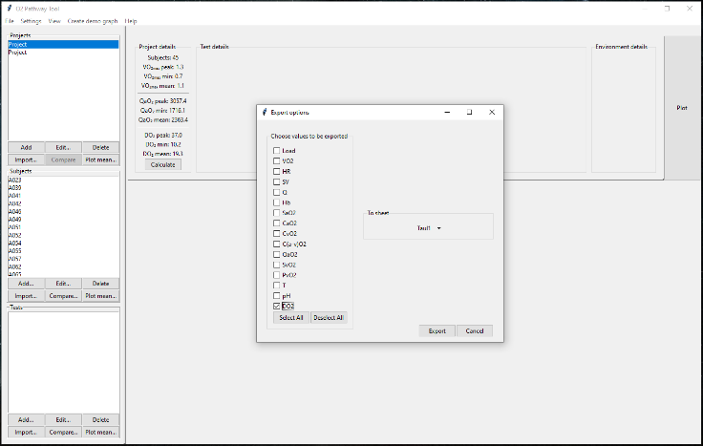Select parameters to be exported
   1. You can deselect all by clicking the “**Deselect All**”-button
   2. You can select all by clicking the “**Select All**”-button

6



1. Select the sheet you want to append the data to

7

1. Click “**Export**”-button
2. Wait for the file explorer popup window to appear and define the exporting location
   1. Name the file
   2. Click “**Save**”-button
   3. Successful export is indicated with a green message in the top part of the window

1. An excel file is created and the selected data is appended to the selected sheet

# Troubleshooting

## “Invalid values. Please check the units…”

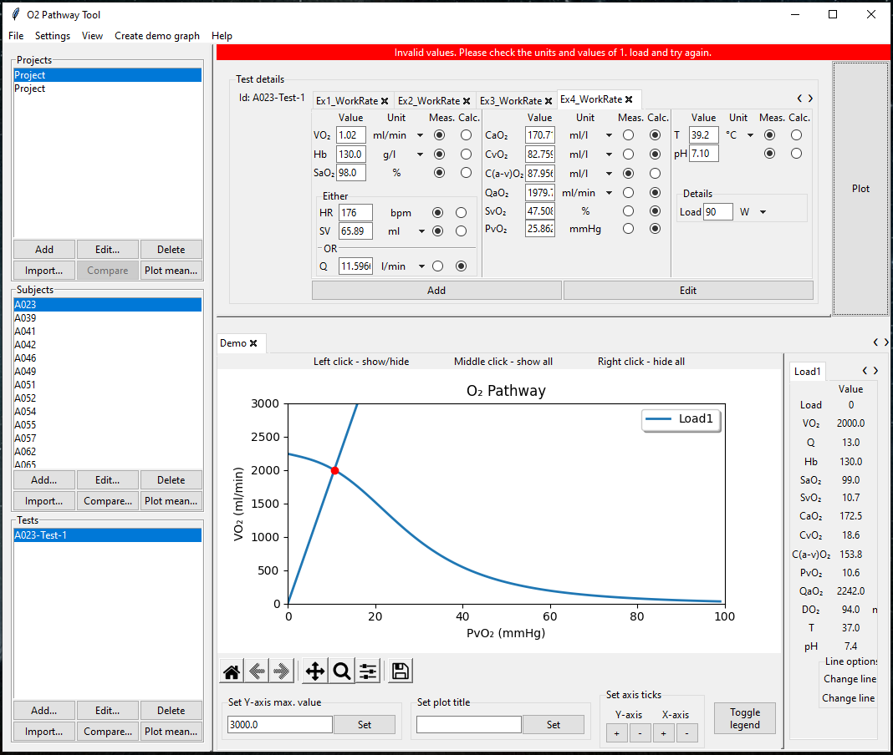

This error message appears when the O2 Pathway Tool cannot model the pathway with the given values. This usually means that one of the following situations occurred:

1. Some parameters unit is incorrect
2. Some parameter is missing, and the modelling cannot be done

To fix the first situation do the following:

1. 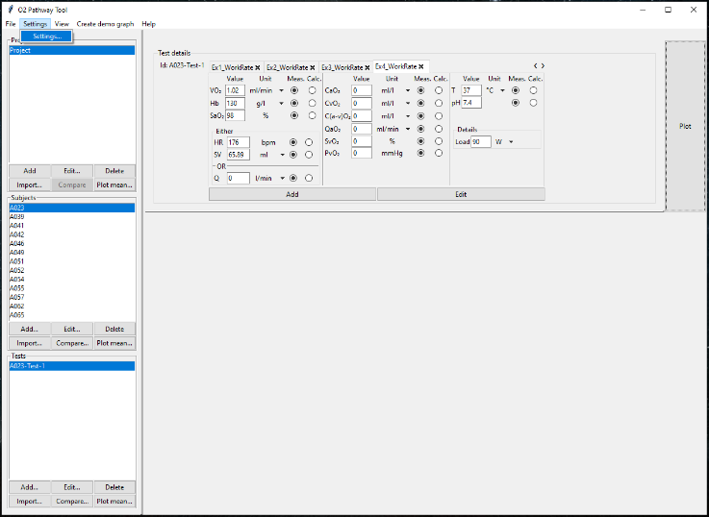Open default settings from the “**Settings**”-menu in the main menu bar
2. 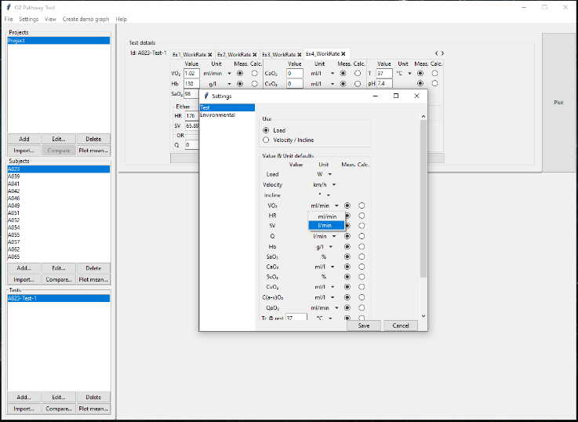Change the incorrect unit by clicking the corresponding parameter’s dropdown menu button
3. Save changes by clicking “**Save**”-button
4. The test details module is updated with the new default settings and the model can be created